Bhartendu Awasthi

DiSCO, squad - 4

User guide - Drop frequency optimization tool

SECTION I : Overview of the Tool

1. Objective
2. How optimizer works
3. Tool Architecture
4. Pros and Cons of the tool

SECTION II : Tool functionalities and usage

1. Where planners must interact with the tool
2. Feeding TPR input data to the tool
3. Running the tool
   1. Sheet 1 - “prepare_data_for_optimizer”
   2. Sheet 2 - “user_selection_filters”
   3. Sheet 3 - “drop_schedule_Dxxx”
   4. Sheet 4 - “drop_plan_summary_Dxxx”

SECTION I : OVERVIEW OF THE TOOL

**Objective :**

Drop frequency optimization tool was created with the aim to assist planners in creating an optimal drop schedule. Soon after the TPR of a department is finalized, planners have an important task of building a drop plan for different options that are going to range in the planning half. This tool is an attempt to standardize (to large extent) and automate the process of building a drop plan. Through this tool planners can quickly sense check how the drops are shaping up and edit the input data accordingly (if required).

**How optimizer works :**

Armed with attributes of new/existing options, ranging information, buy quantity, inventory from previous half etc. the tool scientifically creates an optimal drop schedule for each option using a sophisticated optimization algorithm.   
For each option, the algorithm tries to maximize number of drops, minimize the weeks where weeks on cover is below desired threshold, and minimize the gap between lowest and highest weeks of cover (this is also called as the objective function). While choosing the best possible drop plan (per the aforementioned objective function), the algorithm also tries to honor a set of constraints that planners specify, such as (including but not limited to) : magnitude of first drop, shipping minimum order quantity (SMOQ), desired threshold of weeks of cover etc.   
By construct, optimizer is highly interactive – planners can continually change the inputs/selections such as say, magnitude of first drop, SMOQ etc., and then re-run it to get the revised drop plan. Tool is great to create multiple scenarios of drop plans, to perform comparison.

**Tool Architecture :**

Front end for the tool is MS excel and the backend optimization engine is implemented in python programming language (<https://www.python.org/>) leveraging Google OR-Tools (<https://developers.google.com/optimization>)

As a starting point, planners will have to provide 2 sets of inputs to the tool :

1. Planners will have to fill an excel template which has the information around all the options to be ranged in the planning period. This is done non-interactively. This is one-time input (please see this section for more details)
2. Planners will have to input their selections in the tool interactively. These selections are for e.g. SMOQ level, magnitude of first drop size etc. (please this section for more details)

After point ii) from above, the required inputs are fed to the MS excel, which then passes the input data to python where a series of programs are written that leverages mathematical optimization. Optimization programs then return the optimal drop plan which is written back to the excel application/tool. Planners can then analyze the drop plan schedule directly from MS excel.

**Pros and cons of the Tool:**

Below are some of the pros and cons of the tool:

Pros:

1. **Automated** with minimal manual intervention
2. **Fast run time**. <= 90 secs on average for an entire department
3. **Flexible**. Planners can choose from a variety of settings to tailor the drops   
    as per the requirement / business context
4. **Scenario building**. By choosing different settings for an option, planners can   
    compare how the drop schedule will vary, and then choose the best setting
5. **Easy to refresh.** If TPR input data gets updated, tool can easily be refreshed   
    to incorporate the latest refresh
6. **Extendible.** Any additional criteria’s can be incorporated in future versions

Cons:

1. **Business context.** Tool is blind to business context

SECTION II :

Tool functionalities and usage:

**Where planners must interact with the tool**

The front end (MS excel) of the tool is saved inside the folder ./drop_frequency_optimization_tool/results. File name : “**optimal_drop_schedule.xlsm**”. Planners will primarily interact with this excel file.

* Planners are expected to provide inputs (interactively) in first 2 sheets (only) of the above file, i.e. : “**prepare_data_for_optimizer**” and “**user_selection_filters**”.
* 3rd sheet : “drop_schedule_Dxxx” has the results
* 4th sheet : “drop_plan_summary_Dxxx” has the summary of the results

CAUTION: Please don’t edit the name of the file, or any of the 4 worksheets

More detailed explanation of each of the above worksheets and their usage is in the below section : “Running the tool”

**Feeding TPR input data to the tool**

Starting point for the tool to function is the input data from TPR process. This input file has information around different options that are going to range in the planning half such as product’s merch hierarchy information, launch & markdown time period, buy quantity, inventory from previous half etc.   
The template to feed this information is saved at below path. This is the single stop to feed all the information/data to the tool :  
./drop_frequency_optimization_tool/ input_data/raw_input_data  
File name : “**Dxxx_inputs_for_drop_freq_optimization_tool**”  
There are different files for each of the department.  
  
CAUTION: Please don’t edit the name of the file, and the column names.  
There is column named : “Planning_period” (column U), over here please provide the first quarter of the planning period. For instance, if we are planning for FY 23, H1, then value to be fed here should be “2023-Q1”. For FY 23, H2, value = “2023-Q3”

Planners are expected to fill this template with the required information. This is the only place where planners have to manual feed the information to the tool. After this point, planners don’t have to provide any more data (through excel file) to the tool. Functioning of the tool is automated after this step

**Running the tool**

To run the tool, please access the file “**optimal_drop_schedule.xlsm”,** saved at the path - ./drop_frequency_optimization_tool/results

“**optimal_drop_schedule.xlsm”** has 4 worksheets, as highlighted above in one of the previous sections, planners will interact in terms of providing with appropriate selection to different criteria’s in the first 2 sheets. Last 2 sheets display the output post the optimizer runs through the input data.

**Below is detailed explanation of each of the 4 worksheets :**

**Sheet 1 - “prepare_data_for_optimizer”**

**Purpose** : This sheet pulls the NPDF forecast for the desired department

There are 2 selections to be made by the planner in this worksheet :

1. Planner chooses his/her department in cell “**B5**”.
2. Planner chooses if he/she plans to drop even beyond the planning half in cell “**B9**”  
   Let’s illustrate this with an example, let’s say planners are planning for FY 23, H1, but a certain option’s launch date is P1 wk1 and the markdown date is P7 wk4.  
   Now, there are 2 possibilities for cell “**B9**” (Yes & No):
   1. “**B9**” = “No” => NPDF forecast are pulled from P1 wk1 till P6 wk5 only since we are planning till P6 wk5 only (TPR : FY 23, H1). Hence “No” means we are not going beyond the planning half which ends at P6 wk5
   2. “**B9**” = “Yes” => NPDF forecast are pulled from P1 wk1 till markdown week i.e. P7 wk4. Here we are going beyond the P6 wk5 till markdown week

NOTE: Whatever selection we make in cell “B9” will impact all options. Hence, we cannot have drops planned till planning half end (P6 wk5) for some options and drops planned till markdown week (P7 wk4, say) for the others

**Pulling the NPDF data** : After making the selection in cells : “B5” and “B9”, please click the box named as “**RUN-DATA PREP MODULE**”. Clicking the box will trigger the pull of NPDF forecast. After a few seconds, command prompt window will pop up which will reflect the status of the data pull. Upon the successful completion of the pull, you should see a window like below : 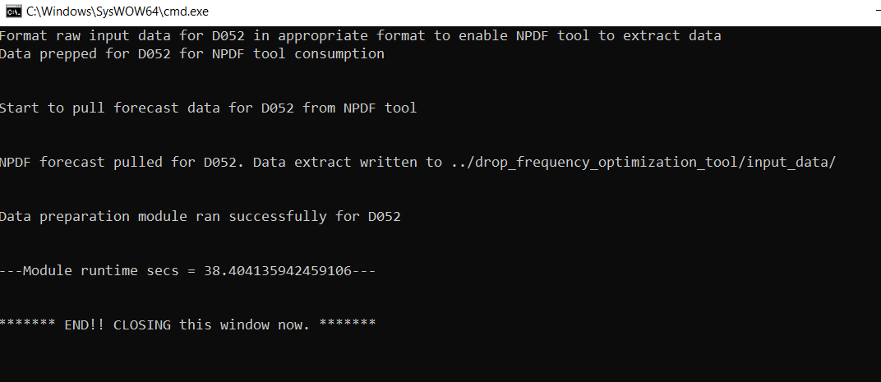

Above is a snapshot of NPDF data pull for D52. This window will close automatically after a few seconds post the successful pull.

NOTE: If any edits are made to the “**Dxxx_inputs_for_drop_freq_optimization_tool**” saved in the path - ./drop_frequency_optimization_tool/ input_data/raw_input_data, then the planner would have to again pull the data from NPDF via this sheet following the above process

After the successful pull, the NPDF forecast are saved in the below path  
./drop_frequency_optimization_tool/input_data/prepped_input_data_optimizer  
File name : “**sales_forecast_npdf.csv**” . Please make a note of this. We will circle back on this file when we talk about the second worksheet

**Sheet 2 - “user_selection_filters”**

This is the most involved sheet of the tool, in terms of number of selections that planners need to make.

**Purpose :** Provide appropriate selection to a list of criteria’s that will guide the optimizer to prepare the most optimal drop plan. Below are the key such criteria’s :

1. Strategy for choosing the first drop : Planners need to provide their input in cell “**E5**”. By choosing this selection planner is telling the optimizer that for new options (only) what is the strategy for placing the first drop.   
   2 possibilities are : WOC (weeks on cover) and shelf capacity
2. Magnitude of the first drop : Closely related to above is deciding the magnitude of the first drop. Planners need to provide their input in either cell “**E9**” OR “**F9**” (but not both). If selection of “WOC” is made in cell “**E5**”, then planners need to provide input in cell “**E9**”, else if planners chose “shelf capacity” in cell “E5”, then planners need to provide input in cell “**F9**”  
   “WOC” is self-explanatory. A selection of “shelf capacity” in cell “E5”, and a selection of 100% in cell “F9” would mean the first drop should fill all the stores per shelf capacity. So, if shelf capacity per store is say, 30 and the product is ranging say in 300 stores, to the first drop will be 30 * 300 * 100% = 9000 units  
   NOTE: Throughout this worksheet, any cells that are highlighted in grey implies that they are de-selected and no input should be provided for them (ignore these cells)

1. WOC to be maintained : Planners need to make their selection in cell “**G5**”. This selection tells the optimizer that what is the WOC that the planner desires to maintain throughout drop plan period (barring the first week for new options, because for them first drop size is pre-decided, hence WOC also)
2. Number of weeks drops zero : Planners need to make their selection in cell “**H5**”.  
   This selection is relevant for only those options that will go on markdown in the planning half. It says in how many weeks from the markdown week there should be no drops. So, say, if the markdown week is P3 wk4, and the selection value in cell “H5” is 4 then no drops will be placed from P3 wk1 till P3 wk4
3. Shipping minimum order quantity (SMOQ) : Planners need to make their selection in cell “**I9**”. This selection tells optimizer what is the minimum drop quantity that can be placed in any week. For e.g. is the value of the selection is 1000, then drop size either must be greater than equal to 1000 *OR* there should be no drop at all
4. Markdown sales reduction factor : This is an *optional* selection. This is closely related to selection : “Number of weeks drops zero”. Planners can *optionally* provide their inputs in cells : “**M5 : M10**”  
   If planner feels that sales forecast in last “x” weeks from markdown week is on a relatively higher side then planners can slash the sales forecast in last “x” weeks. “x” weeks is same as the input provided in cell “H5”. By whatever magnitude the forecast is reduced for last “x” weeks, the same get added up in the prior weeks. The tool adjusts this.
5. Options to send to optimizer : This is again an *optional* selection. Planners can *optionally* provide their inputs in **column V**. This column suggests which options should be send to optimizer to optimize the drop plan for. By default, all the options are marked as “y”, which implies run optimizer for all options. If we want to limit the run to only a few sets of options (say 5) then we should select “y” against these 5 options and “n” for the rest.   
   The rationale behind this selection is that suppose planners have finalized the drop plan for 50 options (say), and now they want to focus on the remaining options, then in this case there is potentially no merit in running the tool again for 50 options again (since their drop plan is already finalized). Then planners can choose “n” against these 50 options and “y” against the remaining ones

When in section **Sheet 1 - “prepare_data_for_optimizer”,** we touched upon the fact (reference) that the NPDF forecast : :**sales_forecast_npdf.csv”** are saved at this location : ./drop_frequency_optimization_tool/input_data/prepped_input_data_optimizer.   
In case planners feel that these forecasts are not in line with business expectations, then they can edit the sales forecast in column F. Post the edit, please save the file and visit   
Sheet 1 - “prepare_data_for_optimizer”, and re-run the box “**RUN-DATA PREP MODULE**”. Now the tool will use the revised forecast that was inputted by the planner. In case we want to revert to the original forecast, please re-run and then we will again get back the original forecast

**An overarching selection :**

There is an overarching selection that governs the working of the entire worksheet. That selection is placed at cell “**B3**”. This selection tells us whether planner wants to use the same set of selection criteria for all the options *OR* they want to customize the settings for every (or a bunch) option.   
If planners choose “Yes” for cell “B3” then it implies that all the selections from a) till e) [defined above] will apply for each option.

If planners choose “No” for cell “B3” then it implies that planners now have the flexibility to choose selections a) – e) [defined above] individually for every option.  
Please note that upon choosing “Yes”, selections above “row 10” will get de-selected (greyed out), and selection below “row 10” will NOW get enabled.   
Planners now, must feed the appropriate selection value for a) till e) but now in **column I till column P** onwards

Please note that filters f) and g) are common irrespective of the fact the planners choose “Yes” OR “No” in cell “**B3**”

**Running the optimizer :**

Upon making the desired selections above, planners will have to invoke the optimizer to build the drop plan. This is done by clicking on the box named “**RUN – OPTIMIZER**”.  
This will trigger the optimization process. After a few seconds, command prompt window will pop up which will reflect the status of the optimization process

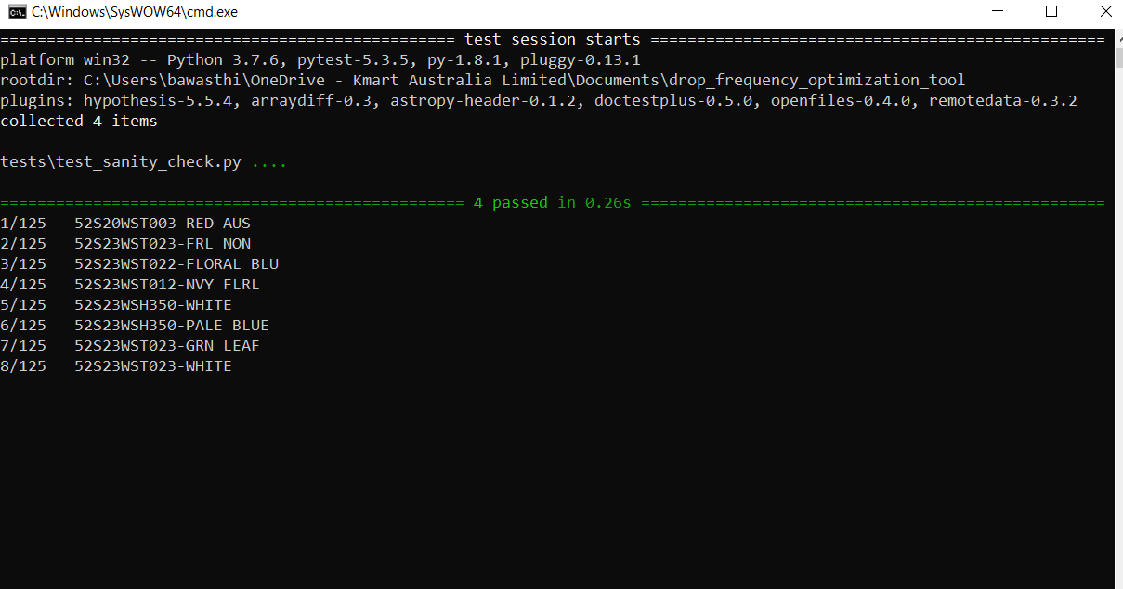

Part 1: This tells that the optimization process has been triggered and drop for 8 out 125 options has been created. Below screenshot confirms that optimizer has successfully ran for the remainder of the options

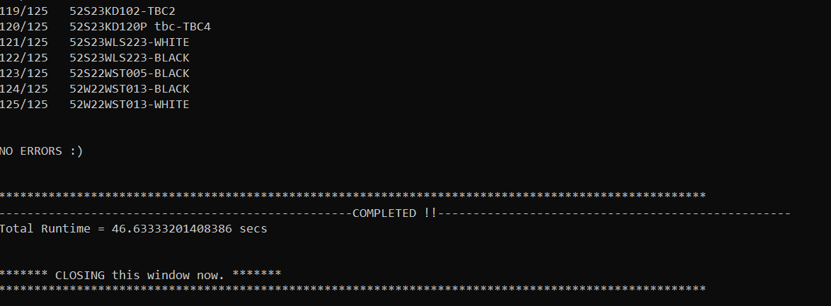

Part 2 : Above screenshot suggest that optimization process has ran for all the 125 options. This window will close automatically after a few seconds

**Sheet 3 - “drop_schedule_Dxxx”**

This sheet and the next sheet report the drop plan outputted from the optimizer. Both these sheets do not require any user input from planner

**Purpose** :To report out the drop plan result for each of the option. The format of the report is made consistent with that of the buy plan to enable easy copy-paste

**Column D :** “Quantity” highlights the magnitude of the drop size for every week.

**Column L** has the sales forecast pulled from the NPDF tool. This is directly coming from “**sales_forecast_npdf.csv”** saved in the path ./drop_frequency_optimization_tool/input_data/prepped_input_data_optimizer  
Please refer to “Sheet 1 - prepare_data_for_optimizer” for more details

**Column M** depicts the stock on hand

**Column N** depicts the weeks on cover. Any value of WOC less than 0 is highlighted in Red and any WOC less than 1.5 is highlighted in Orange

Please note that the drop plan generated respects the selection made in the earlier 2 worksheets : “prepare_data_for_optimizer” and “user_selection_filters”

Errors : options for which optimizer failed are reported in **column Q** (for these options drop plan is not generated)

Options Skipped : Reported in **column S**. These options have buy quantity less than that of SMOQ. Hence no drop plan created for these options

**Sheet 4 - “drop_plan_summary_Dxxx”**

**Purpose** : This sheet summarizes the drop plan result reported in the previous worksheet to report out a few key metrics

Below are some of the key column definitions:

**Column H** : Total_drops – In how many weeks did the optimizer placed the drops

**Column I :** Total wks in half – Total number of weeks in the planning half

**Column J :** Total wks excl mkdn – Total number of weeks in the planning half excluding those number weeks where no drops would be placed (i.e. last 4/6 weeks from markdown week. Same is highlighted in sheet “user_selection_filters” cell “H5”)

**Column K** : Avg drop freq – This is defined as column H / column J.

**Column L :** Avg drop vol – Average drop size. Average of all non-zero drop volume

**Column M** : Min Drop vol – Minimum drop size (which is greater than zero)

**Column N** : Avg_weeks_cover – what is the average weeks on cover. Values less than 4 are highlighted in Orange

**Column O** : Num_wks_WC_lessThan_4 – Number of weeks where WOC was less than 4

**Column AE – AH :** Has the overall summary