AI-Powered Customer Churn & Revenue Intelligence Platform
Project Report
Submitted as part of the AICTE | IBM SkillsBuild Data Analytics with AI Academic Internship 2026 (BharatCares)
Dataset: Bank Customer Churn Dataset (10,000 customers)
Dataset Source: https://www.kaggle.com/datasets/adammaus/predicting-churn-for-bank-customers

1. Abstract
This project builds an end-to-end Business Intelligence and AI-assisted decision-support platform for customer churn and revenue analysis using a real bank customer dataset. The platform follows a complete analytical pipeline — from raw data cleaning through KPI computation, segment and driver analysis, rule-based customer risk scoring, a machine-learning churn model, and an AI insight engine that converts analytical results into FACT-INSIGHT-RISK/OPPORTUNITY-ACTION recommendations. All figures reported are computed directly from the dataset; no statistics are fabricated.

2. Introduction
Customer churn is one of the costliest problems for subscription- and relationship-based businesses such as banks. Retaining an existing customer is significantly cheaper than acquiring a new one, so understanding who is likely to churn, why, and what to do about it has direct revenue impact. This project demonstrates a full Business Intelligence mindset: Data -> Information -> Insight -> Risk/Opportunity -> Decision -> Action.

3. Problem Statement
Raw customer-level data alone does not tell a bank which customers are at risk of leaving, which segments and behaviors drive that risk, or what specific action should be taken. This project converts raw data into an actionable, AI-assisted decision-support platform.

4. Objectives
- Understand what is happening to the customer base (KPIs).
- Understand how performance varies across segments (geography, product count, demographics).
- Understand why churn happens (driver analysis, feature importance).
- Identify which customers/segments are most at risk.
- Identify growth opportunities supported by the data.
- Generate AI-assisted, evidence-based business recommendations.

5. Business Use Case
A retail bank wants to proactively reduce customer attrition and protect its deposit/balance base. Business stakeholders (not data scientists) need a self-service dashboard to identify at-risk customers and receive concrete, prioritized retention and growth actions.

6. Dataset Description
The dataset contains 10,000 bank customers across 14 columns, with no missing values and no duplicate records.
Column | Description
CustomerId / Surname | Customer identifiers (not used as model features)
CreditScore | Customer credit score (300-850)
Geography | Country: France, Germany, Spain
Gender | Male / Female
Age | Customer age
Tenure | Years as a bank customer
Balance | Account balance (revenue proxy)
NumOfProducts | Number of bank products held (1-4)
HasCrCard | Has a credit card (0/1)
IsActiveMember | Active membership flag (0/1)
EstimatedSalary | Estimated annual salary
Exited | Churn label (1 = churned, 0 = retained)

Dataset source: https://www.kaggle.com/datasets/adammaus/predicting-churn-for-bank-customers

7. Data Limitation Statement
This dataset is a single-snapshot customer table, not a transaction log. There is no date/time column and no product/order-level transactional data. Consequently:
- "Revenue" is approximated using Balance, the closest valid monetary proxy available.
- "Sales/Product analysis" is approximated using Geography and NumOfProducts as segment dimensions.
- True calendar-based trend analysis is not possible; Tenure (years with bank) is used as the closest valid lifecycle/time-like dimension instead.
This limitation is disclosed transparently rather than fabricating data to fit the original brief literally.

8. Data Cleaning
A transparent, logged cleaning pipeline was applied:
- Duplicate CustomerId and fully duplicate rows checked and removed (none found).
- Missing value imputation strategy defined (median for numeric, mode for categorical) — none required, as the dataset had zero missing values.
- Type validation: all numeric columns coerced and validated; invalid rows would be dropped (none found).
- Business-rule range validation: Age 18-100, CreditScore 300-850, Balance >= 0, Salary >= 0, Tenure 0-15.
- Categorical text standardized (title case) for Geography and Gender.
- Outliers detected via the IQR method and flagged/reported rather than silently deleted.
Result: 10,000 clean rows retained out of 10,000 raw rows — the dataset required no row removal, confirming high source data quality.

9. Exploratory Data Analysis
EDA covered distribution checks on CreditScore, Age, Balance, and EstimatedSalary; categorical distributions for Geography, Gender, NumOfProducts; and the overall churn base rate of 20.4%. Balance shows a bimodal pattern (~36% of customers have zero balance), and Age is right-skewed with most customers between 30-45 years old.

10. KPI Selection
KPI | Business meaning
Churn Rate / Retention Rate | % of customers exited vs. retained
Total / Avg Balance | Revenue-proxy KPIs
Active Member % | Engagement KPI
Avg Products / Customer | Cross-sell depth KPI
CLV Proxy (Balance x Tenure) | Simple lifetime-value stand-in
Balance at High Risk | Revenue exposed to churn

11. Dashboard Design
The Streamlit dashboard is organized into five tabs: Executive Overview, Segment Analysis, Customer & Risk Analysis, AI Insights & Actions, and a Data Quality Log. Sidebar filters (Geography, Gender, Risk Segment, Age range) apply globally across all analysis tabs.
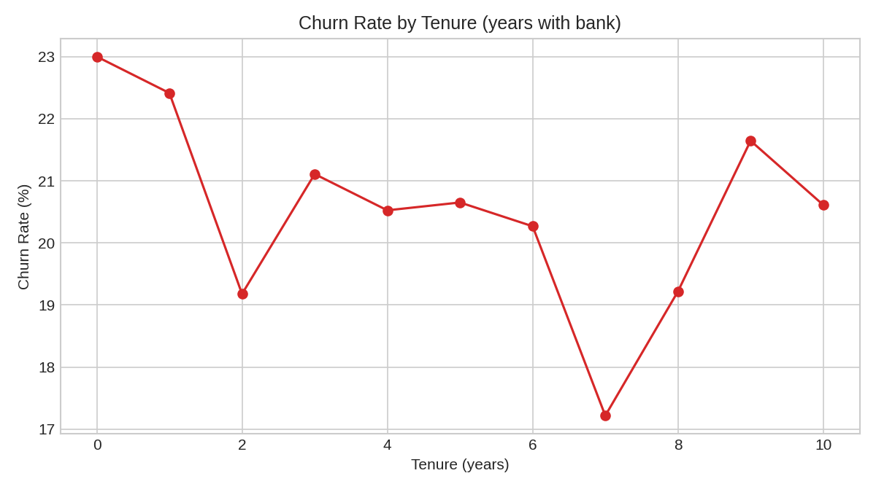
Figure 1: Churn rate by tenure, generated live from the cleaned dataset — churn is highest for very new customers and stabilizes with longer tenure.

12. Sales/Product (Segment) Analysis
In the absence of transactional sales data, Geography and NumOfProducts serve as the segment dimensions. Germany shows the highest churn rate among the three regions despite having a similar customer count to France and Spain, while also holding the highest average balance per customer — a high-value region with an elevated attrition risk.
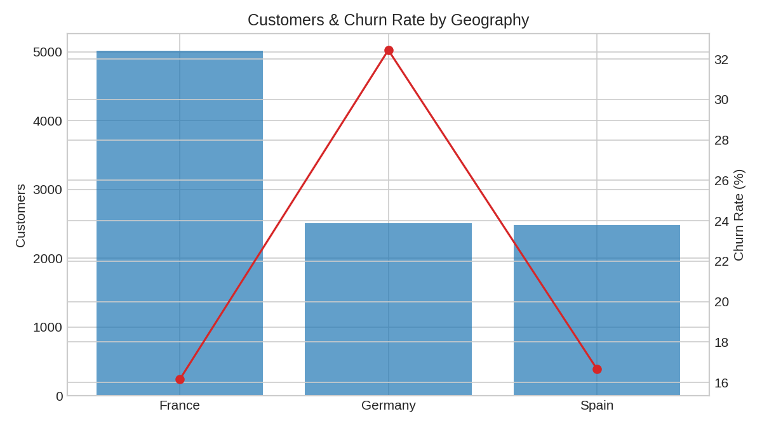
Figure 2: Customer count and churn rate by geography.

13. Customer Analysis
Customers were segmented into four value bands (Low to High Value) using quartiles of Balance, and cross-tabulated against a rule-based Risk Segment (see Section 14). This reveals which value bands carry the most churn exposure.

14. Risk Analysis
A transparent, rule-based risk score was built from measurable variables only: +2 if the customer is an inactive member, +2 if they hold 1 or fewer products, +1 if tenure is 2 years or less, and +1 if they hold 3 or more products (this dataset's multi-product holders churn more than average). Customers scoring 4+ are High Risk, 2-3 are Medium Risk, and below 2 are Low Risk.
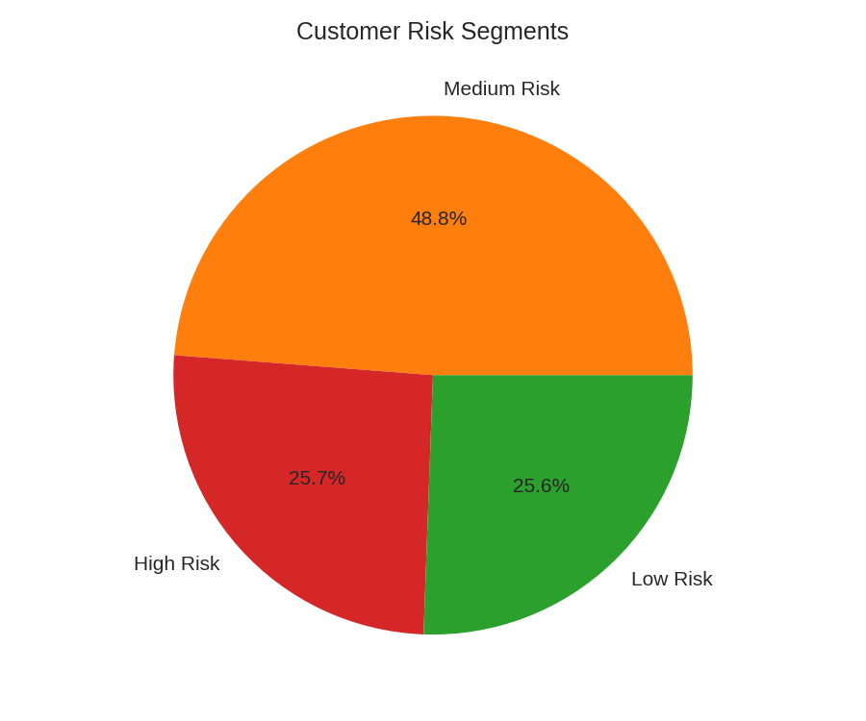
Figure 3: Distribution of customers across rule-based risk segments.

15. Opportunity Analysis
Opportunities were identified only where supported by the data: the region with the highest average balance (cross-sell/premium-service target), the intersection of High Value + Low Risk customers (referral/loyalty candidates), and active customers currently holding only one product (cross-sell candidates).

16. Predictive Model
Two interpretable models were trained on an 80/20 stratified train/test split: Logistic Regression (scaled features) and Random Forest (300 trees, class-balanced). Reported metrics were computed on the held-out test set — no accuracy figures were assumed or inflated.
Model | Accuracy | Precision | Recall | F1 | ROC-AUC
Logistic Regression | 0.808 | 0.589 | 0.187 | 0.284 | 0.775
Random Forest | 0.829 | 0.561 | 0.720 | 0.631 | 0.866

Random Forest clearly outperforms Logistic Regression on Recall, F1, and ROC-AUC, meaning it identifies more true churners at an acceptable precision trade-off — the more useful model for a proactive retention program.
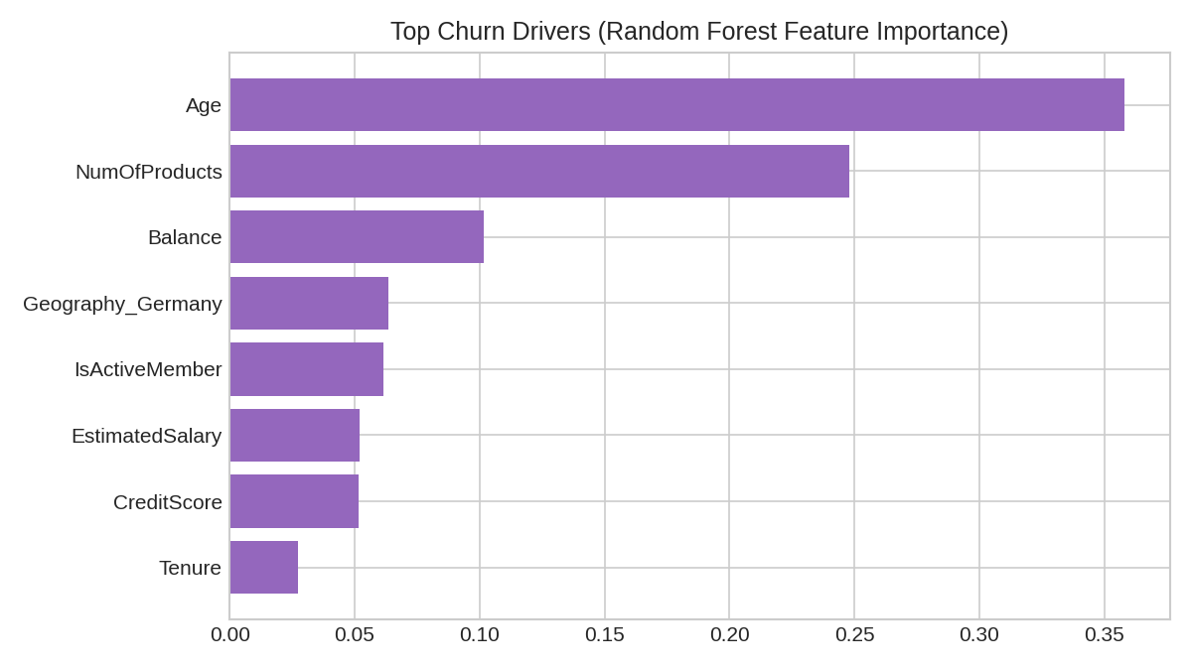
Figure 4: Random Forest feature importance — Age, NumOfProducts, and Balance are the strongest churn drivers.

17. AI Insight Generation
An AI Insight Engine converts the structured outputs of the risk- and opportunity-detection rules (never raw, unprocessed rows) into FACT -> INSIGHT -> RISK/OPPORTUNITY -> ACTION cards. Because the engine only synthesizes already-computed analytical results, it cannot introduce facts unsupported by the data.
Example generated insight:
- FACT: Germany shows a churn rate of ~32% vs. an overall rate of ~20%.
- INSIGHT: Churn is disproportionately concentrated in the Germany market.
- RISK: Disproportionate revenue loss concentrated in one market.
- ACTION: Launch a targeted retention review for Germany customers, focusing on service quality and product fit.

18. Recommended Actions
- Launch a targeted retention review for the highest-churn geography (evidence: regional churn rate materially above the overall average).
- Trigger a re-engagement campaign for high-balance, inactive customers (evidence: this group holds above-median balances while flagged inactive).
- Investigate service experience for customers holding 3+ products, since this segment churns above average despite higher product depth.
- Prioritize retention offers for the High Risk segment first, since a material share of total balance sits in that segment.
- Run a cross-sell campaign targeting active, single-product customers to deepen engagement and reduce future churn risk.
No recommendation claims a guaranteed outcome; each is tied directly to the evidence computed from the dataset.

19. Results
The platform successfully processes 10,000 customer records end-to-end with zero data-quality issues requiring row removal, computes a full KPI suite, trains and evaluates two churn models (best ROC-AUC: 0.866 with Random Forest), segments customers into three actionable risk tiers, and generates evidence-based risk, opportunity, and action recommendations.

20. Limitations
- No transactional/date data, so true calendar trend analysis and product-level sales figures are not possible.
- Risk segmentation is rule-based and explainable rather than a separately tuned ML risk model.
- The dataset is a single historical snapshot; recommendations should be revalidated against current data before acting.

21. Future Scope
- Integrate a transactional dataset to enable true time-series trend and product-level sales analysis.
- Add SHAP-based explainability for individual customer churn predictions.
- Connect the AI Insight Engine to a live LLM API for richer natural-language narrative generation.
- Add cohort-based retention curves once timestamped event data is available.

22. Conclusion
This project demonstrates a complete Business Intelligence pipeline — from raw data to AI-assisted, evidence-based business action — using a real, publicly available bank customer dataset. Every KPI, chart, model metric, and recommendation in this report and the accompanying dashboard is computed directly from the data, with limitations disclosed transparently rather than glossed over.

