Contents

1. Dataset Description 2

2. List of features 2

3. Metadata 3

4. References 4

# Depth Analysis

|  |  |  |
| --- | --- | --- |
| **Zoo – Dataset (Decision Tree)** | | |
| **Depth** | **Accuracy** | **Error Rate** |
| 1 | 62.86 | 37.14 |
| 2 | 77.14 | 22.86 |
| 3 | 91.43 | 8.57 |
| 4 | 91.43 | 8.57 |
| 5 | 91.43 | 8.57 |
| 6 | 91.43 | 8.57 |
| 7 | 91.43 | 8.57 |
| 8 | 91.43 | 8.57 |
| 9 | 91.43 | 8.57 |

# Decision Tree and Confusion Matrix – Zoo Dataset

## 1.1 Depth = 1

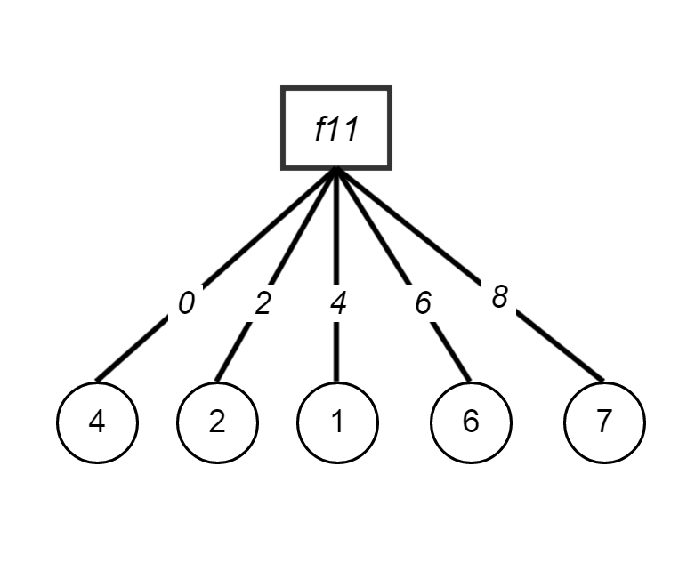

******************************************************************************************

Decision Tree

******************************************************************************************

------------------------------------------------------------------------------------------

Attribute: root Node: f11 Level: 0 Children Count: 5

------------------------------------------------------------------------------------------

***Children***

Attribute: 0 Node: 4 Level: 1 ClassificationLabel: 4 ****** Leaf *****

Attribute: 2 Node: 2 Level: 1 ClassificationLabel: 2 ****** Leaf *****

Attribute: 4 Node: 1 Level: 1 ClassificationLabel: 1 ****** Leaf *****

Attribute: 6 Node: 6 Level: 1 ClassificationLabel: 6 ****** Leaf *****

Attribute: 8 Node: 7 Level: 1 ClassificationLabel: 7 ****** Leaf *****

#### Confusion Matrix Depth=1

|  |  |  |  |  |  |  |  |  |
| --- | --- | --- | --- | --- | --- | --- | --- | --- |
|  | **Predicted Value** | | | | | | | |
| **Expected Values** |  | ***1*** | ***3*** | ***2*** | ***5*** | ***4*** | ***7*** | ***6*** |
| ***1*** | 8 | 0 | 4 | 0 | 2 | 0 | 0 |
| ***3*** | 2 | 0 | 0 | 0 | 0 | 0 | 0 |
| ***2*** | 0 | 0 | 7 | 0 | 0 | 0 | 0 |
| ***5*** | 1 | 0 | 0 | 0 | 0 | 0 | 0 |
| ***4*** | 0 | 0 | 0 | 0 | 4 | 0 | 0 |
| ***7*** | 1 | 0 | 0 | 0 | 3 | 0 | 0 |
| ***6*** | 0 | 0 | 0 | 0 | 0 | 0 | 3 |

## Depth = 2

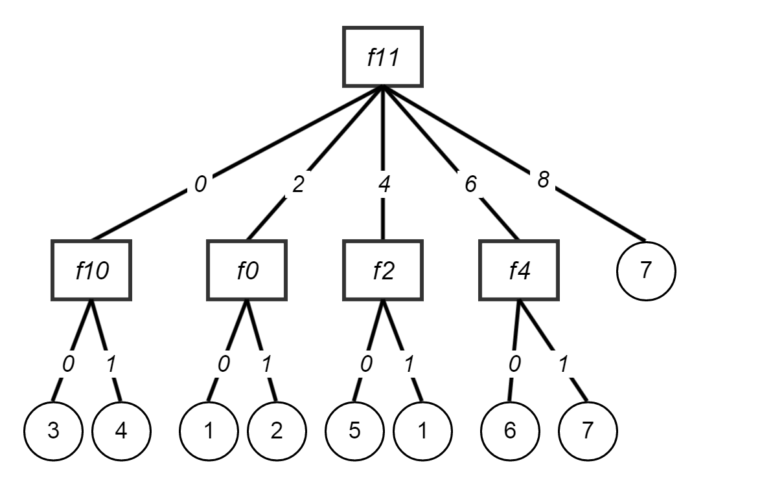

******************************************************************************************

Decision Tree

******************************************************************************************

------------------------------------------------------------------------------------------

Attribute: root Node: f11 Level: 0 Children Count: 5

------------------------------------------------------------------------------------------

***Children***

Attribute: 0 Node: f10 Level: 1

Attribute: 2 Node: f0 Level: 1

Attribute: 4 Node: f2 Level: 1

Attribute: 6 Node: f4 Level: 1

Attribute: 8 Node: 7 Level: 1 ClassificationLabel: 7 ****** Leaf *****

------------------------------------------------------------------------------------------

Attribute: 0 Node: f10 Level: 1 Children Count: 2

------------------------------------------------------------------------------------------

***Children***

Attribute: 0 Node: 3 Level: 2 ClassificationLabel: 3 ****** Leaf *****

Attribute: 1 Node: 4 Level: 2 ClassificationLabel: 4 ****** Leaf *****

------------------------------------------------------------------------------------------

Attribute: 2 Node: f0 Level: 1 Children Count: 2

------------------------------------------------------------------------------------------

***Children***

Attribute: 0 Node: 1 Level: 2 ClassificationLabel: 1 ****** Leaf *****

Attribute: 1 Node: 2 Level: 2 ClassificationLabel: 2 ****** Leaf *****

------------------------------------------------------------------------------------------

Attribute: 4 Node: f2 Level: 1 Children Count: 2

------------------------------------------------------------------------------------------

***Children***

Attribute: 0 Node: 5 Level: 2 ClassificationLabel: 5 ****** Leaf *****

Attribute: 1 Node: 1 Level: 2 ClassificationLabel: 1 ****** Leaf *****

------------------------------------------------------------------------------------------

Attribute: 6 Node: f4 Level: 1 Children Count: 2

------------------------------------------------------------------------------------------

***Children***

Attribute: 0 Node: 6 Level: 2 ClassificationLabel: 6 ****** Leaf *****

Attribute: 1 Node: 7 Level: 2 ClassificationLabel: 7 ****** Leaf *****

#### Confusion Matrix Depth=2

|  |  |  |  |  |  |  |  |  |
| --- | --- | --- | --- | --- | --- | --- | --- | --- |
|  | **Predicted Value** | | | | | | | |
| **Expected Values** |  | ***1*** | ***3*** | ***2*** | ***5*** | ***4*** | ***7*** | ***6*** |
| ***1*** | **12** | 0 | 0 | 0 | 2 | 0 | 0 |
| ***3*** | 0 | **0** | 0 | 2 | 0 | 0 | 0 |
| ***2*** | 0 | 0 | **7** | 0 | 0 | 0 | 0 |
| ***5*** | 0 | 0 | 0 | **1** | 0 | 0 | 0 |
| ***4*** | 0 | 0 | 0 | 0 | **4** | 0 | 0 |
| ***7*** | 1 | 3 | 0 | 0 | 0 | **0** | 0 |
| ***6*** | 0 | 0 | 0 | 0 | 0 | 0 | **3** |

## 1.1 Depth = 3

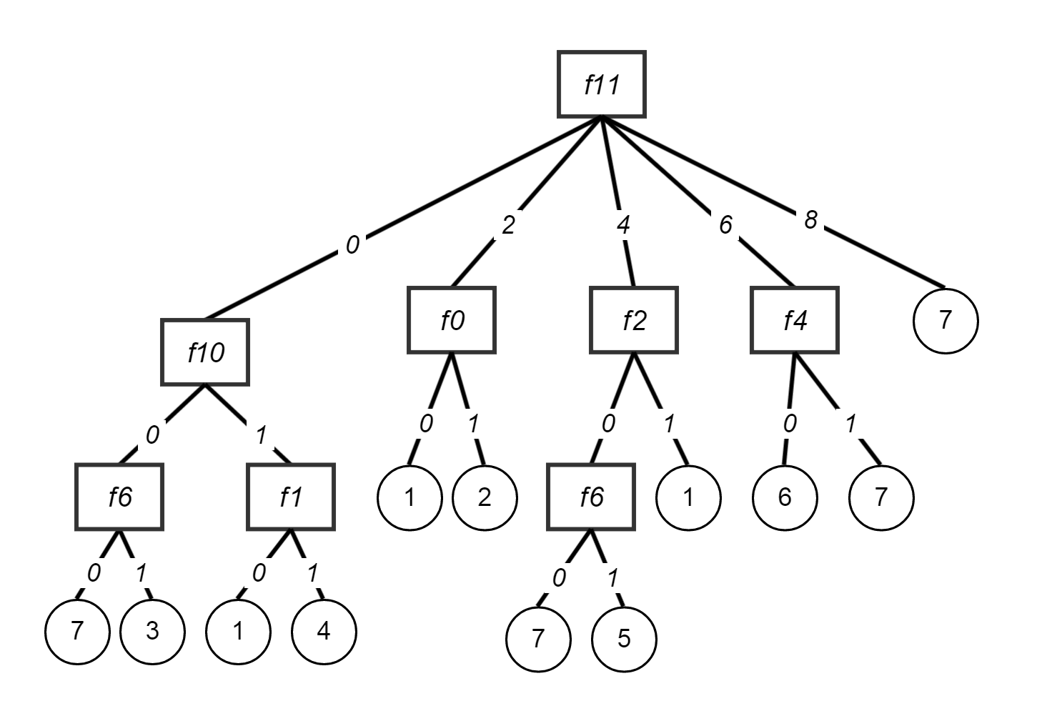

******************************************************************************************

Decision Tree

******************************************************************************************

------------------------------------------------------------------------------------------

Attribute: root Node: f11 Level: 0 Children Count: 5

------------------------------------------------------------------------------------------

***Children***

Attribute: 0 Node: f10 Level: 1

Attribute: 2 Node: f0 Level: 1

Attribute: 4 Node: f2 Level: 1

Attribute: 6 Node: f4 Level: 1

Attribute: 8 Node: 7 Level: 1 ClassificationLabel: 7 ****** Leaf *****

------------------------------------------------------------------------------------------

Attribute: 0 Node: f10 Level: 1 Children Count: 2

------------------------------------------------------------------------------------------

***Children***

Attribute: 0 Node: f6 Level: 2

Attribute: 1 Node: f1 Level: 2

------------------------------------------------------------------------------------------

Attribute: 0 Node: f6 Level: 2 Children Count: 2

------------------------------------------------------------------------------------------

***Children***

Attribute: 0 Node: 7 Level: 3 ClassificationLabel: 7 ****** Leaf *****

Attribute: 1 Node: 3 Level: 3 ClassificationLabel: 3 ****** Leaf *****

------------------------------------------------------------------------------------------

Attribute: 1 Node: f1 Level: 2 Children Count: 2

------------------------------------------------------------------------------------------

***Children***

Attribute: 0 Node: 1 Level: 3 ClassificationLabel: 1 ****** Leaf *****

Attribute: 1 Node: 4 Level: 3 ClassificationLabel: 4 ****** Leaf *****

------------------------------------------------------------------------------------------

Attribute: 2 Node: f0 Level: 1 Children Count: 2

------------------------------------------------------------------------------------------

***Children***

Attribute: 0 Node: 1 Level: 2 ClassificationLabel: 1 ****** Leaf *****

Attribute: 1 Node: 2 Level: 2 ClassificationLabel: 2 ****** Leaf *****

------------------------------------------------------------------------------------------

Attribute: 4 Node: f2 Level: 1 Children Count: 2

------------------------------------------------------------------------------------------

***Children***

Attribute: 0 Node: f6 Level: 2

Attribute: 1 Node: 1 Level: 2 ClassificationLabel: 1 ****** Leaf *****

------------------------------------------------------------------------------------------

Attribute: 0 Node: f6 Level: 2 Children Count: 2

------------------------------------------------------------------------------------------

***Children***

Attribute: 0 Node: 7 Level: 3 ClassificationLabel: 7 ****** Leaf *****

Attribute: 1 Node: 5 Level: 3 ClassificationLabel: 5 ****** Leaf *****

------------------------------------------------------------------------------------------

Attribute: 6 Node: f4 Level: 1 Children Count: 2

------------------------------------------------------------------------------------------

***Children***

Attribute: 0 Node: 6 Level: 2 ClassificationLabel: 6 ****** Leaf *****

Attribute: 1 Node: 7 Level: 2 ClassificationLabel: 7 ****** Leaf *****

#### Confusion Matrix Depth=3

|  |  |  |  |  |  |  |  |  |
| --- | --- | --- | --- | --- | --- | --- | --- | --- |
|  | **Predicted Value** | | | | | | | |
| **Expected Values** |  | ***1*** | ***3*** | ***2*** | ***5*** | ***4*** | ***7*** | ***6*** |
| ***1*** | **14** | 0 | 0 | 0 | 0 | 0 | 0 |
| ***3*** | 0 | **0** | 0 | 1 | 0 | 1 | 0 |
| ***2*** | 0 | 0 | **7** | 0 | 0 | 0 | 0 |
| ***5*** | 0 | 0 | 0 | **1** | 0 | 0 | 0 |
| ***4*** | 0 | 0 | 0 | 0 | **4** | 0 | 0 |
| ***7*** | 1 | 0 | 0 | 0 | 0 | **3** | 0 |
| ***6*** | 0 | 0 | 0 | 0 | 0 | 0 | **3** |

# Evaluation with Weka – Zoo Dataset

**Following default J48 algorithm in weka**

**=== Summary ===**

**Correctly Classified Instances 32 91.4286 %**

**Incorrectly Classified Instances 3 8.5714 %**

#### Decision tree built

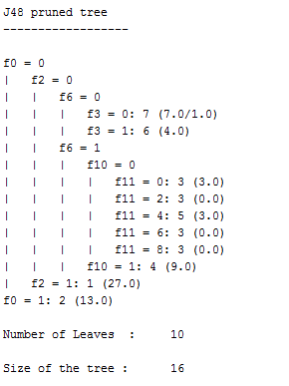

#### Confusion Matrix

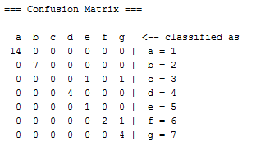

# Decision Tree and Confusion Matrix – Zoo Dataset

Our aim is to solve the biggest challenge of any auto dealer purchasing a used car at an auto auction to vehicle might have serious issues that prevent it from being sold to customers. The auto community calls these unfortunate purchases "kicks".

Our aim is to predict whether a car purchased at an auction is a Good Buy or a Bad Buy

Training set = 1000 data points (500 good buys, 500 bad buys)

Test set = 75 data points (25 bad buys, 50 good buys)

## 4.1 Depth = 1

## 4.2 Step 3