# BFS:-

Traversal path: SABBDCDCDG

Exact path: SADG

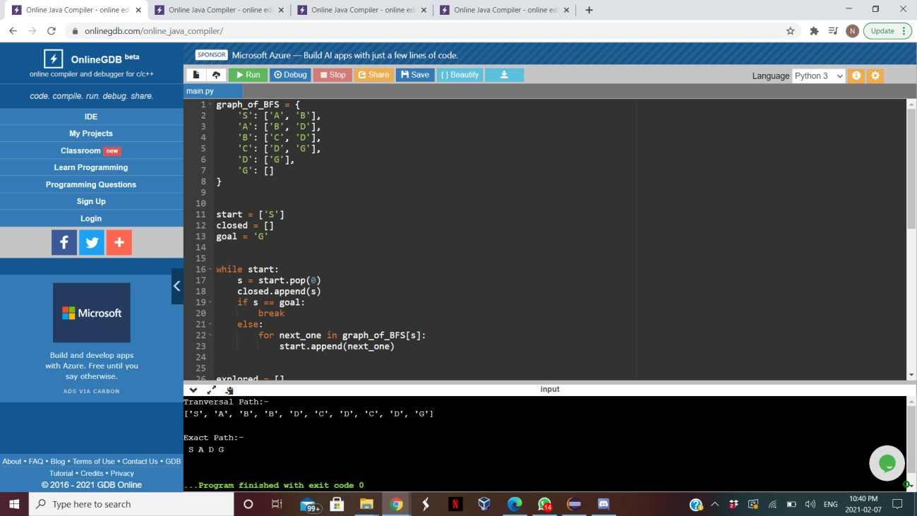

# DFS:-

Traversal path: SABCDG

Exact path: SABCDG

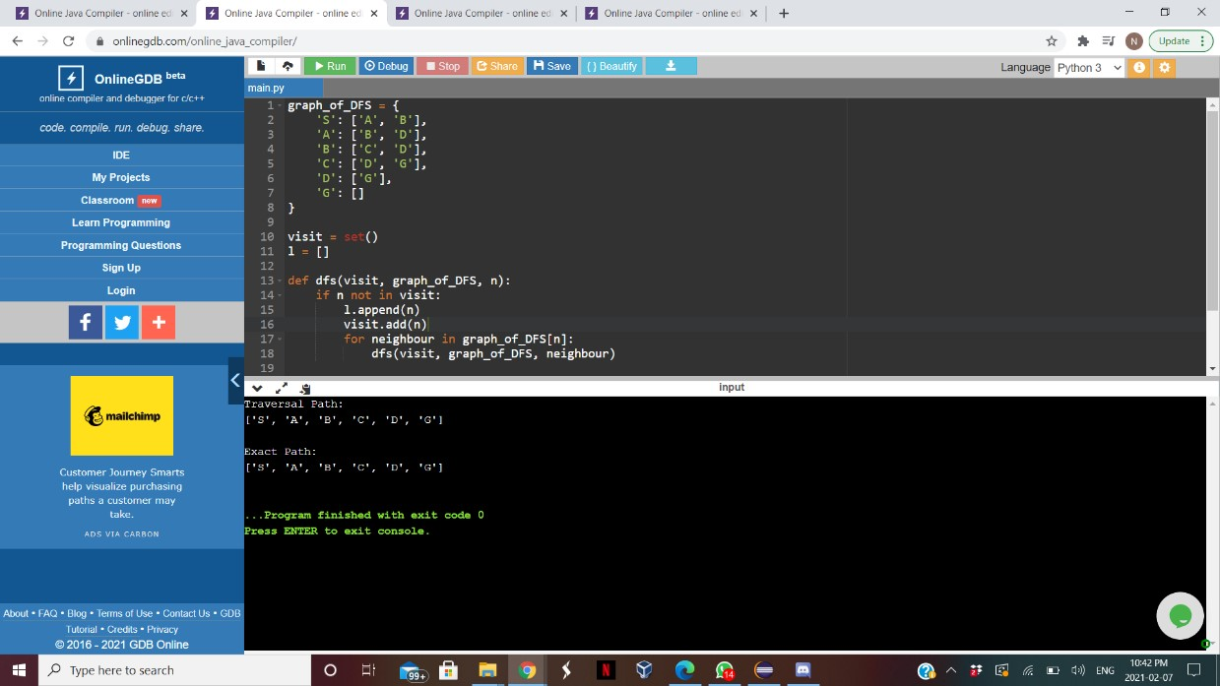

1. IDS:-

Traversal path: S SAB SABDBCD SABCDDG

Exact path: SADG

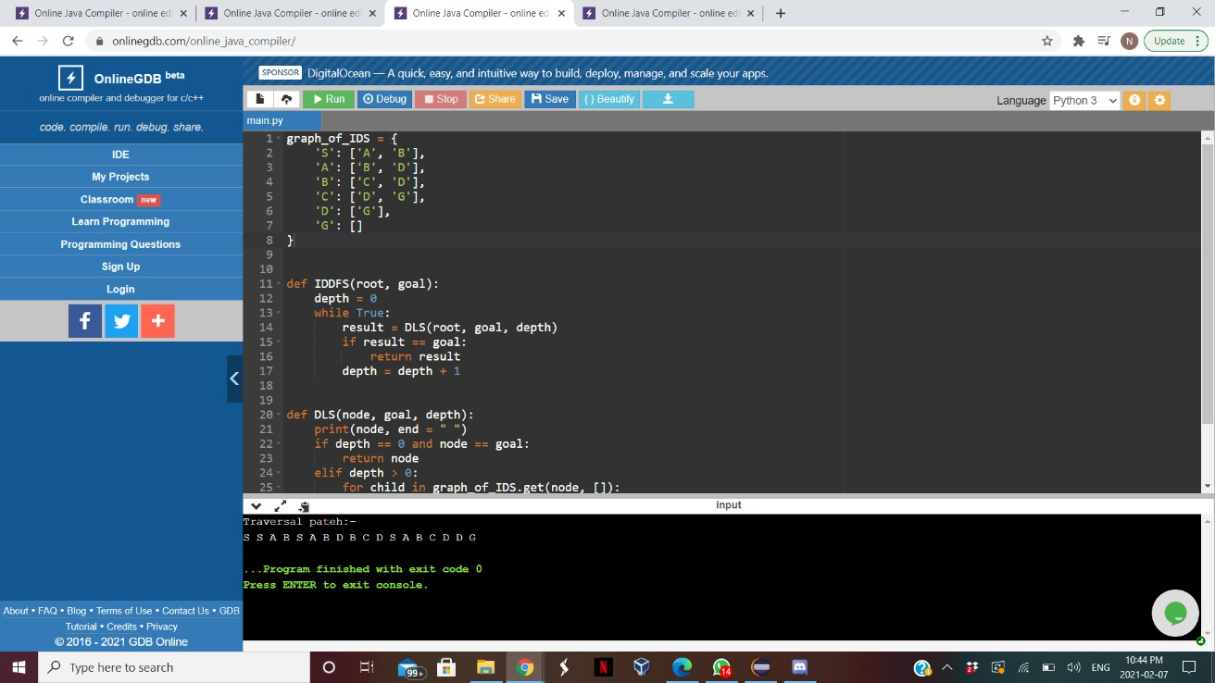

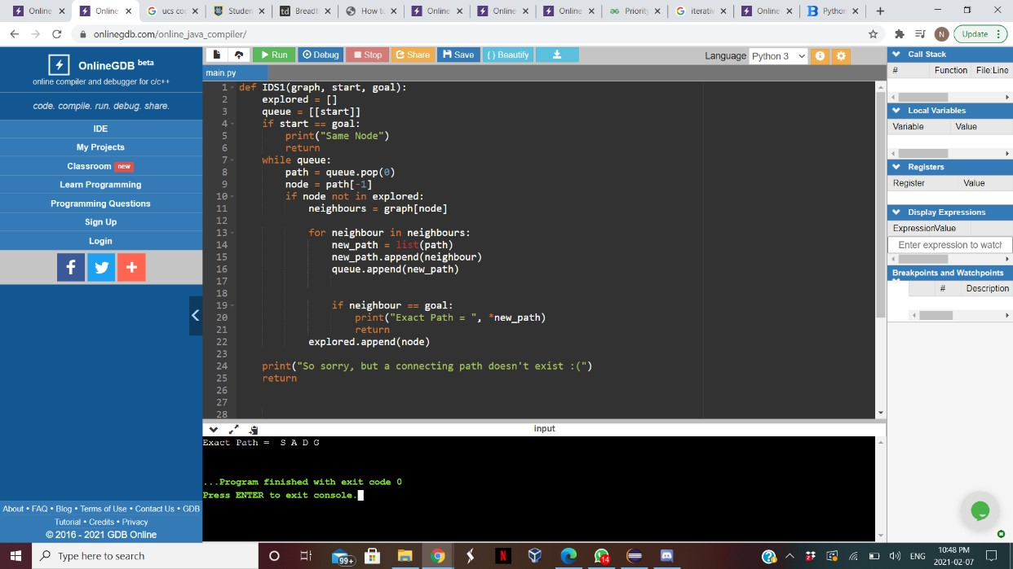

1. UCS:-

Traversal path: SBABCDG

Exact path: SBDG

