Search: DFS – O(b^m), O(bm) BFS – O(b^s), O(b^s) ID – O(b^d), O(bd)

UCS - O(b^C\*/ε ), O(b^C\*/ε), If that solution costs C\* and arcs cost at least ε, optimal

A\* - heuristic is admissible if its less than true cost to goal, A\* Review: f(n) = UCS + Heuristic

* As heuristics get closer to the true cost, you will expand fewer nodes but usually do more work per node to compute the heuristic itself
* The cost of an optimal solution to a relaxed problem is an admissible heuristic for the original problem
* Max of admissible heuristics is admissible, Optimal if heuristic is admissible / consistent
* O(b^d), O(b^d)

CSPs: Backtracking search is the basic uninformed algorithm for solving CSPs - Idea 1: One variable at a time Idea 2: Check constraints as you go

Filtering: Keep track of domains for unassigned variables and cross off bad options • Forward checking: Cross off values that violate a constraint when added to the existing assignment

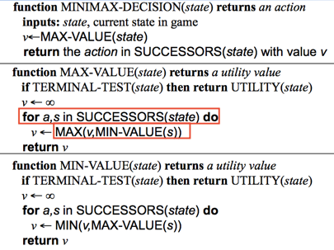Arc: A simple form of propogation makes sure all arcs are consistent:

Variable Ordering: Minimum remaining values (MRV): – Choose the variable with the fewest legal left values in its domain

Value Ordering: Least Constraining Value – Given a choice of variable, choose the least constraining value – I.e., the one that rules out the fewest values in the remaining variables

Adversarial Search: Using the current state as the initial state, build the game tree uniformly to the maximal depth h (called horizon) feasible within the -me limit 2) Evaluate the states of the leaf nodes 3) Back up the results from the leaves to the root and pick the best ac-on assuming the worst (for us) from MIN

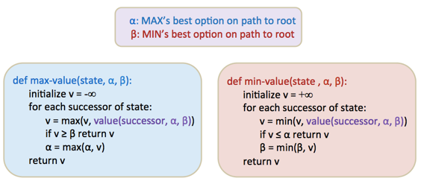Min-Max: Expand the game tree uniformly from the current state (where it is MAX’s turn to play) to depth h 2. Compute the evaluation function at every leaf of the tree 3. Back-up (propagate) the values from the leaves to the root of the tree as follows: a. A MAX node gets the maximum of the evaluation of its successors b. A MIN node gets the minimum of the evaluation of its successors 4. Select the move toward a MIN node that has the largest backed-up value, How efficient is minimax? – Just like (exhaustive) DFS – Time: O(b^m) – Space: O(bm)

Pruning: With perfect ordering, time complexity is O(b^d/2) , space is O(bm)

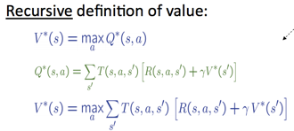MDPs: For MDPs, we want an optimal policy π\*: S → A – A policy π gives an action for each state – An optimal policy is one that maximizes expected utility if followed – An explicit policy defines a reflex agent

Markov decision processes: – Set of states S – Start state s0 – Set of actions A – Transitions P(s’|s,a) (or T(s,a,s’)) – Rewards R(s,a,s’) (and discount γ)

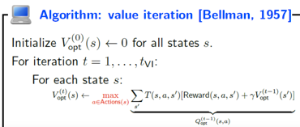Value Iteration: O(A\*S^2) per iteration

Both value interaction and policy interaction compute the same thing (all optimal values) • In value interaction: – Every interaction updates both the values and (implicitly) the policy – We don’t track the policy, but taking the max over actions implicitly recomputes it • In policy interaction: – We do several passes that update utilities with fixed policy (each pass is fast because we consider only one action, not all of them) – After the policy is evaluated, a new policy is chosen (slow like a value interaction pass) – The new policy will be better (or we’re done)

So you want to…. – Compute optimal values: use value iteration or policy itera.on – Compute values for a par.cular policy: use policy evalua.on – Turn your values into a policy: use policy extraction (one-step lookahead) • These all look the same! – They basically are – they are all varia.ons of Bellman updates – They all use one-step lookahead expectimax fragments – They differ only in whether we plug in a fixed policy or max over ac.ons

Convergence: Case 1: If the tree has maximum depth M, then VM holds the actual untruncated values • Case 2: If the discount is less than 1 – Sketch: For any state Vk and Vk+1 can be viewed as depth k+1 expectimax results in nearly identical search trees – The difference is that on the bottom layer, Vk+1 has actual rewards while Vk has zeros – That last layer is at best all RMAX – It is at worst RMIN – But everything is discounted by γk that far out – So Vk and Vk+1 are at most γk max|R| different – So as k increases, the values converge

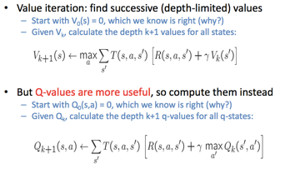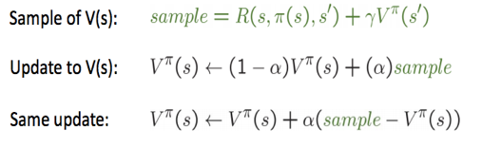

Temporal: Temporal difference learning of values – Policy still fixed, still doing evaluation! – Move values toward value of whatever successor occurs: running average

Better is q-value as gives policy

a. For what values of p is the optimal action from s2 to move right if the discount γ is 1? E[left] = (+1)(p) +(-1)(1-p) = 2p-1 E[always go right] >= 10p^6 – 1(1-p^6) > 2p-1 => (11/2)p^5 > 1 => p > 0.71

b. For what values of γ is the optimal action from s2 to move right if p = 1? 10 \* γ^6 > γ => γ >=0.63

