Customer Engagement and Product Utilization Analytics for Retention Strategy in Retail Banking
A Data-Driven Analysis of Churn Determinants, Engagement Scoring, and Premium-Customer Risk in a European Retail Bank
Research Paper
Customer Engagement & Retention Analytics Study
Prepared using a retail banking customer dataset of N = 10,000 records
Geographies represented: France, Germany, Spain
July 2026

Abstract
Customer attrition remains one of the most consequential and preventable sources of revenue loss for retail banks. This paper presents an empirical analysis of a 10,000-customer retail banking dataset drawn from three European markets (France, Germany, and Spain) to identify the behavioral, demographic, and product-holding determinants of customer churn and to construct an actionable retention framework. Beyond the raw dataset fields, we engineer twelve derived features — including an Engagement Score, a Relationship Strength Index, and a composite Retention Score — designed to translate transactional attributes into business-interpretable measures of customer health. Using descriptive statistics, cross-tabulation, correlation analysis, and twenty supporting visualizations, we find that member activity status is the single strongest observed correlate of churn (a churn-rate gap of roughly 12 percentage points between active and inactive members), that a meaningful share of high-balance ‘premium’ customers are simultaneously disengaged, and that product cross-selling exhibits a non-monotonic relationship with retention — churn falls as customers move from one to two products, but rises sharply beyond that point. Geographic and age-based heterogeneity further indicate that a uniform, one-size-fits-all retention policy is unlikely to be optimal. We conclude with a set of concrete, data-grounded recommendations for retention prioritization and outline the limitations of a cross-sectional, non-causal design as motivation for future longitudinal and model-based work.
Keywords: customer churn, retention analytics, retail banking, customer engagement scoring, feature engineering, exploratory data analysis

1. Introduction

1.1 Background and Motivation
Customer churn — the loss of an existing customer relationship — is a first-order concern for retail banks operating in mature, competitive markets where acquiring a new customer is substantially more costly than retaining an existing one. Prior industry and academic estimates commonly place customer acquisition costs at several multiples of retention costs, which makes even modest reductions in churn rate financially significant at portfolio scale. Despite this, many banks continue to rely on lagging indicators of attrition (e.g., account closure requests) rather than leading indicators derived from engagement and product-usage behavior.
This paper addresses that gap by analyzing a structured retail banking dataset that combines demographic attributes (age, gender, geography), account attributes (balance, tenure, credit score), product-holding behavior (number of products, credit card ownership), and behavioral status (active membership) against a binary churn outcome. Rather than treating churn prediction purely as a classification problem, we adopt an analytics-for-strategy framing: the objective is to surface interpretable, decision-relevant patterns that a retention team could act on directly, alongside a set of engineered composite scores intended for ongoing portfolio monitoring.

1.2 Research Objectives
- To quantify the overall churn and retention rates of the analyzed customer portfolio and establish a baseline against which segment-level variation can be compared.
- To identify which demographic, behavioral, and product-holding factors are most strongly associated with customer churn.
- To engineer and validate a set of composite engagement and relationship-strength metrics that condense multiple raw attributes into decision-ready indicators.
- To identify a segment of high-value ('premium') customers who are simultaneously at elevated risk of attrition, and to quantify the scale of this hidden risk.
- To translate the empirical findings into a concrete, prioritized set of retention recommendations for banking stakeholders.

1.3 Structure of the Paper
Section 2 situates the study within the existing literature on customer churn and retention analytics. Section 3 describes the dataset and the data-quality procedures applied prior to analysis. Section 4 details the feature engineering methodology used to construct composite engagement and retention indicators. Section 5 presents the descriptive and correlational results, organized by demographic, behavioral, and product dimensions, and supported by the visualizations produced during the analysis. Section 6 discusses the business implications of these findings and proposes a prioritized retention strategy. Section 7 addresses the limitations of the study and outlines directions for future work, and Section 8 concludes.

2. Literature Review
Customer churn analysis has a well-established tradition in both the marketing and financial-services literature, typically organized around three complementary perspectives: predictive modeling, behavioral segmentation, and customer lifetime value (CLV) management.

2.1 Predictive and Statistical Approaches to Churn
A substantial body of work applies statistical and machine-learning classifiers — logistic regression, decision trees, ensemble methods, and neural networks — to structured customer data in order to predict the probability of churn for individual accounts. These approaches are valuable for triage and targeting but are frequently criticized for producing outputs (probability scores) that are difficult for frontline retention teams to interpret or act upon without an accompanying explanatory layer. This motivates complementary descriptive and feature-engineering work, of the kind undertaken in this paper, that renders the underlying behavioral signal legible to non-technical stakeholders.

2.2 Engagement and Relationship-Based Retention Frameworks
A parallel stream of research in relationship marketing emphasizes that the depth and quality of the customer relationship — rather than any single transactional attribute — is the more reliable predictor of long-term loyalty. This has led to widespread industry adoption of composite engagement scores that blend multiple behavioral signals (recency and frequency of activity, product depth, tenure) into a single index. Our engineered Engagement Score and Relationship Strength Index follow this tradition, though we deliberately test rather than assume their predictive validity against the observed churn outcome in Section 5.

2.3 The 'Profitable but Disengaged' Customer Problem
A recurring finding in banking customer-analytics literature is that balance or income alone is an unreliable proxy for loyalty: high-value customers can simultaneously be disengaged from the institution, creating a segment of clients who are both important to protect and difficult to detect through balance-based segmentation alone. This paper's construction of an 'At-Risk Premium Customer' flag, and its empirical incidence within the analyzed portfolio, is a direct empirical contribution to this line of inquiry.

2.4 Product Cross-Selling and Retention
Cross-selling additional products is a standard retention lever in retail banking on the theory that deeper product relationships raise switching costs. However, several practitioner and academic studies caution that product bundling driven by sales incentives rather than genuine customer need can produce the opposite effect, generating dissatisfaction that manifests as elevated churn among heavily cross-sold customers. Section 5.4 of this paper provides direct empirical evidence bearing on this debate within the analyzed dataset.

3. Data and Methodology

3.1 Data Source and Structure
The dataset comprises 10,000 retail banking customer records spanning three geographies — France, Germany, and Spain — with each record describing a single customer as of a single snapshot period. The raw fields include a unique customer identifier, surname, credit score, geography, gender, age, tenure (years as a bank customer), account balance, number of products held, credit card ownership (binary), active membership status (binary), estimated salary, and a binary churn indicator ('Exited').

3.2 Data Validation and Quality Assurance
Prior to analysis, the dataset was subjected to a structured validation pass covering: missing-value detection across all columns; duplicate-row and duplicate-CustomerId detection; range checks on binary fields (HasCrCard, IsActiveMember, Exited) to confirm values were restricted to {0, 1}; datatype verification for all numeric fields; plausibility checks on age (flagging values outside 18–100); and non-negativity checks on account balance and estimated salary. No missing values, duplicate records, or out-of-range binary values were present in the source data, indicating a high baseline data quality; this is consistent with the dataset's origin as a curated benchmark file rather than a raw transactional extract.

3.3 Data Cleaning Procedure
Although the source data required minimal remediation, a standardized cleaning pipeline was applied for robustness and reproducibility: numeric fields with missing values would be imputed using column medians, categorical fields using the modal category; age values would be clipped to a plausible [18, 100] range; negative balances and salaries would be clipped to zero; and product counts would be clipped to a valid [1, 4] range. Outlier treatment for Balance, Estimated Salary, and Credit Score was performed using the interquartile range (IQR) method, capping rather than deleting extreme values in order to preserve legitimate high-net-worth customers who are of particular analytical interest in a banking retention context.

3.4 Analytical Approach
The analysis proceeds in four stages. First, univariate and bivariate descriptive statistics establish baseline churn and retention rates and their variation across demographic and geographic segments. Second, engineered composite features (Section 4) are constructed to translate raw attributes into business-interpretable engagement and relationship metrics. Third, correlation analysis quantifies the linear association between numeric features (including the engineered composites) and the churn outcome. Fourth, an automated business-insight generation step synthesizes the preceding statistical results into plain-language, quantitatively grounded observations, which form the empirical basis for the recommendations in Section 6.
It is important to note at the outset that this is a cross-sectional, observational, descriptive-statistical study. All reported relationships are correlational; no causal claims are made or should be inferred without further quasi-experimental or longitudinal validation, a point we return to in Section 7.

4. Feature Engineering
Twelve derived features were constructed from the eleven raw predictor fields in order to capture business constructs — engagement, relationship depth, customer value tier, and risk — that are not directly observable in any single raw column. Table 1 summarizes these features; formal definitions follow.

4.1 Composite Scores
- Engagement Score (0–100): a weighted composite of active-membership status (40% weight), credit card ownership (15%), normalized product count (25%), and normalized tenure (20%), designed to capture how behaviorally 'plugged in' a customer currently is to the banking relationship.
- Relationship Strength Index (0–100): a weighted composite of normalized tenure (35%), normalized product depth (35%), and a capped balance-to-salary ratio (30%), intended to capture the structural depth of the customer relationship independent of current activity.
- Product Depth Index (0–1): a min-max normalized transformation of the number of products held, used as a continuous input to the two composites above.
- Retention Score (0–100): an equally weighted blend of the Engagement Score and the Relationship Strength Index, intended as a single top-line indicator of a customer's likelihood of remaining with the bank.

4.2 Categorical and Flag Features
- Premium Customer (Yes/No): flagged when both account balance and estimated salary are at or above the portfolio's 75th percentile.
- Sticky Customer (Yes/No): flagged for customers who are simultaneously active, credit-card holders, and have a tenure of five years or more.
- At-Risk Premium Customer (Yes/No): flagged for Premium customers who are either inactive or whose Engagement Score falls below 50, identifying high-value clients with a latent disengagement signal.
- Customer Lifetime Segment: a four-level categorization of tenure into New (≤2 years), Growing (3–5 years), Established (6–8 years), and Veteran (9+ years).
- Age Group, Balance Category, and Salary Category: standard demographic and financial bucketing (quantile- or threshold-based) used for segment-level cross-tabulation.
- Risk Level (Low/Medium/High): a heuristic, rule-based churn-risk classification combining inactivity, single-product holding, age above 50, absence of a credit card, and zero balance — explicitly not a fitted statistical or machine-learning risk score, but a transparent, auditable scoring rule.
We emphasize that Risk Level is a heuristic composite rather than a trained propensity model; it is included to provide a simple, auditable rule that a retention team could implement without a modeling pipeline, and its output should not be read as a calibrated probability estimate. Section 7 discusses the case for complementing this heuristic with a properly validated predictive model.

5. Results

5.1 Portfolio-Level Churn and Retention Baseline
Of the 10,000 customers in the portfolio, 2,037 had churned at the observation snapshot, yielding an overall churn rate of 20.4% and a corresponding retention rate of 79.6% (Figure 1). This baseline serves as the reference point against which all subsequent segment-level comparisons are made: a segment whose churn rate materially exceeds 20.4% is, in relative terms, an area of elevated risk, while a segment below this threshold is comparatively more stable.
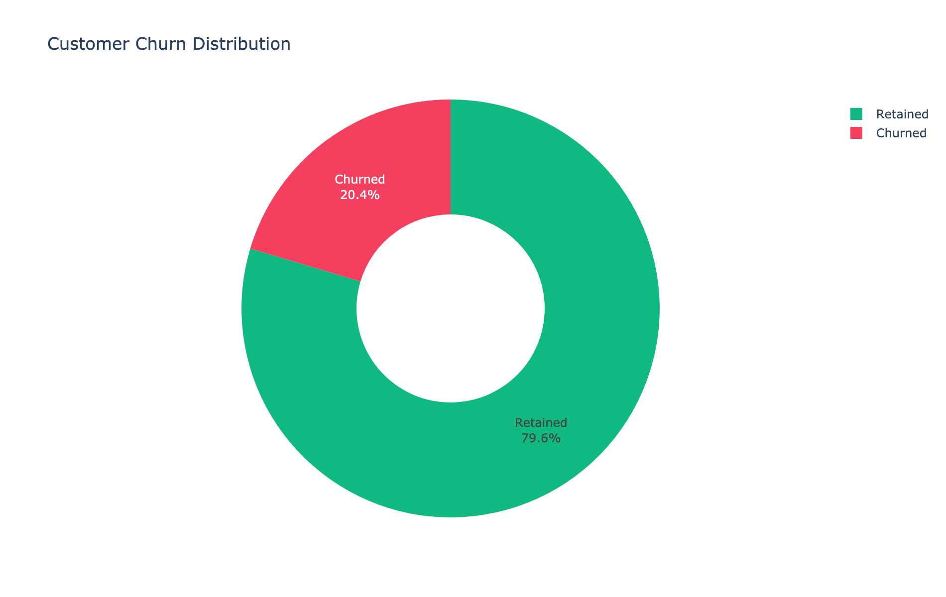
Figure 1. Overall customer churn distribution (N = 10,000).

5.2 Geographic and Demographic Variation
Churn is not evenly distributed across the three geographies represented in the portfolio (Figure 2). Germany exhibits the highest regional churn rate among the three markets, at approximately 32.4%, notably above both the portfolio-wide baseline of 20.4% and the rates observed in France and Spain. Because Germany's customer count is smaller than France's in absolute terms yet still exhibits a proportionally much higher churn rate, this is unlikely to be a sample-size artifact alone and instead points toward market-specific drivers — competitive intensity, service quality, or pricing — that merit dedicated local investigation rather than a portfolio-wide remedy.
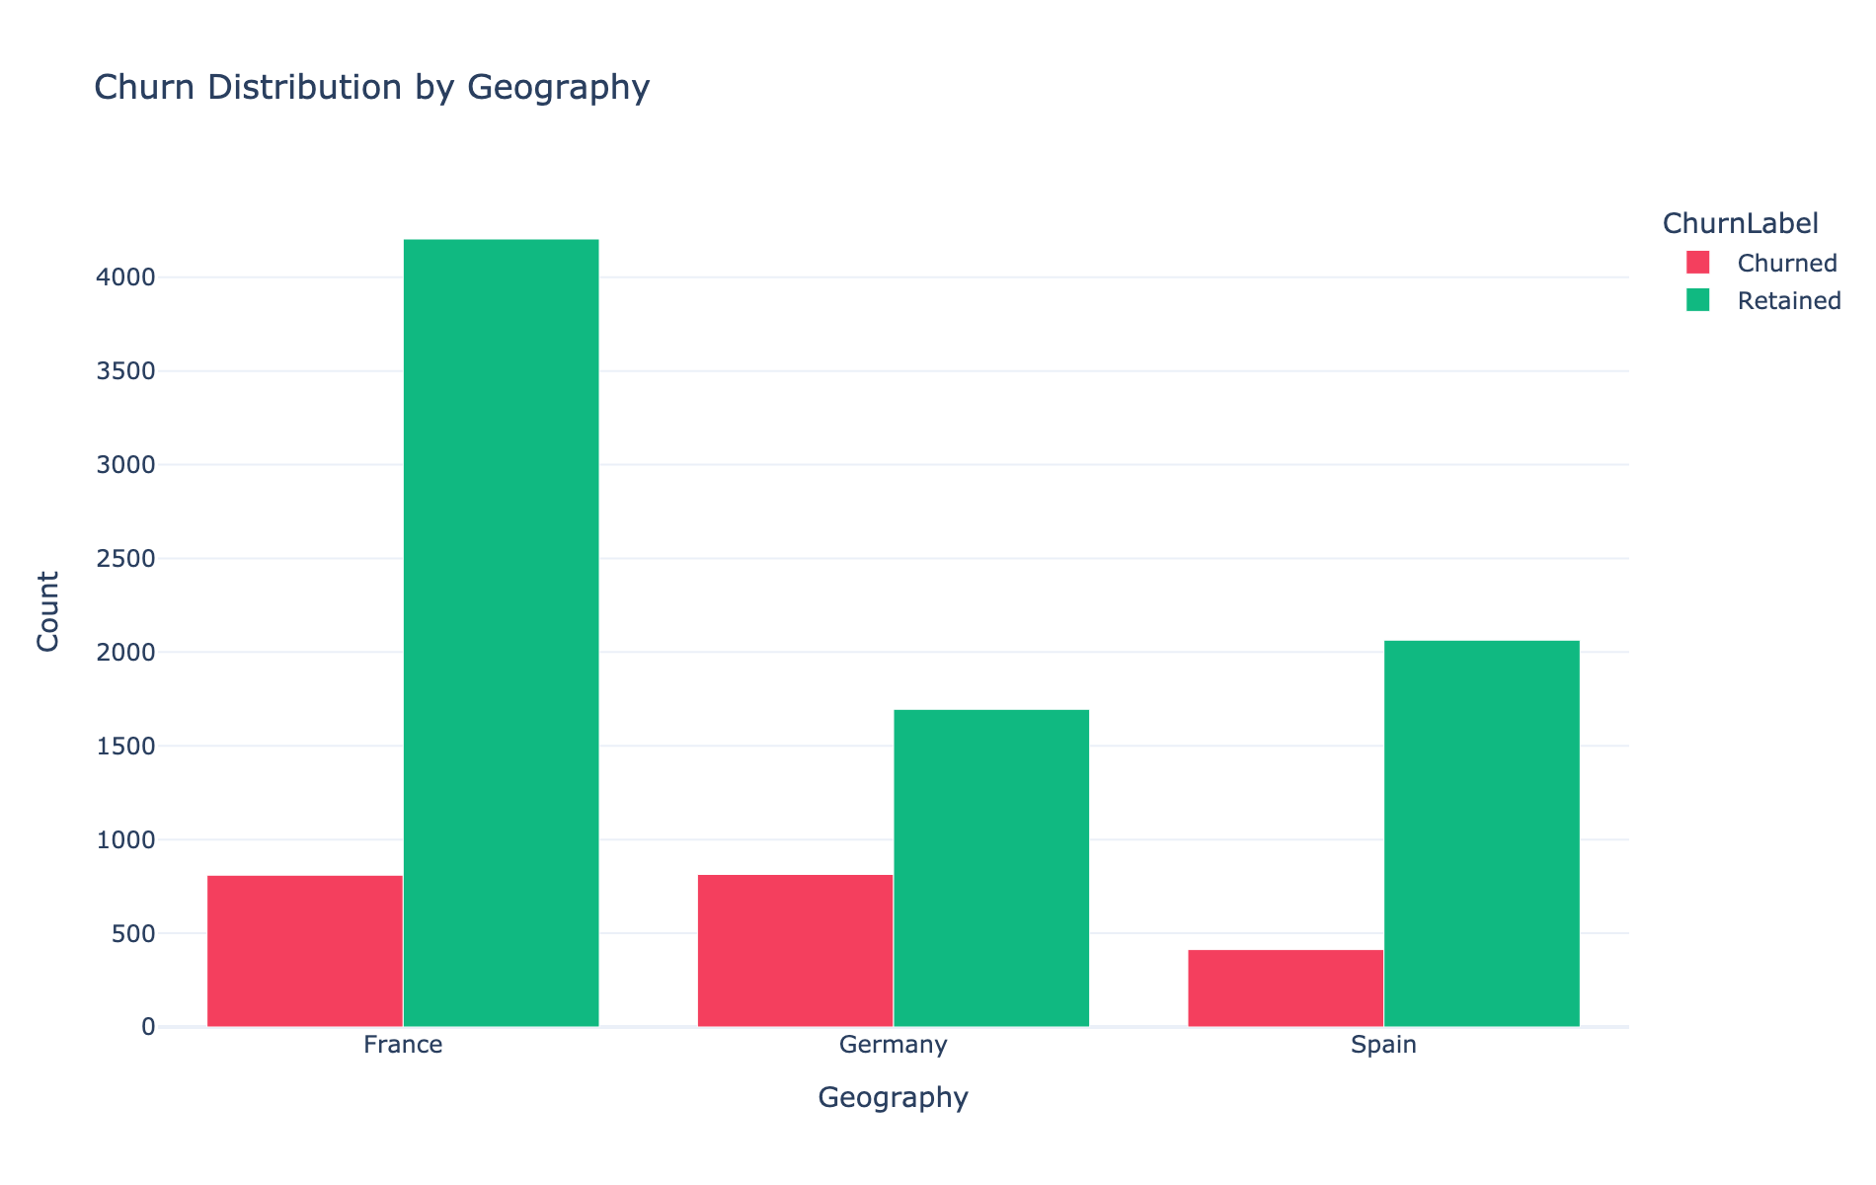
Figure 2. Churn distribution by geography (France, Germany, Spain).
Gender-based churn differences are present but modest in this portfolio (Figure 3): a higher proportion of female customers churn relative to male customers, though the gap is smaller in relative terms than the geographic or activity-based differences discussed elsewhere in this section, suggesting gender alone is a weak standalone segmentation variable for retention targeting.
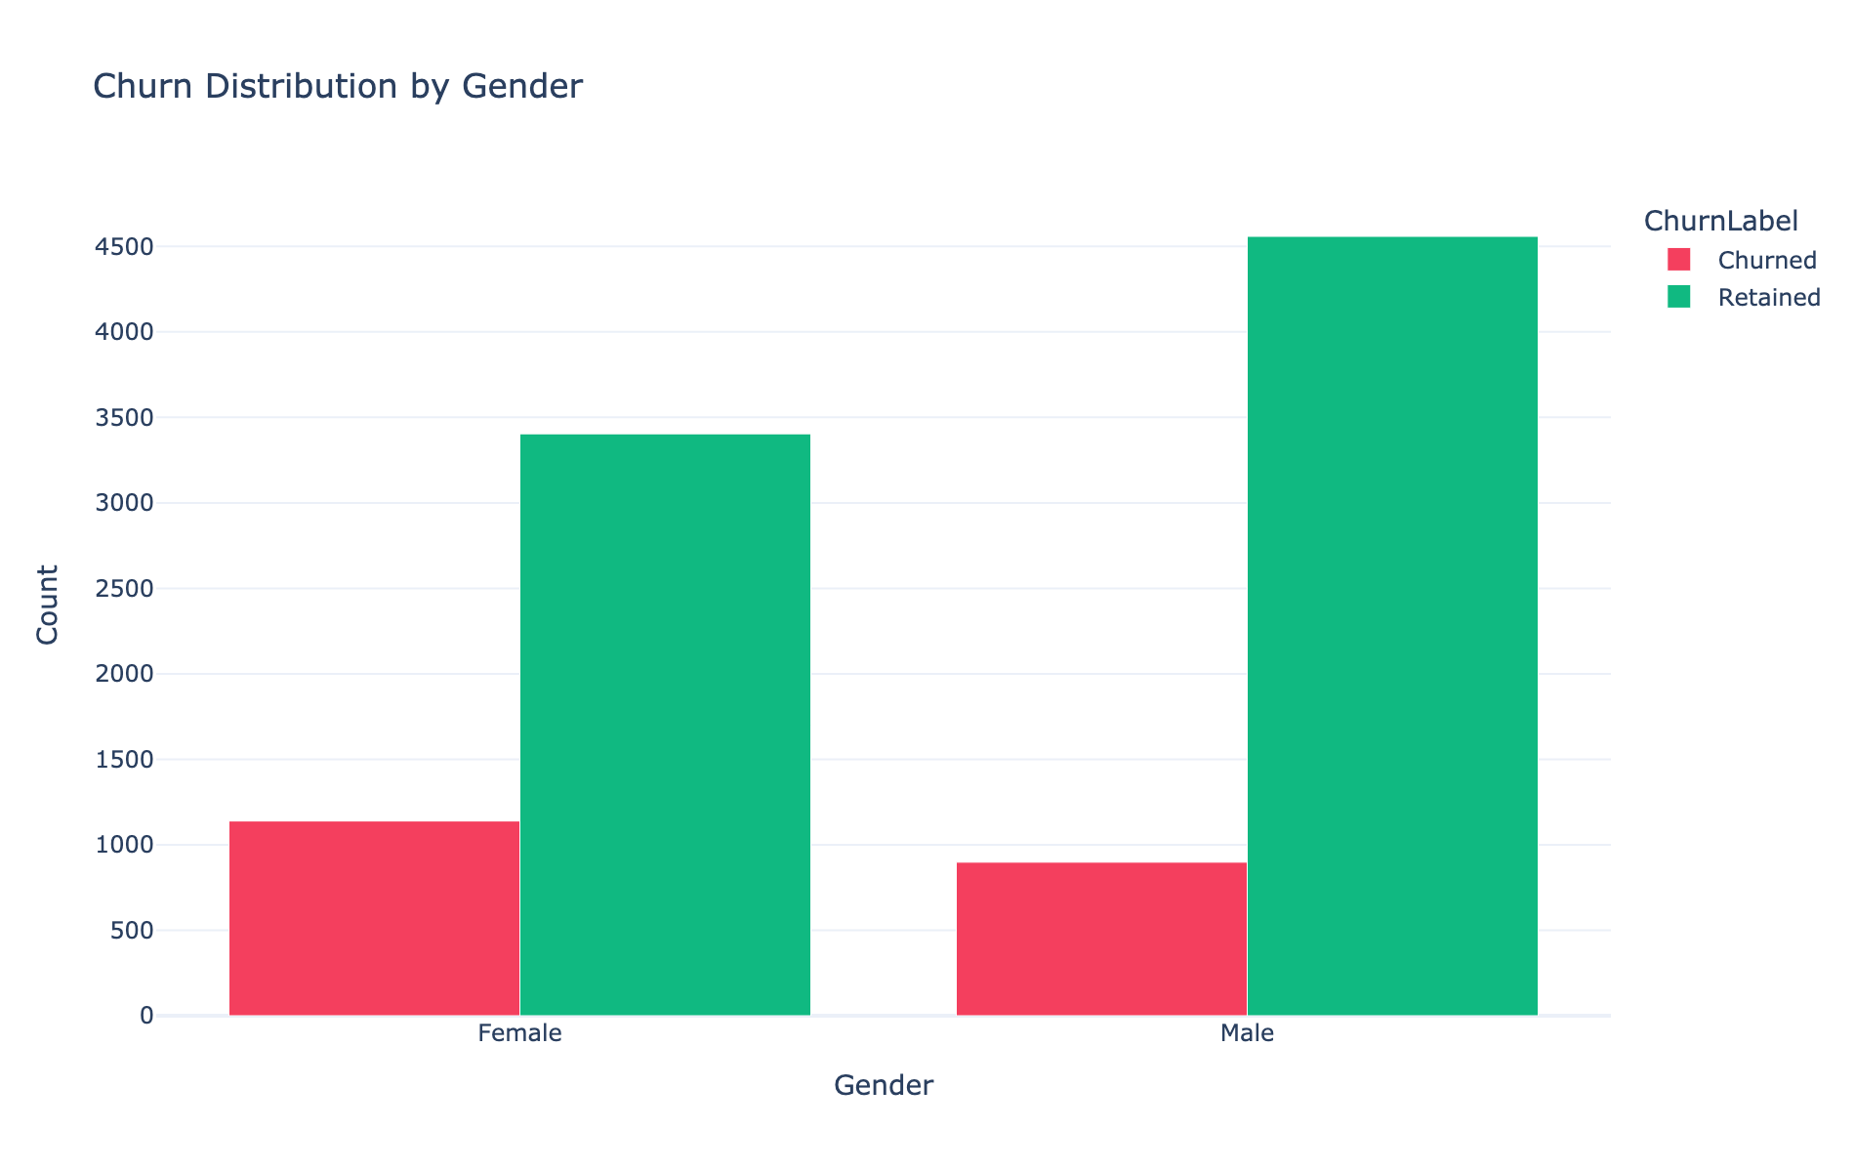
Figure 3. Churn distribution by gender.
Age exhibits a more pronounced relationship with churn than gender. The customer base is heavily concentrated between ages 25 and 45 (Figure 4), but churned customers are disproportionately concentrated in the middle-to-upper age bands: the Middle Aged (46–60) segment exhibits the highest churn rate of any age group at approximately 51.1%, substantially above the portfolio average. This is visible in Figure 4 as the widening red (churned) band relative to green (retained) in the 45–65 age range, even though this range contains fewer total customers than the 25–45 peak.
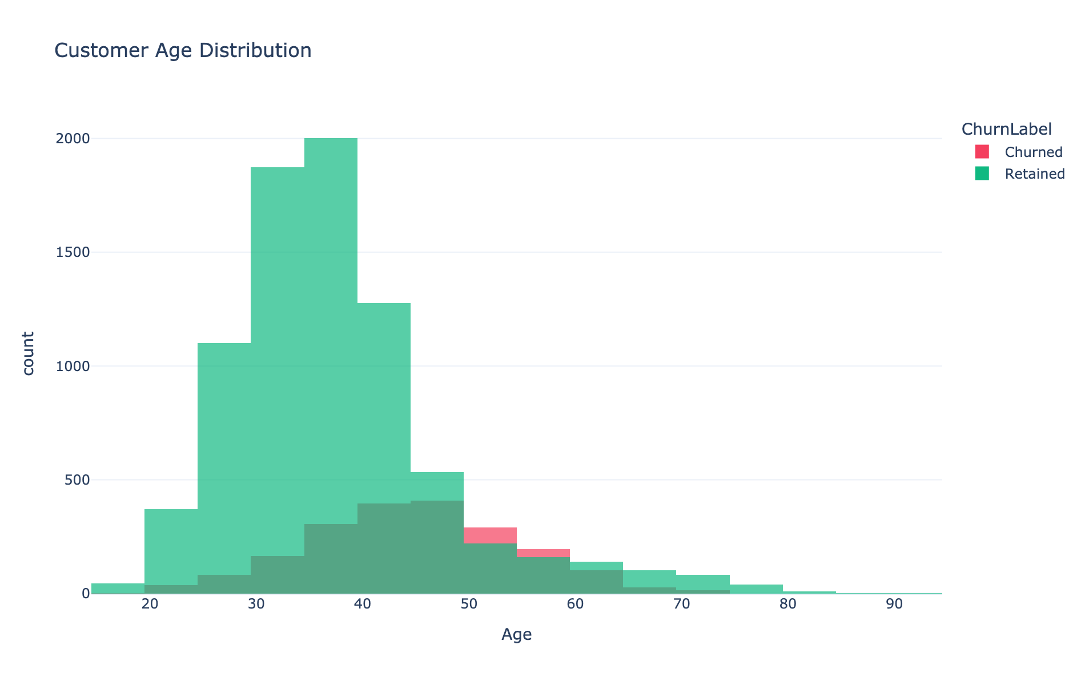
Figure 4. Customer age distribution, overlaid by churn status.

5.3 Financial Attributes: Balance and Salary
Account balance is strongly bimodal: approximately 36% of customers carry a zero balance, while the remainder follow an approximately normal distribution centered near €115,000–€120,000 (Figure 5). Estimated salary, by contrast, is approximately uniformly distributed across its observed range of roughly €0 to €200,000 (Figure 6), indicating that salary was likely either synthetically generated or independently assigned rather than mechanically linked to balance or product holding.
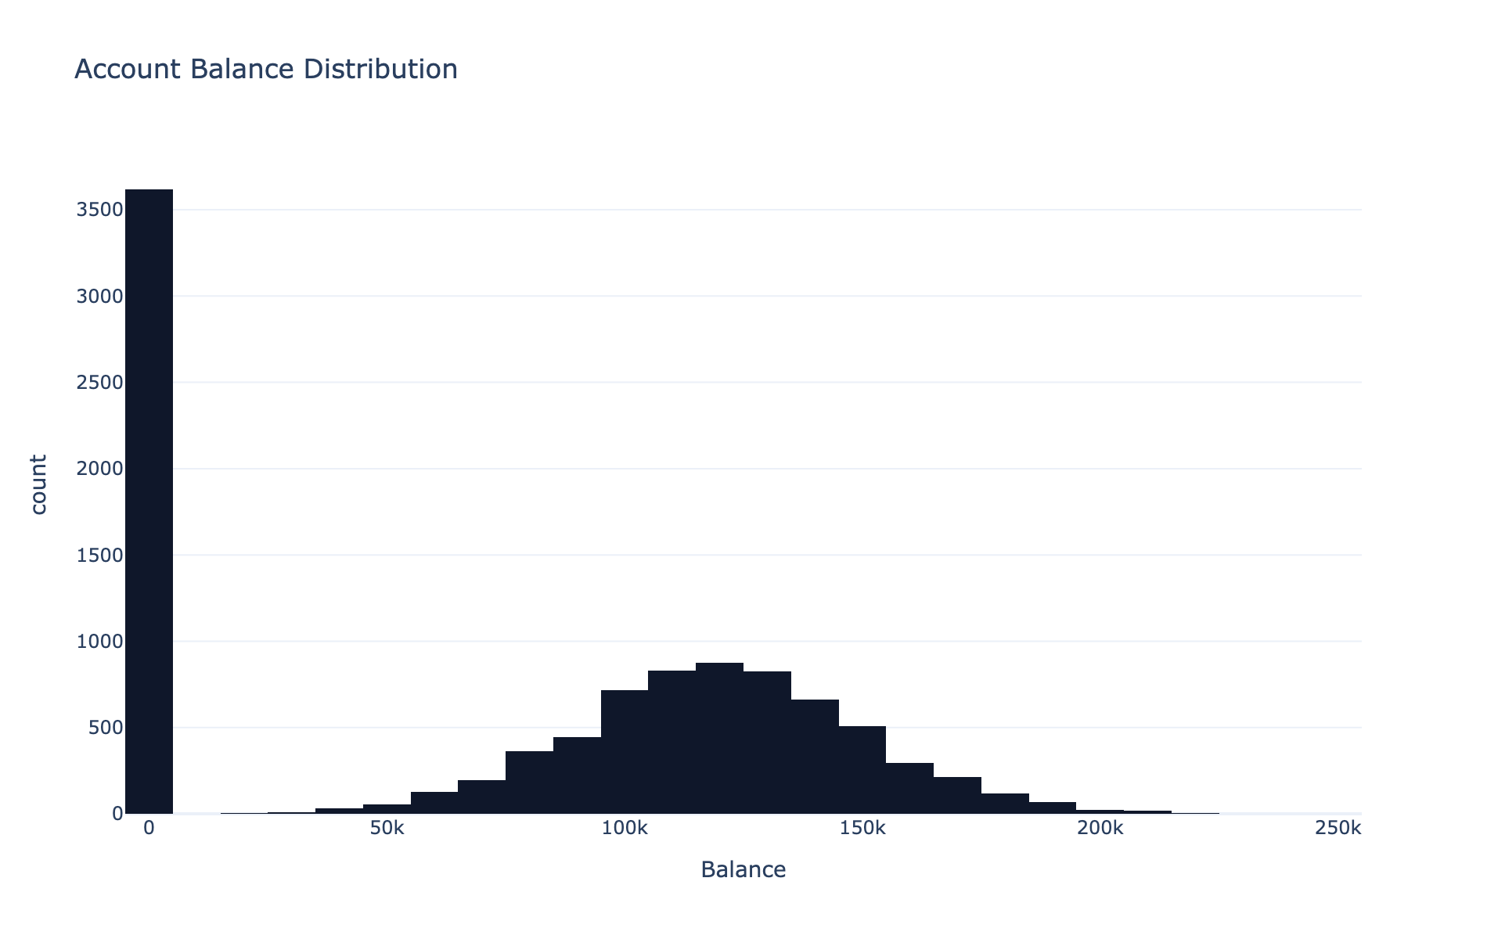
Figure 5. Account balance distribution across the portfolio.
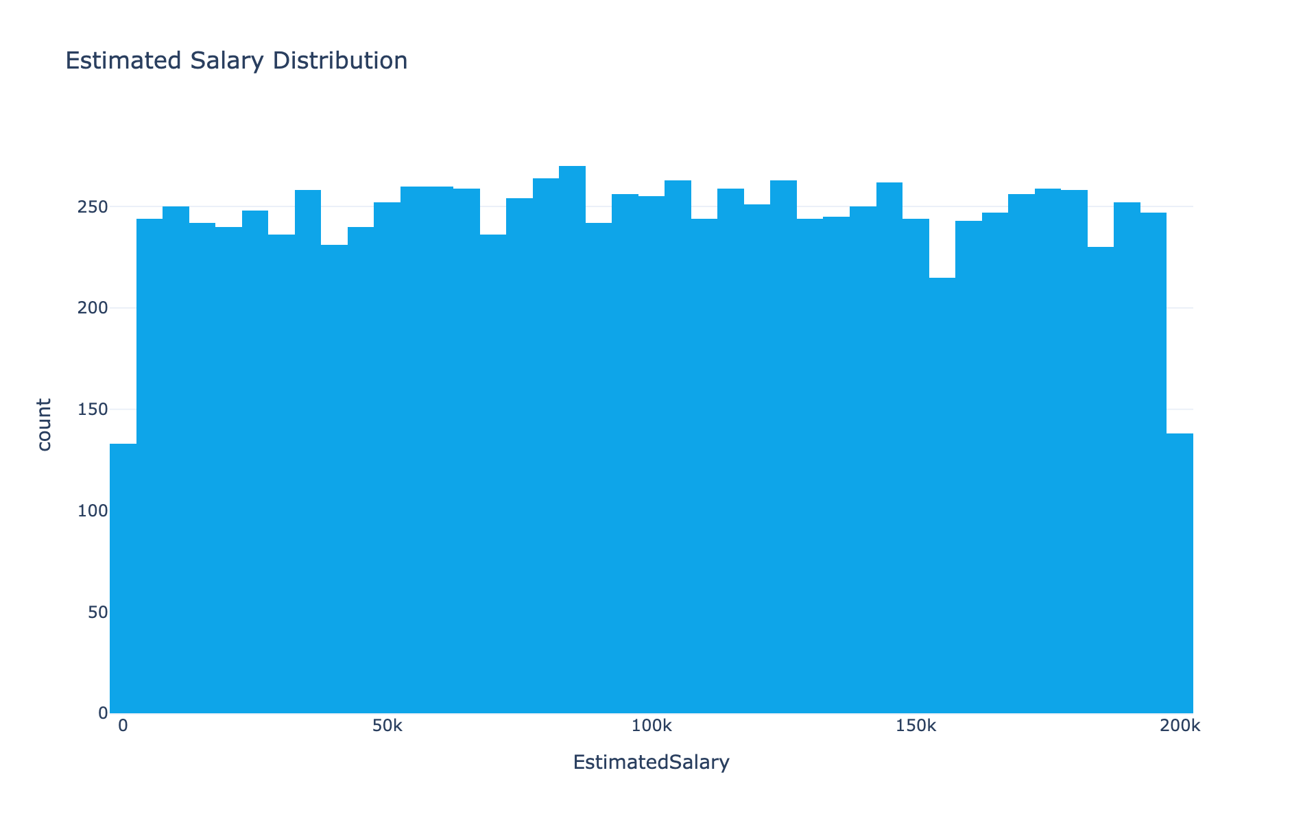
Figure 6. Estimated salary distribution across the portfolio.
Critically, a higher account balance does not translate into materially lower churn risk in this portfolio. Customers classified into the 'High Balance' category churn at approximately 24.5%, which is above the 20.4% portfolio-wide average rather than below it (see also the boxplot analysis in Section 5.6). This directly contradicts the intuitive assumption that larger depositors are automatically more loyal, and is a central empirical finding of this paper, discussed further in Section 6.

5.4 Product Holding and Churn: A Non-Monotonic Relationship
Product-holding behavior displays the most striking and policy-relevant pattern in the dataset (Figure 7). Customers holding two products churn least frequently, at approximately 7.6%. Customers holding one product churn at a substantially higher rate (approximately 27.7%), consistent with the standard cross-selling thesis that a single-product relationship is more easily severed. However, the relationship reverses sharply beyond two products: customers holding three products churn at approximately 82.7%, and customers holding four products churn at 100% in this sample. The three- and four-product segments are considerably smaller in absolute count (266 and 60 customers respectively) than the one- and two-product segments (5,084 and 4,590 customers), and the four-product figure in particular should be interpreted with appropriate statistical caution given its small base — but the direction and magnitude of the reversal is consistent enough across both the three- and four-product segments that it is unlikely to be pure sampling noise.
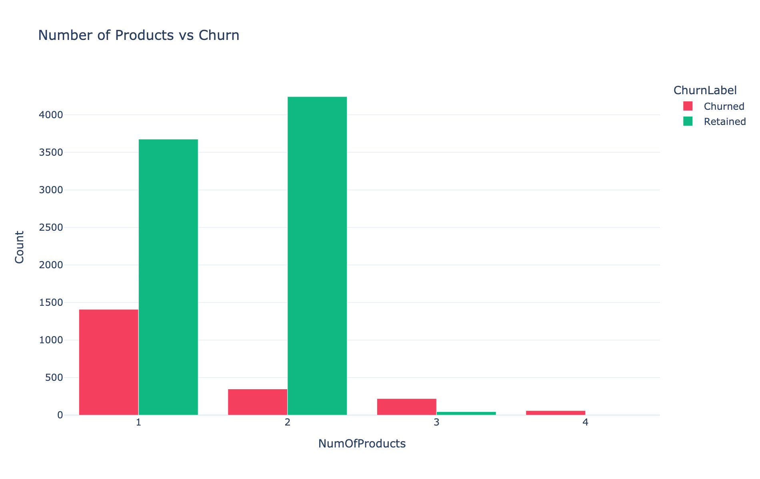
Figure 7. Number of products held versus churn outcome.
This pattern is consistent with the 'over-selling' hypothesis discussed in Section 2.4: beyond an apparent optimum of two products, additional product holding in this portfolio is associated with, rather than protective against, churn — suggesting that in at least a subset of cases, three- and four-product relationships may reflect forced bundling, dissatisfaction-driven service escalation, or already-departing customers who accumulate products shortly before exit, rather than genuine multi-product loyalty.

5.5 Behavioral Status: Activity and Credit Card Ownership
Member activity status is the clearest and most actionable behavioral signal identified in this study (Figure 8). Inactive members churn at approximately 26.9%, compared to approximately 14.3% for active members — a gap of roughly 12.6 percentage points, and the largest simple two-group churn differential observed anywhere in the dataset. Unlike geography or age, activity status is a variable that a bank can directly attempt to influence through reactivation campaigns, making this the highest-priority behavioral lever identified in the analysis.
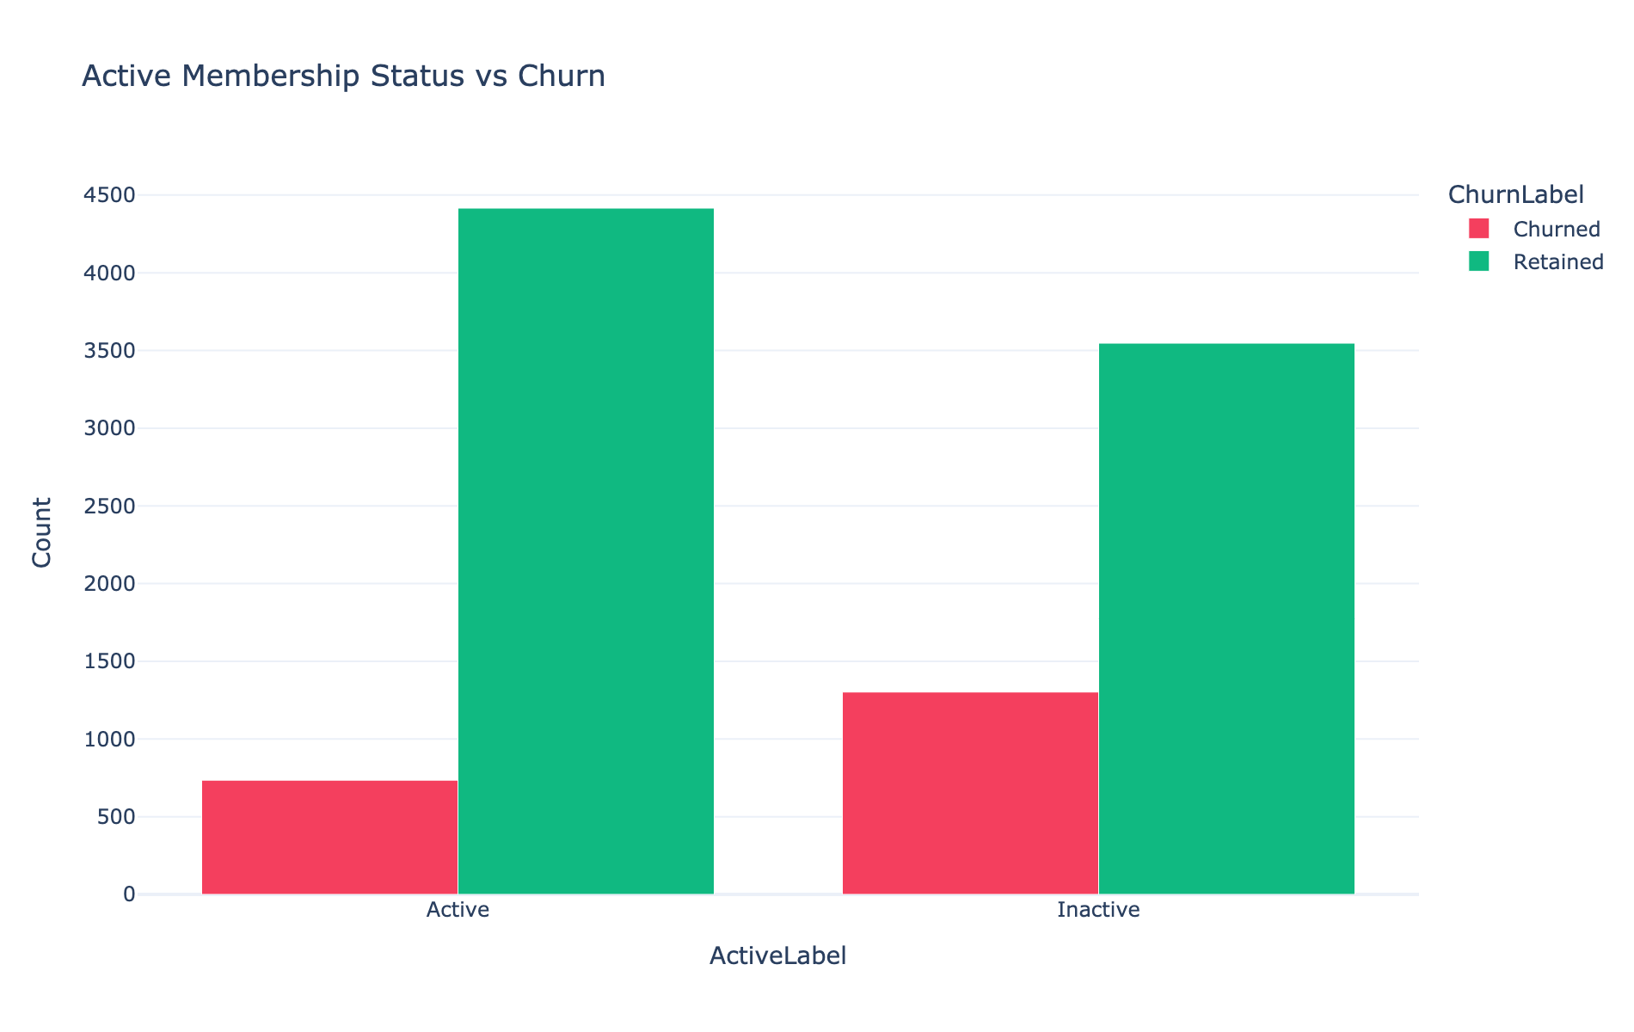
Figure 8. Active membership status versus churn outcome.
By contrast, credit card ownership shows a materially weaker association with retention than might be assumed a priori (Figure 9). Customers with a credit card retain at approximately 79.8%, compared to approximately 79.2% for customers without one — a difference of roughly six-tenths of one percentage point, which is not a practically meaningful gap at this portfolio size. This suggests that, within this dataset, credit card ownership functions more as a co-occurring feature of an engaged customer relationship than as an independent causal driver of retention, and should not be treated as a stand-alone retention lever.
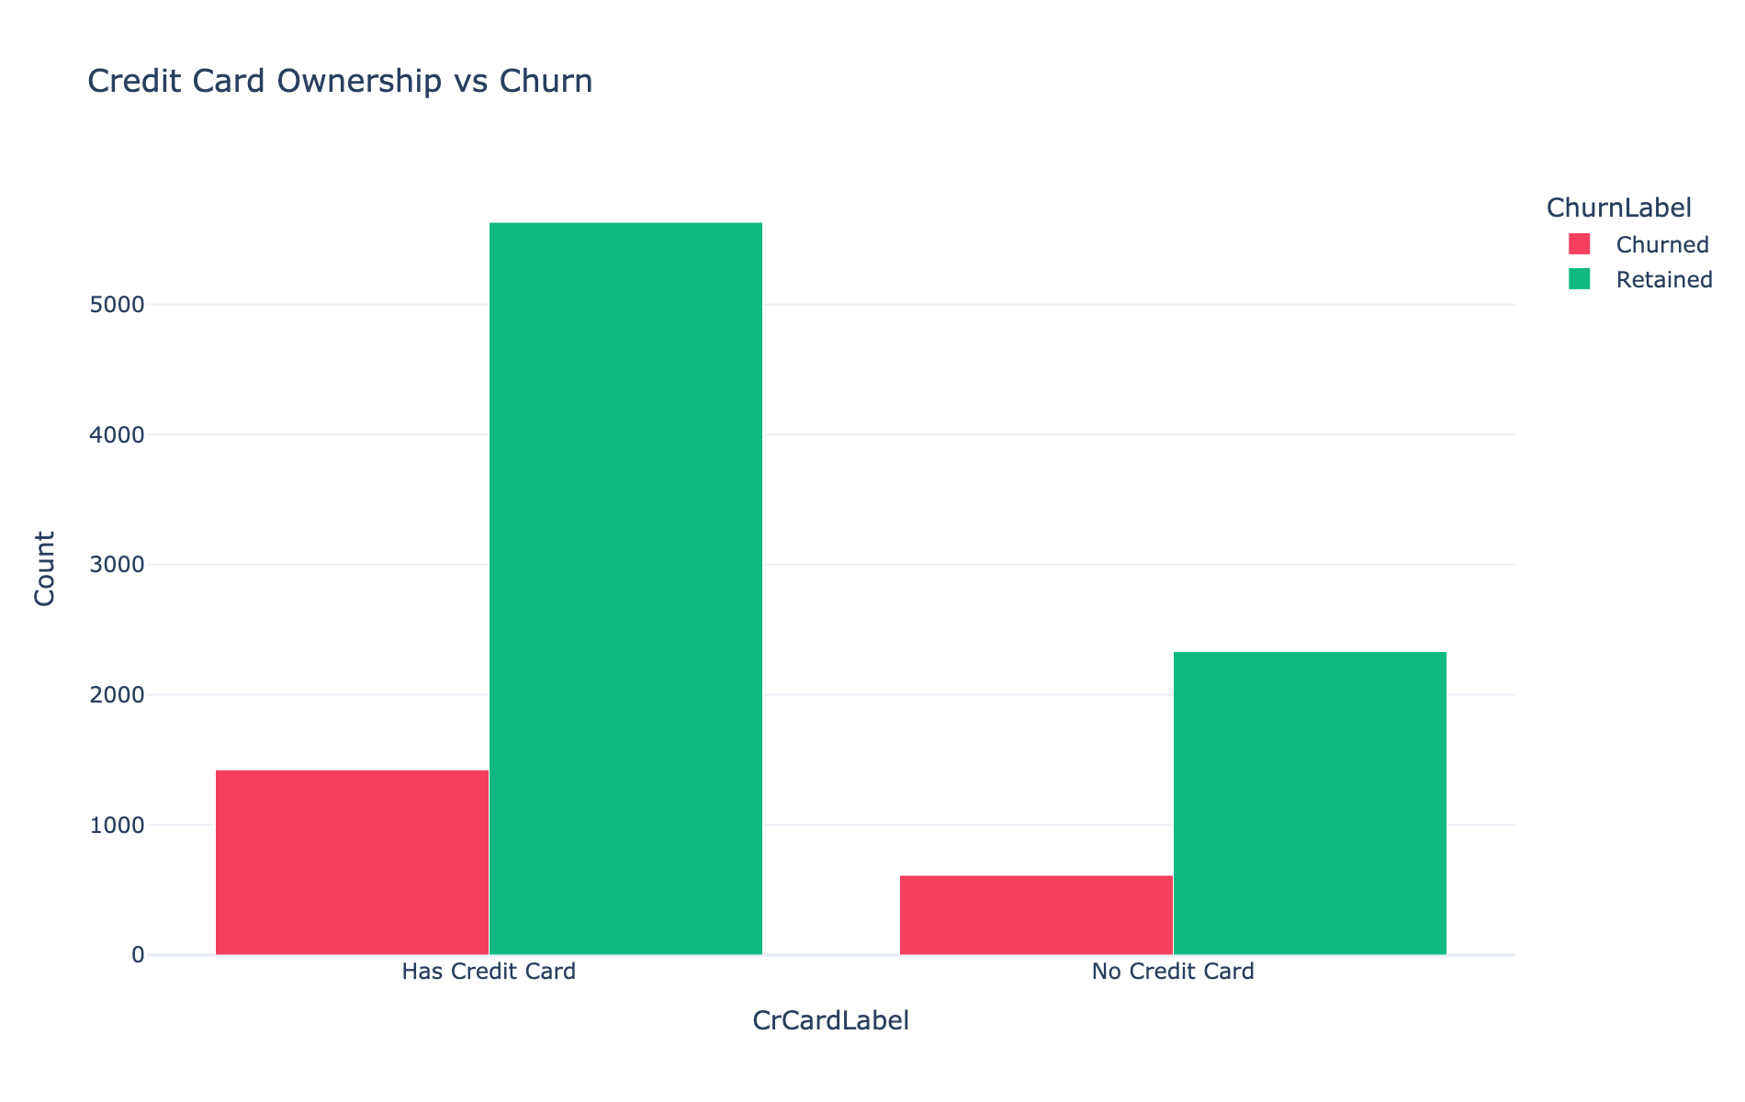
Figure 9. Credit card ownership versus churn outcome.
Tenure shows a comparatively flat relationship with churn across most of its range (Figure 10): the count of both retained and churned customers rises sharply in the first year and then plateaus from roughly year 1 through year 9, with both series declining together at year 10 (likely reflecting a smaller cohort at the tail of the tenure distribution rather than a change in underlying churn propensity). This flatness indicates that tenure alone — unlike activity status — is a weak standalone predictor of churn in this portfolio once a customer has passed the first year.
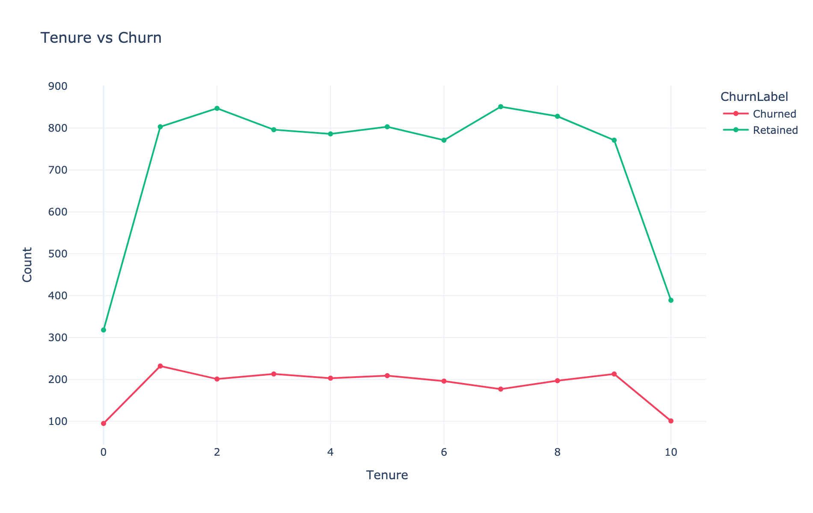
Figure 10. Tenure (years) versus churn outcome.

5.6 Correlation Structure Among Numeric Features
Figure 11 presents the Pearson correlation matrix across the core numeric fields and the engineered composite scores. Several patterns are notable. First, the churn indicator ('Exited') correlates most strongly, in absolute terms, with Age (r = 0.29) and with IsActiveMember (r = −0.16), consistent with the descriptive findings in Sections 5.2 and 5.5. Second, the engineered Engagement Score correlates very strongly with IsActiveMember (r = 0.89) and with the Retention Score (r = 0.89) by construction, confirming the composite is behaving as intended, while its correlation with Exited itself (r = −0.16) is identical in magnitude to that of raw activity status — indicating the composite adds interpretability without amplifying the underlying signal beyond what activity status alone provides. Third, and importantly, the Relationship Strength Index correlates only weakly with churn (r ≈ 0.01 once computed at the full-sample level), despite showing strong internal correlation with Tenure (r = 0.74) and NumOfProducts (r = 0.40). This indicates that relationship depth, as constructed here, is not by itself a strong predictor of attrition in this portfolio — a finding that qualifies some of the relationship-marketing literature discussed in Section 2.2 and is discussed further in Section 6.
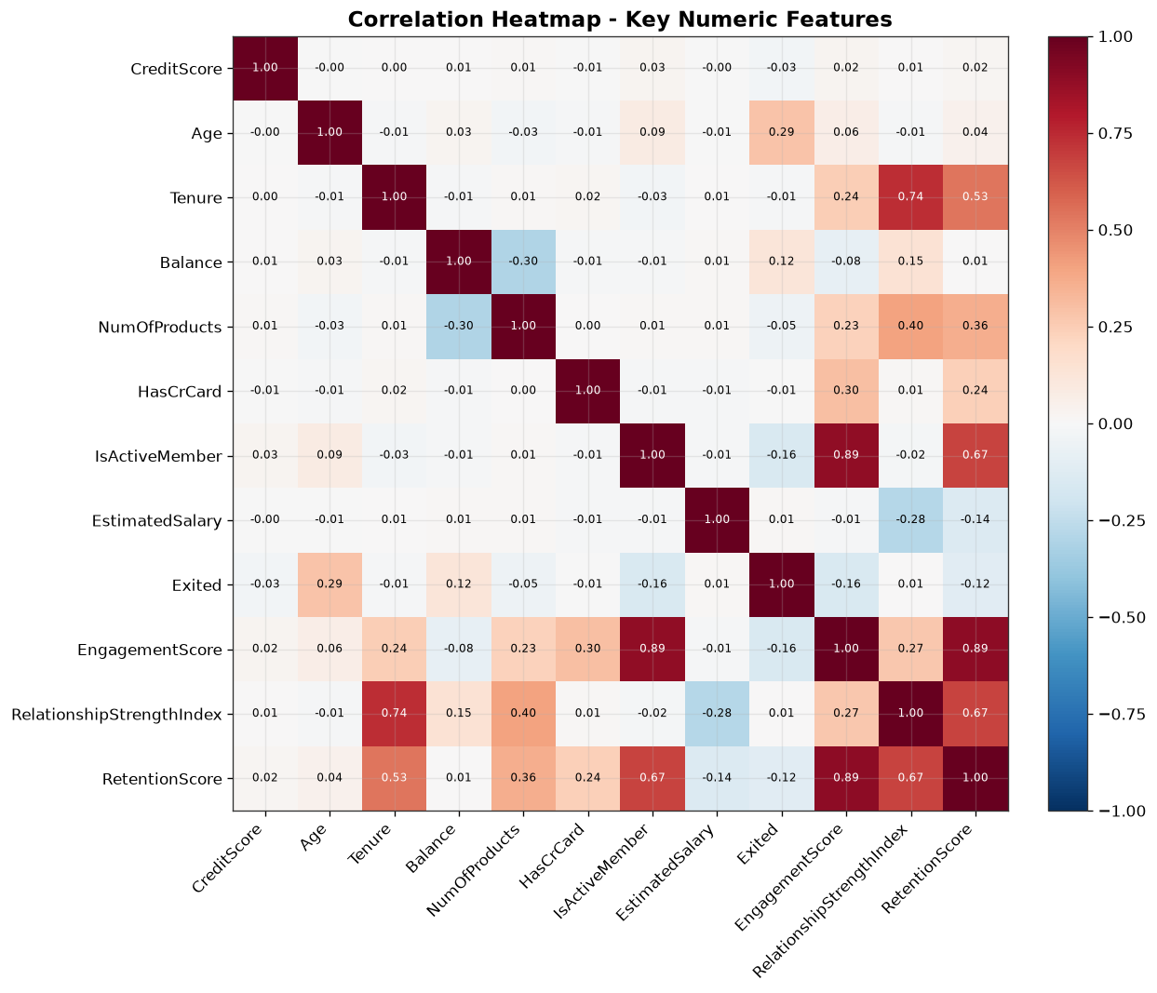
Figure 11. Correlation heatmap across core numeric and engineered features.

5.7 Engagement and Relationship Score Distributions
The Engagement Score distribution (Figure 12) is bimodal, with concentrations of customers around scores of roughly 20–35 and 60–75, and only a small tail of very high-engagement customers above 85. The Relationship Strength Index (Figure 13) is right-skewed, with the bulk of customers scoring between 10 and 45 and a long tail extending toward 80. The relative scarcity of customers in the uppermost engagement and relationship bands suggests there is meaningful headroom for engagement-building interventions across a large share of the portfolio, not merely among an already-identified at-risk minority.
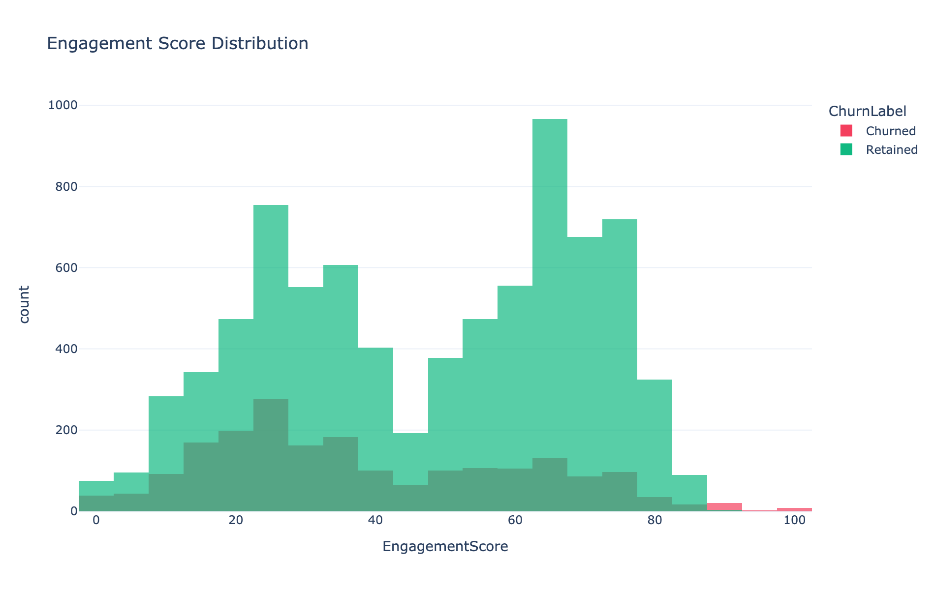
Figure 12. Engagement Score distribution, overlaid by churn status.
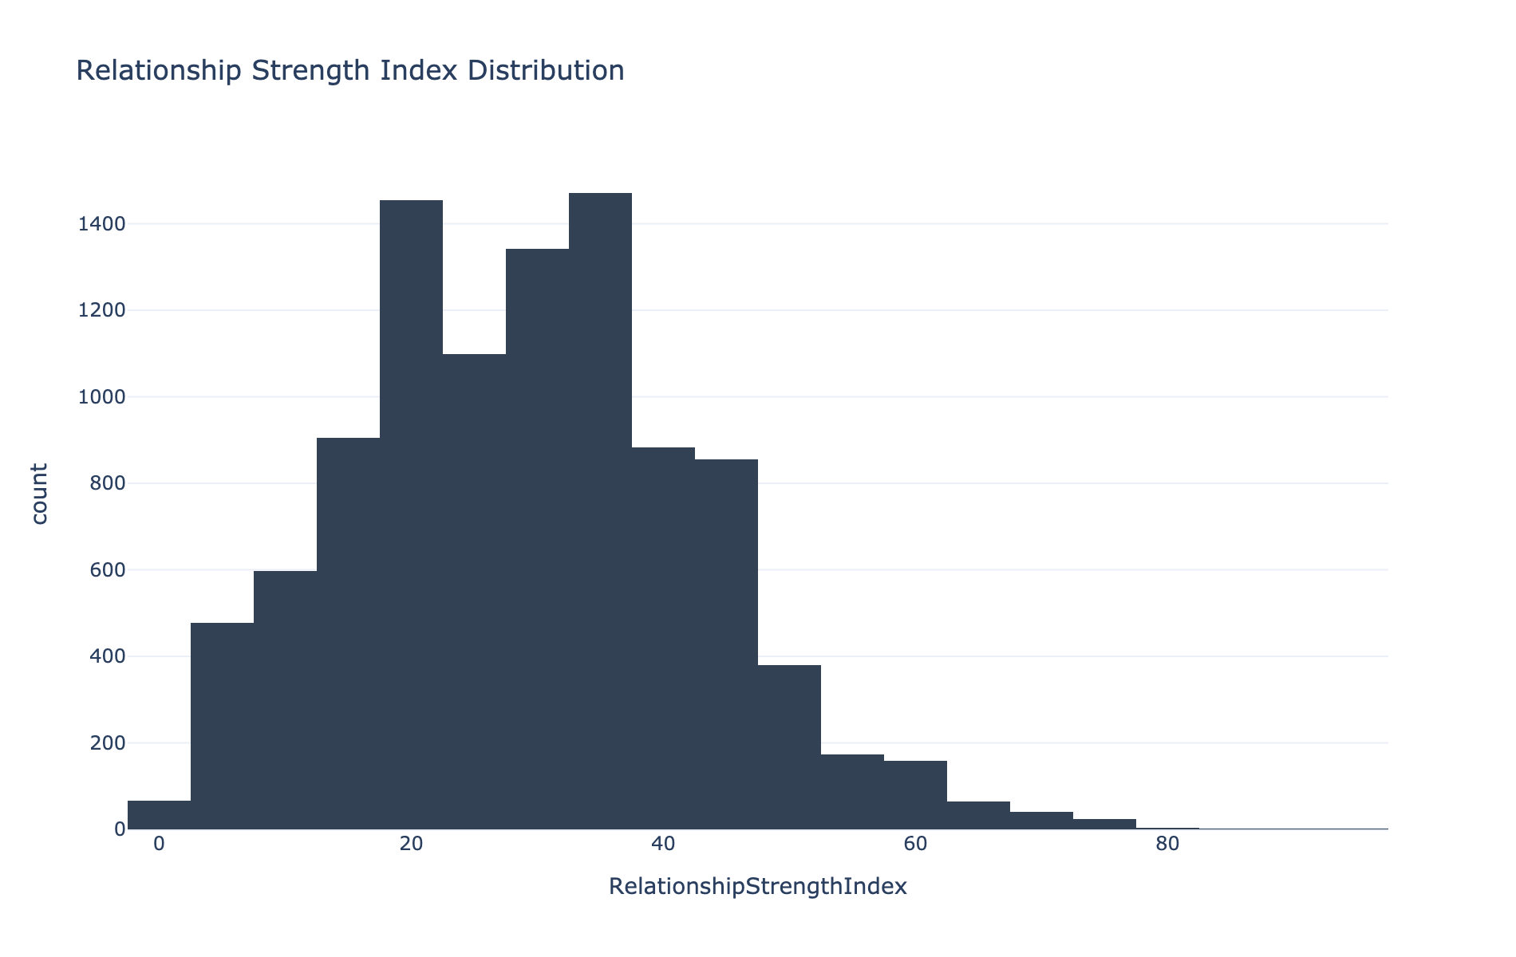
Figure 13. Relationship Strength Index distribution.

5.8 The Premium Customer Segment and Hidden Risk
Approximately 6.5% of the portfolio qualifies as 'Premium' under the joint balance-and-salary threshold defined in Section 4.2. Of these, a non-trivial share are simultaneously flagged as 'At-Risk Premium Customers' — that is, high-value clients who are either inactive or exhibit an Engagement Score below 50 (Figure 14). In absolute portfolio terms, At-Risk Premium Customers represent approximately 3.5% of the entire 10,000-customer base. While this is a minority of the portfolio, it is disproportionately significant in revenue terms given that, by definition, every customer in this segment sits in the top balance-and-salary quartile of the bank's client base.
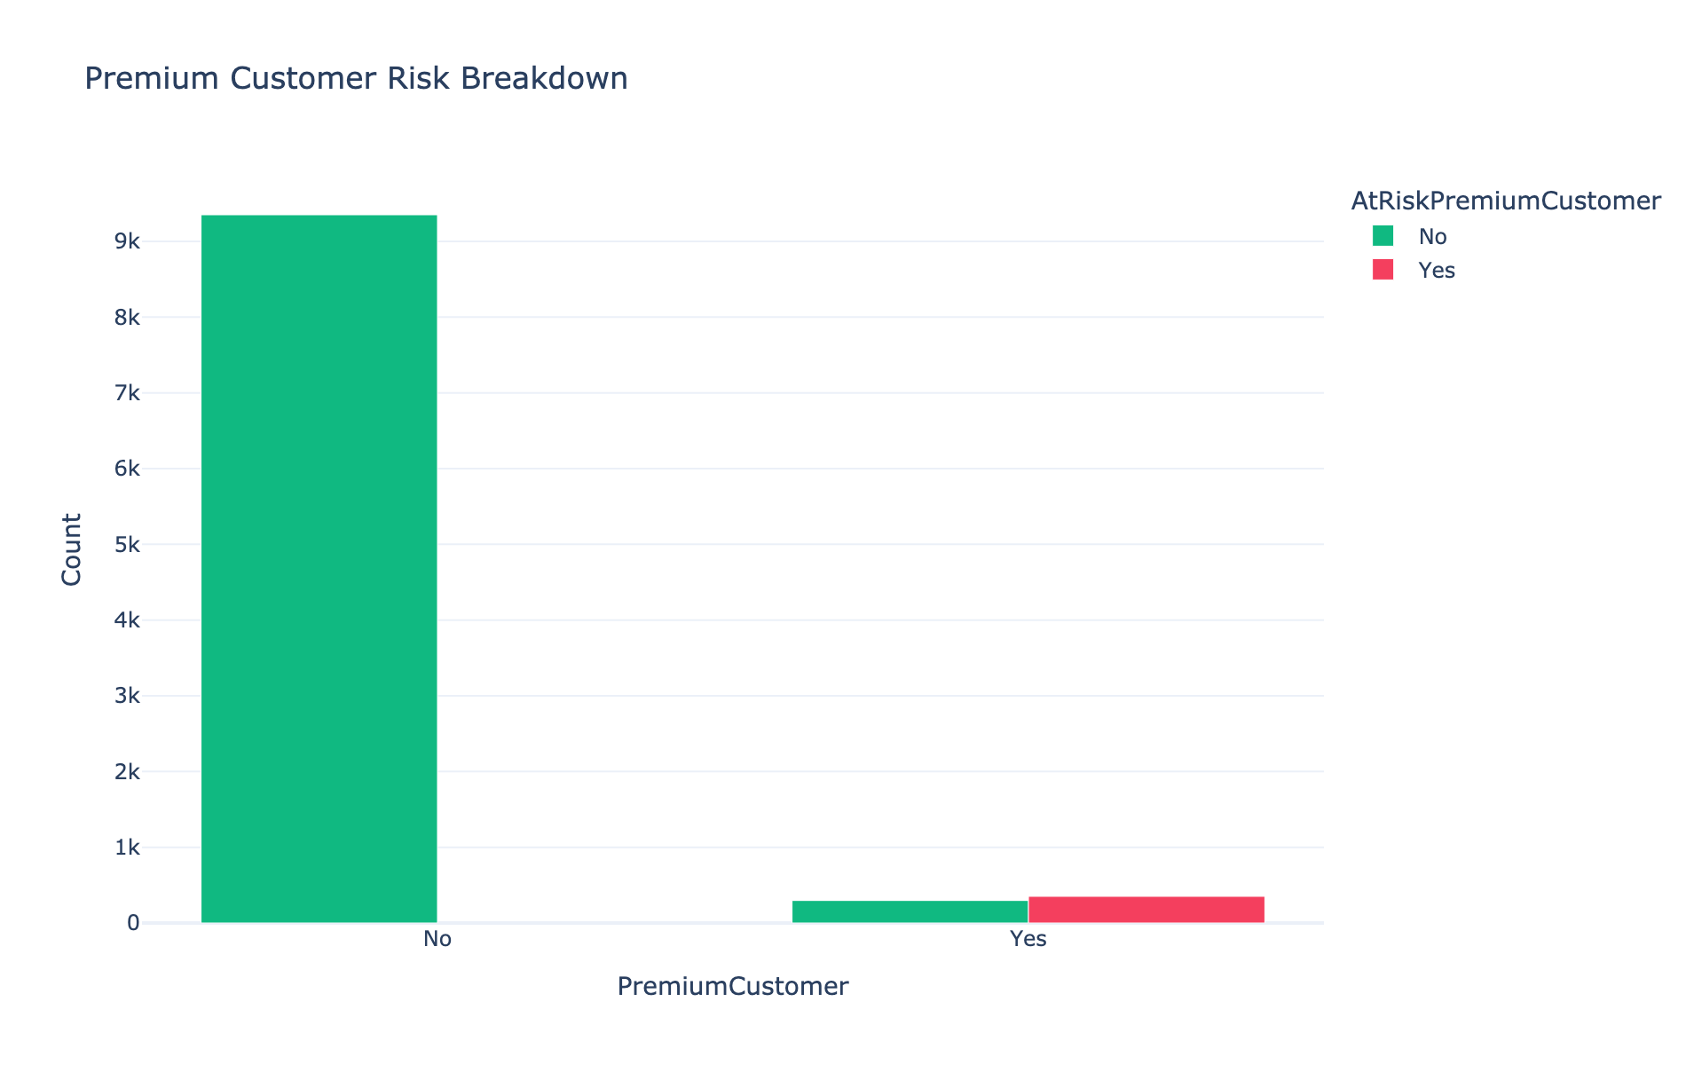
Figure 14. Premium customer segment, subdivided by At-Risk Premium Customer status.
The 'Sticky Customer' segment — defined as active, credit-card-holding customers with five or more years of tenure — shows the expected direction of association with retention (Figure 15): churned customers are a smaller proportion of the Sticky group than of the non-Sticky group. This is a useful validation check confirming that the composite behavioral flags constructed in Section 4 are internally consistent with the raw churn outcome, even where any single constituent variable (as with credit card ownership alone, Section 5.5) shows a weak marginal effect.
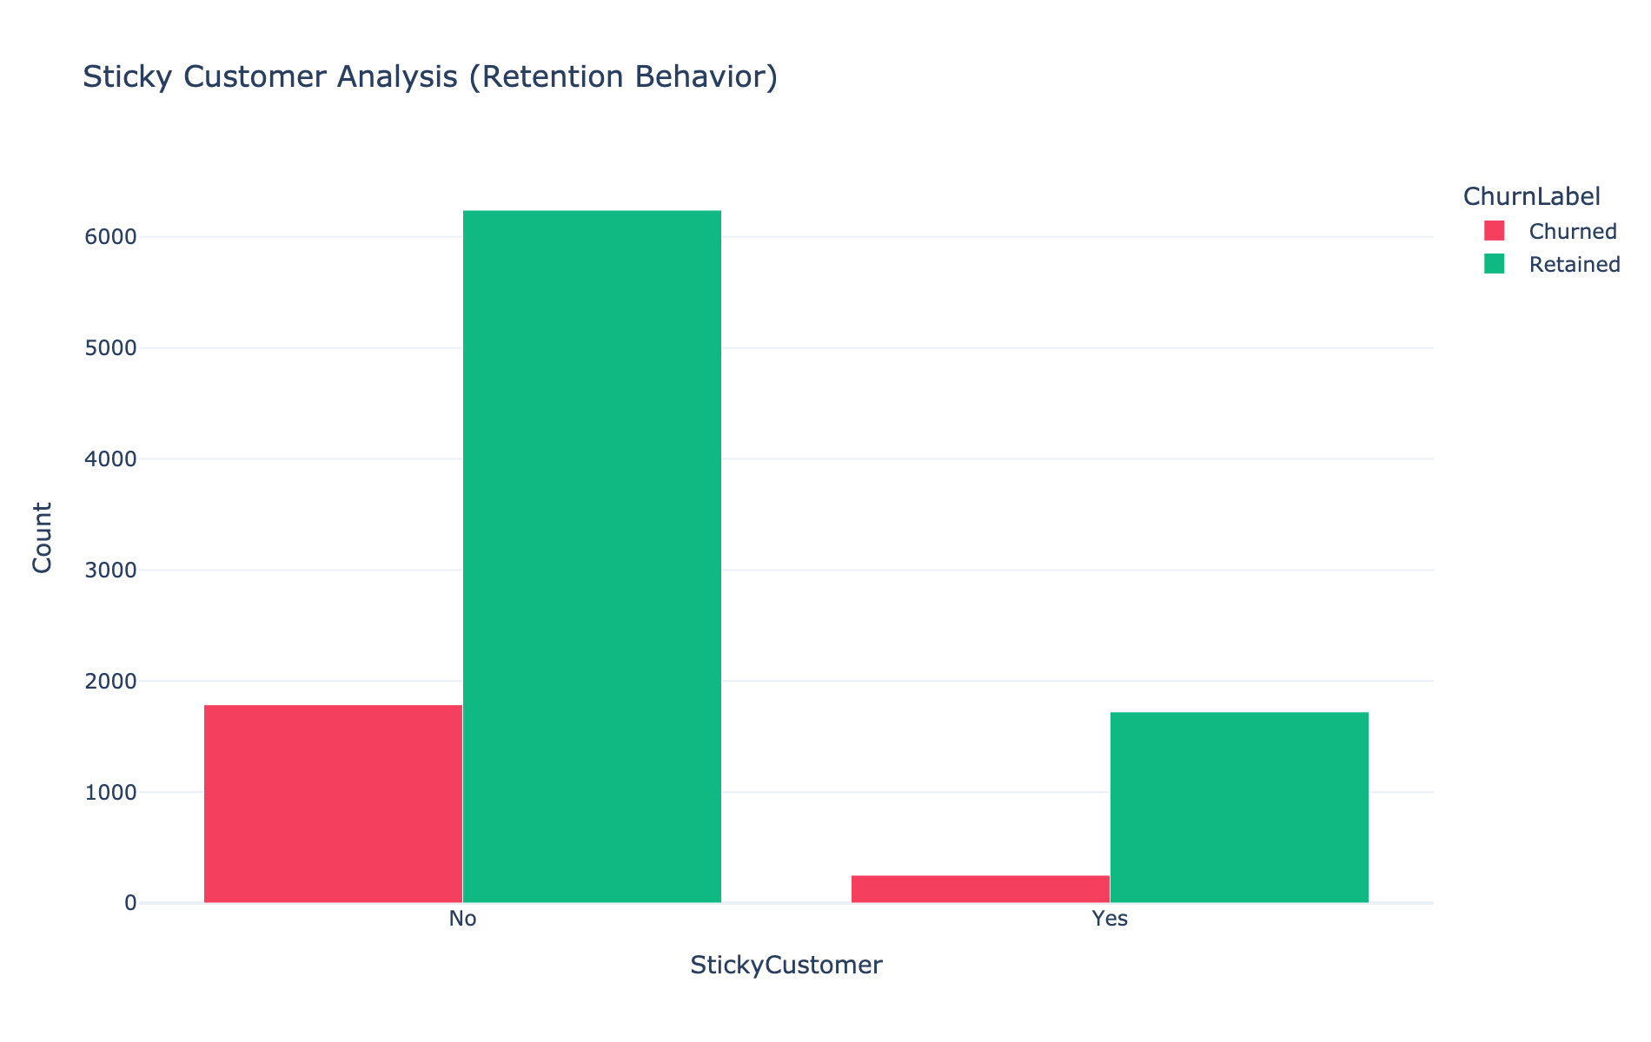
Figure 15. Sticky Customer classification versus churn outcome.

5.9 Customer Lifecycle Segmentation and Product Utilization
Segmenting the portfolio by tenure-based lifecycle stage (Figure 16) shows a relatively balanced distribution across Established (tenure 6–8 years, ~30% of customers), Growing (3–5 years, ~30%), New (≤2 years, ~25%), and Veteran (9+ years, ~15%) segments. This balance suggests the bank has maintained a reasonably steady acquisition rate over time rather than experiencing a sharp historical growth spike or contraction, which is a useful baseline fact for any subsequent cohort-based analysis (see Section 7).
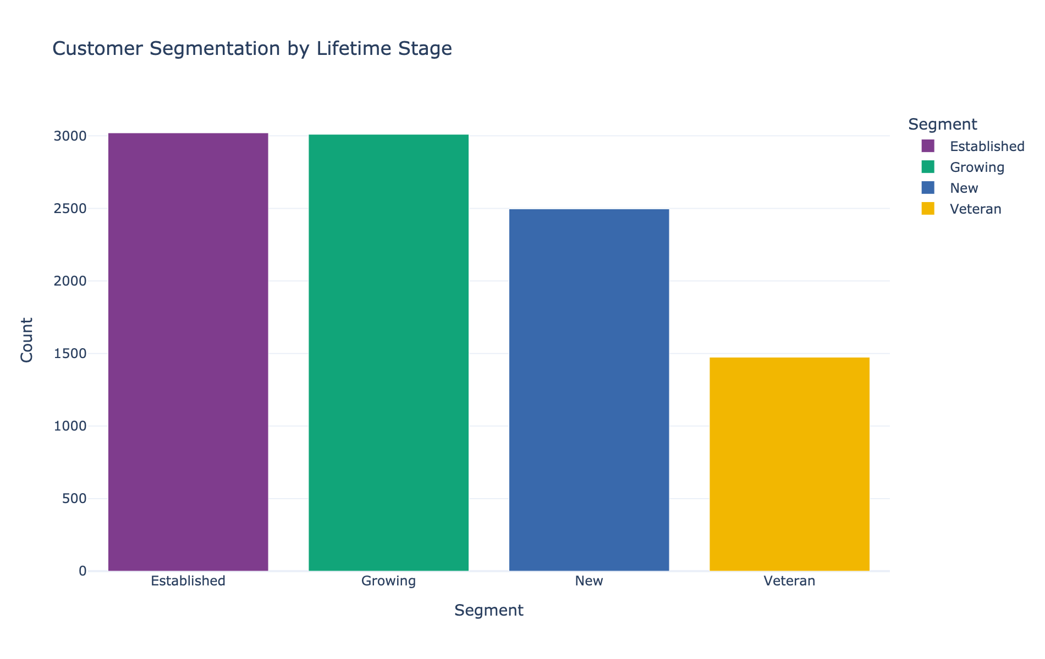
Figure 16. Customer segmentation by lifetime stage.
Product utilization across the portfolio (Figure 17) confirms the concentration noted in Section 5.4: the large majority of customers (over 96%) hold either one or two products, with three- and four-product holders together comprising well under 5% of the base. Any retention strategy premised on migrating large numbers of customers into three-or-more-product relationships should therefore be approached cautiously in light of the elevated churn observed in that segment.
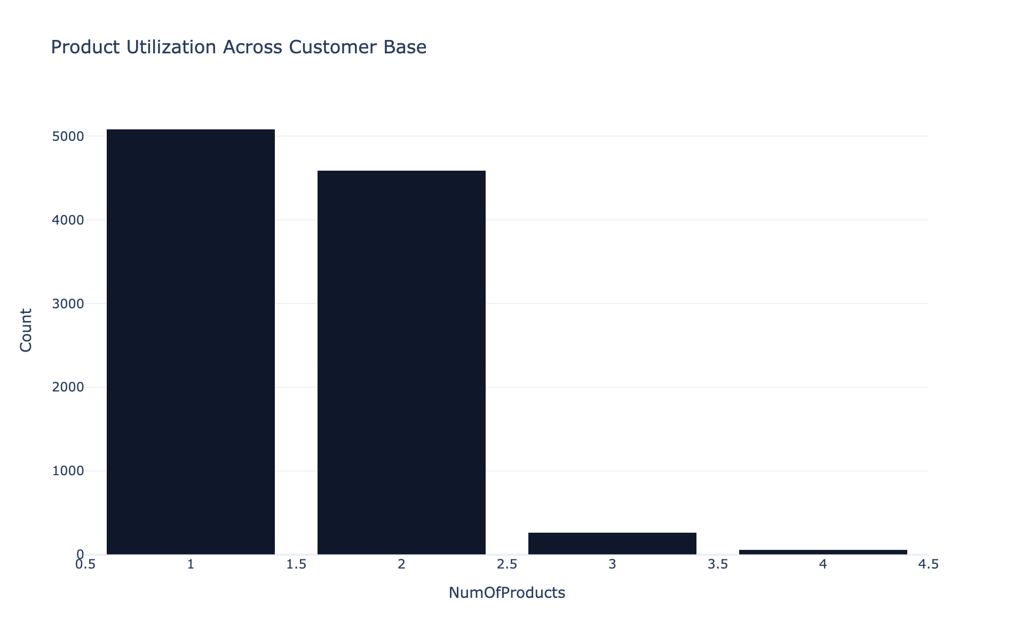
Figure 17. Product utilization distribution across the customer base.

5.10 Joint Distribution of Salary, Balance, and Churn
The scatter plot of estimated salary against account balance, colored by churn status (Figure 18), shows no visually obvious linear separation between churned and retained customers across the salary dimension, reinforcing the earlier finding (Section 5.3) that these financial attributes are, at best, weak standalone churn predictors. The dense horizontal band at Balance = 0 corresponds to the zero-balance customer sub-population identified in Section 5.3 and is present across the full range of estimated salary, indicating that a zero balance is not confined to any particular income band.
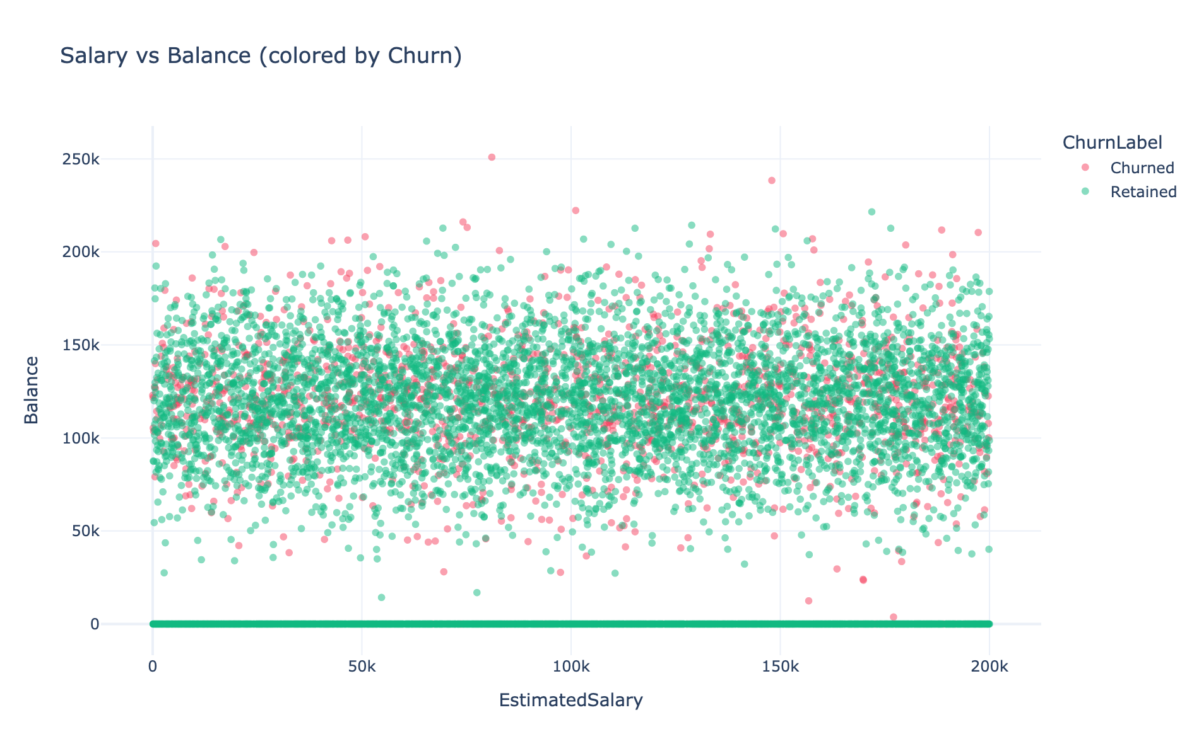
Figure 18. Estimated salary versus account balance, colored by churn status.
The boxplot comparison of balance by churn status (Figure 19) makes the balance–churn relationship from Section 5.3 more precise: the median balance among churned customers (≈€109,000) is modestly higher than the median balance among retained customers (≈€92,000), even though both groups share the same zero-balance floor and similar upper whiskers. This confirms, at the distributional level rather than only the categorical level, that higher balances are mildly associated with a greater rather than lesser propensity to churn in this portfolio.
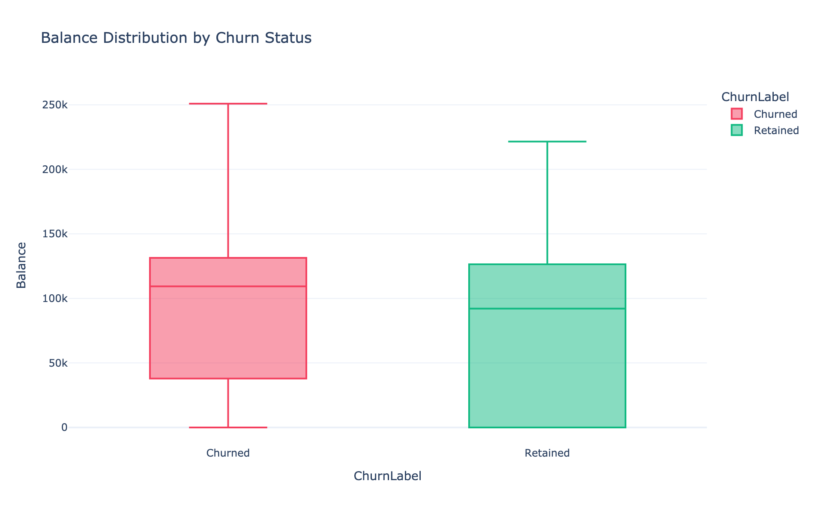
Figure 19. Account balance distribution by churn status (boxplot).

5.11 Executive Summary Dashboard
Figure 20 consolidates four of the preceding findings into a single executive-facing view: the overall churn/retention split (Section 5.1), average engagement score by geography (Section 5.2), the distribution of customers across the heuristic Risk Level classification (Section 4.2), and average Retention Score by lifecycle segment (Section 5.9). Notably, average Retention Score rises monotonically from the New segment through the Veteran segment, which is consistent with the Retention Score's construction (Section 4.1) as a blend of Engagement Score and Relationship Strength Index, both of which incorporate tenure-linked terms.
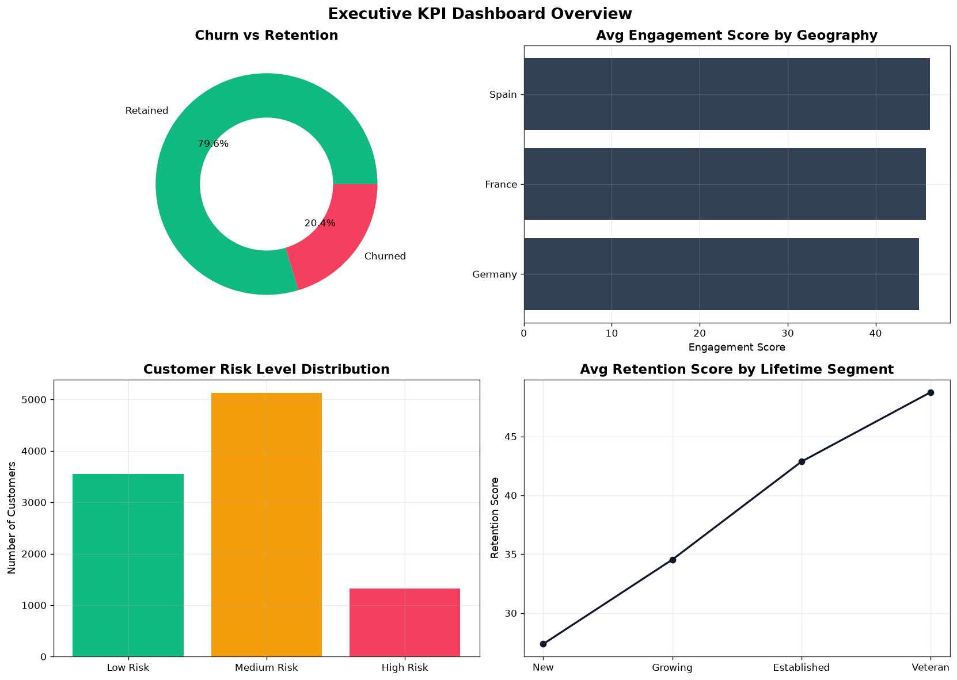
Figure 20. Executive KPI dashboard: churn split, geographic engagement, risk-level distribution, and retention score by lifecycle segment.

5.12 Summary of Key Performance Indicators
Table 1 consolidates the portfolio-level KPIs computed across the full customer base.
KPI | Value
Total Customers | 10,000
Total Churn | 2,037
Churn Rate | 20.37%
Retention Rate | 79.63%
Average Balance | €76,485.89
Average Estimated Salary | €100,090.24
Average Products per Customer | 1.53
Average Credit Score | 650.56
Active Customer (%) | 51.51%
Inactive Customer (%) | 48.49%
Premium Customer (%) | 6.49%
Product Utilization Index | 38.26%
Average Relationship Strength Index | 29.10 / 100
Engagement/Retention Ratio | 1.22
High-Balance Disengagement Rate | 49.15%
Credit Card Stickiness Score | 79.82%
Average Tenure | 5.01 years

Two figures in Table 1 warrant particular attention. The High-Balance Disengagement Rate of 49.15% indicates that essentially half of all high-balance customers are currently inactive members — a striking figure given the disproportionate revenue importance of this segment, and one of the clearest quantitative expressions of the 'profitable but disengaged' problem discussed in Section 2.3. The Engagement/Retention Ratio of 1.22 indicates that, on average, retained customers exhibit an Engagement Score approximately 22% higher than churned customers, providing further corroborating evidence — alongside the correlation results in Section 5.6 — that engagement, more so than any single financial attribute, differentiates retained from churned customers in this portfolio.

6. Discussion and Strategic Implications

6.1 Activity Status as the Primary Retention Lever
The single most actionable finding of this study is the approximately 12.6 percentage-point churn-rate gap between active and inactive members (Section 5.5). Unlike geography, age, or account balance — all of which are either fixed or slow-moving customer attributes — activity status is directly susceptible to intervention through reactivation campaigns, renewed digital engagement, and proactive relationship-manager contact. We therefore recommend this as the top-priority lever for any retention program built on this analysis.

6.2 Addressing the 'Profitable but Disengaged' Segment
The finding that high-balance customers churn at a rate above the portfolio average (24.5% versus 20.4%, Section 5.3), combined with the observation that nearly half of high-balance customers are inactive (Section 5.12), together identify a segment of substantial hidden risk. We recommend the construction of a dedicated relationship-manager alert system triggered by the At-Risk Premium Customer flag (Section 4.2), rather than relying on balance size alone as a proxy for loyalty.

6.3 Reconsidering Product Cross-Selling Targets
The non-monotonic relationship between product count and churn (Section 5.4) suggests that cross-selling strategies calibrated purely to maximize product count per customer may be counterproductive beyond a threshold of two products. We recommend that product cross-selling initiatives be evaluated against a needs-based rather than volume-based objective function, with particular scrutiny applied to any incentive structure that rewards relationship managers for the sheer number of products sold per customer.

6.4 Geographic and Age-Based Targeting
The elevated churn rate observed in Germany (Section 5.2) and in the 46–60 age segment (Section 5.2) both indicate that a uniform, portfolio-wide retention message is unlikely to be optimal. We recommend a focused root-cause investigation into the German market specifically — potentially examining local competitive dynamics, pricing, or service-quality metrics not captured in this dataset — and the development of age-tailored retention communications for the 46–60 segment.

6.5 Weaker-Than-Expected Levers: Credit Cards and Relationship Depth
Two variables often assumed to be strong retention levers performed weakly in this analysis: credit card ownership (a 0.6-percentage-point retention gap, Section 5.5) and the engineered Relationship Strength Index (r ≈ 0.01 with churn, Section 5.6). We recommend that retention budgets not be allocated to credit card cross-sell campaigns on retention grounds alone, and that any relationship-depth-based scoring model be validated against the specific portfolio it is deployed on rather than assumed from general marketing theory.

7. Limitations and Future Research

7.1 Cross-Sectional, Non-Causal Design
This study is based on a single-snapshot, cross-sectional dataset. All reported relationships — including the activity-status churn gap and the product-count reversal — are correlational. It is possible, for example, that inactivity is partly a consequence of an already-forming decision to leave (reverse causation) rather than purely a cause of it. Longitudinal, panel-structured data tracking the same customers over multiple periods would be required to disentangle these directions and to support genuinely causal retention-intervention claims.

7.2 Absence of a Validated Predictive Model
The Risk Level classification used in this paper (Section 4.2) is a transparent, rule-based heuristic rather than a statistically fitted and validated churn-propensity model. Future work should complement this heuristic with a trained classifier (e.g., gradient-boosted trees or logistic regression with regularization), evaluated via proper train/test splitting and calibration diagnostics, and ideally paired with explainability tooling (e.g., SHAP values) to preserve the interpretability that motivated the heuristic approach in the first place.

7.3 Small-Sample Caution for Extreme Product Counts
The four-product customer segment comprises only 60 individuals (0.6% of the portfolio), and its 100% observed churn rate (Section 5.4), while directionally consistent with the three-product segment, should be treated as suggestive rather than definitive given its small base. Replication on a larger sample, or pooling of three- and four-product holders into a single 'high product count' category, would strengthen confidence in this finding.

7.4 Unobserved Confounders and External Validity
The dataset does not include several variables that are plausibly relevant to churn in retail banking — competitor pricing, service-complaint history, digital-channel usage, marketing-contact history, and macroeconomic conditions at the time of observation — any of which could confound the associations reported here. Furthermore, because the dataset spans only three European geographies, external validity to other markets or institution types (e.g., credit unions, digital-only banks) should not be assumed without further data collection.

7.5 Directions for Future Work
- Longitudinal cohort tracking to test whether the tenure-based lifecycle segments (Section 5.9) predict future churn trajectories rather than only concurrent status.
- A validated, explainable machine-learning churn model benchmarked against the heuristic Risk Level classification used here.
- Survival analysis (time-to-churn modeling) to complement the binary churn framing used throughout this paper.
- A market-specific qualitative investigation into the elevated German churn rate identified in Section 5.2.
- A/B-tested reactivation campaigns targeting inactive members, to move from the correlational finding in Section 5.5 toward a causally validated intervention.

8. Conclusion
This paper analyzed a 10,000-customer retail banking dataset to identify the primary behavioral, demographic, and product-holding correlates of customer churn, and to construct a set of engineered engagement and relationship metrics suitable for ongoing retention monitoring. The overall portfolio churn rate of 20.4% masks substantial heterogeneity: inactive members churn at nearly double the rate of active members; a meaningful share of high-balance 'premium' customers are simultaneously disengaged; product cross-selling shows a clear optimum at two products with sharply elevated churn beyond that point; and churn varies materially by geography and age. Credit card ownership and the engineered Relationship Strength Index, by contrast, showed only weak associations with churn in this portfolio, cautioning against uncritical reliance on commonly assumed retention levers.
Taken together, these findings support a retention strategy that prioritizes behavioral reactivation over acquisition, builds a dedicated monitoring process for at-risk premium customers, recalibrates product cross-selling incentives around customer need rather than raw product count, and applies geographically and demographically targeted interventions rather than a single portfolio-wide campaign. As a cross-sectional, descriptive study, these conclusions should be treated as a foundation for, rather than a substitute for, the longitudinal and model-based validation work outlined in Section 7.

References
Note: This paper is an empirical, data-driven analysis of a structured customer dataset rather than a literature synthesis, and Section 2 characterizes broad research traditions in churn analytics, relationship marketing, and cross-selling rather than citing specific individual studies. Readers seeking primary literature are directed to the following representative topic areas for further reading: (1) statistical and machine-learning approaches to customer churn prediction in subscription and banking contexts; (2) relationship-marketing and customer-engagement scoring frameworks; (3) customer lifetime value (CLV) modeling in retail banking; and (4) empirical studies of cross-selling effectiveness and its relationship to customer satisfaction and attrition.

