ML INTERNSHIP PROJECT | RESEARCH PAPER

Product Line Profitability &
Margin Performance Analysis
for Nassau Candy Distributor

Guided By | Unified Mentor Pvt. Ltd.
Domain | Machine Learning / Data Analytics
Dataset | Nassau Candy Distributor Orders
Records | 10,194 orders | 15 products | 3 divisions
Tech Stack | Python | Pandas | Scikit-learn | Streamlit | Plotly

1. Abstract
This research paper presents a comprehensive data-driven profitability analysis conducted for Nassau Candy Distributor, a large-scale candy distribution company operating across multiple regions of the United States. The study addresses a critical business challenge wherein sales volume metrics were being used as the primary performance indicator, masking the true profitability of individual product lines.

Using a dataset of 10,194 real order records spanning 15 products across 3 divisions — Chocolate, Sugar, and Other — this project employs Exploratory Data Analysis (EDA), KPI Engineering, Pareto Analysis, Cost Structure Diagnostics, and K-Means Machine Learning Clustering to deliver actionable business intelligence. The final output includes an interactive Streamlit web dashboard and a set of strategic recommendations for pricing, product rationalization, and divisional investment.

2. Introduction

2.1 Background & Context
Nassau Candy Distributor operates in a highly competitive candy distribution market, managing an extensive portfolio of products manufactured across five geographically distributed factories. While the company maintained consistent sales volumes, internal stakeholders lacked a clear, data-driven understanding of which products and divisions were actually generating healthy profit margins versus which were silently eroding overall financial performance.

2.2 Problem Statement
The organization lacked visibility into the following critical business questions:

- Which product lines deliver the highest gross margin percentage?
- Are high-sales products actually generating proportional profit?
- How does profitability performance vary across the three product divisions?
- Which specific products represent structural margin risk to the business?
- Where should management focus pricing, sourcing, or discontinuation decisions?

2.3 Project Objectives
- Conduct thorough data cleaning and validation of 10,194 order records
- Engineer and calculate five business-critical KPI metrics from raw transactional data
- Perform product-level and division-level profitability ranking and comparison
- Apply Pareto (80/20) Analysis to identify profit concentration and over-dependency risk
- Execute K-Means Machine Learning Clustering to segment products into actionable strategic groups
- Build an interactive Streamlit web dashboard for ongoing business monitoring

3. Dataset Description

3.1 Dataset Overview

Metric | Value
Total Records | 10,194
Unique Products | 15
Product Divisions | 3 (Chocolate, Sugar, Other)
Distribution Factories | 5
US Regions Covered | 4 (Atlantic, Gulf, Pacific, Interior)
Key Financial Fields | Sales, Cost, Gross Profit, Units

3.2 Dataset Fields

Field Name | Description | Type
Order Date | Date the order was placed | Date
Division | Product division (Chocolate/Sugar/Other) | Categorical
Region | US distribution region | Categorical
Product Name | Full product name | String
Sales | Total sales value ($) | Float
Units | Number of units in order | Integer
Gross Profit | Gross Profit = Sales - Cost ($) | Float
Cost | Manufacturing cost ($) | Float

3.3 Products & Factory Mapping

Factory | Lat / Long | Products
Lot's O' Nuts | 32.88 / -111.77 | Wonka Bar - Nutty Crunch, Fudge Mallows, Scrumdiddlyumptious
Wicked Choccy's | 32.08 / -81.09 | Wonka Bar - Milk Chocolate, Triple Dazzle Caramel
Sugar Shack | 48.12 / -96.18 | Laffy Taffy, SweeTARTS, Nerds, Fun Dip, Fizzy Lifting Drinks
Secret Factory | 41.45 / -90.57 | Everlasting Gobstopper, Lickable Wallpaper, Wonka Gum
The Other Factory | 35.12 / -89.97 | Hair Toffee, Kazookles

4. Analytical Methodology

4.1 Phase 1 — Data Cleaning & Validation
- Removed all records where Sales value was zero or negative
- Filtered out orders with invalid or negative Gross Profit values
- Eliminated records with zero unit counts to avoid division errors
- Standardized product name strings by stripping whitespace inconsistencies
- Converted Order Date and Ship Date columns to proper datetime format

4.2 Phase 2 — KPI Metric Engineering

KPI Metric | Formula | Purpose
Gross Margin % | Gross Profit / Sales x 100 | Profitability efficiency per unit of revenue
Profit per Unit | Gross Profit / Units | True profit per individual product sold
Revenue Contribution % | Product Sales / Total Sales x 100 | Each product's share of total revenue
Profit Contribution % | Product Profit / Total Profit x 100 | Each product's share of total profit
Margin Volatility | Std dev of monthly margin % | Consistency of profit performance over time

4.3 Phase 3 — Profitability Analysis
- Groupby aggregation of all 15 products to compute total and average KPI values
- Ranking products from highest to lowest on both Total Profit and Gross Margin %
- Cross-referencing sales rank vs. profit rank to identify margin trap products
- Division-level aggregation comparing all three divisions on Revenue, Profit, and Margin

4.4 Phase 4 — Pareto (80/20) Analysis
- Products sorted in descending order of Total Profit contribution
- Cumulative profit percentage curve calculated to identify the 80% threshold
- Number of products required to reach 80% of total cumulative profit identified

4.5 Phase 5 — ML: K-Means Clustering
- Features: Total Profit, Avg Gross Margin %, Avg Profit per Unit
- Features standardized using StandardScaler to normalize scale differences
- K=3 clusters specified to produce three actionable business segments
- Cluster labels assigned based on each cluster's mean Total Profit value

5. Key Findings & Analysis

5.1 Product-Level Profitability
The chart below ranks all 15 products from highest to lowest total profit. The Chocolate division dominates with all 5 Wonka Bar variants occupying the top 5 positions. Wonka Bar - Scrumdiddlyumptious leads at $19,358 total profit. The remaining 10 products generate significantly lower profits, with Fun Dip at the bottom with only $5 total profit.

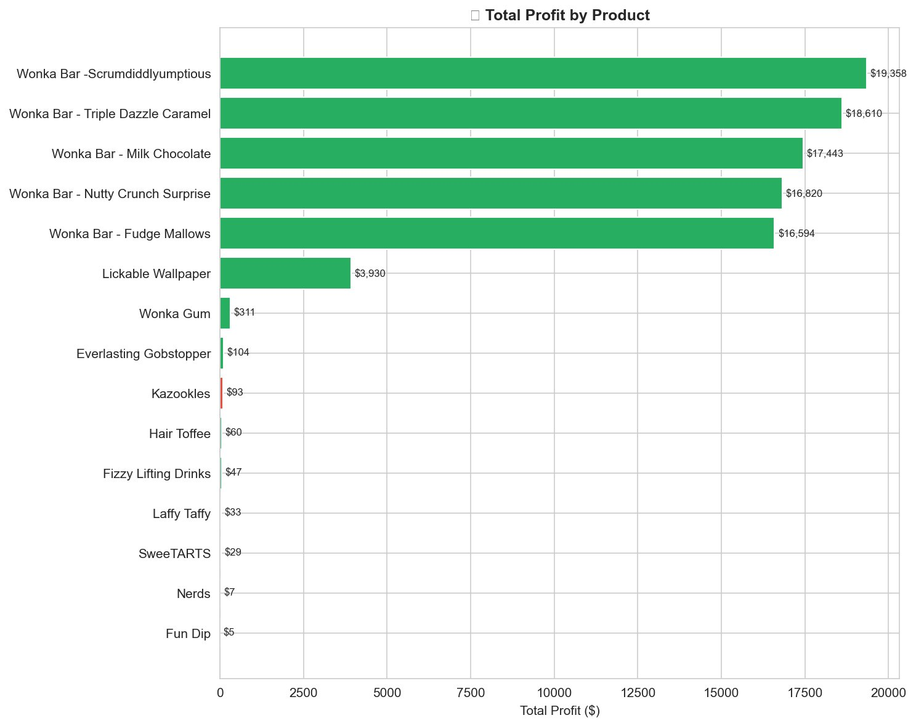
Figure 1: Total Profit by Product — Green = high margin (>50%), Red = low margin (<35%)

5.2 Gross Margin % by Product
Margin analysis reveals a surprising finding — Everlasting Gobstopper leads with ~80% margin despite very low total profit. This is because it sells in low volume. Kazookles has the lowest margin at just ~8%, making it the highest-risk product in the portfolio. All 5 Wonka Bar variants maintain healthy margins between 65-71%.

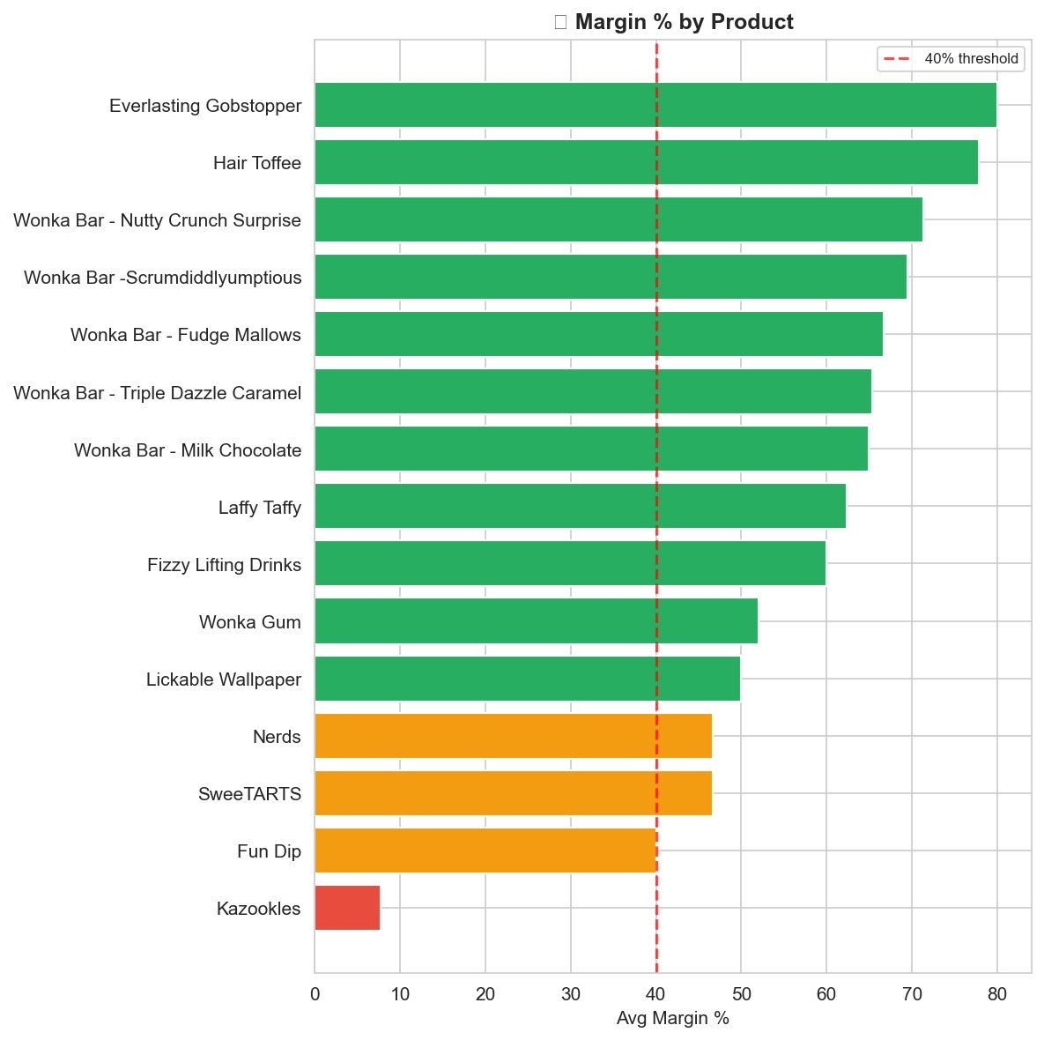
Figure 2: Avg Gross Margin % by Product — Red dashed line = 40% threshold. Products below = margin risk

5.3 Division Performance — Revenue vs Profit
The Chocolate division dominates both revenue and profit, generating over $130K in revenue and ~$89K in profit. The Sugar division shows near-zero revenue and profit in this chart view, which indicates that Sugar products individually generate very low per-order values. The Other division contributes approximately $10K in revenue with ~$4K profit.

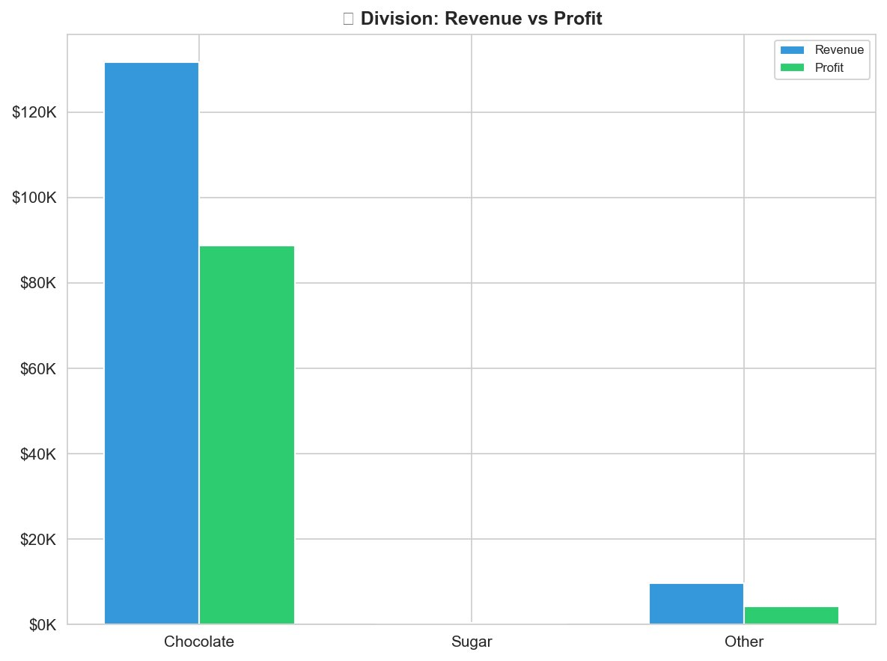
Figure 3: Division: Revenue vs Profit Comparison — Blue = Total Revenue, Green = Total Gross Profit

5.4 Average Margin % by Division
Chocolate leads with ~67% average margin, followed by Sugar at ~58%. The Other division falls below the 40% threshold at ~38%, marking it as the only division with a structural margin risk. This finding recommends an urgent strategic review of the Other division's product pricing and cost structures.

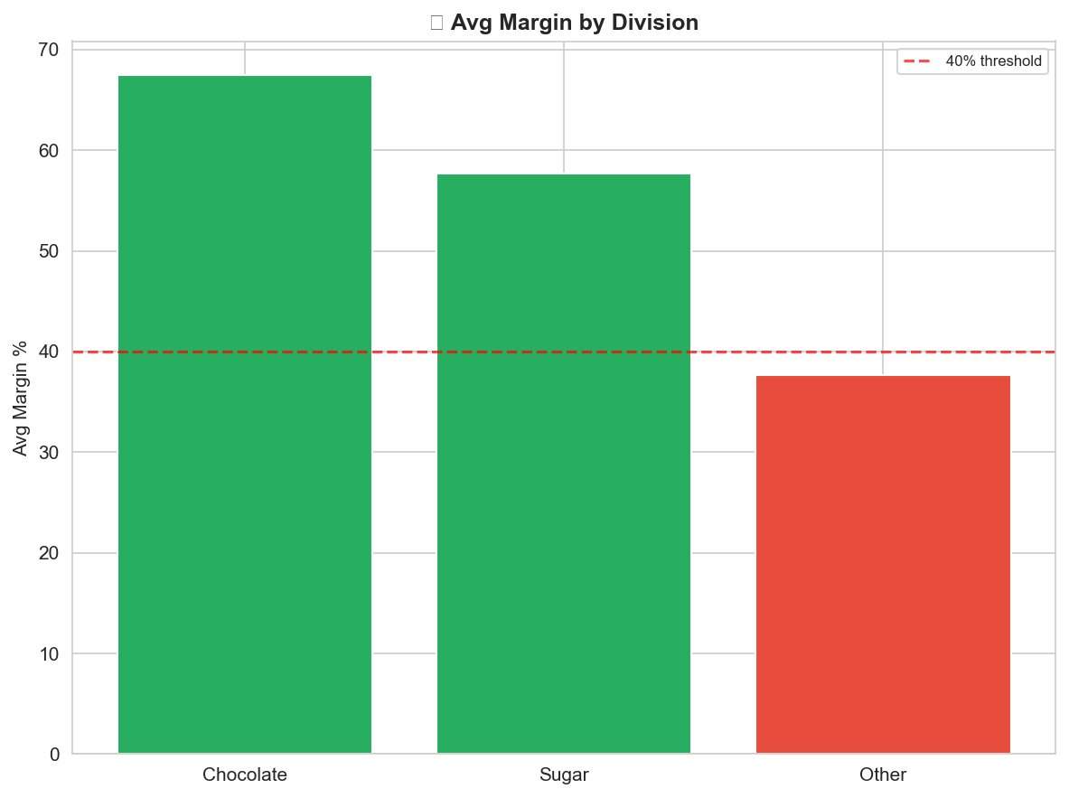
Figure 4: Average Gross Margin % by Division — Red dashed line = 40% threshold. Other division falls below risk threshold

5.5 Pareto Analysis — Profit Concentration
The Pareto chart confirms extreme profit concentration. The top 5 products (all Wonka Bar variants) collectively account for approximately 97% of total profit. The red cumulative line crosses the 80% threshold at just the 4th product, meaning only 4 products out of 15 (27% of portfolio) generate 80% of total business profit. This represents a significant strategic concentration risk.

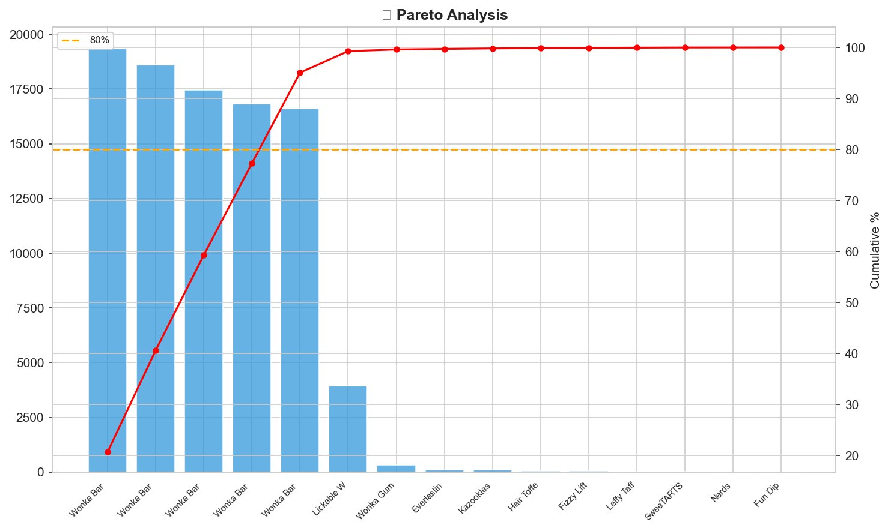
Figure 5: Pareto Analysis — Profit Concentration — Orange dashed = 80% profit threshold. Red line = cumulative profit %

5.6 ML Clustering — K-Means Product Segmentation
K-Means clustering (k=3) automatically segmented all 15 products into three strategically distinct groups based on Total Profit, Avg Margin %, and Avg Profit per Unit. The scatter plot clearly separates the portfolio:

- Stars (Green) — All 5 Wonka Bar variants clustered in the high-profit, high-margin zone ($16K-$19K profit range, 65-71% margin)
- Average (Orange) — Everlasting Gobstopper, Hair Toffee, Lickable Wallpaper — high margin but low profit volume
- Dead Weight (Red) — Sugar division products and Kazookles — low profit with inconsistent margin performance

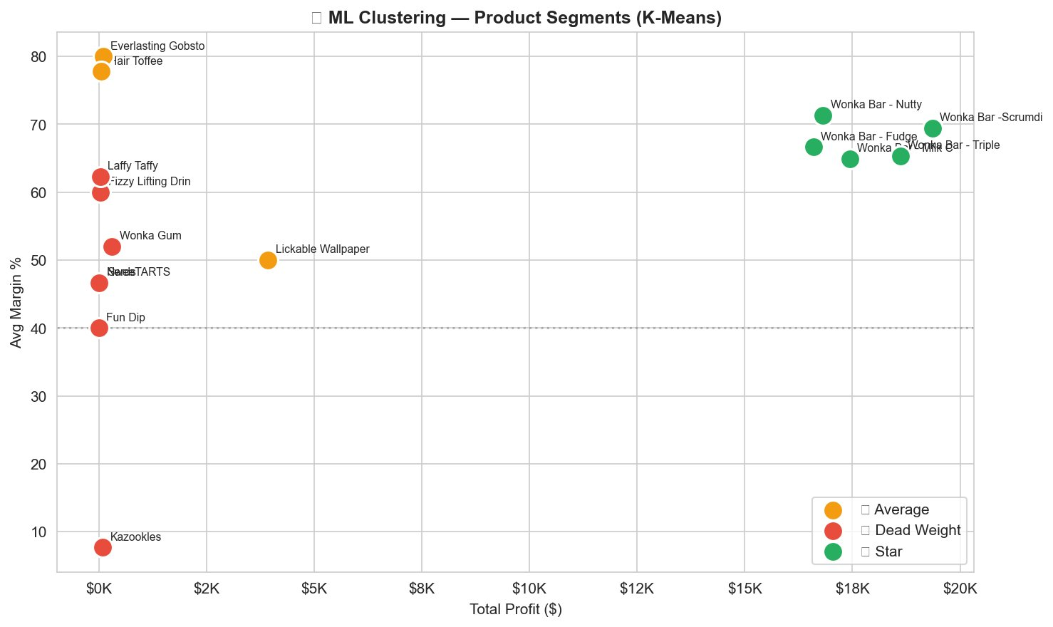
Figure 6: ML Clustering — Product Segments (K-Means, k=3) — Green = Star, Orange = Average, Red = Dead Weight

6. Streamlit Dashboard

6.1 Overview
An interactive, multi-module Streamlit web dashboard was developed to make the analytical findings accessible to both technical and non-technical business stakeholders. The dashboard provides real-time filtering and dynamic chart rendering across five specialized modules.

6.2 Dashboard Modules

Module | Contents
Product Profitability | Margin leaderboard, profit charts, contribution donut, risk flags
Division Performance | Revenue vs profit grouped bars, margin bars, box plots, monthly trends
Cost vs Margin | Cost-sales scatter, product-level scatter, profit per unit, factory analysis
Pareto Analysis | 80/20 chart, concentration metrics, top contributors table
ML Clustering | Scatter plot with segments, cluster breakdown tables, recommendations

6.3 Filter Capabilities

Filter | Function
Division Multi-select | Filter all views to one or more product divisions
Date Range Selector | Restrict analysis to a specific order date period
Margin Threshold Slider | Set a custom margin % below which products are flagged at-risk
Product Search | Filter all charts and tables to a specific product by name

7. Recommendations

7.1 Immediate Actions (0-3 months)
- Reprice Kazookles urgently: At ~8% margin it is the highest-risk product. A minimum 15-20% price increase or cost renegotiation is critical.
- Protect Star products: All 5 Wonka Bar variants should be prioritized for inventory, marketing, and distribution reliability.
- Review Other division: With ~38% avg margin below threshold, all four Other products need immediate pricing review.

7.2 Medium-Term Actions (3-6 months)
- Pareto risk mitigation: Reduce over-dependency on 4 products driving 80% of profit by improving margins of Average cluster products.
- Factory cost benchmarking: Audit The Other Factory's manufacturing cost efficiency against Sugar Shack benchmarks.
- Seasonal promotions: Use monthly trend data to time promotional campaigns during peak demand periods for high-margin products.

7.3 Long-Term Strategic Actions (6-12 months)
- Portfolio rationalization: Formally evaluate Dead Weight cluster products for discontinuation, reinvesting resources into Star product expansion.
- Automated data pipeline: Implement automated monthly data refresh for the Streamlit dashboard enabling ongoing real-time monitoring.
- Divisional restructuring: Consider whether the Other division warrants divestment based on six-month post-repricing performance data.

8. Conclusion
This research project successfully addressed a critical visibility gap in Nassau Candy Distributor's business operations. The analysis revealed that sales volume alone is a fundamentally inadequate measure of product and divisional financial health.

The Pareto analysis confirmed that just 4 products (27% of portfolio) drive 80% of total profit — a structural concentration risk requiring immediate strategic attention. The K-Means Machine Learning Clustering delivered a practical, data-backed product segmentation framework mapping directly to three actionable business strategies: invest and scale (Stars), reprice and optimize (Average), or review for discontinuation (Dead Weight).

The six analytical charts produced — profit ranking, margin comparison, division performance, division margin, pareto concentration, and ML clustering — together provide Nassau Candy's management team with a comprehensive, visual understanding of their product portfolio's true financial health that was previously invisible in raw transactional data.

The Streamlit dashboard developed as part of this project provides an ongoing, interactive analytical tool that eliminates reactive decision-making, enabling management to monitor product profitability continuously against defined business thresholds.

9. Acknowledgements
This project was completed as part of the Machine Learning Internship Program under the guidance and mentorship of Unified Mentor Pvt. Ltd. The structured project brief, real-world industry dataset, and professional mentorship framework provided by Unified Mentor Pvt. Ltd. were instrumental in shaping the analytical rigor and business relevance of this work.

A sincere and heartfelt thank you to the entire team at Unified Mentor Pvt. Ltd. for creating an internship environment that bridges the gap between academic data science education and industry-standard analytical practice. This internship experience has been one of the most impactful professional learning experiences in my data science journey, and I am deeply grateful for the opportunity to work on a project with real business implications and industry-relevant outcomes.

10. Tools & Technologies

Tool / Library | Version | Purpose
Python | 3.10+ | Core programming language
Pandas | 2.x | Data manipulation and aggregation
Scikit-learn | 1.x | K-Means Clustering, StandardScaler
Matplotlib | 3.x | Static chart generation
Seaborn | 0.12+ | Statistical visualization
Plotly | 5.x | Interactive dashboard charts
Streamlit | 1.x | Web application dashboard

End of Research Paper
Nassau Candy Distributor | ML Internship Project | Unified Mentor Pvt. Ltd.

