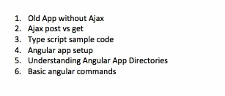

Old Client Server Form –

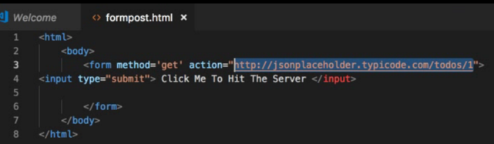

Ajax –

Angular – from cmd - ng new AngularDemo (application name) – To create new application in Angular

* Start application server – ng serve
* Components
* Services

Apache – Web Server – Static data/page

Tomcat – Application server – Dynamic/Db data