# Income and Expense Management System

Done by:

Ratan Dheeraj K. (318506408039)

Niharshini M. (318506408033)

Navya N. (318506408032)

Tarun Teja K. (318506408051)

Snigdha M. (318506408056)

Siva Sandeep Reddy Y. (318506408048)

Contents

1. Abstract
2. Problem Specification
3. SRS Document
   1. Aim
   2. Scope
   3. Objective
   4. Feasibility
   5. Definitions, Acronyms and Abbreviations
   6. Reference
   7. Overview
   8. Overall Description
      1. Product Perspective
      2. Product Function
      3. User Details
      4. Income Details
      5. Expense Details
      6. Budget Details
      7. User Characteristics
      8. General Constrains
      9. Assumptions and Dependencies
      10. Administrators
      11. Users
4. System Design
   1. Specific Requirements
   2. External Interface Requirements
      1. User Interface
      2. Hardware Requirements
      3. Software Requirements
   3. Functional Requirements
      1. Add Users
      2. Assign ID
      3. Administration Module
      4. Performance Requirements
      5. Response Time
      6. Capacity
      7. User Interface
      8. Maintainability
      9. Errors
      10. Availability
   4. Non-Functional Requirements
      1. Security
      2. Login ID
      3. Modification
      4. User Rights
      5. Administrator Rights
5. UML Diagrams
   1. Use Case Diagram
   2. Class Diagram
   3. Object Diagram
   4. Component Diagram
   5. Deployment Diagram
   6. ER Diagram
   7. Sequence Diagram
   8. Collaboration Diagram
   9. Data Flow Diagram Level 0
   10. Data Flow Diagram Level 1
   11. Data Flow Diagram Level 2
   12. State Chart
   13. Activity Diagram
6. Testing Methods
   1. Unit Testing
   2. Integration Testing
   3. System testing
   4. Black box testing
   5. Functional Testing
7. SQL
   1. Data Definition Language
   2. Data Query Language
   3. Data Manipulation Language
   4. Data Control Language
   5. Transaction Control Language
8. User Interface
9. Conclusion

Abstract

In today’s busy and expensive life, we are in a great rush to make money. But at the end of the month, we broke off. As we are unknowingly spending money on little and unwanted things. So, we have come over with the idea to track our earnings. Income and Expense Management System aims to help everyone who are planning to know their expenses and save from it. This is an application which users can execute in their mobile phones or computers and update their daily expenses so that they are well known to their expenses.

Here user can define their own categories for expense type like food, clothing, rent and bills where they have to enter the money that has been spent and also can add some information in additional information to specify the expense. User can also define expense categories. User will be able to see pie chart of expense. Everyone who wants to track their expense can use this application.

Daily expense tracking System will generate report at the end of month/day or year to show Income-Expense Curve. It will let you add the savings amount, which you had saved for some particular Festivals or days like Birthday or Anniversary. This gives the user the complete information about their expenses and as a result the user will get the complete control over their money which will eventually lead to a better life with more savings.

Problem Specification

In existing system if we want to keep a track on our expenses, we need to maintain the Excel sheets, CSV etc. files for the user daily and monthly

expenses. In existing, there is no as such complete solution to keep a track of its daily expenditure easily. To do so a person as to keep a log in a diary or in a computer, also all the calculations need to be done by the user which may sometimes results in errors leading to losses or incorrect track of data.

There is lack of security in this method as anyone can read our work, and this consumes a lot of time and effort. There is a lot of paperwork involved which frustrates people.

The expenses cannot be visualized i.e., by pie charts or by reports, therefore cost cutting and cost management is a tedious task.

Aim

Income and Expense Tracker aims to help everyone who are planning to know their expenses and save from it. This is a web app which users can execute in any device and update their daily expenses and incomes so that they are well known to their expenses. Here user can define their own categories for expense type like food, clothing, rent and bills where they have to enter the money that has been spent and also can add some information in additional information to specify the income and expense. User can also define expense and income categories. User will be able to see pie chart of expense. Although this app is focused on new job holders, interns and teenagers, everyone who wants to track their expense can use this app.

Scope

It may help collecting perfect management in details. In a very short time, the collection will be obvious, simple and sensible. It will help a person to know the management of passed year/month/day perfectly and vividly. It also helps in current all works relative to Income and Expense Management System. It will also reduce cost in paper work and reduces human effort.

Our project aims at automation, i.e., we have tried to computerize various processes of Income and Expense Management System.

* In computer system the person just has to fill the form to save the expense/income details.
* Anyone can use this application.
* It produces reports to get the data about our expenses and incomes.
* It produces pie chats to understand how we are using our money and to take steps in cost cutting.
* It will satisfy the user requirement.
* User can see their budget at any time.
* User can determine the amount of money he currently has.
* It has user friendly User Interface.
* It is scalable.

Objective

Our objective is to provide:

* Friendly user interface so anyone can understand.
* Error free calculations.
* Data encryption so that data is safe.
* Scalable software.
* Easily understand money flow.
* Easily generate reports.
* Help set a budget and money wisely.

Feasibility

The overall scope of the feasibility study was to provide sufficient information to allow a decision to be made as to allow a decision to be made as to whether the online services system project should proceed and so its relative priority in the context of any of the websites providing one or more services.

The feasibility study of this project has undergone through various steps which as described under:

1. Identify the origin of the information at different levels
2. Identify the exception of user from the computerised system
3. Analyse the drawback of existing system

Definitions, Acronyms and Abbreviations

CFD: Context Flow Diagram.

DFD: Data flow diagram.

Java: Platform independent, OOP.

SQL: Structured Query Language.

HTML: Hypertext Markup Language.

SRS: Software Requirements Specification.

Reference

Object-Oriented Software Engineering: Using UML, Patterns and Java, Bernd

Bruegge and Allen H. Dutoit, 2nd Edition, Pearson Education Asia.

Overview

Incomes and Expenses Management System is way to keep track of all our incomes and expenses so that we’ll understand how the money is being used and set a budget to minimize the expenses whenever possible.

Overall Description:

Product Perspective

The Income and Expense Management System gives a procedural approach about managing the income and expenses in our daily life. The user can manage things like income, expenses, budget etc., aspects for managing their expenditures.

Product Function

The data represented in the Income and Expense Management System will perform the major functions:

User Details

It includes details like user name, email id, password, contact number and other required details.

Income Details

It includes details about the total income and the source of income of the user.

Expense Details

It includes details about the aspects of the user's income expenditure.

Budget Details

As already said, the Income and Expense Management System has a track of income and expenditure, it also facilitates budget management. Based on the income and expenses details, the user can manage his budget.

User Characteristics

This software is developed such that the total appearance of the product makes it more user friendly. The user can have access with his unique username and password. General users with basic computer skills can use this software.

General Constraints

Any update regarding the users or any functionality in the website are to be recorded to have updated and accurate values.

Assumptions and Dependencies

This software package is developed using HTML as frontend and PHP as backend.

It is assumed that compatible computers will be available before the system is installed and tested.

It is assumed that the calculations that are done by the Income and Expense Management System are accurate.

Administrators

The administrator will have basic computer training for maintaining the data privacy of the user’s account details and managing the access of the data.

Users

All the users need to have basic knowledge of computers. They will be easily directed to the dashboard as soon as they login and they can manage the data.

System Designs

Specific Requirements

It describes all the details that the software needs to know for designing and developing the project.

External Interface Requirements

User Interface

The user interface is designed in a friendly manner. The user has to give details about the income and expenditure for that he will interact with keyboard and mouse.

Hardware Requirements

1. PC with 250 GB or more Hard disk.
2. PC with 2 GB RAM.
3. PC with Pentium 1 or above.

Software Requirements

1. Any Operating System
2. PHP Server (XAMPP is preferable)
3. Database MySQL
4. IDE Visual Code
5. Google Chrome, Mozilla Firefox, Safari, Edge, Brave etc.,

Functional Requirements

Add Users

The system shall allow administrators to add new users to the system or the users can register themselves.

Assign ID

The system shall allow the administrators to give each user an ID to access his own data and perform actions.

Administration Module

This module enables users to insert, update and delete the user information like updating password etc.

Performance Requirements

The capability of the computer depends on the performance of the software. The software can take any number of inputs provided the database size is large enough.

Response Time

The system should respond in a fraction of seconds after the user input.

Capacity

The system is capable of maintaining a number of users at a time.

User Interface

The user interface screen should respond in a fraction of seconds.

Maintainability

The system shall provide the capability to back up the data in case of loss.

Errors

The system shall keep a log of all errors.

Availability

The system shall be available all the time.

Non-Functional Requirements

Security

The system requires the user to identify using the User ID.

Login ID

Any user who uses the system shall have a unique userId and password.

Modification

Any modification to the database shall be synchronized and done only by the administrator.

User Rights

Users shall only be able to view all the information belonging to their account. The data of a user can’t be accessed or viewed by the other users. The data should be kept unintervealed.

Administrator Rights

Administrator shall be able to view and manage the users, login and logouts, change passwords and update the profile of the users.

**UML Diagrams**

Use Case Diagram

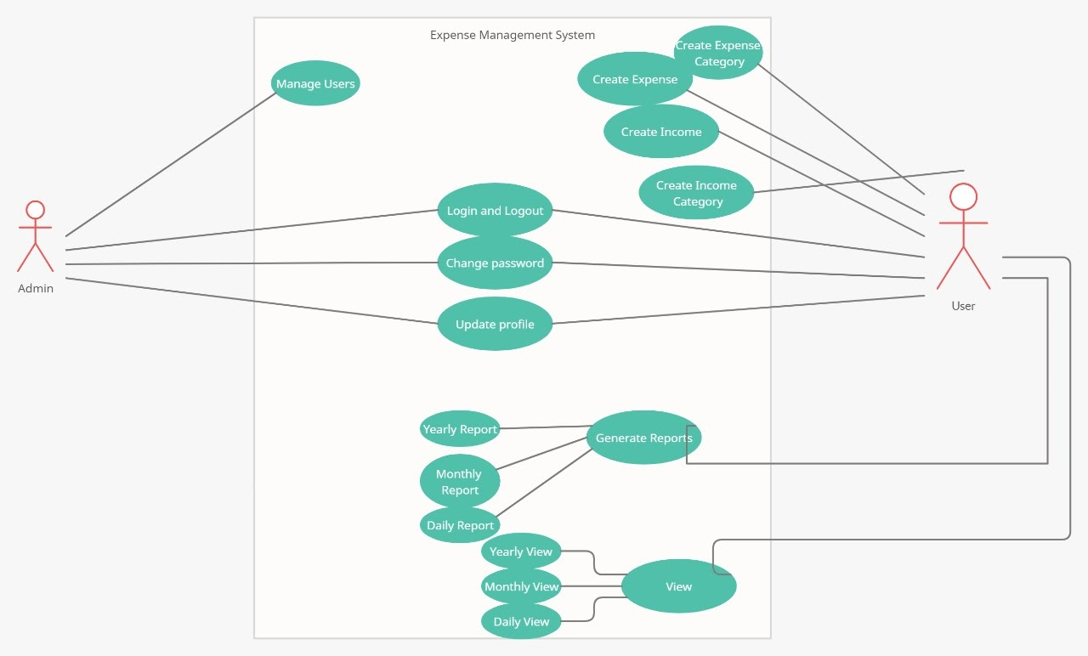

Use Case Diagram Description

The actors of the project “Income and Expense Management System” are admin and users.

There are some common actions to one or more actors.

Login needs to be done by all users and can be viewed by the admins. Updating of details such as email id, phone number, account details can be done by the user and can be viewed by the admin.

Insertion of details like income and expenses should be done only by the user and the admin can’t view it as those details are confidential.

The admin alone is allowed to manage the users. One user can't view or access the details of the other user.

Logout action is common for all the users and it can be viewed by the admin

Class Diagram

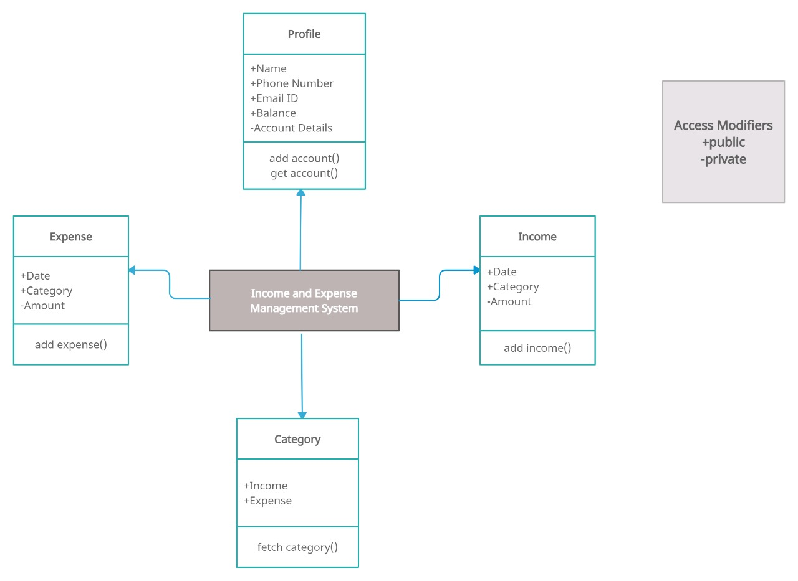

Class Diagram Description

This class diagram is used to represent the project named “Income and Expenses Management Systems''. There are four main classes named Profile, Category, Income, and Expense.

The profile class contains Name, Phone Number, Email ID, Account Details, and Balance. It has methods like get account () and add account ().

The Category class contains two attributes: Income and Expense. It has methods like fetch category ().

The Income class contains attributes Date, Category and Amount. It has methods like add income ().

The Expense class contains attributes Date, Category and Amount. It has methods like add expense ().

Object Diagram

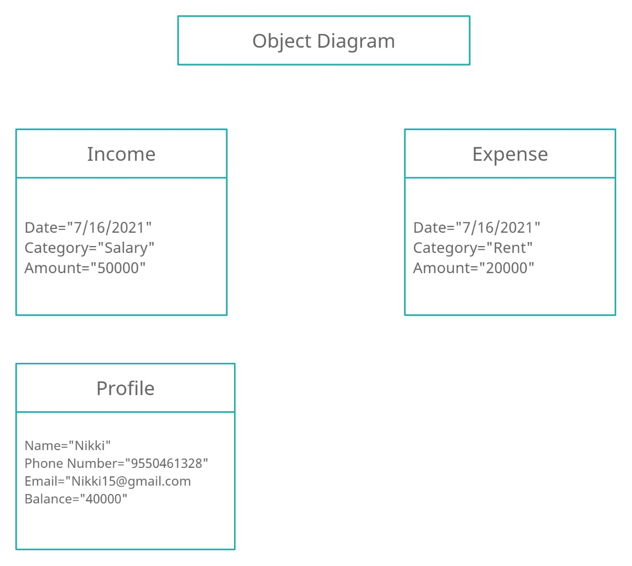

Object Diagram Description

An object diagram represents a specific instance of a class diagram at a certain moment in time. An object diagram focuses on the attributes of a set of objects and how those objects relate to each other. For Instance this diagram shows objects that the class named Profile has an object Nikki and the details of her .Many Objects can be created for a class.

This Diagram shows that the class Income has an object named Salary with an amount of 40000 /-. The class Expense has an object named Rent with an amount 20000/-. Object diagrams can be drawn for any management system with interrelated parts.

Component Diagram

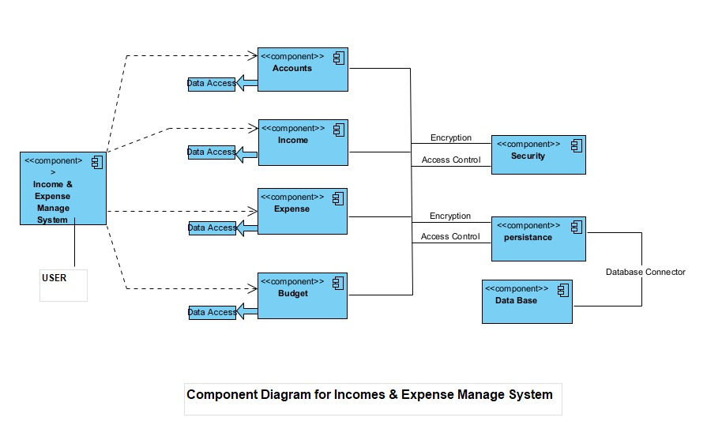

Component Diagram Description

It represents a set of components and their relationships. This diagram consists of classes, interfaces or collaborations. It represents the implementation view of a system. The diagram shows the implementation view of the project "Income and expenses Management System".

This diagram shows components at package level, they are:

Accounts component which manages the users account and their credentials. Income component categories income into different categories by accessing the data of categories and saves the income details in a log. Expenses component categories expenses into different categories by accessing the data of categories and saves the expenses details in a log. Budget component organizes the budget periodically and budget limit given by the user. Security component encrypts and decrypts the data. Database component provides access control to record details into the database and retrieve the data.

Deployment Diagram

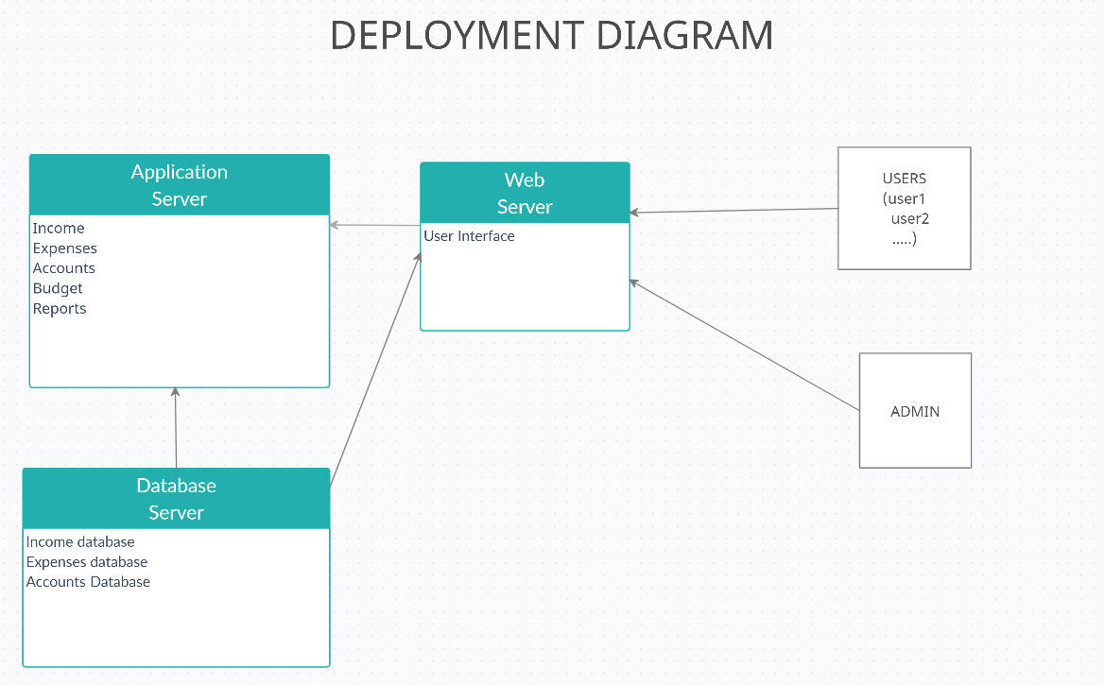

Deployment Diagram Description

It is a set of nodes and their relationships. They are used for visualizing the deployment view of a system. This is generally used by deployment team. The diagram shows the deployment view of the project "Income and expenses Management System".

The application server, web server and database server are called as nodes. The components inside them are called as parts. The webserver consists of user interface with which the users

(user1, user2, ...) and the admin interacts. The webserver sends and receives the data from the database server through the application server.

The database server consists of incomes, expenses and accounts database. The application server consists of income, expenses, accounts, budget and reports.

ER Diagram

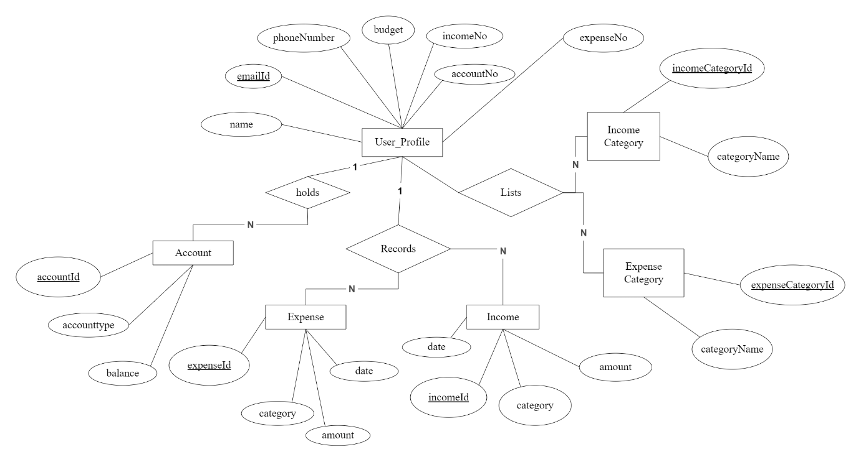

ER Diagram Description

Entity Relationship (ER) diagrams represents real-world entities and the relationships between them. This ER diagram shows the concept of Income and Expense Management System. The rectangle boxes represent entities. The diamonds represent the relationships among entities. The ovals represent attributes. The lines represent the link between the entities and relationships and attributes. The links with N and 1 represent many to one and one to one relationship respectively.

In the following diagram records, hold, and lists are the relationships and the entities are user profile, income category, expense category, account, expense, income. In this diagram each entity has many attributes. For instance in this diagram the user profile entity has attributes like name, phone number, budget, account details and so on. In this way each and every entity has two or more attributes.

Sequence Diagram

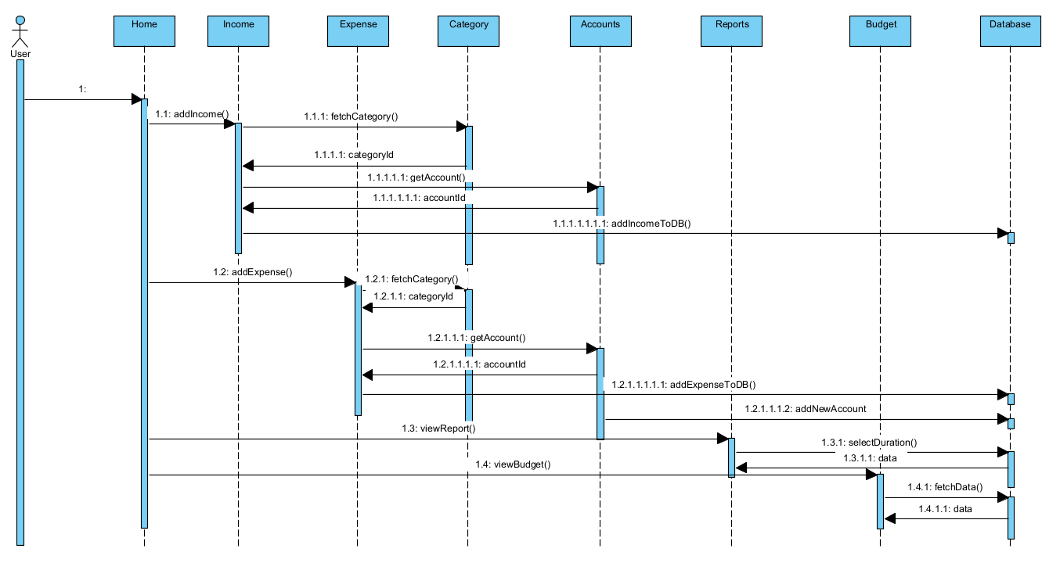

Sequence Diagram Description

The sequence diagram of income and expense manager focusses on the user, after the user is logged in, they’ll be redirected to the home page, from where the user can do anything. If user wants to add income/expense first, the category is fetched if exists otherwise new category will be added, the account id to which the particular transaction should occur will be fetched then the data will be stored in the database.

If user chooses to see the report or budget the data will be fetched from the database. Here the database is connected to all cases as it is the prime source of data.

Collaboration Diagram

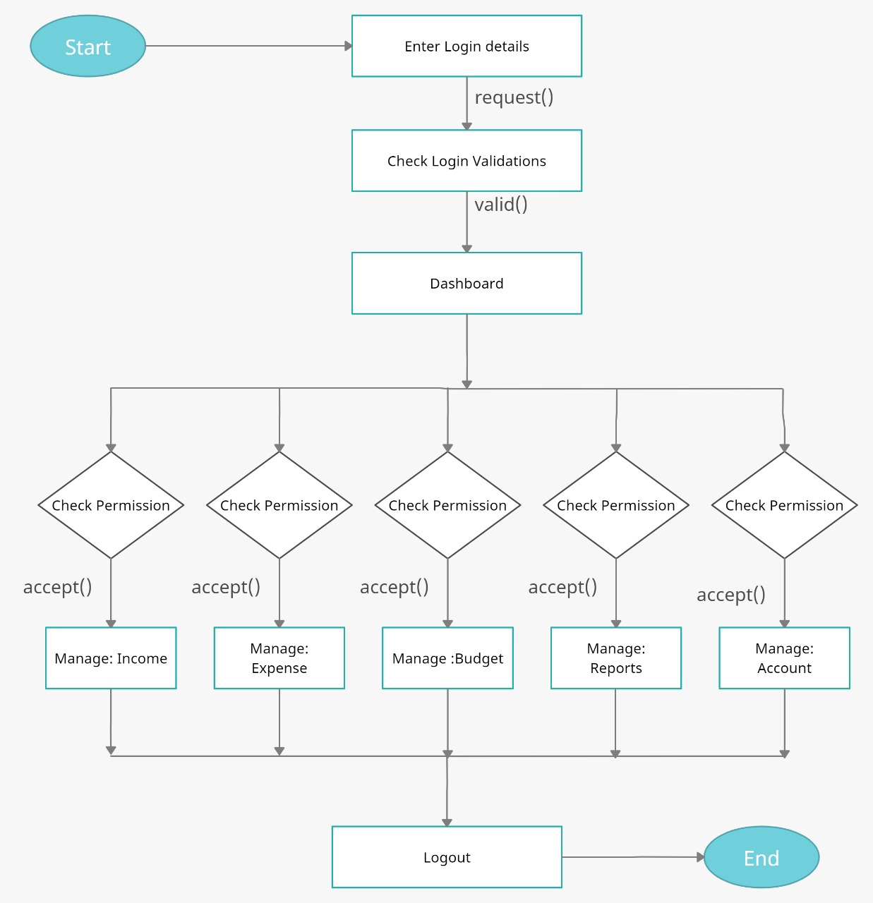

Collaboration Diagram Description

Collaboration diagram represents the structural organization of the Income and Expense Management System and the messages sent/received. The user will first enter the login details and send a request. Then the admin checks the validations of the login details. If the details are true, the user will be directed to the dashboard. From there the user can access the data and perform actions. When the user tries to perform any action, the admin checks the permission and accepts accordingly. Then the user can perform actions like managing income, expenses, budget, reports.

After performing the required operations, the user logs out of the system.

DFD 0

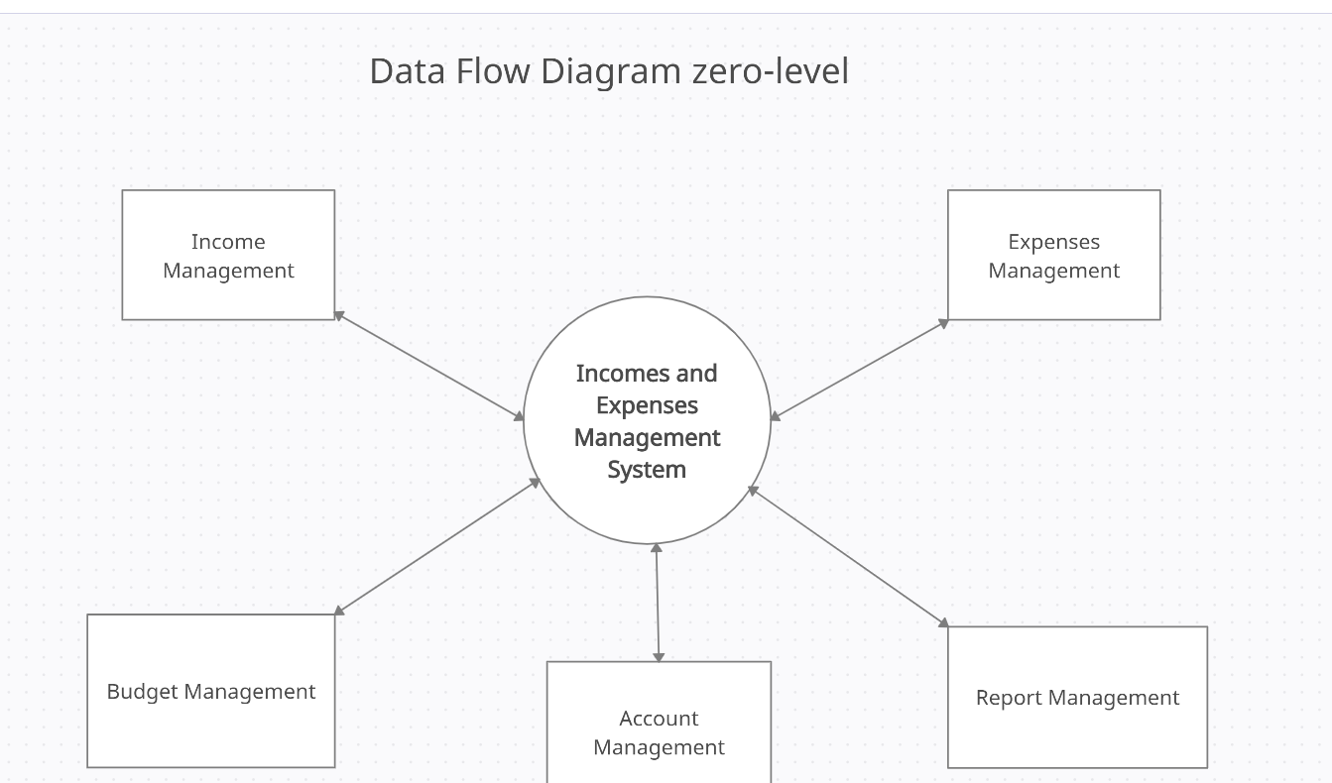

DFD 0 Description

The zero-level data flow diagram is drawn to represent the system of different levels of abstraction. The diagram shows the zero-level data flow diagram of the project "Income and

expenses Management System". The zero-level data flow diagram maintains higher level of abstraction. So, it focuses on the main concepts of the project. The concepts include income

management, expenses management, report management, budget management, account management.

DFD 1

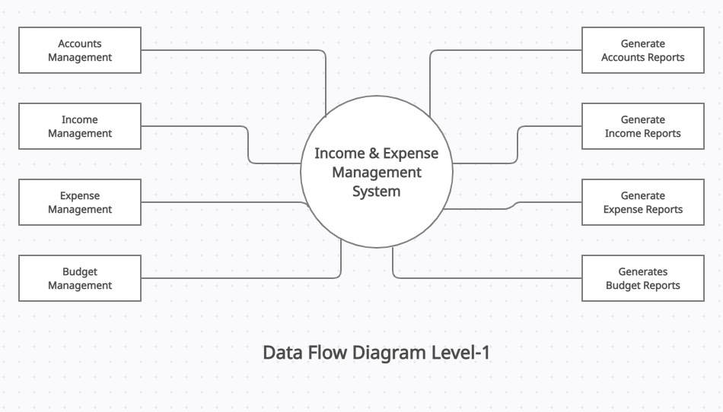

DFD 1 Description

The level-1 data flow diagram of the project "Income and expenses Management System" explains about:

Account management which deals with the user accounts offered by the project. Income management categorizes and manages the income from the user. Expenses management records and categorizes the expenses spent by the users. Budget management deals with the budget set by the user. The reports management system generates reports for the related categories.

DFD 2

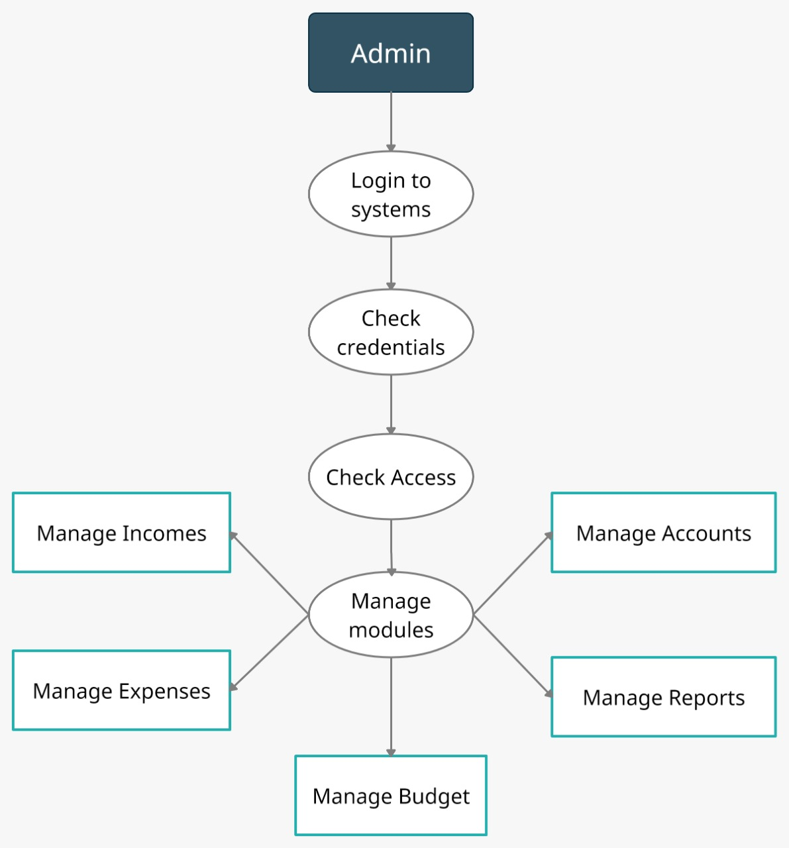

DFD 2 Description

Level-2 DFD of the project “Income and Expense Management System” explains:

The user enters into the system after the credentials have been verified. If the credentials are not verified the user can’t enter into the system.

After entering into the system, the admin checks the access of the user i.e., which account can be managed by the user etc. and gives permission accordingly to access and manage the data. The actions performed by the person are in the form of modules accessible to the user.

It includes managing accounts, incomes, expenses, budget and account.

State Chart

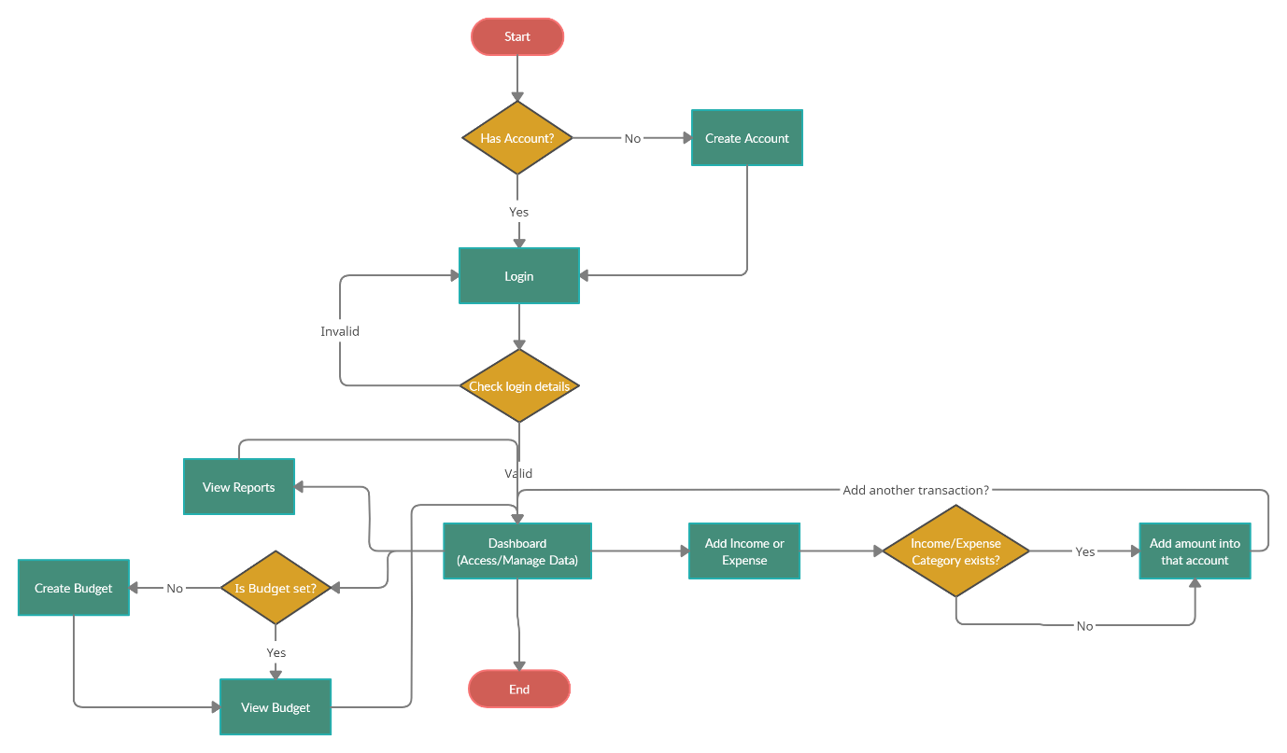

State Chart Description

The state machine diagram or State chart shows the order of states undergone by an object within the “Income and Expenses Management System”. Firstly, to access the data or manage data the user must login to the Income and Expenses Management System, if the user has an account, then he enters his login credentials. If it is validated, then he can access the data. If the user doesn’t have an account, then he must create an account by clicking the “Signup” button.

After creating the account, the user must login to access the data. Once the user is logged in, there are several states which the user can go like add income or expense, view reports or view budget. If user wants to add income/expense the system checks if the category exists, if yes it will add amount into that category else the system will create a category to add money into that. If user wishes to check their budget the system the system will display if budget exists else it will prompt the user to create a budget.

Activity Diagram

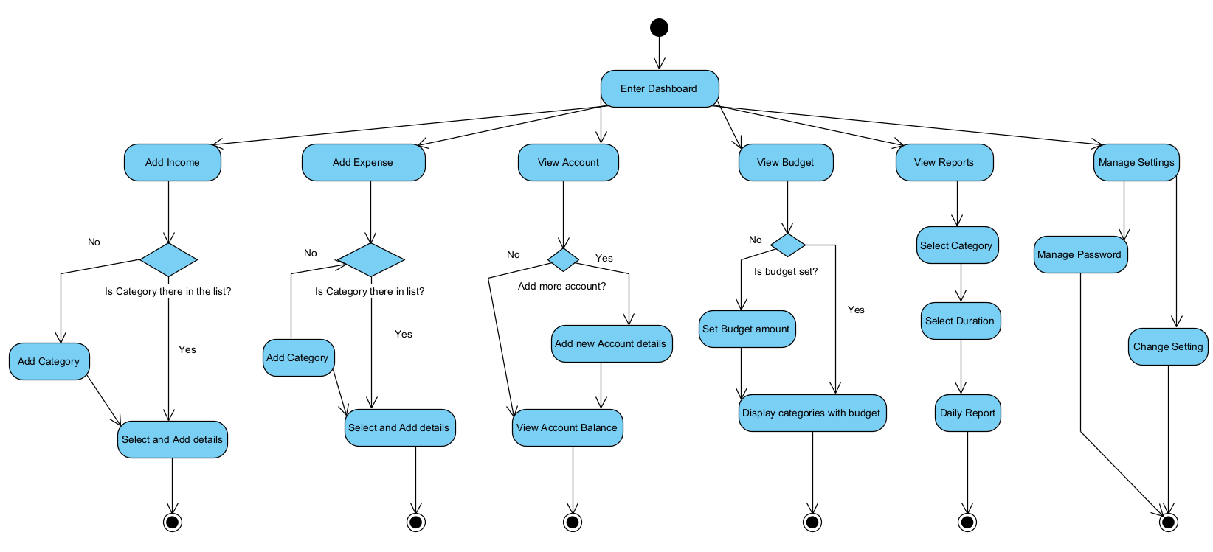

Activity Diagram Description

Activity diagram is used to represent the activities performed by the Income and Expense management system. There are various activities like you can manage the account settings and view it and manage the budget and reports, and manage incomes and expenses.

You can first create your profile and edit the profile when required. Viewing the daily reports of the income and expense activities can be performed. Limiting of Budget can be done by setting the specific amount of budget and change it.

Activity like managing income can also be performed. You can add the income amount and view and modify when required. In the same way managing expenses can also be performed. Add the Expense with the amount and view and modify when required

Testing Methods

**1) Unit testing:** White-box testing is done during unit testing to ensure that the code is working as

intended, before any integration happens with previously tested code. White-box testing during unit

testing catches any defects early on and aids in any defects that happen later on after the code is

integrated with the rest of the application and therefore prevents any type of errors later on.

**2) Integration testing:** White-box testing at this level are written to test the interactions of each

interface with each other. The Unit level testing made sure that each code was tested and working

accordingly in an isolated environment and integration examines the correctness of the behaviour in

an open environment through the use of white-box testing for any interactions of interfaces that are

known to the programmer.

**3) System testing:** It ensures that the entire integrated software system meets requirements. It tests configuration to ensure known and predictable result.

**Black-Box Testing**

Black-box testing is a method of software testing that examines the functionality of an application without peering into its internal structures or workings. This method of test can be applied virtually

to every level of software testing: unit, integration, system and acceptance. It typically comprises most if not all higher-level testing, but can also dominate unit testing as well.

**Functional Testing**

It is a testing technique that is used to test the features/ functionality of the system or software should cover all the scenarios including failure paths and boundary cases.

SQL

Structured Query Language or SQL is the database language by the use of which we can perform certain operations on existing database.

1. DDL
2. DQL
3. DML
4. DCL
5. TCL

**(I)Data Definition Language:**

It consists of the SQL commands that can be used to define the database schema. It simply deals with description of the database.

* Create
* Drop
* Truncate
* Alter

**(II) Data Query Language:**

DQL statements are used for performing queries on the data within schema objects the purpose of DQL command is to get some schema relation based on the query passed to it.

* Select

**(III)Data Manipulation Language:**

It deals with the manipulation of data present in the database belong to DML.

* Insert
* Update
* Delete

**(IV)Data Control Language:**

DCL such as Grant, Revoke which mainly deals with the rights, permissions.

* Grant
* Revoke

**(V)Transaction Control Language:**

They deal with the transaction in the database.

* Begin transaction
* Set transaction
* Commit

**User Interface:**

Login Screen

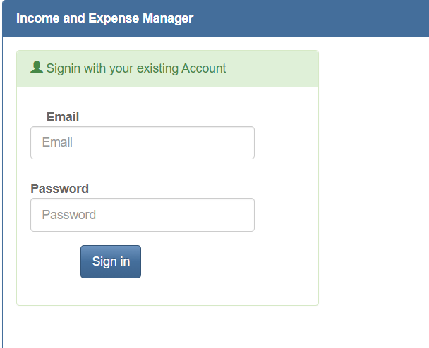

Sign-up page

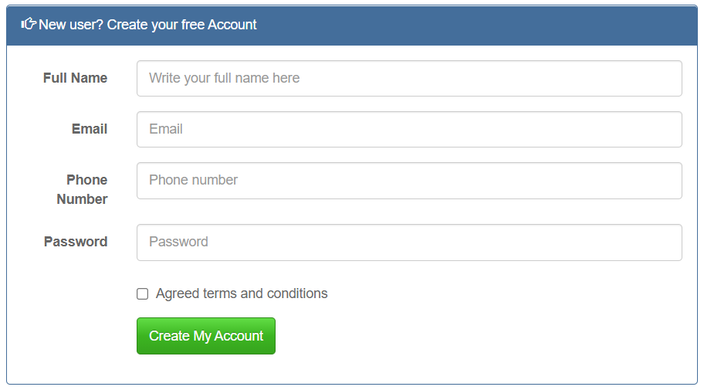

Dashboard

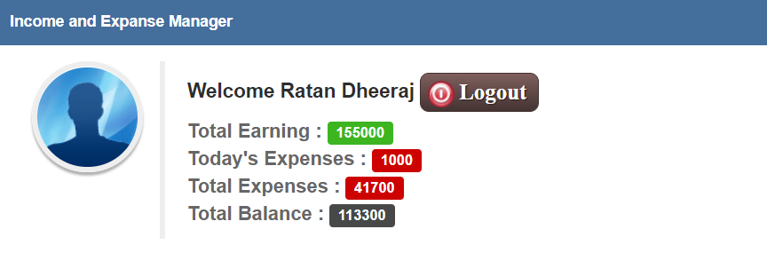

Add Income or Expense

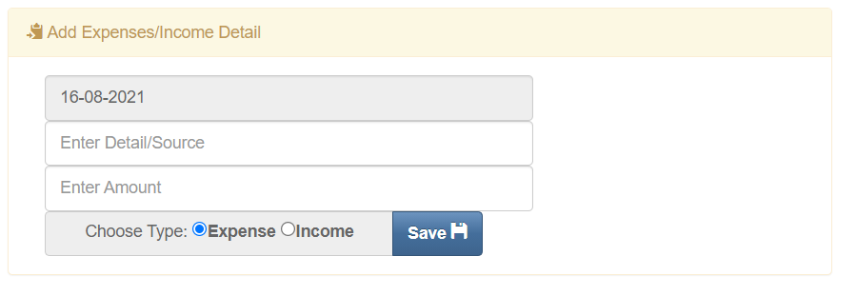

Generate Report

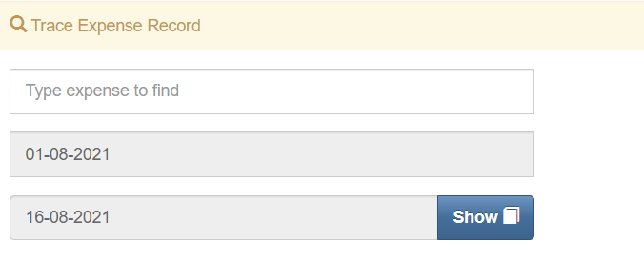

Income Report

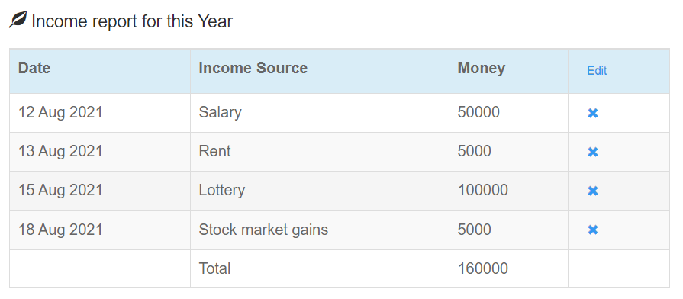

Expenses Report

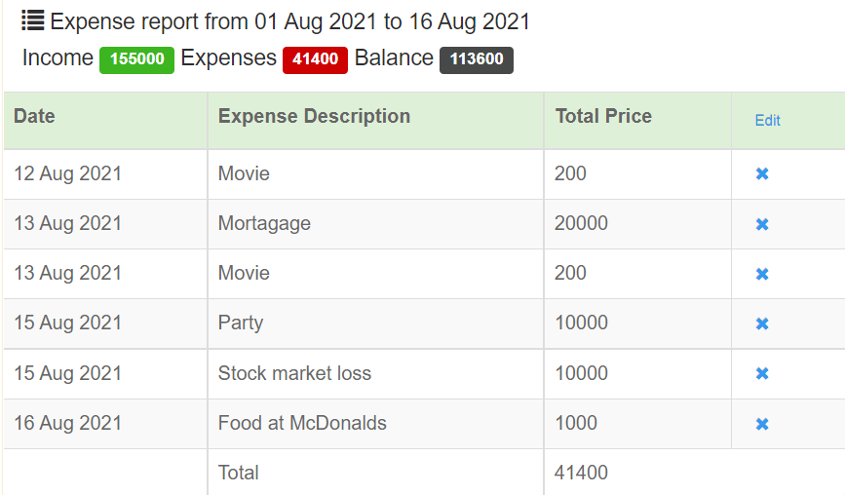

Conclusion

After making this application we assure that this application will help its users to manage the cost of their daily expenditure. It will guide them and aware them about their daily expenses. It will prove to be helpful for the people who are frustrated with their daily budget management, irritated because of amount of expenses and wishes to manage money and to preserve the record of their daily cost which may be useful to change their way of spending money. In short, this application will help its users to overcome the wastage of money.