Overview :

1. Implementation of S language (created by John Chambers)
2. Developed by Ross Ihaka and Robert Gentleman
3. Developed as a free software environment for teaching
4. Maintained by R development core team
5. Statstical software package
6. Comparable to commercial packages such as SAS,SPSS
7. Free Intercative programming language and environment
8. Used in various applications

**Time Line:**

|  |  |  |  |  |  |  |  |  |  |
| --- | --- | --- | --- | --- | --- | --- | --- | --- | --- |
| **Early 1990s** |  | **1997** |  | **2000** |  | **2004** |  | **2013** |  |
| **R Development Started** |  | **Alpha version** |  | **Version 1.0** |  | **Version 2.0** |  | **Version 3.0** |  |

Why R:

1. Free and open source
2. Run on windows/Mac/Linux
3. Great extensibility
4. Active community
5. Integration with other language and packages

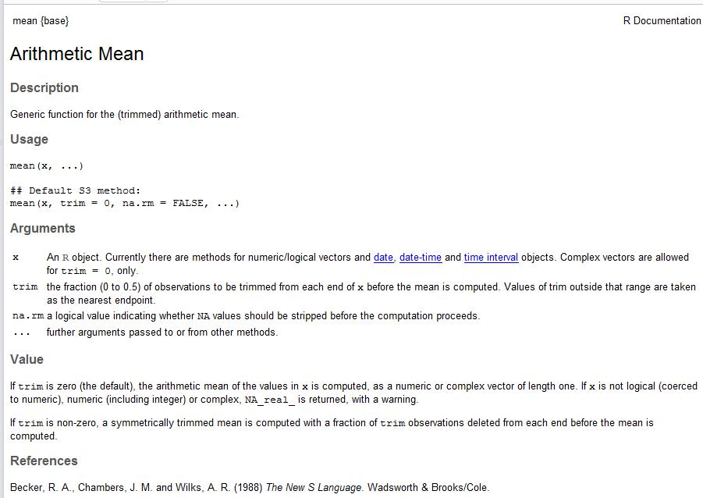

Help command:

Search local R documentation.

* Description
* Usage
* Arguments
* Value
* References
* Examples

Syntax:

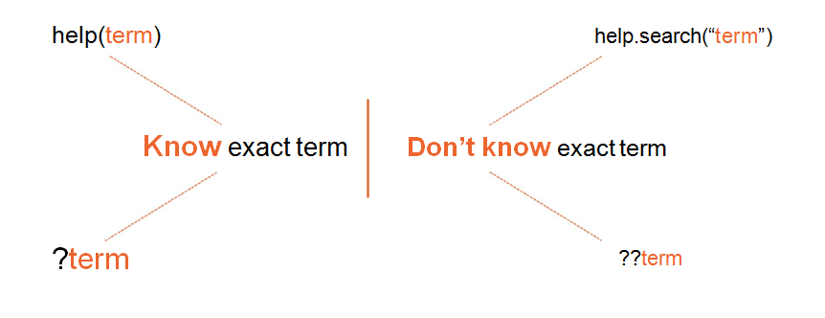

If you know the exact term to search:

Help(term)

?term

If you don’t know the exact term to search :

Help.search(“term”)

??term

Demo Command:

* See demonstrations of certain topic
* Sample usage with dummy data
* 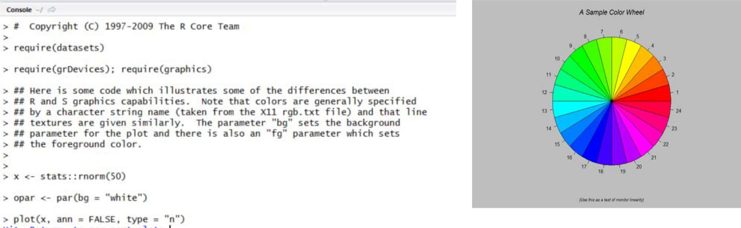Code and related items.

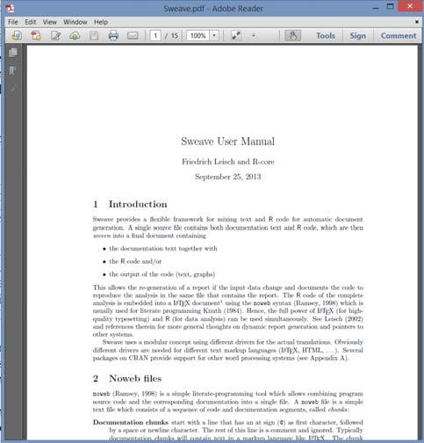

Vignette:

* Short to mid size documents
* cover part or all functionalities of a package
* Typically available in PDF format
* Brief Introduction, Background Information,

Usage, Results, References

Data structure in R:

* Vector
* Matrix
* list
* data frame

Vector :

vector is the collection of elements.

v1=c(1,5,10) 🡸 This is how you can declare a vector

Vector can have only one data type.

v2=c(1,2,’A’) 🡺 It will throw warning and will convert integers to char.

v3= c(1,2,A) 🡺 It will throw an error as A is not within quotes.

Indexing of vector:

Indexing in R starts with 1.

|  |  |  |  |  |  |  |  |  |  |
| --- | --- | --- | --- | --- | --- | --- | --- | --- | --- |
| v4 = | c | (56, | 78, | 90, | 87, | 45, | 13, | 26, | 76) |
| Index 🡺 |  | **1** | **2** | **3** | **4** | **5** | **6** | **7** | **8** |
|  |  |  |  |  |  |  |  |  |  |

|  |
| --- |
| > v2=c(45,67,89,100,'A','B',78) # declaring a vector V2  > v2  [1] "45" "67" "89" "100" "A" "B" "78"  > v2[2]  [1] "67"  > v2[7]  [1] "78"  > v2[-5]  [1] "45" "67" "89" "100" "B" "78"  > v2[1:5]  [1] "45" "67" "89" "100" "A"  > v2[v2=='A']  [1] "A"  > v3=v1[v1>2]  > v3  [1] 4 5 6  > v2[c(2,3,4)]  [1] "67" "89" "100"  > v2[2,3] # error  Error in v2[2, 3] : incorrect number of dimensions  > v1[v1>3 & v1<6]  [1] 4 5 |
|  |
| |  | | --- | | > | |