Basic Networking from Pluralsight :

Data Networking :

* data networking is transforming information.
* A system of hardware , software and protocols used to move information from one device to another.

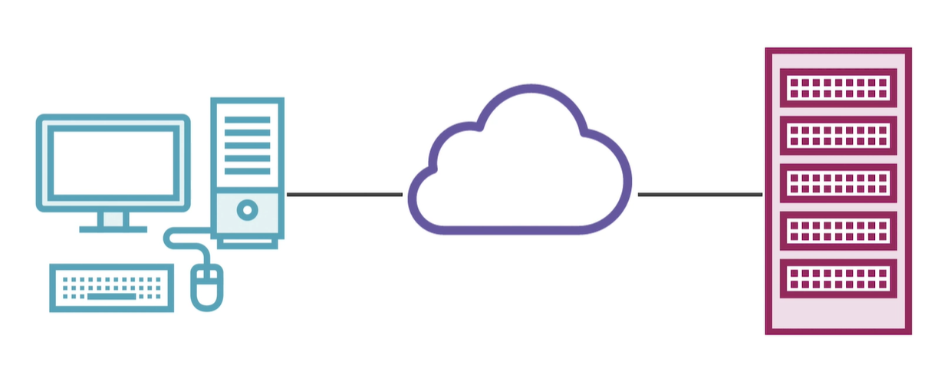

Communication process :

Its a constant process of transmitting message from from one type of signal to another type of signal without loosing the data.

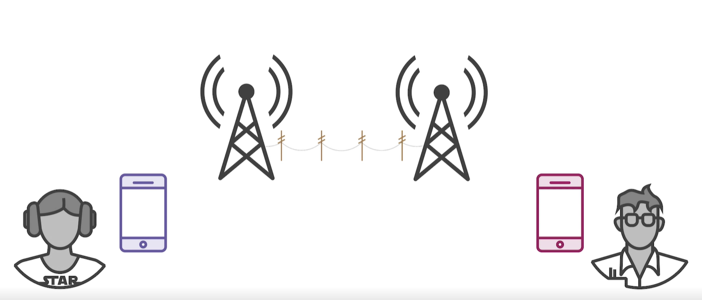

Proxies

SSL

Load balancers

LDAP

SSL :

* SSL is stands for secure sockets layer.
* SSL is the standard security technology for establishing an encrypted link between a web server and a browser.
* This link ensures that all data passed between the web server and the browser remains private.
* HTTP uses port 40 by default. HTTPS use port 443 by default.

Proxies:

* Proxies are of two types
* - Forward proxy is normally known as proxy
* - Reverse proxy

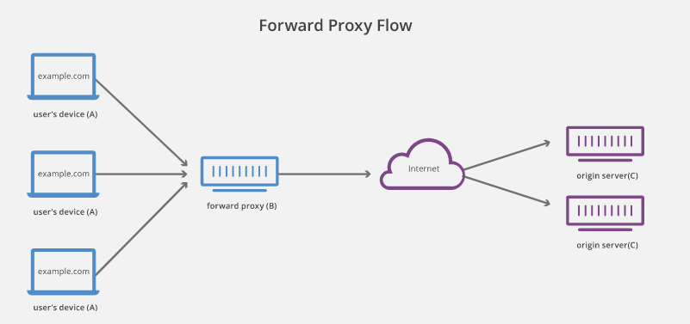

* A forward proxy, often called a proxy, proxy server, or web proxy. It is a server that sits in front of a group of client machines.
* The Proxy server intercepts requests received from user/client machines and communicate with web servers.
  + To block access to certain contents
  + To protect users data
  + To avoid state or institutional browsing restrictions.

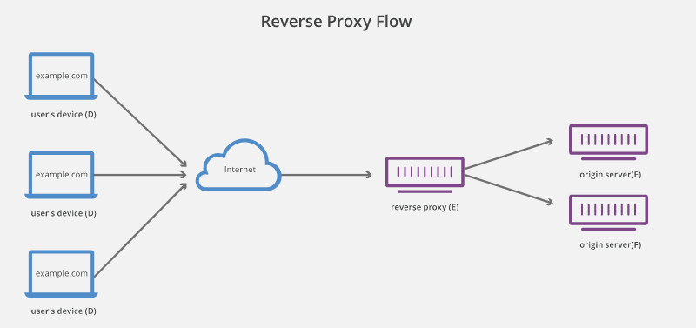

* Reverse proxy intercepts the communication from clients to web server.
* Advantages of reverse proxy
  + Load balancing
  + Protection from attack
  + Global server loading balance (GSLB)
  + Caching
  + SSL encryption

Load Balancing :

Handling huge traffic is difficult for a single origin server. A reverse proxy can provide a load balancing solution which will distribute the incoming traffic evenly among the different origin servers to prevent any single server getting over loaded.

Global Server Load Balancing (GSLB) :

In this form of load balancing, a website can be distributed on several servers around the globe and the reverse proxy will send clients to the server that’s geographically close to them. This decreases the distances that requests and responses need to travel, minimizing load times.

DIFFERENT TOPIC \*\*\*\*\*\*\*\*\*\*\*\*\*\*\*\*\*\*\*\*\*\*\*\*\*\*\*\*

OSI MODEL 🡺

* OSI model stands for open systems Interconnect.
* model developed in 1970's
* it gives a place to categorize each of these protocols as well as give the exact order that those protocols need to be processed in.

Physical Layer 🡺

* In the below example, the different cables present in the system that we use for data communications.
* Though cables are simple wires, they are of different types and do different set of tasks. Each component is connected to a different set of cables.
* Each cable follow set of rules/protocols, however they don’t have any specific electronic device in it.
* different cables are fiber optics, coax,twisted,wireless.
* all of these cables that we use here are part of physical layer of OSI model for data communications.

