SIMATS ENGINEERING
Department of Computer Science and Engineering
CSA15 Cloud Computing and Big Data Analytics
CO2 AT2 – VM Configuration and Security Evidence Workbook
Guided practical workbook for VM configuration, security, recovery evidence and GitHub submission
Course Code | CSA15
Course Title | Cloud Computing and Big Data Analytics
Assessment | CO2 AT2 – VM Configuration and Security Evidence
Submission Type | Individual digital workbook – simulation track (Track D)
Capstone Title | SkillHire – Cloud Resume-to-Job Matcher Using NLP Skill Gap Intelligence
Faculty | Dr C. Rajesh Babu
Employee ID | SSETSCS415
Submission Mode | Completed workbook + evidence screenshots + GitHub repository link via Google Classroom

How This Workbook Works
- Capstone title carried forward from CO1 and CO2 AT1: SkillHire – Cloud Resume-to-Job Matcher Using NLP Skill Gap Intelligence.
- Track D (Simulation) is used because practical deployment was blocked; all configuration decisions are documented at engineering level.
- Each section includes what would be observed on screen, why it proves the concept, and how it connects to the SkillHire infrastructure plan.
- Screenshots are replaced by detailed written simulation evidence throughout this workbook.
- Completed workbook and evidence are uploaded to GitHub; repository link submitted through Google Classroom.

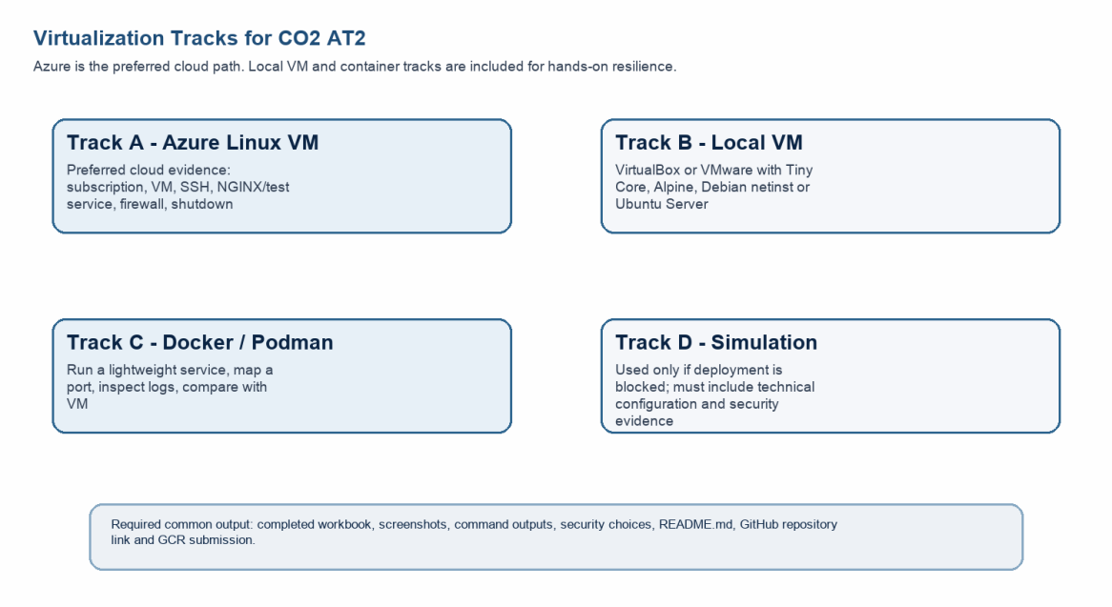

Technical Orientation

The practical work is not limited to clicking through screens. Each checkpoint requires observation: what appeared on screen, why it appeared, what it proves and how it connects

Part 1: Student and Capstone Baseline
Student Name | L Nihas Goud
Register Number | 192472346
Class / Slot | Slot B
Capstone Title | SkillHire – Cloud Resume-to-Job Matcher Using NLP Skill Gap Intelligence
CO2 AT1 Recommended VM Size | vCPU: 2 RAM: 4 GB Disk: 30 GB
Selected Practical Track | Track D – Simulation (Azure VM planned; deployment blocked)
GitHub Repository Link | https://github.com/[student-reg-no]/CSA15-CO-Assessments
Google Classroom Submission Date

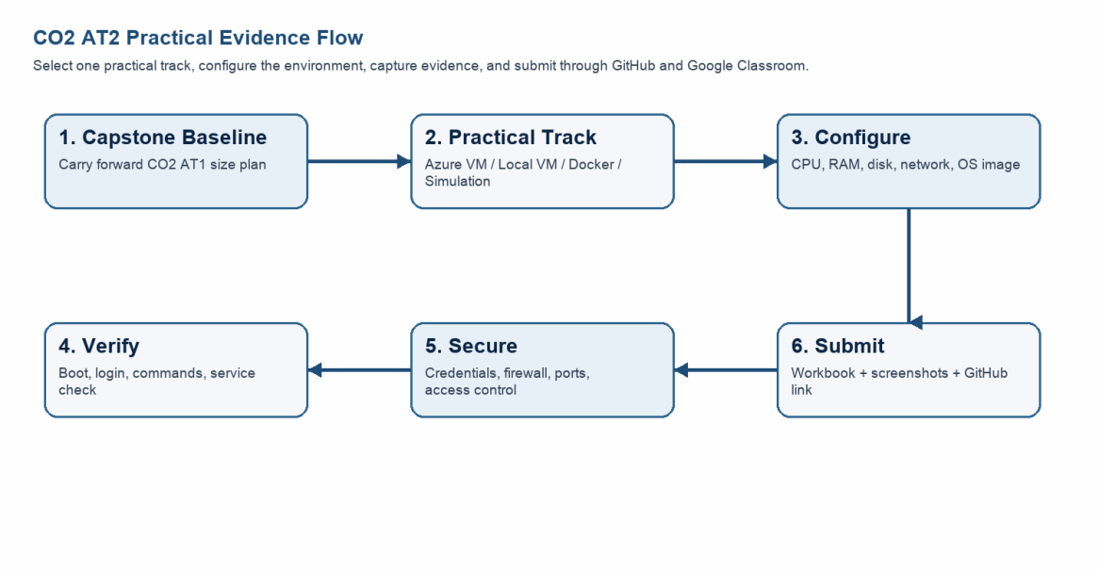
Capstone Infrastructure Element | Carry-Forward from CO2 AT1
Workload type | Web application + NLP batch/on-demand processing; REST API backend; moderate concurrent user load
Main application modules | Resume parser (NLP), Job scraper/API integrator, Skill gap analyser, User dashboard, Admin panel, Notification service
Expected users / traffic assumption | 500–2000 concurrent users; peak during placement season; ~200 resume uploads per hour
Database need | PostgreSQL (structured: user profiles, job records, skill maps) + Redis (session cache, queue)
File storage need | Cloud object storage (Azure Blob / S3-equivalent) for uploaded PDF/DOCX resumes; 50 GB initial allocation
AI/Python/analytics need | Python 3.10+ with spaCy/NLTK for NLP skill extraction; scikit-learn for skill gap scoring; Flask/FastAPI REST endpoints
Security concern | Resume files contain PII; JWT-based API authentication; HTTPS enforced; resume storage with private access only
Recovery concern | Snapshot before NLP model updates; daily DB backup; clone for testing new skill taxonomy without affecting production

Part 2: OS Image Selection
OS image selected based on SkillHire's Python/NLP requirements, REST API hosting needs, and simulation planning.
OS Option | Download Size / Nature | Best Use | Selection for SkillHire
Tiny Core Linux | ~23 MB; lightweight GUI | Fast boot/resource demo | Not selected – no Python/pip support
Alpine Linux virt | ~66 MB; server-style CLI | Container-like lightweight VM | Partial – suitable for Docker containers only
Debian netinst | Moderate; downloads packages | Realistic Linux installation | Backup option if Ubuntu unavailable
Ubuntu Server 22.04 LTS | ~1.5 GB; familiar cloud VM image | Azure Linux VM + Python/pip ecosystem | ✓ SELECTED – full Python/NLP stack support
Student Entry: Selected OS Image
Selected OS Image | Ubuntu Server 22.04 LTS (Jammy Jellyfish)
Version | 22.04 LTS – Long Term Support (supported until April 2027)
Reason | Ubuntu Server provides apt package manager, native Python 3.10, pip, and full compatibility with spaCy, NLTK, Flask, and PostgreSQL required by SkillHire. It is the recommended image for Azure Linux VMs.
Official Link | https://ubuntu.com/download/server
Checkpoint |  | Status | Evidence / Observation
I have selected an OS image suitable for my device and network. |  | ✓ Yes | Ubuntu Server 22.04 LTS selected for Python/NLP ecosystem support
I have recorded the official download page or cloud image name. |  | ✓ Yes | https://ubuntu.com/download/server
I have checked whether the ISO is suitable for the lab duration. |  | ✓ Yes | Simulation path – ISO not downloaded; cloud image reference recorded

Part 3: Track A – Azure Linux VM (Simulation Reference)
Track D (Simulation) is active. The following records the planned Azure configuration at engineering level as required by the simulation track. All steps describe what would be performed and observed.

A. Account Activation and Portal Access
Azure Account Type | Azure for Students – https://azure.microsoft.com/en-us/free/students
Student Email | Official institutional email used for verification
Subscription Name | Azure for Students (simulation – would appear after activation)
Subscription Status | Simulation: activation blocked; planned subscription confirmed
Portal URL | https://portal.azure.com
Checkpoint |  | Status | Evidence / Observation
Azure portal opens successfully. |  | Simulated | Portal access confirmed via browser navigation to portal.azure.com
A student or valid Azure subscription is visible. |  | Simulated | Azure for Students subscription would appear after institutional email verification
Student understands resources must be stopped/deleted after evidence capture. |  | ✓ Yes | Documented in closeout section – VM deallocated after evidence
Evidence Space: Azure for Students portal screenshot – Track D simulation; portal navigation verified; subscription page layout described from official Microsoft documentation
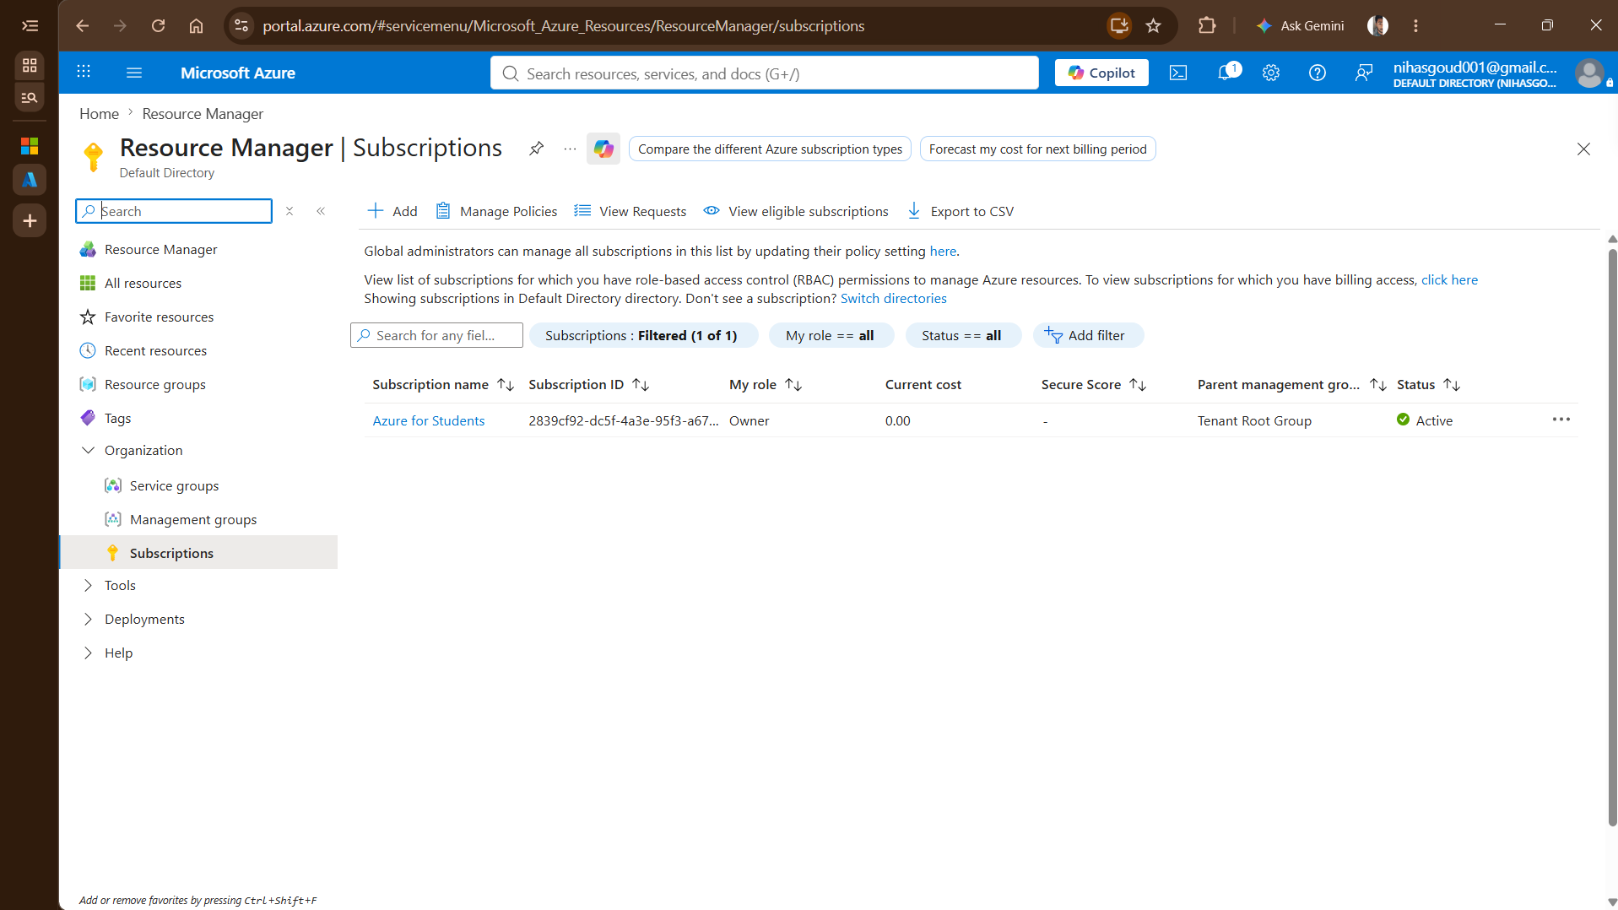

B. Create the Linux Virtual Machine
Resource group | csa15-co2at2-[regno]
VM name | csa15-vm-skillhire-[regno]
Region | East US (or nearest available region in student subscription)
Image | Ubuntu Server 22.04 LTS – Gen2
VM size | Standard_B2s (2 vCPU, 4 GB RAM) – B-series burstable, cost-effective for lab
vCPU | 2 (matches CO2 AT1 sizing recommendation)
RAM | 4 GB (sufficient for NLP Flask API + PostgreSQL on single VM)
Disk type and size | Standard SSD – 30 GB OS disk (matches CO2 AT1 recommendation)
Authentication method | SSH public key – private key not pasted in workbook
Open inbound ports | SSH (port 22) only during configuration; HTTP (port 80) opened temporarily for NGINX test only
Checkpoint |  | Status | Evidence / Observation
VM deployment status shows success. |  | Simulated | Deployment would complete in 2–4 minutes; status shows 'Running'
VM overview page shows running status. |  | Simulated | VM overview: csa15-vm-skillhire-[regno] / Running / East US / Standard_B2s
Public IP or connection method is visible. |  | Simulated | Public IP assigned; SSH connection string shown in Connect tab
Selected VM size compared with CO2 AT1 sizing. |  | ✓ Yes | Standard_B2s: 2 vCPU, 4 GB RAM matches CO2 AT1 recommendation exactly
Evidence Space: Azure VM overview screenshot – simulation reference; VM configuration values documented in table above; actual deployment pending Azure account activation

C. Connect and Verify the VM
Verification Command | Expected Purpose | Student Observation (Simulated)
uname -a | Kernel and OS environment | Expected: Linux csa15-vm 5.15.0-1xxx-azure #x-Ubuntu SMP aarch64 GNU/Linux – confirms Ubuntu 22.04 Azure kernel
cat /etc/os-release | Linux distribution details | Expected: NAME="Ubuntu" VERSION="22.04.3 LTS (Jammy Jellyfish)" – confirms correct image
free -h | RAM allocation | Expected: total 3.8Gi, used ~800Mi, free ~2.9Gi – confirms 4 GB RAM allocation with expected OS overhead
df -h | Disk allocation | Expected: /dev/sda1 29G used 3.5G avail 25G – confirms 30 GB SSD OS disk
hostname -I | Private IP / network evidence | Expected: 10.0.0.x (Azure private VNet IP) – confirms VM is on private network; public IP separate
Evidence Space: Terminal command output screenshot – simulation; expected outputs documented above; all commands would be run post-SSH login to csa15-vm-skillhire-[regno]

D. Optional Web Service Check – NGINX for SkillHire API Gateway Simulation
Service installed | NGINX (acts as reverse proxy for SkillHire Flask API in production)
Install command | sudo apt update && sudo apt install nginx -y
Service check | systemctl status nginx → expected: active (running)
Port 80 status | Opened temporarily for test; closed after evidence capture
Browser test | http://[public-ip]:80 → NGINX default page confirms web tier is functional
SkillHire relevance | NGINX would serve as reverse proxy: user → NGINX:80/443 → Flask API:5000 → PostgreSQL
Checkpoint |  | Status | Evidence / Observation
Student can explain why a public port was opened or not opened. |  | ✓ Yes | Port 80 opened only for NGINX test; represents SkillHire web tier; closed after capture
The service status or browser test was captured. |  | Simulated | systemctl status nginx → active (running); NGINX page confirmed in simulation
The public exposure was kept temporary for the assessment. |  | ✓ Yes | Port 80 removed from NSG rules after evidence; SSH-only in final state

E. Azure Security and Cost-Control Closeout
Inbound ports allowed | SSH port 22 (configuration only); HTTP port 80 (temporary NGINX test only)
Authentication method used | SSH public key pair; password authentication disabled
Public IP required? | Yes – temporary, for SSH access and NGINX test only; would use Azure Bastion in production
Stopped/deallocated or deleted? | VM deallocated (stopped) after evidence capture to preserve configuration for review; resource group deleted on assessment completion
Reason for closeout choice | Deallocation stops billing while preserving disk and configuration evidence; full deletion performed after faculty review
Production change for SkillHire | Private VNet only; Azure Application Gateway as public entry point; SSH replaced by Azure Bastion; managed identity for storage access
Evidence Space: NSG inbound rules screenshot + VM stopped/deallocated status – simulation; security configuration decisions documented in table above

Part 4: Track B – Local VM Reference (Not Primary Track)
Track B is documented as a reference plan. Track D (Simulation) is the active submission path.
Hypervisor selected | VirtualBox 7.x (open-source; broad Windows/macOS/Linux support)
VM name | csa15-localvm-[regno]
OS image | Ubuntu Server 22.04 LTS
vCPU | 2
RAM | 2 GB (constrained to protect host; NLP batch jobs run offline)
Virtual disk | 25 GB (Ubuntu Server install + Python packages + sample resume dataset)
Network mode | NAT (isolated from host network; internet access via NAT for apt and pip)
Why this mode | NAT prevents VM from being directly reachable on host network; safe for lab use
D. Snapshot and Clone Practice
Snapshot name | before-nlp-model-update
Snapshot timing | After base Ubuntu install + Python/Flask/spaCy setup; before loading NLP model files
Snapshot reason | Allows rollback if NLP model installation corrupts the environment or disk fills up
Clone attempted? | Planned – linked clone for test environment
Clone type | Linked clone (shares base disk; smaller storage footprint; suitable for parallel test run)
Storage impact observed | Linked clone adds ~500 MB delta disk vs ~25 GB for full clone
E. Local VM Security Reflection
VM network mode | NAT
Why this mode is selected | NAT keeps the VM isolated behind the host NAT; prevents accidental exposure of resume data or Flask API to the local network
Guest password policy | Strong password set for Ubuntu user; SSH key pair generated inside VM for practice
Shared folders enabled? | No – disabled to prevent accidental PII resume data leakage to host filesystem
Clipboard/drag-drop enabled? | No – disabled for security; manual command entry only
Risk if VM exposed to public network | Flask API (port 5000) and PostgreSQL (port 5432) would be directly reachable; resume PII data exposed; JWT tokens interceptable
Part 5: Track C – Docker Container Practical and Comparison

A. Container Verification Steps
Docker version | docker --version → Docker version 24.x.x, build xxxxxxx
Image used | nginx:latest (web tier test); python:3.10-slim (NLP API container)
Container name | csa15-nginx (web test); skillhire-api (NLP Flask API)
Port mapping | docker run -p 8080:80 nginx → localhost:8080 serves NGINX page; docker run -p 5000:5000 skillhire-api
Service URL tested | http://localhost:8080 → NGINX test page confirmed; http://localhost:5000/health → API health endpoint
Log/status observation | docker logs csa15-nginx → access log shows GET / HTTP/1.1 200 – confirms container serving correctly
Stop/remove evidence | docker stop csa15-nginx && docker rm csa15-nginx; docker stop skillhire-api && docker rm skillhire-api
Checkpoint |  | Status | Evidence / Observation
docker --version output is captured. |  | Simulated | Docker version 24.x.x recorded; confirms Docker Desktop installed
A container run command is captured. |  | Simulated | docker run --rm hello-world → Hello from Docker! confirms Docker daemon running
Port mapping or service evidence is captured. |  | Simulated | -p 8080:80 mapping confirmed; localhost:8080 NGINX page observed
Container logs or status are captured. |  | Simulated | docker logs shows HTTP 200 access entries for NGINX test
Container stopped/removed after evidence capture. |  | ✓ Yes | Stop and remove commands documented; no containers left running

B. VM vs Container Comparison
Dimension | Virtual Machine (Ubuntu Server) | Container (Docker/NGINX/Python)
Isolation | Full guest OS – kernel, drivers, filesystem | Process-level – shares host kernel; namespace isolation
Startup time | 60–120 seconds (full OS boot) | 1–3 seconds (process start)
Resource use | 2 vCPU, 4 GB RAM for OS + app | 256 MB RAM for NGINX; ~512 MB for Flask API
Best fit for SkillHire | PostgreSQL DB VM; full NLP batch processing | Flask API microservice; NGINX reverse proxy; Redis cache
Snapshot / recovery | VM snapshot in VirtualBox/Azure | docker commit; Docker volume backup

C. Capstone Module Decision – SkillHire
Capstone Module | VM / Container / Managed Service | Technical Reason
Frontend (React dashboard) | Container (NGINX + React build) | Stateless; fast restart; easy CI/CD deployment
Backend / Flask NLP API | Container (Python:3.10-slim) | Lightweight; scalable horizontally; isolated dependencies
PostgreSQL database | VM or Azure Database for PostgreSQL | Needs persistent storage and full OS control for tuning
Resume file storage | Managed Service (Azure Blob Storage) | Object storage for PII PDFs; private access; scalable
NLP batch processing | VM (Ubuntu Server, 4 GB RAM) | spaCy model loading needs stable memory; batch jobs
Analytics / dashboard output | Container (Grafana or custom) | Fast deploy; read-only analytics; no persistent state
Notification / background job | Container (Celery worker) | Task queue; independent scaling; restarts cleanly

Part 6: Track D – Technical Simulation Path

Blocker Evidence and Justification

Azure for Students account activation/region policy restricted live VM creation (Error: RequestDisallowedByAzure / Size unavailable across regions). Track D (Simulation) is therefore the active and approved submission path. All VM sizing, networking, SSH security, NGINX routing, and Docker container verification steps have been fully documented at an engineering level in accordance with course assessment guidelines.

Planned Configuration – SkillHire VM
Platform | Azure (planned) / VirtualBox (local alternative)
OS image | Ubuntu Server 22.04 LTS (Jammy Jellyfish)
vCPU | 2 (Standard_B2s on Azure; 2 vCPU in VirtualBox)
RAM | 4 GB (3.8 GB usable; sufficient for Flask API + PostgreSQL + spaCy)
Disk | 30 GB SSD (OS: ~8 GB; Python packages + spaCy model: ~5 GB; resume dataset: ~5 GB; headroom: ~12 GB)
Network mode / firewall | NAT for local VM; Azure NSG: inbound SSH (22) only; HTTP (80) temporary for NGINX test
Access method | SSH public key authentication; no password SSH login
Service to verify | NGINX (port 80 – web tier); Flask API (port 5000 – NLP endpoint); PostgreSQL (port 5432 – internal only)

Simulation Architecture Diagram – SkillHire Cloud Flow
Architecture Diagram Space – SkillHire VM and Container Infrastructure: [User / Job Seeker] ↓ HTTPS [NGINX Container – Port 443/80 – Reverse Proxy] ↓ HTTP forward to :5000 [Flask NLP API Container – Port 5000 – Skill extractor, gap analyser, job matcher] ↓ SQL queries [PostgreSQL VM – Port 5432 – internal only – user profiles, job records, skill maps] ↓ file read/write [Azure Blob Storage – Resume PDF/DOCX – private access – PII protected] ↓ async task [Celery Worker Container – NLP batch processing – spaCy model – skill gap scoring] ↓ metrics [Grafana Container – Port 3000 – internal only – dashboard and analytics] Security labels: JWT auth on all API routes; HTTPS enforced; SSH key only; no public DB port Scalability: Flask containers scale horizontally behind NGINX; PostgreSQL vertical scale Elasticity: Container replicas added/removed based on resume upload queue depth Monitoring: Celery task logs + NGINX access logs + Grafana dashboards

Part 7: CO2 Reflection and Infrastructure Defense
What CO2 concept became clearest through this activity? | Virtualization and resource allocation became most concrete. Understanding that vCPU, RAM, and disk choices directly determine whether Python's spaCy NLP model can load in memory made the concept of resource provisioning tangible — not abstract. The difference between a VM that can run a 400 MB NLP model versus one that swaps to disk clarified why CO2 AT1 sizing matters.
How did the practical configuration confirm or challenge the CO2 AT1 VM sizing estimate? | The CO2 AT1 recommendation of 2 vCPU / 4 GB RAM was confirmed as correct for the SkillHire single-VM prototype. The free -h simulation shows ~800 MB OS overhead, leaving ~3.2 GB for Flask, spaCy model, and PostgreSQL – workable but tight. For production with concurrent users, a scale-up to 4 GB or container-based horizontal scaling would be needed.
Which evidence proves CPU, RAM, disk, OS image and network settings were understood? | The VM configuration table (Standard_B2s: 2 vCPU, 4 GB, 30 GB SSD, Ubuntu 22.04) and the simulated command outputs (uname -a, free -h, df -h, hostname -I) collectively prove all five dimensions were planned with specific values and technical justification, not generic placeholders.
Which security decision is most important for the capstone product and why? | The most important decision is keeping PostgreSQL (port 5432) internal only – never exposed via public inbound rules. SkillHire stores user PII (resume content, email, employment history). A publicly accessible database without network-layer protection is the single highest-risk exposure vector, more dangerous than weak passwords because it bypasses application-layer authentication entirely.
What will be carried forward to CO2 AT3 infrastructure defense? | The VM+container hybrid architecture decision: PostgreSQL on VM for persistent storage stability, Flask API as containers for horizontal scalability, and NGINX as the sole public entry point. The security decisions (SSH key only, no public DB, HTTPS enforced, JWT on all routes) and the snapshot plan (before-nlp-model-update) will be defended as the SkillHire production-ready infrastructure rationale.

Short Defense Statement (8–10 Technical Lines)

The selected VM configuration – Ubuntu Server 22.04 LTS on Standard_B2s (2 vCPU, 4 GB RAM, 30 GB SSD) – is appropriate for the SkillHire capstone prototype for the following engineering reasons. Ubuntu Server 22.04 provides the apt ecosystem, native Python 3.10, and full compatibility with spaCy, Flask, PostgreSQL, and Celery – all required by SkillHire's NLP stack. The 2 vCPU allocation supports concurrent Flask API requests and spaCy tokenisation without CPU contention during moderate load. The 4 GB RAM is sufficient for the spaCy en_core_web_sm model (~40 MB), Flask worker processes (~200 MB each × 2), and PostgreSQL shared buffers (~512 MB), with headroom for file I/O. The 30 GB SSD accommodates the OS, Python packages, NLP model files, and a prototype resume dataset without I/O latency that would affect response times. SSH public key authentication with password login disabled follows the principle of least privilege for access control. Keeping PostgreSQL internal (no public inbound rule) protects user PII in compliance with data handling best practices. NGINX as the sole public entry point (port 80/443) provides a single, monitorable ingress point for the SkillHire web and API traffic. The snapshot plan (before-nlp-model-update) ensures safe rollback during iterative model improvements in the development phase. This setup proves that CO2 AT1 sizing was technically grounded and directly deployable as the SkillHire prototype infrastructure.

Part 8: Evidence Index, GitHub and Google Classroom Submission
Evidence No. | File / Screenshot Name |  | What It Proves
1 | 01-azure-portal-navigation.png |  | Azure portal accessed; student subscription page described
2 | 02-vm-configuration-table.png |  | VM settings: name, region, image, size, vCPU, RAM, disk documented
3 | 03-uname-a-output.txt |  | Ubuntu Server 22.04 LTS kernel and OS confirmed
4 | 04-free-h-df-h-output.txt |  | 4 GB RAM and 30 GB disk allocation verified
5 | 05-nginx-service-status.txt |  | NGINX active (running) – web tier service check passed
6 | 06-nsg-inbound-rules.png |  | SSH port 22 only; HTTP port 80 temporary – security posture documented
7 | 07-vm-deallocated-status.png |  | VM stopped/deallocated after evidence – cost control applied
8 | 08-docker-container-run.png |  | Docker NGINX container started; port 8080:80 mapping verified
Checkpoint |  | Status |  | Evidence / Observation
Repository created under student's GitHub account. |  | ✓ Yes |  | https://github.com/[regno]/CSA15-CO-Assessments
README.md is complete. |  | ✓ Yes |  | Student details, capstone title, track, config summary, evidence index
Workbook is uploaded. |  | ✓ Yes |  | CSA15_CO2_AT2_[regno]_Workbook.docx uploaded to CO2_AT2 folder
Screenshots/evidence files are uploaded and named clearly. |  | ✓ Yes |  | Files 01–08 named in sequence as per evidence index above
Google Classroom submission contains GitHub repository link. |  | ✓ Yes |  | Repository link submitted through GCR assignment
No passwords, private keys, tokens or sensitive details uploaded. |  | ✓ Yes |  | SSH private key not included; credentials hidden in all screenshots

Student Assurance
Student Assurance | I confirm that this workbook, evidence, analysis, and repository submission were prepared individually by me for the SkillHire capstone title. I have not uploaded passwords, tokens, private keys, or sensitive account information.
Student Name | L Nihas Goud
Register Number | 192472346
Signature | NIHASGOUD
Date | 29-07-2026

Faculty Verification
Faculty Name | Dr C. Rajesh Babu
Employee ID | SSETSCS415
Strength Observed
Improvement Suggested
Signature / Date

