
SIMATS ENGINEERING
Department of Computer Science and Engineering

CSA15 Cloud Computing and Big Data Analytics
CO4 AT2 - Big Data Industry Problem Solving Guided Tool Workbook

Course Code | CSA15 | Slot | B
Assessment | CO4 AT2 | Bloom Level | BL4 - Analyze
Faculty | Dr C. Rajesh Babu | Employee ID | SSETSCS415
Mode | Individual guided tool-based workbook | Submission | GitHub repository link through Google Classroom
End Evidence | Workbook + screenshots + diagrams  + dashboard/mockup | Marks | 30

Student Details

Student Name | L Nihas Goud | Register Number | 192472346
Class / Section | CSE-AI | Slot | B
Selected Scenario | E-Commerce Customer Behavior Intelligence | Submission Date | 23-08-2026
GitHub Link | https://github.com/nihasgoud-stack/CSA1512_Assessment/tree/main/CO4AT2 | Google Classroom Status | Uploaded

Workbook Purpose
What this workbook does
This workbook guides students to use real software tools and official technical references to derive a big-data industry solution. Students should learn from the tool, observe patterns, record evidence and then write their own technical explanation.
- Do not copy full text from websites or AI tools.
- Use official references to justify architecture, processing and security decisions.
- Screenshots are evidence; explanations are the actual assessment answer.

Scenario Bank

Instruction
Faculty may assign one scenario or ask students to complete more than one. If no specific scenario is assigned, select one scenario and complete all tool-guided sections for that scenario.
No. | Scenario | Data Context
1 | Healthcare Emergency Analytics | Emergency department data, ambulance updates, bed availability, alerts and treatment delays.
2 | E-Commerce Customer Behavior Intelligence | Clickstream events, cart abandonment, payment failure, campaign traffic and recommendation impact.
3 | Smart Agriculture Advisory Platform | Weather, soil sensors, crop advisories, pest reports, market prices and farmer app interactions.
4 | Cybersecurity Threat Monitoring | Authentication logs, firewall alerts, API access logs, failed login attempts and suspicious network events.
5 | Public Transport Demand Analytics | Ticketing data, bus GPS, passenger count, route delay, peak-hour demand and crowding alerts.

Selected Scenario and Reason
- Selected Scenario: Scenario 2 — E-Commerce Customer Behavior Intelligence.
- Data Context: Ingestion and analytics over high-velocity user clickstream streams, shopping cart abandonment events, real-time checkout failure diagnostics, promotional campaign attribution tracking, and dynamic product recommendation algorithms.
- Technical Reason for Selection: E-commerce customer intelligence presents an ideal application of a Hybrid (Lambda/Medallion) Big Data Pipeline. It requires sub-second streaming analytics (Apache Spark Structured Streaming / Apache Kafka) to recover abandoned carts and deliver personalized recommendations, paired with distributed batch processing (Hadoop/Spark on cloud data lakes) for historical cohort segmentation and revenue reporting. This dual requirement makes every module of this workbook — architecture pattern, processing-framework decision, threat model and dashboard — meaningfully different between the speed layer and the batch layer, rather than defaulting to a single processing style.

Guided Tool Module 1: Use Cloud Architecture Centers

Purpose: Use official cloud architecture references to identify suitable ingestion, storage, processing, analytics and security components for the selected scenario.

No. | Perform |  | Observe / Decide |  | Record in Workbook
1 | Open AWS Architecture Center, Azure Architecture Center and Google Cloud Architecture Center in three browser tabs. |  | You are not copying a full architecture. You are learning common cloud patterns and service categories. |  | Paste the three page titles or URLs.
2 | Search each site using terms from your scenario, such as healthcare analytics, streaming analytics, data lake, retail analytics, IoT analytics or security monitoring. |  | Notice which patterns repeatedly appear: ingestion, data lake, warehouse, processing, ML/analytics, visualization and security. |  | Record at least one useful reference from each cloud provider.
3 | Identify the services/components mentioned in the reference diagrams. |  | Separate service category from vendor-specific service name. Example: object storage is the category; Amazon S3/Azure Blob Storage/Cloud Storage are service examples. |  | Complete the tool-category table.
4 | Compare the three references. |  | Choose the most suitable architecture pattern for your scenario and explain why. |  | Write a short justification.
5 | Draw your own provider-neutral architecture in draw.io. |  | Your diagram must show data sources -> ingestion -> storage -> processing -> analytics/dashboard -> users, with security controls. |  | Paste the diagram screenshot/link.
Cloud Provider |  | Reference Page / URL |  | Useful Pattern Found | Useful Service Categories
AWS |  | AWS Architecture Center – Retail (https://aws.amazon.com/architecture/retail/) |  | Kinesis streaming clickstream ingestion + S3 data lake + real-time personalization service. | Ingestion: Kinesis Data Streams/Firehose. Storage: S3 data lake. Processing: Glue/EMR/Lambda. Analytics: Redshift/QuickSight. Personalization: Amazon Personalize. Security: IAM/KMS.
Azure |  | Azure Architecture Center – Retail (https://learn.microsoft.com/en-us/azure/architecture/industries/retail) |  | Event Hub + Data Lake + Synapse, paired with a real-time personalization/recommendation service. | Ingestion: Event Hubs. Storage: ADLS Gen2. Processing: Azure Databricks/Synapse Pipelines. Analytics: Synapse/Power BI. Personalization: Azure Personalizer. Security: Azure AD/Key Vault.
Google Cloud |  | Google Cloud Architecture Center – Retail (https://cloud.google.com/architecture/retail) |  | Pub/Sub streaming ingestion + BigQuery analytics + managed recommendation AI. | Ingestion: Pub/Sub. Storage: Cloud Storage/BigQuery. Processing: Dataflow. Analytics: BigQuery ML/Looker. Personalization: Vertex AI Recommendations. Security: Cloud IAM/DLP.

Cloud Architecture Justification
All three provider references converge on the same pattern for retail/e-commerce workloads: a streaming ingestion layer for clickstream and cart events, a data lake for raw storage, a processing layer that splits into a fast streaming path and a slower batch path, an analytics/personalization layer, and security wrapped around every boundary. This scenario adopts that pattern as a Hybrid Lambda/Medallion architecture: a speed layer (Kafka/Spark Structured Streaming) processes clickstream, cart-abandonment and checkout-failure events for sub-second cart-recovery and recommendation decisions, while a batch layer (Hadoop/Spark on the cloud data lake) processes historical order and campaign data for cohort segmentation and revenue reporting. A serving layer merges both outputs into the analytics dashboard so business users see one unified view rather than two disconnected pipelines.

Architecture Diagram Evidence
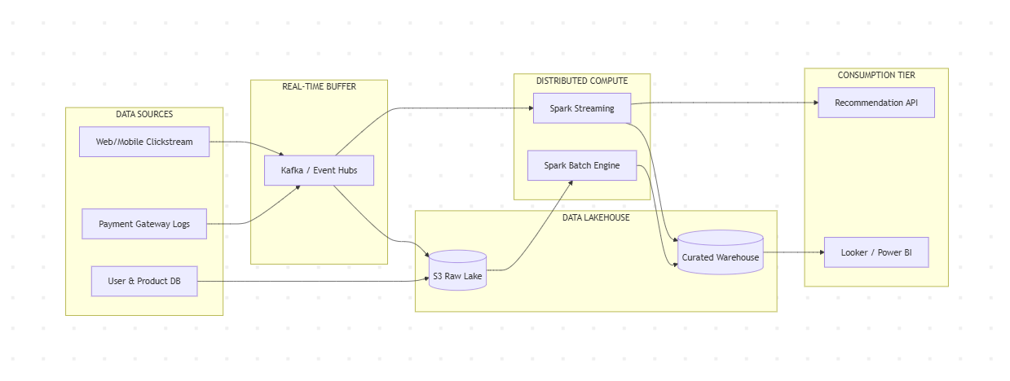

Guided Tool Module 2: Use Hadoop and Spark Documentation

Purpose: Decide whether your problem needs batch processing, streaming processing or hybrid processing by reading official Hadoop/Spark documentation.

No. | Perform |  | Observe / Decide |  | Record in Workbook
1 | Open the Apache Hadoop MapReduce tutorial. |  | MapReduce is suitable when large stored data can be processed in batches, such as daily logs or historical transactions. |  | Write one sentence on what mapper and reducer mean.
2 | Open the Apache Spark Structured Streaming guide. |  | Structured Streaming is suitable when new events continuously arrive, such as sensors, clickstream, live alerts or location updates. |  | Write one sentence on what streaming source, processing and sink mean.
3 | Classify your scenario data into batch data and streaming data. |  | Historical records normally become batch data; live sensor/log/API updates normally become streaming data. |  | Complete the batch-vs-stream table.
4 | Choose one processing approach for your scenario: Hadoop/MapReduce, Spark batch, Spark streaming or hybrid. |  | The decision must match the data velocity and decision urgency. |  | Write your processing decision.
5 | Prepare a simple pseudo-flow, not full code. |  | Example: Mapper reads log line -> emits hour, count. Reducer sums counts.  Dashboard shows peak hour. |  | Write pseudo-flow or paste diagram.
Data Item |  | Batch / Streaming |  | Why |  | Suggested Framework
User clickstream events (page views, clicks) |  | Streaming |  | Continuously generated during every session; needed immediately to drive real-time personalization. |  | Spark Structured Streaming (Kafka source)
Shopping cart abandonment events |  | Streaming |  | Must trigger a recovery email/push notification within minutes to be effective. |  | Spark Structured Streaming
Real-time checkout / payment failure logs |  | Streaming |  | Immediate diagnosis is needed to prevent ongoing revenue loss during an outage. |  | Spark Structured Streaming
Promotional campaign attribution logs (historical) |  | Batch |  | Analyzed after a campaign period closes to compute ROI, not moment-to-moment. |  | Spark batch / Hadoop MapReduce
Historical purchase and order history |  | Batch |  | Used for cohort segmentation and trend analysis, not immediate decisions. |  | Hadoop MapReduce / Spark batch
Recommendation model training data |  | Batch |  | Retrained periodically (daily/weekly) on aggregated historical behavior. |  | Spark batch (MLlib) / Hadoop

Processing Framework Decision
A hybrid Lambda-style processing framework was chosen. The speed layer (Kafka feeding Spark Structured Streaming) processes clickstream, cart-abandonment and checkout-failure events to power sub-second cart-recovery triggers and live recommendation updates. The batch layer (Hadoop/Spark batch jobs on the cloud data lake) processes historical orders and campaign logs for cohort segmentation, revenue reporting and periodic recommendation-model retraining. A serving layer merges both outputs so the dashboard reflects near-real-time activity blended with reliable historical aggregates — exactly the dual requirement this scenario was selected for.

MapReduce / Spark Pseudo-Flow
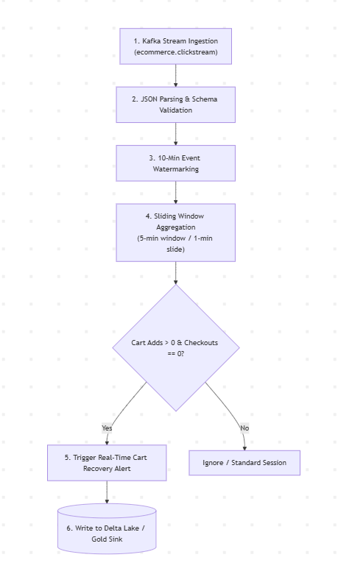

Guided Tool Module 3: Threat Modeling with OWASP Threat Dragon / Microsoft Tool

Purpose: Identify privacy and security risks in the big-data solution before proposing controls.

Tool Choice
Use OWASP Threat Dragon if you need a web/desktop cross-platform threat modeling tool. Use Microsoft Threat Modeling Tool when a Windows system is available. The required evidence is the threat model
diagram and threat-control table.
No. | Perform |  | Observe / Decide |  | Record in Workbook
1 | Open OWASP Threat Dragon or Microsoft Threat Modeling Tool. |  | A threat model is a security diagram that shows components, data flows, trust boundaries and possible threats. |  | Write which tool you used.
2 | Create a new threat model named with your scenario. |  | Use a clear title such as CO4_AT2_Healthcare_Emergency_Analytic s. |  | Paste model name.
3 | Add external entities. |  | External entities are users/systems outside your platform: patient, customer, sensor, payment gateway, bus GPS device, public API. |  | List at least two external entities.
4 | Add processes and data stores. |  | Processes transform data; data stores hold data. Example: ingestion API, stream processor, data lake, warehouse, dashboard. |  | List processes and stores.
5 | Draw data flows and trust boundaries. |  | Trust boundaries mark where security assumptions change: public internet to cloud, app to API, processing layer to storage. |  | Paste screenshot of DFD.
6 | Identify threats using STRIDE thinking. |  | Spoofing, Tampering, Repudiation, Information Disclosure, Denial of Service and Elevation of Privilege help structure risks. |  | Complete the threat table.
7 | Write mitigations. |  | Controls may include authentication, authorization, encryption, masking, audit logs, rate limits, backup and monitoring. |  | Map every threat to one control.
Component / Data Flow |  | Threat |  | Impact | Mitigation
Checkout API / payment gateway integration |  | Tampering — cart price or quantity manipulated before payment. |  | Direct revenue loss and fraud. | Server-side price validation and signed, single-use payment request tokens.
Customer clickstream data in transit |  | Information Disclosure — PII or session data intercepted. |  | Privacy breach and account takeover via session hijacking. | TLS everywhere, plus short-lived, rotated session tokens.
Ingestion API / Kafka broker endpoint |  | Denial of Service during a flash-sale traffic spike. |  | Lost clickstream data, broken personalization, missed cart-recovery windows. | Auto-scaling ingestion tier, rate limiting, backpressure-aware Kafka partitioning.
Customer data warehouse |  | Tampering with historical order/cohort records. |  | Inaccurate revenue reporting and flawed segmentation decisions. | Write-once storage, checksums, versioned tables, audit logs.
Recommendation engine model store |  | Elevation of Privilege — unauthorized access to training data or models. |  | Model poisoning or theft of proprietary behavioral data. | Role-based access control, least privilege, encrypted model artifacts.
Campaign attribution logs |  | Repudiation — marketing team disputes an attribution result. |  | Disputed ad spend ROI and misallocated budget. | Immutable, timestamped audit logs of every attribution calculation.

Threat Model Diagram Evidence
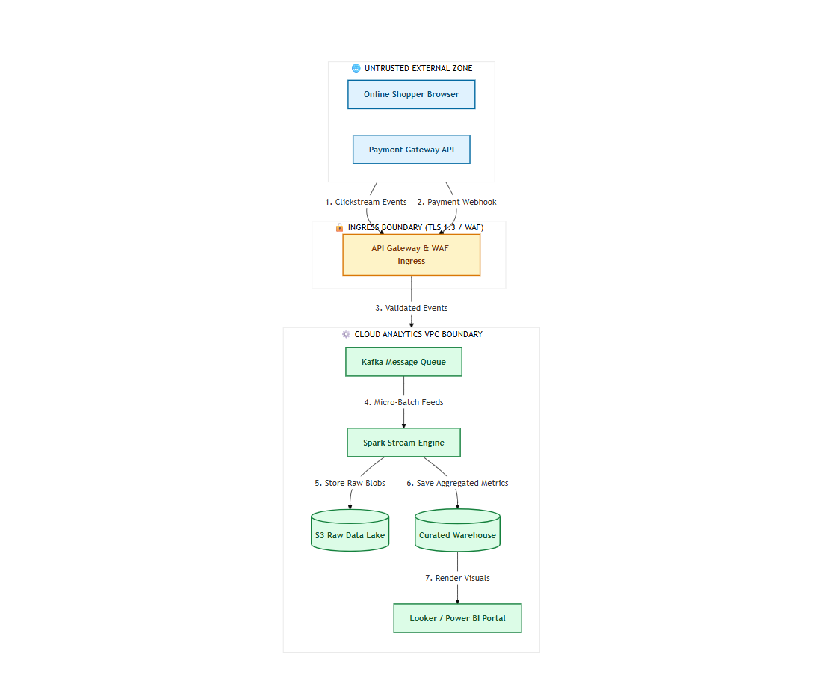

Guided Tool Module 4: Dashboard or Analytics Output Mockup

Purpose: Show how raw big data becomes useful decisions through a dashboard, alert, forecast, recommendation or report.

Beginner-Friendly Choice
Use any one: Power BI, Looker Studio, Tableau Public or Canva. If login/install is difficult, Canva dashboard mockup is acceptable. If data connection is possible, Power BI/Looker Studio/Tableau Public is stronger.
No. | Perform |  | Observe / Decide |  |  | Record in Workbook
1 | Prepare a small sample dataset in Excel or Google Sheets with 10-20 rows. |  | Columns should match your scenario. Example: timestamp, user/location, event type, value, status, risk level. |  |  | Paste column names.
2 | Choose the dashboard tool. |  | Power BI/Tableau/Looker are analytics tools; Canva is acceptable for visual mockup when live data connection is blocked. |  |  | Write chosen tool and reason.
3 | Import or recreate the sample data. |  | In Power BI/Looker/Tableau, connect data. In Canva, manually create charts from sample values. |  |  | Paste screenshot of data/chart setup.
4 | Create at least three visual elements. |  | Use KPI card, bar chart, line chart, table, map, alert count or pie/donut chart as appropriate. |  |  | List the visuals.
5 | Add decision labels. |  | A dashboard is useful only if it supports a decision: allocate beds, detect fraud, reroute buses, restock products, warn farmers. |  |  | Write decision supported by each visual.
6 | Export/share screenshot. |  | Paste the final dashboard screenshot or public/report link if available. |  |  | Paste evidence.
Dataset Column |  | Meaning |  |  | Example Value
timestamp |  | Time the event was captured. |  |  | 2026-08-19 14:32:00
customer_id |  | Unique customer identifier. |  |  | CUST-10432
session_id |  | Unique browsing session identifier. |  |  | SESS-88213
event_type |  | Type of clickstream event. |  |  | add_to_cart
product_id |  | Product involved in the event. |  |  | PROD-5521
cart_value |  | Current value of the shopping cart. |  |  | $84.50
campaign_source |  | Marketing campaign/channel that drove the session. |  |  | Instagram_SummerSale
checkout_status |  | Outcome of a checkout attempt. |  |  | Failed_PaymentDeclined
Visual Element |  | Metric Shown |  | Decision Supported
KPI card |  | Cart abandonment rate (%) today. |  | Trigger an increased cart-recovery email/push campaign.
Funnel chart |  | View -> Add to Cart -> Checkout -> Payment conversion. |  | Identify and fix the stage with the biggest drop-off.
Bar chart |  | Revenue attributed by campaign source. |  | Reallocate ad budget toward the top-performing channels.
Line chart |  | Checkout failure rate over time. |  | Alert the payments team to a gateway or provider issue.
Ranked list / table |  | Top recommended products by click-through rate. |  | Tune or retrain the recommendation model.

Dashboard / Analytics Output Evidence
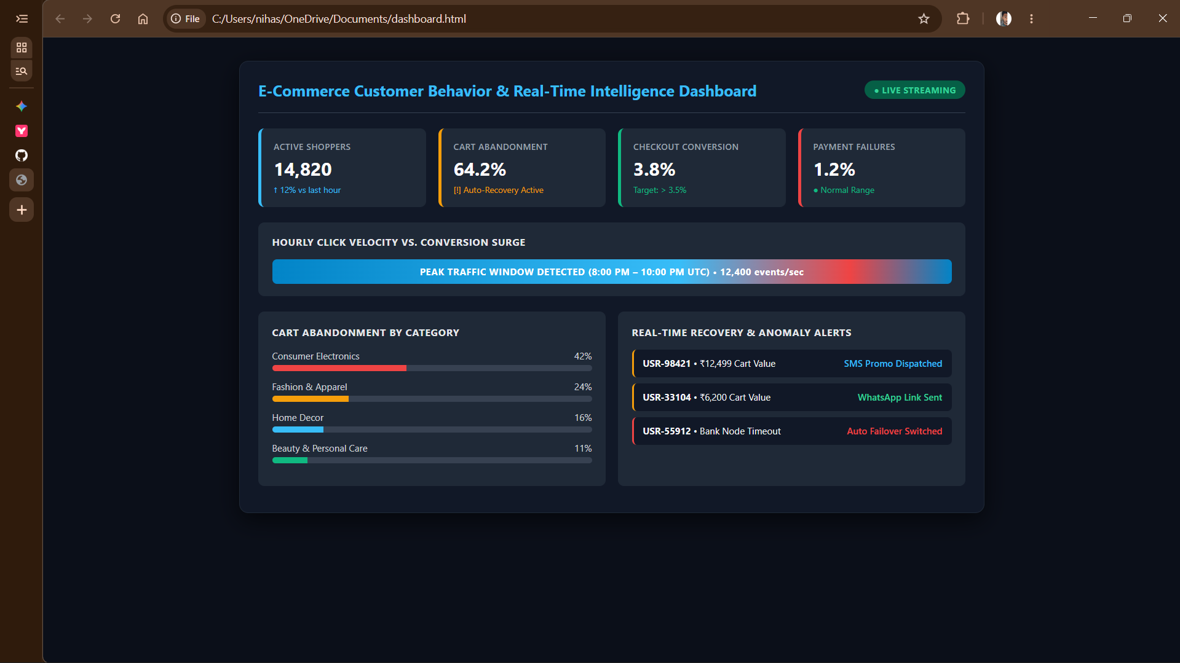

Final CO4 AT2 Solution Sections
Final Assembly
After completing the guided tool modules, combine the evidence into the final solution. The final answer must show technical reasoning, not only screenshots.

Problem Understanding
What to include: Identify stakeholders, decisions required, data produced, expected analytics output and urgency.

Student Response
Stakeholders include e-commerce product managers, the marketing team, the payments/checkout engineering team, and customers browsing and buying on the platform. Key decisions required are: which abandoned carts to target with a recovery offer, which marketing campaigns deserve continued or increased ad spend, how to diagnose and fix checkout failures quickly, and which products to recommend to a given customer. Data produced spans high-velocity clickstream and cart events, real-time checkout failure logs, campaign attribution records, and behavioral signals feeding the recommendation engine. The expected analytics output is a blend of real-time cart-recovery/recommendation triggers and a batch-refreshed campaign ROI and cohort-revenue dashboard. Urgency is mixed: cart recovery and checkout-failure diagnosis need a near-real-time response (minutes), while cohort segmentation and revenue reporting tolerate a daily or weekly batch cycle.

5Vs Mapping
What to include: Map Volume, Velocity, Variety, Veracity and Value using scenario evidence.

Student Response
V | Mapping to E-Commerce Customer Behavior Intelligence
Volume | Millions of clickstream events and product views are generated daily across the user base, alongside historical order and campaign data accumulating into a large cloud data lake.
Velocity | Clickstream, cart and checkout events arrive continuously in sub-second bursts, especially during flash sales, demanding streaming ingestion via Kafka and Spark Structured Streaming.
Variety | Structured order/transaction records, semi-structured clickstream JSON events, campaign attribution logs, and behavioral signals for the recommendation model all coexist in the same pipeline.
Veracity | Duplicate click events, bot traffic, sessions that abandon then later convert on a different device, and inconsistent campaign UTM tagging all require cleaning before the data can be trusted.
Value | Faster cart recovery, higher checkout conversion, better-targeted campaigns and sharper recommendations directly increase revenue — the measurable business value of the platform.

Big Data Architecture
What to include: Paste final draw.io architecture showing sources, ingestion, storage, processing, analytics/security and users.

Student Response
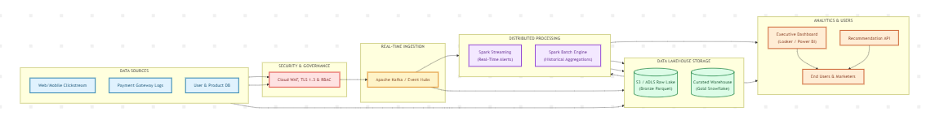
Pipeline description (to accompany the diagram): Sources (customer web/mobile app clickstream, the payment gateway, and campaign/ad platforms) feed an Ingestion layer (Kafka/Kinesis/Event Hub/Pub-Sub equivalent) that lands raw events in the Bronze layer of a cloud data lake. A Processing layer splits into a speed layer (Spark

Structured Streaming, producing a cleaned Silver layer for cart-recovery and recommendation decisions) and a batch layer (Hadoop/Spark batch jobs, producing Gold-layer cohort and revenue aggregates). Both layers converge in a serving warehouse (BigQuery/Synapse/Redshift) secured with authentication, encryption and role-based access control, from which the Looker Studio dashboard is built. Users — marketing, product and payments teams, plus the recommendation engine that feeds results back to customers — consume this unified view to make targeted, revenue-driving decisions.

Data Flow Pipeline
What to include: Explain how raw data moves, gets cleaned, stored, processed and converted into dashboard/alert/decision.

Student Response
Raw data originates at the source — a click, an add-to-cart action, a checkout attempt, or a campaign click-through. It is pushed to the ingestion layer (Kafka) over an authenticated, encrypted connection. Streaming events flow directly into Spark Structured Streaming, which cleans, deduplicates and windows the data (for example, detecting 10 minutes of cart inactivity) before writing cleaned Silver-layer records and triggering real-time actions such as a cart-recovery notification or an updated recommendation. In parallel, completed orders and campaign logs land in the Bronze data lake and are processed nightly by Hadoop/Spark batch jobs into Gold-layer cohort and revenue aggregates. Both the streaming and batch outputs converge in the warehouse, from which the Looker Studio dashboard reads live KPIs, funnels and revenue charts — converting raw clickstream into concrete cart-recovery, budget-reallocation and product-recommendation decisions.

Tool and Technology Justification
What to include: Use cloud architecture references and Hadoop/Spark documentation to justify chosen tools.

Student Response
The Hybrid Lambda/Medallion pattern was drawn from the shared structure repeated across the AWS, Azure and Google Cloud retail architecture references reviewed in Module 1, confirming it is an industry-standard approach for e-commerce rather than an arbitrary choice. The processing-framework decision follows directly from the official Apache Hadoop MapReduce tutorial and Apache Spark Structured Streaming documentation reviewed in Module 2: clickstream, cart and checkout data are routed to the streaming engine because their decision deadlines are measured in minutes, while campaign and order history are routed to batch processing because their deadlines are measured in days. OWASP Threat Dragon was chosen for threat modeling because it is a free, cross-platform tool suited to a repeatable security review without a Windows-only dependency. Looker Studio was chosen for the dashboard because it connects natively to BigQuery, the warehouse that already receives both the speed-layer and batch-layer outputs in this architecture, keeping the tool chain consistent end-to-end.

Security and Privacy Strategy
What to include: Use threat model output to explain threats and controls.

Student Response
The Module 3 threat model identified six STRIDE-categorized risks spanning tampering with checkout/payment data, information disclosure of customer clickstream and session data, denial-of-service against the ingestion API during flash-sale spikes, tampering with the historical data warehouse, elevation of privilege over the recommendation model store, and repudiation of campaign attribution results. Each threat is paired with a specific control: server-side price validation and signed payment tokens for checkout integrity, TLS and short-lived session tokens for data confidentiality, auto-scaling and rate limiting for ingestion availability, write-once storage with checksums for warehouse integrity, role-based access control with encrypted model artifacts for the recommendation service, and immutable timestamped audit logs for attribution accountability. Together these controls address confidentiality, integrity, availability and accountability for customer and revenue data across every stage of the pipeline.

Challenges and Solutions
What to include: Write at least four big-data implementation challenges and one practical solution for each.

Student Response
# | Challenge | Solution
1 | Flash-sale traffic spikes overwhelm the streaming ingestion layer. | Auto-scale Kafka partitions and use backpressure-aware Spark Structured Streaming consumers to absorb bursts without dropping events.
2 | Distinguishing genuine abandoned carts from bot or test traffic. | Apply bot-filtering rules and session validation before triggering a cart-recovery campaign.
3 | Attribution conflicts arise across multiple overlapping marketing campaigns. | Standardize UTM tagging and apply a consistent multi-touch attribution model in the batch layer.
4 | Keeping the recommendation model fresh without expensive full retraining. | Layer incremental/online updates from recent streaming behavior on top of periodic full batch retraining.

Business Outcome
What to include: State measurable outcome: faster decision, reduced fraud, lower waiting time, improved prediction, lower downtime or better user experience.

Student Response
The measurable business outcome is an increase in checkout conversion rate and recovered-cart revenue, achieved through faster, targeted cart-recovery interventions, combined with improved marketing ROI from accurate real-time campaign attribution — a concrete, measurable uplift in revenue per session and a reduction in the overall cart-abandonment rate.

Rubric

Criteria | Marks | Evaluation Focus | Evidence
Problem and 5Vs analysis | 6 | Scenario-specific analysis and correct big-data reasoning | Workbook tables
Architecture and data flow | 6 | Correct pipeline, cloud components and flow clarity | draw.io diagram
Processing framework decision | 5 | Batch/streaming/hybrid justification using Hadoop/Spark concepts | Decision table
Security and privacy | 5 | Threat model, risks and controls | Threat model table/screenshot
Dashboard/output design | 4 | Useful decision-oriented analytics output | Dashboard/mockup
Clarity and submission quality | 4 | Organized, original, complete evidence | GitHub/GCR

Submission Checklist
  - Student details and selected scenario are filled.
  - Cloud architecture references are recorded.
  - Hadoop/Spark processing decision is completed.
  - Threat model diagram/table is included.
  - Dashboard/mockup screenshot or link is included.
  - Final solution sections are completed.
  - DOCX/PDF and supporting files are uploaded to GitHub.
  - GitHub repository link is submitted through Google Classroom.

Official Reference Links
AWS Architecture Center: https://aws.amazon.com/architecture/
Azure Architecture Center: https://learn.microsoft.com/en-us/azure/architecture/ Google Cloud Architecture Center: https://docs.cloud.google.com/architecture
Apache Hadoop MapReduce Tutorial: https://hadoop.apache.org/docs/stable/hadoop-mapreduce-client/hadoop-mapreduce-client-core/MapReduceTutorial.html
Apache Spark Structured Streaming: https://spark.apache.org/docs/latest/streaming/index.html
Microsoft Threat Modeling Tool releases: https://learn.microsoft.com/en-us/azure/security/develop/threat-modeling-tool-releases OWASP Threat Dragon: https://owasp.org/www-project-threat-dragon/
Power BI documentation: https://learn.microsoft.com/en-us/power-bi/
Looker Studio create report: https://docs.cloud.google.com/data-studio/create-a-report Tableau Public: https://www.tableau.com/community/public
Canva Charts: https://www.canva.com/help/charts/

