**COVID-19 Cases Analysis**

**Introduction:**

* The COVID-19 pandemic, caused by the novel coronavirus SARS-CoV-2, has rapidly become one of the most significant global health crises of our time. Its profound effects on health, society, and the economy have necessitated rigorous analysis to grasp the full scope of the challenges it presents.
* In this essay, we embark on a journey to delve into the analysis of COVID-19 cases. Our objective is not only to comprehend the spread of the virus but also to draw meaningful insights from the data and formulate actionable recommendations. The lessons learned from this analysis are not only pertinent to the ongoing battle against COVID-19 but also serve as valuable guidelines for tackling future health crises.

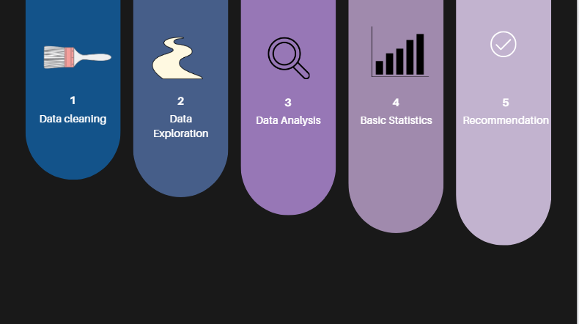

**Step 1: Data Collection:**

First we need a data set to analysis.As we get the data form kaggle,we don’t need to worry about the data collection.Otherwise we need to collect data from companies,peoples etc,.

**Step 2: Data Exploration**

Clean the data to ensure its quality. This step includes handling missing values, removing duplicates, addressing inconsistencies, and verifying the accuracy of data entries.

**Handling Missing Values:** Identify and address data points with missing values. You can choose to remove rows with missing data, fill in missing values with reasonable estimates, or use imputation techniques.

**Outlier Detection and Handling:** Identify and address outliers, which are data points that significantly deviate from the majority of the data. Depending on the context, outliers can be removed or treated to minimize their impact.

**Data Validation:** Check for data that doesn't conform to expected formats**.** This may include data types, ranges, or formats, and errors should be corrected.

**Deduplication:** Detect and remove duplicate records in the dataset, ensuring that each data point is unique.

**Normalization and Standardization**: If necessary, transform data to a common scale to facilitate comparisons. This is particularly relevant when working with features measured in different units.

**Handling Categorical Data**: Convert categorical data into a numerical format, such as one-hot encoding, to make it suitable for analysis.

**Step 3: Data Analysis**

Visualize and summarize the data to understand its characteristics and identify initial patterns or trends. We can put graphs to visualize the data. As covid-19 is diseases which increases day by day we can use line graph to show the intensity of the covid-19.

**Time Series Line Chart**: This chart displays the progression of COVID-19 cases over time. The x-axis represents dates, and the y-axis shows the number of cases. It's useful for tracking trends and identifying spikes in cases.

**Bar Chart**: Bar charts can be used to compare the number of COVID-19 cases between different regions or countries. Each bar represents a specific location, and the height of the bar represents the number of cases.

**Pie Chart**: Pie charts are useful for showing the proportional distribution of COVID-19 cases by region, age group, or other categories. Each "slice" of the pie represents a category's share of the total cases.

**Step 4: Basic Statistics**

**Regression Analysis**: Use regression analysis (linear, logistic, or other types) to explore relationships between variables. For example, you can examine how factors like population density, healthcare infrastructure, or public health measures correlate with COVID-19 cases.

**Hypothesis Testing**: Hypothesis testing can help determine whether observed differences or associations in your data are statistically significant. For instance, you can test whether there's a significant difference in case counts before and after the implementation of a specific intervention.

**Clustering Analysis**: If you're interested in grouping regions or countries with similar COVID-19 trends, you can apply clustering techniques like k-means or hierarchical clustering.

**Step 5: Recommendations:**

After doing the analysis, we can come to a recommendation.We come to recommendation by the visualization analysis and the test results from the regression analysis, Clustering Analysis,Hypothesis testing.we may choose extra analysis in future to draw clear and concise recommendation.

**Step 6: Conclusion:**

In the conclusion, we summarize our key findings. We highlight the implications for public health, the economy, and preparedness. The key lesson is that we must be ready for future challenges.