**Flowchart of the algorithm:**

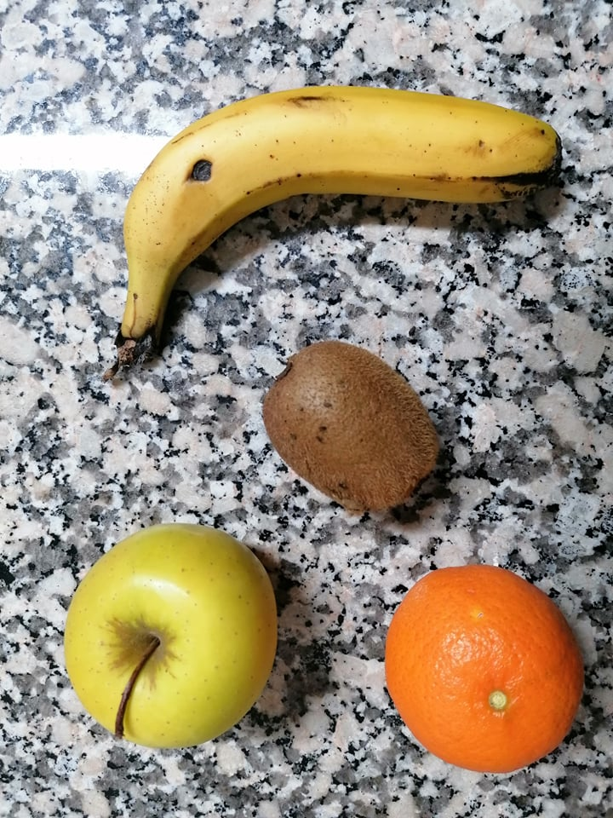**Image Taken:**

**Results:**