Final Report of the TÜBİTAK Weed Classification Project Using Deep Learning

1. Material and Methods
In Figure 1, the methodology used to conduct this study is shown. Dataset consists of images of wild weed species that were collected through both primary collection and secondary online sources. This dataset was used to develop a five-class classification model to differentiate species from each other. Networks that were pre-trained such as MobileNetV3, ResNet50 and VGG16 were used as classification models. Before splitting images from each class into training, testing and validation sets, images were resized according to the requirements of the models that were planned to be used.

Figure 1: A diagram of the proposed approach

1.1 Dataset
Initially, datasets for all species - Amaranthus retroflexus, Chenopodium album, Solanum nigrum, Convolvulus arvensis and Salsola kali - were compiled from publicly available images collected through internet searches conducted in different languages on Google Images and various websites.
Each class was split into training, testing and validation sets using a ratio of 70:15:15. Figure 2 shows samples from each species of wild weed. Whereas the number of images in each class and their division are shown in Table 1.

Figure 2: Sample images of 5 classes
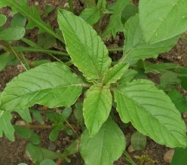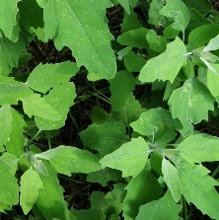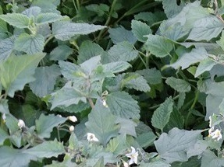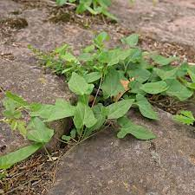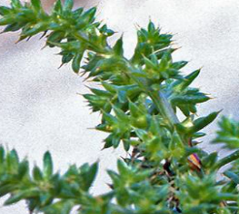
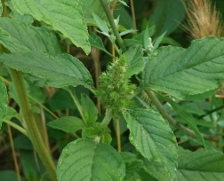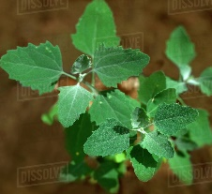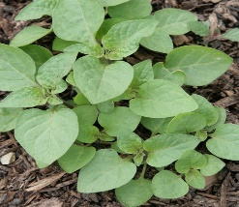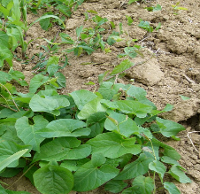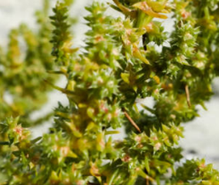
Amaranthus retroflexus Chenopodium album Solanum nigrum Convolvulus arvensis Salsola kali

Table 1: Dataset division
Class Name | Training Set | Validation Set | Testing Set | Number of images per class
Amaranthus retroflexus | 196 | 42 | 42 | 280
Chenopodium album | 196 | 42 | 42 | 280
Solanum nigrum | 196 | 42 | 42 | 280
Convolvulus arvensis | 196 | 42 | 42 | 280
Salsola kali | 196 | 42 | 42 | 280
Total | 980 | 210 | 210 | 1400

During the classification process, the image datasets of Amaranthus retroflexus, Chenopodium album, and Solanum nigrum displayed considerable visual similarity, which resulted in lower accuracy scores for these species. To address this issue, these three species were grown under controlled greenhouse conditions in pots, and a new dataset was collected through primary image acquisition. This approach aimed to determine whether the model could better differentiate morphologically similar species when trained and tested with condition-specific images.
Images were captured weekly using a Samsung Galaxy S24 Ultra smartphone camera with the 3× zoom feature, allowing documentation of three distinct growth stages for each species. Each class was divided into training, testing, and validation sets using a 70:15:15 ratio. Figure 3 displays representative samples from each weed species that is collected through primary collection, while the number of images per class and their distribution are presented in Table 2.

Figure 3: Representative samples from the primarily collected image datasets
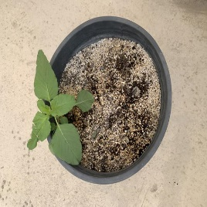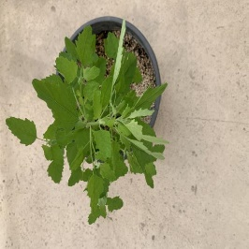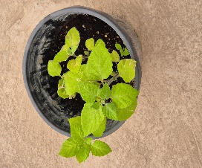
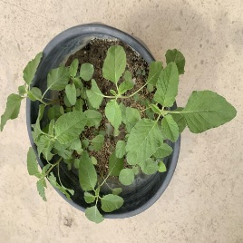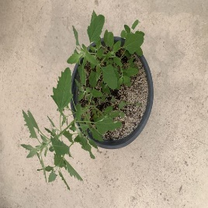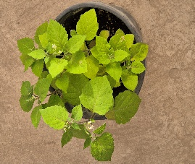
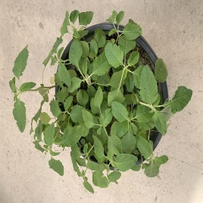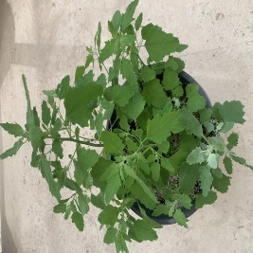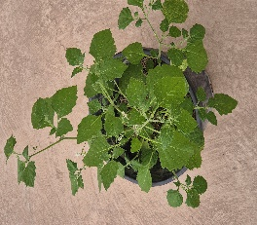
Amaranthus retroflexus Chenopoidum album Solanum nigrum

Table 2: Primary dataset division
Class Name | Training Set | Validation Set | Testing Set | Number of images per class
Amaranthus retroflexus  (Primary) | 252 | 54 | 54 | 360
Chenopodium album  (Primary) | 252 | 54 | 54 | 360
Solanum nigrum  (Primary) | 252 | 54 | 54 | 360
Convolvulus arvensis (Secondary) | 210 | 45 | 45 | 300
Salsola kali (Secondary) | 196 | 42 | 42 | 280
Total | 1162 | 249 | 249 | 1660

1.2. Convolutional neural network (CNN) models
In this study, models that we have chosen are well-established convolutional neural network models that are widely and reliably used in image classification applications. More specifically, MobileNetV3, ResNet50 and VGG16 were selected for this comparative study.

1.2.1 MobileNetV3
MobileNetV3, is relatively a lightweight convolutional neural network (CNN) model in comparison to ResNet50 and VGG16. It embraces depth wise separable convolution and bottleneck. This feature enables reduced number of parameters while maintaining high accuracy. To match the number of pixels with input requirement of the model, images were resized to 224 ×224 resolution. To improve non-linear representation while remaining efficient computation wise, h-swish activation function is utilized by the network. In this study, MobileNetV3 was chosen as one of the models to be used for its moderate accuracy potential despite relatively lower required computational power.

1.2.2 ResNet50
ResNet50, in terms of required computational power and accuracy potential, is in the middle ground. In order to address vanishing gradient problem and enhance effective training in deep networks, ResNet50 is a 50 layers residual CNN that utilizes skip connections. Similar to MobileNetV3, to match the number of pixels, images are resized to 224x224 pixels. For classification, ReLU activations along with pooling and connected layers were utilized. In this study, ResNet50 was chosen as one of the models to be used for its considerable accuracy potential and moderate required computational power.

1.2.3 VGG16
VGG16 is widely used because of its simplicity combined with high effectiveness in image classification. VGG16 is a 16 layers CNN model along with convolutional layers and three fully connected layers. The architecture with 3x3 filters that it follows is uniform, besides with max pooling layers. The other factors that contribute to its impressive performance are VGG16’s depth and small filter size. VGG16 achieved an outstanding performance in ImageNet dataset despite its simplicity. However, VGG16 is a highly expensive and memory intensive model because of its large number of parameters, which limits its usage in environments with limited resources. Nevertheless, because of its powerful accuracy potential, VGG16 is chosen as one of the models to be used in this study, despite its highly required computation power.
1.3 Performance evaluation metrics
In order to evaluate performance of models in classifying all five wild weed species, several metrics like accuracy, precision, recall and F1-score, were utilized as indicators. Accuracy reflects the proportion of samples from all classes that are correctly classified. Recall indicates how many true positive cases the model successfully identifies out of all actual positives, while precision measures how many of the predicted positive cases are truly positive. These performance metrics were computed using several equations.

$$Accuracy=\frac{True Positive+True Negative}{True Positive+True Negative+False Positive+False Negative}$$

$$Recall=\frac{True Positive}{True Positive+False Negative}$$

$$Precision=\frac{TP}{True Positive+False Positive}$$

$$F1-Score=2x\frac{RecallxPrecision}{Recall+Precision}$$

2. Results
The classification was performed on a Windows 10 Pro system which contains NVIDIA GeForce GTX 1660 SUPER graphics card, 16 GB of DDR4 1600 MHz RAM, and an intel Core i5-10400F processor with computation power of 2.90 GHz. The classification program required Python 3.9 and Keras 2.10.0 to run properly.
The performance of the selected models (MobileNetV3, ResNet50, VGG16) was assessed by standard metrics, with the result shown in separate sections. To further demonstrate how the models performed during training, graphs showing the change in training accuracy and loss across epochs are presented. The models started with pre-trained ImageNet weights, and transfer learning was not applied during both training and testing. To make sure that the results could be compared, all training procedures used the same batch, dataset split ratio, learning rate, and optimizer.

The number of epochs were indicated as 50, no early stop parameters were introduced, the batch size was set to 16, the learning rate was set to 0.000001, and during the training process, the SGD optimizer was chosen as the optimizer.
2.1 Training with Table 1 Dataset
Figure 4 displays the training accuracy, validation accuracy, training loss, and validation accuracy per the number of epochs across models considered in this study.

It can be seen from Figure 4(A) that MobileNetV3 had initiated with training accuracy of around 20%. Until there was no significant increase in the training accuracy, it gradually increased and maintained training accuracy of 60%-65%. Differing from other models, it can be seen from the Figure 4(A) that the validation accuracy starting at near 25% in 10th epoch, it maintained higher performance than training accuracy throughout all the epochs reaching approximately to 70% by the final epoch. Moving to the training and validation loss, it can be picked from the figure that initially, the model had significant difficulty in reducing the error. It is apparent from Figure(A) that both training and validation loss curves are absent from the graph. This indicates that both parameters maintained above the 1.0 threshold throughout all the epochs, therefore remaining invisible in graph. This anomaly suggests that internet collected images cause high noise levels and inconsistencies within the dataset. Ultimately, we can conclude from Figure 4(A) that model was unable to reduce loss below the 1.0 threshold because of the fact that visual similarities in the initial dataset between species was too high for MobileNetV3 to resolve effectively without clean, primary data.

Moving to the Figure 4(B), training accuracy in ResNet50 initiated at 20% and continued to improve gradually. Different from MobileNetV3, the model accuracy reached the optimal level of 85% by last epochs, which suggests that model has been performing significantly better. When it comes to the validation accuracy, similar to the Figure 4(A), had been performing higher than training accuracy until it reached to the final epochs. Around 40th epoch, both metrics started to perform almost identical. Looking at validation and training losses, it can be seen from the Figure 4(B) that initially, both metrics did not perform optimal, thus, staying above the threshold of 1.0. But, in approximately 20th epoch, both metrics became visible and gradually reduced to around 0.5 until the last epoch. This suggests that after 20th epoch, model started to learn and remember more about the data. Ultimately, it can be concluded that ResNet50 has outperformed MobileNetV3 due to its deeper residual architecture allowing it to recognize details more efficiently from noisy internet-collected data.

In Figure 4(C), training accuracy of VGG16 initiated around 25% and gradually increased until 40th epoch. After reaching the optimal level of 85%, it maintained the same level until the final epoch. Whereas validation accuracy, initiated approximately 20%, increased gradually towards 85% throughout all the epochs. However, around 40th epoch, it started to perform identical to the training accuracy, then eventually surpassing it by the final epoch. Training and validation loss remained invisible because they fell above the threshold of 1.0 until approximately 20th epoch. However, they became visible afterwards and gradually decreased throughout the third and fourth quartiles. Whereas training loss maintaining to reduce below 0.4 sharply, the validation loss remained a steady line at around 45th epoch. This suggests that VGG16 model started to memorize specific details in training set rather than generalizing it, a phenomenon known as overfitting. It may have caused by multiple factors such as the number of parameters in VGG16 being too high, which makes it computationally expensive and prone to overfitting in such noisy internet-collected datasets.

Figure 4:
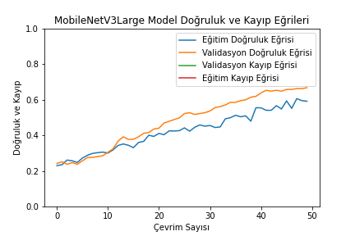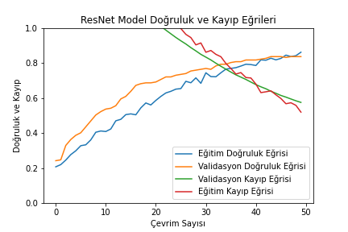
MobileNetV3(A) ResNet50(B)
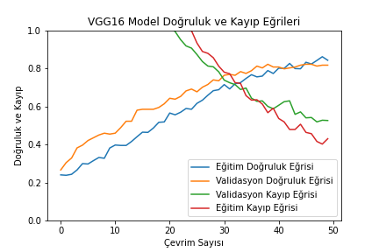
VGG16(C)
In Figure 5, there are multiple confusion matrices belonging to each model, showing the result of their performance in identifying each species correctly.
According to the confusion matrix of MobileNetV3 in Figure 5(A), the model struggled significantly to identify distinct species. Moreover, judging from Amaranthus retroflexus class, the model only managed to predict 12 images correctly while misclassifying significant number of Convolvulus arvensis (12) and Solanum nigrum (10). The values disrupted the diagonal shape substantially, which is the optimal shape that had been looked for.
Moving to Figure 5(B), the diagonal shape in matrix belonging to ResNet50 appears to be much more visible, showing success in classifying especially Convolvulus arvensis (40) and Salsola kali (39). However, similar to the MobileNetV3, it had difficulty in identifying Amaranthus retroflexus, in which 7 images were predicted as Chenopodium album and Solanum nigrum each.
Finally, in Figure 5(C), the confusion matrix of VGG16 performed even more visible diagonal shape than ResNet50. It successfully classified majority of the images correctly to corresponding classes. However, it made considerable number of misclassifications in identifying Amaranthus retroflexus, resulting in classifying Solanum nigrum (4) and Convolvulus arvensis (5) as Amaranthus retroflexus.

Figure 5
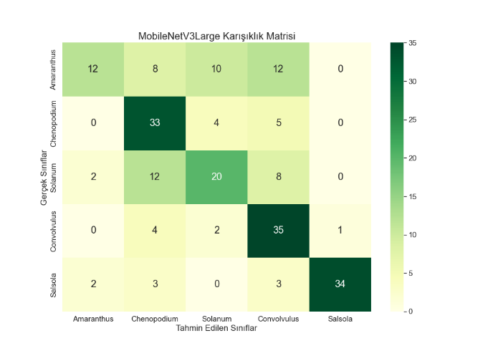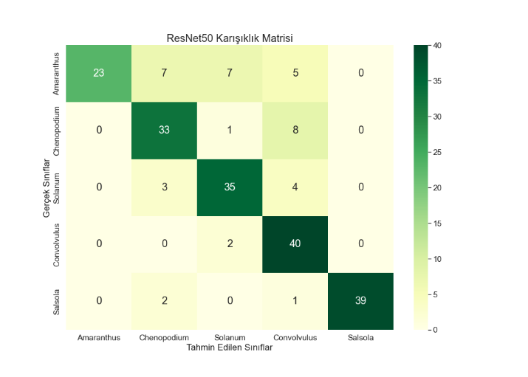
MobileNetV3(A) ResNet50(B)
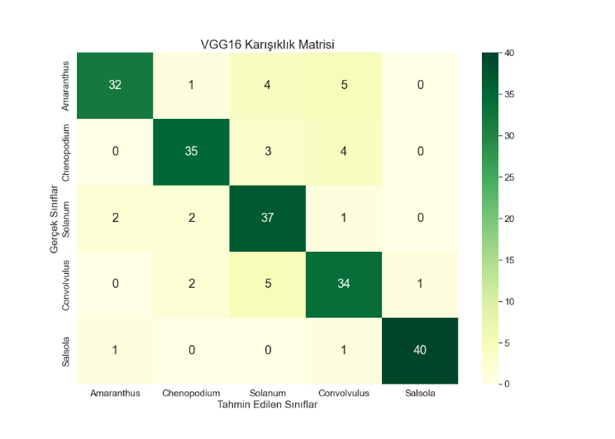

VGG16(C)
Certain metrics are presented in Table 3 in order to evaluate each models performance in classifying all five wild weed species.
According to Table 3, MobileNetV3 had indicated its highest success in classifying Salsola kali with precision metric of 97.1% and f1-score of 88.3%. However, the model struggled significantly with the discrimination of other species. Specifically, it had the most difficulty identifying Amaranthus retroflexus, resulting in an F1-score of 41.4% and a precision of 75.0%. In classifying the remaining species (Chenopodium album, Solanum nigrum, and Convolvulus arvensis), the model demonstrated moderate results, with precision scores of 55.0%, 55.6%, and 55.6%, recall scores of 78.6%, 47.6%, and 83.3%, and F1-scores of 64.7%, 51.3%, and 66.7%, respectively.
Moving to ResNet50, the model had indicated highest success in classifying Salsola kali with f1-score of 96.3% and with a perfect precision metric of 100.0%. Despite its perfect precision metric of 100.0% in classifying Amaranthus retroflexus, the model struggled the most in discriminating it with F1-score of 70.8%. In classifying remaining species (Chenopodium album, Solanum nigrum, and Convolvulus arvensis), the model demonstrated relatively better results in comparison to MobileNetV3, with precision scores of 73.3%, 77.8% and 69.0%, recall scores of 78.6%, 83.3%, and 95.2%, and F1-scores of 75.9%, 80.5% and 80.0%, respectively.
Finally, Moving to VGG16, the model indicated its highest performance in identifying Salsola kali with F1-score of 96.4% and precision metric of 97.6%. VGG16 consistently performed F1-scores around 80% in discriminating other species, but it is worth to note that the model had poorest performance in identifying Convolvulus arvensis with F1-score of 78.2% and precision metric of 75.6%. However, the model was mostly consistent with classifying other species (Amaranthus retroflexus, Chenopodium album and Solanum nigrum), with F1-scores of 83.1%, 85.4% and 81.3%, recall scores of 76.2%, 83.3%, and 88.1%, and precision metrics of 91.4%, 87.6% and 75.5%, respectively.

Table 3: Evaluation Metrics for the Performance of Models
Model | Class | Precision | Recall | F1-Score
 | Amaranthus retroflexus | 0.750 | 0.286 | 0.414
 | Chenopodium album | 0.550 | 0.786 | 0.647
MobileNetV3 | Solanum nigrum | 0.556 | 0.476 | 0.513
 | Convolvulus arvensis | 0.556 | 0.833 | 0.667
 | Salsola kali | 0.971 | 0.810 | 0.883
 | Amaranthus retroflexus | 1.000 | 0.548 | 0.708
 | Chenopodium album | 0.733 | 0.786 | 0.759
ResNet50 | Solanum nigrum | 0.778 | 0.833 | 0.805
 | Convolvulus arvensis | 0.690 | 0.952 | 0.800
 | Salsola kali | 1.000 | 0.929 | 0.963
 | Amaranthus retroflexus | 0.914 | 0.762 | 0.831
 | Chenopodium album | 0.876 | 0.833 | 0.854
VGG16 | Solanum nigrum | 0.755 | 0.881 | 0.813
 | Convolvulus arvensis | 0.756 | 0.810 | 0.782
 | Salsola kali | 0.976 | 0.952 | 0.964

Table 4 summarizes the overall performance of all three models during the classification process. MobileNetV3 indicates poor testing accuracy of 63.8% and high loss of 1.098. This indicates that the lightweight architecture of MobileNetV3 struggles with noisy internet-collected data. In contrast, the models with higher number of parameters such as ResNet50 and VGG16, proved better results with 81.0% and 84.8% testing accuracies along with relatively lower losses with 0.602 and 0.414, respectively.

Table 4: Overall performance of models
Model | Train Acc | Train Loss | Val Acc | Val Loss | Test Acc | Test Loss
MobileNetV3 | 0.591 | 1.115 | 0.667 | 1.077 | 0.638 | 1.098
ResNet50 | 0.861 | 0.519 | 0.836 | 0.574 | 0.810 | 0.602
VGG16 | 0.842 | 0.430 | 0.816 | 0.526 | 0.848 | 0.414

From the results in Table 4, it is evident that the internet-collected dataset contained too much noise for the models to handle effectively. As observed, MobileNetV3 failed to minimize its loss below 1.0, confirming that the visual similarity between species was too high to resolve with such inconsistent data. Although ResNet50 and VGG16 performed better, the underlying data quality issues and overfitting risks persisted. Therefore, to test the true classification capability of these architectures without the interference of background noise, we proceeded to the next phase using the primary dataset cultivated in the greenhouse.

2.2 Training with Table 2 Dataset
Figure 6 displays the training accuracy, validation accuracy, training loss, and validation accuracy per the number of epochs across models considered in this study.
According to Figure 6(A), MobileNetV3 performs significantly better than initial internet-collected dataset based experiment. From Figure 6(A), unlike in previous experiment, training and validation loss curves are visible in the graph, starting to appear from around 5th to 8th epochs, and decreasing to around 0.4 and 0.2, respectively by the time it reaches to final epoch. Both training accuracy and validation accuracy initiated from 0.2 and exponentially increased to the level of 0.92-0.9 5 until 30th epoch, then maintained the same level until the final epoch. Similar to previous experiment, throughout all the epochs, validation accuracy maintained a slightly higher metric compare to the training accuracy. However, overall performance of the model, confirms that noise reduction in the primary dataset allowed a relatively lightweight model such as MobileNetV3 to perform significantly better.
Moving to the Figure 6(B), ResNet50 had achieved a near-perfect performance. Both training accuracy and validation accuracy climbed to the 1.0 rapidly just within first 15 epochs, and both training and validation loss appearing from around 10th epoch, rapidly decreased to almost 0.0 by the final epochs. Compare to MobileNetV3, the model achieved even better results thanks to its higher number of parameters.
Finally, Looking at the Figure 6(C), the overfitting issue that observed in previous experiment regarding VGG16, has been completely resolved. It can be seen from the graph that the validation loss followed training loss closely, eventually both rapidly falling to 0.0 without any deviation like observed in previous VGG16 experiment. The model achieved near-perfect accuracy in both training and validation metrics as we previously observed from Figure 6(B). This confirms that the overfitting issue indeed occurred from noisy internet-collected datasets, not by the VGG16 architecture itself. With the condition specific data, VGG16 was able to demonstrate a reliable generalization.

Figure 6
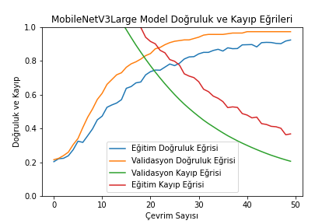
MobileNetV3(A)
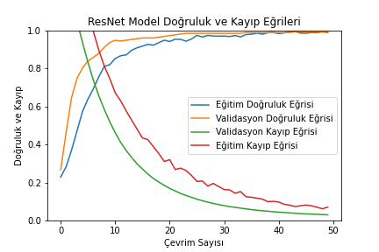
ResNet50(B)
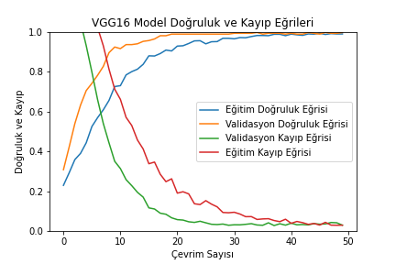
VGG16(C)
In Figure 7, there are multiple confusion matrices belonging to each model, showing the result of their performance in identifying each species correctly.
From Figure 7(A), we can observe that MobileNetV3 indicated a remarkable recovery, and displayed a clear diagonal line, unlike scattered results observed from previous experiment. Specifically, for the primary greenhouse species (Amaranthus retroflexus, Chenopodium album and Solanum nigrum), the model achieved near-perfect result, predicting 54, 52 and 51, respectively, successfully. This confirms that the distinct morphological features in the condition-specific dataset were successfully captured even by the lightweight architecture.
Moving to Figure 7(B) and Figure 7(C), both models achieved perfect results in classifying primary greenhouse species (Amaranthus retroflexus, Chenopodium album and Solanum nigrum), classifying 54 out of 54 of each of them successfully. Even though they present slight scatters away from perfect diagonal line in classifying secondary species (Convolvulus arvensis and Salsola kali), the overall matrices display ideal diagonal lines in both models.
Crucially, even If all three CNN models displayed similar results, it is important to note that the pace of them reaching these results differ significantly. As observed from Figure 6, ResNet50 and VGG16 achieved their optimal performance by 10-15 epochs, which is much sooner than MobileNetV3, which achieved its optimal performance within around 40th epoch. This suggests that while clean greenhouse data allowed MobileNetV3 to eventually catch-up, ResNet50 and VGG16 achieved near-perfect results almost instantly by using their high number of parameters.
Figure 7: Confusion matrices
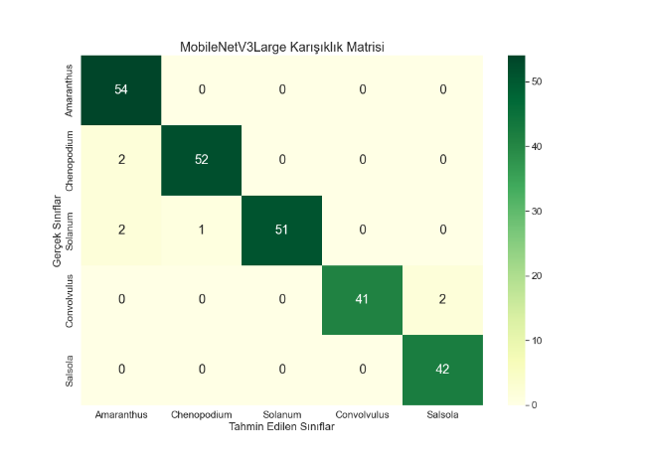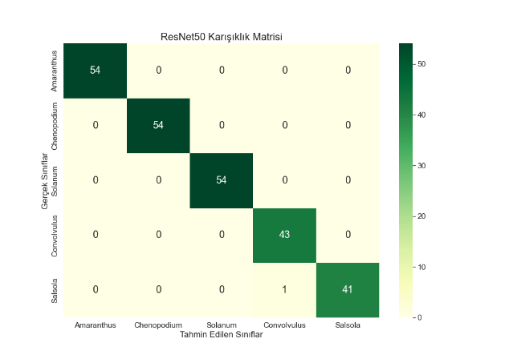
MobileNetV3(A) ResNet50(B)
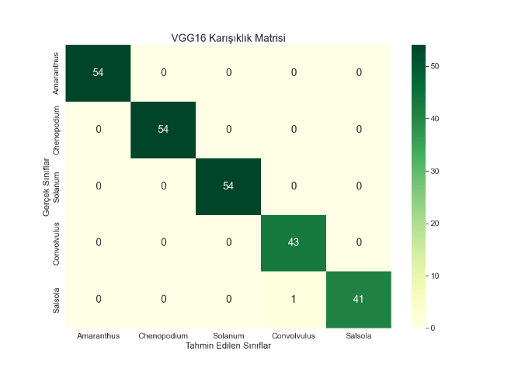
VGG16(C)
According to Table 5, MobileNetV3 presented constant high performance across all categories. The model indicated high precision scores ranging from 93.1% to 100.0%, with F1-scores consistently maintaining results above 96% for all species. Notably, for Solanum nigrum and Convolvulus arvensis, the model achieved perfect precision, while maintaining recall scores of 94.4% and 95.3%, respectively.
Moving to ResNet50, the results can be considered optimal for classification purposes. It achieved perfect precision , recall, and F1-scores across Amaranthus retroflexus, Chenopodium album and Solanum nigrum. For the remaining species, the metrics maintained high scores, with F1-scores of 98.9% and 98.8%, and recall scores of 100.0% and 97.6%, respectively. These results suggest that model fully resolved the details of primary dataset.
Finally, VGG16 performed optimal results similar to the ResNet50 as well. Identical to ResNet50, it achieved perfect precision, recall, and F1-scores across Amaranthus retroflexus, Chenopodium album and Solanum nigrum. For the remaining species, the metrics maintained high scores, with F1-scores of 98.9% and 98.8%, and recall scores of 100.0% and 97.6%, respectively. Notably, Precision metric of Convolvulus arvensis is slightly lower than ResNet50, with VGG16 achieving precision score of 97.7%, while maintaining a perfect recall of 100.0%. These results suggest that this model as well fully resolved the details of the primary dataset.

Table 5: Evaluation Metrics for the Performance of Models
Model | Class | Precision | Recall | F1-Score
 | Amaranthus retroflexus | 0.931 | 1.000 | 0.964
 | Chenopodium album | 0.981 | 0.963 | 0.972
MobileNetV3 | Solanum nigrum | 1.000 | 0.944 | 0.971
 | Convolvulus arvensis | 1.000 | 0.953 | 0.976
 | Salsola kali | 0.955 | 1.000 | 0.977
 | Amaranthus retroflexus | 1.000 | 1.000 | 1.000
 | Chenopodium album | 1.000 | 1.000 | 1.000
ResNet50 | Solanum nigrum | 1.000 | 1.000 | 1.000
 | Convolvulus arvensis | 0.978 | 1.000 | 0.989
 | Salsola kali | 1.000 | 0.976 | 0.988
 | Amaranthus retroflexus | 1.000 | 1.000 | 1.000
 | Chenopodium album | 1.000 | 1.000 | 1.000
VGG16 | Solanum nigrum | 1.000 | 1.000 | 1.000
 | Convolvulus arvensis | 0.977 | 1.000 | 0.989
 | Salsola kali | 1.000 | 0.976 | 0.988

The final table summarizes the overall performance of all three models on the primary dataset. It can be observed that MobileNetV3 achieved a remarkable testing accuracy of 97.2% with a loss of 0.190, indicating effective convergence. Meanwhile, ResNet50 and VGG16 demonstrated near-perfect performance, both reaching a testing accuracy of 99.6% with minimal losses of 0.034 and 0.040, respectively.
Table 6: Overall performance of models
Model | Train Acc | Train Loss | Val Acc | Val Loss | Test Acc | Test Loss
MobileNetV3 | 0.922 | 0.367 | 0.972 | 0.206 | 0.972 | 0.190
ResNet50 | 0.988 | 0.070 | 0.992 | 0.030 | 0.996 | 0.034
VGG16 | 0.989 | 0.029 | 0.996 | 0.029 | 0.996 | 0.040

