EVENTFLOW AI
Enterprise AI-Powered Event & Festival Management Platform
High Level Design (HLD) Document

Version 1.3 | Approved for Engineering Review
07 July 2026
Office of the Chief Architect
Confidential - Internal & Licensed Partner Use Only

Confidentiality Statement
This document, and all information contained within it, constitutes confidential and proprietary information of EventFlow AI and its parent organization. It is provided solely for the purpose of enabling authorized personnel - solution architects, engineers, security reviewers, and executive stakeholders - to design, build, secure, and operate the EventFlow AI platform.
This document must not be reproduced, distributed, or disclosed, in whole or in part, to any third party without prior written authorization from the Office of the Chief Architect. Recipients of this document are bound by their existing confidentiality and intellectual property agreements with the organization.
Any architectural diagrams, technology decisions, risk assessments, or strategic roadmap content contained herein reflect the state of the architecture as of the version and date noted on the cover page and Version History (Section 4), and are subject to change as the platform evolves. This document does not constitute a contractual commitment to any specific feature, timeline, or service level; such commitments are governed exclusively by applicable customer agreements and statements of work.
If you have received this document in error, please notify the Office of the Chief Architect immediately and destroy all copies in your possession.

Document Information
Field | Value
Document Title | EventFlow AI - High Level Design Document
Product | EventFlow AI - Enterprise AI-Powered Event & Festival Management Platform
Document Type | High Level Design (HLD)
Intended Audience | Solution Architects, Backend/Frontend/AI Engineers, DevOps, Security, QA, Technical Leads, CTOs, Investors
Confidentiality | Confidential - Internal & Licensed Partner Use Only
Current Version | 1.3
Status | Approved for Engineering Review
Owning Team | Office of the Chief Architect
Review Cycle | Quarterly, or upon major architectural change
Related Documents | Low Level Design (LLD), API Specification (OpenAPI 3.1), Database ERD, Security Threat Model, Non-Functional Requirements (NFR) Register

Version History
Version | Date | Author | Description
0.1 | 12 Feb 2026 | Chief Architect Office | Initial draft: scope, modules, tech stack
0.5 | 04 Mar 2026 | Solution Architecture Team | Added multi-tenant model and database architecture
0.8 | 22 Apr 2026 | AI Systems Architecture Team | Added AI agent orchestration and tool calling design
1.0 | 18 May 2026 | Chief Architect Office | First baselined release for stakeholder review
1.1 | 02 Jun 2026 | Security Architecture Team | Expanded security, RBAC, and audit sections
1.2 | 20 Jun 2026 | DevOps Architecture Team | Added CI/CD, infrastructure, and DR/backup strategy
1.3 | 07 Jul 2026 | Chief Architect Office | Final consistency pass; approved for engineering review

Table of Contents
The interactive table of contents below is generated from this document's heading structure. In Microsoft Word, right-click the field and select "Update Field" (or press F9) to refresh page numbers after any edits.

6. Executive Summary
EventFlow AI is a production-grade, multi-tenant, AI-augmented Software-as-a-Service platform purpose-built for the administration of educational institutions, competitive festivals, and large-scale events. The platform unifies student and staff management, event scheduling, judging and adjudication, results processing, certificate issuance, analytics, and organizational communication into a single, coherent system of record, while layering a governed AI agent framework on top to automate validation, scheduling assistance, results analysis, and natural-language administration.
The platform is architected as a modular monolith following Clean Architecture and Domain-Driven Design principles, explicitly engineered so that individual bounded contexts (Registrations, Scheduling, Judging, Certificates, AI Orchestration, and so on) can be extracted into independent microservices as the organization's scale and team topology mature, without requiring a rewrite of core business logic. This document formalizes that architecture at a level of detail suitable for immediate engineering execution: it enumerates every major subsystem, the responsibilities and boundaries of each, the technologies selected and the rationale behind them, the communication patterns between components, and the operational strategies (scalability, availability, disaster recovery, security, and deployment) required to run the platform commercially at enterprise scale.
EventFlow AI is designed from day one for strict multi-tenant isolation on a shared PostgreSQL database using a discriminator-column (row-level) tenancy model reinforced by database-level Row Level Security policies, tenant-aware middleware, and a tenant-scoped ORM manager. This approach was selected over dedicated-schema or dedicated-database tenancy because it minimizes operational overhead and infrastructure cost while still providing strong logical isolation guarantees appropriate for the platform's target customer segment (schools, festival boards, and competition organizers), with a documented migration path to schema-per-tenant or database-per-tenant isolation for enterprise customers with elevated compliance requirements.
The AI subsystem is treated as a first-class architectural concern rather than a bolt-on feature. A provider-abstraction layer decouples the platform's business logic from any single large language model vendor, currently supporting OpenAI and Google Gemini, with a documented extension path to self-hosted models via Ollama and to the Model Context Protocol (MCP) for standardized tool interoperability. Six purpose-built AI agents - Registration Validation, Scheduling Assistant, Result Analysis, Certificate Verification, Announcement Generation, and a Natural Language Admin Assistant - are orchestrated through a common Agent Orchestrator, Tool Registry, Context Builder, and Guardrails pipeline, ensuring every AI-driven action is auditable, reversible where required, and bounded by explicit tool permissions rather than open-ended model autonomy.
This document targets a commercial, revenue-bearing deployment, not a prototype. Every architectural decision recorded here - from connection pooling strategy to disaster recovery RTO/RPO targets to the CI/CD approval gates - reflects assumptions appropriate for a SaaS vendor operating under customer contracts, data protection obligations, and uptime commitments. Readers should treat this HLD as the authoritative architectural contract between product, engineering, security, and operations until superseded by a later version.

7. Architecture Goals
The following goals were established at the outset of the EventFlow AI architecture process and are used as the evaluation criteria for every major design decision recorded in this document.
Goal | Description | Primary Measure of Success
Multi-Tenant Scalability | Support hundreds of independent organizations on shared infrastructure without cross-tenant data leakage or noisy-neighbor performance degradation. | P95 API latency stable within 10% as tenant count grows 10x
Modular Extensibility | Every domain module (Events, Judging, Certificates, AI, etc.) must be independently testable and extractable into a microservice without touching unrelated modules. | Zero cross-module import violations enforced by architecture tests
AI Governance & Safety | AI agents must operate within an explicit, auditable tool permission boundary; no agent may take irreversible action without a defined approval or validation gate. | 100% of AI-initiated mutations traceable in the audit log
Security by Design | Authentication, authorization, tenant isolation, and data protection must be enforced at the framework level, not left to individual developers per endpoint. | Zero critical findings in quarterly OWASP-aligned penetration tests
Operational Resilience | The platform must tolerate the failure of any single node, availability zone, or dependent service without data loss and with bounded downtime. | RTO under 1 hour, RPO under 15 minutes for the primary database
Developer Velocity | New features should be shippable by a single feature team without requiring coordinated deploys across unrelated modules. | Lead time from PR merge to production under 30 minutes via CI/CD
Commercial Viability | Infrastructure cost per tenant must decrease as the platform scales, supporting healthy SaaS gross margins. | Infrastructure cost per active organization trending downward release over release
Cloud Portability | The architecture must not be structurally locked to a single cloud vendor; all cloud-native primitives used must have equivalent offerings on AWS, Azure, and GCP. | Reference deployment validated on at least two cloud providers

8. Design Principles
EventFlow AI's architecture is grounded in a consistent set of software engineering principles, applied uniformly across all nineteen platform modules and the AI subsystem. The table below maps each principle to its concrete application within the codebase.
Principle | How It Is Applied in EventFlow AI
Clean Architecture | Domain entities and business rules live in a framework-independent core; Django, DRF, Celery, and external AI providers are treated as replaceable infrastructure adapters at the outer layer.
Domain-Driven Design | The platform is decomposed into bounded contexts that map directly to the module list (Organization, Academic Year, Events, Judging, Certificates, AI, etc.), each with its own ubiquitous language and aggregate roots.
Service Layer Pattern | All business logic is encapsulated in service classes invoked by DRF views; views remain thin controllers responsible only for HTTP concerns (parsing, serialization, status codes).
Repository Pattern (Selective) | Applied for aggregates with complex querying or multiple data sources (Analytics, Audit, AI Conversation Memory); simple CRUD-heavy entities use the Django ORM directly to avoid unnecessary indirection.
SOLID Principles | Single Responsibility is enforced via one-service-per-use-case; Dependency Inversion underlies the AI Provider Abstraction and Notification Channel abstraction so concrete vendors can be swapped without touching callers.
DRY | Shared cross-cutting concerns (tenant resolution, permission checks, audit logging, notification templating) are implemented once as reusable middleware, mixins, and base classes rather than duplicated per module.
KISS | Where a pattern would add indirection without a corresponding scalability or testability benefit (e.g. simple lookup tables), the simplest Django idiom is used rather than defaulting to full hexagonal ceremony.
API-First Design | Every module exposes its capability first as a versioned REST contract (OpenAPI 3.1); the React frontend and AI tool layer are both first-class consumers of the same public API surface, not privileged internal callers.
Modular Monolith | All modules are deployed as a single Django project with strict internal module boundaries enforced by import-linter rules, giving microservice-grade separation without premature distributed-systems complexity.
Future Microservice Ready | Each bounded context communicates internally through service interfaces and domain events, so it can be lifted into an independent service behind the same interface with minimal call-site changes.
Event-Driven Architecture | State-changing operations publish domain events (via Django signals bridged to Celery) consumed by Notification, Audit, Analytics, and AI Trigger handlers, decoupling side effects from the originating transaction.
Twelve-Factor App | Configuration via environment variables, strict dev/stage/prod parity through Docker images, stateless application processes, and logs treated as event streams shipped to a centralized collector.
Cloud-Native Design | Stateless, horizontally scalable application containers; externalized session and cache state in Redis; managed database and object storage services; health checks and graceful shutdown for orchestrator compatibility.

9. Architecture Overview
EventFlow AI is organized into five logical layers: the Client Layer (React/TypeScript single-page application), the Edge Layer (CDN, load balancer, WAF and rate limiting), the Application Layer (the Django modular monolith exposing a DRF API, encompassing authentication, tenant resolution, domain services, and AI orchestration), the Asynchronous Layer (Celery workers and the Celery Beat scheduler for background and scheduled processing), and the Data Layer (PostgreSQL for system-of-record data, Redis for caching, session, broker and AI memory concerns, and object storage for binary assets such as certificates and uploaded media).
Within the Application Layer, the platform is further decomposed into nineteen cooperating modules - Authentication, RBAC, Organization, Academic Year, Students, Teachers, Teams, Houses, Festivals, Events, Registrations, Scheduling, Venues, Judging, Results, Certificates, Reports, Analytics, Notifications, Dashboard, Audit Logs, and the AI Module - each implemented as a self-contained Django app with its own models, serializers, service layer, and test suite. Cross-module communication is deliberately restricted to well-defined service interfaces and domain events; direct ORM queries across module boundaries are prohibited and enforced through automated import-boundary linting in CI.
The AI Module sits alongside, not inside, the domain modules: it does not own business data, but instead orchestrates calls into the domain service layer through a governed Tool Registry, ensuring that AI agents operate through the same validated, permissioned code paths as human users rather than through privileged backdoors. This design guarantees that every AI-initiated action is subject to the same authorization, validation, and audit logging as an equivalent human-initiated action.
The platform is deployed as a set of Docker containers (Nginx, Gunicorn/Django, Celery workers, Celery Beat) behind a load balancer, backed by managed PostgreSQL and Redis services, with GitHub Actions driving a fully automated build, test, and deployment pipeline. The architecture is explicitly cloud-agnostic: every managed service referenced in this document (relational database, in-memory cache, object storage, secrets manager, container registry) has direct equivalents across AWS, Azure, and GCP, and the reference deployment topology in Section 45 is expressed in vendor-neutral terms with cloud-specific notes.
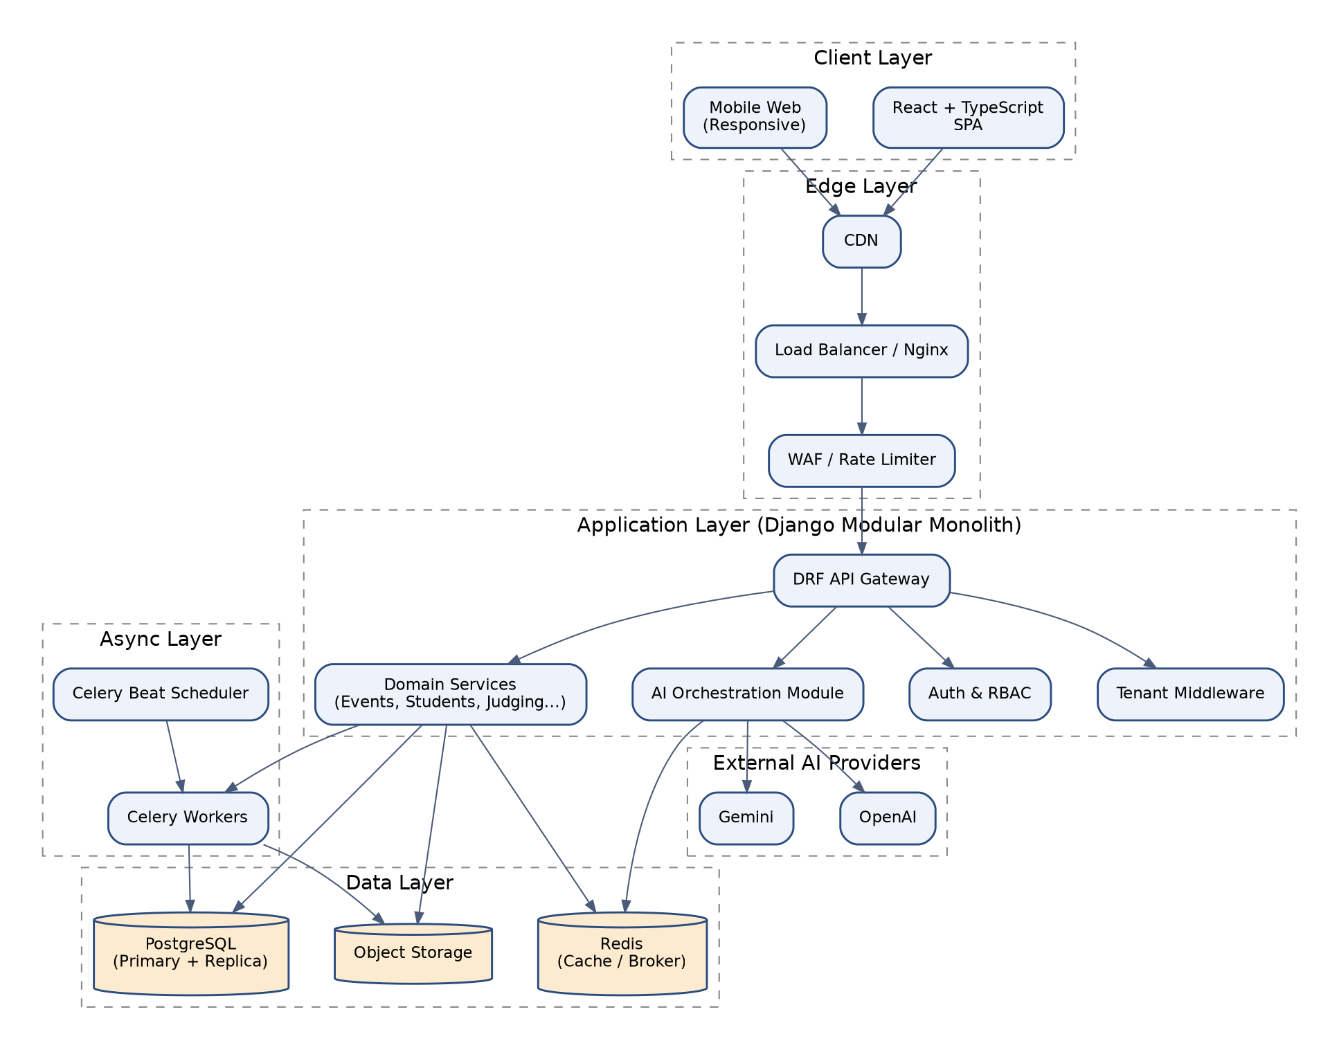
Figure 9.1 - Architecture Overview (see Section 11 for full detail)

10. System Context Diagram
The System Context Diagram establishes the outermost boundary of EventFlow AI, identifying every human actor and external system that interacts with the platform. It is the reference point for all subsequent, more detailed diagrams in this document.
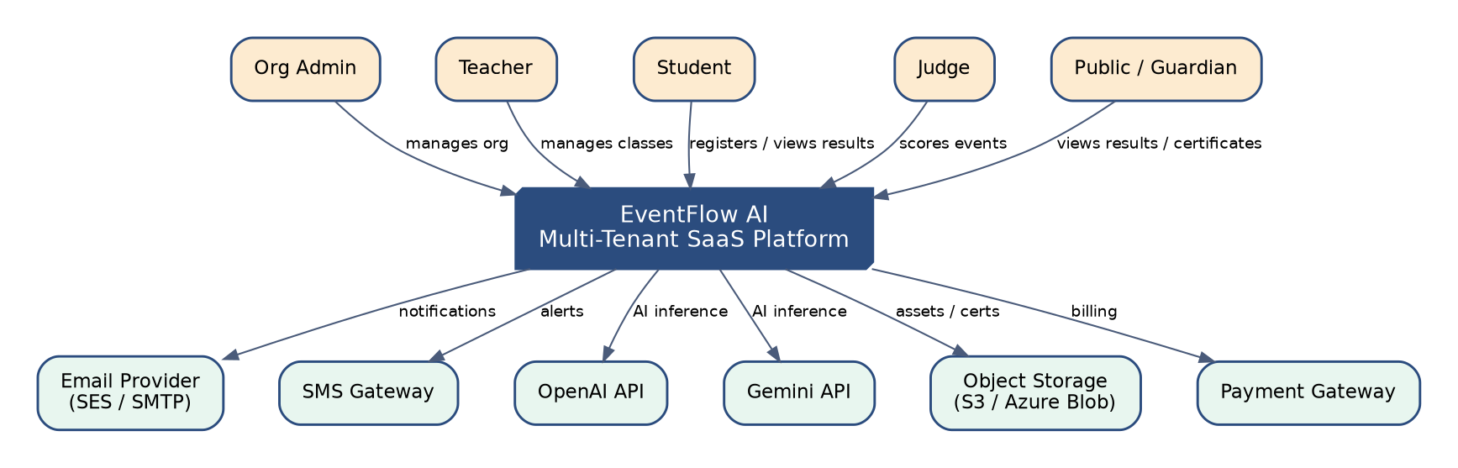
Figure 10.1 - System Context Diagram

Purpose
To define the platform's boundary, its human actors, and the external systems it depends on, providing a shared mental model for all stakeholders before any internal decomposition is introduced.

Responsibilities
- Enumerate all actor classes: Organization Admin, Teacher, Student, Judge, and Public/Guardian users.
- Enumerate all external system dependencies: email provider, SMS gateway, AI providers, object storage, and payment gateway.
- Establish the trust boundary that all subsequent architecture diagrams operate within.

Components
- Actors: Org Admin, Teacher, Student, Judge, Public/Guardian.
- The EventFlow AI system boundary itself.
- External systems: Email Provider, SMS Gateway, OpenAI, Gemini, Object Storage, Payment Gateway.

Dependencies
- Email delivery provider (Amazon SES or SMTP relay) for transactional email.
- SMS gateway for critical alerts (registration deadlines, result publication).
- OpenAI and Gemini APIs for AI inference.
- Object storage provider for certificates, media, and document uploads.
- A PCI-compliant payment gateway for subscription and event-fee billing.

Technology
C4-model System Context notation rendered via Graphviz; no runtime technology is implied at this level of abstraction.

Communication Pattern
All actor-to-system communication occurs over HTTPS via the public API and web application. All system-to-external-system communication occurs over authenticated HTTPS APIs, with webhooks used for asynchronous callbacks (e.g. payment confirmation, email bounce notifications).

Advantages
- Gives non-technical stakeholders (CTOs, investors) an accessible entry point into the architecture.
- Forces explicit identification of every external dependency early, surfacing vendor risk before deep design work begins.

Limitations
- Deliberately omits internal structure, so it cannot answer questions about scalability or component responsibility on its own.
- Must be kept in sync manually as new external integrations are added.

Future Scalability
As EventFlow AI adds integrations (calendar sync, SSO identity providers, learning management systems), this diagram is the first artifact updated, ensuring the context boundary remains the canonical map of external coupling.

11. High Level Architecture Diagram
The High Level Architecture Diagram decomposes the system boundary from Section 10 into its five logical layers, showing the primary flow of control from client through edge, application, asynchronous, and data layers, including the AI provider boundary.

Figure 11.1 - High Level Architecture Diagram

Purpose
To communicate the platform's macro-structure - how the client, edge, application, async, and data layers cooperate - as the primary architectural reference for engineering onboarding and design reviews.

Responsibilities
- Depict the Client Layer (React SPA, mobile web).
- Depict the Edge Layer (CDN, load balancer, WAF/rate limiter).
- Depict the Application Layer (API gateway, auth/RBAC, tenant middleware, domain services, AI orchestration).
- Depict the Async Layer (Celery workers, Celery Beat).
- Depict the Data Layer (PostgreSQL, Redis, object storage) and external AI providers.

Components
- React/TypeScript SPA and mobile web client.
- CDN, load balancer, and WAF.
- DRF API Gateway, Auth & RBAC, Tenant Middleware, Domain Services, AI Orchestration Module.
- Celery Workers and Celery Beat scheduler.
- PostgreSQL (primary/replica), Redis, Object Storage.
- OpenAI and Gemini as external AI providers.

Dependencies
- Application Layer depends on Data Layer for all persistence and caching.
- AI Orchestration depends on external AI providers and Redis for conversation memory.
- Async Layer depends on Redis as its message broker and result backend.

Technology
React 18 + TypeScript + Tailwind CSS; Nginx and a CDN at the edge; Django 5 + Django REST Framework on Gunicorn; Celery 5 with Redis broker; PostgreSQL 15+; Redis 7+; S3-compatible object storage.

Communication Pattern
Synchronous HTTPS/REST from client to API Gateway; synchronous internal Python calls between API views and domain services; asynchronous message-passing (via Redis-backed queues) from domain services to Celery workers; synchronous HTTPS from AI Orchestration to external LLM providers with streaming support where applicable.

Advantages
- Single diagram communicates 90% of onboarding context for new engineers.
- Clear separation of synchronous request/response concerns from asynchronous background processing.
- AI is shown as a peer module to domain services rather than a special-cased subsystem, reinforcing governed access.

Limitations
- Does not show tenant-level data partitioning (see Section 22).
- Does not show deployment topology or redundancy (see Sections 14 and 45).

Future Scalability
Individual boxes in this diagram (e.g. Domain Services, AI Orchestration) are designed to become independently deployable services; the diagram's layering is preserved even after such an extraction, only the deployment unit boundary changes.

12. Logical Architecture
The logical architecture describes how EventFlow AI's source code is organized into layers and modules independent of any deployment concern, forming the basis for the Clean Architecture and DDD principles adopted platform-wide.

Purpose
To define the internal code organization - domain, application, infrastructure, and interface layers - so that business logic remains independent of Django, DRF, Celery, and any specific AI vendor.

Responsibilities
- Isolate domain entities and business rules from framework code.
- Define the service layer as the single entry point for use-case execution.
- Define the interface layer (DRF views/serializers) as a thin adapter over the service layer.
- Define the infrastructure layer (ORM models, external API clients) as replaceable adapters.

Components
- Domain layer: plain Python entities, value objects, and domain events per bounded context.
- Application/service layer: use-case classes orchestrating one or more domain operations.
- Interface layer: DRF ViewSets, Serializers, permission classes.
- Infrastructure layer: Django ORM models, Celery tasks, AI provider adapters, notification channel adapters.

Dependencies
- Interface layer depends on the service layer, never the reverse.
- Service layer depends on domain interfaces (repositories, gateways), not concrete infrastructure classes, honoring the Dependency Inversion Principle.

Technology
Plain Python 3.12 for the domain layer; Django ORM for persistence adapters; DRF for the interface layer; dependency injection achieved via Django app configuration and factory functions rather than a heavyweight DI framework.

Communication Pattern
Strict downward dependency flow: Interface -> Application -> Domain, with Infrastructure implementing interfaces defined by the Application/Domain layers and injected at runtime.

Advantages
- Business logic is unit-testable without a database or HTTP server.
- Framework upgrades (Django major versions) or infrastructure swaps (e.g. switching AI vendors) touch only the outer layers.
- New engineers can reason about a single bounded context without loading the entire codebase mentally.

Limitations
- Requires discipline; without automated import-boundary checks, layering can erode over time.
- Adds a small amount of indirection (interfaces, factories) that is unnecessary for the simplest CRUD modules.

Future Scalability
Because business logic never imports Django or DRF directly, extracting a bounded context into a standalone service (e.g. FastAPI-based) later requires only rewriting the thin infrastructure and interface layers, not the domain logic itself.

13. Physical Architecture
The physical architecture maps the logical layers onto concrete runtime processes, containers, and network zones, describing what actually executes where.

Purpose
To specify the physical distribution of the system across processes, containers, and network segments, providing the bridge between the logical architecture and the deployment/infrastructure architecture.

Responsibilities
- Map application code to Gunicorn worker processes inside application containers.
- Map background processing to Celery worker and Celery Beat containers.
- Map data persistence to managed PostgreSQL and Redis instances in a private network segment.
- Define network zone boundaries (public, application, data).

Components
- Public zone: CDN, load balancer, WAF.
- Application zone: Nginx + Gunicorn + Django containers, Celery worker and Beat containers.
- Data zone: PostgreSQL primary/replica, Redis cluster, object storage - all reachable only from the application zone.

Dependencies
- Application zone containers depend on network routes to the data zone secured via security groups/firewall rules.
- All zones depend on a private VPC/VNet with no direct public ingress to the data zone.

Technology
Docker containers orchestrated via Docker Compose for staging and a managed container platform (ECS/AKS/GKE or Kubernetes) for production; VPC/VNet network isolation; security groups/NSGs for zone-to-zone access control.

Communication Pattern
Public zone communicates with the application zone over HTTPS on standard ports; application zone communicates with the data zone over internal-only TCP (5432 for PostgreSQL, 6379 for Redis) with TLS in transit for managed services that support it.

Advantages
- Clear network segmentation reduces blast radius of a compromised application container.
- Physical mapping is decoupled from logical architecture, allowing infrastructure changes without code changes.

Limitations
- Adds operational complexity (network policy management) relative to a single flat network.
- Requires careful IP address and subnet planning as the platform scales across regions.

Future Scalability
The three-zone model extends cleanly to multi-region deployment by replicating the application zone per region while keeping a single data zone (or region-local read replicas) as the source of truth.

14. Deployment Architecture
The deployment architecture describes how EventFlow AI is distributed across availability zones for resilience, with redundant application and worker nodes fronted by a load balancer and backed by a replicated database tier.
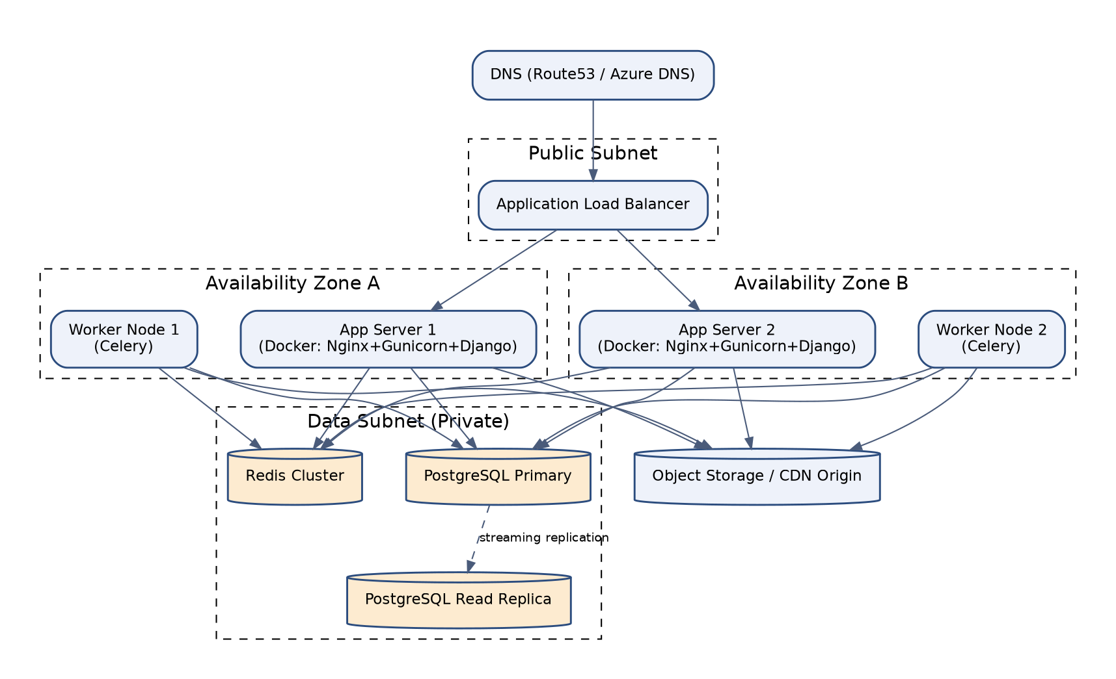
Figure 14.1 - Deployment Architecture

Purpose
To define the concrete, highly-available runtime topology used in production, ensuring no single node or availability zone failure causes a full outage.

Responsibilities
- Distribute application and worker nodes across at least two availability zones.
- Route traffic through a load balancer with health-check-based failover.
- Replicate the primary database to a standby/read replica in a separate zone.
- Terminate TLS at the load balancer and enforce HTTPS end-to-end.

Components
- DNS (Route 53 / Azure DNS / Cloud DNS).
- Application Load Balancer.
- App Server nodes (Nginx + Gunicorn + Django) per zone.
- Worker nodes (Celery) per zone.
- PostgreSQL primary and read replica.
- Redis cluster.
- Object storage / CDN origin.

Dependencies
- Load balancer depends on health-check endpoints exposed by each app node.
- Worker nodes depend on the same Redis broker and PostgreSQL primary as app nodes.
- Cross-zone replication depends on adequate network bandwidth and low inter-AZ latency.

Technology
AWS ALB/Azure Application Gateway/GCP Load Balancing; EC2/VM Scale Sets/Compute Engine or container platform equivalents; managed PostgreSQL with synchronous or asynchronous streaming replication; managed Redis with cluster mode.

Communication Pattern
Active-active for application and worker nodes (both zones serve traffic concurrently); active-passive for the database tier (writes go to the primary; the replica serves read-heavy queries and stands ready for promotion).

Advantages
- Tolerates a full availability zone outage with no data loss and minimal service interruption.
- Horizontal scaling is achieved simply by adding nodes behind the existing load balancer.

Limitations
- Read replica introduces potential replication lag, which must be accounted for in read-after-write consistency-sensitive flows.
- Cross-zone data transfer incurs cloud provider network costs.

Future Scalability
The topology extends to a third availability zone or to multiple regions with minimal redesign; automated failover/promotion tooling (e.g. Patroni or the cloud provider's managed failover) is the natural next step as availability targets tighten.

15. Container Architecture
The container architecture zooms into the C4 'container' level, showing each independently deployable runtime unit - web server, application server, worker, scheduler, database, cache, monitoring - and how they communicate.
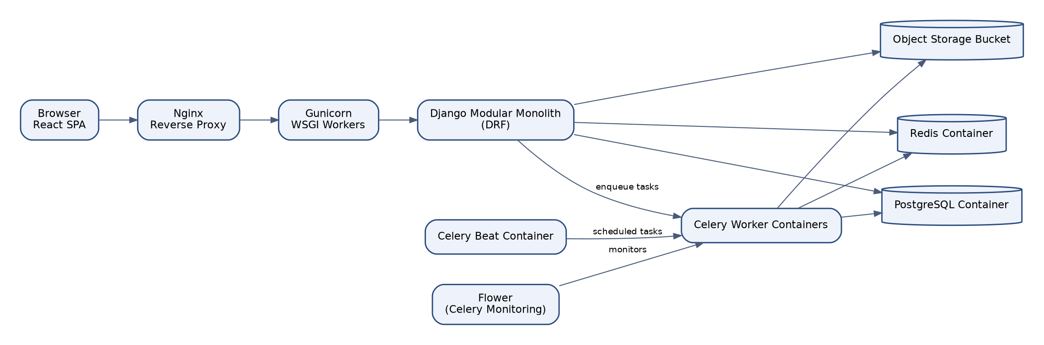
Figure 15.1 - Container Architecture (C4 Container View)

Purpose
To enumerate every independently deployable and independently scalable runtime unit in the system and their direct communication paths.

Responsibilities
- Define the Nginx reverse proxy container's responsibility for static asset serving, TLS termination (or pass-through), and request forwarding.
- Define the Gunicorn/Django container as the WSGI application server executing business logic.
- Define Celery worker and Beat containers for asynchronous and scheduled processing.
- Define Flower as the operational monitoring container for Celery.

Components
- Nginx container.
- Gunicorn/Django container (the modular monolith).
- Celery worker container(s).
- Celery Beat container.
- Flower container.
- PostgreSQL container/managed service.
- Redis container/managed service.
- Object storage bucket.

Dependencies
- Gunicorn/Django depends on PostgreSQL, Redis, and object storage.
- Celery workers depend on the same PostgreSQL, Redis, and object storage as the Django container to share business logic and models.
- Flower depends on Redis to introspect queue and worker state.

Technology
Nginx 1.25+; Gunicorn with sync or gevent workers tuned to CPU core count; Celery 5.x; Flower for operational visibility; Docker images built from a shared base image to minimize drift between the Django and Celery containers.

Communication Pattern
Nginx-to-Gunicorn over a Unix socket or loopback TCP; Django-to-Celery via Redis-backed task messages (fire-and-forget or with result backend polling); Flower polls Redis directly for read-only monitoring.

Advantages
- Each container can be scaled independently based on its own resource profile (e.g. more Celery workers for AI-heavy workloads without scaling web-facing Gunicorn nodes).
- Shared base image and shared Python codebase between Django and Celery containers eliminates model/schema drift.

Limitations
- Sharing a single Docker image/codebase between web and worker containers means a full redeploy is required for changes to either, until they are split into independent deployables.
- Flower must be secured behind authentication as it exposes operational task detail.

Future Scalability
As specific task types (e.g. AI inference tasks) grow disproportionately, they can be split into dedicated worker containers with their own image and scaling policy without affecting the web-serving container, as previewed in the Celery Architecture (Section 25).

16. Component Architecture
The component architecture illustrates the internal decomposition of a representative module - the AI Module - into its constituent components: orchestrator, tool registry, context builder, prompt store, memory, guardrails, and provider abstraction.
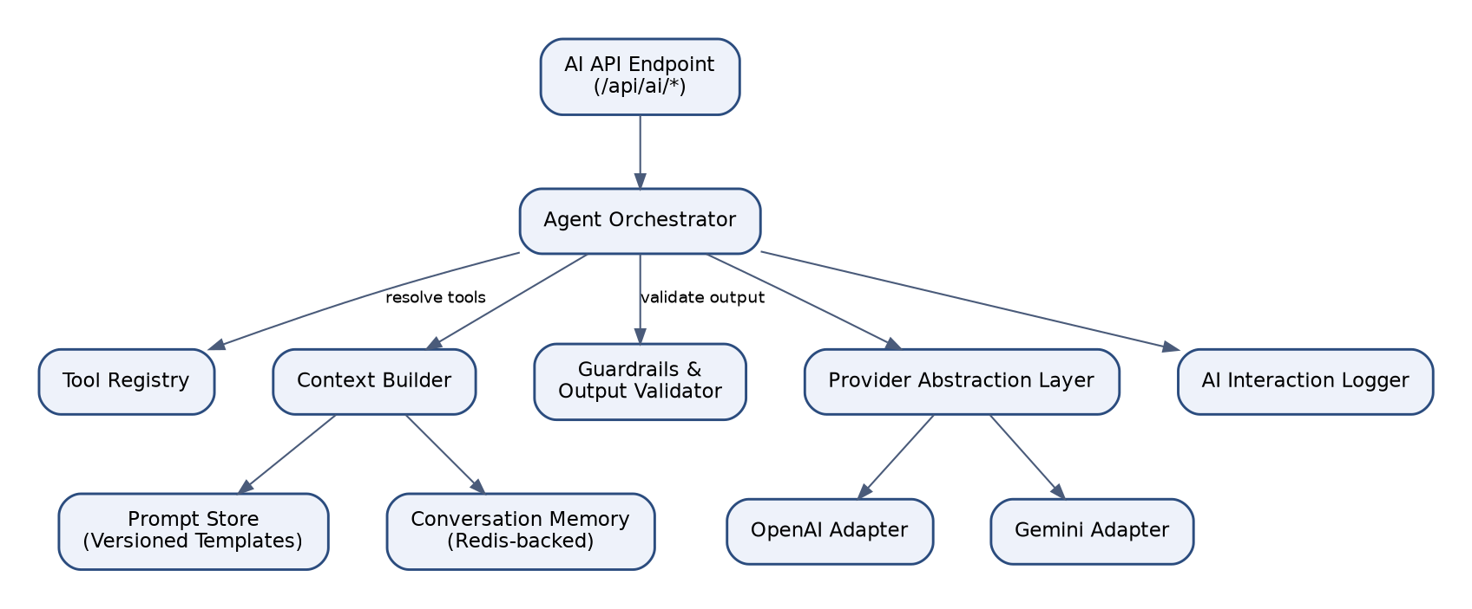
Figure 16.1 - Component Architecture (AI Module Detail)

Purpose
To show, at the finest C4 grain used in this document, how a single module's internal classes and services collaborate to fulfill its responsibilities.

Responsibilities
- Route incoming AI requests to the Agent Orchestrator.
- Build request context from the Prompt Store and Conversation Memory.
- Resolve permitted tools via the Tool Registry.
- Validate model output via Guardrails before returning a response.
- Delegate provider-specific calls to the Provider Abstraction layer.

Components
- AI API Endpoint.
- Agent Orchestrator.
- Tool Registry.
- Context Builder.
- Prompt Store (versioned templates).
- Conversation Memory (Redis-backed).
- Guardrails & Output Validator.
- Provider Abstraction Layer with OpenAI and Gemini adapters.
- AI Interaction Logger.

Dependencies
- Context Builder depends on the Prompt Store and Conversation Memory.
- Agent Orchestrator depends on the Tool Registry to resolve which domain operations an agent may invoke.
- Provider Abstraction depends on tenant-level AI configuration (model, API key, temperature) stored in the Organization module.

Technology
Python service classes implementing a common AIAgent interface; Redis for conversation memory with TTL-based expiry; JSON Schema for tool definitions consumed by both OpenAI function-calling and Gemini function-calling formats.

Communication Pattern
Synchronous request/response within a single Django process for lightweight agent calls; asynchronous (Celery-dispatched) execution for longer-running agents such as Result Analysis and Announcement Generation, with polling or webhook-based completion notification to the client.

Advantages
- Every AI component has a single, well-defined responsibility, mirroring the Service Layer pattern used across the rest of the platform.
- The same component decomposition template applies to every other module, giving engineers a consistent mental model across the codebase.

Limitations
- The AI Module's component count is higher than a typical CRUD module, increasing onboarding time specifically for AI feature work.
- Conversation Memory's Redis dependency means AI context is best-effort persistent, not durable, by design.

Future Scalability
New AI agents are added by implementing the common AIAgent interface and registering with the Agent Selector, without modifying the Orchestrator, Tool Registry, or Provider Abstraction, satisfying the Open/Closed Principle.

17. Module Interaction Diagram
The module interaction diagram shows the directed dependency graph between all nineteen platform modules, confirming that dependencies flow in one direction (avoiding cycles) and that AI and Audit act as cross-cutting observers rather than upstream dependencies.
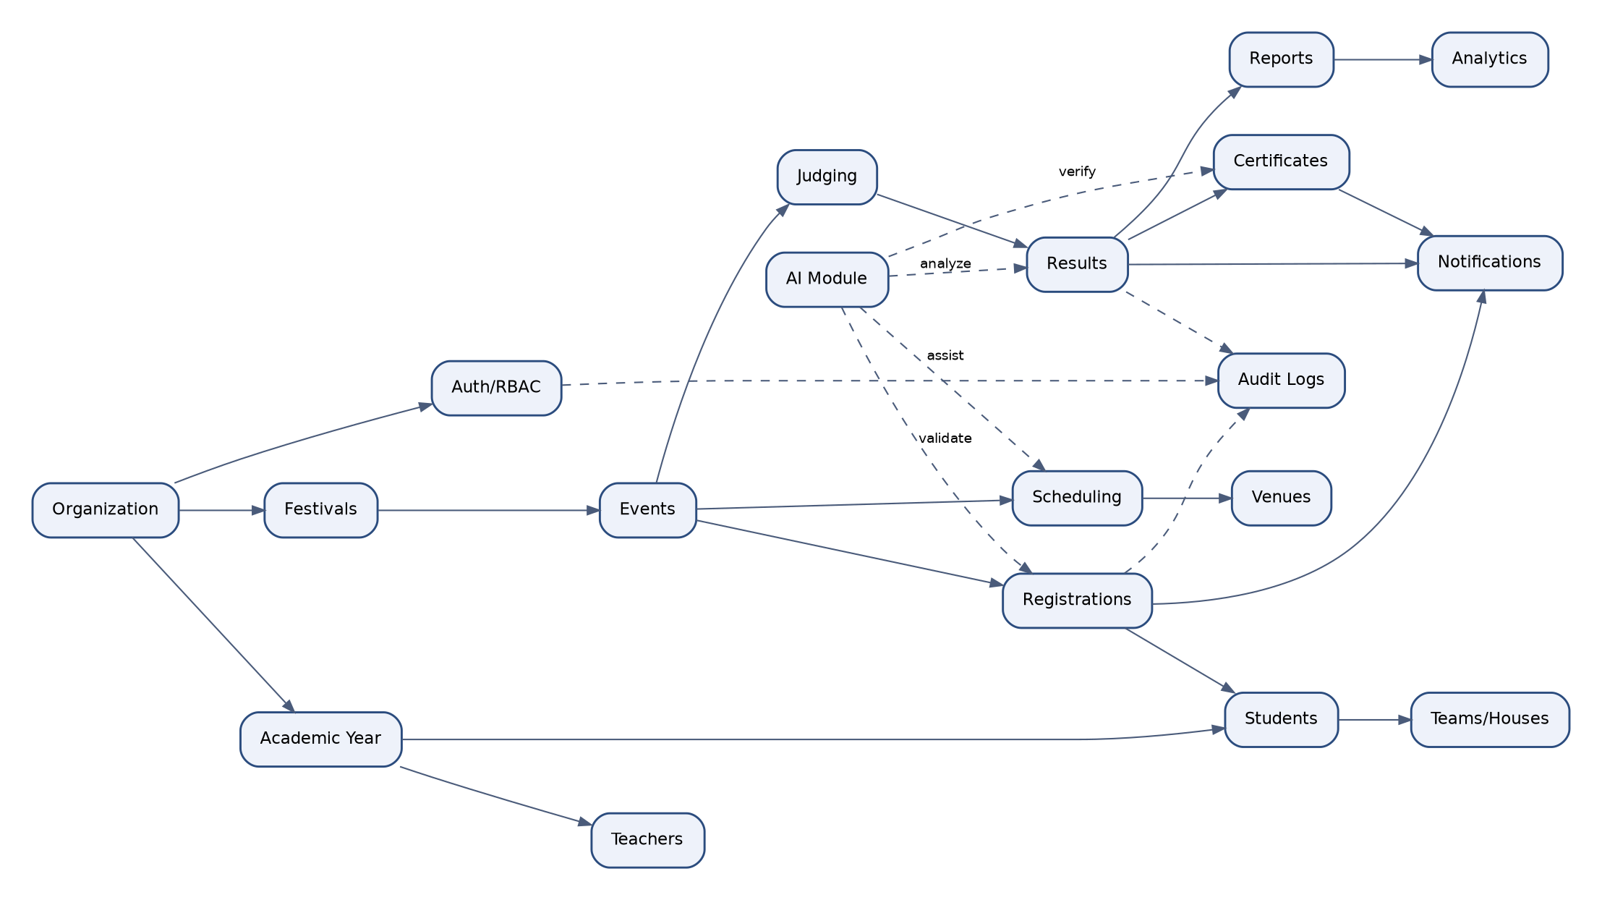
Figure 17.1 - Module Interaction Diagram

Purpose
To validate and communicate the allowed dependency graph between modules, forming the basis for the automated import-boundary linting rules enforced in CI.

Responsibilities
- Document which modules may call which other modules' service layers directly.
- Identify cross-cutting modules (AI, Audit, Notifications) that observe events from many modules but are not depended upon by core domain logic.
- Prevent circular dependencies between bounded contexts.

Components
- Core domain modules: Organization, Academic Year, Students, Teachers, Teams/Houses, Festivals, Events, Registrations, Scheduling, Venues, Judging, Results, Certificates, Reports, Analytics.
- Cross-cutting modules: Auth/RBAC, Notifications, AI Module, Audit Logs.

Dependencies
- Festivals and Events depend on Organization and Academic Year.
- Registrations depend on Events and Students.
- Judging depends on Events; Results depend on Judging; Certificates and Reports depend on Results.
- AI, Notifications, and Audit subscribe to events from core modules but are never imported by them.

Technology
import-linter (Python) configured with contract rules per module boundary, executed as a required CI check on every pull request.

Communication Pattern
Direct synchronous service-layer calls for same-transaction operations (e.g. Registrations calling into Events to check capacity); asynchronous domain events for cross-cutting concerns (e.g. Results publishing a ResultFinalized event consumed by Certificates, Notifications, Analytics, and AI).

Advantages
- Prevents architectural erosion by making illegal dependencies a build failure rather than a code review judgment call.
- Makes the true shape of the system visible and auditable at any time by regenerating this diagram from the import graph.

Limitations
- Requires ongoing maintenance of the import-linter contract file as new modules are added.
- Legitimate cross-module reads (e.g. a report needing data from five modules) must go through a dedicated read-model or query service rather than ad hoc joins.

Future Scalability
This dependency graph is precisely the seam along which future microservice extraction occurs: any module with no incoming synchronous dependencies from other modules (e.g. Analytics, AI) is the lowest-risk first candidate for extraction.

18. Service Communication Flow
This section formalizes the two communication patterns used between services: direct synchronous calls for consistency-critical operations, and asynchronous domain events for decoupled side effects, mediated by an internal event bus.
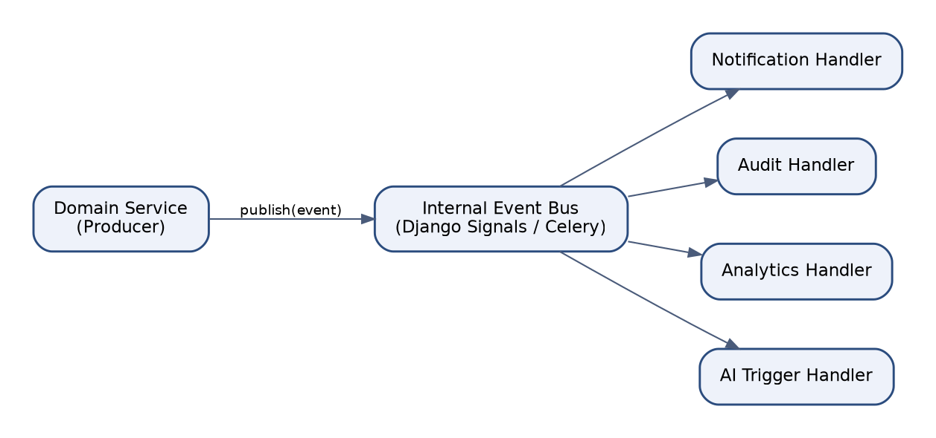
Figure 18.1 - Event-Driven Service Communication Flow

Purpose
To specify precisely when services communicate synchronously versus asynchronously, preventing ad hoc, inconsistent choices at the point of feature implementation.

Responsibilities
- Define the internal Event Bus (implemented via Django signals bridged to Celery) as the single mechanism for cross-module asynchronous communication.
- Classify each inter-module interaction as either a same-transaction synchronous call or a published domain event.
- Guarantee at-least-once delivery for domain events with idempotent consumer handlers.

Components
- Producer domain services (e.g. Results, Registrations).
- Internal Event Bus (Django signal dispatch -> Celery task enqueue).
- Consumer handlers: Notification Handler, Audit Handler, Analytics Handler, AI Trigger Handler.

Dependencies
- Event Bus depends on Redis as the Celery broker for durable, asynchronous delivery.
- Consumer handlers depend on idempotency keys embedded in each event payload to safely handle redelivery.

Technology
Django's built-in signal framework for in-process event emission; Celery tasks for the actual asynchronous dispatch and retry semantics; JSON-serialized event payloads with a versioned event schema.

Communication Pattern
Producer commits its database transaction, then emits a domain event; the event handler enqueues a Celery task per subscriber, each retried independently on failure with exponential backoff, isolating one subscriber's failure from others.

Advantages
- Decouples side effects (notify, audit, analyze) from the core transaction, keeping request latency low.
- New consumers (e.g. a future webhook-to-customer-system handler) can subscribe to existing events without modifying producers.

Limitations
- Eventual consistency window between the core transaction committing and side effects completing (typically sub-second to a few seconds).
- Requires disciplined event versioning to avoid breaking consumers when producer payloads evolve.

Future Scalability
The internal Event Bus is designed to be swapped for a dedicated message broker (e.g. Kafka or SNS/SQS) once event volume or the need for multi-service fan-out exceeds what Celery/Redis comfortably supports, without changing producer or consumer code, only the transport adapter.

19. Request Lifecycle
This section traces a single HTTP request end-to-end, from the client through Nginx, Gunicorn, the Django middleware stack, the DRF view/service layer, and back, making explicit every cross-cutting concern applied along the way.
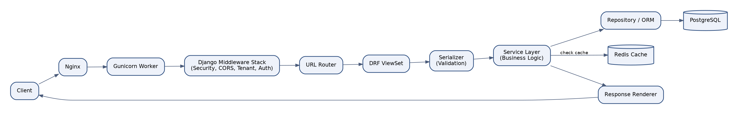
Figure 19.1 - Request Lifecycle

Purpose
To document the exact sequence of processing every request undergoes, so engineers can reason precisely about where to add new cross-cutting behavior (e.g. a new security header or logging concern).

Responsibilities
- Terminate/forward the connection at Nginx and Gunicorn.
- Apply the Django middleware stack in a fixed, documented order: security headers, CORS, tenant resolution, authentication, then business routing.
- Validate input via DRF serializers before invoking the service layer.
- Apply caching where a service layer method is marked cacheable.
- Render and return the response, including consistent error envelope formatting.

Components
- Nginx.
- Gunicorn worker.
- Django Middleware Stack (Security, CORS, Tenant, Auth).
- URL Router.
- DRF ViewSet.
- Serializer.
- Service Layer.
- Repository/ORM.
- Redis Cache.
- Response Renderer.

Dependencies
- Middleware stack ordering is a hard dependency: tenant resolution must occur before authentication, which must occur before any business logic executes.
- Service layer depends on Redis for cache reads before falling back to PostgreSQL.

Technology
Django 5 middleware framework; DRF generic ViewSets and Serializers; django-redis for cache integration; custom exception handler producing an RFC 7807-style problem+json error envelope.

Communication Pattern
Strictly sequential, synchronous pipeline per request; no request proceeds to business logic until all preceding middleware succeeds, and any middleware failure short-circuits with an appropriate error response (401, 403, 400, etc.).

Advantages
- A single, well-documented request pipeline makes security and tenant-isolation guarantees provable by inspection rather than per-endpoint review.
- Consistent error envelope simplifies frontend and third-party API consumer error handling.

Limitations
- Every request pays the fixed cost of the full middleware stack even for lightweight endpoints; this is deliberately accepted as a security-over-micro-optimization trade-off.
- Adding a new middleware requires careful placement to avoid breaking the tenant-then-auth ordering invariant.

Future Scalability
As specific endpoints prove to be extremely high-throughput (e.g. a public results-lookup endpoint), they can be fronted by an edge cache or dedicated read-replica-backed path without altering the canonical request lifecycle for the rest of the API.

20. Authentication Architecture
Authentication is implemented using short-lived JWT access tokens and longer-lived, Redis-tracked refresh tokens, with optional multi-factor authentication for elevated-privilege roles, all issued by a dedicated Auth Service.
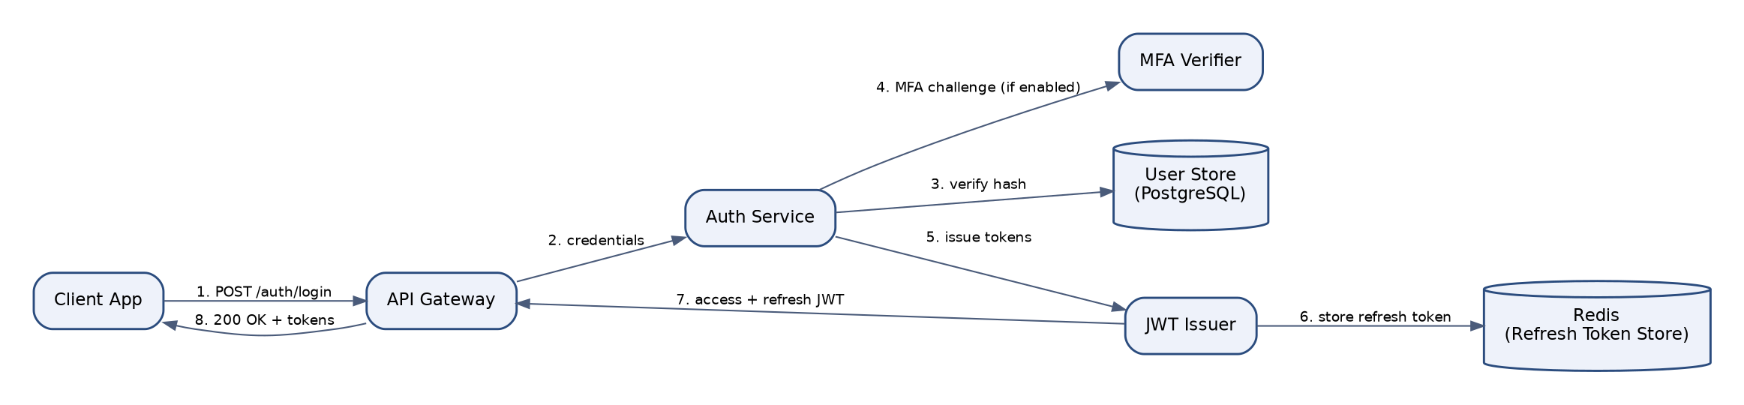
Figure 20.1 - Authentication Flow

Purpose
To establish verified identity for every request while supporting stateless horizontal scaling of the application tier and enabling immediate token revocation when required.

Responsibilities
- Verify user credentials against securely hashed passwords (Argon2id).
- Challenge MFA-enabled users (Org Admins and Judges by default policy) during login.
- Issue signed JWT access tokens (short-lived, 15 minutes) and refresh tokens (7 days, rotated on use).
- Track active refresh tokens in Redis to support immediate revocation on logout or security incident.

Components
- Auth Service.
- User Store (PostgreSQL).
- MFA Verifier (TOTP-based).
- JWT Issuer.
- Redis Refresh Token Store.

Dependencies
- Auth Service depends on the User Store for credential verification and on Redis for refresh token session tracking.
- All other modules depend on the Auth Service's JWT validation for identity, but never on its internals.

Technology
djangorestframework-simplejwt with RS256 asymmetric signing; Argon2id password hashing via Django's password hasher framework; pyotp for TOTP-based MFA; Redis for refresh token allow-listing.

Communication Pattern
Client authenticates once via POST /auth/login, receiving an access/refresh token pair; subsequent requests present the access token as a Bearer header, validated statelessly (signature + expiry) without a database round-trip; refresh occurs via a dedicated endpoint that rotates the refresh token and checks the Redis allow-list.

Advantages
- Stateless access-token validation allows any application node to authenticate a request without a shared session store lookup, supporting horizontal scaling.
- Refresh token allow-listing in Redis still permits immediate, centralized revocation despite JWTs being otherwise stateless.

Limitations
- Access tokens cannot be revoked before their natural 15-minute expiry, which is an accepted trade-off bounding the blast radius of a leaked token.
- RS256 key rotation requires a documented, tested procedure to avoid invalidating all outstanding tokens simultaneously.

Future Scalability
The Auth Service's interface is designed to support future federation (SAML/OIDC SSO for enterprise school-district customers) as an additional credential-verification strategy plugged in ahead of JWT issuance, without changing how downstream modules consume the resulting access token.

21. Authorization Architecture
Authorization is enforced through a Role-Based Access Control engine evaluated on every request after tenant resolution and authentication, with permission decisions cached per-role in Redis for performance.
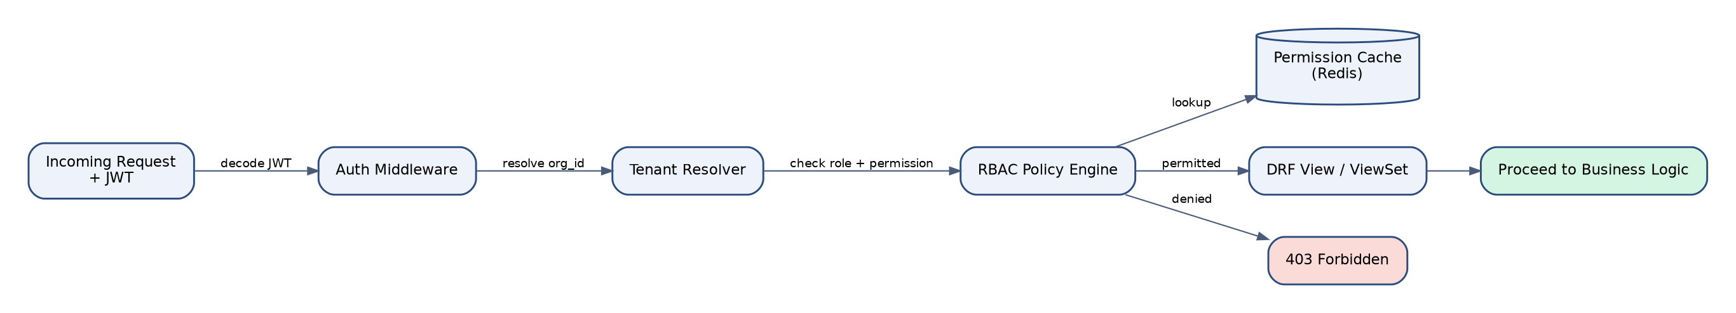
Figure 21.1 - Authorization (RBAC) Flow

Purpose
To ensure every action a user attempts is checked against their role and organizational context before it reaches business logic, with a default-deny posture.

Responsibilities
- Resolve the authenticated user's role(s) within the currently resolved tenant.
- Evaluate the requested action against the RBAC Policy Engine's permission matrix.
- Cache resolved role-to-permission mappings to avoid repeated database lookups per request.
- Deny by default when no explicit permission grant exists.

Components
- Auth Middleware.
- Tenant Resolver.
- RBAC Policy Engine.
- Permission Cache (Redis).
- DRF View/ViewSet permission classes.

Dependencies
- RBAC Policy Engine depends on the Tenant Resolver to scope role lookups to the correct organization, since the same user identity may hold different roles in different organizations (e.g. a guardian across two schools).
- Permission Cache depends on invalidation signals whenever a role or permission assignment changes.

Technology
Custom DRF permission classes backed by a role/permission data model (Role, Permission, RolePermission, UserOrganizationRole); django-guardian evaluated for object-level cases requiring per-record permission (e.g. a judge scoped to only their assigned events); Redis for the permission cache with signal-based invalidation.

Communication Pattern
Synchronous, in-request evaluation: the permission check occurs as a DRF permission class invoked before the view's business logic executes, returning HTTP 403 immediately on denial without touching downstream services.

Advantages
- Centralizing authorization in a policy engine (rather than scattered `if user.role == 'admin'` checks) makes the full permission matrix auditable in one place.
- Object-level permissions allow fine-grained scoping (e.g. a judge sees only events they are assigned to) without proliferating custom roles.

Limitations
- A cached permission model requires careful invalidation; a stale cache could transiently under- or over-grant access for the cache TTL window (bounded to 60 seconds by policy).
- Highly granular object-level permissions can add query overhead for list endpoints if not paired with efficient pre-filtering.

Future Scalability
The RBAC model is designed to extend to attribute-based access control (ABAC) rules (e.g. time-bound judge access during a live competition window) by adding policy predicates to the existing engine rather than replacing it.

22. Multi Tenant Architecture
EventFlow AI uses a shared-database, discriminator-column tenancy model: every tenant-scoped table carries an organization_id column, request-scoped tenant context is resolved once per request, and PostgreSQL Row Level Security policies provide a database-enforced backstop against accidental cross-tenant queries.
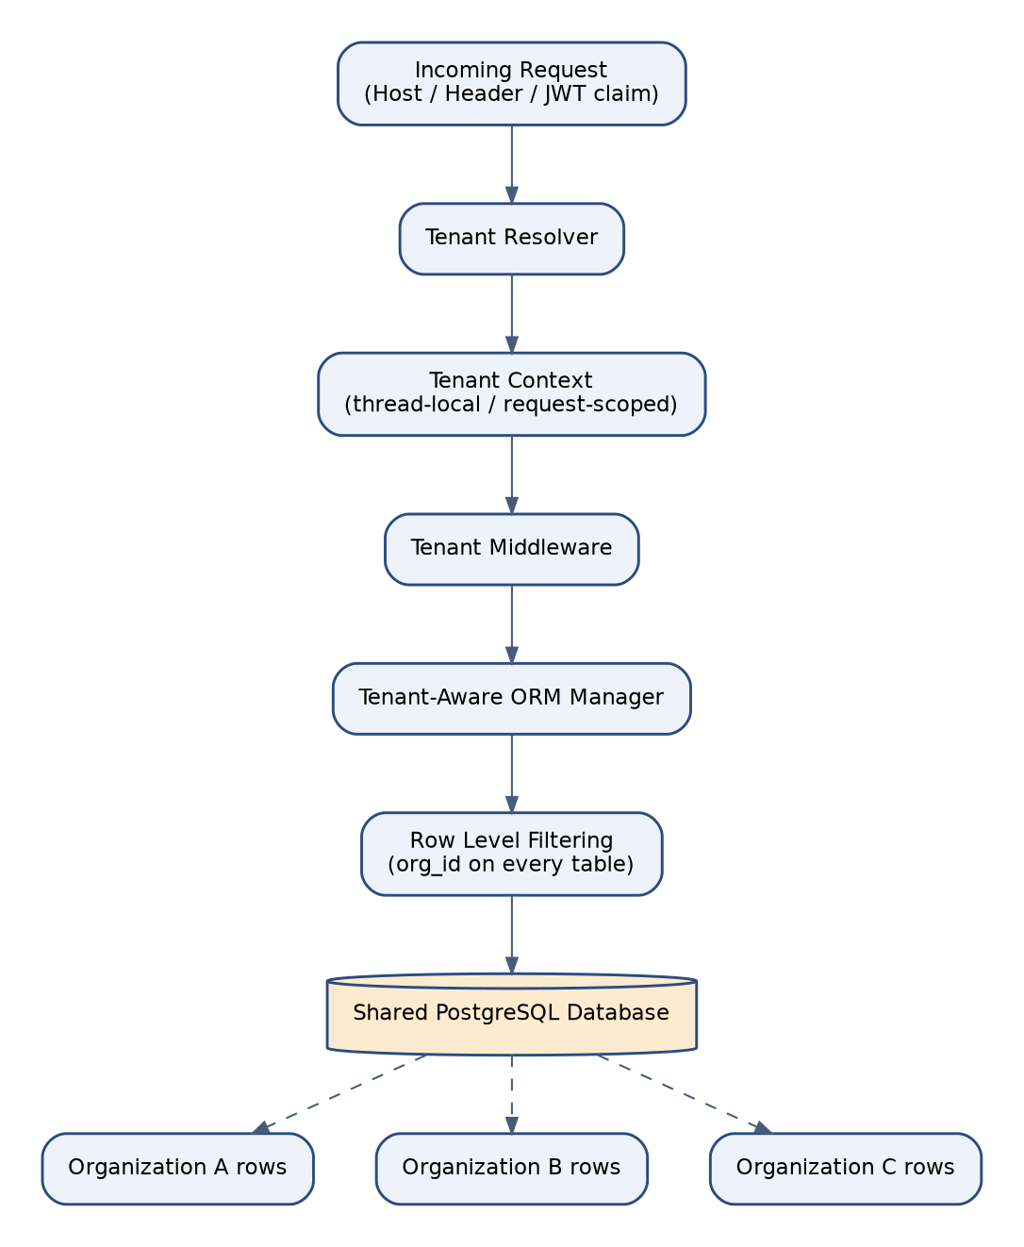
Figure 22.1 - Multi-Tenant Isolation Architecture

Purpose
To guarantee complete logical data isolation between organizations sharing the same database and application infrastructure, at a cost profile appropriate for the platform's target market.

Responsibilities
- Resolve the requesting tenant from the subdomain, custom domain header, or JWT claim on every request.
- Bind the resolved tenant to a request-scoped context (thread-local/async-local) consumed by the ORM layer.
- Automatically scope every ORM query to the current tenant via a custom manager.
- Enforce tenant scoping a second time at the database level via Row Level Security policies as defense-in-depth.

Components
- Tenant Resolver.
- Tenant Context (request-scoped).
- Tenant Middleware.
- Tenant-Aware ORM Manager.
- Row Level Security policies on every tenant-scoped table.
- Shared PostgreSQL database.

Dependencies
- Tenant Resolver depends on either the request's Host header (subdomain-based resolution), a custom domain mapping table, or a validated JWT organization claim.
- Row Level Security depends on the database session variable set by the application (`app.current_org_id`) at the start of each request/transaction.

Technology
Custom Django middleware for tenant resolution; a base TenantScopedManager overriding get_queryset() on all tenant models; PostgreSQL native Row Level Security (RLS) with `CREATE POLICY` statements referencing a session GUC variable.

Communication Pattern
Tenant resolution happens once at the start of the request lifecycle, before authentication; the resolved tenant ID is set as a PostgreSQL session variable at the start of each database transaction, so RLS policies apply automatically to every query, including ones issued by third-party or future code that might bypass the application-level manager.

Advantages
- Two independent layers of enforcement (application-level manager + database RLS) mean a single coding mistake cannot cause cross-tenant data leakage.
- Shared-database tenancy keeps infrastructure and operational cost low relative to per-tenant databases, supporting a healthy margin at the platform's target price point.

Limitations
- Noisy-neighbor risk exists at the database level since all tenants share connection pool and I/O capacity; mitigated via per-tenant rate limiting and query timeouts.
- Bulk cross-tenant analytics (for platform-level reporting) require an explicit, audited superuser bypass of RLS rather than being a natural query pattern.

Future Scalability
Enterprise customers with elevated compliance requirements can be migrated to a dedicated schema or a fully separate database using the same Tenant Resolver abstraction, simply by changing the resolved connection/schema target - the application code above the ORM layer requires no changes.

23. Database Architecture
PostgreSQL serves as the platform's system of record, organized into six core schema domains (Identity, Academic, Events, Judging, Certificates, Audit), fronted by PgBouncer for connection pooling and backed by streaming replication and continuous WAL archiving for durability.
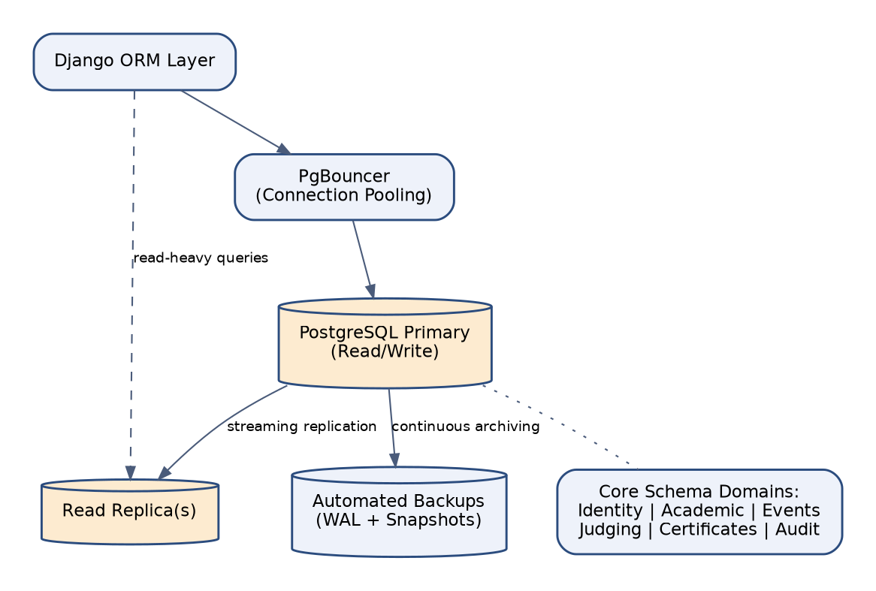
Figure 23.1 - Database Architecture

Purpose
To define the relational data platform's topology, pooling strategy, and durability guarantees underpinning every module's persistence needs.

Responsibilities
- Store all tenant-scoped transactional data with strong ACID guarantees.
- Pool and multiplex application-layer connections to avoid exhausting PostgreSQL's native connection limit under horizontal application scaling.
- Continuously replicate to at least one read replica for both read scaling and failover readiness.
- Continuously archive write-ahead logs for point-in-time recovery.

Components
- PostgreSQL Primary.
- Read Replica(s).
- PgBouncer connection pooler.
- Automated backup/WAL archiving pipeline.
- Six schema domains: Identity, Academic, Events, Judging, Certificates, Audit.

Dependencies
- Application and Celery containers depend on PgBouncer rather than connecting directly to PostgreSQL.
- Backup pipeline depends on object storage for WAL segment and snapshot retention.

Technology
PostgreSQL 15+ with logical schema separation by domain within a single physical database per tenant-shard; PgBouncer in transaction pooling mode; managed automated backups (RDS/Cloud SQL/Azure Database) supplemented by explicit `pg_dump` logical backups for portability.

Communication Pattern
Application services issue queries through the Django ORM, which connects via PgBouncer; read-heavy, replication-lag-tolerant queries (e.g. dashboards, reports) are explicitly routed to the read replica via a dedicated database alias; all writes go to the primary.

Advantages
- Connection pooling allows the application tier to scale horizontally far beyond PostgreSQL's native max_connections limit.
- Read replica offloads reporting and analytics query load from the primary, protecting write-path latency for transactional operations.

Limitations
- Transaction-mode pooling in PgBouncer disallows session-level features like prepared statements across requests, requiring careful ORM configuration.
- Logical schema separation within one physical database does not provide the hard resource isolation that fully separate databases would.

Future Scalability
The schema-domain organization is intentionally aligned with likely future service boundaries; as individual domains (e.g. Analytics) are extracted into microservices, their schema can be migrated to a dedicated physical database with minimal query-layer rework.

24. Cache Architecture
Redis is used as a multi-purpose in-memory data platform, logically partitioned by database index into caching, Celery broker/result-backend, AI conversation memory, and rate-limiting concerns, deployed in a highly-available Sentinel/cluster configuration.
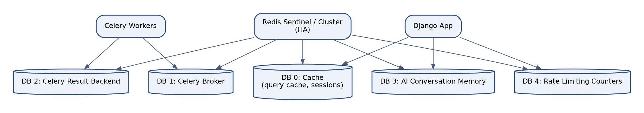
Figure 24.1 - Redis Cache Architecture

Purpose
To reduce read latency and database load for frequently accessed, infrequently changing data, and to provide the durable-enough transport layer for asynchronous task processing and rate limiting.

Responsibilities
- Cache expensive or frequent read queries (permission lookups, dashboard aggregates, organization configuration) with sensible TTLs.
- Serve as the Celery message broker and result backend.
- Store short-to-medium-lived AI conversation memory scoped per user session.
- Track rate-limiting counters per tenant and per user to enforce API fair-use policies.

Components
- DB 0: Application cache (query cache, sessions).
- DB 1: Celery broker.
- DB 2: Celery result backend.
- DB 3: AI conversation memory.
- DB 4: Rate limiting counters.
- Redis Sentinel/Cluster for high availability.

Dependencies
- Cache invalidation depends on Django signal handlers firing on the relevant model's save/delete.
- Celery depends on Redis DB 1/2 availability to enqueue and retrieve task results; a Redis outage pauses background processing entirely until it recovers.

Technology
Redis 7.x with django-redis as the Django cache backend; redis-py client with connection pooling; Sentinel for automated primary failover in production.

Communication Pattern
Cache-aside pattern for read paths (check cache, fall back to database, populate cache on miss); write-through invalidation on model mutation via signals; Celery uses Redis as a durable-enough (AOF-persisted) queue rather than a pure ephemeral cache.

Advantages
- Logical database-index partitioning within a single Redis deployment keeps operational footprint small while still isolating concerns (a spike in AI memory usage does not evict cache entries in a different DB index).
- Cache-aside pattern is simple to reason about and requires no changes to the underlying PostgreSQL query logic.

Limitations
- Redis persistence (AOF/RDB) provides durability short of PostgreSQL-grade guarantees; the platform never treats Redis as the sole source of truth for business-critical state.
- Cluster mode adds operational complexity (hash slot management) relative to a single-node deployment, justified only once throughput requires it.

Future Scalability
As the platform grows, cache and broker concerns can be split onto physically separate Redis deployments (already logically separated by DB index) with a single configuration change, avoiding a redesign of caching or task-dispatch code.

25. Background Job Architecture
Celery provides the platform's asynchronous and scheduled processing backbone, with dedicated queues and worker pools for default tasks, notifications, AI tasks, and report generation, coordinated by Celery Beat for cron-style scheduling and monitored via Flower.
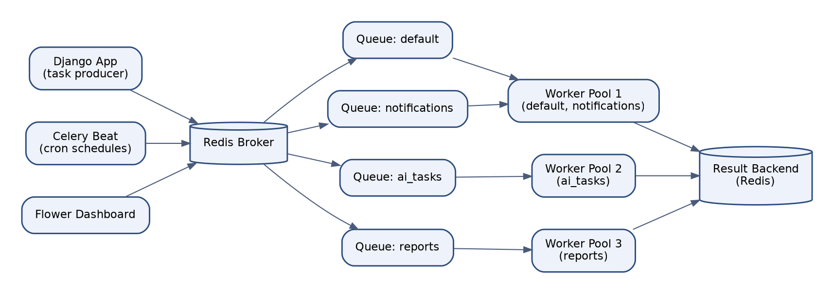
Figure 25.1 - Celery Background Job Architecture

Purpose
To offload long-running, non-request-critical work (notification delivery, AI inference, report generation, scheduled reminders) from the synchronous request/response path.

Responsibilities
- Execute enqueued tasks reliably with automatic retry and exponential backoff on failure.
- Route tasks to appropriately resourced worker pools based on task type (default, notifications, ai_tasks, reports).
- Execute scheduled/cron-style tasks (nightly aggregate rebuilds, deadline reminder emails) via Celery Beat.
- Expose real-time operational visibility into queue depth and worker health via Flower.

Components
- Django App (task producer).
- Redis Broker.
- Named Queues: default, notifications, ai_tasks, reports.
- Worker Pool 1 (default, notifications), Worker Pool 2 (ai_tasks), Worker Pool 3 (reports).
- Celery Beat.
- Result Backend (Redis).
- Flower dashboard.

Dependencies
- All worker pools depend on the same Redis broker and result backend as the Django application.
- AI task workers depend on the AI Provider Abstraction layer and, transitively, on external LLM provider availability.

Technology
Celery 5.x with the `redis` transport; separate worker pool deployments per queue for independent scaling (e.g. more `ai_tasks` workers during peak registration season); Flower for monitoring; django-celery-beat for database-backed dynamic schedule management.

Communication Pattern
Fire-and-forget task dispatch from Django views/services via `.delay()`/`.apply_async()`; workers pull from their assigned queue(s), execute, and write results to the backend; failed tasks retry with exponential backoff up to a configured maximum before landing in a dead-letter queue for manual inspection.

Advantages
- Per-queue worker pools let operations scale exactly the resource that is under load (e.g. AI inference capacity) without over-provisioning unrelated task types.
- Dead-letter handling ensures failed tasks are never silently lost, supporting operational accountability.

Limitations
- A broker outage (Redis) pauses all background processing platform-wide until recovery, making Redis availability a critical dependency requiring its own HA strategy.
- Long-running AI tasks must be carefully timeboxed to avoid worker starvation during traffic spikes.

Future Scalability
The named-queue structure is designed to map directly onto dedicated worker fleets (potentially on different instance types, e.g. GPU-adjacent instances for future self-hosted AI models) without any change to task-dispatch call sites in the domain services.

26. AI Architecture
The AI Architecture governs how all six platform AI agents receive requests, are selected and orchestrated, and interact with domain services exclusively through a permissioned tool layer, ensuring AI-driven behavior is bounded, observable, and consistent with human-driven behavior under the same authorization rules.
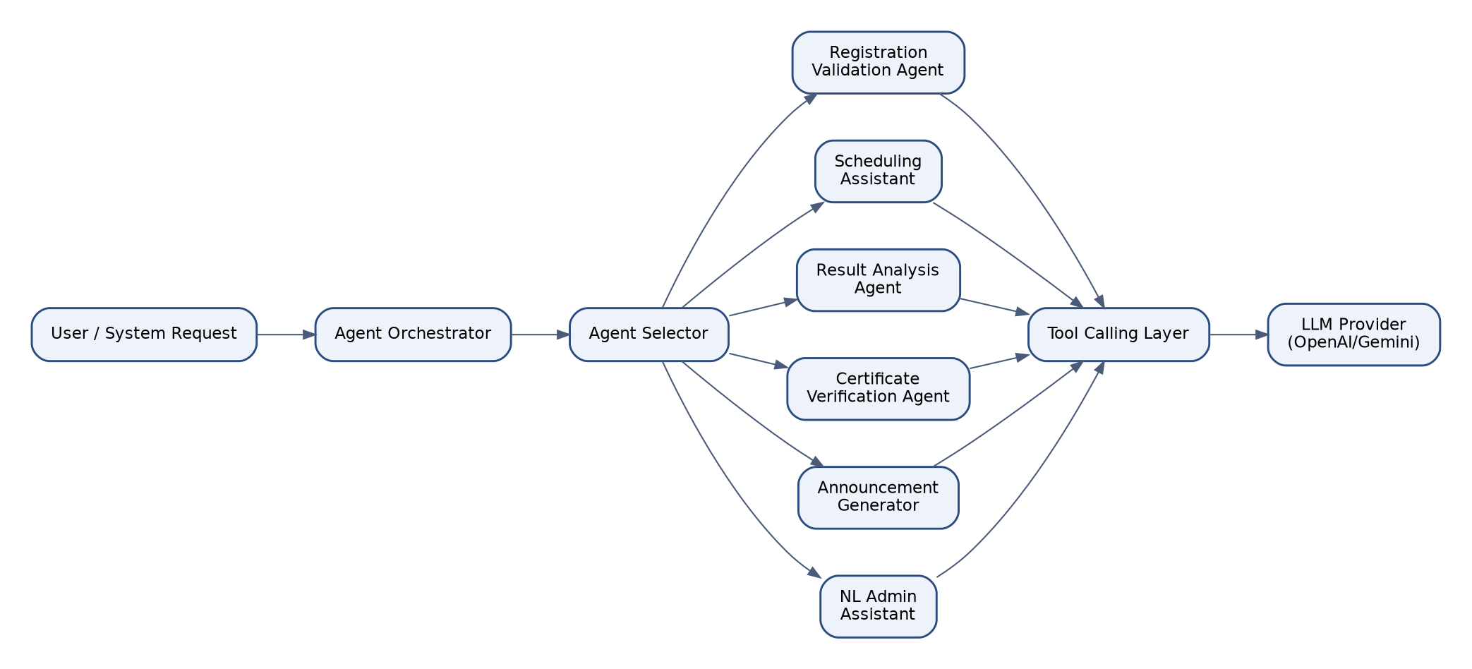
Figure 26.1 - AI Agent Request Flow

Purpose
To provide a single, governed entry point for all AI-driven functionality across the platform, preventing ad hoc, ungoverned model integrations from proliferating module by module.

Responsibilities
- Receive AI requests from either end users (Natural Language Admin Assistant) or internal domain events (e.g. Registration Validation triggered automatically on submission).
- Select the appropriate specialized agent for the request.
- Ensure every agent call is subject to the same tenant, authentication, and authorization context as any other platform action.
- Log every AI interaction (prompt, tool calls, response, model, cost) for audit and cost-tracking purposes.

Components
- Agent Orchestrator.
- Agent Selector.
- Six specialized agents (Registration Validation, Scheduling Assistant, Result Analysis, Certificate Verification, Announcement Generator, Natural Language Admin Assistant).
- Tool Calling Layer.
- Provider Abstraction (OpenAI/Gemini).

Dependencies
- Every agent depends on the Tool Calling Layer to interact with domain data; no agent holds a direct database connection.
- The Agent Orchestrator depends on the current request's tenant and user context, propagated from the standard request lifecycle.

Technology
Python-based orchestration layer using OpenAI's and Gemini's native function-calling/tool-use APIs; Celery for agents whose latency profile does not suit a synchronous HTTP response (Result Analysis, Announcement Generation).

Communication Pattern
Synchronous request/response for latency-sensitive agents invoked inline during a user action (e.g. Registration Validation at submission time); asynchronous, event-triggered execution for agents operating on larger datasets or producing longer-form output (Result Analysis, Announcement Generator), with results delivered via notification or dashboard update.

Advantages
- A single orchestration layer means security, logging, and cost-tracking are implemented once and inherited by every current and future agent.
- Treating agents as a peer to, not a replacement for, domain services keeps business rule enforcement in one place regardless of whether a human or an AI agent initiates an action.

Limitations
- Adds a layer of indirection and latency (tool resolution, guardrail validation) relative to a naive direct-to-LLM integration.
- Requires ongoing prompt and tool-schema maintenance as domain models evolve.

Future Scalability
The architecture is designed to onboard new agents (e.g. a future Attendance Anomaly Detection agent) purely through configuration and a new AIAgent implementation, without touching the Orchestrator, Tool Registry, or Provider Abstraction.

27. AI Provider Abstraction
All calls to external large language models pass through a common AIProvider interface, with concrete OpenAI and Gemini adapters selected at runtime via a Provider Factory driven by per-tenant configuration, insulating the rest of the platform from vendor-specific APIs.
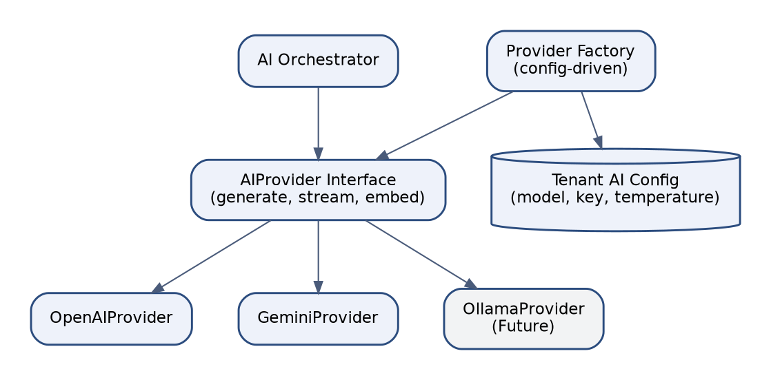
Figure 27.1 - AI Provider Abstraction Layer

Purpose
To prevent vendor lock-in and enable per-tenant or per-agent model selection without touching business logic, honoring the Dependency Inversion Principle at the platform's most strategically important integration point.

Responsibilities
- Define a single interface (generate, stream, embed) that every LLM interaction in the platform must go through.
- Select the concrete provider implementation per request based on tenant-level AI configuration.
- Normalize provider-specific response formats (including tool-call structures) into a single internal representation.
- Track token usage and cost per provider for billing and budgeting purposes.

Components
- AIProvider Interface.
- OpenAIProvider implementation.
- GeminiProvider implementation.
- OllamaProvider (future, self-hosted).
- Provider Factory.
- Tenant AI Configuration store.

Dependencies
- Provider Factory depends on the Organization module's AI configuration (selected model, API key reference, temperature/parameters).
- Concrete providers depend on their respective vendor SDKs and API credentials, stored in the platform's secrets manager, never in application configuration files.

Technology
Python abstract base class defining the AIProvider contract; official `openai` and `google-generativeai` SDKs wrapped behind adapters; a factory function resolving the concrete provider from tenant configuration at request time.

Communication Pattern
All internal callers (agents) depend only on the AIProvider interface, never on a concrete SDK; the Provider Factory is the single point of vendor-specific instantiation, making a future third or fourth provider (or a self-hosted Ollama model) a matter of adding one new adapter class.

Advantages
- Enables A/B testing or cost-based routing between OpenAI and Gemini without any change to agent logic.
- Provides a natural seam for future compliance requirements (e.g. a customer requiring an EU-hosted or self-hosted model) to be satisfied per-tenant.

Limitations
- The common interface necessarily exposes only the lowest common denominator of provider-specific features; provider-unique capabilities require explicit, documented interface extensions rather than being immediately available.
- Normalizing tool-call formats across providers with differing function-calling conventions adds translation logic that must be kept current with each vendor's API evolution.

Future Scalability
Ollama support (self-hosted open-weight models) and future MCP (Model Context Protocol) support are both designed as additional adapters/transports behind the same AIProvider interface, requiring no changes to the Agent Orchestrator or Tool Registry.

28. AI Agent Orchestration
The Agent Orchestrator is the central coordinator responsible for selecting the correct specialized agent, assembling its context, executing any required tool calls, validating output through Guardrails, and returning a governed final response.

Figure 28.1 - Agent Orchestration Detail

Purpose
To coordinate the lifecycle of a single AI request from intake to final validated response, ensuring consistent behavior regardless of which of the six agents is invoked.

Responsibilities
- Accept an incoming AI request with its tenant/user context.
- Delegate agent selection to the Agent Selector based on request type or intent classification.
- Assemble context via the Context Builder (relevant prompt template + conversation memory + relevant domain data).
- Invoke the selected agent, which may issue one or more tool calls through the Tool Calling Layer.
- Pass the agent's draft output through Guardrails before returning the final response and logging the full interaction.

Components
- Agent Orchestrator.
- Agent Selector.
- Context Builder.
- Tool Calling Layer.
- Guardrails & Output Validator.
- AI Interaction Logger.

Dependencies
- Agent Selector depends on either an explicit request type parameter (from the API) or a lightweight intent-classification step for free-form Natural Language Admin Assistant requests.
- Guardrails depend on a configurable rule set per agent (e.g. Certificate Verification Agent output must include a verifiable reference ID or be rejected).

Technology
A Python orchestration service coordinating calls to the Context Builder, Tool Calling Layer, and Provider Abstraction; JSON Schema-validated guardrail rules; structured logging to the AI Interaction Logger for every step of the pipeline.

Communication Pattern
Sequential pipeline per request: select agent -> build context -> execute (with zero or more tool-call round-trips to the LLM provider) -> validate output -> log -> respond. Tool-call round-trips are synchronous within the pipeline even when the overall agent execution is dispatched asynchronously via Celery.

Advantages
- Guardrails applied uniformly across all agents prevent any single agent implementation from bypassing output validation.
- Centralized logging gives a complete, queryable audit trail of every AI decision platform-wide, supporting both debugging and compliance review.

Limitations
- The orchestration pipeline adds latency (typically 200-800ms of overhead beyond raw model inference time) which must be budgeted for in synchronous agent use cases.
- Guardrail rules require ongoing tuning to avoid both false rejections (frustrating legitimate use) and false acceptances (allowing unsafe output through).

Future Scalability
The pipeline's staged design allows future insertion of a Retrieval-Augmented Generation (RAG) step between Context Builder and agent execution without restructuring the orchestrator itself, as previewed in Section 27's future-state notes.

29. Tool Calling Architecture
AI agents interact with platform data exclusively through a registered set of tools - thin, permissioned wrappers around existing domain services - ensuring that any action an AI agent takes is subject to the identical validation and authorization as an equivalent human-initiated API call.
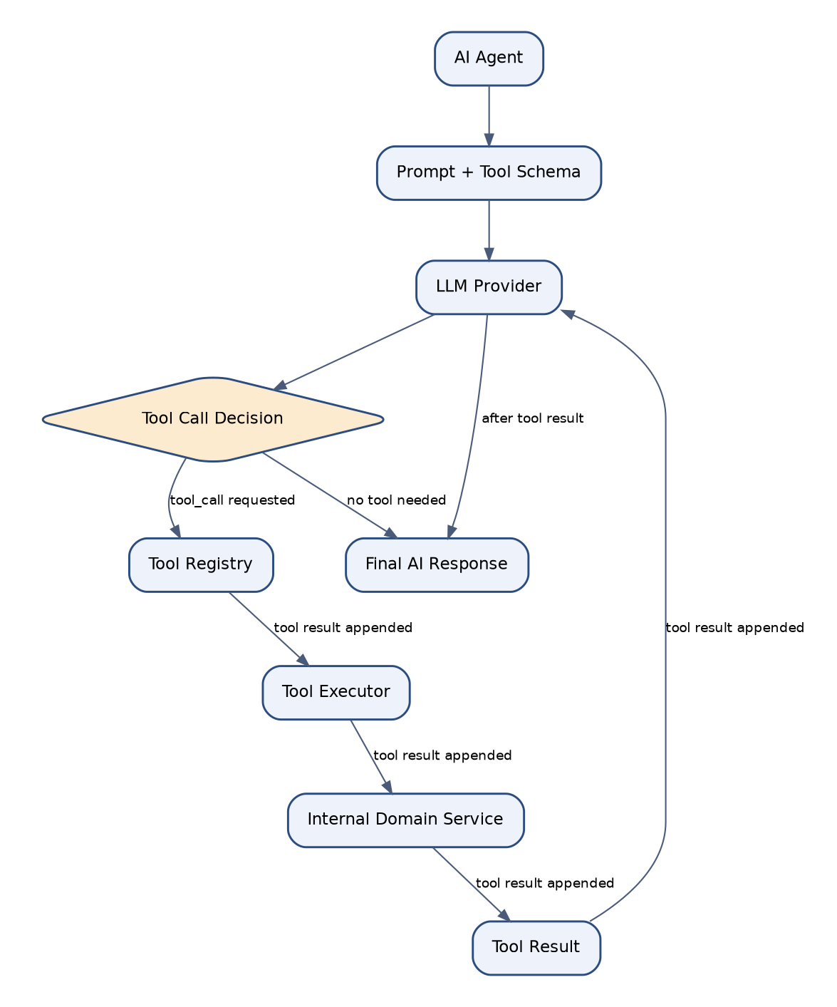
Figure 29.1 - Tool Calling Architecture

Purpose
To provide AI agents with a strictly bounded, auditable set of capabilities rather than open-ended access to the codebase or database, making AI behavior predictable and safe by construction.

Responsibilities
- Maintain a Tool Registry mapping named tools (e.g. `get_event_schedule`, `validate_registration`, `generate_certificate_draft`) to underlying domain service methods.
- Expose each tool's schema (parameters, return type, description) to the LLM provider in its native function-calling format.
- Execute the requested tool against the real domain service layer upon a model-issued tool call, applying the same authorization checks as a normal API request.
- Return the tool's result to the LLM for incorporation into its final response.

Components
- Tool Registry.
- Tool Executor.
- Internal Domain Service (the actual business logic invoked).
- Tool Result formatter.

Dependencies
- Every tool implementation depends on an existing, already-tested domain service method; tools are never a separate code path from the one used by human-facing API endpoints.
- Tool execution depends on the current request's authenticated user and tenant context to enforce identical RBAC rules as any other action.

Technology
A Python decorator-based tool registration mechanism (`@tool_registry.register(...)`) generating JSON Schema automatically from type-annotated function signatures; adapters translating this schema into OpenAI and Gemini's respective function-calling formats.

Communication Pattern
The LLM provider returns a structured tool-call request (tool name + arguments) rather than free text; the Tool Executor validates the arguments against the registered schema, checks authorization, invokes the underlying domain service, and returns a structured result appended to the conversation for the model's next turn.

Advantages
- Because tools call the same domain services as human-facing endpoints, there is no risk of an AI agent bypassing a business rule that exists only in the API layer.
- New tools are added declaratively (a decorator plus a schema), keeping the AI surface area explicit and reviewable in pull requests.

Limitations
- Every new domain capability intended for AI use requires an explicit tool registration step; this is a deliberate friction point to prevent accidental over-exposure of internal operations to AI agents.
- Complex multi-step workflows may require several tool-call round-trips, adding latency proportional to workflow complexity.

Future Scalability
The Tool Registry's schema-driven design is directly compatible with a future migration to the Model Context Protocol (MCP), where the same registered tools could be exposed as an MCP server, allowing third-party MCP-compatible clients to use EventFlow AI's governed tool surface.

30. Notification Architecture
Notifications are triggered by domain events, rendered through a shared template engine, and delivered asynchronously across email, SMS, and in-app/push channels via dedicated Celery workers, with every delivery attempt logged for support and compliance purposes.
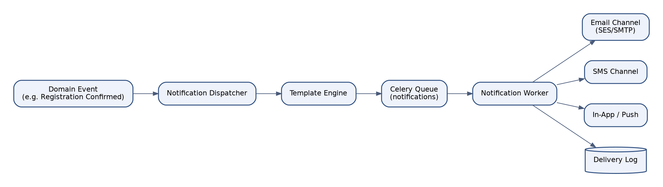
Figure 30.1 - Notification Architecture

Purpose
To provide a single, consistent mechanism for informing users of relevant platform events across all communication channels, decoupled from the business logic that triggers those events.

Responsibilities
- Subscribe to relevant domain events (registration confirmed, schedule published, result finalized, certificate issued).
- Render channel-appropriate content from a shared, versioned template set.
- Deliver notifications asynchronously without blocking the originating request.
- Record delivery status (sent, delivered, bounced, failed) for every notification.

Components
- Notification Dispatcher.
- Template Engine.
- Celery Queue (notifications).
- Notification Worker.
- Email Channel (SES/SMTP).
- SMS Channel.
- In-App/Push Channel.
- Delivery Log.

Dependencies
- Dispatcher depends on the internal Event Bus (Section 18) as its trigger source.
- Email and SMS channels depend on third-party provider APIs and their respective webhook callbacks for delivery status.

Technology
Django templating (or a dedicated templating library) for channel-specific rendering; Celery for asynchronous, retryable delivery; Amazon SES or SMTP relay for email; a third-party SMS gateway API; WebSocket or polling-based delivery for in-app notifications.

Communication Pattern
Fire-and-forget dispatch from the domain event handler into the notifications queue; each channel delivery is retried independently on transient failure; delivery status webhooks (bounce, complaint, delivered) update the Delivery Log asynchronously after the fact.

Advantages
- A single template and dispatch mechanism keeps notification content and branding consistent across channels without duplicating logic per module.
- Asynchronous delivery ensures a slow or degraded email provider never impacts the responsiveness of the triggering user action.

Limitations
- Users are not guaranteed instantaneous delivery, which is unsuitable for truly time-critical alerts (mitigated by SMS as parallel high-urgency channel for such cases).
- Requires ongoing management of sender reputation and compliance (unsubscribe handling, CAN-SPAM/GDPR requirements) for email and SMS.

Future Scalability
New channels (e.g. WhatsApp Business API, Slack/Teams integration for staff notifications) are added as additional channel adapters behind the existing Notification Dispatcher, with no change to how domain modules trigger notifications.

31. Certificate Architecture
Upon final result approval, the Certificate module generates a templated PDF certificate, applies a digital signature and QR-coded verification identifier, stores it in object storage, and exposes a public verification endpoint checked by the Certificate Verification AI Agent and by third parties.
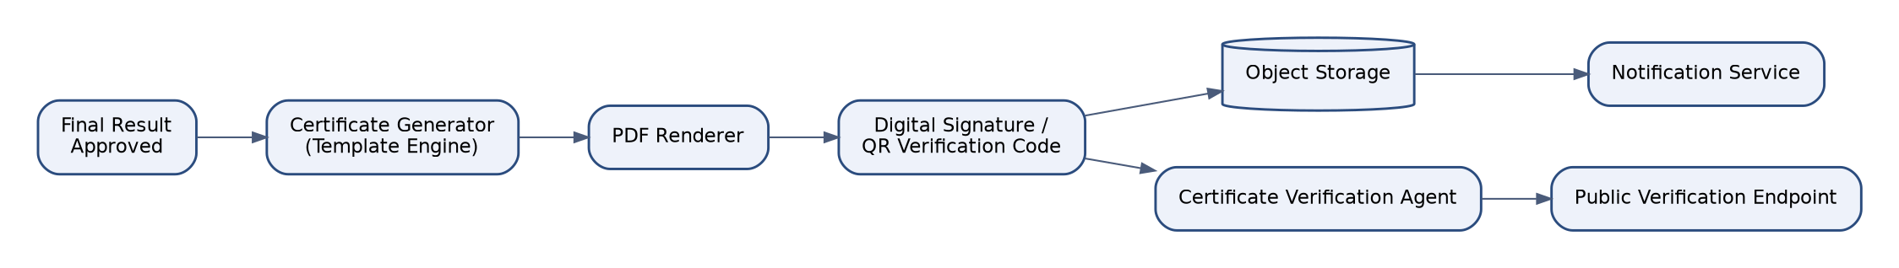
Figure 31.1 - Certificate Generation & Verification Flow

Purpose
To produce authentic, tamper-evident, and independently verifiable certificates of achievement at scale, without manual per-certificate production effort.

Responsibilities
- Generate certificates automatically upon final result approval using organization-branded templates.
- Render certificates as PDF documents with embedded student, event, and placement data.
- Apply a cryptographic signature and a unique QR-coded verification code to each certificate.
- Store issued certificates durably and make them retrievable by students, guardians, and verifying third parties.
- Expose a public verification endpoint that confirms a certificate's authenticity without requiring platform login.

Components
- Certificate Generator (Template Engine).
- PDF Renderer.
- Digital Signer / QR Code Generator.
- Object Storage.
- Certificate Verification Agent.
- Public Verification Endpoint.

Dependencies
- Certificate Generator depends on the Results module's finalized, approved result records.
- Public Verification Endpoint depends on a read-only, rate-limited API surface distinct from the authenticated platform API.

Technology
WeasyPrint or a similar HTML-to-PDF rendering engine for template-driven certificate layout; RSA or ECDSA digital signatures embedded as certificate metadata; QR codes encoding a signed verification token; S3-compatible object storage with versioning enabled for issued documents.

Communication Pattern
Synchronous generation for single-certificate re-issuance requests (e.g. a correction); asynchronous, Celery-driven bulk generation for entire festival result sets, with progress reported via the Dashboard module and completion notified via the Notification module.

Advantages
- Automated, templated generation scales to thousands of certificates per festival without manual production bottlenecks.
- Cryptographic signing and public verification prevent forged or altered certificates from being accepted as genuine by third parties (e.g. university admissions offices).

Limitations
- Bulk generation for very large festivals (tens of thousands of participants) requires careful queue capacity planning to complete within an acceptable window.
- Template changes require regression testing across all supported languages and organization branding variants.

Future Scalability
The template engine is designed to support blockchain-anchored or third-party credentialing standards (e.g. Open Badges, Verifiable Credentials) as an additional signing/verification strategy layered on top of the existing PDF generation pipeline.

32. Reporting Architecture
The Reporting module provides scheduled and on-demand generation of operational, academic, and financial reports across organizational, festival, and event scopes, rendered to PDF/CSV/XLSX and delivered via the Dashboard or asynchronously via email.

Purpose
To transform raw operational data into decision-ready documents for administrators, teachers, and organizational leadership without requiring direct database access or manual spreadsheet assembly.

Responsibilities
- Define a library of parameterized report templates (participation summary, results summary, judge scoring consistency, revenue and billing summary).
- Execute report queries against the read replica to avoid impacting primary transactional performance.
- Render reports to PDF, CSV, and XLSX formats as appropriate to the report type.
- Support both on-demand generation and scheduled recurring delivery (e.g. a weekly registration summary emailed to org admins).

Components
- Report Template Library.
- Report Query Engine.
- Rendering Engine (PDF/CSV/XLSX).
- Scheduled Report Runner (Celery Beat).
- Report Delivery (Notification integration).

Dependencies
- Report Query Engine depends on the PostgreSQL read replica for query execution.
- Rendering Engine depends on the same PDF rendering technology used by the Certificate module for visual consistency.

Technology
Django ORM aggregation queries against the read replica; WeasyPrint for PDF rendering; openpyxl for XLSX generation; Celery Beat for scheduled report execution.

Communication Pattern
Synchronous generation for lightweight, fast-executing reports triggered from the Dashboard; asynchronous, Celery-dispatched generation for large or scheduled reports, with the finished artifact stored in object storage and a download link delivered via notification.

Advantages
- Offloading report queries to the read replica isolates reporting load from transactional workloads, protecting core platform responsiveness during peak registration or results periods.
- A shared template library keeps report formatting and branding consistent across the platform.

Limitations
- Very large exports (e.g. multi-year historical analytics) can require significant memory during rendering, requiring streaming-friendly export strategies for the largest organizations.
- Report templates require versioning discipline as underlying data models evolve to avoid silently incorrect historical reports.

Future Scalability
The Report Query Engine is designed to be redirected to a dedicated analytical data store (see Section 33) as reporting query complexity grows beyond what read-replica PostgreSQL comfortably serves.

33. Analytics Architecture
Domain events are collected into an analytical store maintained via materialized views and scheduled aggregation jobs, exposed through a dedicated Analytics API that powers dashboard visualizations and data exports without querying transactional tables directly.
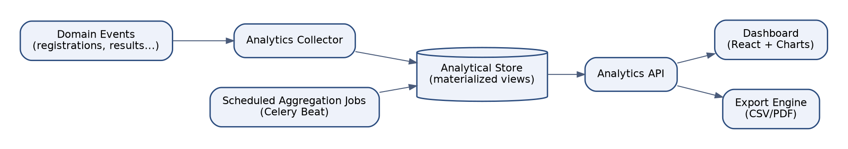
Figure 33.1 - Analytics Architecture

Purpose
To provide fast, aggregate-level insight into platform usage, participation trends, and outcomes without imposing analytical query load on the transactional database path.

Responsibilities
- Collect relevant domain events (registrations, results, certificate issuance, notification engagement) into an analytics-oriented store.
- Periodically refresh materialized views and pre-aggregated rollups via scheduled Celery Beat jobs.
- Expose a dedicated Analytics API decoupled from the transactional API for dashboard consumption.
- Support ad hoc export of aggregate data to CSV/PDF.

Components
- Analytics Collector.
- Analytical Store (materialized views).
- Scheduled Aggregation Jobs.
- Analytics API.
- Dashboard (React + charting library).
- Export Engine.

Dependencies
- Analytics Collector depends on the internal Event Bus (Section 18) as its ingestion source.
- Aggregation jobs depend on Celery Beat for scheduling and on sufficient database resources allocated to materialized view refresh.

Technology
PostgreSQL materialized views refreshed via `REFRESH MATERIALIZED VIEW CONCURRENTLY`; Celery Beat for scheduled refresh jobs; Recharts/Chart.js on the frontend for visualization; pandas for complex export transformations where needed.

Communication Pattern
Asynchronous, event-driven ingestion into the analytical store; synchronous, read-only queries from the Analytics API against pre-aggregated views, ensuring dashboard load times remain fast regardless of underlying transactional data volume.

Advantages
- Pre-aggregation via materialized views delivers consistent, fast dashboard performance even as historical data volume grows into the tens of millions of rows.
- Decoupling the Analytics API from transactional models allows analytical schema evolution independent of operational schema changes.

Limitations
- Materialized views introduce a refresh-interval staleness window (typically 5-15 minutes) that is acceptable for trend analytics but unsuitable for real-time operational dashboards.
- Aggregation job failures require monitoring and alerting to avoid silently stale analytics.

Future Scalability
As analytical query complexity and data volume grow, the Analytical Store can be migrated from PostgreSQL materialized views to a dedicated columnar warehouse (e.g. ClickHouse or BigQuery) behind the same Analytics API contract, without requiring frontend changes.

34. Audit Architecture
Every mutating action across the platform - whether initiated by a human user or an AI agent - is intercepted, enriched with actor and context metadata, and written asynchronously to an immutable audit log store, queryable through a dedicated compliance interface.
Figure 34.1 - Audit Logging Architecture

Purpose
To provide a complete, tamper-evident record of who did what, when, and in what tenant context, satisfying both internal accountability needs and external compliance obligations.

Responsibilities
- Intercept every create/update/delete operation across all modules via a shared signal-based interceptor.
- Enrich each captured action with actor identity, tenant, source IP, timestamp, and a before/after data snapshot where applicable.
- Persist audit entries asynchronously to an append-only, immutable store.
- Expose a query interface restricted to compliance/admin roles for audit review and export.

Components
- Audit Middleware / Signal Interceptor.
- Context Enricher.
- Async Audit Queue.
- Immutable Audit Log Store.
- Audit Query API.
- Compliance/Admin UI.

Dependencies
- Audit Interceptor depends on the same domain event mechanism used by Notifications and Analytics (Section 18), guaranteeing consistent coverage across all mutating operations.
- The Audit Log Store's immutability guarantee depends on database-level revoke of UPDATE/DELETE privileges for the application role on the audit table.

Technology
Django signals for interception; a dedicated append-only PostgreSQL table (or table set) with revoked update/delete grants for the application database role; JSON columns for flexible before/after payload storage; Celery for asynchronous persistence to avoid adding latency to the originating transaction.

Communication Pattern
Asynchronous, at-least-once delivery from the originating action to the Audit Log Store, mirroring the Event-Driven Service Communication pattern (Section 18); audit writes are idempotent, keyed by a unique event ID to tolerate redelivery.

Advantages
- A shared interception mechanism guarantees no module can be mutated without leaving an audit trail, rather than relying on each module's developers to remember to log manually.
- Database-enforced immutability (revoked UPDATE/DELETE grants) protects the audit trail even against a compromised application-layer credential.

Limitations
- Asynchronous persistence means there is a brief window (typically sub-second) where an audit entry for a just-completed action may not yet be queryable.
- High-volume bulk operations (e.g. bulk certificate generation) require batched audit entries to avoid overwhelming the audit queue.

Future Scalability
The immutable audit store is designed to be exported on a scheduled basis to a dedicated, WORM-compliant (Write Once Read Many) archival store for customers with long-term regulatory retention requirements, without changing the real-time audit capture path.

35. Logging Architecture
All application, worker, and infrastructure components emit structured JSON logs shipped by a lightweight collector to a centralized log store, enabling correlated, searchable operational visibility across the entire platform.
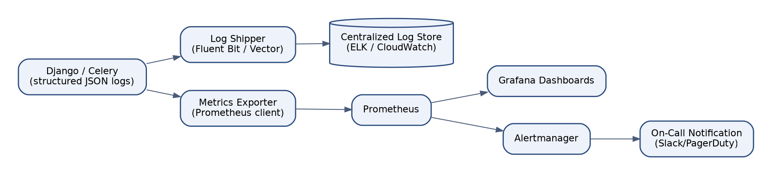
Figure 35.1 - Logging & Monitoring Architecture

Purpose
To provide engineers and operations staff with a searchable, correlated record of system behavior for debugging, incident response, and operational trend analysis.

Responsibilities
- Emit structured (JSON) log entries from every component, including a consistent request/correlation ID threaded through the request lifecycle and any resulting asynchronous tasks.
- Ship logs from each container to a centralized store without requiring application-level knowledge of the destination.
- Retain logs for a duration meeting both operational and compliance requirements.
- Redact sensitive fields (passwords, tokens, PII where applicable) before persistence.

Components
- Structured JSON logger (Django/Celery).
- Log Shipper (Fluent Bit / Vector).
- Centralized Log Store (ELK stack or CloudWatch Logs / Azure Monitor Logs).

Dependencies
- Log Shipper depends on a sidecar or daemonset deployment pattern within the container orchestration platform.
- Correlation IDs depend on being generated at the edge (Nginx/load balancer) and propagated through every subsequent internal call and Celery task.

Technology
python-json-logger or structlog for structured application logging; Fluent Bit or Vector as the log shipping agent; Elasticsearch/OpenSearch with Kibana, or the cloud provider's native logging service, as the centralized store.

Communication Pattern
Logs are written to stdout/stderr by convention (Twelve-Factor compliant) and collected by the container runtime, then shipped asynchronously by the collector agent to the centralized store, decoupling log emission from log storage availability.

Advantages
- Structured logging with correlation IDs allows a single user-reported issue to be traced across the web request, any triggered Celery tasks, and any AI agent invocations in one search.
- Treating logs as an event stream (Twelve-Factor) keeps application code entirely unaware of the logging backend, simplifying local development and backend migration.

Limitations
- High-cardinality structured fields can increase log storage cost if not curated; field allow-listing policy is enforced in the logging library configuration.
- Centralized log stores require their own scaling and retention-cost management as platform usage grows.

Future Scalability
The logging pipeline's agent-based shipping model allows the centralized store to be swapped (e.g. from a self-managed ELK stack to a managed observability vendor) without any change to application logging code.

36. Monitoring Architecture
Every component exports metrics via a Prometheus-compatible endpoint, scraped and visualized through Grafana dashboards, with Alertmanager routing threshold-based alerts to on-call engineers via Slack and PagerDuty.

Figure 36.1 - Metrics, Alerting & Monitoring Architecture

Purpose
To provide real-time visibility into system health and performance, and to proactively notify engineers of degrading conditions before they become customer-visible incidents.

Responsibilities
- Export application-level metrics (request latency, error rate, queue depth, AI provider latency/cost) in Prometheus exposition format.
- Scrape and store time-series metrics for historical trend analysis.
- Visualize key operational dashboards (API health, Celery queue depth, database connection pool utilization, AI cost burn rate).
- Route threshold-based alerts to the appropriate on-call channel with defined severity levels.

Components
- Metrics Exporter (Prometheus client library).
- Prometheus server.
- Grafana.
- Alertmanager.
- On-Call notification integration (Slack/PagerDuty).

Dependencies
- Prometheus depends on network access to scrape each component's metrics endpoint.
- Alertmanager depends on defined alerting rules co-owned by the DevOps and Security Architecture teams.

Technology
django-prometheus and celery-prometheus-exporter for application-level metrics; Prometheus for scraping and storage; Grafana for dashboards; Alertmanager with Slack and PagerDuty integrations.

Communication Pattern
Pull-based metrics scraping by Prometheus at a configured interval (typically 15 seconds); push-based alert routing from Alertmanager to on-call channels upon rule threshold breach, with configurable severity-based escalation policies.

Advantages
- Pull-based scraping keeps metrics collection simple and resilient to individual instance restarts, since Prometheus naturally re-discovers targets via service discovery.
- Pre-built dashboards for the most critical operational signals (API latency, queue depth, AI cost) give on-call engineers immediate context during an incident without ad hoc query construction.

Limitations
- Prometheus's local storage model requires an additional long-term storage solution (e.g. Thanos or a managed equivalent) for retention beyond a few weeks at high resolution.
- Alert fatigue is a real operational risk; alert thresholds require periodic tuning based on observed false-positive rates.

Future Scalability
The monitoring stack's standard Prometheus exposition format allows a future migration to a managed observability platform (Datadog, New Relic, Grafana Cloud) via a simple scrape-target or remote-write reconfiguration, without changing any instrumented application code.

37. Security Architecture
Security is treated as a cross-cutting architectural concern spanning authentication, authorization, tenant isolation, secrets management, encryption, input validation, and continuous vulnerability management, rather than a bolt-on feature of any single module.

Purpose
To codify the platform's defense-in-depth security posture across every layer, from network to application to data, meeting the expectations of enterprise customers and their own compliance auditors.

Responsibilities
- Enforce JWT-based authentication and RBAC-based authorization on every request (Sections 20-21).
- Enforce multi-tenant isolation at both the application and database level (Section 22).
- Require multi-factor authentication for administrative and judging roles.
- Apply per-tenant and per-user API rate limiting to mitigate abuse and credential-stuffing attacks.
- Manage all secrets (API keys, database credentials, signing keys) via a dedicated secrets manager, never in source control or plain environment files.
- Encrypt data at rest (database, object storage) and in transit (TLS 1.2+ everywhere).
- Apply security headers (CSP, HSTS, X-Frame-Options, X-Content-Type-Options) to every HTTP response.
- Maintain a complete, immutable audit trail (Section 34).

Components
- Auth & RBAC subsystems.
- Tenant isolation subsystem.
- MFA Verifier.
- Rate Limiter (Redis-backed, per-tenant and per-user).
- Secrets Manager integration.
- TLS termination at the load balancer/edge.
- Security header middleware.
- Audit Log Store.

Dependencies
- Rate limiting depends on Redis DB 4 (Section 24).
- Secrets management depends on a cloud provider's managed secrets service (AWS Secrets Manager, Azure Key Vault, GCP Secret Manager) or an equivalent self-hosted Vault deployment.

Technology
django-ratelimit or a custom Redis-backed limiter; cloud-native secrets manager SDKs; django-security-headers or equivalent middleware for consistent header application; TLS 1.2+ enforced at the load balancer with modern cipher suites only; AES-256 encryption at rest for database and object storage.

Communication Pattern
Security controls are applied as middleware and infrastructure configuration rather than per-endpoint code, ensuring uniform enforcement; security-relevant events (failed logins, permission denials, rate-limit breaches) are emitted to both the Audit Log and the Monitoring/Alerting pipeline for real-time detection.

Advantages
- Defense-in-depth (multiple independent controls at network, application, and data layers) ensures no single control failure results in a full compromise.
- Centralizing security controls in middleware and infrastructure, rather than per-developer discipline, produces consistent, auditable enforcement across the entire codebase.

Limitations
- Defense-in-depth necessarily adds latency and operational complexity relative to a minimal security posture; this is an accepted trade-off for an enterprise SaaS platform handling student and institutional data.
- Security controls require ongoing investment (quarterly penetration testing, dependency scanning, key rotation) that must be budgeted as a permanent operational cost, not a one-time project.

Future Scalability
The security architecture is designed to support future compliance certifications (SOC 2 Type II, ISO 27001) by ensuring the necessary controls (audit trail, encryption, access review, incident response) are already architecturally present rather than retrofitted under audit pressure.

38. API Architecture
EventFlow AI exposes a single, versioned, OpenAPI 3.1-documented REST API consumed identically by the React frontend, the AI Tool Calling layer, and any future third-party integrations, with consistent pagination, filtering, error handling, and rate-limiting conventions across every endpoint.

Purpose
To provide one coherent, well-documented API surface serving all consumers of the platform's capabilities, rather than a fragmented set of internal and external APIs with diverging conventions.

Responsibilities
- Expose every domain capability through a versioned REST endpoint following consistent resource naming and HTTP verb conventions.
- Auto-generate and publish OpenAPI 3.1 documentation from DRF serializers and viewsets.
- Apply consistent pagination (cursor-based for large collections), filtering, and sorting conventions across all list endpoints.
- Return a consistent, machine-parseable error envelope (RFC 7807 problem+json) for all error conditions.
- Version the API explicitly (URL path versioning, e.g. /api/v1/) to allow non-breaking evolution.

Components
- DRF ViewSets and Routers.
- OpenAPI schema generator (drf-spectacular).
- Pagination classes.
- Custom exception handler (error envelope).
- API versioning scheme.

Dependencies
- The AI Tool Calling layer (Section 29) depends on the same API/service-layer contracts as the public API, ensuring no divergent, AI-only code paths.
- Third-party integrations (future) depend on the published OpenAPI specification as their integration contract.

Technology
Django REST Framework with drf-spectacular for OpenAPI 3.1 schema generation; cursor-based pagination via DRF's CursorPagination; django-filter for consistent query-parameter filtering; a shared custom exception handler.

Communication Pattern
Synchronous request/response over HTTPS/REST as the primary pattern; a small number of endpoints (e.g. bulk export status) use polling against a job-status resource rather than long-lived connections, keeping the API's operational model simple and stateless.

Advantages
- A single API surface for all consumers (web, AI, future integrations) eliminates duplicate business logic and divergent behavior between 'internal' and 'external' code paths.
- Auto-generated OpenAPI documentation stays in sync with the actual implementation by construction, rather than requiring manually maintained API docs.

Limitations
- A single shared API surface requires careful versioning discipline, since a breaking change affects the web frontend, AI tools, and any external integrations simultaneously.
- Cursor-based pagination, while scalable, is less familiar to some third-party integrators than simple offset-based pagination.

Future Scalability
The versioned API design and OpenAPI-first approach directly support a future public developer platform (webhooks, API keys, a partner integration marketplace) without requiring a parallel API to be built.

39. Integration Architecture
All external integrations - email, SMS, AI providers, object storage, and payment processing - are accessed through dedicated adapter classes conforming to internal interfaces, isolating the core platform from vendor-specific API changes and enabling vendor substitution with minimal impact.

Figure 39.1 - External Integration Boundaries (see also Figure 10.1)

Purpose
To manage the platform's external dependencies consistently, ensuring that a vendor outage, API change, or vendor switch affects only a small, well-defined adapter rather than propagating through business logic.

Responsibilities
- Define a stable internal interface for each category of external dependency (email, SMS, AI, storage, payment).
- Implement one or more concrete adapters per interface, selected via configuration.
- Handle vendor-specific error conditions and translate them into consistent internal exception types.
- Implement circuit-breaker and retry logic around each external integration to protect the platform from cascading failures during a vendor outage.

Components
- Notification Channel adapters (Email, SMS, Push).
- AI Provider adapters (OpenAI, Gemini).
- Object Storage adapter (S3-compatible interface).
- Payment Gateway adapter.

Dependencies
- Each adapter depends on vendor-specific SDKs or REST APIs and on credentials sourced from the Secrets Manager (Section 37).
- Circuit breakers depend on the Monitoring architecture (Section 36) to expose their state (open/closed/half-open) as an operational metric.

Technology
Adapter classes implementing shared internal interfaces (e.g. `EmailChannel`, `AIProvider`, `ObjectStore`, `PaymentGateway`); `pybreaker` or an equivalent circuit-breaker library; exponential backoff retry via `tenacity`.

Communication Pattern
All outbound calls to external systems flow through their respective adapter, never called directly from domain services; circuit breakers trip after a configured failure threshold, causing subsequent calls to fail fast with a clear internal error rather than hanging or cascading failures into the request path.

Advantages
- Vendor substitution (e.g. switching SMS gateways) requires implementing one new adapter class, not hunting through the codebase for scattered vendor SDK calls.
- Circuit breakers contain the blast radius of a third-party outage, preventing it from exhausting application server threads/connections.

Limitations
- Adapters necessarily lag slightly behind newly released vendor-specific features until explicitly wrapped.
- Circuit breaker thresholds require tuning per integration to balance fast-fail behavior against false-positive tripping during transient blips.

Future Scalability
The adapter pattern directly supports onboarding new integration categories (calendar sync, SSO identity providers, LMS integrations) by defining a new internal interface and one or more adapters, following the same proven pattern as existing integrations.

40. Scalability Strategy
EventFlow AI scales horizontally at every stateless tier (application servers, Celery workers) behind a load balancer, with the stateful data tier scaled through read replicas, connection pooling, and (for the largest tenants) an available path to dedicated database resources.

Figure 40.1 - Horizontal Scaling Topology (see also Figure 14.1)

Purpose
To ensure the platform can absorb growth in tenant count, concurrent users, and event-season traffic spikes (e.g. festival registration windows) through configuration and infrastructure scaling rather than architectural rework.

Responsibilities
- Scale application server and Celery worker node counts horizontally in response to load, using CPU/memory/queue-depth-based auto-scaling policies.
- Scale read-heavy database load via read replicas, keeping write-path latency insulated from reporting/analytics load.
- Scale the AI task queue independently from other Celery queues during peak AI-usage periods (e.g. bulk registration validation at a submission deadline).
- Cache aggressively (Section 24) to reduce repeated load on PostgreSQL for frequently accessed, slow-changing data.

Components
- Auto-scaling groups for application and worker nodes.
- PgBouncer connection pooling.
- PostgreSQL read replica(s).
- Redis cache and per-queue Celery worker scaling.
- CDN for static asset and certificate delivery offload.

Dependencies
- Auto-scaling depends on the Monitoring architecture (Section 36) to supply the metrics (CPU, queue depth, request latency) driving scaling decisions.
- Database scaling ultimately depends on the underlying managed database service's supported replica count and instance size ceiling.

Technology
Cloud-native auto-scaling groups/managed instance groups keyed to CPU utilization and Celery queue-depth custom metrics; PgBouncer for connection multiplexing; a CDN (CloudFront/Cloudflare/Azure CDN) for static and semi-static asset delivery.

Communication Pattern
Horizontal scaling is transparent to application code: new nodes register with the load balancer or worker pool without requiring code changes, since all application state lives in PostgreSQL, Redis, or object storage rather than in-process memory.

Advantages
- Stateless application design (Twelve-Factor, Section 8) means scaling is purely an infrastructure operation, not a code change, minimizing the risk and effort of responding to traffic growth.
- Independent scaling of the AI task queue prevents a burst of AI-heavy workload (e.g. mass registration validation) from starving unrelated background processing.

Limitations
- The shared-database tenancy model (Section 22) means the database tier scales vertically and via read replicas rather than horizontally partitioning writes, which will eventually require sharding for the platform's largest possible scale.
- Auto-scaling reaction time (typically 1-3 minutes) means very sudden traffic spikes may briefly degrade latency before additional capacity comes online, mitigated by conservative baseline provisioning during known peak periods (e.g. festival season).

Future Scalability
Should a single shared PostgreSQL instance become a genuine bottleneck at extreme scale, the tenant-scoped data model (Section 22) provides a natural sharding key (organization_id), enabling a future migration to a sharded database architecture without redesigning the application's data access patterns.

41. Availability Strategy
EventFlow AI targets 99.9% monthly uptime through multi-AZ redundancy at every tier, automated health-check-based failover, graceful degradation of non-critical subsystems (e.g. AI features) during partial outages, and a documented incident response process.

Purpose
To define the concrete mechanisms and targets by which the platform maintains service continuity in the face of individual component, node, or availability zone failure.

Responsibilities
- Maintain redundant application and worker nodes across at least two availability zones (Section 14).
- Maintain an automatically promotable database read replica for failover.
- Detect and route around unhealthy nodes via load balancer health checks within seconds.
- Degrade gracefully: if the AI provider or the notification channel is unavailable, core registration/scheduling/judging workflows continue to function without AI assistance or immediate notification delivery, queuing the affected work for later completion.
- Maintain a documented, regularly rehearsed incident response runbook.

Components
- Multi-AZ application, worker, and database deployment.
- Load balancer health checks.
- Database failover/promotion tooling.
- Circuit breakers around external dependencies (Section 39).
- Incident response runbook and on-call rotation.

Dependencies
- Availability targets depend on the underlying cloud provider's own SLA for the managed services in use (load balancer, managed database, managed Redis).
- Graceful degradation depends on the domain services being designed so that AI and notification failures raise handled, non-fatal exceptions rather than propagating as request failures.

Technology
Cloud provider health-check-integrated load balancers; managed database automated failover (RDS Multi-AZ, Cloud SQL HA, Azure Database zone-redundant HA) or Patroni-based failover for self-managed PostgreSQL; circuit breakers (Section 39) as the graceful-degradation mechanism for third-party dependencies.

Communication Pattern
Health checks poll each node at a short interval (typically 10-15 seconds); on repeated failure, the load balancer removes the node from rotation without operator intervention; database failover is either fully automated (managed service) or triggered by an on-call engineer following the documented runbook, targeting sub-5-minute recovery.

Advantages
- Graceful degradation of AI and notification features, rather than a hard dependency, means an OpenAI or SES outage never takes down core registration and judging functionality.
- Automated health-check-based routing eliminates the need for manual intervention in the common case of a single node failure.

Limitations
- 99.9% monthly uptime still permits approximately 43 minutes of downtime per month; customers with stricter requirements are documented as an enterprise-tier commercial offering with additional redundancy investment.
- Full database failover, even when automated, typically introduces 30-90 seconds of write unavailability during the promotion window.

Future Scalability
The availability strategy's targets and mechanisms are designed to tighten incrementally (e.g. to 99.95% or 99.99%) by adding a third availability zone, multi-region active-passive deployment, and fully automated database failover, without changing the fundamental architecture.

42. Disaster Recovery Strategy
The platform's disaster recovery plan targets a Recovery Time Objective (RTO) of under one hour and a Recovery Point Objective (RPO) of under fifteen minutes for the primary database, achieved through continuous WAL archiving, cross-region backup replication, and a documented, periodically tested recovery runbook.

Purpose
To ensure the platform can be restored to a known-good state within an acceptable time and data-loss window following a catastrophic event (region outage, data corruption, ransomware) that exceeds the scope of the standard Availability Strategy (Section 41).

Responsibilities
- Continuously archive PostgreSQL write-ahead logs to durable, cross-region object storage.
- Take automated full database snapshots on a defined schedule (daily, retained per the Backup Strategy in Section 43).
- Replicate critical object storage (certificates, uploaded documents) to a secondary region.
- Maintain a documented, versioned disaster recovery runbook, including infrastructure-as-code definitions sufficient to rebuild the full environment in a new region.
- Conduct scheduled disaster recovery drills at a defined cadence to validate the runbook remains accurate.

Components
- Continuous WAL archiving pipeline.
- Automated snapshot schedule.
- Cross-region object storage replication.
- Infrastructure-as-Code (Terraform) environment definitions.
- DR runbook and drill schedule.

Dependencies
- Cross-region recovery depends on infrastructure-as-code definitions being kept continuously in sync with the actual production environment, validated by including infrastructure deployment in the standard CI/CD pipeline (Section 44).
- RPO/RTO targets depend on the underlying managed database service's supported point-in-time recovery granularity.

Technology
PostgreSQL continuous archiving (WAL-G or the managed database provider's native point-in-time recovery); cross-region S3/Blob replication; Terraform for infrastructure-as-code; a documented runbook stored in the same version-controlled repository as application code.

Communication Pattern
Disaster recovery is fundamentally an offline, manually-triggered process (unlike the automated failover of Section 41): an on-call incident commander declares a disaster recovery event, executes the runbook to provision infrastructure in the recovery region via Terraform, restores the database to the most recent recoverable point, and redirects DNS once validated.

Advantages
- Cross-region backup replication protects against a full regional cloud provider outage, which the multi-AZ Availability Strategy alone does not cover.
- Infrastructure-as-Code ensures the recovery environment is not dependent on undocumented manual configuration that may have drifted from the original setup.

Limitations
- A full disaster recovery event, even well-rehearsed, is expected to take up to the full one-hour RTO, representing a materially longer outage than a routine single-node or single-AZ failure.
- Point-in-time recovery granularity means up to fifteen minutes of the most recent transactions may be lost in a true disaster scenario, a trade-off documented explicitly in customer-facing SLAs.

Future Scalability
As the platform's customer base grows to include organizations with zero-data-loss requirements, the architecture supports tightening RPO toward near-zero via synchronous cross-region replication, at the cost of increased write latency, offered as a premium enterprise tier rather than the default configuration.

43. Backup Strategy
Automated daily full database snapshots, continuous write-ahead log archiving, and versioned object storage backups are retained on a tiered schedule (30 days full, 12 months monthly, 7 years for compliance-flagged records), with periodic restoration tests validating backup integrity.

Purpose
To guarantee that any single point in recent history can be recovered from, independent of the broader disaster recovery scenario, covering routine cases such as accidental data deletion or a faulty deployment.

Responsibilities
- Take automated, encrypted full database snapshots on a daily schedule.
- Continuously archive write-ahead logs to enable point-in-time recovery between snapshots.
- Enable versioning on all object storage buckets containing certificates and uploaded documents.
- Retain backups on a tiered schedule balancing storage cost against recovery flexibility.
- Periodically execute a full restoration into an isolated environment to validate backup integrity.

Components
- Automated snapshot scheduler.
- WAL archiving pipeline.
- Object storage versioning.
- Backup retention policy engine.
- Restoration test harness.

Dependencies
- Backup encryption depends on the same key management infrastructure used for at-rest encryption (Section 37).
- Restoration tests depend on an isolated, non-production environment provisioned via the same Infrastructure-as-Code used for disaster recovery (Section 42).

Technology
Managed database automated backup features (RDS/Cloud SQL/Azure Database snapshot scheduling) or WAL-G for self-managed PostgreSQL; S3/Blob object versioning and lifecycle policies for tiered retention; a scheduled CI job performing quarterly restoration drills into an ephemeral environment.

Communication Pattern
Backup creation is fully automated and asynchronous relative to normal platform operation, requiring no application-level coordination; restoration is a manually-triggered, operator-supervised process guided by a documented runbook.

Advantages
- Point-in-time recovery via continuous WAL archiving allows restoration to any specific minute, not just the most recent daily snapshot, minimizing data loss for routine recovery scenarios.
- Quarterly restoration drills catch backup corruption or configuration drift long before an actual incident, avoiding the worst-case scenario of discovering a broken backup during a real emergency.

Limitations
- Long-term compliance retention (up to 7 years for certain audit and academic records) requires ongoing storage cost management via tiered/cold storage classes.
- Restoration drills consume engineering time and non-production infrastructure cost, which must be budgeted as a recurring operational expense rather than treated as optional.

Future Scalability
The tiered backup retention policy is designed to be extended per-tenant for enterprise customers with bespoke regulatory retention requirements (e.g. a 10-year retention mandate for a public school district), configured as tenant-level policy rather than a platform-wide change.

44. CI/CD Architecture
Every code change flows through a fully automated GitHub Actions pipeline - lint, unit/integration tests, security scanning, Docker image build, staging deployment, end-to-end smoke tests, and a manual approval gate - before a rolling production deployment.
Figure 44.1 - CI/CD Pipeline

Purpose
To ensure every production deployment is consistently tested, security-scanned, and reviewed, eliminating manual, error-prone release processes while keeping lead time from merge to production low.

Responsibilities
- Run linting and static analysis on every pull request.
- Execute the full unit and integration test suite, blocking merge on any failure.
- Perform automated security scanning (SAST and dependency vulnerability audit).
- Build and tag versioned Docker images for the Django and Celery containers.
- Deploy automatically to a staging environment and execute end-to-end/smoke tests.
- Require a manual approval gate before production deployment.
- Perform a rolling production deployment with automated rollback on health-check failure.

Components
- GitHub Actions workflows.
- Linting and static analysis tooling (ruff, mypy, eslint).
- Test suite (pytest, Jest).
- Security scanning tooling (Bandit/Semgrep for SAST, pip-audit/npm audit for dependencies).
- Container Registry.
- Staging environment.
- E2E test suite (Playwright).
- Production deployment orchestration.

Dependencies
- The pipeline depends on the same Docker images and Infrastructure-as-Code definitions used for disaster recovery (Section 42), ensuring staging, production, and recovery environments never drift.
- The manual approval gate depends on a defined release-approver group, typically the on-call Technical Lead or Engineering Manager.

Technology
GitHub Actions for orchestration; Docker for image build and the container registry (ECR/ACR/Artifact Registry); pytest and Jest for automated testing; Playwright for E2E smoke testing; a rolling deployment strategy (e.g. via the container orchestration platform's native rolling update support).

Communication Pattern
A strictly sequential pipeline with fail-fast semantics: any stage failure halts the pipeline and notifies the responsible engineer, preventing a partially-tested change from proceeding toward production; the production deployment stage itself uses a rolling strategy, shifting traffic gradually to new instances while monitoring health checks, with automatic rollback if the error rate exceeds a defined threshold.

Advantages
- Full automation removes human error from the release process and makes every production change traceable to a specific, tested, approved pull request.
- Automated rollback on health-check failure bounds the impact of a bad deployment to a short window rather than requiring manual detection and intervention.

Limitations
- The manual approval gate, while a valuable safety control, introduces a human-availability dependency into the release cadence, which must be staffed appropriately (including out-of-hours coverage for urgent fixes).
- End-to-end smoke tests, by nature, add several minutes to total pipeline duration, a deliberate trade-off favoring release confidence over absolute speed.

Future Scalability
The pipeline's stage-based design supports future enhancements - canary deployments, feature-flag-gated progressive rollout, or automated performance regression testing - as additional stages inserted into the existing sequential flow without restructuring the overall pipeline.

45. Infrastructure Architecture
The reference infrastructure topology uses auto-scaling compute tiers for application and worker workloads, managed data services (relational database, in-memory cache, object storage), and centralized secrets and monitoring services, expressed in cloud-neutral terms with direct equivalents on AWS, Azure, and GCP.
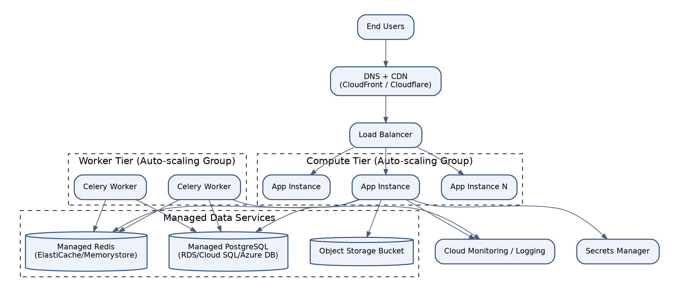
Figure 45.1 - Cloud Infrastructure Architecture

Purpose
To define the concrete cloud infrastructure building blocks the platform depends on, in a form that is portable across major cloud providers rather than locked to any single vendor's proprietary primitives.

Responsibilities
- Provide auto-scaling compute capacity for application and worker tiers.
- Provide managed, highly-available relational database and in-memory cache services.
- Provide durable, versioned object storage with CDN integration.
- Provide centralized secrets management and cloud-native monitoring/logging integration.
- Express every component in Infrastructure-as-Code (Terraform) for repeatable, auditable provisioning.

Components
- DNS + CDN.
- Load Balancer.
- Auto-scaling compute tier (application) and worker tier (Celery).
- Managed PostgreSQL, managed Redis, object storage bucket.
- Secrets Manager.
- Cloud Monitoring/Logging integration.

Dependencies
- All infrastructure is defined and provisioned via Terraform, depending on the CI/CD pipeline (Section 44) for validated, repeatable application to each environment.
- Cloud-native services chosen (managed database, managed cache, secrets manager) must have equivalent offerings across AWS, Azure, and GCP to preserve the platform's stated cloud-portability goal.

Technology
AWS: EC2/ECS or EKS, RDS for PostgreSQL, ElastiCache for Redis, S3, Secrets Manager, CloudWatch, CloudFront. Azure: VM Scale Sets/AKS, Azure Database for PostgreSQL, Azure Cache for Redis, Blob Storage, Key Vault, Azure Monitor, Azure CDN. GCP: Compute Engine/GKE, Cloud SQL for PostgreSQL, Memorystore, Cloud Storage, Secret Manager, Cloud Monitoring, Cloud CDN. Terraform as the common Infrastructure-as-Code layer across all three.

Communication Pattern
Infrastructure provisioning and change is exclusively managed through Terraform applied via the CI/CD pipeline; no manual, out-of-band infrastructure changes are permitted in production, ensuring the Terraform state remains the single source of truth for environment configuration.

Advantages
- Expressing infrastructure in vendor-neutral Terraform modules with per-cloud provider variable sets allows the same architecture to be deployed on whichever cloud provider a given enterprise customer or region requires.
- Infrastructure-as-Code makes every environment (dev, staging, production, DR) reproducible and diffable, eliminating configuration drift as a source of incidents.

Limitations
- Maintaining true cloud portability requires avoiding certain highly proprietary managed services (e.g. cloud-specific serverless database variants), which can mean forgoing some vendor-specific cost or performance optimizations.
- Terraform module maintenance across three cloud providers multiplies the infrastructure code surface area that must be kept current and tested.

Future Scalability
The Terraform module structure is organized so that a new region or a new cloud provider deployment is primarily a matter of supplying new variable values and, where necessary, a provider-specific module implementation, rather than redesigning the infrastructure architecture itself.

46. Production Deployment Strategy
Production deployments use a rolling update strategy across multiple availability zones, gated by the CI/CD pipeline's automated tests and manual approval, with health-check-driven traffic shifting and automated rollback, targeting zero-downtime releases for the vast majority of changes.

Figure 46.1 - Production Deployment Topology (see also Figure 14.1)

Purpose
To define exactly how a validated, approved build reaches production users safely, with minimal or no service disruption, and a clear, fast path to rollback if something goes wrong.

Responsibilities
- Deploy new application container versions incrementally across nodes/zones, never all at once.
- Verify each newly deployed instance's health check before shifting production traffic to it.
- Automatically halt and roll back the deployment if the error rate or latency of newly deployed instances exceeds a defined threshold.
- Run database migrations as a distinct, backward-compatible step preceding application code deployment, following an expand-migrate-contract pattern for schema changes.
- Maintain the ability to redeploy the previous known-good image version within minutes.

Components
- Rolling deployment orchestration (container platform native rolling update, or a blue/green strategy for higher-risk releases).
- Health check endpoints.
- Automated rollback trigger.
- Database migration runner (Django migrations) as a pre-deployment step.
- Deployment notification (Slack) integration.

Dependencies
- Production deployment depends on the CI/CD pipeline (Section 44) having already passed all automated gates and the manual approval step.
- Zero-downtime schema changes depend on developers following the platform's documented expand-migrate-contract migration convention (add new column nullable -> backfill -> switch reads -> drop old column in a later release).

Technology
Container orchestration platform's native rolling update mechanism (Kubernetes Deployment rolling update, ECS rolling deployment, or equivalent); Django's migration framework with a documented backward-compatibility policy; health check endpoints exposed by the application for orchestrator readiness/liveness probing.

Communication Pattern
The orchestrator incrementally replaces old instances with new ones, routing traffic only to instances that pass their readiness probe; the load balancer never routes to an instance mid-startup or mid-shutdown, ensuring users experience no dropped requests during a routine deployment.

Advantages
- Rolling deployment with health-check gating achieves zero-downtime releases for the overwhelming majority of changes, a key commercial requirement for a platform used during live, time-sensitive events (festival day).
- The expand-migrate-contract migration convention allows database schema evolution without ever requiring application downtime for a migration.

Limitations
- Rolling deployments mean two versions of the application code run simultaneously for a short window, requiring that consecutive versions remain backward/forward compatible at the API and database level.
- Certain rare, high-risk changes (major dependency upgrades, significant schema restructuring) still warrant a scheduled maintenance window despite the platform's general zero-downtime capability.

Future Scalability
The rolling deployment foundation directly supports evolving toward blue/green or canary deployment strategies with progressive traffic shifting and automated metric-based promotion, as previewed in the CI/CD future enhancements (Section 44).

47. Technology Decisions
Every core technology selection made for EventFlow AI was evaluated against the Architecture Goals in Section 7. The table below records the primary decisions and the alternatives considered.
Decision Area | Selected Technology | Rationale | Alternatives Considered
Backend Framework | Django + Django REST Framework | Mature, batteries-included framework with a strong ORM, admin tooling, and security defaults; DRF provides a well-trodden path to a versioned, documented REST API. | FastAPI (less batteries-included for a large modular monolith), Flask (would require assembling ORM/admin/auth from scratch)
Primary Database | PostgreSQL | Best-in-class support for Row Level Security, JSONB for flexible AI/audit payloads, materialized views for analytics, and mature replication tooling. | MySQL (weaker RLS/JSONB support), MongoDB (would sacrifice ACID guarantees needed for academic/judging records)
Cache & Broker | Redis | Single technology serving cache, Celery broker/result-backend, AI conversation memory, and rate-limiting needs, minimizing operational surface area. | Memcached (no pub/sub or persistence, unsuitable as a broker), RabbitMQ (stronger broker but adds a second technology purely for messaging)
Background Processing | Celery | The de facto standard for Django-based asynchronous processing, with mature retry, scheduling (Beat), and monitoring (Flower) tooling. | Dramatiq (smaller ecosystem), custom queue polling (reinventing a well-solved problem)
Frontend Framework | React + TypeScript + Tailwind CSS | Largest talent pool and ecosystem for enterprise SPA development; TypeScript's static typing reduces runtime defects at scale; Tailwind enforces design-system consistency without heavyweight CSS-in-JS overhead. | Vue (smaller enterprise hiring pool), Angular (heavier framework overhead for this platform's needs)
AI Providers | OpenAI + Google Gemini (multi-provider) | Avoids single-vendor lock-in and pricing risk; both offer mature function-calling APIs required by the Tool Calling Architecture (Section 29). | Single-provider integration (simpler but strategically risky), fully self-hosted models only (insufficient quality/cost trade-off at this stage)
Containerization | Docker + Docker Compose (dev/staging), managed container orchestration (production) | Docker provides environment parity from a developer's laptop through to production, satisfying Twelve-Factor App principles. | Bare-metal/VM-only deployment (loses environment parity and portability)
CI/CD | GitHub Actions | Tight integration with the GitHub-hosted source repository, mature ecosystem of actions for Docker build/push, and sufficient flexibility for a multi-stage pipeline without a separate CI system to operate. | Jenkins (higher operational overhead to self-host), CircleCI/GitLab CI (viable alternatives, not selected primarily for GitHub integration simplicity)
Authentication | JWT (djangorestframework-simplejwt) | Enables stateless, horizontally scalable authentication validation without a shared session store lookup on every request. | Server-side session authentication (would require a shared, low-latency session store queried on every request, reducing horizontal scalability)

48. Trade-offs
No architecture is free of trade-offs. This section records the significant trade-offs made in the design of EventFlow AI, along with the rationale, so that future architects can revisit these decisions with full context rather than rediscovering the reasoning from first principles.
Trade-off | Choice Made | What Was Gained | What Was Given Up
Modular Monolith vs. Microservices at Launch | Modular Monolith with clear module boundaries | Faster initial development velocity, simpler operational footprint, easier transactional consistency across modules. | Cannot independently scale or deploy individual modules until explicitly extracted; requires discipline to avoid boundary erosion.
Shared Database Multi-Tenancy vs. Database-per-Tenant | Shared database with row-level discriminator + RLS | Significantly lower infrastructure cost per tenant, simpler operational overhead (one database to patch, back up, monitor). | Slightly higher engineering rigor required to guarantee isolation; noisy-neighbor risk requires active mitigation (rate limiting, query timeouts).
Multi-Provider AI vs. Single Vendor | Provider abstraction supporting OpenAI and Gemini | Reduced vendor lock-in risk and pricing exposure; ability to route by cost/quality per use case. | Additional engineering investment to build and maintain the abstraction layer; can only use the lowest-common-denominator of provider-specific features without extension work.
Synchronous Tool-Calling AI Agents vs. Fully Autonomous Agents | Agents restricted to a governed Tool Registry with human-equivalent authorization checks | Predictable, auditable, safe AI behavior; no risk of an agent bypassing business rules. | Some latency overhead per agent action; agents cannot take actions outside their explicitly registered tool set, requiring engineering effort to expand capability.
Read Replica for Reporting vs. Dedicated Analytical Warehouse | PostgreSQL read replica + materialized views initially | Avoids introducing a second database technology and ETL pipeline before it is truly necessary. | Reporting query complexity ceiling is lower than a dedicated columnar warehouse; a future migration (Section 33) will eventually be required at sufficient scale.
JWT Stateless Auth vs. Server-Side Sessions | Short-lived JWT access tokens + Redis-tracked refresh tokens | Stateless horizontal scaling of the application tier without a shared session-lookup bottleneck. | Access tokens cannot be instantly revoked before natural expiry (mitigated by a short 15-minute lifetime).
Rolling Deployment vs. Blue/Green by Default | Rolling deployment as the default strategy | Lower infrastructure cost (no full duplicate environment required for every release) with genuine zero-downtime behavior for the common case. | Slightly slower rollback than a true blue/green switch, and requires strict backward-compatibility discipline between consecutive versions.

49. Risks
The following risk register captures the most significant architectural, security, and operational risks identified for EventFlow AI, along with their likelihood, potential impact, and the specific mitigations already designed into the architecture described in this document.
Risk | Category | Likelihood | Impact | Mitigation
AI provider outage or API deprecation | External Dependency | Medium | Medium | Provider Abstraction Layer (Section 27) enables rapid provider substitution; circuit breakers (Section 39) ensure core platform functions degrade gracefully rather than failing.
Cross-tenant data leakage due to a coding defect | Security | Low | Critical | Defense-in-depth: application-level tenant-scoped ORM manager plus database-level Row Level Security (Section 22) as an independent second control; mandatory code review checklist item for any new tenant-scoped model.
AI agent hallucination producing incorrect administrative output | AI Quality/Trust | Medium | Medium | Guardrails and Output Validator (Section 28) enforce structural and business-rule validation on all agent output; agents act through the same authorization-checked tool layer as humans, and high-impact actions (e.g. certificate issuance) require the underlying domain service's normal approval workflow, not blind AI trust.
Database becomes a scaling bottleneck as tenant count grows | Scalability | Medium | High | Read replica offload for reporting (Section 23), aggressive caching (Section 24), and a documented sharding path keyed on organization_id (Section 40) as scale demands it.
Key personnel dependency on modular monolith boundaries | Organizational | Medium | Medium | Automated import-linter boundary enforcement (Section 17) makes architectural boundaries a build-time guarantee rather than tribal knowledge, reducing bus-factor risk.
Regulatory/compliance requirements (student data protection, e.g. FERPA/GDPR) not met for a new market | Compliance | Medium | High | Audit architecture (Section 34), encryption at rest/in transit (Section 37), and tenant-configurable data retention policies (Section 43) provide the technical controls; legal/compliance review remains a required companion process to any new market entry.
Celery/Redis broker outage halts all background processing | Availability | Low | High | Redis deployed in Sentinel/cluster HA configuration (Section 24); monitoring and alerting (Section 36) on queue depth and broker health for rapid detection and response.
Cost overrun from uncontrolled AI token usage | Financial | Medium | Medium | Per-provider token usage and cost tracking in the Provider Abstraction layer (Section 27); tenant-level AI usage budgets and alerting integrated with the Monitoring architecture (Section 36).
Vendor lock-in to a single cloud provider | Strategic | Low | Medium | Infrastructure expressed in cloud-neutral Terraform modules (Section 45) with documented equivalents across AWS, Azure, and GCP.

50. Future Architecture Evolution
The architecture described in this document is deliberately designed with explicit seams for future evolution. This section summarizes the highest-priority evolution paths, each of which builds directly on a mechanism already present in the current architecture rather than requiring a future rewrite.
- Microservice Extraction: As individual bounded contexts (starting with Analytics and the AI Module, which already have minimal incoming synchronous dependencies per Section 17) grow in scale or require independent release cadence, they will be extracted into standalone services communicating over the same internal API/event contracts already in place, following the strangler-fig pattern rather than a disruptive rewrite.
- Retrieval-Augmented Generation (RAG): The AI Context Builder (Section 16) is designed to accept a retrieval step sourcing relevant organizational documents, historical event data, and judging guidelines from a vector store, improving the accuracy and specificity of AI agent responses without requiring changes to the Agent Orchestrator or Tool Registry.
- Model Context Protocol (MCP) Adoption: The existing schema-driven Tool Registry (Section 29) is directly compatible with exposure as an MCP server, allowing third-party MCP-compatible AI clients and internal tooling to interact with EventFlow AI's governed capability surface using an emerging industry-standard protocol.
- Self-Hosted Model Support (Ollama): The Provider Abstraction layer (Section 27) already defines the interface an Ollama-backed adapter would implement, enabling cost-sensitive or data-residency-sensitive customers to run inference on self-hosted, open-weight models for specific agents.
- Database Sharding: Should a single shared PostgreSQL primary become a genuine bottleneck at extreme tenant scale, the organization_id discriminator already present on every tenant-scoped table (Section 22) provides a ready-made shard key for a future horizontally-partitioned database architecture.
- Dedicated Analytical Warehouse: The Analytics module's Analytics API (Section 33) is designed so that its backing store can migrate from PostgreSQL materialized views to a dedicated columnar warehouse (e.g. ClickHouse, BigQuery, or Snowflake) without any change to frontend dashboard code.
- Enterprise Identity Federation: The Auth Service's credential-verification step (Section 20) is designed to accept an additional SAML/OIDC-based verification strategy ahead of JWT issuance, enabling single sign-on integration with school district and enterprise identity providers.
- Expanded Compliance Certification: The existing audit trail, encryption, and access-control architecture (Sections 34, 37) is designed as the technical foundation for pursuing SOC 2 Type II and ISO 27001 certification as the platform's enterprise customer base grows.
- Multi-Region Active-Active Deployment: The current multi-AZ deployment topology (Section 14) is designed to extend to a multi-region active-passive, and eventually active-active, topology as international customer demand and data-residency requirements grow, building on the same Infrastructure-as-Code foundation (Section 45).

51. Appendix

A. Glossary of Terms
Term | Definition
Tenant / Organization | A single customer entity (school, festival board, competition organizer) whose data is logically isolated from all other tenants sharing the platform.
Bounded Context | A DDD concept describing a module's self-contained domain model and business rules, with an explicit boundary and interface to other contexts.
RBAC | Role-Based Access Control - an authorization model granting permissions based on a user's assigned role(s) within an organization.
RLS | Row Level Security - a PostgreSQL feature enforcing row-visibility policies directly in the database engine, independent of application code.
Agent (AI) | A specialized AI component (e.g. the Registration Validation Agent) responsible for a single, well-defined class of AI-assisted task.
Tool Calling | The mechanism by which an LLM requests execution of a registered, permissioned function (tool) rather than producing free-text output alone.
Guardrails | Validation logic applied to AI agent output before it is returned to a user or used to trigger a platform action, ensuring structural and business-rule compliance.
RTO | Recovery Time Objective - the maximum acceptable time to restore service following a disaster.
RPO | Recovery Point Objective - the maximum acceptable amount of data loss, measured in time, following a disaster.
Twelve-Factor App | A methodology for building SaaS applications emphasizing configuration via environment, stateless processes, and strict dev/prod parity.
Modular Monolith | A single deployable application internally structured into strictly bounded modules, offering many microservice benefits without distributed-systems operational overhead.
MCP | Model Context Protocol - an emerging open standard for connecting AI models to external tools and data sources in a standardized way.

B. Non-Functional Requirements Summary
Category | Target
Availability | 99.9% monthly uptime (core platform); graceful degradation of AI/notification features during partial outages
Performance | P95 API latency under 300ms for standard CRUD endpoints; P95 under 3s for synchronous AI agent responses
Scalability | Support 500+ concurrent organizations and 50,000+ concurrent authenticated users at launch scale, horizontally scalable thereafter
Recovery | RTO under 1 hour; RPO under 15 minutes for the primary database
Security | Zero critical findings in quarterly penetration testing; all data encrypted at rest and in transit
Compliance Readiness | Architecture supports SOC 2 Type II and regional student-data protection regulations (e.g. FERPA-aligned controls)
Deployment Frequency | Multiple production deployments per week via fully automated CI/CD with sub-30-minute merge-to-production lead time

C. Multi-Tenant Design Reference
This appendix consolidates the multi-tenant design concepts referenced throughout the document (see primarily Section 22) for quick reference:
- Tenant Isolation: Enforced through a dual mechanism - an application-level tenant-scoped ORM manager and database-level PostgreSQL Row Level Security policies.
- Shared Database: All tenants reside in a single physical PostgreSQL database, partitioned logically via an organization_id discriminator column present on every tenant-scoped table.
- Organization Context: A request-scoped context object carrying the resolved tenant identity, propagated through middleware, the service layer, and into any triggered Celery tasks.
- Tenant Middleware: Resolves the tenant from the request's subdomain, custom domain mapping, or JWT claim, and binds it to the Organization Context before any business logic executes.
- Row Level Security: Database-enforced policies referencing a session variable set at the start of each request/transaction, providing a defense-in-depth backstop independent of application code correctness.
- Tenant Resolver: The specific component responsible for the resolution strategy (subdomain, custom domain, or JWT claim) and for validating that the resolved tenant is active and in good standing.
- Tenant Lifecycle: Organizations progress through Trial, Active, Suspended, and Archived states, each governing feature access and data retention behavior.
- Tenant Scaling: The largest tenants can be migrated to a dedicated schema or dedicated database using the same Tenant Resolver abstraction, without requiring application-layer code changes.

D. Security Control Reference
This appendix consolidates the security controls referenced throughout the document (see primarily Section 37) for quick reference:
- JWT: Short-lived, RS256-signed access tokens with Redis-tracked, rotating refresh tokens (Section 20).
- RBAC: Centralized policy engine evaluating role and object-level permissions per request, with a default-deny posture (Section 21).
- MFA: TOTP-based multi-factor authentication required by default for Organization Admin and Judge roles.
- Rate Limiting: Redis-backed, per-tenant and per-user request throttling to mitigate abuse and credential-stuffing attacks.
- OWASP: The platform's security controls are mapped against the OWASP ASVS and Top 10 as part of the quarterly security review cycle.
- Secrets Management: All credentials and API keys are stored in a cloud-native secrets manager and injected at runtime, never committed to source control or plain environment files.
- Encryption: AES-256 encryption at rest for database and object storage; TLS 1.2+ enforced in transit everywhere.
- Security Headers: CSP, HSTS, X-Frame-Options, and X-Content-Type-Options applied uniformly via middleware to every HTTP response.
- Audit Trail: An immutable, database-enforced audit log capturing every mutating action platform-wide (Section 34).

E. AI Architecture Reference
This appendix consolidates the AI architecture concepts referenced throughout the document (see primarily Sections 26-29) for quick reference:
- Agent Manager (Orchestrator): Coordinates the end-to-end lifecycle of every AI request across all six agents.
- Prompt Store: A versioned repository of prompt templates per agent, allowing prompt iteration without a code deployment.
- Prompt Versioning: Every prompt template change is versioned and attributable, with the active version recorded in the AI Interaction Logger for reproducibility.
- Tool Registry: A schema-driven catalog of permissioned functions agents may invoke, each backed by an existing, authorization-checked domain service.
- Context Builder: Assembles the prompt, relevant conversation memory, and relevant domain data into the context passed to the model.
- Conversation Memory: Redis-backed, TTL-bound storage of recent conversational turns scoped per user session.
- AI Logging: Every prompt, tool call, and response is logged for audit, debugging, and cost-tracking purposes.
- Guardrails: Structural and business-rule validation applied to all agent output before it reaches a user or triggers a platform action.
- Provider Abstraction: A common interface decoupling agent logic from any single LLM vendor's API (Section 27).
- OpenAI / Gemini: The two LLM providers currently supported through concrete adapters.
- Future Ollama: A planned adapter for self-hosted, open-weight models for cost- or residency-sensitive use cases.
- Future MCP: A planned exposure of the existing Tool Registry as a Model Context Protocol server for standardized third-party interoperability.
- Future RAG: A planned retrieval step within the Context Builder to ground agent responses in organization-specific documents and historical data.

F. Deployment Reference
This appendix consolidates the deployment stack referenced throughout the document (see primarily Sections 14, 15, 44-46) for quick reference:
- Docker: All application, worker, and scheduler processes are packaged as Docker images built and tested in CI.
- Docker Compose: Used for local development and staging environments to replicate the full multi-container topology.
- Nginx: Reverse proxy handling static asset serving and request forwarding to Gunicorn.
- Gunicorn: WSGI application server executing the Django/DRF codebase.
- Redis: Cache, Celery broker/result-backend, AI conversation memory, and rate-limiting store.
- Celery: Asynchronous and scheduled background task processing.
- PostgreSQL: Primary system of record with read replica(s) for reporting/analytics offload.
- GitHub Actions: Fully automated CI/CD pipeline from pull request to production deployment.
- Production: Multi-availability-zone, auto-scaling, rolling-deployment topology with automated rollback.
- Horizontal Scaling: Stateless application and worker tiers scale by adding nodes behind the existing load balancer/queue.
- Load Balancer: Health-check-driven traffic distribution and failover across application nodes.
- Object Storage: Durable, versioned storage for certificates, uploaded documents, and static assets, fronted by a CDN.

