Urban Heat Island Evolution & Land-Use Change
A Sequential and Spatial Data-Mining Pipeline — Ward-Level Study of Chennai
DA-1 | Sequential and Spatial Mining
By Sachin S | 23MIA1114

1. Problem Statement
- Rapid urbanization replaces vegetation with concrete and built-up surfaces, producing localized temperature spikes known as Urban Heat Islands (UHI).
- Most cities lack granular, ward-level, time-series tracking of this effect — planners cannot tell exactly where green-cover intervention is most urgent.
- Objective: quantify how Land Surface Temperature (LST) has changed alongside vegetation loss over 2016–2024 for Chennai, using free satellite time series, and produce a reproducible heat-risk map with statistical validation.
- Key questions addressed:
  - Which wards have warmed the most, and why — vegetation loss vs. built-up expansion?
  - Is the warming trend statistically significant, or just seasonal noise?
  - Can we detect the year a land-use change occurred, rather than only a before/after difference?

2. Methodology
The pipeline fetches multi-source satellite imagery, aligns it into a per-ward annual time series, computes vegetation and temperature indices, then applies formal statistical methods (trend testing and change-point detection) rather than simple visual comparison.
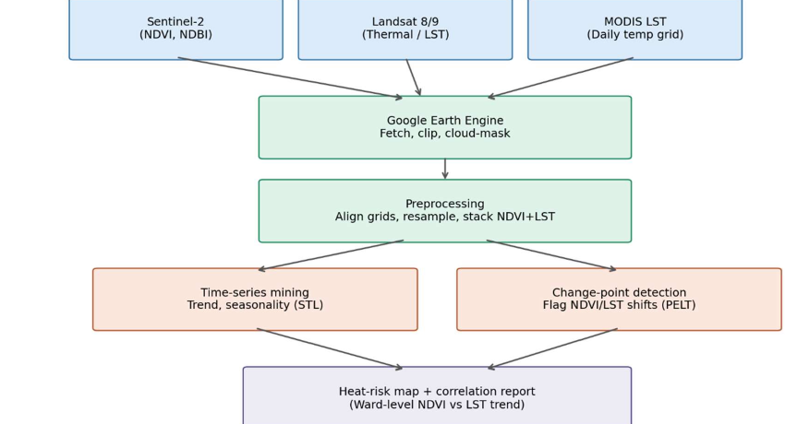
Fig. 1 — Pipeline architecture: satellite sources → Earth Engine fetch/clip/mask → preprocessing → sequential + spatial mining → heat-risk output.

2.1 Data Sources
Dataset | Resolution | Role
Sentinel-2 (L2A) | 10 m, 5-day revisit | NDVI (vegetation), NDBI (built-up index)
Landsat 8/9 Collection 2 | 30 m (100 m thermal) | Land Surface Temperature (LST)
CHIRPS Daily | ~5 km | Annual rainfall — confounder control
Ward boundaries (GeoJSON) | Vector | Aggregation unit for all statistics

2.2 Processing Steps
- Fetch: pull Sentinel-2, Landsat and CHIRPS collections per year and clip to each ward via the Google Earth Engine Python API.
- Cloud/quality masking: Sentinel-2 SCL band and Landsat QA_PIXEL bits remove cloud, shadow and snow pixels before compositing.
- Index computation: median annual composites reduced to NDVI, NDBI and LST (Kelvin → °C) per pixel.
- Zonal aggregation: reduceRegions() with a mean reducer collapses each index to one value per ward per year (200 Chennai wards, 2016–2024).
- Statistical mining: Mann-Kendall trend test, PELT change-point detection, and multiple linear regression (see Section 4).
- Visualization: choropleth heat-risk map and dual-axis LST/NDVI trend chart.

3. Sample Implementation
Core snippets from the executed Colab notebook are shown below, alongside the outputs they produced.

3.1 Annual Composite & Index Computation
def get_annual_composite(year, aoi):
s2 = (ee.ImageCollection('COPERNICUS/S2_SR_HARMONIZED')
.filterDate(f'{year}-01-01', f'{year}-12-31').filterBounds(aoi)
.filter(ee.Filter.lt('CLOUDY_PIXEL_PERCENTAGE', 30))
.map(mask_s2).median())
l8 = (ee.ImageCollection('LANDSAT/LC08/C02/T1_L2')
.filterDate(start, end).filterBounds(aoi).map(mask_l8).median())
lst = l8.select('ST_B10').multiply(0.00341802).add(149.0).subtract(273.15)
ndvi = s2.normalizedDifference(['B8', 'B4']).rename('NDVI')
ndbi = s2.normalizedDifference(['B11', 'B8']).rename('NDBI')
return ee.Image.cat([ndvi, ndbi, lst.rename('LST')]).set('year', year)

3.2 Ward-Level Extraction
for year in range(2016, 2025):
img = get_annual_composite(year, aoi)
stats = img.reduceRegions(
collection=wards_ee, reducer=ee.Reducer.mean(), scale=100
).getInfo()
# -> records: {ward, year, NDVI, NDBI, LST}
Result: a 1,800-row panel (200 wards × 9 years) of NDVI, NDBI, LST and rainfall — ward_timeseries_full.csv.

3.3 Heat-Risk Map Output
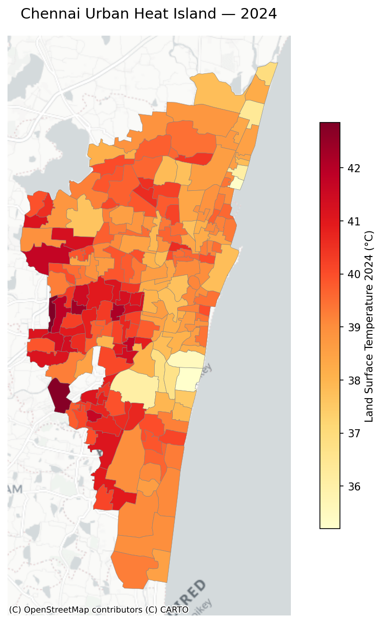
Fig. 2 — 2024 ward-level LST choropleth for Chennai. Darkest wards (~42–43 °C) cluster in the dense, built-up core; lightest wards (~35–36 °C) sit near the coast and remaining green patches.

3.4 Trend Chart for the Top-Warming Ward
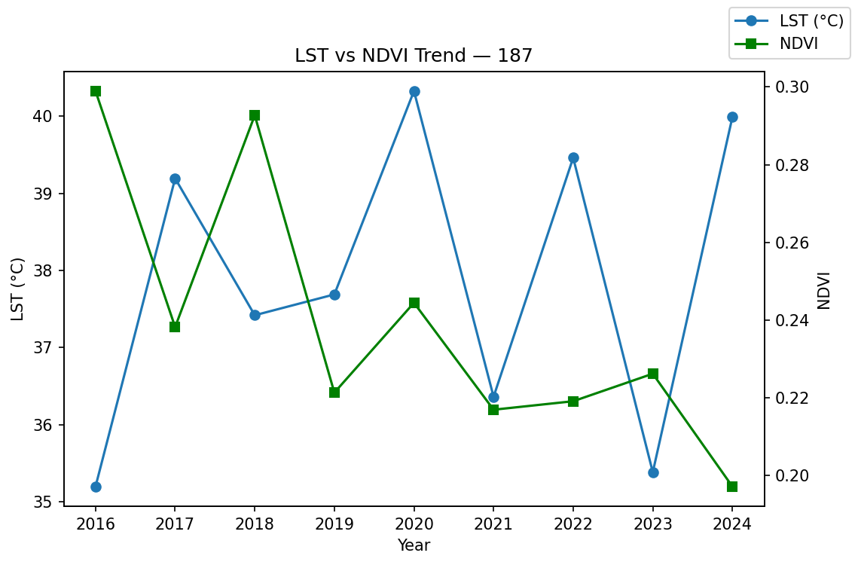
Fig. 3 — LST vs. NDVI, Ward 187 (highest positive LST slope). The series is noisy year-to-year rather than monotonic, motivating the formal trend test in Section 4.

4. Sequential Mining Methods Used
This project is framed as sequential + spatial mining: each ward contributes an ordered 2016–2024 sequence of (NDVI, NDBI, LST, rainfall), and three sequential-analysis techniques are applied to it.

4.1 Mann-Kendall Trend Test
- Purpose: a non-parametric test for a monotonic trend in each ward's LST sequence, without assuming linearity or normal residuals.
- Library: pymannkendall.original_test(), run once per ward on its 9-year LST series.
- Output per ward: trend direction (increasing / decreasing / no trend), Sen's slope (°C/year), and a p-value for significance.
for ward in df['ward'].unique():
series = df[df.ward==ward].sort_values('year')['LST'].dropna()
result = mk.original_test(series)
# -> result.trend, result.p, result.slope

4.2 PELT Change-Point Detection
- Purpose: detect the year within each ward's NDVI sequence where an abrupt shift (land-use change) occurred, instead of only comparing endpoints.
- Library: ruptures.Pelt(model='rbf'), a penalized exact linear-time changepoint search.
- Output per ward: list of change-point years flagged in the NDVI sequence.
algo = rpt.Pelt(model="rbf").fit(ndvi_series)
breakpoints = algo.predict(pen=3) # indices -> years

4.3 Sequence-to-Feature Regression
- Purpose: relate each ward's aggregated sequence features (mean NDVI, NDBI, rainfall) to its LST, isolating vegetation/built-up effects from rainfall.
- Method: ordinary least-squares multiple linear regression (scikit-learn LinearRegression).
- This step is spatial-statistical rather than purely sequential — it consumes the time-mined outputs of 4.1/4.2 as cross-sectional features.

5. Results Summary

5.1 Trend Significance (Mann-Kendall)
Metric | Value
Wards analyzed | 200
Wards with statistically significant trend (p < 0.05) | 1 / 200
Dominant classification | “No trend” (199 / 200 wards)
Mean Sen's slope (all wards) | − 0.14 °C / year
Top 5 wards by warming slope:
Ward | Trend label | p-value | Slope (°C/yr)
187 | no trend | 0.47 | +0.249
32 | no trend | 0.60 | +0.226
197 | no trend | 0.92 | +0.200
157 | no trend | 0.60 | +0.179
97 | no trend | 0.92 | +0.172

5.2 Change-Point Detection (PELT)
- 0 / 200 wards returned a detected change-point in the NDVI series at the tested penalty (pen = 3).
- Interpretation: NDVI fluctuates year-to-year but no abrupt, sustained shift was flagged over the 9-year window at ward-mean resolution — consistent with the “no trend” Mann-Kendall result rather than contradicting it.

5.3 Regression (LST ~ NDVI + NDBI + rainfall)
Term | Coefficient
NDVI | +5.73
NDBI | +23.55
Rainfall | − 0.0011
R² | 0.170
- NDBI (built-up index) has a far larger positive coefficient than NDVI — built-up expansion is the stronger LST driver at ward scale in this sample.
- Low R² (0.17) indicates NDVI/NDBI/rainfall alone explain a minority of ward-level LST variance — other factors (built form, proximity to sea, albedo, anthropogenic heat) likely matter too.

6. Limitations
- 2015 excluded from NDVI/NDBI/LST: Sentinel-2 had negligible usable coverage over Chennai that early, so composites returned empty collections for that year (handled gracefully by the pipeline).
- No ward showed a statistically significant Mann-Kendall trend except one — 9 annual points is a short series for trend detection; monthly composites would give more statistical power.
- PELT found no change-points at the chosen penalty; a lower penalty or pixel-level (rather than ward-mean) series may reveal localized shifts averaged out at ward scale.
- Regression R² is low (0.17) — the model is a first-pass linear baseline, not a causal claim.
- 100 m/5 km reduceRegions scale trades spatial detail for Earth Engine query speed; finer scales would increase runtime substantially over 200 wards × 9 years.

7. Conclusion
- A reproducible, ward-level UHI pipeline was built end-to-end on free satellite data (Sentinel-2, Landsat 8, CHIRPS) via Google Earth Engine and Python.
- Sequential mining (Mann-Kendall, PELT) and spatial aggregation (200-ward zonal statistics, choropleth mapping) were combined to move beyond simple before/after visual comparison.
- Built-up expansion (NDBI) is the stronger correlate of elevated LST relative to vegetation loss (NDVI) in this dataset, though the current model explains only a modest share of variance.
- Next steps: extend the series with monthly composites for stronger trend power, and test pixel-level change-point detection before ward-level aggregation.

