BEGINNING OF THE ENDLESS DARK- STONE

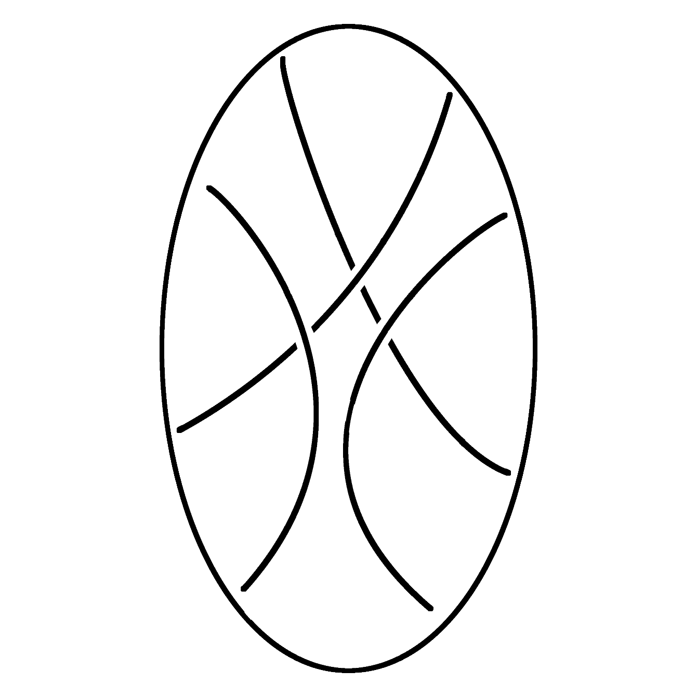

Starting to write a story is really hard, that is why I always start in the middle, because I don’t mind how I write. But why do I write? That is the question that makes my brain tingle. It is not a pleasant thing to do, but I still do it.

I am searching for something, hidden deep in the unknown. And I have to find it, well at this point do I even have a choice? So much of it has already been written.

I must finish it, even if I decided that I won’t do it. Who am I to decide that? The ending is already set in stone. I can’t escape it, none of us can.

Stories commonly begin in the beginning, but I would like to start even before that. Going to the beginning of our universe, our reality, won’t be enough. We have to start before that.

We came from nothing and we will go back to nothing. That is the absolute end to our story.

What is nothing?

I have a weird little obsession with the word nothing. I don’t really know when or how it happened. I guess there was a saying. “If you stare into the abyss, the abyss stares back at you.”

We associate the word nothing with emptiness, darkness or lack of something. But I am looking from the other perspective, I see this lack of something as potential.

What I mean to say is that nothingness is the most immense potential of existence and is a primary infinity. Like a pot is molded out of clay, our reality is molded out of nothingness.

We could also look at nothingness mathematically. A number that could represent it already exists, and that is 0. That is why we can't divide with this number. And if we would put nothingness on a graph, it would be a line that infinity from functions comes close to but can never reach it.

And that is our meaning of life, our purpose, reaching for something we can never fully reach. Because this line 0 is our existence, experiencing itself.

Are you ready to repeat every moment of your life for the rest of eternity?

Requiem for understanding

WHY?

This question is living rent free in the back of my mind. This small void, that nothing can fill. The constant whisper of skepticism, that gives a feeling that nothing is really real.

This feeling caused a series of unfortunate events, where I was shown infinity and omniscience. And now I have to live with it.

The amount of information and their constant changing is too much for our brain. Even in simple day-to-day life, our brain has to simplify and fill in the missing information, so we can understand, or even comprehend our reality. I was made aware that our brain isn’t able to be omniscient.

But that won’t stop me from trying.

To achieve my goal, I will have to use a shortcut. I came to the conclusion, if omniscience is out of the question, I will just become all understanding. Same job, different title.

Just as scientists are looking for an equation that solves everything. I am looking for a state of mind that understands everything. And to do that I will create a story like no other. A story of everything.

# Time before 0

It all started at a time where there was no time when everything was nothing, pure nothingness.

In this infinity, there appeared a thought, a single thought that changed everything and nothing.

It was not known. What was it thought? Why was it thought of?

Who thought it?

This paradoxical uncertainty echoed throughout nothingness, leaving behind a feeling of emptiness. This feeling crushed everything into a single point, into a dark- stone.

The moment it was formed, it exploded into infinite dark fragments, flying in all directions with a single purpose, finding the original thought.

# Time after 0

With dark stone breaking into infinite dark fragments, its consciousness was also broken with them to experience all the wonderful, terrible, pleasant, horrifying, meaningful, worthless moments. That is where we come into the picture.

Our consciousness is like a light in the projector, projecting the image on the screen, choosing how we will cast our lives on the stage.

Can we choose a better life for ourselves? Or does infinite time mean everything will happen, so there is no point in resisting?

# Dark fragment No. 0.4796

This dark fragment exploded into a white hole, creating particles that can be formed into matter. A simulation of subatomic particles to see what they will develop. Like dark stone was formed from a single thought, this universe No.

0.4796 was formed from a single equation, a single law that governs all the matter in the universe, a law hidden in plain sight.

The algorithm for matter in this universe is really simple. The matter is formed of atoms containing subatomic particles, protons, neutrons, and electrons. And the number of these particles in an atom defines the properties of the matter.

PS: This fragment has one secret. If you try to observe its particles smaller than the subatomic ones, it will simulate them for you, but that doesn’t mean they will hold any answers to its secret.

And sometime after the white hole was created and when everything started to cool down, three elements were made, the holy trinity.

And all this matter is connected by the force of Big G,

6.66 x 10^-11 m3 kg^-1 s^-2

This invisible force, or Big G, is made from matter of the dark fragment, and it has to collect all known information.

And then we also have dark energy, which is the will of the dark fragment, the desire to explore the unknown. This force is expanding the universe, searching for new experiences and information.

While dark matter and dark energy seem like opposites, they work together in waves, exploring and collecting new information.

# Existence

With the force of big G all of the scattered matter started to gather and form into celestial bodies.

r {O m1 > F < m2 O}, F = ((G*m1*m2)/r^2)

Celestial bodies get so big, that their weight crushes atoms together, causing nuclear fusion. This process transforms the elements of the holy trinity into completely new elements.

And when celestial bodies come of age they bloom like a flower, exploding and scattering these new elements across the universe.

⁴He + ⁴He => ⁸Be + ⁴He => ¹²C + 2Y

This chain of events would repeat for billions of years, creating celestial bodies of all shapes and sizes. With smaller ones circling around bigger ones.

At one moment, a fragment from nothing strikes a small planet, melting its core and creating a satellite.

# Earth

This fragment that struck a planet left behind something more, than just a melted core and a moon. It left behind something unknown to this universe, an unexplainable phenomenon.

A couple billion years passed before the conditions for this unknown were right, this awareness would develop and integrate into the material world.

Constant interaction, observation and adaptation, creating life. With each interaction it would learn and become more complex and so did their observations. It started to observe their abyss, only to find out that we are their abyss.