Q1. Given the graph and the straight-line distance heuristic table below, find the path from Start to Goal. Apply –
- Greedy Best First Search [5]
- A* Search [5]
In both cases, show your simulation, the path found, and the total cost of the path.
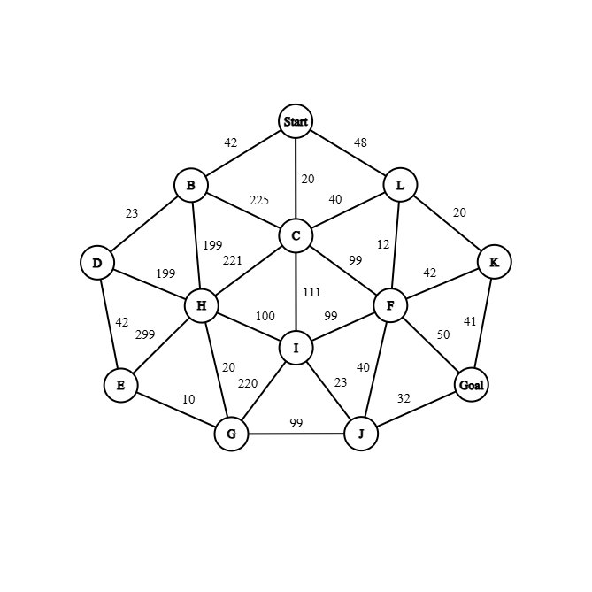 | Node h(n)  Start 51  B 50  C 32  D 28  E 42  F 14  G 33  H 43  I 50  J 32  K 41  L 56  Goal 0

Q2. Prove, using a bidirectional graph with 5 nodes and 4 edges, that along all paths from the start to the goal node, the f(n) values are increasing for a consistent heuristic. [3]
Q3. Show local maxima using a 5-queen board (move only one queen to two possible locations), and an 8-puzzle game (move the empty tile to four possible positions). [5]
Q4. Discuss the importance of the temperature value in simulated annealing. [2]

