Zachary Rump

ECE 4655

Fall 2017

**Assignment 1: Histogram Equalization**

**Objective**

The objective for this assignment was to write a program to transform an input image using histogram equalization and write the output image to disk. Some test images from the textbook were provided as inputs.

**Methods**

The method I used for this is the same one that was reviewed in class. The steps can be broken down as follows:

1. Read the image into an MxN matrix
2. Compute histogram for the image
3. Find probability function by normalizing the histogram.
4. Compute the transform (look up table) from probability function.
5. Round transform function values to nearest integer.
6. Write output image by using transform function on input.

To elaborate on the transform function, it gives a new intensity value, k2, given an input intensity value, k1. So, to transform the whole image it’s as simple as iterating through each pixel in the input, plugging the intensity at that pixel (k1) into the transform, and then writing the output of the function (k2) at the given pixel in the output image.

**Results**

**C:\Users\nihil\Desktop\46551\inputs\fig38_input.tifC:\Users\nihil\Desktop\46551\outputs\fig38_output.tif**

Figure 3.8 from the textbook. Left side is the original image; right side is the result of histogram equalization.

C:\Users\nihil\Desktop\46551\inputs\fig39_input.tifC:\Users\nihil\Desktop\46551\outputs\fig39_output.tif

Figure 3.9 from the textbook. Left side is original; right side is output.

**C:\Users\nihil\Desktop\46551\inputs\fig316_1_input.tif**

Figure 3.16.1 (Above) is the input image

**C:\Users\nihil\Desktop\46551\outputs\fig316_1_output.tif**

Figure 3.16.1 after histogram equalization.

**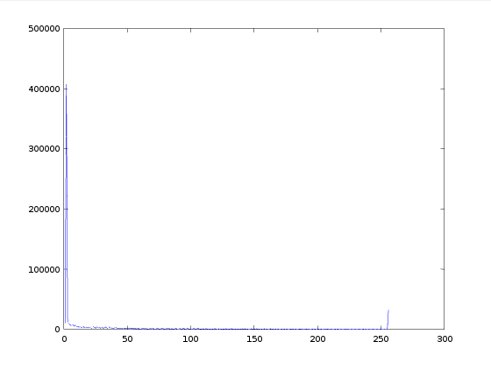**

Image above shows the histogram of Figure 3.9 prior to equalization.

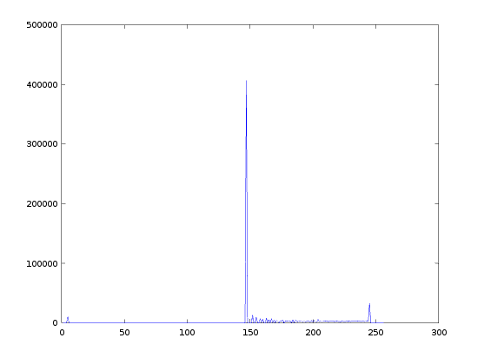

Image above shows histogram of Figure 3.9 **after** equalizing.

**Remaining Issues**

* Program takes a hardcoded input file (‘in.tif’) and gives hard coded output files (out.tif, out\_control.tif). Should turn into function that takes input and output parameters, and maybe uses implicit input/outputs if not specified.
* Will complain if you try to run it using Matlab with the `pkg image` line left intact. If there’s a way to detect Matlab or Octave at runtime that would be preferable.