**Zachary Rump**

**ECE 4655**

**Fall 2017**

**Assignment 2**

**Objective**

The objective for this lab was to perform some different types of image processing techniques. In part 1 a smoothing / blur filter is applied using three techniques: Averaging, Gaussian, and Median. In part 2 we attempt to apply a filter to sharpen an image, and in part 3 a Gaussian pyramid is constructed using the Lenna image.

**Methods**

The method is slightly different for all of them, but in general the steps are just:

1. Read image into matrix
2. Initialize a filter / window size
3. Convolve the filter with the image.
4. Write the output

Additionally, I tried to use matlab’s built-in functions whenever possible to generate a ‘control’ image with which to compare my results.

**Results**

**Average smoothing**

**C:\Users\nihil\46552\src\part1\average\figure312\result.tif**

Figure 1. Shows Figure 3.12 smoothed using Matlab average smoothing function (ks=3) (left), using my average smoothing with kernel size=3 (center), and average smoothing with kernel size 5 (right).

C:\Users\nihil\46552\src\part1\average\figure333\result.tif

Figure 2. Shows Figure 3.33. Left is the original image, center is using my average smoothing with kernel size 5. Rightmost image is Matlab’s average function with ks=5.

C:\Users\nihil\46552\src\part1\average\figure334\result.tif

Figure 3. Figure 3.34. Left – Original image, Center – Output of my averaging, Right – output of Matlab’s averaging.

C:\Users\nihil\46552\src\part1\average\figure335\result.tif

Figure 4. - Figure 3.35, Original is left, Mine is center, Matlab’s control is right.

**Gaussian smoothing**

C:\Users\nihil\46552\src\part1\gaussian\figure335\result.tif

Figure 5 - Figure 3.35 after Gaussian smoothing. My result is center, Matlab’s control is right. Original is on the left.

**Median smoothing**

C:\Users\nihil\46552\src\part1\median\figure333\result.tif

Figure 6 -Figure 3.33 after median smoothing. This figure had most noticeable result with the median smoothing. Matlab control is on the right, my output is center, original image on the left.

**Part 2.**

C:\Users\nihil\46552\src\part2\result.tif

Figure 7. Shows my attempt at sharpening figure 3.38 I don’t think I got this to work correctly but including it anyway. Original is left, center is after Gaussian blur, right is after “sharpen.”

C:\Users\nihil\46552\src\part2\result.tif

Figure 8. Same as figure 7 but for the logo image (Fig. 3.40)

**Part 3**

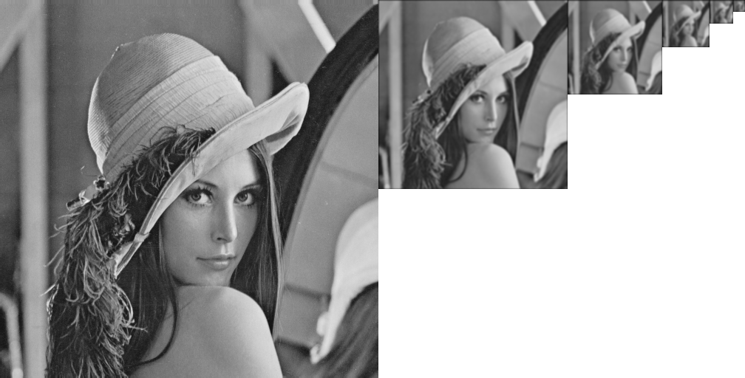

Figure 9. Shows Gaussian pyramid. I ended up using imagemagick to make this (convert +append).

**Remaining Issues**

* My implementation of Gaussians (and others) use ‘0’ for the filter value whenever the filter is outside image. I.e. I pad all the images with 0’s so it produces a black border.
* Additionally, my programs could be improved by taking kernel size as a parameter. I kind of hard-coded and changed manually window_size+padding.
* Never got sharpen to work quite right. Still need to get this working but I included my results

anyway.

* Program(s) are clunky to use (still). Need to script the inputs/outputs filenames.
* Had more trouble with the Pyramid than I expected – ended up using imagemagick to make this instead of Matlab. Could be improved e.g. by resizing the down sampled images e.g. resize 16x16 to 512x512 so the ‘details’ of the small images can be seen.