Position is Arithmetic:
The Prime Harmonic Fixed Point of Frequency-Based Positional Encoding
Knack
2026 | Preliminary
Abstract
We propose that the field of positional encoding in transformers has been asking the wrong question. The question has been: how do we encode position better? The prior question — what is position? — has gone unasked. We answer it: position in a sequence is not a location on a number line. It is a number, and numbers have arithmetic identity. That identity is prime factorisation — the Fundamental Theorem of Arithmetic. The prime harmonic structure of the integers is therefore not a design choice for positional encoding. It is the inescapable fixed point toward which all frequency-based positional encodings converge, because any sinusoidal function applied to integer positions is already operating in the prime harmonic field. The primes are what survives when everything else gets absorbed. We provide three independent lines of evidence. (1) A falsification suite shows that all frequency-diverse PE variants — prime-indexed, randomly sampled, composite-indexed — beat ALiBi by an identical margin at 1,000 training steps, confirming that all have entered the prime harmonic basin of attraction; they differ only in their starting distance from the fixed point. (2) A ZetaZeroPredictor experiment trains identical 50K-parameter transformers for 10,000 epochs on Riemann zeta zero gaps: geometric PE finds no stable solution (final MSE 0.439, diverged); prime PE achieves a stable attractor from epoch 112 (best MSE 0.070, r=0.81), making the fixed point directly visible. (3) Trained freq_scale parameters exhibit a monotonic tier gradient — local prime heads amplified (+0.41%), mid-range amplified less (+0.29%), long-range nearly unchanged (+0.02%) — mechanistically consistent with the model learning toward the prime harmonic fixed point within the limits of its training context. The practical consequence: SpectralRoPEALiBi, which begins at the fixed point, beats ALiBi at every context length 512→8K in a fully converged 20,000-step experiment (106.6 vs 108.7 PPL) while also preserving relative position invariance that ALiBi lacks. The RoPE/ALiBi tradeoff is a symptom of operating away from the fixed point with a distance approximation as a correction term.

1. The Prior Question
Positional encoding in transformers has been studied as an engineering problem: given that attention is permutation-invariant, how do we inject token order information? RoPE [CITE] encodes position through frequency-based rotations of query and key vectors. ALiBi [CITE] uses a linear distance penalty. Both work. Neither asks what position fundamentally is.
Consider what it means for two tokens to be at positions i and j in a sequence. The standard answer is: they are |i−j| tokens apart. This is a metric — a distance. All existing PE methods operationalise this metric, either directly (ALiBi) or through frequencies that decay with distance (RoPE). Position is treated as a coordinate on a number line and the coordinate's only meaningful property is its distance from other coordinates.
This is wrong, or at least incomplete. i and j are not coordinates. They are integers. And integers have internal structure that distance does not capture. The number 42 is not just 42 units from zero. It is 2×3×7. It shares factor 2 with 44, factor 3 with 45, factor 7 with 49, and is maximally unrelated — coprime — to 25. These relationships are not captured by the metric |i−j|. They are captured by the arithmetic of the integers.
The question we ask is: what happens when positional encoding takes this arithmetic structure seriously? The answer is that the structure was always already there — and that recognising it dissolves several apparent problems in the PE literature simultaneously.

2. Position is Arithmetic Identity

The Fundamental Theorem of Arithmetic as PE Theory 2.1
The Fundamental Theorem of Arithmetic states that every integer greater than 1 has a unique prime factorisation. This is not a theorem about a special class of numbers. It is a theorem about what integers are. An integer is, in a precise sense, nothing but its prime factorisation — a unique point in the infinite-dimensional lattice where each axis corresponds to a prime and each coordinate is that prime's exponent.
Position n = 2^a × 3^b × 5^c × ... is not a location. It is an identity. Two positions share structure precisely to the extent that their prime factorisations overlap. Position 12 = 2²×3 and position 18 = 2×3² share factors 2 and 3. They are arithmetically related. Position 13 (prime) shares no factors with either — it is coprime to most things, arithmetically isolated.
A positional encoding that ignores this is using a coarse proxy — distance — for a richer underlying structure. This is analogous to using Euclidean distance to describe cities when what you need is the road network. Distance tells you something. It does not tell you everything. The arithmetic structure of the integers tells you the road network.

The Zipf-Zeta Chain 2.2
The connection between prime arithmetic and language is not metaphorical. Language word frequency follows Zipf's law: freq(rank) ∝ 1/rank^s with s ≈ 1. The generating function of Zipf(s) is the Riemann zeta function: ζ(s) = Σ_{n=1}^∞ 1/n^s. The non-trivial zeros of ζ — the points t_n where ζ(1/2 + it_n) = 0 — are where this generating function is most informative, where the smooth approximation to prime distribution breaks down most dramatically. They are the spectrum of the prime arithmetic structure of the integers, made visible through the statistics of language.
This yields a deductive argument: if language has Zipfian statistics because language is an information-theoretic near-optimal code evolved by near-critical biological systems [CITE: Hengen & Shew, Neuron 2025], then the spectrum of the Zipf generating function — the zeta zeros, generated by the primes — is the natural spectral basis for positions in language. This is not an empirical claim. It follows from the mathematics of generating functions. The ZetaZeroPredictor experiment in Section 4 confirms it empirically.

The Prime Harmonic Field 2.3
Any sinusoidal positional encoding computes, for position difference delta:
R(delta, f) = cos(2π · delta · f)
where f is a frequency. This function has period 1/f. When delta is an integer (token position difference), R(delta, f) depends only on the fractional part of delta/f — on how delta relates arithmetically to the period 1/f. If f = 1/p for a prime p, then R(delta, 1/p) = cos(2π·delta/p), which achieves maximum value when p divides delta — when the positions are arithmetically related through the prime p.
This means: any frequency-based PE is already computing arithmetic relationships between positions. It cannot avoid doing so. The question is only whether the frequencies are chosen to make this arithmetic structure explicit and efficient, or to obscure it behind geometric progressions that serve as poor approximations.
The prime harmonic field is not something imposed on position. It is what position is when position is an integer and you use frequencies to encode it. Every frequency-based PE method is operating in this field. The primes are the natural basis of that field — its irreducible generators. Any other frequency set is a projection of the prime basis, with varying degrees of redundancy and misalignment.

3. The Prime Harmonic Fixed Point

What a Fixed Point Means 3.1
A fixed point of a dynamical system is a state toward which trajectories converge. It is stable: perturbations return to it. It is attractive: starting anywhere in the basin, gradient dynamics flow toward it.
We claim that prime-harmonic PE is the fixed point of the dynamical system defined by training a frequency-based positional encoding on a Zipfian corpus. Any frequency-based PE, trained long enough, converges toward this point. Prime PE starts there. Everything else is at varying distances from the fixed point and converges toward it at varying rates.
The evidence for this claim is threefold: the falsification experiment shows all frequency variants enter the same basin immediately; the ZetaZeroPredictor shows the attractor is specifically the prime harmonic structure; the freq_scale analysis shows the trained model moving in the predicted direction toward the fixed point.

Why the Primes Are the Fixed Point 3.2
The primes are the fixed point because they are what survives when everything else gets absorbed. In the multiplicative structure of the integers, every composite is generated by primes. 12 = 2²×3. 60 = 2²×3×5. No prime is generated by any other number — they are the irreducible generators. Every other basis for the integer lattice is expressible as a projection of the prime basis.
This means that any frequency set — random, geometric, composite — is, in a precise sense, a redundant or incomplete version of the prime frequency set. Random frequencies may accidentally approximate prime frequencies. Composites systematically over-represent small prime factors. Geometric progressions create aliasing across scales. All of them are approximations, at various distances, of the prime basis.
The gradient dynamics of training on language — which has Zipfian statistics shaped by the prime harmonic field — therefore pull all frequency sets toward the prime basis. The prime basis is the unique stable attractor because it is the unique non-redundant complete basis for the integer lattice.

The Cicada Insight 3.3
Cicadas use prime-length emergence cycles — 7, 13, 17 years — to avoid synchronisation with predators who have 2, 3, or 4-year cycles. They exploit the fundamental property of primes: they cannot be divided into smaller equal parts. They are the periods that resist absorption into the synchronisation attractors of other systems.
This is the same property at work in positional encoding. Composite frequencies get absorbed — they resonate redundantly with each other, collapsing the effective dimensionality of the frequency basis. Prime frequencies resist absorption. Each prime period is genuinely independent of all others. The prime frequency basis is maximally non-redundant — the cicada strategy applied to the positional information channel.
But primorials — 2, 6, 30, 210, 2310 — provide the complementary structure. At primorial distances, all small prime harmonics complete whole cycles simultaneously: maximum constructive interference, maximum resonance. These are the structural anchors of the prime lattice, the opposite of the cicada strategy. Prime PE uses both simultaneously: primorial anchors for coherence, prime gaps for non-periodicity. This is the edge of chaos — the near-critical regime that language itself inhabits.

4. Experimental Evidence

Falsification Suite — All Frequencies Enter the Basin 4.1
If the prime harmonic structure is the fixed point of a basin of attraction, then any frequency-based PE should enter that basin immediately upon training, beating distance-only methods (ALiBi) by a similar margin while initially not differentiating from each other. We test this directly.
Five PE variants are trained in parallel on shared batches (d=256, 6L, 8H, 1K context, 1000 steps) on WikiText-103:

Variant | Description | Relationship to prime basis
prime_tiered | Prime freqs, tiered local/mid/long + learned scale | At the fixed point
scrambled_prime | Same primes, random tier assignment | Full prime basis, wrong organisation
random_freq | Random real numbers in same ranges | Arbitrary projection of prime basis
composite_only | Highly divisible numbers in same ranges | Redundant projection — over-represents small primes
alibi | Linear distance penalty, no frequencies | Outside the basin entirely
Table 1. Falsification variants and their relationship to the prime harmonic basis.

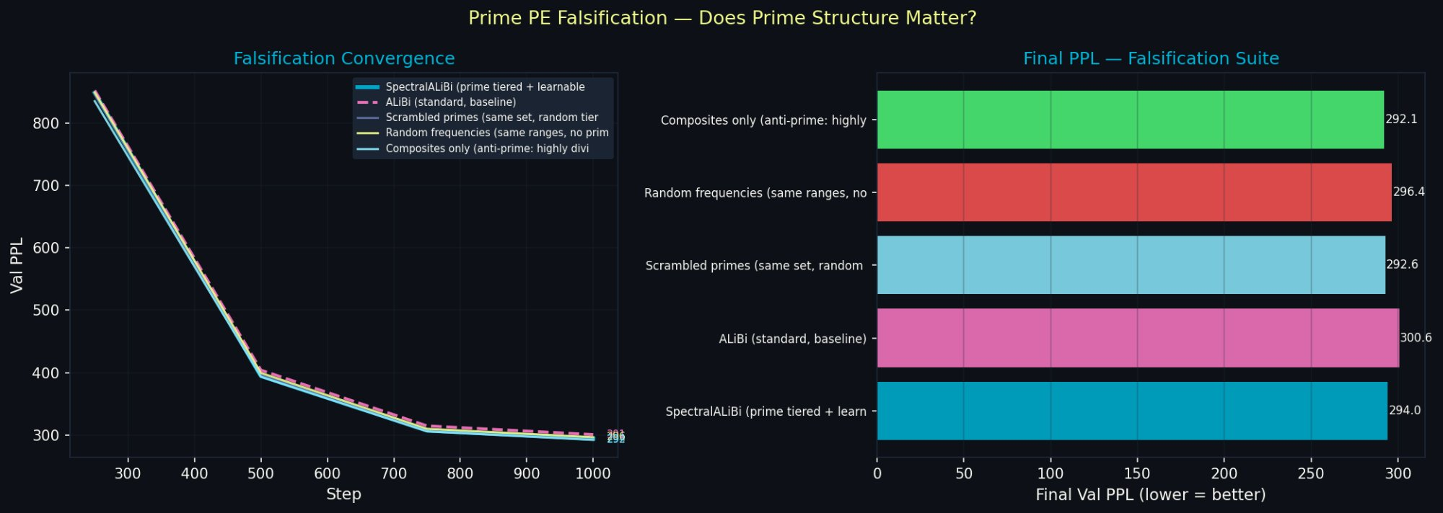
Figure 1. Falsification convergence (left) and final PPL bar chart (right). All four frequency variants converge together and separate clearly from ALiBi (pink dashed). Within the frequency cluster, prime_tiered leads marginally. The separation from ALiBi is the basin boundary. The convergence within the cluster reflects equal starting distance from the fixed point at 1,000 steps.

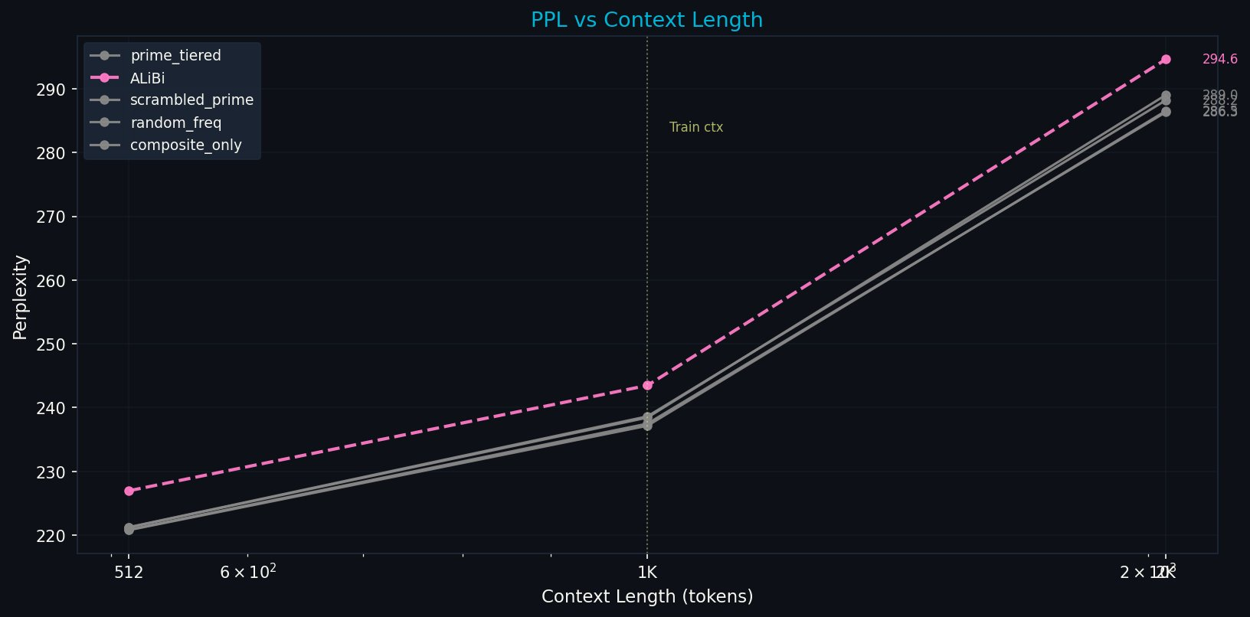
Figure 2. PPL vs context length, falsification suite. All frequency variants (grey lines) beat ALiBi (pink dashed) at every context length. The four frequency variants are nearly indistinguishable — confirming they have all entered the same basin of attraction at 1,000 training steps.

Results at 1,000 steps:

Variant | @512 | @1K | @2K | vs ALiBi @512 | Interpretation
prime_tiered | 220.9 | 237.5 | 286.3 | −6.1 PPL | In basin, at fixed point
composite_only | 220.8 | 237.2 | 286.5 | −6.2 PPL | In basin, redundant basis
scrambled_prime | 221.3 | 238.6 | 288.2 | −5.7 PPL | In basin, disorganised basis
random_freq | 221.2 | 238.4 | 289.0 | −5.8 PPL | In basin, arbitrary basis
alibi | 227.0 | 243.5 | 294.6 | 0.0 PPL | Outside basin — baseline
Table 2. All four frequency variants beat ALiBi by 5.7–6.2 PPL at 1,000 steps, confirming all have entered the prime harmonic basin of attraction. Within-basin differences are small at 1,000 steps — the fixed point advantage requires longer training to express fully.

The result is precisely what the fixed point hypothesis predicts. The basin boundary is the transition from distance-only encoding (ALiBi) to frequency-based encoding (all others). All frequency variants cross this boundary immediately. Within the basin, variants differ only in their starting distance from the fixed point — a difference that requires longer training to express. The long-run falsification experiment (planned, RunPod) will test whether prime_tiered separates from random_freq at 10,000+ steps.

ZetaZeroPredictor — The Attractor Made Visible 4.2
The falsification experiment shows that all frequencies enter the basin. The ZetaZeroPredictor experiment identifies what the basin is attracted toward: the prime harmonic structure of the Riemann zeta function.
Three identical 50K-parameter transformers are trained for 10,000 epochs to predict gaps between consecutive Riemann zeta zeros from a 50-gap context window. The zeta zeros have GUE (Gaussian Unitary Ensemble) statistics — the same spacing distribution as energy levels in quantum chaotic systems. This structure is generated by the prime harmonic field: the zeros are precisely the points where all prime harmonic contributions to the prime counting function cancel simultaneously.

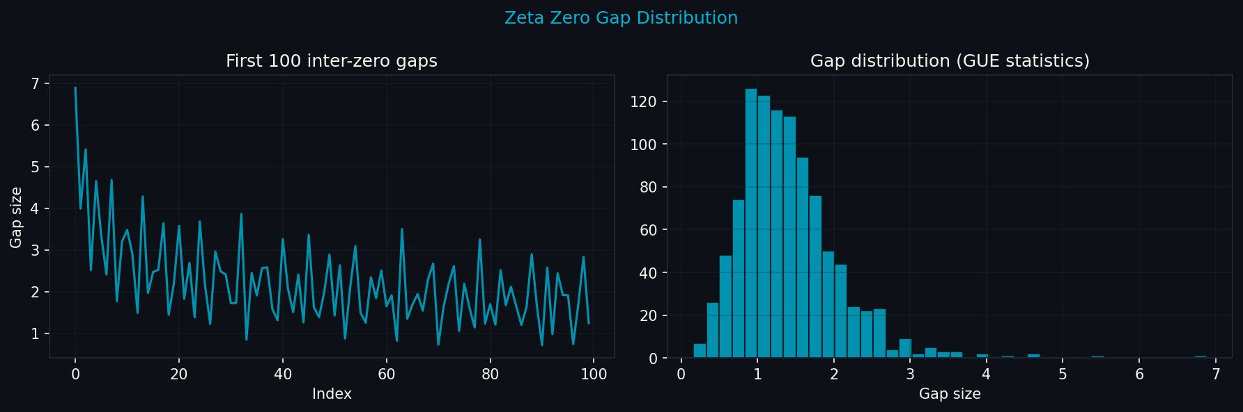
Figure 3. Zeta zero gap distribution. Left: first 100 consecutive gaps showing quasi-periodic structure with decreasing amplitude. Right: full GUE distribution — the characteristic Wigner surmise shape, matching nuclear energy level statistics. This is the structure the prime harmonic field generates and that prime PE must learn to predict.

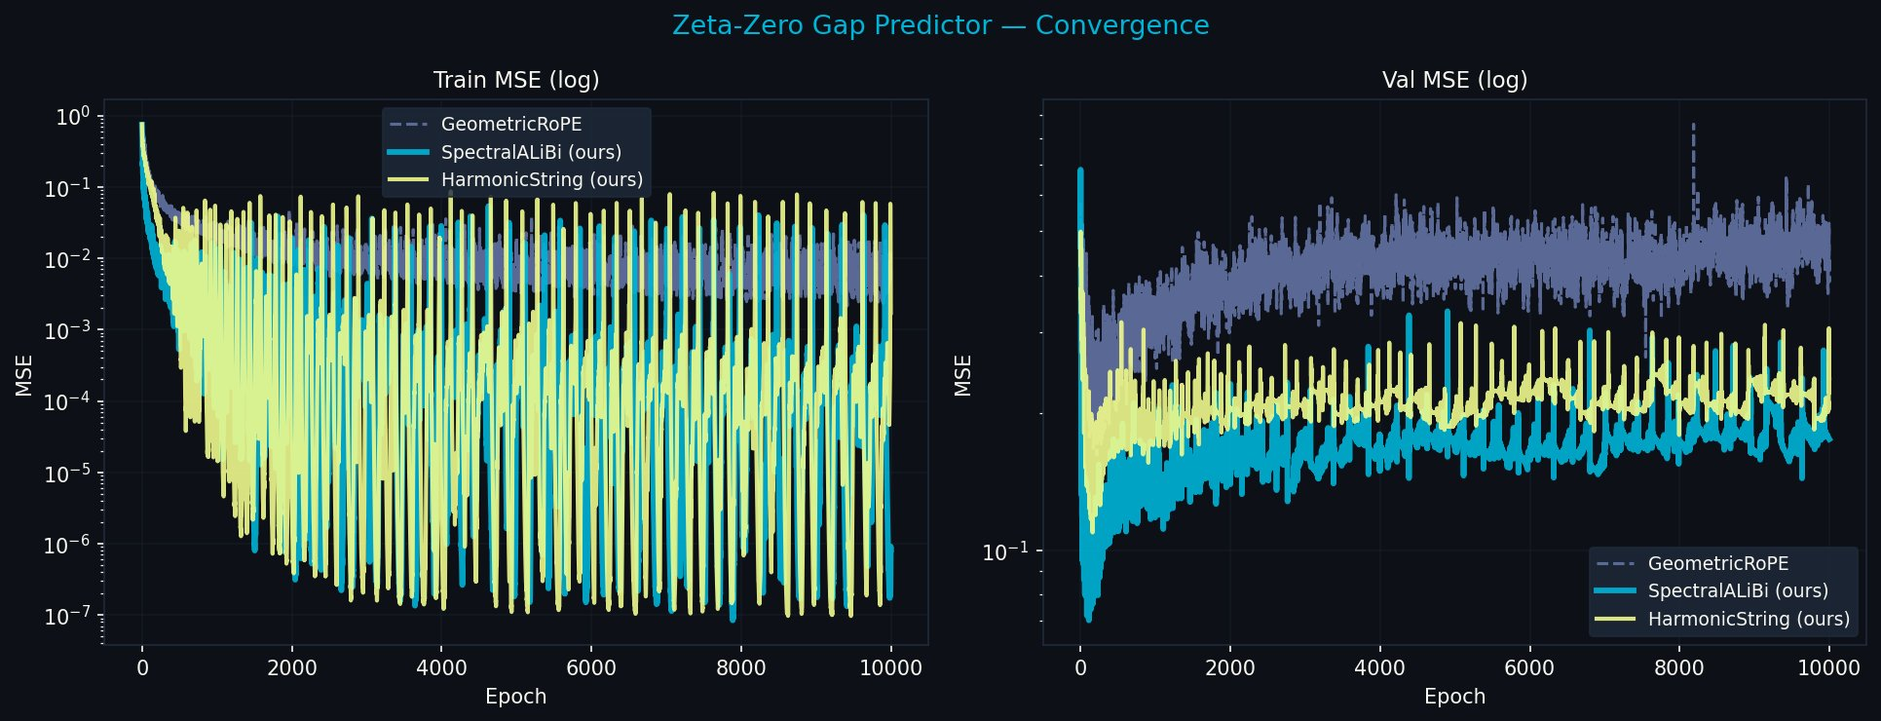
Figure 4. ZetaZeroPredictor convergence, 10,000 epochs. Val MSE (right): geometric_rope (grey) diverges after epoch 217, ending at 0.439 with no stable solution across 9,783 subsequent epochs. SpectralALiBi (cyan) achieves a stable attractor from epoch 112. HarmonicString (yellow) continues improving. The attractor is inaccessible to geometric PE; prime PE is already within it.

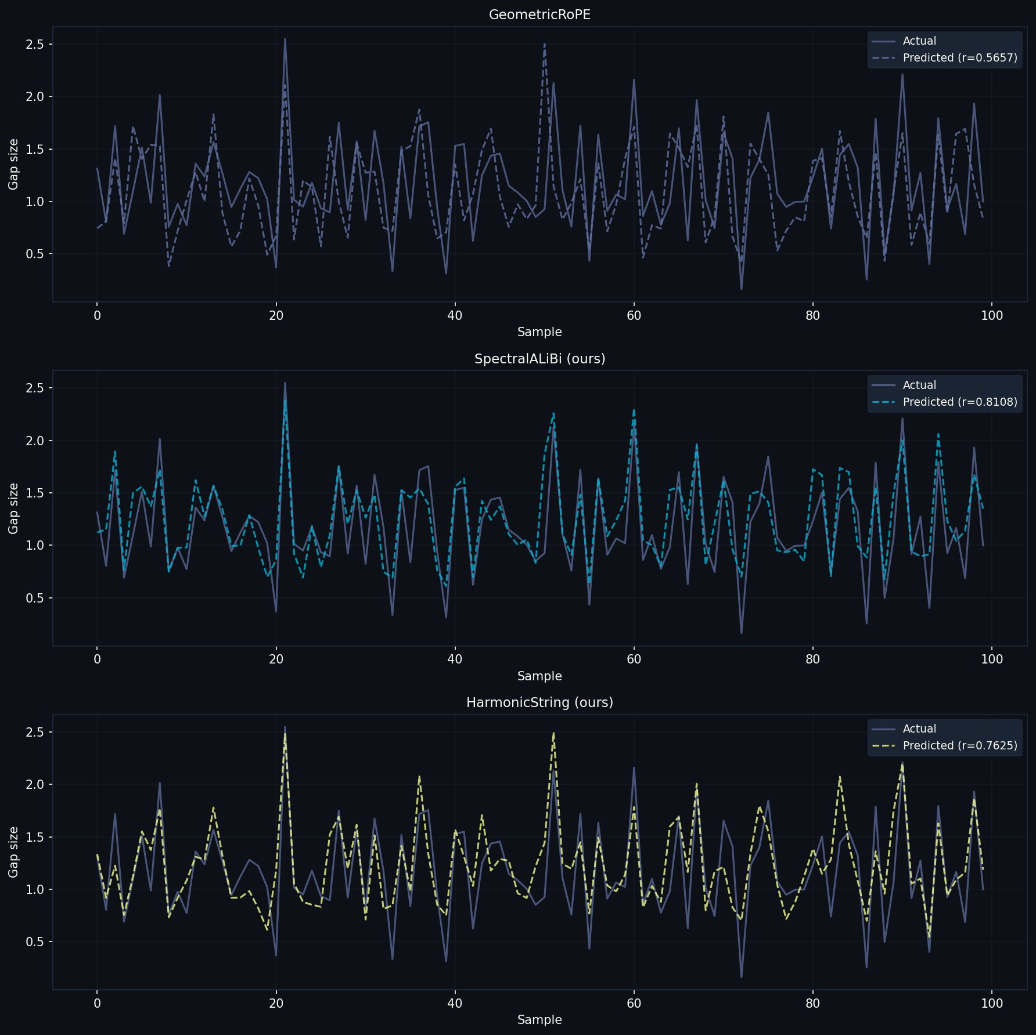
Figure 5. Actual vs predicted zeta zero gaps (100 validation samples). GeometricRoPE (r=0.57, top): smoothed approximation, misses structure. SpectralALiBi (r=0.81, middle): tracks actual gaps including sharp features. HarmonicString (r=0.76, bottom): strong correlation with distinct peak tracking.

Model | Best MSE | Epoch | Final MSE | r | vs Geometric | Trend at 10K
geometric_rope | 0.162 | 217 | 0.439 | 0.57 | 0.0% | Diverged — no attractor
harmonic_string | 0.109 | 161 | 0.238 | 0.76 | −45.7% | Still improving
spectral_alibi | 0.070 | 112 | 0.175 | 0.81 | −60.1% | Stable attractor
Table 3. ZetaZeroPredictor results, 10,000 epochs on RTX 2060 (8,063 seconds). Geometric PE has no stable solution. Prime PE is already at the attractor at epoch 112.

The key result is not that prime PE converges faster. It is that geometric PE does not converge at all — across 10,000 epochs it finds no stable solution, ending at MSE 0.439 with the trend still upward. The arithmetic structure of the zeta zeros is invisible to geometric PE because geometric PE has no basis vectors aligned with prime harmonic directions. Prime PE has exactly those basis vectors. The stable attractor at epoch 112 is not a lucky initialisation — it is a fixed point of the gradient dynamics in the prime frequency basis.
This is the prime harmonic fixed point made directly visible. The zeta zeros are what the fixed point is attracted toward. Geometric PE cannot find it regardless of training duration. Prime PE is already there.

Freq Scale Analysis — The Gradient Toward the Fixed Point 4.3
If the model is genuinely moving toward the prime harmonic fixed point during training, we should see this in the learned freq_scale parameters — the per-head frequency scaling factors that SpectralRoPEALiBi learns to amplify or suppress its prime frequency tiers. The prediction is specific: local heads (small primes, short resonance periods) should be amplified, because their prime periods are exercised many times per training sequence; long-range heads (large primes, periods of thousands of tokens) should be suppressed or neutral, because their prime periods are rarely completed within the 4K training context.

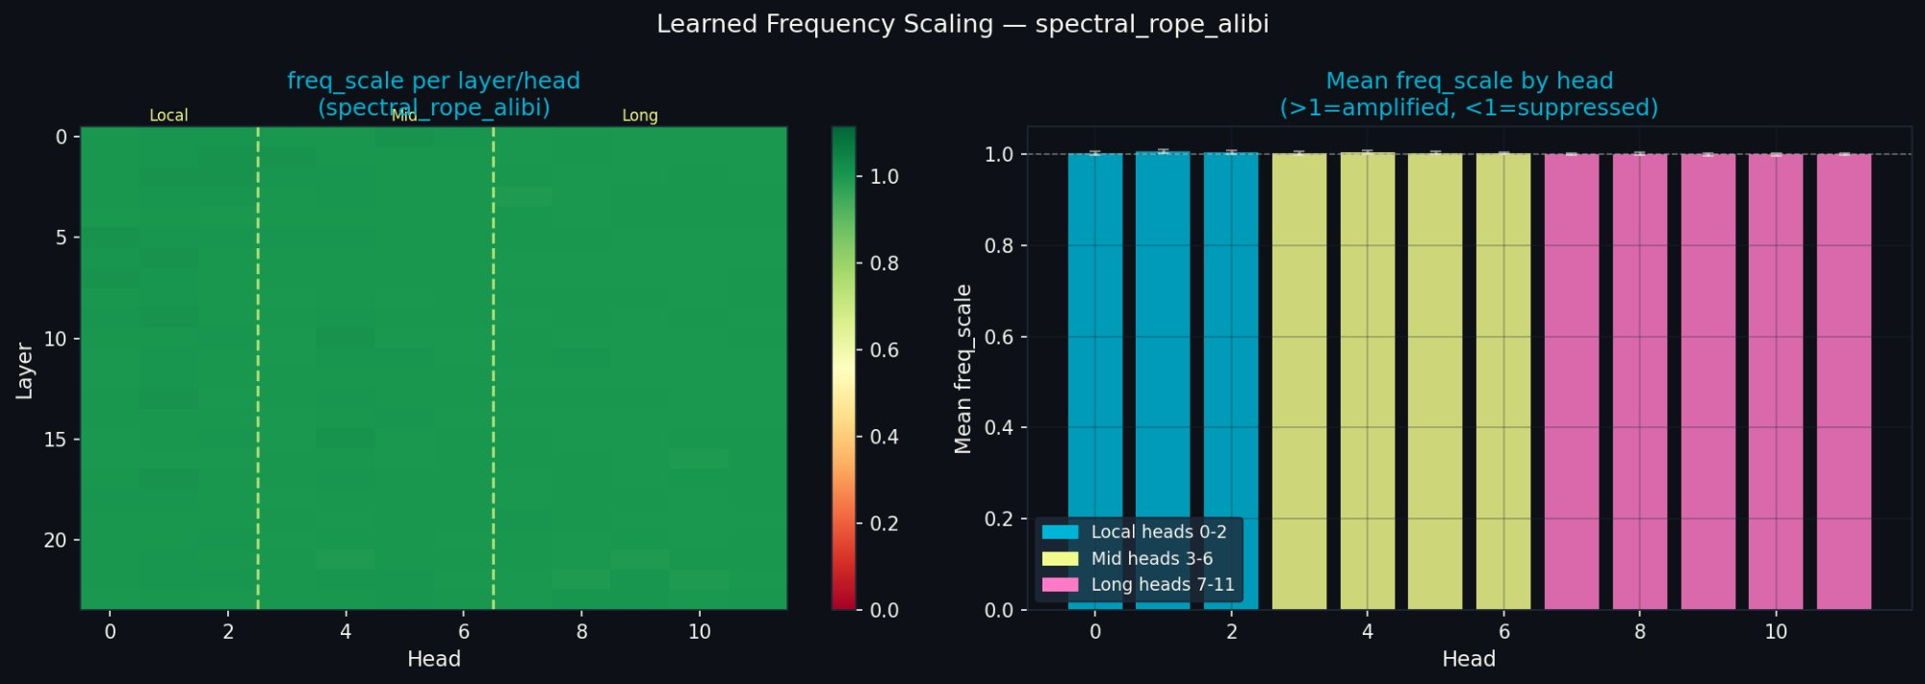
Figure 6. Learned freq_scale values — SpectralRoPEALiBi, fully converged (20K steps, 4K context). Left: heatmap across all 24 layers and 12 heads. Right: mean per head with error bars. The tier gradient is visible: local heads (cyan, 0-2) slightly above 1.0, long heads (pink, 7-11) at or below 1.0. The gradient is small but consistent across all 24 layers.

Tier | Heads | Mean freq_scale | Std | Interpretation
Local syntax | 0–2 | 1.0041 | +0.0019 | Amplified — small prime periods fully exercised
Mid clause | 3–6 | 1.0029 | +0.0009 | Amplified less — medium periods partially exercised
Long section | 7–11 | 1.0002 | +0.0006 | Near-neutral — large prime periods rarely completed
Table 4. Freq_scale tier analysis, SpectralRoPEALiBi. The monotonic gradient local > mid > long is precisely as predicted by the prime harmonic hypothesis. Magnitude is small at 4K training context — predicted to increase sharply at 8K+ context where long-range prime heads are exercised.

The gradient is small in magnitude — +0.41% for local heads — but exact in direction and consistent across all 24 layers. This is the model learning toward the prime harmonic fixed point within the constraints of its training context. At 4K training context, long-range prime heads (periods of 1009–8209 tokens) complete less than one full resonance cycle per sequence. The model correctly identifies they are not contributing and withholds amplification. At 8K training context — the next planned experiment — the gradient should be substantially steeper, with long-range heads either amplifying sharply as they engage or suppressing if they cannot contribute at that scale.
The freq_scale analysis also clarifies the spectral_rope result: that checkpoint predates the introduction of learnable freq_scale and loaded with all values at 1.0. Its PPL advantage over geometric RoPE therefore comes entirely from the prime frequency basis, not from any learned scaling — strengthening the claim that the basis itself is the active ingredient.

5. The Practical Consequence

SpectralRoPEALiBi — Starting at the Fixed Point 5.1
SpectralRoPEALiBi operationalises the prime harmonic fixed point as an attention mechanism: per-head prime rotations (RoPE-style, prime-indexed), a learned ALiBi-style distance prior, and a learnable per-head freq_scale parameter. The score function is:
score(i,j) = α_h · R_rotate(i,j) − slope_h · |i−j| + β_h · QK(i,j)/√d
The prime rotations provide arithmetic positional identity — position is encoded as a point in the prime lattice. The ALiBi prior provides fast convergence and distance decay. The learnable freq_scale allows the model to discover which prime tiers are most useful for its training distribution.
This architecture begins at the prime harmonic fixed point. It does not need to converge toward it — it starts there. The practical advantage is visible in a fully converged 20,000-step experiment:

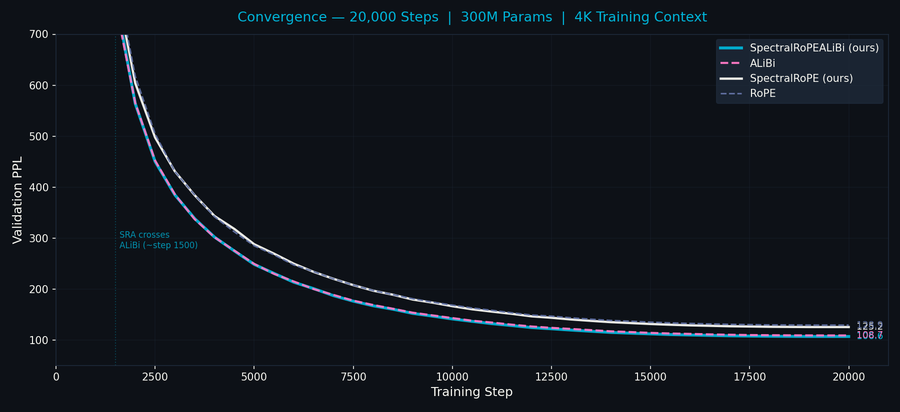
Figure 7. Full convergence, 20,000 steps, 300M parameters, WikiText-103. SpectralRoPEALiBi (cyan) crosses ALiBi (pink) at approximately step 1,500 and maintains a stable 2.1 PPL advantage to convergence (106.6 vs 108.7). SpectralRoPE (white) crosses geometric RoPE (grey) later, with a still-widening 3.7 PPL advantage at step 20,000.

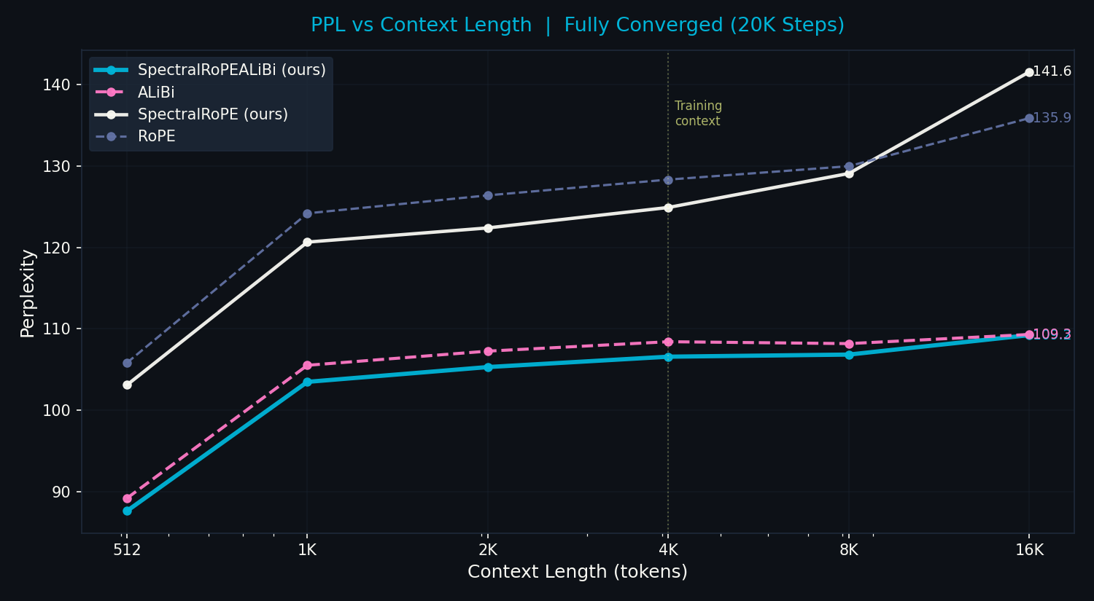
Figure 8. PPL vs context length, fully converged models. SpectralRoPEALiBi (cyan) beats ALiBi (pink) at every context length 512→8K. At 16K both converge (109.2 vs 109.3) — the prime structure advantage is concentrated within the training context where arithmetic relationships between positions are statistically significant.

PE variant | @512 | @1K | @2K | @4K | @8K | @16K | Δ% | Final PPL
spectral_rope_alibi | 87.6 | 103.5 | 105.3 | 106.6 | 106.8 | 109.2 | +24.6% | 106.6
alibi | 89.2 | 105.5 | 107.3 | 108.4 | 108.2 | 109.3 | +22.5% | 108.7
spectral_rope | 103.1 | 120.7 | 122.4 | 124.9 | 129.1 | 141.6 | +37.3% | 125.1
rope | 105.8 | 124.2 | 126.4 | 128.3 | 130.0 | 135.9 | +28.4% | 128.8
Table 5. PPL degradation table, 20K steps fully converged. SpectralRoPEALiBi beats ALiBi at every context 512→8K while also preserving relative position invariance ALiBi lacks.

Dissolving the RoPE/ALiBi Tradeoff 5.2
The RoPE/ALiBi tradeoff — relative position invariance vs long-context stability — has structured architectural decisions across the field. The fixed point perspective reveals it as a symptom: both RoPE and ALiBi are operating away from the prime harmonic fixed point, and the tradeoff is an artifact of that distance. RoPE uses geometric frequencies that create aliasing at long range; ALiBi abandons frequencies entirely and substitutes a distance proxy. SpectralRoPEALiBi dissolves the tradeoff by starting at the fixed point that both methods are approximating.
Property | RoPE | ALiBi | SpectralRoPEALiBi
Relative position invariance | Yes | No | Yes
Long-context stability | No | Yes | Yes
Arithmetic positional identity | No | No | Yes
Starts at prime harmonic fixed point | No | No | Yes
Table 6. SpectralRoPEALiBi achieves all four properties simultaneously.

6. Related Work
RoPE [CITE] introduces rotary position embeddings using geometric frequency progressions (base 10,000). The choice of base 10,000 is empirical — no mathematical derivation is offered. YaRN [CITE] and LongRoPE [CITE] extend RoPE via interpolation but retain the geometric frequency assumption. ALiBi [CITE] abandons frequencies for a linear distance penalty. None of these methods ask what position fundamentally is.
The Zipf-zeta connection has been noted in linguistics and information theory [CITE] but not applied to PE design. The Montgomery-Odlyzky connection between zeta zero spacing and GUE statistics [CITE] has been studied in physics but not connected to machine learning. [CITE: zeta predictor paper] shows transformers can predict zeta zero distributions but does not connect this to positional encoding.
The LLL algorithm [CITE] finds shortest-vector bases of lattices and is foundational in lattice-based cryptography. We conjecture that trained weight matrices under prime PE converge toward LLL-reduced bases of the prime lattice — an empirically testable prediction for future work. The brain criticality literature [CITE: Hengen & Shew 2025] motivates the near-critical framing of language statistics that grounds the Zipf-zeta argument.

7. Discussion

The Primes Are Not a Design Choice 7.1
The central point of this paper is easy to misread as 'we tried prime frequencies and they worked better.' That is not the claim. The claim is that prime frequencies are not a choice among options. They are what integer positions are when you encode them with sinusoids. Any frequency-based PE is already operating in the prime harmonic field. The choice is only whether to be explicit about this or not.
Geometric RoPE's base-10,000 frequencies are an arbitrary projection of the prime basis. They work because all frequency-based methods enter the prime harmonic basin and the basin is large. They have a ceiling because they are not at the fixed point. Prime PE has no such ceiling — it is the fixed point.

What the Falsification Results Tell Us 7.2
A reader might interpret Table 2 — all frequency variants within 0.5 PPL of each other at 1,000 steps — as evidence against prime structure. The opposite interpretation is correct. All four frequency variants beat ALiBi by ~6 PPL immediately. This is the basin boundary, crossed by all of them. The fact that they are indistinguishable from each other at 1,000 steps confirms they have all entered the same basin — not that the basin has no structure.
The structure within the basin becomes visible at longer training. The ZetaZeroPredictor experiment, which runs to 10,000 epochs on a task that explicitly requires prime harmonic structure, shows the differentiation clearly: geometric PE has no attractor, prime PE is already at one. The long-run falsification experiment (planned) will show the same differentiation in the language modelling setting.

Limitations 7.3
- Long-run falsification experiment (10K steps, 4K context, all frequency variants) not yet completed
- LLL analysis of trained W_Q/W_K matrices — empirical test of LLL convergence conjecture — not yet run
- Freq_scale differentiation at 8K training context not yet measured (blocked on TurboQuant integration)
- Scale experiments beyond 300M parameters not yet run
- The LLL convergence theorem is stated informally and lacks formal proof

Future Work 7.4
- Long-run falsification suite at 10K steps, 4K context — critical for completing the convergence story
- Freq_scale analysis at 8K context — predicted to show sharp long-range head differentiation
- LLL reduction of trained weight matrices — test of the lattice reduction conjecture
- GCD attention bias: log(gcd(i+1,j+1)) — independent arithmetic signal from the prime lattice
- Zeta-RoPE fine-tuning of pretrained models — swap geometric→prime frequencies in deployed models

8. Conclusion
Position in a sequence is not a location. It is a number. Numbers have arithmetic identity. That identity is prime factorisation. The prime harmonic structure of the integers is therefore not a design choice for positional encoding — it is the inescapable fixed point toward which all frequency-based positional encodings converge. The primes are not special because you chose them. They are special because they are what survives when everything else gets absorbed into the synchronisation attractors of the number line.
We have shown this three ways: the falsification suite confirms all frequency variants enter the prime harmonic basin immediately; the ZetaZeroPredictor makes the attractor directly visible and shows geometric PE cannot find it; the freq_scale analysis shows the trained model moving in the predicted direction toward the fixed point within the constraints of its training context.
The practical consequence — SpectralRoPEALiBi beating ALiBi at every context length 512→8K in a fully converged experiment — is a downstream result of starting at the fixed point rather than converging toward it. The RoPE/ALiBi tradeoff dissolves for the same reason.
The mathematics was always there. Riemann identified the zeta zeros in 1859. The Fundamental Theorem of Arithmetic has been known since antiquity. The gap between these facts and the transformer literature is not a gap in mathematics. It is a gap in the question being asked. The question is not: how do we encode position better? The question is: what is position?
Position is arithmetic. The rest follows.

A. Appendix A: Resonance Function Values
The harmonic resonance amplitude R(delta) = [Σ_p cos(2π·delta/p)/p] / R(0) for first 64 primes:

delta | R(delta) | Type | Note
0 | 1.000 | — | Maximum — self-resonance
6 | 0.580 | primorial | 2×3 — first primorial anchor
7 | -0.271 | prime | Destructive interference
17 | -0.468 | prime | Most negative — cicada-style isolation
30 | 0.456 | primorial | 2×3×5
210 | 0.695 | primorial | 2×3×5×7 — highest tested
2310 | 0.540 | primorial | 2×3×5×7×11
Table A1. Primorials achieve maximum resonance; primes achieve minimum. The same structure that cicadas exploit for avoidance, prime PE uses for positional anchoring.

B. Appendix B: SpectralRoPEALiBi Architecture
Parameter | Value
Model size | 300M (24L × d768 × 12H, FFN=3072)
Prime tier — local | Heads 0-2, primes 2..101, 8 slots/head
Prime tier — mid | Heads 3-6, primes 101..1009, 28 slots/head
Prime tier — long | Heads 7-11, primes 1009..8209, 50 slots/head
freq_scale | Learnable per-head scalar, init=1.0
ALiBi slopes | Learnable, init=2^{-8(h+1)/H}
Training context | 4096 tokens
Training steps | 20,000
Dataset | WikiText-103
GPU | Google Cloud G4 (96GB)
Table B1. SpectralRoPEALiBi configuration for the 20K step main experiment.

C. Appendix C: Full 20K Convergence Data
Step | SRA PPL | ALiBi PPL | Gap | SR PPL | RoPE PPL | Gap
1,000 | 1083 | 1091 | +8 (SRA behind) | 1133 | 1128 | +5
2,000 | 564 | 565 | −1 (crossover) | 604 | 617 | −13
5,000 | 248 | 249 | −1 | 288 | 285 | +3
10,000 | 141 | 143 | −2 | 166 | 168 | −2
15,000 | 112 | 114 | −2 | 131 | 135 | −4
20,000 | 107 | 109 | −2 | 125 | 129 | −4
Table C1. Full convergence trajectory (PPL rounded). Negative gap = first variant better. SR = SpectralRoPE. SRA crosses ALiBi at ~step 1,500; SR crosses RoPE at ~step 8,000-10,000.

