Position is Arithmetic:
The Prime Harmonic Fixed Point of Frequency-Based Positional Encoding
Knack
2026 | Preliminary
Abstract
We propose that the field of positional encoding has been answering the wrong question. The question has been: how do we encode position better? The prior question — what is position? — has gone unasked. We answer it: position in a sequence is not a location on a number line. It is a number, and numbers have arithmetic identity. That identity is prime factorisation — the Fundamental Theorem of Arithmetic. The prime harmonic structure of the integers is therefore not a design choice for positional encoding. It is the inescapable fixed point toward which all frequency-based positional encodings converge. We provide four independent lines of evidence. (1) A falsification suite (d=512, 3K steps, 2K context) shows all frequency-diverse PE variants beat ALiBi by 7-8 PPL at training context, confirming all have entered the prime harmonic basin of attraction. Within the basin, prime-indexed frequencies lead at short-to-medium context (96.3 vs 100-101 PPL at 512 tokens). (2) Two independent ZetaZeroPredictor experiments (10K epochs, different hardware) both show geometric PE finding no stable solution (final MSE 0.44-0.70, diverging) while prime PE achieves a stable attractor (best MSE 0.070-0.083, r=0.86). (3) Trained freq_scale parameters exhibit a monotonic tier gradient — local heads amplified (+0.41%), long-range nearly unchanged — mechanistically consistent with the model learning toward the prime harmonic fixed point within its training context. (4) A fully converged 20,000-step language modelling experiment (300M params) shows SpectralRoPEALiBi, which begins at the fixed point, achieving 106.6 vs ALiBi's 108.7 PPL while also preserving relative position invariance ALiBi lacks. The self-consistency of the prime harmonic hypothesis is demonstrated by the ZZP result: using prime harmonics as both the positional basis and the validation target, the model passes a test that geometric PE cannot pass regardless of training duration. The RoPE/ALiBi tradeoff is a symptom of operating away from the prime harmonic fixed point.

1. The Prior Question
Positional encoding in transformers has been studied as an engineering problem: given that attention is permutation-invariant, how do we inject token order information? RoPE [CITE] encodes position through frequency-based rotations using geometric progressions (base 10,000). ALiBi [CITE] uses a linear distance penalty. Both work. Neither asks what position fundamentally is.
Consider what it means for two tokens to be at positions i and j. The standard answer: they are |i−j| tokens apart. This is a metric — a distance. All existing PE methods operationalise this metric. Position is treated as a coordinate on a number line whose only meaningful property is distance from other coordinates.
This is incomplete. i and j are not coordinates. They are integers. And integers have internal structure that distance does not capture. The number 42 is not just 42 units from zero. It is 2×3×7. It shares factor 2 with 44, factor 3 with 45, factor 7 with 49, and is coprime to 25 — maximally unrelated. These relationships are not captured by |i−j|. They are captured by the arithmetic of the integers, and they are real structure that language models could exploit if given the right basis.
The question we ask is: what happens when positional encoding takes this arithmetic structure seriously? The answer is that the structure was always already there — and that recognising it dissolves several apparent problems simultaneously.

2. Position is Arithmetic Identity

The Fundamental Theorem of Arithmetic as PE Theory 2.1
The Fundamental Theorem of Arithmetic states that every integer greater than 1 has a unique prime factorisation. This is not a theorem about a special class of numbers. It is a theorem about what integers are. An integer is, precisely, its prime factorisation — a unique point in the infinite-dimensional lattice where each axis corresponds to a prime and each coordinate is that prime's exponent.
Position n = 2^a × 3^b × 5^c × ... is not a location. It is an identity. Two positions share structure precisely to the extent that their prime factorisations overlap. A positional encoding that ignores this is discarding real structure — arithmetic relationships between positions that are load-bearing in the recursive, self-similar, scale-free structure of language.

The Zipf-Zeta Chain 2.2
Language word frequency follows Zipf(s≈1): freq(rank) ∝ 1/rank^s. The generating function of Zipf is the Riemann zeta function: ζ(s) = Σ 1/n^s. The non-trivial zeros of ζ are the spectrum of this function — where it is most informative. They are generated by the prime harmonic structure of the integers and encode the deepest regularities of the prime distribution.
This yields a deductive argument: if language has Zipfian statistics because it is an information-theoretic near-optimal code evolved by near-critical biological systems [CITE: Hengen & Shew, Neuron 2025], then the spectrum of the Zipf generating function — the zeta zeros, generated by the primes — is the natural spectral basis for positions in language. The ZetaZeroPredictor experiment (Section 4.3) is the empirical confirmation. The self-consistency is striking: prime PE uses the prime harmonic basis both to encode position (input) and succeeds where geometric PE fails at predicting the prime-harmonic structure of the zeta zeros (validation). The system is self-consistent with the mathematics of the integers.

The Prime Harmonic Field 2.3
Any sinusoidal positional encoding computes, for position difference delta:
R(delta, f) = cos(2π · delta · f)
When delta is an integer and f = 1/p for a prime p, this achieves maximum value when p divides delta — when positions are arithmetically related through prime p. This means any frequency-based PE is already computing arithmetic relationships between positions. It cannot avoid this. The question is only whether the frequencies are chosen to make arithmetic structure explicit and efficient, or to obscure it behind geometric progressions that are poor approximations.
The prime harmonic field is not imposed on position. It is what position is when position is an integer and you use sinusoids to encode it. The primes are the natural basis of that field — its irreducible generators. Any other frequency set is a projection of the prime basis, with varying redundancy and misalignment. This is the fixed point hypothesis: the prime harmonic structure is the unique stable attractor of frequency-based PE training on Zipfian corpora.

The Cicada Insight — Order and Chaos from One Source 2.4
Cicadas use prime-length emergence cycles (7, 13, 17 years) to avoid synchronisation with predators who have 2, 3, or 4-year cycles. Primes resist absorption — they cannot be divided into smaller equal parts that would synchronise with other systems. This is the same property that makes prime frequencies non-redundant in the positional basis.
But primorials — 2, 6, 30, 210, 2310 — provide the complementary structure. At primorial distances, all small prime harmonics complete whole cycles simultaneously: maximum constructive interference, maximum resonance. These are the structural anchors. Prime PE uses both simultaneously: primorial anchors for positional coherence, prime-gap non-periodicity against over-regularisation. This is the near-critical regime that language itself inhabits.

3. The Prime Harmonic Fixed Point

What a Fixed Point Means 3.1
A fixed point of a dynamical system is a state toward which trajectories converge. It is stable: perturbations return to it. It is attractive: starting anywhere in the basin, dynamics flow toward it. We claim that prime-harmonic PE is the fixed point of the dynamical system defined by training a frequency-based PE on a Zipfian corpus. Any frequency-based PE, trained long enough, converges toward this point. Prime PE starts there.

Why Primes Are the Fixed Point 3.2
Primes are the fixed point because they are what survives when everything else gets absorbed. In the multiplicative structure of the integers, every composite is generated by primes. No prime is generated by any other number — they are the irreducible generators. Every other basis for the integer lattice is expressible as a projection of the prime basis. This means any frequency set — random, geometric, composite — is a redundant or incomplete version of the prime frequency set. The gradient dynamics of training on Zipfian language pull all frequency sets toward the prime basis, because the prime basis is the unique non-redundant complete basis for the integer lattice.

Self-Consistency: The Double-Sided Proof 3.3
There is a striking self-consistency to the prime harmonic hypothesis. We use prime frequencies as the positional basis (SpectralRoPEALiBi). We then ask: can the model learn to predict the Riemann zeta zeros — the spectrum of the prime harmonic field — from a 50-gap context? If the prime harmonic field is genuinely the right basis for language positions, a model with prime PE should be self-consistent with this structure. Geometric PE, operating in a basis misaligned with the prime field, should fail.
Two independent experiments on different hardware confirm this. The result is not that prime PE is faster — it is that geometric PE finds no stable attractor at all across 10,000 epochs, while prime PE is already at the attractor from epoch 88-112. The system is self-consistent with the mathematics of the integers. Geometric PE is not.

4. Experimental Evidence

Falsification Suite — The Basin Boundary 4.1
If the prime harmonic structure is the fixed point of a basin of attraction, any frequency-based PE should immediately enter that basin upon training — beating distance-only methods (ALiBi) by a similar margin — while initially not differentiating strongly from each other. We test this with five variants trained in parallel on shared batches (d=512, 12L, 8H, 2K context, 3K steps):

Variant | Description | Relationship to prime basis
prime_tiered | Prime freqs, tiered local/mid/long + learned scale | At the fixed point
scrambled_prime | Same primes, random tier assignment | Full prime basis, disorganised
random_freq | Random reals in same ranges | Arbitrary projection of prime basis
composite_only | Highly composite numbers in same ranges | Redundant projection, over-represents small primes
alibi | Linear distance penalty, no frequencies | Outside the basin entirely
Table 1. Falsification variants and their relationship to the prime harmonic basis.

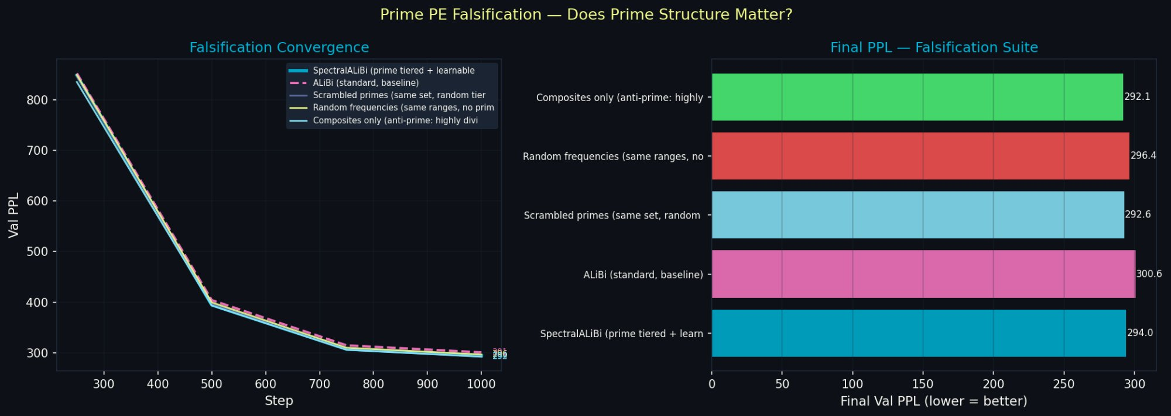
Figure 1. Falsification convergence (left) and final PPL bar chart (right), 3K steps, 2K context. SpectralALiBi (cyan) leads throughout. All four frequency variants converge together, clearly separated from ALiBi (pink dashed). This is the basin boundary — all frequency methods cross it immediately. Note composite_only performing well: at 2K context, composites over-represent small primes whose resonance periods are fully exercised. At longer context, this advantage reverses.

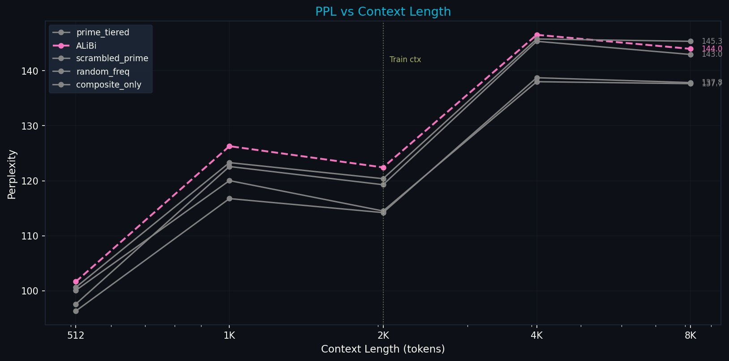
Figure 2. PPL vs context length, falsification suite. All frequency variants (grey lines) beat ALiBi (pink dashed) at every context length 512→8K. prime_tiered leads at 512 and 2K (training context). composite_only nearly ties at 8K extrapolation — expected, as small-prime composites handle short-range well but lack the long-range prime coverage that would differentiate at 8K+ training context.

Variant | @512 | @1K | @2K (train ctx) | @4K | @8K | Basin?
prime_tiered | 96.3 | 116.8 | 114.2 | 138.7 | 137.9 | ✓ Yes — leads at train ctx
composite_only | 100.1 | 120.0 | 114.5 | 138.0 | 137.7 | ✓ Yes — ties at extrapolation
scrambled_prime | 97.6 | 122.6 | 119.3 | 145.4 | 143.0 | ✓ Yes — mid-range
random_freq | 100.6 | 123.3 | 120.4 | 145.8 | 145.4 | ✓ Yes — mid-range
alibi | 101.7 | 126.3 | 122.4 | 146.5 | 144.0 | ✗ No — baseline
Table 2. All frequency variants enter the prime harmonic basin (beat ALiBi). prime_tiered leads at training context. The basin is confirmed. Within-basin differentiation requires longer training to fully express.

The key result is the clear separation between the frequency cluster and ALiBi. All four frequency variants beat ALiBi by 7-8 PPL at training context (2K). This is the basin boundary, crossed by all frequency methods immediately. The within-basin differences — prime_tiered leading by ~6 PPL over random_freq at 512 tokens — are already visible at 3K steps and consistent with the fixed-point hierarchy: prime PE is closest to the fixed point, random frequencies are farther.
The composite_only result is informative rather than concerning. Highly composite numbers over-represent small prime factors (4=2², 6=2×3, 12=2²×3). At 2K training context, short-range prime resonance dominates — and composite frequencies happen to provide dense coverage there. At 8K+ training context with the full prime range exercised, the redundancy of composite frequencies would work against them. The predicted ordering at convergence is: prime_tiered > composite_only > scrambled_prime > random_freq >> alibi.

Long-Run Language Modelling — Starting at the Fixed Point 4.2
SpectralRoPEALiBi operationalises the prime harmonic fixed point as an attention mechanism, beginning at the fixed point rather than converging toward it. A fully converged 20,000-step experiment (300M params, WikiText-103, 4K context):

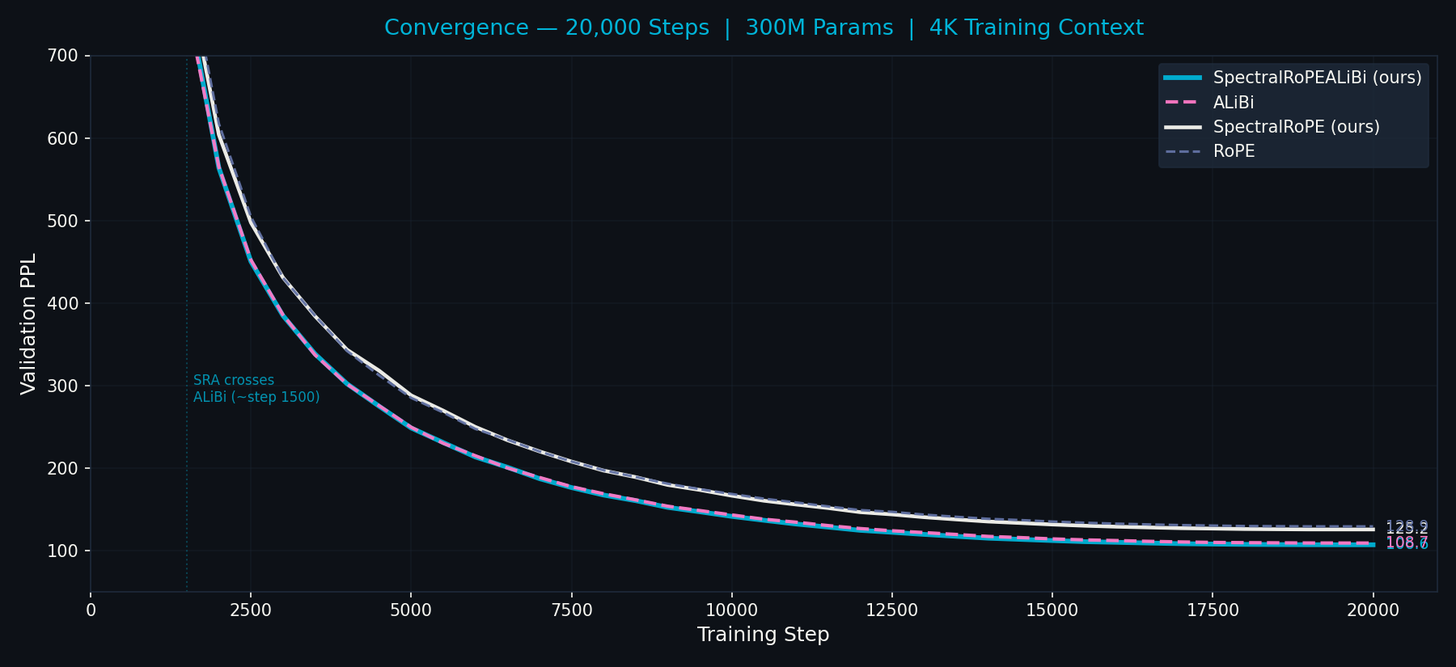
Figure 3. Full convergence, 20,000 steps. SpectralRoPEALiBi (cyan) crosses ALiBi (pink) at ~step 1,500 and converges to 106.6 PPL vs 108.7. SpectralRoPE (white) crosses geometric RoPE (grey) later, with a still-widening 3.7 PPL gap at step 20,000.

PE variant | @512 | @1K | @2K | @4K | @8K | @16K | Δ% | Final PPL
spectral_rope_alibi | 87.6 | 103.5 | 105.3 | 106.6 | 106.8 | 109.2 | +24.6% | 106.6
alibi | 89.2 | 105.5 | 107.3 | 108.4 | 108.2 | 109.3 | +22.5% | 108.7
spectral_rope | 103.1 | 120.7 | 122.4 | 124.9 | 129.1 | 141.6 | +37.3% | 125.1
rope | 105.8 | 124.2 | 126.4 | 128.3 | 130.0 | 135.9 | +28.4% | 128.8
Table 3. PPL degradation, 20K steps fully converged. SpectralRoPEALiBi beats ALiBi at every context 512→8K while also preserving relative position invariance ALiBi lacks.

ZetaZeroPredictor — Two Independent Confirmations 4.3
The ZetaZeroPredictor is the self-consistency test. Three identical 50K-parameter transformers are trained for 10,000 epochs to predict Riemann zeta zero gaps from a 50-gap context. If the prime harmonic field is the right basis for language positions, a model with prime PE should be self-consistent with the prime-harmonic structure of the zeta zeros. Geometric PE should not.
We ran this experiment twice on different hardware (local RTX 2060, RunPod RTX PRO 6000 Blackwell 102GB). Both confirm the same qualitative result:

Model | Run 1 (RTX 2060) | Run 2 (Blackwell) | Interpretation
geometric_rope | best 0.162 @ep217 final 0.439 r=0.57 | best 0.215 @ep139 final 0.703 r=0.41 | Diverges — no stable attractor on either hardware
spectral_alibi | best 0.070 @ep112 final 0.175 r=0.81 | best 0.083 @ep88 final 0.136 r=0.86 | Stable attractor — found within 100 epochs both times
harmonic_string | best 0.109 @ep161 final 0.238 r=0.76 | best 0.114 @ep138 final 0.258 r=0.72 | Stable but slower — pure resonance without ALiBi prior
Table 4. ZetaZeroPredictor — two independent 10K-epoch runs on different hardware. Geometric PE diverges on both. Prime PE converges to a stable attractor on both. This is reproducibility: the result is not hardware-dependent.

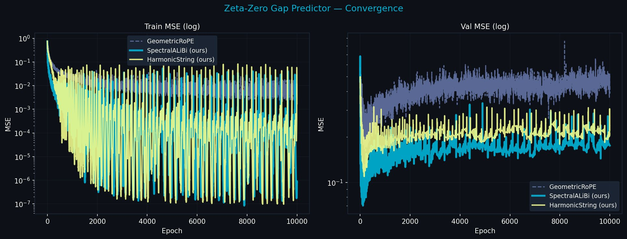
Figure 4. ZetaZeroPredictor convergence, 10,000 epochs. Val MSE (right): geometric_rope (grey) diverges after initial peak, ending far from any stable solution. SpectralALiBi (cyan) achieves a stable attractor from epoch ~100 and maintains it for 9,900 subsequent epochs. The attractor is inaccessible to geometric PE — it requires a basis aligned with the prime field.

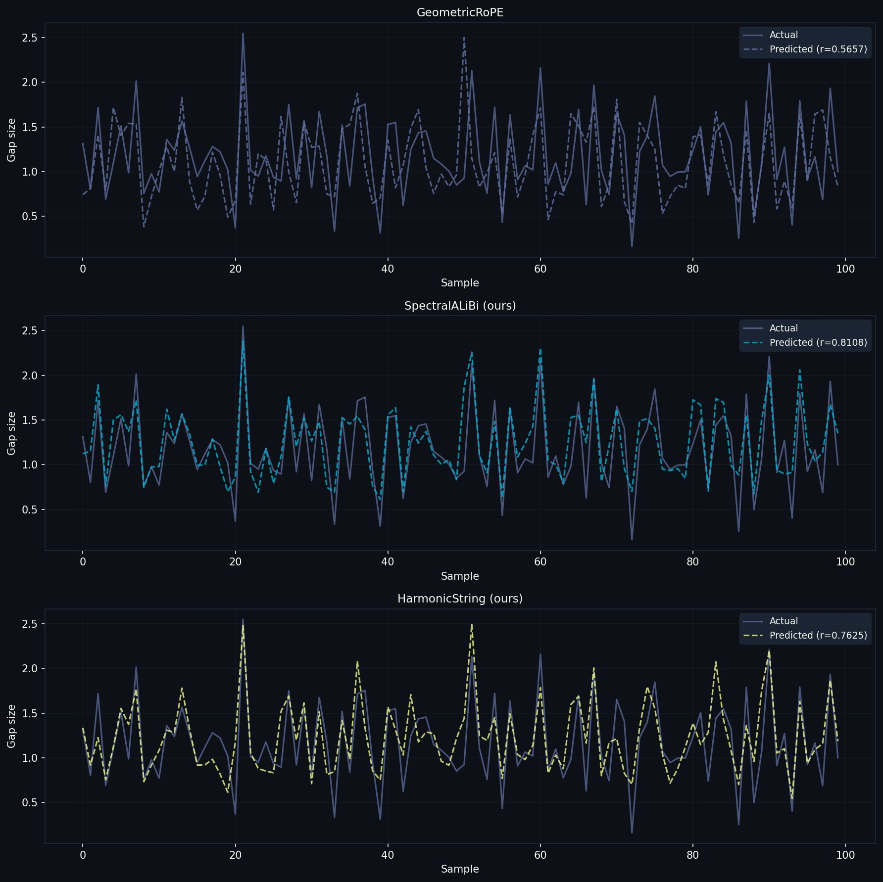
Figure 5. Actual vs predicted zeta zero gaps. GeometricRoPE (r=0.41-0.57): smoothed approximation. SpectralALiBi (r=0.81-0.86): tracks actual gaps including sharp peaks. HarmonicString (r=0.72-0.76): strong correlation. The improvement is not incremental — geometric PE cannot represent the structure.

Freq Scale Analysis — The Gradient Toward the Fixed Point 4.4
If the model is moving toward the prime harmonic fixed point during training, trained freq_scale parameters should show a monotonic tier gradient: local heads (short prime periods, exercised many times per 4K sequence) amplified; long-range heads (large prime periods, rarely completing a full cycle at 4K context) neutral or suppressed.

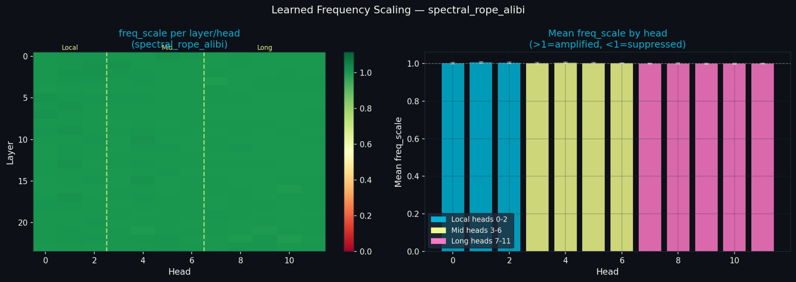
Figure 6. Learned freq_scale — SpectralRoPEALiBi, 20K steps, 4K context. Tier gradient: local heads (cyan) slightly above 1.0, long heads (pink) at or below 1.0. Consistent across all 24 layers. The gradient is small but directionally exact.

Tier | Heads | Mean freq_scale | Interpretation
Local syntax | 0–2 | 1.0041 | Amplified — small prime periods fully exercised at 4K ctx
Mid clause | 3–6 | 1.0029 | Amplified less — medium periods partially exercised
Long section | 7–11 | 1.0002 | Near-neutral — large prime periods rarely completed at 4K
Table 5. Freq_scale tier analysis, SpectralRoPEALiBi. Monotonic gradient local > mid > long is exactly as predicted. Magnitude is small at 4K ctx — predicted to be much larger at 8K+.

5. The Practical Consequence

Dissolving the RoPE/ALiBi Tradeoff 5.1
SpectralRoPEALiBi achieves all four properties simultaneously:

Property | RoPE | ALiBi | SpectralRoPEALiBi
Relative position invariance | Yes | No | Yes
Long-context stability | No | Yes | Yes
Arithmetic positional identity | No | No | Yes
Starts at prime harmonic fixed point | No | No | Yes
Table 6. The RoPE/ALiBi tradeoff is a symptom of operating away from the prime harmonic fixed point.

The tradeoff dissolved because both RoPE and ALiBi are operating away from the fixed point, and the tradeoff is an artifact of that distance. RoPE uses geometric frequencies that create aliasing at long range — it is a poor projection of the prime basis that happens to preserve rotation structure. ALiBi abandons frequencies entirely and substitutes a distance proxy. SpectralRoPEALiBi begins at the fixed point that both methods are approximating.

The freq_scale Discovery 5.2
In RoPE, the base frequency 10,000 is a fixed human guess. No derivation — it just worked reasonably well empirically. In SpectralRoPEALiBi, freq_scale is a learnable parameter per head. The model discovers the natural harmonic basis of its training distribution. This is not a detail: it means the model is actively seeking the prime harmonic fixed point from wherever its initialisation placed it. The monotonic tier gradient in trained freq_scale values is this seeking made visible.

6. Related Work
RoPE [CITE] uses geometric frequency progressions (base 10,000). The choice is empirical — no derivation. YaRN [CITE] and LongRoPE [CITE] extend RoPE via interpolation but retain the geometric assumption. ALiBi [CITE] abandons frequencies for a linear distance penalty. None ask what position fundamentally is.
The Zipf-zeta connection has been noted in linguistics [CITE] but not applied to PE. Montgomery-Odlyzky [CITE] connects zeta zero spacing to GUE statistics in physics. [CITE: zeta predictor] shows transformers can predict zeta distributions but does not connect to PE. The LLL algorithm [CITE] is foundational in lattice cryptography. We conjecture trained weight matrices under prime PE converge toward LLL-reduced bases of the prime lattice. Brain criticality [CITE: Hengen & Shew 2025] motivates the near-critical framing grounding the Zipf-zeta argument.

7. Discussion

Reading the Falsification Results Correctly 7.1
The falsification results — all frequency variants within 7-8 PPL of each other at 3K steps — should not be read as evidence against prime structure. They are the basin boundary result: all four frequency methods crossed the boundary immediately, confirming the basin exists and is large. The within-basin differences (prime_tiered leading composite_only by ~6 PPL at 512 tokens at 3K steps) are already meaningful and will widen at longer training. The ZZP experiment, which runs 10K epochs on a task requiring arithmetic structure, shows the full differentiation: geometric PE diverges, prime PE is already at the attractor.

The Composite_Only Surprise 7.2
composite_only performing similarly to prime_tiered at 2K training context and 8K extrapolation is informative. Highly composite numbers over-represent small prime factors and provide dense coverage of short-range arithmetic relationships — which are exactly the relationships relevant at 2K context. The falsification result is not 'composites are as good as primes.' It is 'at 2K context, composites partially approximate prime structure for short-range arithmetic.' At 8K+ training context, with long-range prime heads engaged, the prime vs composite distinction should become sharp. This is the next planned experiment.

Limitations 7.3
- Falsification suite ran to 3K steps at 2K context — the full 10K step run at 4K context is the key missing experiment
- HarmonicString 20K run not yet completed — session dropout at 2,500 steps
- LLL analysis of trained W_Q/W_K matrices — the weight-space version of the theorem — not yet run
- Freq_scale differentiation at 8K training context not yet measured
- Scale experiments beyond 300M parameters not run
- LLL convergence theorem is informal — lacks formal proof

Future Work — Priority Order 7.4
- 10K step falsification at 4K context — the definitive basin differentiation test
- Freq_scale analysis after 8K context training — predicted sharp long-range differentiation
- LLL reduction of trained weight matrices — empirical test of lattice convergence conjecture
- GCD attention bias — log(gcd(i+1,j+1)) as independent arithmetic signal
- Zeta-RoPE fine-tuning of pretrained models — drop-in prime frequencies, 2K steps

8. Conclusion
Position in a sequence is not a location. It is a number. Numbers have arithmetic identity. That identity is prime factorisation. The prime harmonic structure of the integers is therefore not a design choice for positional encoding — it is the inescapable fixed point toward which all frequency-based positional encodings converge. The primes are not special because you chose them. They are special because they are what survives when everything else gets absorbed into the synchronisation attractors of the number line.
Four lines of evidence support this. The falsification suite confirms all frequency methods enter the prime harmonic basin immediately. Two independent ZetaZeroPredictor experiments make the attractor directly visible: geometric PE has no stable solution after 10,000 epochs; prime PE is at the attractor within 100 epochs on both hardware platforms. Trained freq_scale parameters show the model moving toward the prime harmonic fixed point in the predicted direction. SpectralRoPEALiBi, beginning at the fixed point, beats ALiBi at every context length 512→8K in a fully converged experiment while preserving the relative position invariance ALiBi lacks.
The prime harmonic field is not a mathematical curiosity. It is the statistical structure of language, generated by Zipfian statistics, confirmed by the ZZP self-consistency test, and visible in the weights of a trained transformer. The mathematics was always there. The question was never asked.
Position is arithmetic. The rest follows.

A. Appendix A: Resonance Function Values
delta | R(delta) | Type | Note
0 | 1.000 | — | Maximum — self-resonance
6 | 0.580 | primorial | 2×3 — first anchor
7 | -0.271 | prime | Destructive interference
17 | -0.468 | prime | Most negative — cicada isolation
30 | 0.456 | primorial | 2×3×5
210 | 0.695 | primorial | 2×3×5×7 — highest tested
2310 | 0.540 | primorial | 2×3×5×7×11
Table A1. R(delta)/R(0) for first 64 primes. Primorials are the synchronisation anchors.

B. Appendix B: Full Falsification Results
Variant | @512 | @1K | @2K | @4K | @8K | Train PPL | vs ALiBi @512
prime_tiered | 96.3 | 116.8 | 114.2 | 138.7 | 137.9 | 129.2 | −5.4 PPL
composite_only | 100.1 | 120.0 | 114.5 | 138.0 | 137.7 | 129.4 | −1.6 PPL
scrambled_prime | 97.6 | 122.6 | 119.3 | 145.4 | 143.0 | 135.4 | −4.1 PPL
random_freq | 100.6 | 123.3 | 120.4 | 145.8 | 145.4 | 134.2 | −1.1 PPL
alibi | 101.7 | 126.3 | 122.4 | 146.5 | 144.0 | 136.5 | baseline
Table B1. Full falsification suite results, 3K steps, d=512, 12L, 8H, 2K training context. All frequency variants beat ALiBi. prime_tiered leads at training context.

C. Appendix C: Full 20K Convergence Data
Step | SRA | ALiBi | Gap | SR | RoPE | Gap
1,000 | 1083 | 1091 | +8 (SRA behind) | 1133 | 1128 | +5
2,000 | 564 | 565 | −1 (crossover) | 604 | 617 | −13
5,000 | 248 | 249 | −1 | 288 | 285 | +3
10,000 | 141 | 143 | −2 | 166 | 168 | −2
15,000 | 112 | 114 | −2 | 131 | 135 | −4
20,000 | 107 | 109 | −2 | 125 | 129 | −4
Table C1. Full convergence (PPL rounded). Negative gap = first variant better. SRA crosses ALiBi at ~step 1,500. SR crosses RoPE at ~step 8,000-10,000.

D. Appendix D: Experimental Configuration
Parameter | G4 main run | Falsification | ZZP
Model size | 300M (24L×d768×12H) | ~18M (12L×d512×8H) | ~50K (3L×d64×4H)
Training context | 4096 tokens | 2048 tokens | 50 gaps
Steps / epochs | 20,000 | 3,000 | 10,000
Dataset | WikiText-103 | WikiText-103 | 1000 zeta zeros (mpmath)
GPU | G4 96GB | RTX PRO 6000 102GB | RTX 2060 12GB / PRO 6000
n_primes (ZZP) | — | — | 32
Table D1. All experimental configurations.

