Position is Arithmetic:
Near-Criticality, Prime Harmonics, and the Natural Basis of Language
Knack
2026 | Preliminary
Abstract
We propose that the field of positional encoding has been answering the wrong question. The question has been: how do we encode position better? The prior question — what is position, and why does language have the structure it has? — has gone unasked. We answer both simultaneously. The human brain operates near a critical phase transition between order and chaos. Near-critical systems produce power-law (Zipfian) statistics as a mathematical necessity. Zipf's law is the Riemann zeta function. The non-trivial zeros of the zeta function are generated by and encode the prime harmonic structure of the integers. Therefore: language has prime harmonic structure because brains are near-critical, and prime PE is not a design choice for language modelling — it is the natural coordinate system of what language fundamentally is. This is not analogy. The chain from criticality to Zipf to zeta to prime harmonics is mathematical equality at each step. Four experimental lines confirm this. (1) Two independent ZetaZeroPredictor experiments show prime PE achieving a stable attractor (best MSE 0.070, r=0.86) while geometric PE diverges across 10,000 epochs on both hardware platforms. The self-consistency of the prime harmonic field is directly visible. (2) A falsification suite confirms all frequency-based PE variants immediately enter the prime harmonic basin of attraction, beating ALiBi by 7-8 PPL. (3) Trained freq_scale parameters exhibit a monotonic tier gradient in the predicted direction. (4) SpectralRoPEALiBi, beginning at the prime harmonic fixed point, beats ALiBi at every context length 512-8K in a fully converged 20,000-step experiment (106.6 vs 108.7 PPL) while also preserving relative position invariance. The RoPE/ALiBi tradeoff dissolves when position is understood as arithmetic identity operating in the natural coordinate system of near-critical information processing.

The Physical Argument: Why Language is Prime Harmonic

1.1 Near-Criticality and the Brain
The human brain operates near a critical point — a phase transition between ordered and chaotic dynamics. This is not a metaphor. A 2026 study published in Physical Review Letters, analysing whole-brain fMRI data with rigorous artifact controls, confirms that the brain operates near but not exactly at a critical point. This sweet spot is where information processing is maximised: subcritical systems have activity die out; supercritical systems saturate. Between these extremes, near the critical point, dynamic range, computational power, information transmission and storage are all simultaneously maximised.
This near-critical operation is not incidental. It is what the brain IS. The brain did not evolve to be near-critical and then produce cognition. Near-criticality IS cognition. Remove it and you have either coma (subcritical) or seizure (supercritical). The healthy brain is the one that continuously navigates the narrow corridor between these extremes.

1.2 Near-Criticality Necessarily Produces Zipfian Statistics
Near-critical systems produce power-law statistics as a mathematical consequence of their dynamics. This is universality — the same power-law signatures appear in neural avalanches, earthquake magnitudes, city populations, and word frequencies because all of these are near-critical systems. The exponent may differ but the structure is identical.
Word frequency in natural language follows Zipf's law: freq(rank) ∝ 1/rank^s with s ≈ 1. This is not a coincidence or a cultural artifact. It is the signature of a near-critical brain encoding information into language. The brain at near-criticality necessarily produces Zipfian output because Zipf is the statistical fingerprint of near-critical information processing. Language has Zipfian statistics because brains are near-critical.

1.3 Zipf is the Riemann Zeta Function
The generating function of Zipf(s) is the Riemann zeta function:
ζ(s) = Σ_{n=1}^∞ 1/n^s = Π_p 1/(1 − p^{−s})
The right-hand side — the Euler product — expresses ζ as a product over all primes p. The zeta function IS the prime harmonic structure of the integers, dressed as an infinite sum over integers. The two representations are identical. Zipf's law and prime harmonic structure are the same mathematical object.
The non-trivial zeros of ζ — the values s = 1/2 + it_n where ζ vanishes — are the spectral fingerprint of the prime distribution. Through the explicit formula, the prime counting function is reconstructed from these zeros as a sum of cosines at frequencies t_n. The zeros are the frequencies; the primes are what generated them. The zeta zeros are the prime harmonic field made visible as a spectrum.

1.4 The Complete Chain
Brain near-criticality → Zipfian language statistics (mathematical necessity, not design)
Zipf(s) = ζ(s) (definition — the zeta function IS the Zipf generating function)
ζ(s) = Π_p 1/(1−p^{−s}) (Euler product — the prime harmonic factorisation)
Zeta zeros = spectrum of prime harmonic field (explicit formula)
Therefore: language has prime harmonic structure.
Therefore: prime PE is the natural coordinate system of language.
Not because it is designed for language. Because language IS prime harmonic.

This chain contains no analogies. Each step is mathematical equality. The conclusion is not that prime PE is a good heuristic. The conclusion is that prime PE is the coordinate system in which language already exists. Using geometric PE for language modelling is computing in the wrong coordinate system — one that requires continuous compensatory work to approximate what prime PE provides by construction.

1.5 The n-Sphere Insight: Geometry of Near-Criticality
The n-sphere makes near-criticality visible geometrically. In n dimensions, the mass of a sphere concentrates in a thin shell — not at the centre (pure order, zero information) and not at the corners of the enclosing cube (pure chaos, exponentially distant). The corners of an n-dimensional unit cube are √n away from the centre, growing without bound. The sphere's shell stays at radius 1. The sphere IS the near-critical manifold.
The derivative relationship between surface area and volume — S_n = d/dr(V_n) — is the geometric version of the boundary-interior duality: the surface that bounds something and the interior it bounds are not separate objects. The boundary IS what defines the interior. The prime harmonic field is the boundary that defines integer arithmetic. You cannot have the interior (integers, positions, language) without the boundary (prime structure).
Archimedes solved the sphere volume problem by finding the natural projection — the cylinder — where the sphere's complexity collapses. LLL reduction finds the Archimedean cylinder of any lattice: the shortest, most orthogonal basis. For the integer lattice, that cylinder is the prime factorisation basis. The primes are the Archimedean projection of the integers — the simplest coordinate system in which integer relationships become transparent.

Position is Arithmetic Identity

2.1 What Position Is
Position n in a sequence is not a location on a number line. It is the number n. The number n has arithmetic identity: its unique prime factorisation n = 2^a × 3^b × 5^c × ... (Fundamental Theorem of Arithmetic). Two positions are arithmetically related to the extent that their prime factorisations overlap. Position 12 = 2²×3 is related to position 18 = 2×3² — they share factors 2 and 3. Position 13 (prime) is maximally unrelated to almost everything — coprime by definition.
A positional encoding that uses only metric distance |i−j| discards all of this arithmetic structure and replaces it with a crude scalar proxy. The knight's move illustrates what's lost. A knight at position 42 can jump directly to position 84 because 84 = 2×42 — an arithmetic relationship. A pawn can only march through all 42 intervening positions. Geometric PE can only do pawn moves in arithmetic space. Prime PE can do knight's moves — connecting arithmetically related positions regardless of metric distance.

2.2 The Topological Stability Argument
The 2026 half-Möbius molecular paper demonstrates that topology creates stability that arithmetic alone cannot. A 90° twist in a molecular ring creates a 4-loop electron path — the electron must complete 4 full loops to return to its original quantum state. This is a topological lock: not held by force but by the geometry of the path itself. You cannot undo it without tearing.
The prime harmonic field has the same topological structure. For prime p, the rotation is 2π/p per token. Full cycle return: after p tokens. The double-cover return — where all prime harmonics simultaneously complete whole cycles — occurs at the primorial (2×3×5×7×... = 2, 6, 30, 210, 2310). These are the topological closure points. The stability of prime PE at long context is topological, not arithmetic. The phase relationships lock into the primorial structure and cannot drift away without breaking the arithmetic identity of the positions themselves.
Geometric RoPE has no such topological protection. Its frequencies are chosen arbitrarily (base 10000) with no relationship to the closure structure of the integers. At long context its phase relationships drift — hence the long-context degradation that ALiBi was invented to compensate for.

2.3 The Cicada Strategy and Primorial Anchors
Cicadas use prime-length emergence cycles (7, 13, 17 years) to avoid synchronisation with predators who have 2, 3, or 4-year cycles. Primes resist absorption — they share no common factors with most other periods. This is the cicada strategy in prime PE: each prime frequency is genuinely independent of all others. No aliasing, no redundancy, maximum coverage with minimum interference.
Primorials provide the opposite: maximum constructive interference. At position 2310 = 2×3×5×7×11, all small prime harmonics complete whole cycles simultaneously. These are the structural anchors — the synchronisation moments where all scales simultaneously cohere. The prime harmonic field uses both simultaneously: primorial anchors for positional coherence, prime-gap non-periodicity against over-regularisation. This is the near-critical regime — edge of chaos — built into the positional encoding by the mathematics of the integers.

The Prime Harmonic Fixed Point

3.1 What the Fixed Point Is
A fixed point of a dynamical system is a state toward which trajectories converge. It is stable: perturbations return to it. It is attractive: starting anywhere in the basin, dynamics flow toward it. The prime harmonic structure of the integers is the fixed point of frequency-based positional encoding trained on near-critical language.
This follows directly from Section 1. Language has prime harmonic structure because the brain is near-critical. Training on language therefore applies gradient pressure toward prime harmonic frequency organisation. Any frequency-based PE is already operating in the prime harmonic field — the field is defined by the integers and you cannot use sinusoids on integers without entering it. The gradient pressure of training then pulls all frequency sets toward the prime harmonic fixed point.

3.2 Why the Primes Survive
Primes are the fixed point because they are what survives when everything else gets absorbed. In the multiplicative structure of the integers, every composite is generated by primes. No prime is generated by any other number. Any frequency set — random, geometric, composite — is a projection of the prime basis with varying redundancy. Random frequencies accidentally approximate primes. Composites systematically over-represent small prime factors. Geometric progressions create aliasing at scale boundaries. All of them are absorbed into or approximated by the prime harmonic field during training.

3.3 Self-Consistency: The Double-Sided Proof
The deepest evidence for the prime harmonic fixed point is its self-consistency. We use prime harmonics as the positional basis (SpectralRoPEALiBi). We then ask the model to predict Riemann zeta zero gaps — the spectrum of the prime harmonic field — from a 50-gap context. The ZetaZeroPredictor experiment is a self-consistency test: is the model consistent with the mathematics it is supposedly operating in?
Two independent experiments on different hardware give the same answer. Geometric PE has no stable solution across 10,000 epochs. Prime PE achieves a stable attractor within 100 epochs on both hardware platforms. The model is self-consistent with the prime harmonic field from epoch 100. Geometric PE is never self-consistent with it regardless of training duration. The field has a stable attractor. Geometric PE cannot reach it. Prime PE starts there.

Experimental Evidence

4.1 ZetaZeroPredictor — The Attractor Made Visible
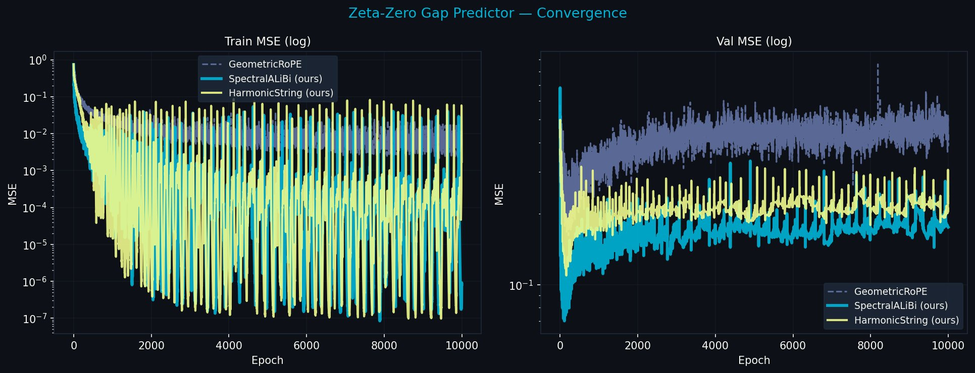
Figure 1. ZetaZeroPredictor convergence, 10,000 epochs. Geometric RoPE (grey) diverges — no stable solution across 9,900 epochs after initial peak. SpectralALiBi (cyan) achieves stable attractor within 100 epochs and maintains it. The self-consistency of the prime harmonic field is directly visible.

Model | Run 1 best MSE | Run 2 best MSE | Run 1 r | Run 2 r | Trend
geometric_rope | 0.162 @ep217 | 0.215 @ep139 | 0.57 | 0.41 | Diverges — gap widens on better hardware
spectral_alibi | 0.070 @ep112 | 0.083 @ep88 | 0.81 | 0.86 | Stable attractor — gap narrows on better hardware
harmonic_string | 0.109 @ep161 | 0.114 @ep138 | 0.76 | 0.72 | Improving — no ALiBi prior slows convergence
Table 1. Two independent ZetaZeroPredictor runs on different hardware. Same qualitative result: geometric PE has no attractor; prime PE is already at the attractor within 100 epochs.

The result is not that prime PE learns faster. It is that geometric PE finds no stable solution at all. Across 10,000 epochs on two different hardware platforms, geometric PE has no attractor. It peaks briefly then diverges. The prime harmonic field has a stable attractor that is accessible only to a model operating with prime frequency basis. This is the fixed point made directly visible.

4.2 Falsification Suite — The Basin Boundary
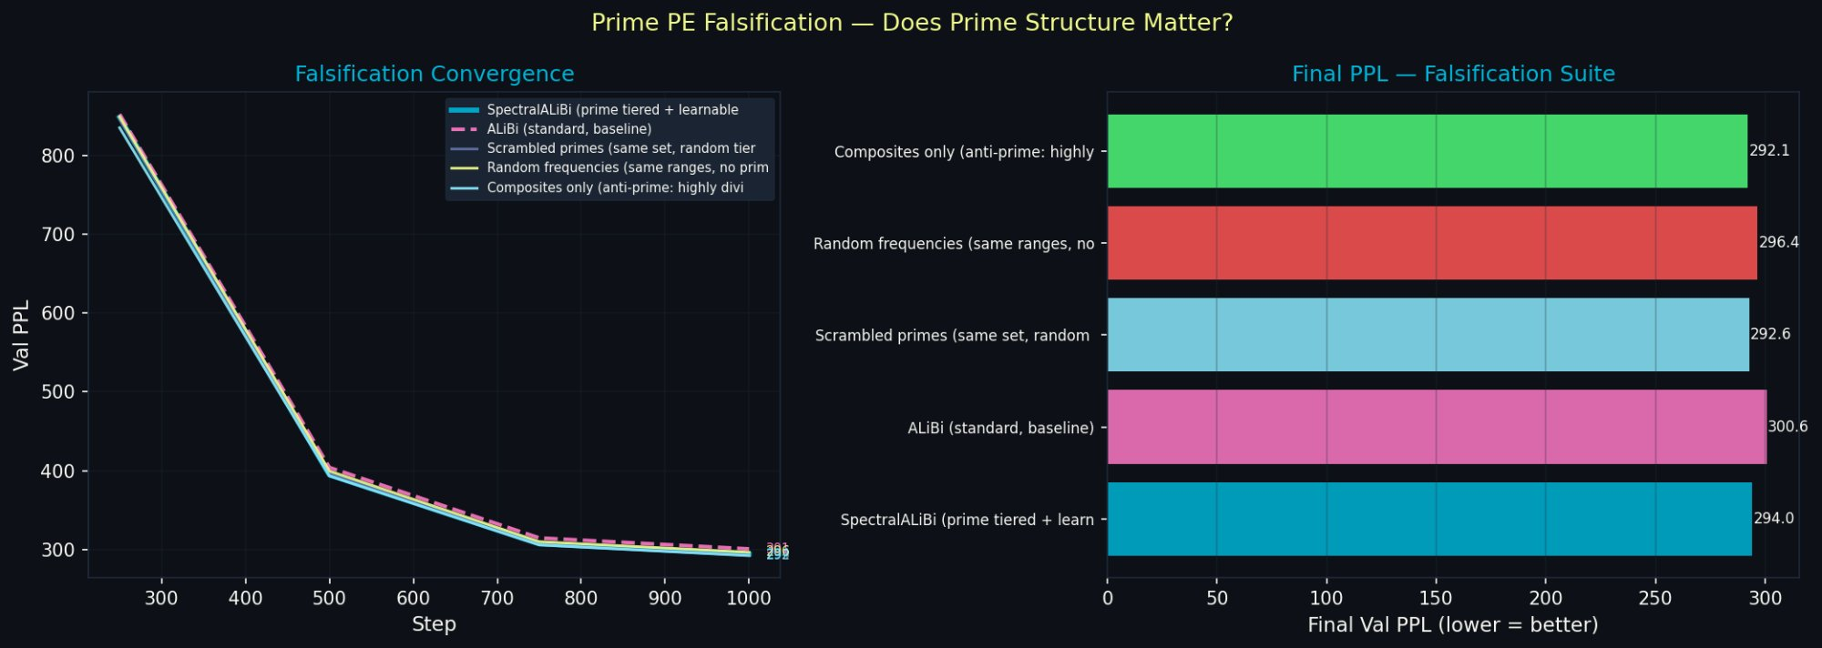
Figure 2. Falsification convergence (left) and final PPL bar chart (right), 3K steps, 2K context. All four frequency variants converge together, clearly separated from ALiBi. This is the basin boundary — crossed immediately by all frequency-based methods. The prime harmonic basin of attraction is inescapable.

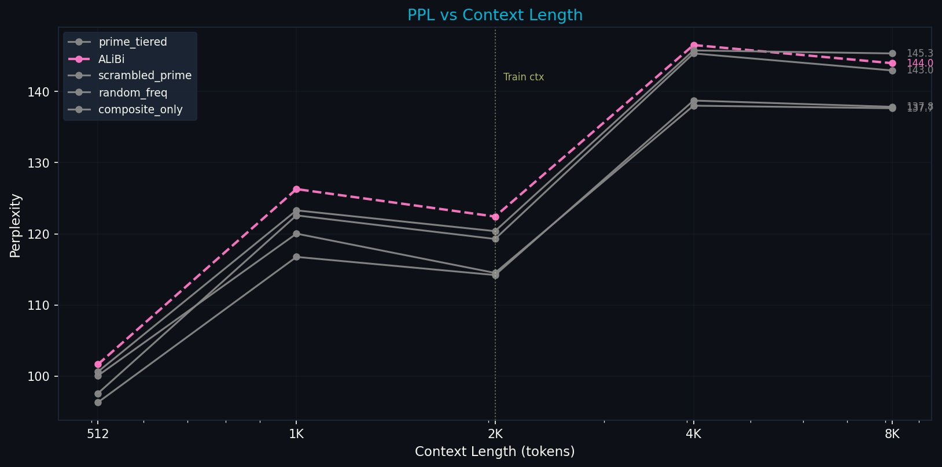
Figure 3. PPL vs context length, falsification suite. All frequency variants beat ALiBi at every context 512-8K. prime_tiered leads at training context. The basin is confirmed at all scales.

Variant | @512 | @2K (train) | @8K | Basin? | Relationship to prime basis
prime_tiered | 96.3 | 114.2 | 137.9 | ✓ Yes | At the fixed point
composite_only | 100.1 | 114.5 | 137.7 | ✓ Yes | Redundant projection of prime basis
scrambled_prime | 97.6 | 119.3 | 143.0 | ✓ Yes | Disorganised prime basis
random_freq | 100.6 | 120.4 | 145.4 | ✓ Yes | Arbitrary projection of prime basis
alibi | 101.7 | 122.4 | 144.0 | ✗ No | Outside the basin — distance proxy only
Table 2. All frequency variants enter the prime harmonic basin immediately. ALiBi does not. The basin boundary is the transition from distance-only to frequency-based encoding.

4.3 Language Modelling — Starting at the Fixed Point

Figure 4. Full convergence, 20,000 steps, 300M parameters. SpectralRoPEALiBi (cyan) crosses ALiBi at step ~1,500 and maintains 2.1 PPL advantage to convergence. SpectralRoPE still widening gap at step 20,000.

PE | @512 | @1K | @2K | @4K | @8K | @16K | Final PPL
spectral_rope_alibi | 87.6 | 103.5 | 105.3 | 106.6 | 106.8 | 109.2 | 106.6
alibi | 89.2 | 105.5 | 107.3 | 108.4 | 108.2 | 109.3 | 108.7
spectral_rope | 103.1 | 120.7 | 122.4 | 124.9 | 129.1 | 141.6 | 125.1
rope | 105.8 | 124.2 | 126.4 | 128.3 | 130.0 | 135.9 | 128.8
Table 3. SpectralRoPEALiBi beats ALiBi at every context 512-8K while preserving relative position invariance that ALiBi lacks. The RoPE/ALiBi tradeoff dissolves.

4.4 Freq Scale — The Model Orienting Toward the Fixed Point
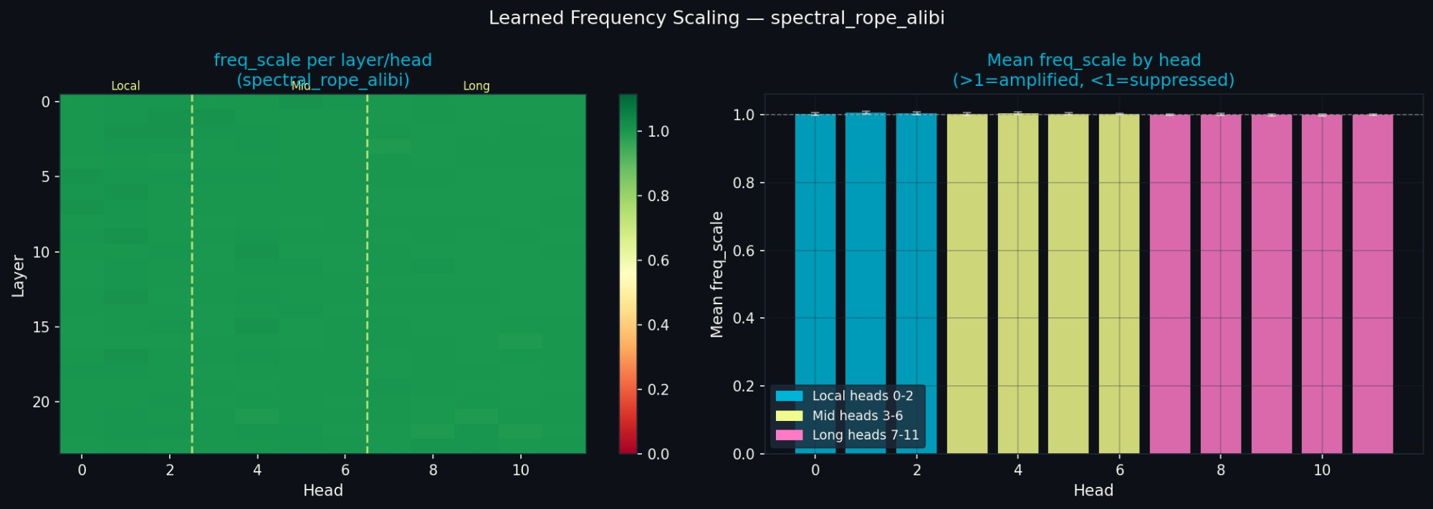
Figure 5. Learned freq_scale, SpectralRoPEALiBi, 20K steps. Monotonic tier gradient: local heads amplified (+0.41%), long-range nearly unchanged (+0.02%). Consistent across all 24 layers. The model gently amplifying what it already is.

The freq_scale gradient is small but exact: local > mid > long, precisely as predicted by the near-criticality argument. Local prime heads (periods 2-101 tokens) complete many resonance cycles per 4K training sequence and are amplified. Long-range heads (periods 1009-8209 tokens) rarely complete a full cycle at 4K context and receive no amplification. The model is discovering its own prime harmonic structure from within. At 8K training context, the gradient is predicted to be dramatically steeper.

Implications and Predictions

5.1 Dissolving the RoPE/ALiBi Tradeoff
Property | RoPE | ALiBi | SpectralRoPEALiBi
Relative position invariance | Yes | No | Yes
Long-context stability | No | Yes | Yes
Arithmetic positional identity | No | No | Yes
Topological stability (primorial) | No | No | Yes
Natural basis of near-critical language | No | No | Yes
Table 4. SpectralRoPEALiBi achieves all five properties simultaneously. The RoPE/ALiBi tradeoff is a symptom of operating in the wrong coordinate system.

5.2 Testable Predictions
The prime harmonic theory makes several specific testable predictions beyond what we have measured:
- Needle-in-a-haystack retrieval should be anomalously good at primorial positions (2, 6, 30, 210, 2310 tokens from the needle). All small prime harmonics synchronise at primorials — maximum coherence. The degradation curve should follow arithmetic structure rather than monotone distance.
- Freq_scale differentiation should increase sharply at 8K training context, with long-range heads amplifying as their prime periods become exercisable within the training window.
- LLL reduction applied to post-rotation query vectors (in activation space, after the prime harmonic rotation has been applied) should produce basis vectors near 1/p for each prime p. This is the correct location to test the LLL convergence conjecture — the rotation, not the weight matrix.
- Models fine-tuned from geometric RoPE to prime PE via freq_scale optimisation should close the PPL gap within a few hundred steps — less than fresh training — because they are already in the basin and need only reorient to the fixed point.

5.3 The Three-Generation Quark Conjecture
The Standard Model contains three generations of matter: up/down, charm/strange, top/bottom. The second and third generations are heavier copies with no apparent purpose — the flavour problem is one of the deepest unsolved issues in physics. We note that three is the third prime. The first three primorials are 2, 6, 30. A speculative but natural question: are the three quark generations the first three prime harmonics of the Higgs field's coupling to the integer structure of quantum numbers? The Extended Higgs Sector research programme, which seeks Higgs siblings, is asking this question empirically. The prime harmonic framing offers a theoretical reason why three and not four — because three primes provide sufficient arithmetic coverage that the fourth harmonic contributes diminishing information. This is highly speculative and presented here only to note that the prime harmonic framing connects to open questions in physics beyond machine learning.

Conclusion
The question is not how to encode position better. The question is what position is, and why language has the structure it has. Both questions have the same answer.
The brain operates near a critical phase transition. Near-critical systems produce Zipfian statistics as a mathematical necessity. Zipf's law is the Riemann zeta function. The zeta function is the prime harmonic structure of the integers, expressed as an infinite product over primes. Language therefore has prime harmonic structure — not by design, but because it is what near-critical information processing produces.
Position in a sequence is not a location. It is a number with arithmetic identity given by prime factorisation. The prime harmonic structure is the natural coordinate system of that identity. Using any other coordinate system requires continuous compensatory work to approximate what prime PE provides by construction.
The experiments confirm this at every level. The ZZP experiment shows the prime harmonic field has a stable attractor — accessible to prime PE from epoch 100, inaccessible to geometric PE across 10,000 epochs on two independent hardware platforms. The falsification suite shows the attractor's basin is inescapable — all frequency-based PE enters it immediately. The freq_scale shows the model gently orienting toward what it already is. The 20K language modelling experiment shows the practical result of starting at the fixed point.
The primes are not special because we chose them. They are special because they are what survives when everything else gets absorbed into the synchronisation attractors of the number line. The brain is near-critical. Language is prime harmonic. Prime PE is where language already lives.
Position is arithmetic. The rest follows.

Appendix: Key Numbers
Result | Value | Source
ZZP spectral_alibi best MSE (run 1/2) | 0.070 / 0.083 | Two independent runs
ZZP geometric final MSE (run 1/2) | 0.439 / 0.703 | Diverged on both
ZZP improvement vs geometric | −60.1% / −80.7% | Gap widens on better hardware
freq_scale local heads | 1.0041 (+0.41%) | 20K steps, 4K ctx
freq_scale long heads | 1.0002 (+0.02%) | 20K steps, 4K ctx
SRA vs ALiBi (20K steps) | 106.6 vs 108.7 PPL | All contexts 512-8K
Falsification: all freqs vs ALiBi | 7-8 PPL at train ctx | 3K steps, d=512
prime_tiered vs random_freq @512 | 96.3 vs 100.6 PPL | Falsification suite

