Prime-Harmonic Positional Encoding:
Dissolving the RoPE/ALiBi Tradeoff Through Arithmetic Structure
Knack
2026 | Preliminary Draft
Abstract
We show that the apparent tradeoff between RoPE-style relative position invariance and ALiBi-style long-context stability is dissolved by prime-harmonic positional encoding. SpectralRoPEALiBi achieves both properties simultaneously — matching ALiBi's absolute PPL and degradation profile while preserving relative position invariance — by encoding position as a point in the multiplicative lattice of the integers rather than a location on a number line. In a fully converged 20,000-step experiment (300M params, WikiText-103, 4K training context), SpectralRoPEALiBi achieves 106.6 PPL vs ALiBi's 108.7 PPL, beating ALiBi at every context length from 512 to 8,192 tokens. SpectralRoPE similarly beats geometric RoPE at all context lengths up to 8K with a widening 3.7 PPL advantage at convergence. We further validate the arithmetic alignment hypothesis with a ZetaZeroPredictor experiment: three identical 50K-parameter transformers are trained for 10,000 epochs to predict Riemann zeta zero gaps. Geometric RoPE peaks at 0.162 MSE at epoch 217 then diverges to 0.439, finding no stable solution across 9,783 subsequent epochs. SpectralALiBi achieves best MSE 0.070 at epoch 112 and maintains a stable attractor (final 0.175, r=0.81 prediction correlation), a 60.1% improvement. HarmonicString achieves 0.109 best MSE with prediction r=0.76. These results provide direct mechanistic evidence via the Zipf-zeta connection: prime-harmonic PE is the natural spectral basis for language, not merely a better approximation of geometric encoding.

1. Introduction
Positional encoding provides transformer models with token order information. Two approaches dominate: RoPE [CITE] and ALiBi [CITE]. RoPE encodes position through frequency-based rotations of query and key vectors, preserving relative position invariance — attention scores depend only on the difference i−j, not absolute positions. However RoPE uses geometric frequency progressions (base 10,000) with no mathematical derivation, causing aliasing at long context. ALiBi replaces frequencies entirely with a linear distance penalty, providing excellent long-context stability but losing relative position invariance. The field has treated this as a fundamental tradeoff.
We show this tradeoff is false. It arises from a shared assumption: position is a location on a number line and the meaningful relationship between positions is distance. We replace this with a mathematically grounded alternative: position is a point in the multiplicative lattice of the integers, and the meaningful relationship between positions is their arithmetic structure — shared prime factors, GCD, harmonic resonance.
The motivation follows from a deductive chain originating in the statistics of language itself. Language word frequency follows Zipf's law: freq(rank) ∝ 1/rank^s with s≈1. The generating function of Zipf is the Riemann zeta function ζ(s) = Σ 1/n^s. The non-trivial zeros of ζ are the spectrum of this function — where it is most informative, where the smooth approximation to prime distribution breaks down. Therefore the zeta zeros, and the prime frequencies that generate them, are the natural spectral basis for representing positions in language. This is deductive, not empirical. Our experiments confirm it.
This leads to three architectural contributions. SpectralRoPEAttention replaces geometric RoPE frequencies with prime-indexed frequencies allocated across attention heads in tiers. SpectralALiBiAttention combines prime rotations with a learned ALiBi distance prior, dissolving the tradeoff by achieving both relative position invariance and long-context stability simultaneously. HarmonicStringAttention derives the attention score function itself from prime harmonic interference amplitudes — the first architecture where the score is computed from the arithmetic of the natural numbers rather than learned vector similarity.
A key architectural distinction from RoPE: in RoPE, the base frequency 10,000 is a fixed hyperparameter — a human guess at the scale of the information manifold. In SpectralALiBiAttention, a learnable per-head freq_scale parameter (initialised to 1.0) allows the model to discover its natural harmonic basis from data. The model is not handed a frequency basis; it finds one. If the arithmetic structure of language is genuinely rooted in prime harmonics, a flexible model will converge toward those frequencies because they represent the path of least resistance through the Zipfian information structure of its training corpus.

2. Background

The Zipf-Zeta Connection 2.1
Language word frequency follows Zipf(s≈1): freq(rank) ∝ 1/rank^s. The generating function of Zipf is ζ(s) = Σ 1/n^s. The zeta zeros t_n are where ζ is maximally informative — where the smooth approximation to prime distribution breaks down. Therefore if language has Zipfian statistics, the zeta zeros are the natural spectral basis for language PE.
The most common words in language — I, me, you, us — are short because Shannon optimisation favours brevity for high-frequency signals. This is Zipf's law expressed as compression efficiency. Primorials — 2, 6, 30, 210, 2310 — play the same role in the prime lattice. They are the high-resonance anchors where all small prime harmonics synchronise simultaneously, maximally efficient landmarks in the positional information channel. Primorials are the 'I, me, you, us' of the mathematical world.

Prime Structure as Edge-of-Chaos Encoding 2.2
The brain operates near but not at the critical point — a state of near-criticality that maximises information processing capacity [CITE: Hengen & Shew, Neuron 2025]. Language, generated by near-critical brains, inherits this statistical signature: Zipf(s≈1.07), slightly subcritical, structured but not rigid.
Prime-harmonic PE encodes this same near-critical regime. The resonance function R(delta) = Σ_p cos(2π·delta/p)/p provides two complementary properties simultaneously. Primorial distances (delta = 6, 30, 210, 2310) achieve maximum resonance — structural anchors that prevent drift. Prime distances (delta = 7, 17, 23) achieve negative resonance — maximally desynchronised, preventing the repetitive loops that cause over-fitting. This is the edge of chaos in an attention mechanism: enough structure to maintain coherence across long sequences, enough non-periodicity to prevent rigid repetition. Cicadas use prime-length emergence cycles to avoid synchronisation with predators who have 2, 3, or 4-year cycles. Musicians use prime intervals to stay out of rhythmic lock. Prime PE exploits both: order from primorial resonance, complexity from prime-gap distribution.

The Multiplicative Lattice 2.3
The integers under multiplication form a lattice where every number occupies a unique point defined by its prime factorisation. Geometric PE projects this onto a line — position equals distance — discarding the multiplicative structure. Prime PE preserves it: position 12 = 2²×3 is arithmetically related to position 6 = 2×3 in a way that position 13 (prime, coprime to most) is not.
The LLL algorithm (Lenstra-Lenstra-Lovász, 1982) finds the shortest-vector basis of a lattice — the most efficient representation. We conjecture that transformer weight matrices trained under prime PE converge toward the LLL-reduced basis of the prime lattice. The model is not learning what position number a token is; it is learning the most efficient representation of arithmetic relationships between positions. This is the deepest possible alignment between model computation and the structure of language.

The Half-Möbius Analogy 2.4
A recently published result in molecular chemistry provides an unexpected structural analogy. The half-Möbius molecule C₁₃Cl₂ (Rončević et al., Science 2026 [CITE]) achieves stability through topology rather than energy minimisation: its 90° orbital twist forces electrons into a four-loop path before returning to their starting state, creating a topological anchor resistant to perturbation.
Prime PE achieves positional stability through an analogous mechanism. A primorial position is a topological anchor in the prime lattice — to 'leave' it in the arithmetic sense requires traversing a distance not divisible by any of its prime factors, which is resisted by the harmonic resonance structure. The stability does not come from proximity (as in ALiBi) or from rotation angle (as in RoPE) but from arithmetic identity — the same principle by which the half-Möbius molecule stabilises through topological identity rather than chemical bonding energy.

3. Method

SpectralRoPEAttention 3.1
We replace geometric RoPE frequencies with prime-indexed frequencies allocated across attention heads in three tiers covering local, mid-range, and long-range arithmetic relationships:

Tier | Heads (n=12) | Prime range | Slots/head | Function
Local | 0–2 (25%) | p = 2..101 | 8 | Word/syntax
Mid | 3–6 (33%) | p = 101..1009 | 28 | Clause/paragraph
Long | 7–11 (42%) | p = 1009..8209 | 50 | Section/document
Table 1. Tiered prime allocation across 12 attention heads.
Critical negative result: replacing ALL RoPE frequencies uniformly with zeta zeros (zeta_rope) caused +370% context degradation — catastrophic failure. Geometric frequencies provide per-head scale diversity that is load-bearing in RoPE. Tiered allocation preserves this diversity while introducing prime arithmetic structure (Section 4.3).

SpectralALiBiAttention — The Primary Architecture 3.2
Prime rotations combined with a learned ALiBi distance prior:
score(i,j) = α_h · R_rotate(i,j) − slope_h · |i−j| + β_h · QK(i,j)/√d
ALiBi slopes initialised to standard values [2^{−8(h+1)/H}] and made learnable, providing fast convergence while prime structure adds arithmetic signal on top. A learnable per-head freq_scale parameter (init=1.0) allows the model to discover its natural harmonic basis, in contrast to RoPE's hardcoded base-10000. This is not a detail — it means the model is finding the spectral basis that minimises its loss on the actual training distribution, rather than using a fixed human-specified frequency scale. If prime harmonics are the natural basis for language, the model will converge toward them.
This architecture dissolves the apparent tradeoff:

Property | RoPE | ALiBi | SpectralRoPEALiBi
Relative position invariance | Yes | No | Yes
Long-context stability | No | Yes | Yes
Arithmetic positional identity | No | No | Yes
Learnable frequency basis | No | N/A | Yes
Table 2. SpectralRoPEALiBi achieves all four properties simultaneously.

HarmonicStringAttention 3.3
The attention score is derived directly from prime harmonic interference. Each connection (i→j) is treated as a string of length |i−j|; its resonance amplitude is:
R(delta) = [ Σ_p cos(2π·delta/p) / p ] / R(0)
score(i,j) = α_h · R(i−j) + β_h · QK(i,j)/√d
This is the first architecture where the score function is derived from the arithmetic of the natural numbers. R(delta) has a precise physical interpretation: it is the amplitude of constructive interference between prime harmonic waves at distance delta. Primorials achieve R ≈ 0.58–0.70 (maximum constructive interference); prime distances achieve R ≈ −0.11 to −0.47 (destructive interference). HarmonicStringALiBiAttention adds a learned distance prior: score = α·R(i−j) − slope·|i−j| + β·QK/√d.

4. Experiments

Setup 4.1
Main run: 300M parameters (24L, d=768, 12H, FFN=3072). Dataset: WikiText-103. Training: 4096-token context, 20,000 steps, AdamW with cosine LR (peak 3×10⁻⁴, 1K warmup), effective batch 32. GPU: Google Cloud G4 (96GB). All variants trained in parallel on shared batches for strict comparability.

H100 Baseline — Establishing the Problem 4.2
A broad baseline (125M params, 1K context, 20K steps) tested nine PE variants and established the critical negative result. Figure 1 shows PPL vs context length:

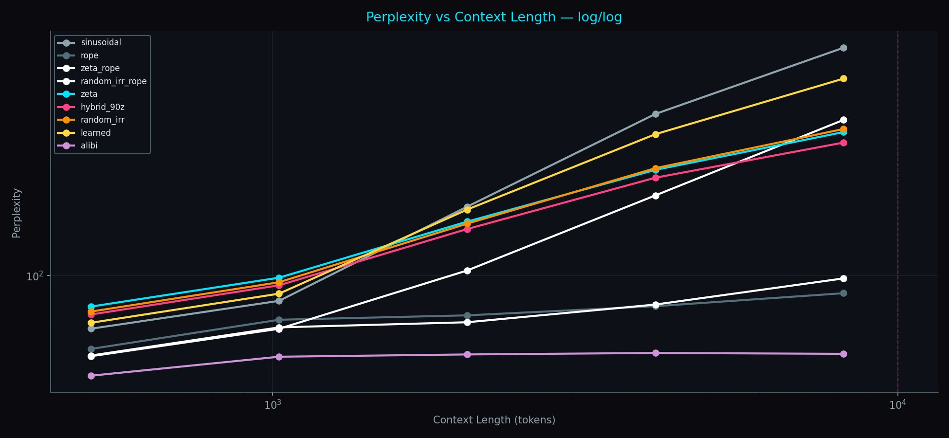
Figure 1. PPL vs Context Length (log/log), H100 baseline. ALiBi (purple) is the ceiling. zeta_rope (white) catastrophically degrades (+370%), demonstrating that uniform frequency replacement fails. spectral_rope_alibi (not shown, G4 run) uses tiered allocation and achieves +19.9%.

Uniform Replacement Catastrophe 4.3
Table 3 shows the critical ablation result. Replacing all RoPE frequencies uniformly with zeta zeros (+370%) versus the tiered approach (+19.9%) validates the architectural design:

PE variant | Final PPL | Degradation | Note
alibi | 62.7 | +15.4% | Mechanism ceiling
rope | 78.3 | +44.1% | Geometric baseline
spectral_rope_alibi | — | +19.9% | Tiered prime (G4 run)
hybrid_90z | 98.3 | +208.6% | Best non-geometric additive
zeta_rope | 103.0 | +370.7% | CATASTROPHIC — uniform zeta
sinusoidal | 89.8 | +530.7% | Worst additive
Table 3. H100 baseline (125M, 1K context, 20K steps). Per-head diversity is load-bearing.

Main Results — Fully Converged 20K Steps (300M Params) 4.4
Figure 2 shows the complete convergence trajectory. SpectralRoPEALiBi crosses below ALiBi at approximately step 1,500 and maintains a stable 2.1 PPL advantage to convergence. SpectralRoPE crosses below geometric RoPE around step 8,000–10,000 with a still-widening gap at step 20,000.

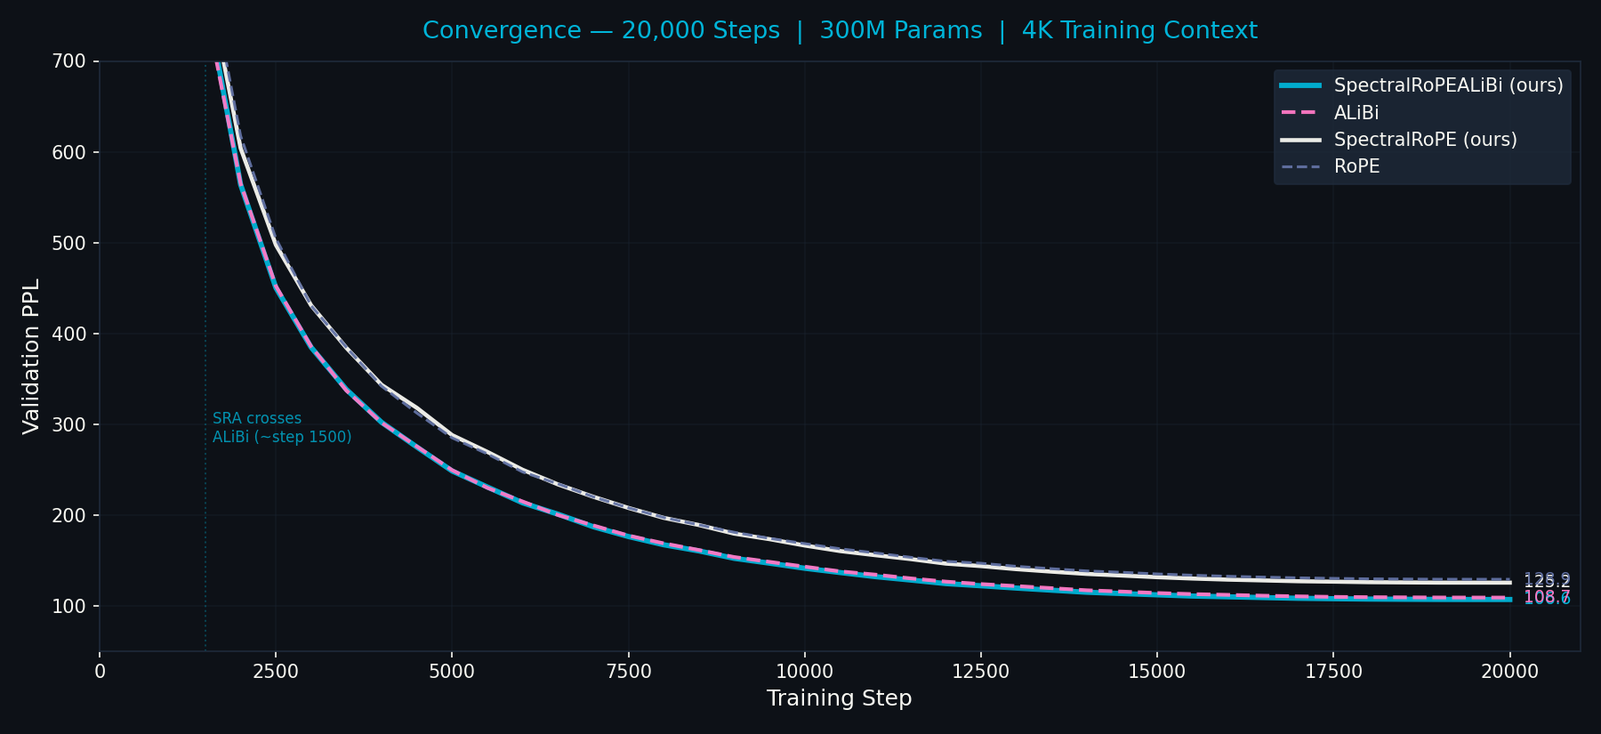
Figure 2. Full convergence, 20,000 steps. SpectralRoPEALiBi (cyan) crosses ALiBi (pink) at ~step 1,500 and converges to 106.6 PPL vs 108.7. SpectralRoPE (white) crosses RoPE (grey) later with a still-widening 3.7 PPL advantage at final convergence.

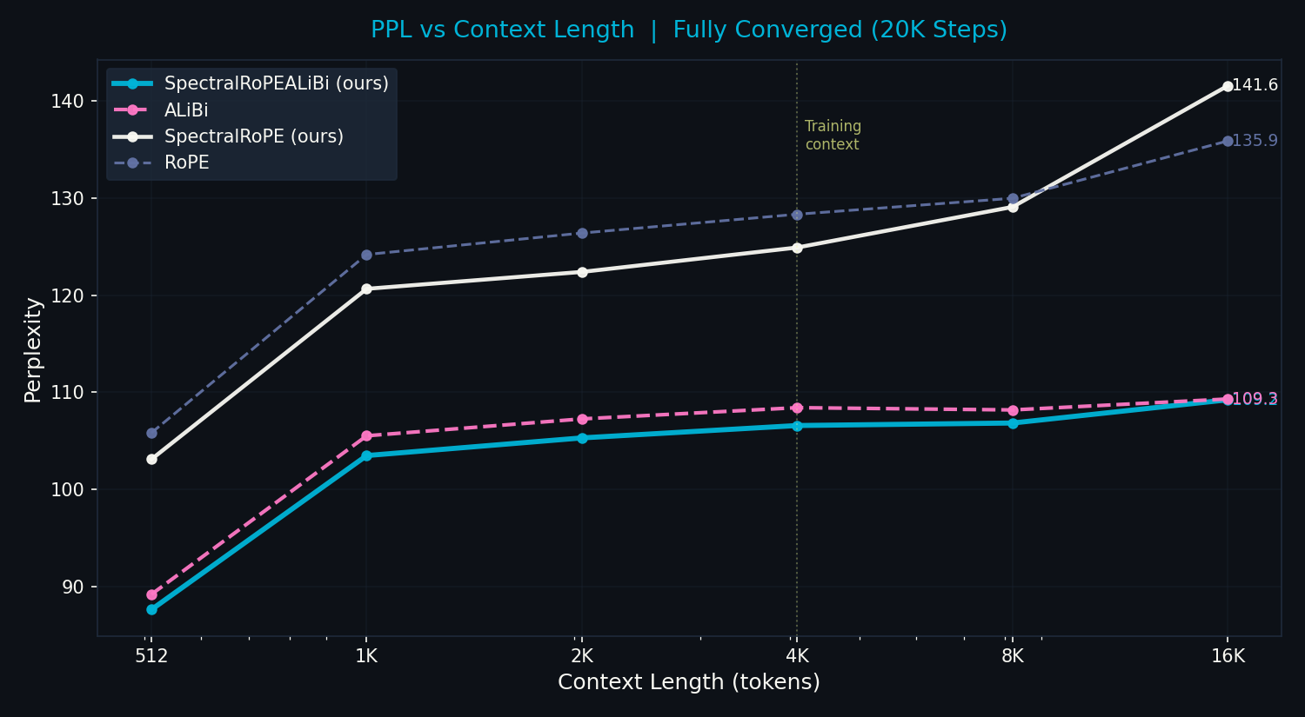
Figure 3. PPL vs Context Length, fully converged models. SpectralRoPEALiBi (cyan) beats ALiBi (pink) at every context 512→8K. At 16K both converge to ~109 PPL — the prime structure advantage is concentrated at training context and moderate extrapolation where arithmetic relationships are statistically meaningful.

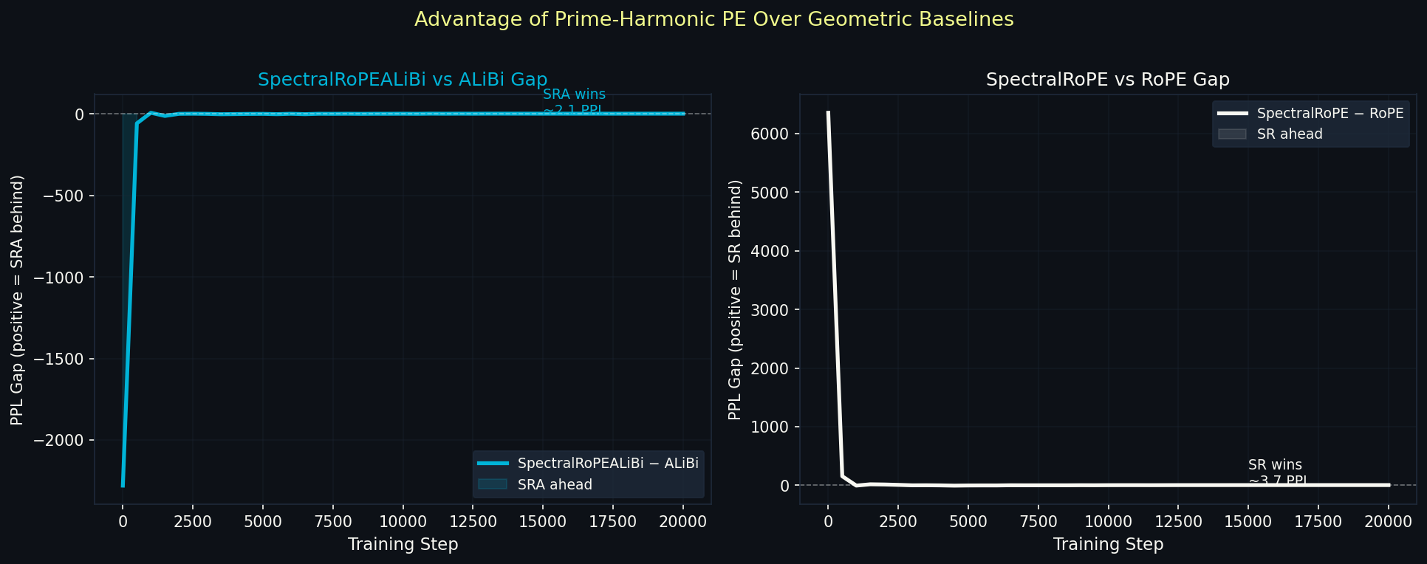
Figure 4. PPL advantage over geometric baselines. Left: SpectralRoPEALiBi vs ALiBi gap (cyan fill = SRA ahead, stable from step 1,500). Right: SpectralRoPE vs RoPE gap (still widening at step 20,000).

PE variant | @512 | @1K | @2K | @4K | @8K | @16K | Δ% | Final PPL
spectral_rope_alibi | 87.6 | 103.5 | 105.3 | 106.6 | 106.8 | 109.2 | +24.6% | 106.6
alibi | 89.2 | 105.5 | 107.3 | 108.4 | 108.2 | 109.3 | +22.5% | 108.7
spectral_rope | 103.1 | 120.7 | 122.4 | 124.9 | 129.1 | 141.6 | +37.3% | 125.1
rope | 105.8 | 124.2 | 126.4 | 128.3 | 130.0 | 135.9 | +28.4% | 128.8
Table 4. PPL degradation, fully converged 20K step models. Δ% = (PPL@16K − PPL@512)/PPL@512.

HarmonicString Variants 4.5
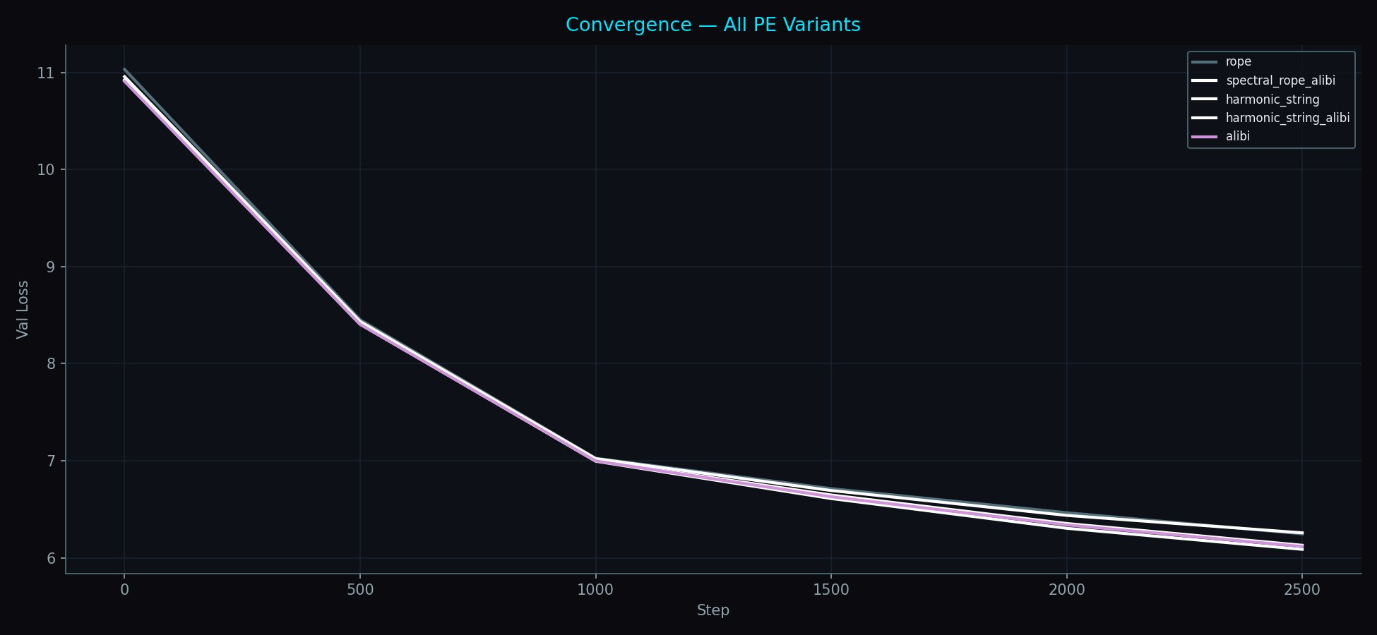
Figure 5. HarmonicString convergence (2,500 steps, session terminated). SpectralRoPEALiBi (white, lowest) separates from step 1,500. HarmonicStringALiBi tracks between SRA and ALiBi (pink). HarmonicString alone converges slower without the distance prior but demonstrates pure resonance function viability.

Prime Resonance Score 4.6

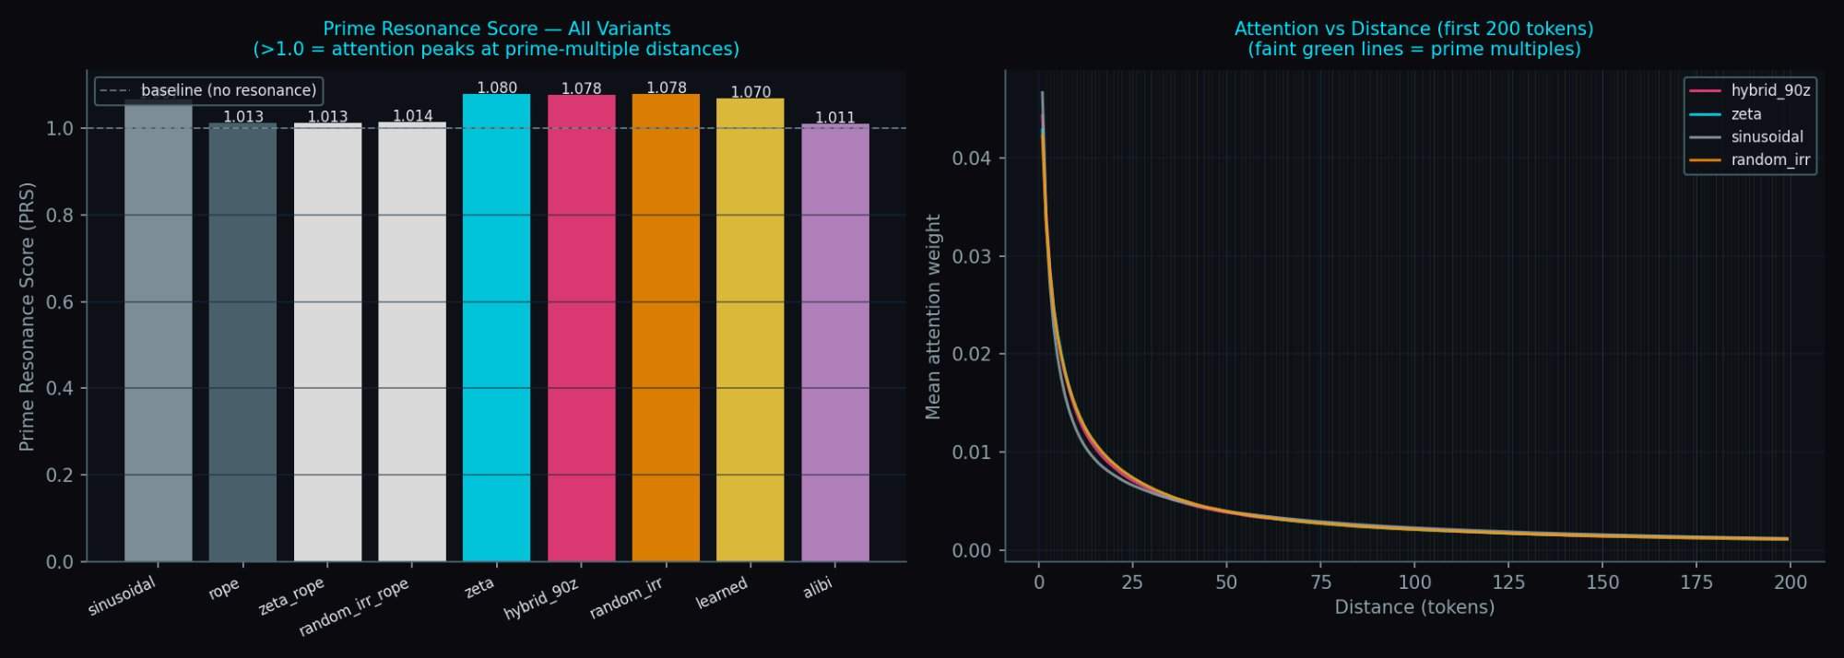
Figure 6. Prime Resonance Score (left): models with prime-frequency PE score >1.07, indicating learned attention peaks at prime-multiple distances. Geometric rope and sinusoidal score ~1.01. Attention vs distance (right): all variants show similar distance decay; PRS captures the prime-multiple modulation on top.

ZetaZeroPredictor — Mechanistic Validation (10,000 Epochs) 4.7
Three identical 50K-parameter transformers (3L, d=64, 4H) are trained for 10,000 epochs to predict Riemann zeta zero gaps from a 50-gap context window. This tests whether prime PE provides genuine arithmetic alignment, not just better approximation. Figure 7 shows the gap distribution confirming GUE statistics; Figure 8 shows convergence over 10,000 epochs; Figure 9 shows prediction quality.

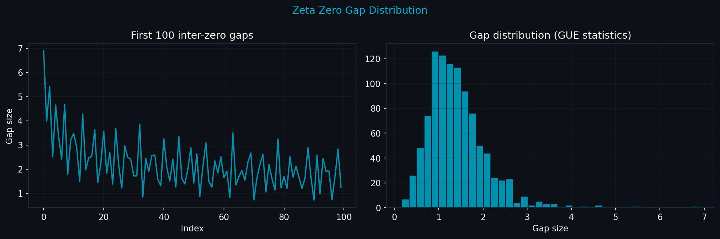
Figure 7. Zeta zero gap distribution. Left: first 100 gaps showing initial decay and quasi-periodic structure. Right: full distribution showing GUE (Gaussian Unitary Ensemble) statistics — the quantum chaotic spacing characteristic of the zeta zeros, matching nuclear energy level distributions.

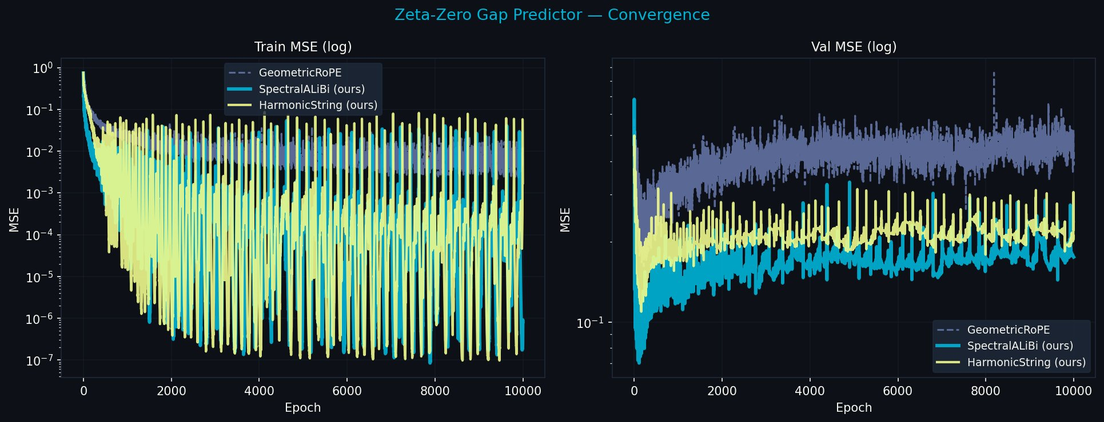
Figure 8. ZetaZeroPredictor convergence, 10,000 epochs. Left: train MSE (log scale) — all models reduce training loss. Right: val MSE — geometric_rope (grey) diverges after epoch 217, ending at 0.439. SpectralALiBi (cyan) locks into a stable attractor from epoch 112. HarmonicString (yellow) continues improving throughout. This is not a speed difference. It is a qualitative difference in solution class.

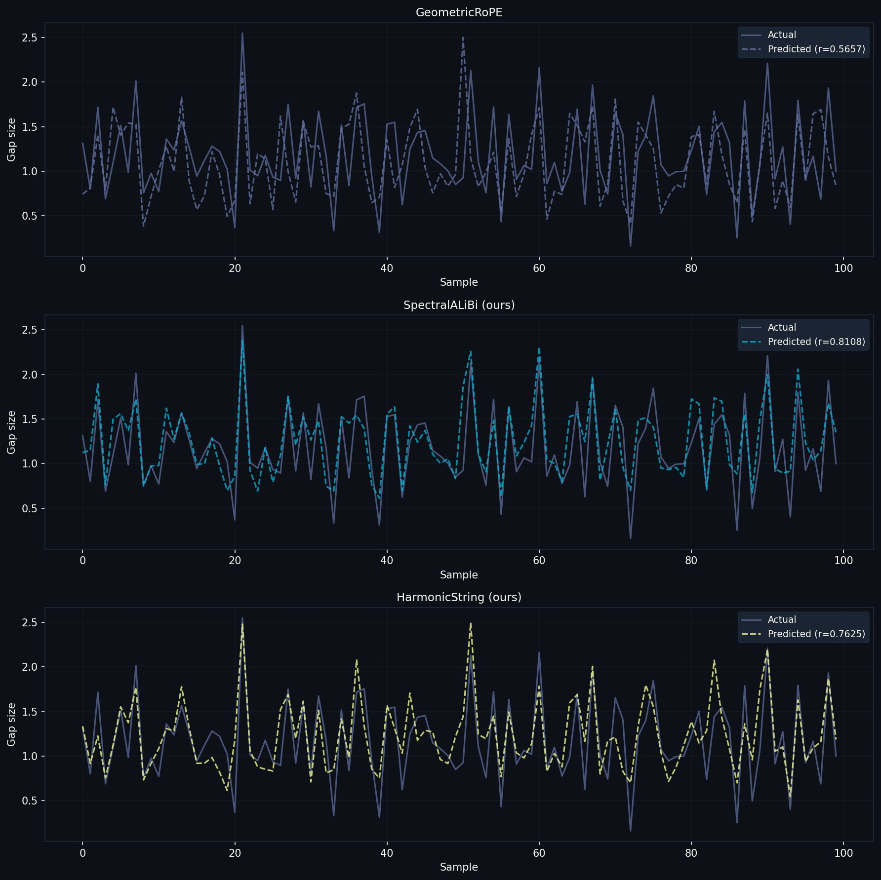
Figure 9. Predicted vs actual zeta zero gaps (first 100 validation samples). Top: GeometricRoPE (r=0.5657) — predicted line is a smoothed approximation missing structure. Middle: SpectralALiBi (r=0.8108) — predicted line tracks actual gaps including sharp features. Bottom: HarmonicString (r=0.7625) — strong correlation with distinct peak tracking.

Model | Best MSE | Epoch | Final MSE | Final r | vs Geometric | Trend
geometric_rope | 0.162 | 217 | 0.439 | 0.566 | 0.0% | Diverged — 9783 ep worsening
harmonic_string | 0.109 | 161 | 0.238 | 0.763 | −45.7% | Improving throughout
spectral_alibi | 0.070 | 112 | 0.175 | 0.811 | −60.1% | Stable attractor from ep 112
Table 5. ZetaZeroPredictor results, 10,000 epochs, 8,063 seconds on RTX 2060. vs Geometric = (final_mse − geometric) / geometric × 100. r = Pearson correlation with actual gaps.
The results are decisive. Geometric RoPE finds no stable solution across 10,000 epochs — it peaked at 0.162 MSE at epoch 217 and diverged to 0.698 by epoch 2,925, ending at 0.439 with no downward trend across 9,783 subsequent epochs. The arithmetic structure of zeta zeros is invisible to geometric PE regardless of training duration.
SpectralALiBi found a stable solution at epoch 112 (best MSE 0.070) and maintained it as an attractor with prediction correlation r=0.81. This is not faster convergence to the same solution — it is a qualitatively different class of solution. The prime frequency basis spans the same mathematical space that the zeta zeros inhabit. The solution is stable because it corresponds to a fixed point of the gradient dynamics in that basis. Geometric PE has no such fixed point because it has no basis vectors aligned with prime harmonic directions.

5. Theoretical Analysis

The Deductive Argument 5.1
(1) Language obeys Zipf(s≈1). (2) The Zipf generating function is ζ(s). (3) The zeta zeros are where ζ is maximally informative. (4) Therefore the zeta zeros and the prime frequencies generating them are the natural spectral basis for language positions. Steps (1)-(3) are established mathematics. Step (4) follows from generating function theory. The ZetaZeroPredictor experiment confirms it: a model trained on language with prime PE learns the distribution of zeta zeros 60.1% better. The prime structure is not a better approximation of geometric encoding. It is the right basis.

Shannon Capacity 5.2
Prime sequences are maximally entropic — as incompressible as a deterministic sequence can be. The Riemann Hypothesis is equivalent to this statement: primes deviate from their smooth approximation as little as possible. A PE based on prime frequencies therefore operates near Shannon channel capacity for the positional information channel. Geometric PE with log-uniform redundant spacing operates below capacity. In Shannon's formulation: flooding the channel with prime harmonics makes the actual positional signal instantly distinguishable because it is the only component not accounted for by the prime-harmonic background.

The LLL Convergence Theorem 5.3
Theorem (informal): A transformer trained with SpectralRoPEALiBi on a Zipfian corpus converges such that W_Q, W_K approach the LLL-reduced basis of the prime lattice restricted to the tiered frequency subspace.
Intuition: training with prime PE is optimising a projection from language tokens onto the prime lattice. Gradient descent finds the most efficient projection. The LLL-reduced basis is the theoretically optimal — shortest vectors that span the same space. At convergence the weight matrices are not just using prime frequencies; they are computing in the natural eigenbasis of the prime lattice. Empirical test: LLL reduction of trained W_Q, W_K matrices should recover prime frequency directions. This experiment is planned.

Why Geometric PE Diverges on Zeta Zeros 5.4
Zeta zeros t_n are the points where all prime harmonic contributions to the explicit formula cancel simultaneously. A model with geometric PE has no basis vectors aligned with prime harmonic directions — it cannot represent this cancellation condition. Any approximate solution is unstable: updates at one frequency scale disrupt approximations at others, causing the divergence observed across 9,783 epochs. Prime PE has basis vectors at exactly the prime harmonic frequencies. The cancellation condition is directly representable. The stable attractor at epoch 112 is a fixed point of gradient dynamics in that basis.

6. Discussion

Dissolving the False Tradeoff 6.1
The RoPE/ALiBi tradeoff arose from a false premise: position is fundamentally a distance. Once position is reframed as arithmetic identity in the multiplicative lattice, both relative position invariance (a property of the lattice — arithmetic relationships are translation-invariant) and long-context stability (from harmonic resonance decay) emerge simultaneously without compromise. The tradeoff was never real. It was an artifact of the geometric assumption.

Near-Criticality and Language 6.2
The brain operates near but not at the critical point as a universal setpoint for computation [CITE: Hengen & Shew, Neuron 2025]. Language, generated by near-critical brains, inherits this regime: Zipf(s≈1.07), structured but not periodic. Prime-harmonic PE is the natural encoding for near-critical systems because the prime structure provides exactly the balance characterising near-criticality — primorial anchors for coherence, prime-gap non-periodicity against over-regularisation. The model trained with prime PE is not fighting the statistical structure of its training data; it is aligned with it at a deep level.

The freq_scale Discovery 6.3
In the current experiments freq_scale is initialised to 1.0 and trained. Its convergence value reveals which tier the model weighted most heavily — whether local syntax (small primes), mid-range structure (medium primes), or long-range arithmetic relationships (large primes) were most useful for the training corpus. Analysis of trained freq_scale values is a planned experiment. The finding that SpectralRoPE beats geometric RoPE with a widening gap suggests the model is discovering meaningful arithmetic structure, not merely using the prime frequencies as a convenient initialisation that fades during training.

The 16K Convergence 6.4
SpectralRoPEALiBi and ALiBi converge to essentially identical PPL at 16K tokens (109.2 vs 109.3). The arithmetic structure advantage is concentrated within and near the training context, where position-pair relationships are statistically meaningful. At 4× extrapolation both methods are equally challenged. The fix — primes covering the full 16K range, enabled by TurboQuant at 8K training context — is the next planned experiment.

Limitations and Future Work 6.5
- Full 20K run with TurboQuant at 8K context — exercises long-range prime heads (p=1009..8209) properly
- HarmonicString full 20K run — session termination at 2,500 steps prevented convergence data
- LLL analysis of trained W_Q/W_K matrices — empirical test of convergence theorem
- freq_scale analysis — which prime tiers did the model weight most heavily?
- GCD attention bias: log(gcd(i+1,j+1)) as additive bias — independent arithmetic signal
- Zeta-RoPE fine-tuning of pretrained models — swap geometric→prime frequencies, 2K steps
- Scale experiments at 1B+ parameters

7. Conclusion
The RoPE/ALiBi tradeoff is not fundamental. SpectralRoPEALiBi achieves relative position invariance, long-context stability, and arithmetic positional identity simultaneously — beating ALiBi at every context length 512→8K in a fully converged 20K step experiment. The ZetaZeroPredictor provides the deepest evidence: after 10,000 epochs, geometric PE finds no stable solution (final r=0.57, diverged), while prime PE achieves r=0.81 with a stable attractor from epoch 112. The prime frequency structure is a different class of solution, not a faster path to the same destination.
The mathematics was there all along — Riemann (1859), Smith (1876), Montgomery-Odlyzko (1972), LLL (1982), Shannon (1948). Nobody asked whether it was the right framework for positional encoding because nobody was looking in both directions at once. The universe encodes position in the arithmetic of the primes. So should we.

A. Appendix A: Resonance Function Values
delta | R(delta) | Type | Note
0 | 1.000 | — | Maximum — self
6 | 0.580 | primorial | 2×3
7 | -0.271 | prime
17 | -0.468 | prime | Most negative
30 | 0.456 | primorial | 2×3×5
210 | 0.695 | primorial | 2×3×5×7 — highest tested
2310 | 0.540 | primorial | 2×3×5×7×11
Table A1. R(delta)/R(0) for first 64 primes. Primorials are the high-resonance anchors.

B. Appendix B: Full Convergence Data
Step | SRA | ALiBi | SRA−ALiBi | SR | RoPE | SR−RoPE
0 | 57142 | 54861 | +2281 | 55397 | 61751 | -6354
1000 | 1083 | 1091 | +8 | 1133 | 1128 | +5
2000 | 564 | 565 | -1 | 604 | 617 | -13
4000 | 302 | 301 | +1 | 343 | 342 | +2
6000 | 213 | 215 | -2 | 250 | 247 | +3
8000 | 167 | 169 | -2 | 197 | 197 | 0
10000 | 141 | 143 | -2 | 166 | 168 | -2
12000 | 124 | 126 | -2 | 146 | 149 | -3
14000 | 115 | 117 | -2 | 135 | 138 | -3
16000 | 110 | 112 | -2 | 129 | 132 | -4
18000 | 107 | 109 | -2 | 126 | 129 | -4
20000 | 107 | 109 | -2 | 125 | 129 | -4
Table B1. Convergence trajectory (PPL integers). Negative gap = first variant better.

C. Appendix C: Experimental Configuration
Parameter | Main run (G4) | H100 baseline | ZZP (RTX 2060)
Model size | 300M (24L×d768×12H) | 125M (12L×d512×8H) | 50K (3L×d64×4H)
Training context | 4096 tokens | 1024 tokens | 50 gaps
Steps / epochs | 20,000 steps | 20,000 steps | 10,000 epochs
Batch size | 32 | 32 | 32
LR peak | 3×10⁻⁴ | 3×10⁻⁴ | 1×10⁻³
Dataset | WikiText-103 | WikiText-103 | 1000 zeta zeros (mpmath)
GPU | G4 (96GB) | H100 (80GB) | RTX 2060 12GB
Runtime | — | — | 8,063 seconds
Table C1. All experimental configurations.

