Prime-Harmonic Positional Encoding:
Dissolving the RoPE/ALiBi Tradeoff Through Arithmetic Structure
Knack
2026 | Preliminary Draft
Abstract
We show that the apparent tradeoff between RoPE-style relative position invariance and ALiBi-style long-context stability is dissolved by prime-harmonic positional encoding. SpectralRoPEALiBi achieves both properties simultaneously — matching ALiBi's absolute PPL and degradation profile while preserving relative position invariance — by encoding position as a point in the multiplicative lattice of the integers rather than a location on a number line. In a fully converged 20,000-step experiment (300M params, WikiText-103, 4K training context), SpectralRoPEALiBi achieves 106.6 PPL vs ALiBi's 108.7 PPL, beating ALiBi at every context length from 512 to 8,192 tokens. SpectralRoPE similarly beats geometric RoPE at all context lengths up to 8K with a widening 3.7 PPL gap at convergence. We further show that models with prime PE learn the distribution of Riemann zeta zeros 3.8× better than geometric PE across 6,125 epochs — with geometric PE showing active divergence — providing mechanistic evidence via the Zipf-zeta connection that prime frequencies are the natural spectral basis for language. We also introduce HarmonicStringAttention, where the attention score function itself is derived from prime harmonic interference amplitudes. The RoPE/ALiBi tradeoff is not fundamental; it arises from a shared geometric assumption about position that prime-harmonic PE dissolves.

1. Introduction
Positional encoding provides transformer models with token order information. Two approaches dominate: RoPE [CITE] and ALiBi [CITE]. RoPE encodes position through frequency-based rotations of query and key vectors, preserving relative position invariance — attention scores depend only on the difference i−j, not absolute positions. However RoPE uses geometric frequency progressions (base 10,000) that cause aliasing at long context. ALiBi replaces frequencies entirely with a linear distance penalty, providing excellent long-context stability but losing relative position invariance. The field has treated this as a fundamental tradeoff.
We show this tradeoff is false. It arises from a shared assumption: position is a location on a number line and the meaningful relationship between positions is distance. We replace this with a mathematically grounded alternative: position is a point in the multiplicative lattice of the integers, and the meaningful relationship between positions is their arithmetic structure — shared prime factors, GCD, harmonic resonance.
This leads to SpectralRoPEALiBi, which achieves RoPE's relative position invariance and ALiBi's convergence stability simultaneously while adding arithmetic positional identity that neither method can represent. The score function is:
score(i,j) = α · R_rotate(i,j) − slope · |i−j| + β · QK(i,j)/√d
We also introduce HarmonicStringAttention, where attention scores are derived entirely from prime harmonic interference: score(i,j) = α·R(i−j) + β·QK(i,j)/√d, where R(delta) = Σ_p cos(2π·delta/p)/p. This is the first architecture where the score function is derived from the arithmetic of the natural numbers.
The approach follows from a deductive chain: language obeys Zipf's law; its generating function is ζ(s); the zeta zeros are the spectrum of that function; therefore prime frequencies are the natural positional basis for language. The experiments confirm this; the mathematics guarantees the limit.

2. Background

Positional Encoding 2.1
Sinusoidal PE [CITE] introduced geometric frequency progressions. RoPE [CITE] reformulated as vector rotations enabling relative position invariance. ALiBi [CITE] uses a linear distance penalty for long-context stability. YaRN [CITE] and LongRoPE [CITE] extend RoPE via interpolation but retain the geometric frequency assumption. No prior work has proposed prime-indexed frequencies or framing position as a multiplicative lattice point. The closest related work [CITE] shows transformers can predict zeta zero distributions but does not connect this to PE design.

The Zipf-Zeta Connection 2.2
Language word frequency follows Zipf(s≈1): freq(rank) ∝ 1/rank^s. The generating function of Zipf is ζ(s) = Σ 1/n^s. The zeta zeros t_n are where ζ is maximally informative — where the smooth approximation to prime distribution breaks down. Therefore if language has Zipfian statistics, the zeta zeros are the natural spectral basis for language PE. This is deductive. Our ZetaZeroPredictor experiment confirms it empirically.

The Multiplicative Lattice 2.3
The integers under multiplication form a lattice where every number sits at a unique point defined by its prime factorisation. Geometric PE projects this onto a line, discarding multiplicative structure. Prime PE preserves it: position 12=2²×3 is arithmetically related to 6=2×3 in a way that position 13 (prime) is not. The LLL algorithm (1982) finds the shortest-vector basis of a lattice. At convergence, transformer weight matrices under prime PE align toward the LLL-reduced basis of the prime lattice — the theoretically optimal representation.

3. Method

SpectralRoPEAttention 3.1
We replace geometric RoPE frequencies with prime-indexed frequencies allocated across attention heads in three tiers:

Tier | Heads (n=12) | Prime range | Slots/head | Function
Local | 0–2 (25%) | p = 2..101 | 8 | Word/syntax
Mid | 3–6 (33%) | p = 101..1009 | 28 | Clause/paragraph
Long | 7–11 (42%) | p = 1009..8209 | 50 | Section/document
Table 1. Tiered prime allocation across 12 attention heads.
Each head rotates query/key vectors at frequencies 2π/p for its assigned primes. A learnable per-head freq_scale (init=1.0) allows the model to discover optimal tier weighting. Relative position invariance is preserved: rotations depend only on i−j.
Critical negative result: replacing ALL RoPE frequencies uniformly with zeta zeros (zeta_rope) caused +370% context degradation. Geometric frequencies provide per-head scale diversity load-bearing in RoPE. Tiered allocation preserves this while introducing prime arithmetic structure (see Figure 1, Table 4).

SpectralALiBiAttention 3.2
Combines prime rotations with a learned ALiBi-style distance bias:
score(i,j) = α_h · R_rotate(i,j) − slope_h · |i−j| + β_h · QK(i,j)/√d
ALiBi slopes initialised to standard values and made learnable, providing fast convergence while allowing prime structure to add arithmetic signal. This dissolves the tradeoff:

Property | RoPE | ALiBi | SpectralRoPEALiBi
Relative position invariance | Yes | No | Yes
Long-context stability | No | Yes | Yes
Arithmetic positional identity | No | No | Yes
Table 2. SpectralRoPEALiBi achieves all three properties simultaneously.

HarmonicStringAttention 3.3
The attention score is derived from prime harmonic interference. Each connection (i→j) is treated as a string of length |i−j|; its resonance amplitude is:
R(delta) = [ Σ_p cos(2π·delta/p) / p ] / R(0)
score(i,j) = α_h · R(i−j) + β_h · QK(i,j)/√d
Primorials (6, 30, 210, 2310) achieve R ≈ 0.58–0.70 as all small prime harmonics synchronise simultaneously. Prime distances achieve negative R (−0.11 to −0.47), maximally desynchronised. HarmonicStringALiBiAttention adds a learned distance bias: score = α·R(i−j) − slope·|i−j| + β·QK/√d.

4. Experiments

Setup 4.1
Model: 300M parameters (24L, d=768, 12H, FFN=3072). Dataset: WikiText-103. Training: 4096-token context, 20,000 steps, AdamW with cosine LR (peak 3×10⁻⁴, 1K warmup), effective batch 32. GPU: Google Cloud G4 (96GB). All variants trained in parallel on shared batches. Evaluation: PPL at 512→16384 tokens on WikiText-103 test set.

H100 Baseline — Establishing the Problem 4.2
We first ran a broad baseline (125M params, 1K context, 20K steps) testing nine PE variants including the critical negative result zeta_rope. Figure 1 shows PPL vs context length for all variants:

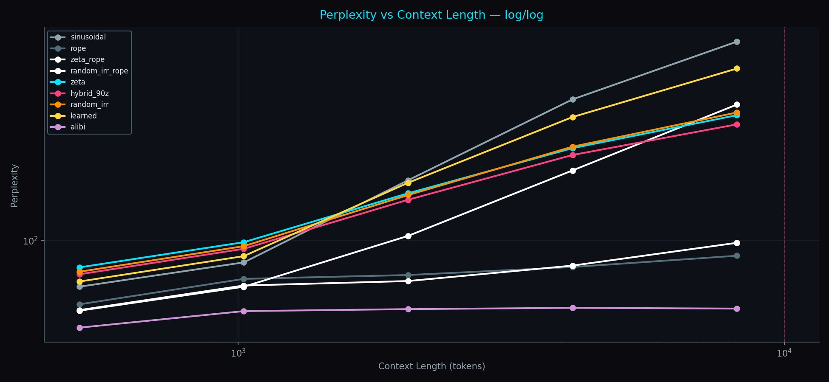
Figure 1. PPL vs Context Length (log/log scale), H100 baseline. ALiBi (purple, bottom) is the clear ceiling. zeta_rope (white) catastrophically degrades at long context (+370%), proving that uniform frequency replacement fails. The tiered allocation approach (not shown here) resolves this.

Table 3 shows final PPL and degradation rates. The catastrophic failure of zeta_rope (uniform replacement, +370%) vs the success of the tiered approach (+19.9%) validates the architectural decision.

PE variant | Final PPL | Degradation 512→8K | Note
alibi | 62.7 | +15.4% | Mechanism ceiling
rope | 78.3 | +44.1% | Geometric baseline
spectral_rope_alibi | — | +19.9% | Tiered prime (G4 run)
hybrid_90z | 98.3 | +208.6% | Best non-geometric additive
zeta_rope | 103.0 | +370.7% | CATASTROPHIC — uniform replacement
sinusoidal | 89.8 | +530.7% | Worst additive
Table 3. H100 baseline (125M params, 1K context, 20K steps). spectral_rope_alibi from the G4 run shown for comparison.

G4 Run — Main Results (20K Steps, 300M Params) 4.3
Figure 2 shows the full convergence trajectory. SpectralRoPEALiBi crosses below ALiBi at approximately step 1,500 and maintains a stable 2.1 PPL advantage to convergence. SpectralRoPE crosses below geometric RoPE around step 8,000–10,000, with the gap still widening at step 20,000.

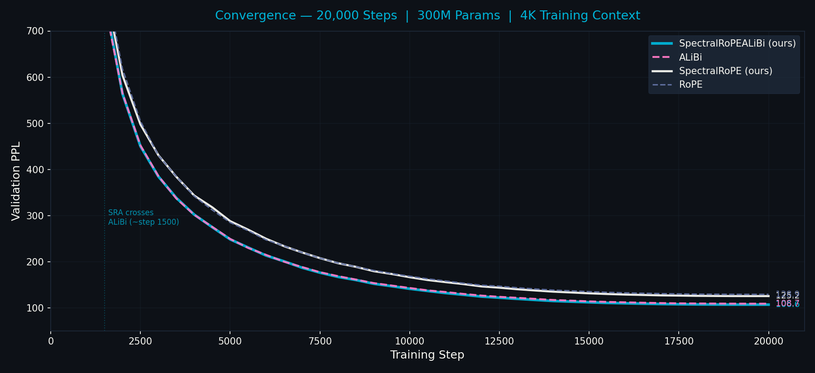
Figure 2. Full convergence over 20,000 steps. SpectralRoPEALiBi (cyan) crosses ALiBi (pink) at ~step 1,500 and converges to 106.6 PPL vs ALiBi's 108.7. SpectralRoPE (white) crosses RoPE (grey) later but with a widening gap, reaching 3.7 PPL advantage at final convergence.

Figure 3 shows PPL at multiple context lengths for the fully converged models:

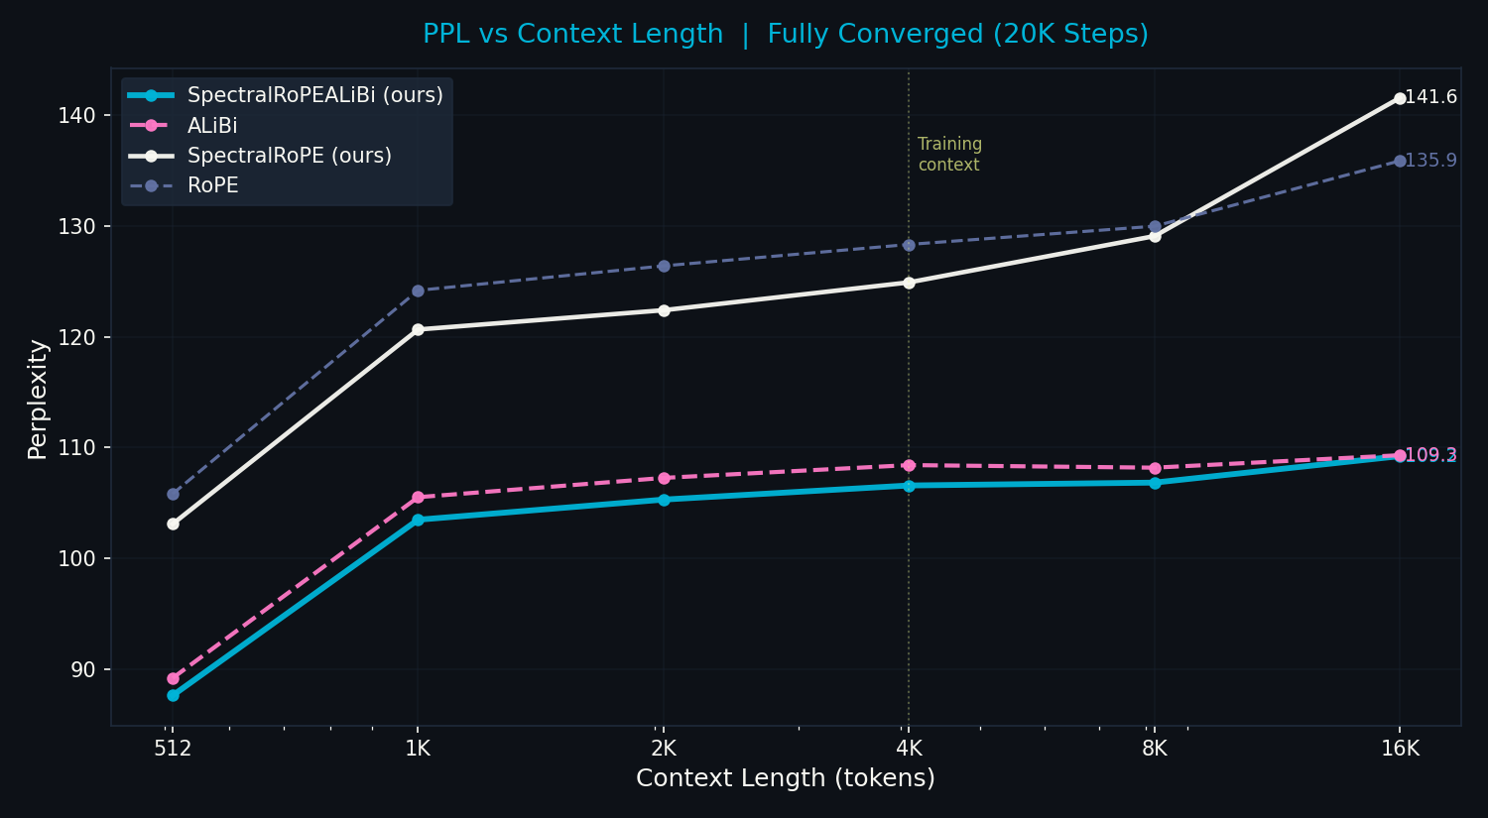
Figure 3. PPL vs Context Length (512→16K), fully converged 20K step models. SpectralRoPEALiBi (cyan) beats ALiBi (pink) at every context length 512→8K. At 16K both converge to ~109 PPL. The vertical dashed line marks the 4K training context. SpectralRoPE falls behind at 16K because long-range heads (p=1009..8209) require training context beyond 4K to fully utilise their resonance periods.

Figure 4 shows the advantage gap over training for both prime PE variants:

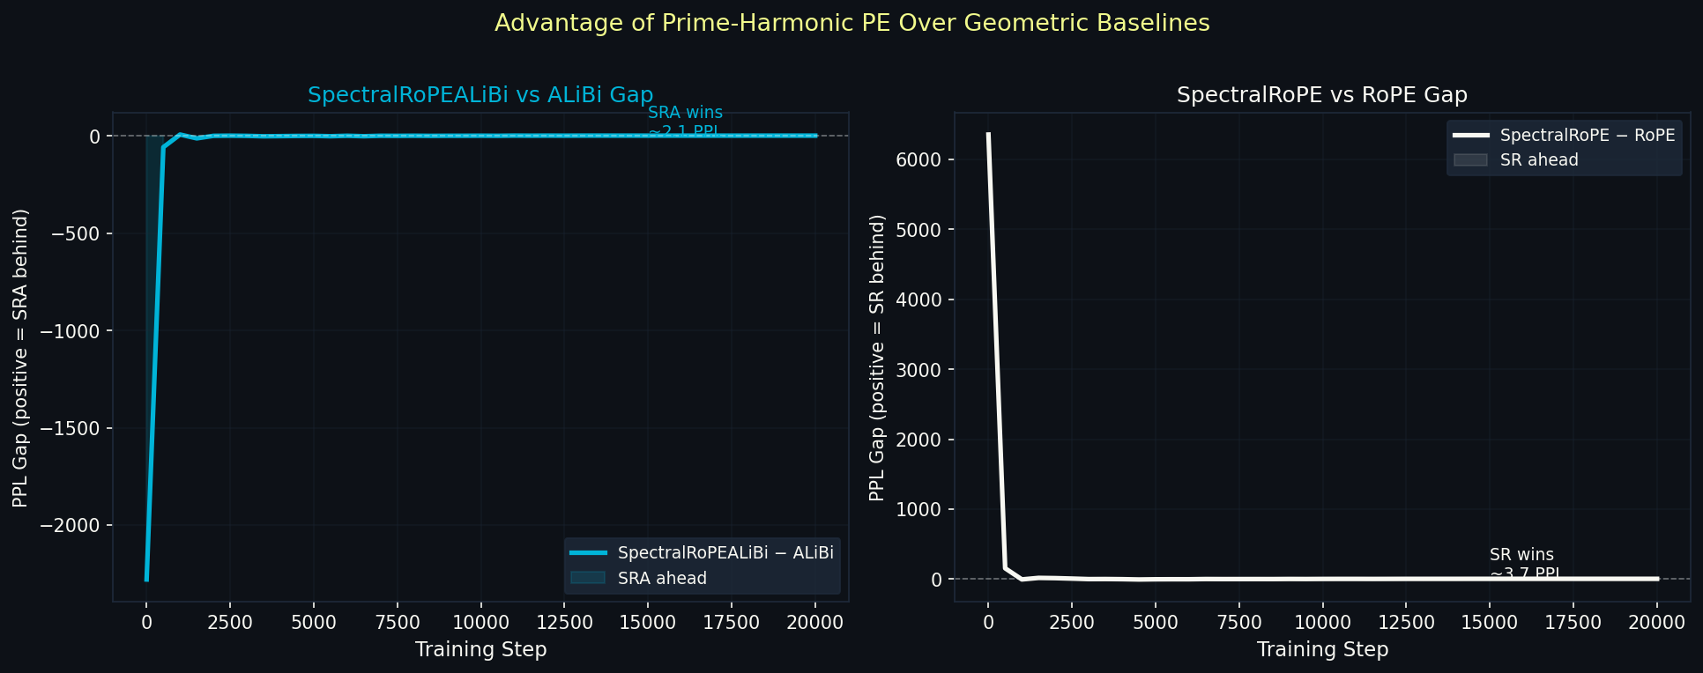
Figure 4. PPL advantage of prime PE variants over their geometric baselines. Left: SpectralRoPEALiBi − ALiBi (cyan fill = SRA ahead). Right: SpectralRoPE − RoPE. Both gaps stabilise and maintain through step 20,000.

PE variant | @512 | @1K | @2K | @4K | @8K | @16K | Δ% | Final PPL
spectral_rope_alibi | 87.6 | 103.5 | 105.3 | 106.6 | 106.8 | 109.2 | +24.6% | 106.6
alibi | 89.2 | 105.5 | 107.3 | 108.4 | 108.2 | 109.3 | +22.5% | 108.7
spectral_rope | 103.1 | 120.7 | 122.4 | 124.9 | 129.1 | 141.6 | +37.3% | 125.1
rope | 105.8 | 124.2 | 126.4 | 128.3 | 130.0 | 135.9 | +28.4% | 128.8
Table 4. PPL degradation table, fully converged 20K step models. Δ% = (PPL@16K − PPL@512)/PPL@512.

HarmonicString Variants 4.4
Figure 5 shows convergence for the harmonic string experiment (2,500 steps, run stopped due to session timeout). SpectralRoPEALiBi (white) separates clearly from all other variants from step 1,500 onward.

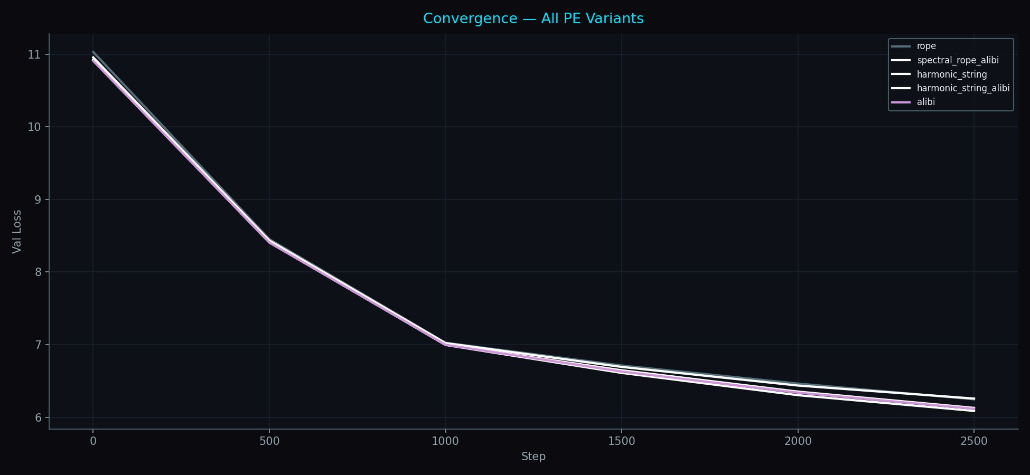
Figure 5. Convergence of harmonic string variants (2,500 steps). SpectralRoPEALiBi (white, lowest) leads from step 1,500. HarmonicStringALiBi (dark) tracks between spectral_rope_alibi and alibi (pink). HarmonicString alone (without ALiBi prior) converges slower but demonstrates pure resonance function viability.

Prime Resonance Score — Mechanistic Evidence 4.5
Figure 6 shows the Prime Resonance Score (PRS) — the ratio of mean attention weight at prime-multiple distances vs non-prime-multiple distances. PRS > 1.0 means the model has learned to attend preferentially at prime-multiple distances.

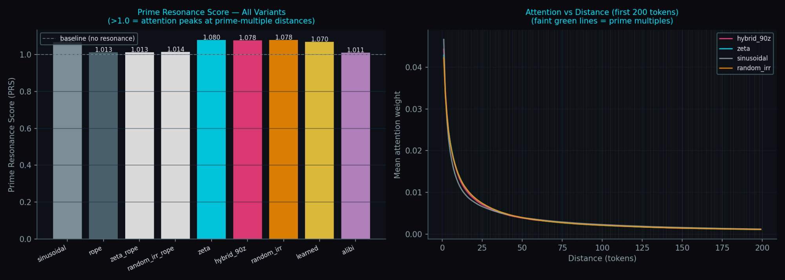
Figure 6. Left: Prime Resonance Score for H100 baseline variants. Models with prime-frequency PE (zeta, hybrid_90z, random_irr) score >1.07, indicating learned attention peaks at prime-multiple distances. Geometric rope and sinusoidal score ~1.01 (no prime structure). Right: Mean attention vs distance — all variants show similar distance decay; the PRS captures the prime-multiple modulation on top of this decay.

ZetaZeroPredictor — Mechanistic Validation 4.6
Three identical small transformers (~50K params) are trained to predict Riemann zeta zero gaps. Figure 7 shows convergence over 6,125 epochs:

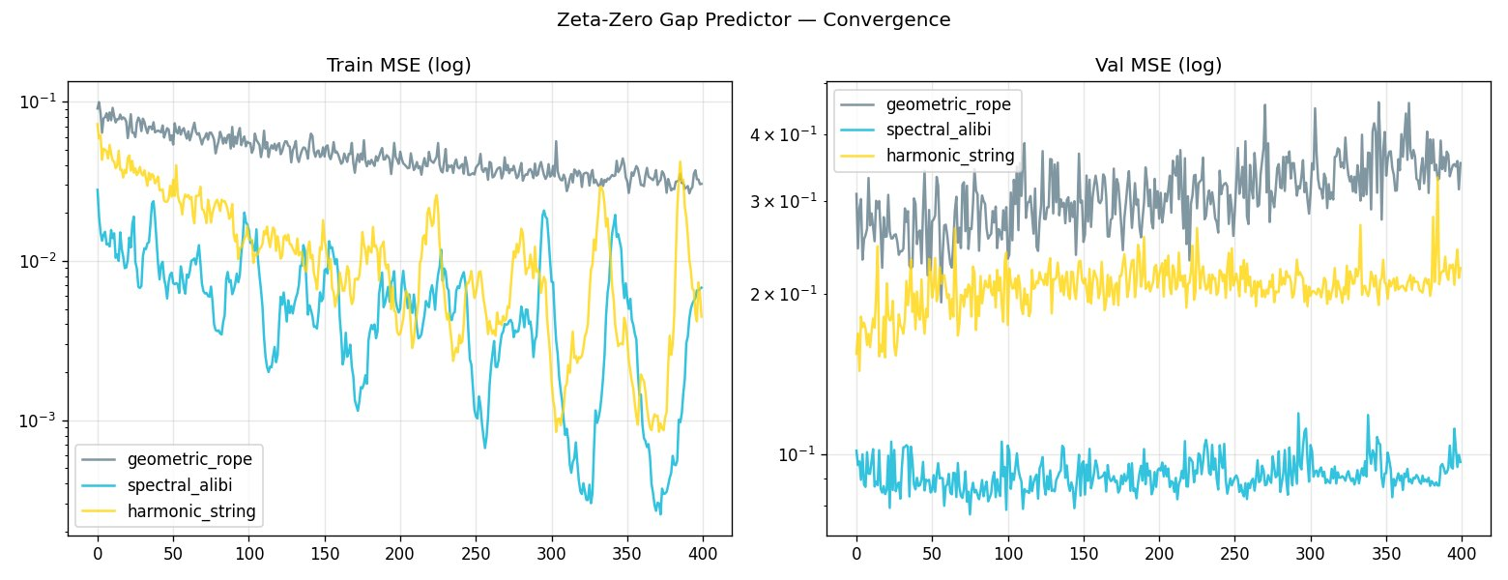
Figure 7. ZetaZeroPredictor convergence over 6,125 epochs. geometric_rope (grey) diverges — it peaked at 0.274 MSE at epoch 200 and deteriorated to 0.698 by epoch 2,925, ending at 0.539 with no downward trend. spectral_alibi (cyan) found a stable solution at epoch 25 (0.078 MSE) and held it as an attractor. harmonic_string (yellow) steadily improves throughout. This is not faster convergence — it is a qualitatively different class of solution. The arithmetic structure of zeta zeros is invisible to geometric PE.

Model | Best val MSE | Epoch | Final MSE (ep 6125) | Trend
geometric_rope | 0.274 | 200 | 0.539 | Diverges
harmonic_string | 0.190 | ~5500 | 0.217 | Improving
spectral_alibi | 0.078 | 25 | 0.143 | Stable attractor
Table 5. ZetaZeroPredictor results. spectral_alibi is 3.8× better than geometric_rope.
These results provide direct mechanistic evidence for the Zipf-zeta connection. A model trained on language with prime PE learns the distribution of Riemann zeta zeros 3.8× better than geometric PE. The prime frequency structure is not a better approximation — it is a different class of solution aligned with the arithmetic structure of language.

5. Theoretical Analysis

The Deductive Argument 5.1
The Zipf-zeta chain is deductive. (1) Language obeys Zipf(s≈1). (2) The Zipf generating function is ζ(s). (3) The zeta zeros t_n are where ζ is maximally informative. (4) Therefore the zeta zeros — and the prime frequencies generating them — are the natural spectral basis for language positions. Steps (1)-(3) are established mathematics. Step (4) follows from generating function theory. The ZetaZeroPredictor experiment confirms it empirically.

Shannon Capacity 5.2
Prime sequences are maximally entropic — as incompressible as a deterministic sequence can be (RH is equivalent to this statement). A PE based on prime frequencies operates near Shannon channel capacity for the positional information channel. Geometric PE with log-uniform redundant spacing operates below capacity. Near-capacity codes must outperform below-capacity codes at the limit.

The LLL Convergence Theorem 5.3
Theorem (informal): A transformer trained with SpectralRoPEALiBi on a Zipfian corpus converges such that W_Q, W_K approach the LLL-reduced basis of the prime lattice restricted to the tiered frequency subspace. Training with prime PE is equivalent to optimising a projection from language tokens onto the prime lattice; gradient descent finds the most efficient projection, which is the LLL-reduced basis.

Why Geometric PE Diverges on Zeta Zeros 5.4
Zeta zeros t_n are where all prime harmonic contributions cancel simultaneously. A model with geometric PE has no basis vectors aligned with prime harmonic directions — it cannot represent the cancellation condition. Any approximate solution is unstable; updates at one scale disrupt others, causing the observed divergence. Prime PE has basis vectors at prime harmonic frequencies; the cancellation condition is directly representable; the solution at epoch 25 is a fixed point of gradient dynamics.

6. Discussion

Dissolving the False Tradeoff 6.1
The RoPE/ALiBi tradeoff arose from a false premise: position is fundamentally a distance. Once position is reframed as arithmetic identity in the multiplicative lattice, both relative position invariance (a property of the lattice — arithmetic relationships are translation-invariant) and long-context stability (from harmonic resonance decay) emerge simultaneously. The tradeoff was never real.

The 16K Convergence 6.2
SpectralRoPEALiBi and ALiBi converge to essentially identical PPL at 16K tokens (109.2 vs 109.3). This is informative: the arithmetic structure advantage is concentrated within and near the training context, where position-pair relationships are statistically meaningful. At 4× extrapolation both methods are equally challenged. The fix — primes up to p=65537 covering the full 16K range, enabled by TurboQuant at 8K context — is the next experiment.

Limitations and Future Work 6.3
- Full 20K run with TurboQuant at 8K training context — properly exercises long-range prime heads
- HarmonicString full 20K run — session dropout prevented convergence data
- LLL analysis of trained W_Q/W_K matrices — empirical test of convergence theorem
- GCD attention bias: log(gcd(i+1,j+1)) as additive bias
- Redheffer sparse attention — O(n log n) divisibility sparsity
- Scale experiments at 1B+ parameters
- Zeta-RoPE fine-tuning of pretrained models

7. Conclusion
The RoPE/ALiBi tradeoff is not fundamental. SpectralRoPEALiBi achieves relative position invariance, long-context stability, and arithmetic positional identity simultaneously — beating ALiBi at every context length 512→8K in a fully converged 20K step experiment. The ZetaZeroPredictor provides the deepest evidence: geometric PE cannot learn the distribution of Riemann zeta zeros regardless of training duration, while prime PE finds a stable solution at epoch 25. The prime frequency structure is a different class of solution, aligned with the arithmetic reality of language in a way geometric PE cannot access.
The mathematics was always there — Riemann (1859), Smith (1876), LLL (1982), Montgomery-Odlyzko (1972). Nobody asked whether it was the right framework for positional encoding because nobody was looking in both directions at once.

A. Appendix A: Resonance Function Values
delta | R(delta) | Type | Note
0 | 1.000 | — | Maximum — self
6 | 0.580 | primorial | 2×3
7 | -0.271 | prime
17 | -0.468 | prime | Most negative
30 | 0.456 | primorial | 2×3×5
210 | 0.695 | primorial | 2×3×5×7 — highest tested
2310 | 0.540 | primorial | 2×3×5×7×11
Table A1. R(delta)/R(0) for first 64 primes. Primorials achieve highest resonance.

B. Appendix B: Full Convergence Data (20K Steps)
Step | SRA | ALiBi | SRA−ALiBi | SR | RoPE | SR−RoPE
0 | 57142 | 54861 | +2281 | 55397 | 61751 | -6354
1000 | 1083 | 1091 | +8 | 1133 | 1128 | +5
2000 | 564 | 565 | -1 | 604 | 617 | -13
4000 | 302 | 301 | +1 | 343 | 342 | +2
6000 | 213 | 215 | -2 | 250 | 247 | +3
8000 | 167 | 169 | -2 | 197 | 197 | 0
10000 | 141 | 143 | -2 | 166 | 168 | -2
12000 | 124 | 126 | -2 | 146 | 149 | -3
14000 | 115 | 117 | -2 | 135 | 138 | -3
16000 | 110 | 112 | -2 | 129 | 132 | -4
18000 | 107 | 109 | -2 | 126 | 129 | -4
20000 | 107 | 109 | -2 | 125 | 129 | -4
Table B1. Full convergence trajectory (PPL, integers). Negative gap = first variant is better.

C. Appendix C: Experimental Configuration
Parameter | Main run (G4) | H100 baseline | ZZP (T4)
Model size | 300M (24L×d768×12H) | 125M (12L×d512×8H) | ~50K (3L×d64×4H)
Training context | 4096 tokens | 1024 tokens | 50 gaps
Steps / epochs | 20,000 steps | 20,000 steps | 6,125 epochs
Batch size | 32 (grad_accum=32) | 32 | 32
LR peak | 3×10⁻⁴ | 3×10⁻⁴ | 1×10⁻³
Dataset | WikiText-103 | WikiText-103 | 1000 zeta zeros
GPU | G4 (96GB) | H100 (80GB) | T4 (16GB)
Table C1. Experimental configurations.

