6COSC023W
Computer Science Final Project

Project Proposal and Requirements Specification (PPRS)
Handout

Lufyco: A Mobile-First, AI-Powered Fashion App for Image-Based Discovery, Context-Aware Outfit Recommendations, and Digital Wardrobe Management

Student: Nihinsa Bandara (20220921)

Supervisor: Ms. Akarshani Amarasinghe

Degree:BEng (Hons) Software Engineering

School of Computer Science & Engineering
College of Design, Creative and Digital Industries
University of Westminster
10/11/2025

Declaration
This document has been prepared based on my own work. Where other published and unpublished source materials have been used, these have been acknowledged in references.
Student Name: Dunithi Nihinsa Saruwa Bandara
Date of Submission: 13/11/2025

1. Definition of the Problem
Problem Description: People have difficulty finding the right clothing online. Search is very basic, recommendations are general, and images from users do not match images from the studio. This creates time-consuming and confusing decisions which abandon the cart.

Significance: An improvement in the user's experience will be advantageous to the seller's bottom line. The mobile AI also represents the potential to be private, speedy, and useful.

2. Aims, Objectives, and Scope
Aim:
Build Lufyco, a mobile app for image-based search, a context-aware stylist, and a digital wardrobe with clear, fast recommendations.
Objectives:
- Create a simple React Native app with secure login.
- Add image search using visual embeddings and fast vector lookup.
- Provide an AI Stylist with short “why this” messages.
- Auto-tag wardrobe items with manual edits.
- Meet latency and accessibility targets.
Scope:
- Inclusions: Photo search; plan look (mood/occasion/weather); wardrobe; browse/filter; wishlist; style cards; basic APIs.
- Exclusions: Merchant dashboards, payments, multi-seller marketplace, web app, AR/3D try-on, global rollout, advanced moderation.

3. Background Review
Key Findings (Literature / Systems):
- Photo-to-product works but struggles on real user photos.
- Popularity-based recommenders miss context.
- Gaps: speed on phones, clear explanations, wardrobe-aware styling, and fairness.
Comparison with Similar Products:
- App A: Good filters, weak photo search, no reasons.
- App B: Nice feed, low personalisation, slow.
- App C: Advice only, no wardrobe, black box.
Differentiation: Lufyco combines photo-first search, context outfits, wardrobe, and short explanations with sub-second goals.

4. Tools (Hardware/Software)
Hardware:
- Test phones (low/mid/high), laptop (i7/Ryzen 7+), optional GPU, broadband.
Software:
- React Native (Expo): App UI.
- Node.js/Express or Python/FastAPI: APIs.
- PyTorch/TensorFlow: Models.
- FAISS/ScaNN: Vector search.
- MongoDB/PostgreSQL: Data.
- Redis: Cache.
- S3/Firebase + Firebase Auth: Storage + auth.
- Docker, CI, Postman, Figma, Zotero.

5. Use Cases and Diagrams
Use Cases:
- Upload photo → similar items.
- Plan look (mood/occasion/weather).
- Manage wardrobe with auto-tags.
- Save/share style card; browse/filter; wishlist.
Diagrams:
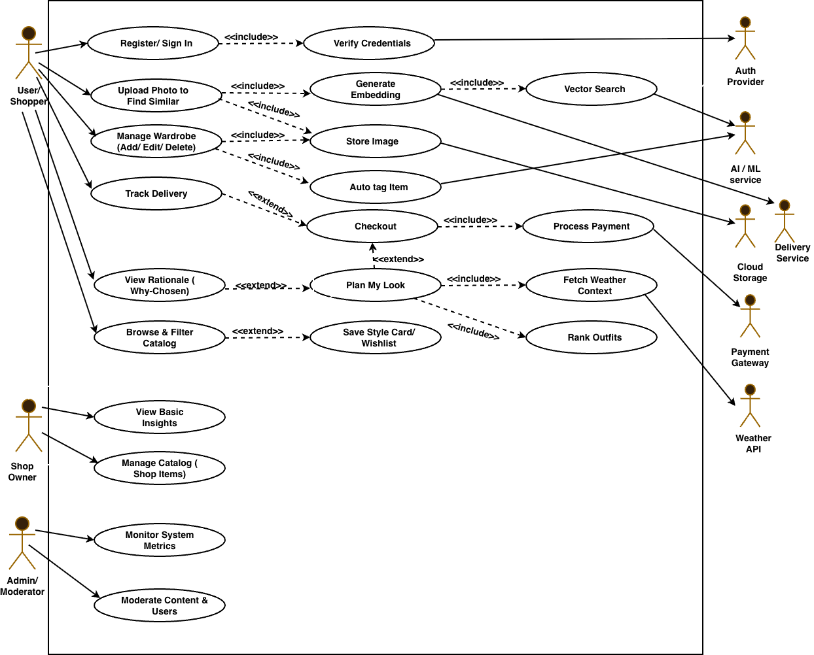
Figure 1:Use Case Diagram

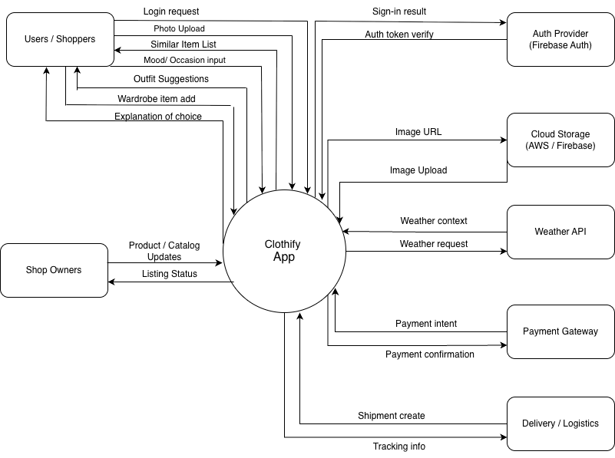
Figure 2: Context Diagram

6. Requirements Elicitation
The system requirements were gathered through surveys, interviews, document analysis, and observation. Surveys helped understand usability, trust, and decision-making time, while interviews with users and shopkeepers revealed practical needs and expectations. Reviewing competitor apps and user reviews highlighted common issues and missing features. Observation and brainstorming supported sketching early workflows and identifying usability problems. The information from all methods was analysed using simple statistics and thematic grouping. From this, the key requirements were defined, including photo-based search, an AI stylist, wardrobe management with tags, short explanations for recommendations, browsing and filtering options, wishlists, style cards, and secure user authentication.

7. Time Schedule
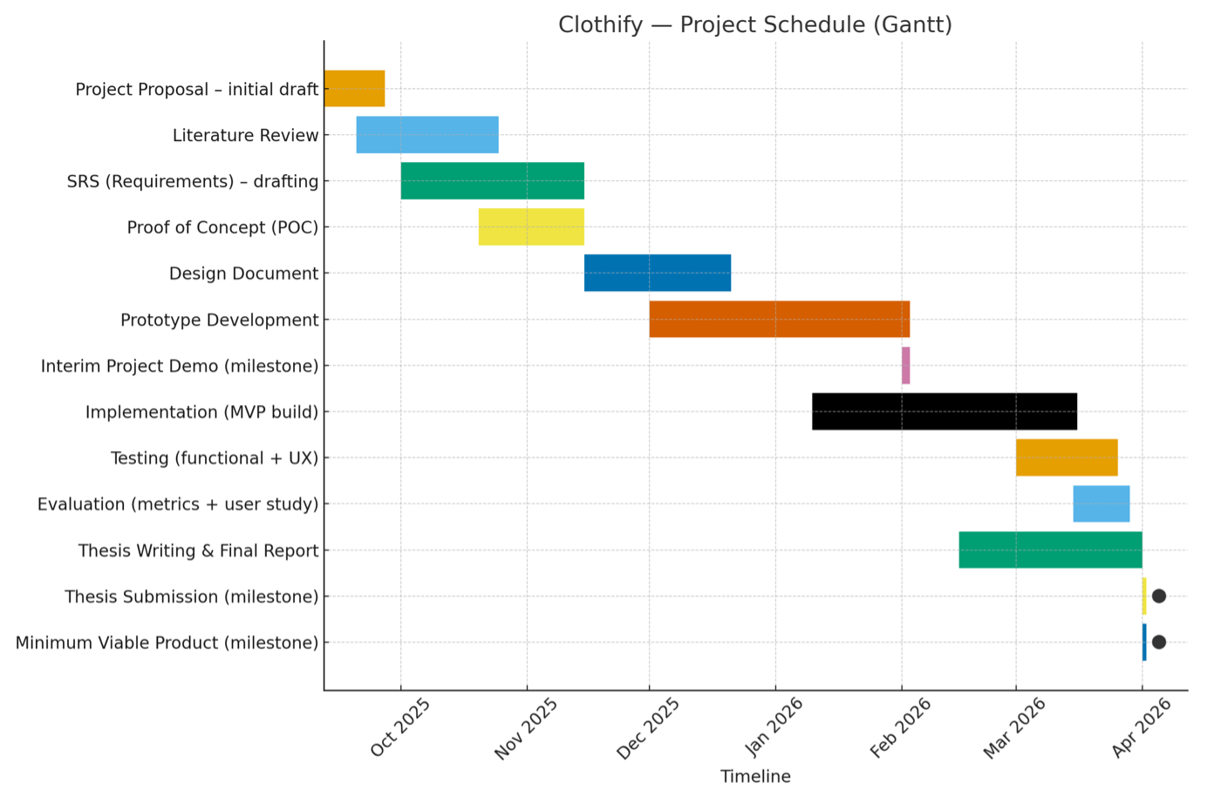
Figure 3:Gantt Chart
8. References
Ajakan, H., Lample, G., Denoyer, L. & Ralaivola, L. (2014). Domain-Adversarial Training of Neural Networks. Available from https://arxiv.org/abs/1505.07818 [Accessed 12 March 2025].
Cui, Z., Liu, S., Zhang, Z., Cao, X. & Shan, S. (2019). Dressing as a Whole: Outfit Compatibility Learning Based on Node-wise Graph Neural Networks. Proceedings of the 42nd International ACM SIGIR Conference on Research and Development in Information Retrieval (SIGIR ’19). Available from https://doi.org/10.1145/3331184.3331268 [Accessed 12 March 2025].
Ge, Y., Zhang, R., Wang, X. et al. (2019). DeepFashion2: A Versatile Benchmark for Detection, Pose Estimation, Segmentation and Re-Identification of Clothing Images. CVPR 2019. Available from https://arxiv.org/abs/1901.07973 [Accessed 12 March 2025].
Guo, R., Sun, P., Lindgren, E., Gaur, Y., Simcha, D., Chern, F. & Kumar, S. (2020). Accelerating Large-Scale Inference with Anisotropic Vector Quantization (ScaNN). Proceedings of Machine Learning and Systems (MLSys). Available from https://research.google/pubs/scann-efficient-vector-similarity-search/ [Accessed 12 March 2025].
He, R., Chen, Z., Kan, M.-Y. & Chen, X. (2016). Neural Outfit Recommendation. Available from https://arxiv.org/abs/1707.05535 [Accessed 12 March 2025].
Hou, Z., Chang, X., Nie, L. & Snoek, C.G.M. (2019). Explainable Outfit Recommendation with Joint Outfit Matching and Comment Generation. Available from https://arxiv.org/abs/1904.02239 [Accessed 12 March 2025].
Jégou, H., Douze, M., Johnson, J. & Matas, J. (2017). Billion-Scale Similarity Search with GPUs (FAISS). Available from https://arxiv.org/abs/1702.08734 [Accessed 12 March 2025].
Kiapour, M.H., Yamaguchi, K., Berg, A.C. & Berg, T.L. (2015). Where to Buy It: Matching Street Clothing Photos in Online Shops. ICCV 2015. Available from https://doi.org/10.1109/ICCV.2015.425 [Accessed 12 March 2025].
Liu, Z., Luo, P., Wang, X. & Tang, X. (2016). DeepFashion: Powering Robust Clothes Recognition and Retrieval with Rich Annotations. CVPR 2016. Available from https://arxiv.org/abs/1608.03088 [Accessed 12 March 2025].
Sun, K., Lu, S., Chen, E. et al. (2020). FashionBERT: Text and Image Matching in the Wild. Available from https://arxiv.org/abs/2005.09801 [Accessed 12 March 2025].
Tan, M. & Le, Q. (2019). EfficientNet: Rethinking Model Scaling for Convolutional Neural Networks. ICML 2019. Available from https://arxiv.org/abs/1905.11946 [Accessed 12 March 2025].
Wang, X., Chen, H., Zhang, Z., Shen, C. & Zhang, J. (2021). FashionCLIP: Connecting Language and Images for Fashion Understanding. Available from https://arxiv.org/abs/2108.09116 [Accessed 12 March 2025].
Zhang, R., Tang, S., Ge, Y., Yi, L. & Wang, X. (2020). Context-Aware Outfit Recommendation with Attribute-Aware Explainability. Available from https://arxiv.org/abs/2006.13174 [Accessed 12 March 2025].

9. Ethics Form
