**SIGNAL-R**

**What is It?**

ASP.NET SignalR is a library for [ASP.NET](https://en.wikipedia.org/wiki/ASP.NET) developers to add real-time web functionality to their applications. Real-time web functionality is the ability to have server-side code push content to the connected clients as it happens, in real-time

It creates a tunnel between the client and the server, so they can communicate in async manner.

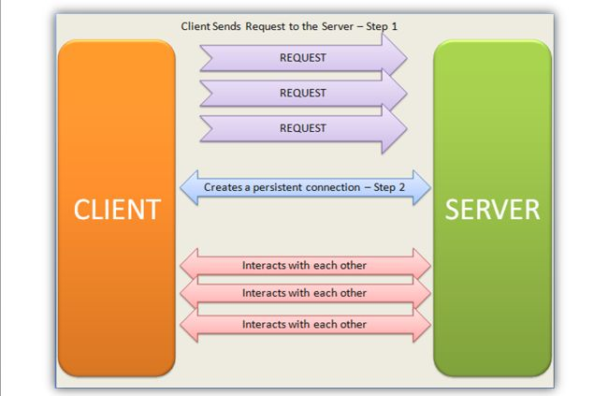

**How does it works ?**

It uses four different technologies, to fulfil the real time need :

1. Web Socket
2. Event Source
3. Forever Frame
4. Long Polling

Note : First three are real-time mechanism and 4th one simulates real time need.

What main things FaceBook does ?

1. You can update your own status/photos
2. You can see others status/photos without refreshing
3. You can chat with other person.

Why Use SignalR ?

1. You have to learn 1 technique, and you get the power of 4 technologies.
2. If you are using SIGNALR and some technology change occurs in any of the 4 mechanisms discussed above, SIGNALR will take the responsibility to handle those changes.
3. Abstraction
4. Compatible with Websites and Mobile App both.
5. Easy

Technical Reason.

1. C# is used as a backend.
2. Grouping can be done with the broadcasting system
3. Scalability

|  |  |
| --- | --- |
| AJAX Polling | Long Polling |
| Says no, if no data available, doesn’t wait | Waits until the data is available, and sends back when it has the data |
| One way | One way |
| No Persitent Connection | No persistent Coonection |

Forever Frame

iFrame : HTML element, i.e, we can embed it in our html pages.

Here, first http request is made and then after server can send you data to client without the client request the data. It is called SERVER Push.

DownSides :

1. Memory Use
2. Client must support Iframe
3. 1 way (server to client)

Event Source / Server Sent Events – SSE

uses content type : text/event-stream

Web – Sockets

1. Bi-Directional
2. Multi-User
3. Full Duplex
4. Asynchronos

Protocol : WS

Hubs and RPC

Hubs : A Hub provides multicast functionality over a WebSocket connection. When any one of the clients send a message to the Hub it broadcasts the message to all the connected clients and makes a connection between them called a Client-Hub Connection.

RPC : Remote Procedure Call

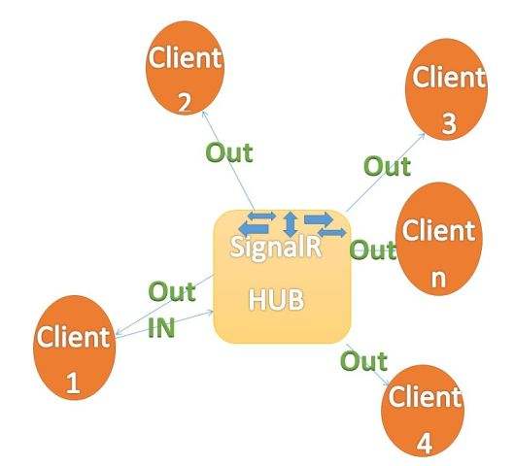

Hub vs Persistent Connection

Hub : creates new instances as requested

Persistent Connection : one instance created per connection

Step By Step Creation of chat application:

https://www.asp.net/signalr/overview/getting-started/tutorial-getting-started-with-signalr