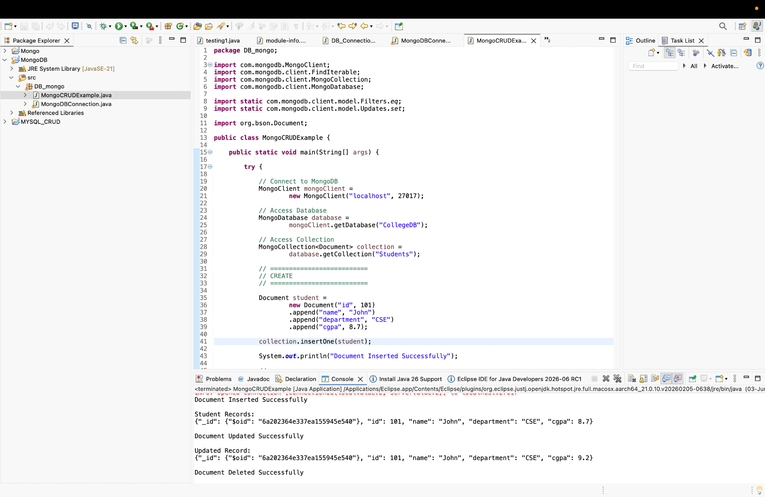

package DB_mongo;
import com.mongodb.MongoClient;
import com.mongodb.client.FindIterable;
import com.mongodb.client.MongoCollection;
import com.mongodb.client.MongoDatabase;
import static com.mongodb.client.model.Filters.eq;
import static com.mongodb.client.model.Updates.set;
import org.bson.Document;
public class MongoCRUDExample {
public static void main(String[] args) {
try {
// Connect to MongoDB
MongoClient mongoClient =
new MongoClient("localhost", 27017);
// Access Database
MongoDatabase database =
mongoClient.getDatabase("CollegeDB");
// Access Collection
MongoCollection<Document> collection =
database.getCollection("Students");
// ==========================
// CREATE
// ==========================
Document student =
new Document("id", 101)
.append("name", "John")
.append("department", "CSE")
.append("cgpa", 8.7);
collection.insertOne(student);
System.out.println("Document Inserted Successfully");
// ==========================
// READ
// ==========================
System.out.println("\nStudent Records:");
FindIterable<Document> students =
collection.find();
for (Document doc : students) {
System.out.println(doc.toJson());
}
// ==========================
// UPDATE
// ==========================
collection.updateOne(
eq("id", 101),
set("cgpa", 9.2)
);
System.out.println("\nDocument Updated Successfully");
// ==========================
// READ UPDATED RECORD
// ==========================
Document updatedStudent =
collection.find(eq("id", 101))
.first();
System.out.println("\nUpdated Record:");
System.out.println(updatedStudent.toJson());
// ==========================
// DELETE
// ==========================
collection.deleteOne(eq("id", 101));
System.out.println("\nDocument Deleted Successfully");
mongoClient.close();
} catch (Exception e) {
e.printStackTrace();
}
}

For many-

package DB_mongo;
import com.mongodb.MongoClient;
import com.mongodb.client.FindIterable;
import com.mongodb.client.MongoCollection;
import com.mongodb.client.MongoDatabase;
import static com.mongodb.client.model.Filters.eq;
import static com.mongodb.client.model.Filters.lt;
import static com.mongodb.client.model.Updates.set;
import java.util.Arrays;
import org.bson.Document;
public class MongoCRUDMany {
public static void main(String[] args) {
MongoClient mongoClient = new MongoClient("localhost", 27017);
MongoDatabase database =
mongoClient.getDatabase("CollegeDB");
MongoCollection<Document> collection =
database.getCollection("Students");
// ==========================
// CREATE MANY
// ==========================
Document s1 = new Document("id", 101)
.append("name", "John")
.append("department", "CSE")
.append("cgpa", 8.7);
Document s2 = new Document("id", 102)
.append("name", "Arjun")
.append("department", "IT")
.append("cgpa", 9.1);
Document s3 = new Document("id", 103)
.append("name", "Nihira")
.append("department", "Cybersecurity")
.append("cgpa", 9.4);
collection.insertMany(Arrays.asList(s1, s2, s3));
System.out.println("Documents Inserted Successfully");
// ==========================
// READ ALL
// ==========================
System.out.println("\nStudent Records:");
FindIterable<Document> students =
collection.find();
for (Document doc : students) {
System.out.println(doc.toJson());
}
// ==========================
// UPDATE MANY
// ==========================
collection.updateMany(
eq("department", "CSE"),
set("cgpa", 10.0)
);
System.out.println("\nDocuments Updated Successfully");
// ==========================
// READ AFTER UPDATE
// ==========================
System.out.println("\nUpdated Records:");
for (Document doc : collection.find()) {
System.out.println(doc.toJson());
}
// ==========================
// DELETE MANY
// ==========================
collection.deleteMany(
lt("cgpa", 9.0)
);
System.out.println("\nDocuments Deleted Successfully");
// ==========================
// FINAL DISPLAY
// ==========================
System.out.println("\nRemaining Records:");
for (Document doc : collection.find()) {
System.out.println(doc.toJson());
}
mongoClient.close();
}
}

