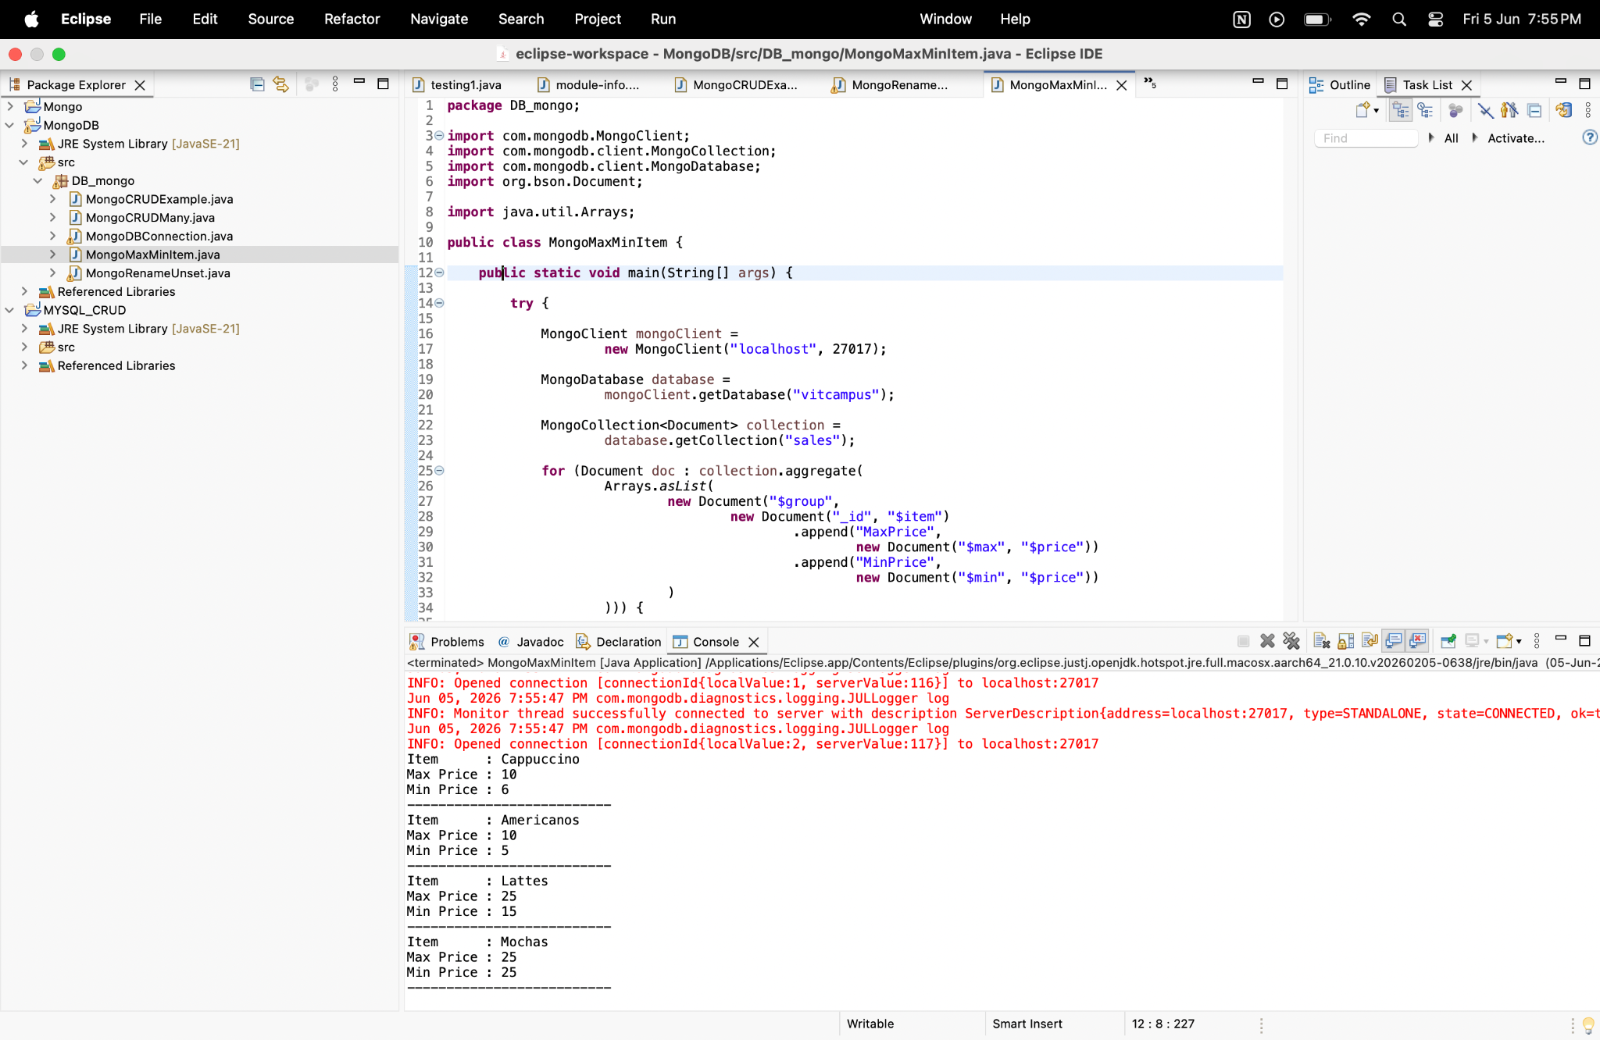

package DB_mongo;
import com.mongodb.MongoClient;
import com.mongodb.client.MongoCollection;
import com.mongodb.client.MongoDatabase;
import org.bson.Document;
import java.util.Arrays;
public class MongoMaxMinItem {
public static void main(String[] args) {
try {
MongoClient mongoClient =
new MongoClient("localhost", 27017);
MongoDatabase database =
mongoClient.getDatabase("vitcampus");
MongoCollection<Document> collection =
database.getCollection("sales");
for (Document doc : collection.aggregate(
Arrays.asList(
new Document("$group",
new Document("_id", "$item")
.append("MaxPrice",
new Document("$max", "$price"))
.append("MinPrice",
new Document("$min", "$price"))
)
))) {
System.out.println("Item : " + doc.get("_id"));
System.out.println("Max Price : " + doc.get("MaxPrice"));
System.out.println("Min Price : " + doc.get("MinPrice"));
System.out.println("--------------------------");
}
mongoClient.close();
} catch (Exception e) {
e.printStackTrace();
}
}
}

