Session 11: Sqoop Flume
Assignment 1 Question

Problem Statement

Perform and explain the code flow and the associated result for the below tasks. Candidates should
create and use their own employee dataset for the same. Share the screenshot of the commands used
and its associated result.
● Transfer data between Mysql and HDFS (Import and Export) using Sqoop.
● Transfer data between Mysql and Hive (Import and Export only selected columns) using Sqoop.

Solution

- Transfer data between Mysql and HDFS (Import and Export) using Sqoop.

Part 1 - Import data from MySQL to HDFS

- Logging into MySQL DB
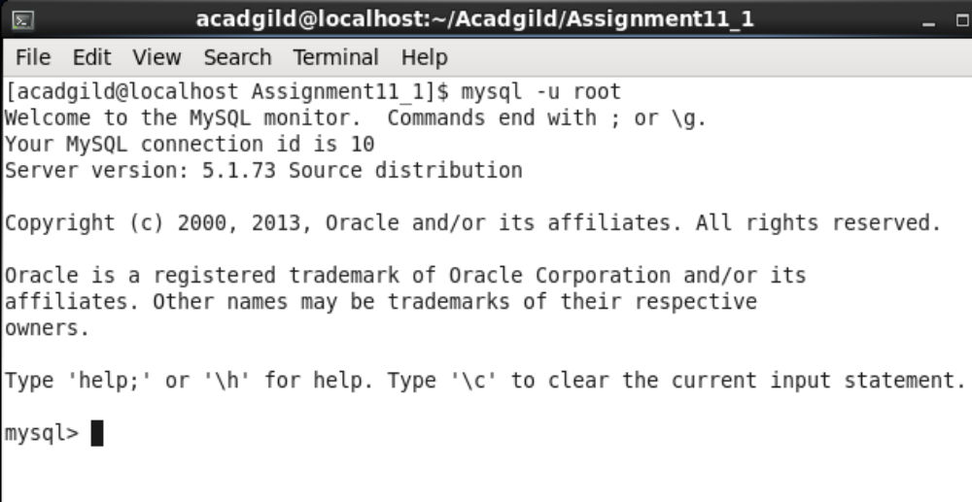

- Creating Database and employee table

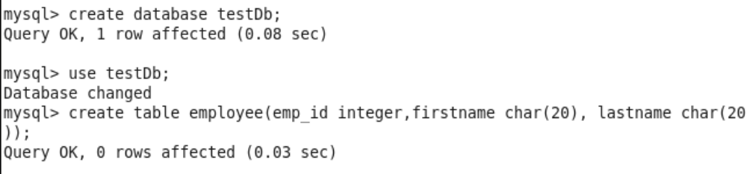

- Inserting data in employee table
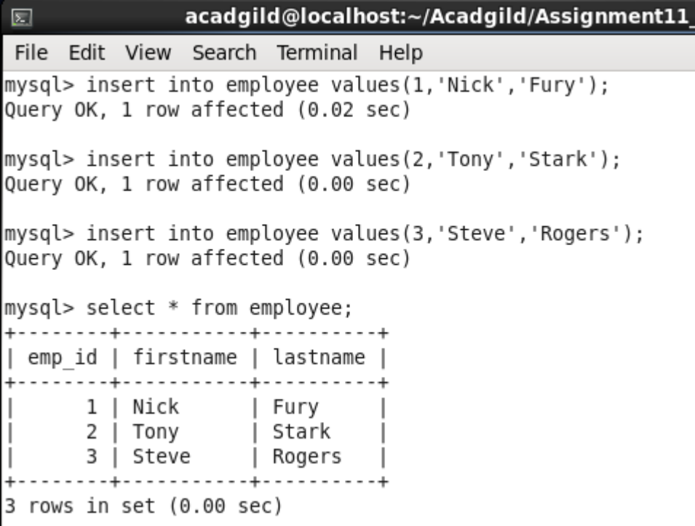

- Creating new user scott with password= tiger for accessing DB
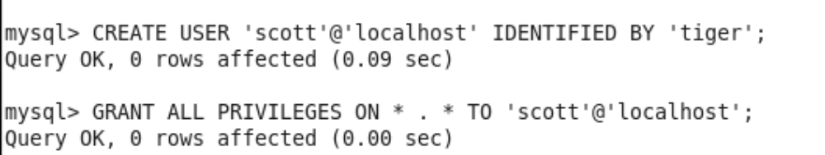

- Running sqoop command to import data to HDFS

Command –

sqoop import --connect jdbc:mysql://localhost/testDb --username scott --password tiger --table employee --target-dir '/Assignment11_1/HDFS_Import' --m 1

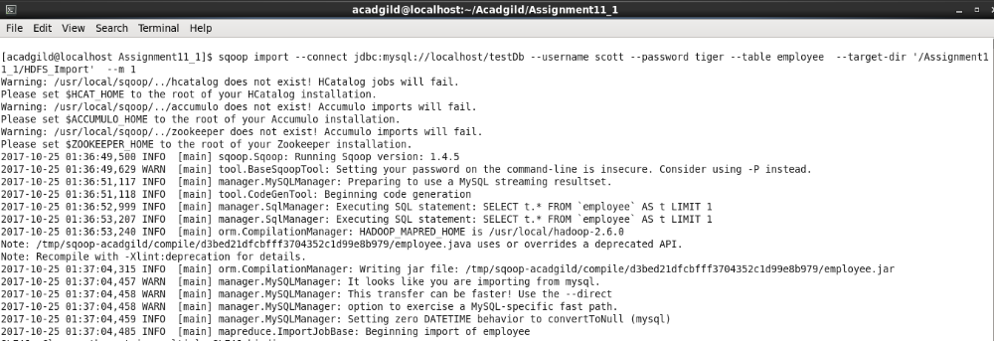

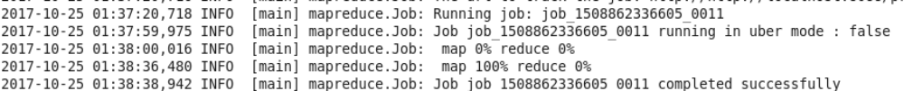

- Checking output file at HDFS://Assignment11_1/HDFS_Import

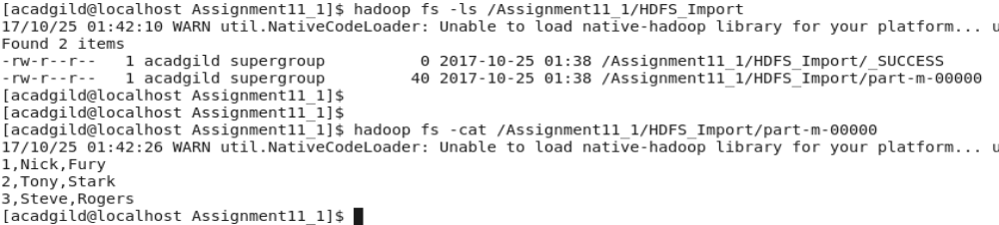

Part 2 - Export data from HDFS to MySQL

- Creating export directory and file in HDFS

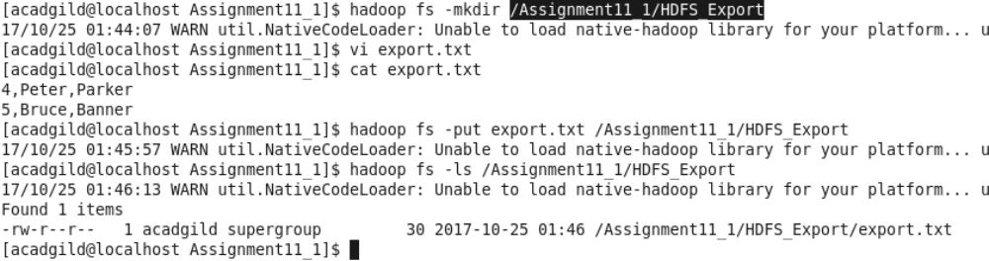

- Running Sqoop command to export from HDFS to MySQL

sqoop export --connect jdbc:mysql://localhost/testDb --username scott --password tiger --table employee --export-dir /Assignment11_1/HDFS_Export/ --m 1

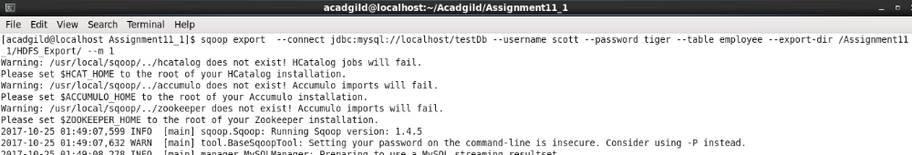

- Checking employee table in MySQL
From the table we could see that contents from export.txt has been inserted into employee table
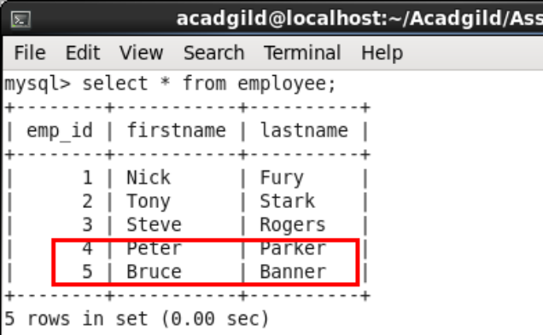

- Transfer data between Mysql and Hive (Import and Export only selected columns) using Sqoop.

Part 1 - Import data from MySQL to Hive (selected columns)

- Using previously created employee table in TestDB
- Running Hive import

sqoop import --connect jdbc:mysql://localhost/testDb
--username scott
--password tiger
--split-by emp_id
--columns emp_id,firstname
--table employee
--target-dir /Assignment11_1/HIVE_Import
--fields-terminated-by ","
--hive-import
--create-hive-table
--hive-table acadgild_db.employee_sqoop

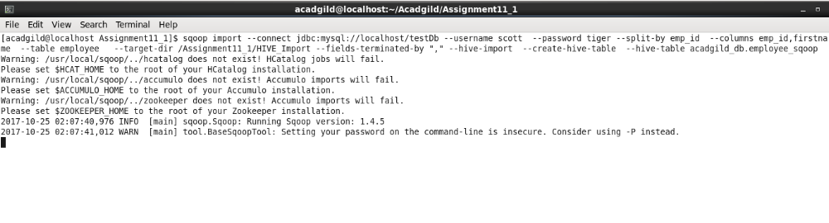
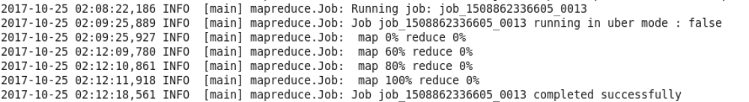

- Checking table in HIVE
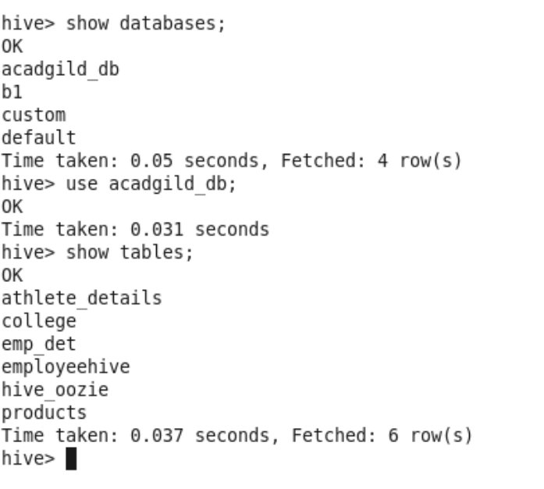
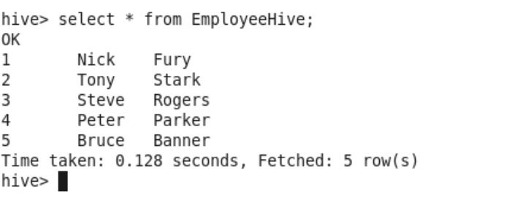
Part 2 - Export data from Hive to MySQL (selected columns)

- Deleting two rows from employee table in MySQL

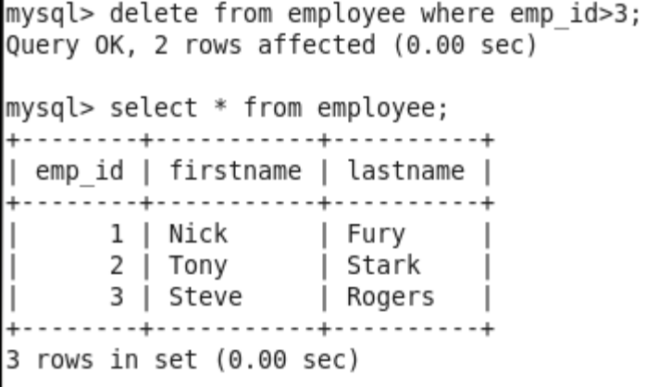

- Running sqoop command to export Hive table to MySQL

Exporting hive table EmployeeHive created previously during the import

sqoop export --connect jdbc:mysql://localhost/testDb --driver com.mysql.jdbc.Driver --username root --table employee --hcatalog-table EmployeeHive --input-fields-terminated-by '\t'

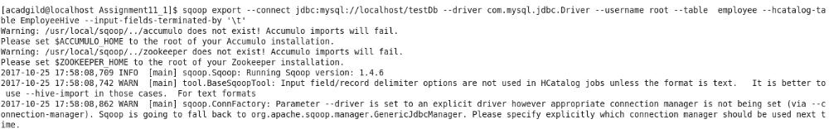

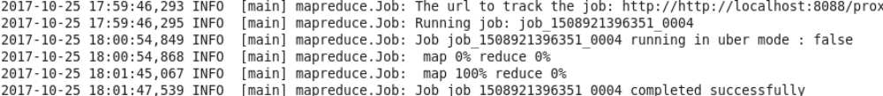

- Checking table in MySQL
We could see that five new rows have been inserted in employee table in MySQL

