Session 17 : RDD’s in Spark
Assignment 2
Problem Statement
Given a dataset of college students as a text file (name, subject, grade, marks) :
Dataset - 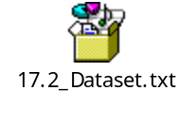
Problem Statement 1:
1. Read the text file, and create a tupled rdd.
2. Find the count of total number of rows present.
3. What is the distinct number of subjects present in the entire school
4. What is the count of the number of students in the school, whose name is Mathew and
marks is 55

Problem Statement 2:
1. What is the count of students per grade in the school?
2. Find the average of each student (Note - Mathew is grade-1, is different from Mathew in
some other grade!)
3. What is the average score of students in each subject across all grades?
4. What is the average score of students in each subject per grade?
5. For all students in grade-2, how many have average score greater than 50?

Problem Statement 3:
Are there any students in the college that satisfy the below criteria :
1. Average score per student_name across all grades is same as average score per
student_name per grade
Hint - Use Intersection Property.

Solution:-
Starting Spark shell
Command - spark-shell
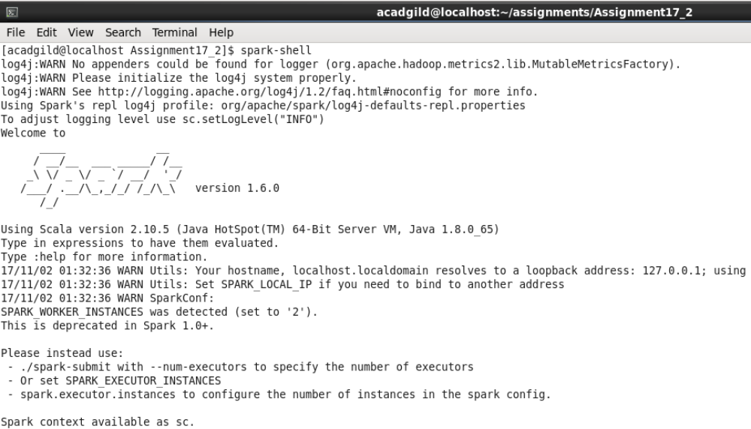
Problem Statement 1:
- Read the text file, and create a tupled rdd.

scala> val textRdd = sc.textFile("17.2_Dataset.txt");

scala> val tupleRdd = textRdd.map(line => line.split(",")).map(array => (array(0), array(1), array(2), array(3)));

scala> tupleRdd.foreach(println);

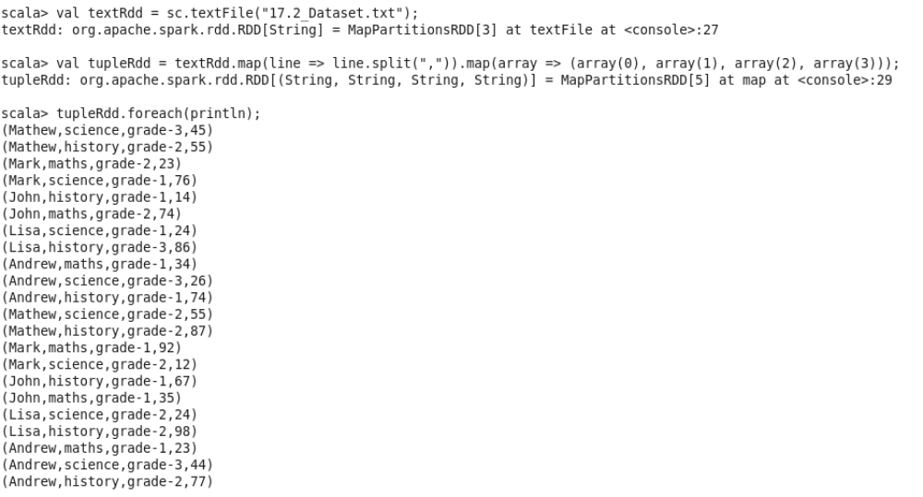

- Find the count of total number of rows present.

Scala> tupleRdd.count();

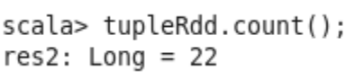

- What is the distinct number of subjects present in the entire school

scala> val uniqueValues = tupleRdd.map(x => x._2).distinct.collect;

- What is the count of the number of students in the school, whose name is Mathew and
marks is 55

scala> val mattRDD=tupleRdd.filter(i => ((i._1=="Mathew")&&(i._4=="55"))).count();

scala> val mattRDD=tupleRdd.filter(i => ((i._1=="Mathew")&&(i._4=="55")));

scala> mattRDD.foreach(println);

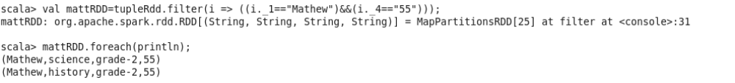

Problem Statement 2:
- What is the count of students per grade in the school?

Scala> val studentsPerGrade = tupleRdd.groupBy(word => word._3);
Scala> val gradeCount = studentsPerGrade.map(x => (x._1, x._2.size));
Scala> gradeCount.foreach(println);

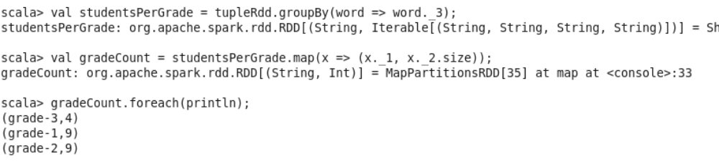

- Find the average of each student (Note - Mathew is grade-1, is different from Mathew in some other grade!)

scala> val studentsGroup = tupleRdd.groupBy(word => (word._1,word._3));

scala> val studentsAvgMarks = studentsGroup.map(x => (x._1._1,x._1._2, x._2.map(_._4.toInt).sum/x._2.size));

scala> studentsAvgMarks.foreach(println);

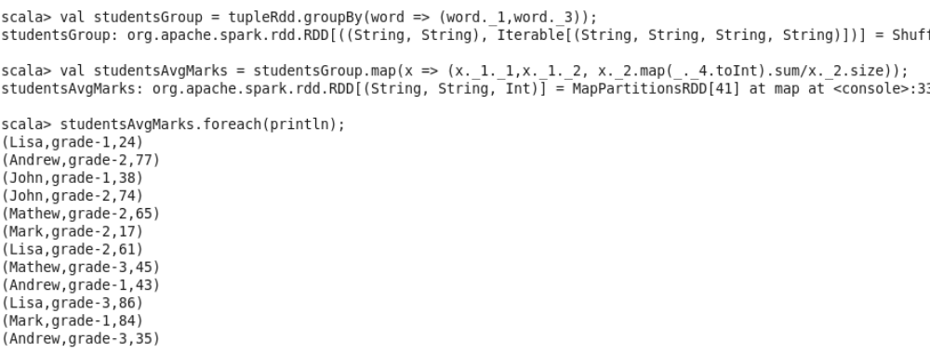

- What is the average score of students in each subject across all grades?

scala> val subjectGroup = tupleRdd.groupBy(word => (word._2));

scala> val subjectAvgMarks = subjectGroup.map(x => (x._1, x._2.map(_._4.toInt).sum/x._2.size));

scala> subjectAvgMarks.foreach(println);

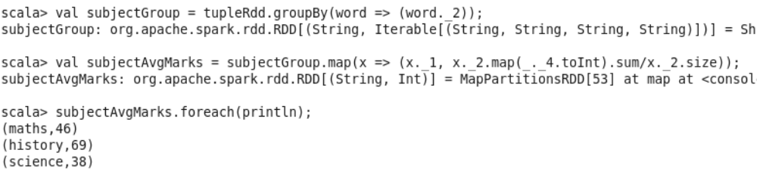

- What is the average score of students in each subject per grade?

scala> val subjectGrpGroup = tupleRdd.groupBy(word => (word._2,word._3));

scala> val subjectGrpAvgMarks = subjectGrpGroup.map(x => (x._1._1,x._1._2, x._2.map(_._4.toInt).sum/x._2.size));

scala> subjectGrpAvgMarks.foreach(println);

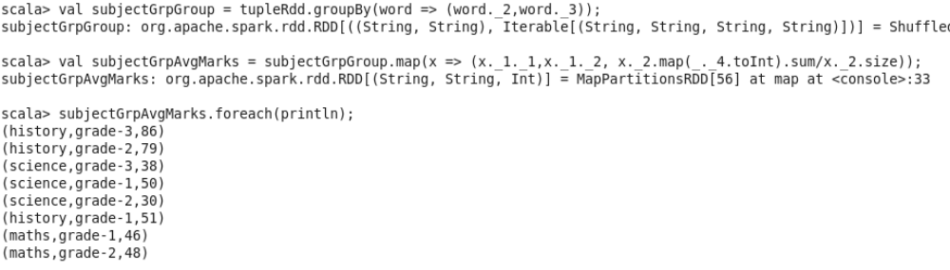

- For all students in grade-2, how many have average score greater than 50?

scala> val stdGroup = tupleRdd.groupBy(word => (word._1,word._3));

scala> val studentAvgMarks = stdGroup.map(x => (x._1._1,x._1._2, x._2.map(_._4.toInt).sum/x._2.size));

scala> val grade2Marks=studentAvgMarks.filter(i => (i._2=="grade-2")&&(i._3.toInt>50));

scala> grade2Marks.foreach(println);
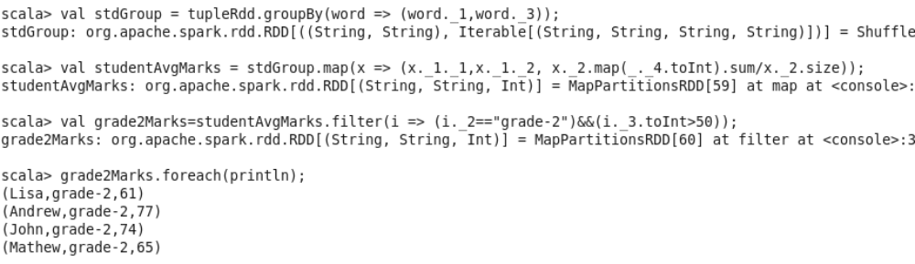

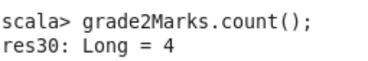

4 students in grade 2 have average marks greater than 50

Problem Statement 3:

Are there any students in the college that satisfy the below criteria :
1. Average score per student_name across all grades is same as average score per
student_name per grade
Hint - Use Intersection Property.

Finding Average score per student_name across all grades

scala> val stdOverallGroup= tupleRdd.groupBy(word => (word._1));

scala> val studentOverallAvgMarks = stdOverallGroup.map(x => (x._1, x._2.map(_._4.toInt).sum/x._2.size));

scala> studentOverallAvgMarks.foreach(println);

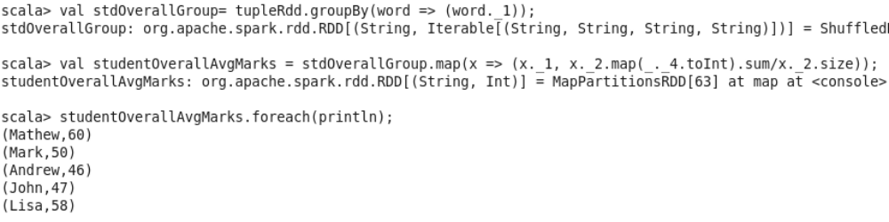

Finding average score per student_name per grade

scala> val stdGroup = tupleRdd.groupBy(word => (word._1,word._3));

scala> val studentAvgMarks = stdGroup.map(x => (x._1._1, x._2.map(_._4.toInt).sum/x._2.size));

scala> studentAvgMarks.foreach(println);

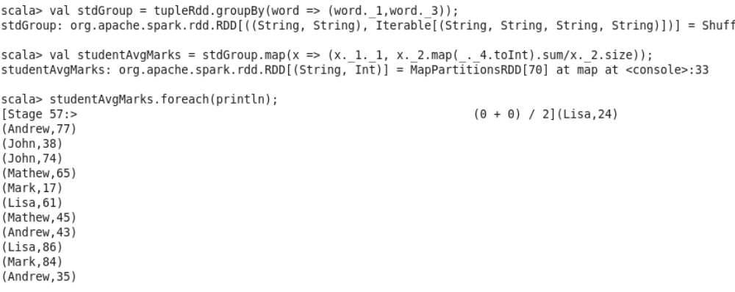

Finding student names for which Average score per student_name across all grades is same as average score per student_name per grade

scala> val result = studentAvgMarks.intersection(studentOverallAvgMarks);

scala> result.count();

scala> result.foreach(println);

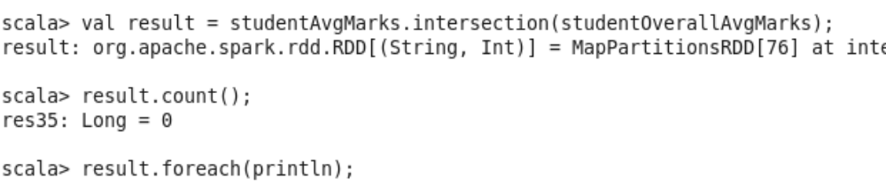

Zero values in intersection of RDDs indicate that there are no student names for which Average score per student name across all grades is same as average score per student name per grade

