Session 22 : SPARK
Assignment 1
Problem Statement

Go through below blog and reiterate the same at your end.
https://docs.google.com/document/d/1csLBlMiEXs_hXWV2Z8VpBlrj_R6RoDQLlZUnA0uBT
Ck/edit

Census data analysis
You can download the dataset from the below link
https://drive.google.com/open?id=0ByJLBTmJojjzWllGZFJFaXFVbU0
Dataset - 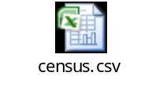
Due to the limitation of 22 elements for a map function, we are taking only 22 columns from the data set.
Here is the total dataset description

State String,District String,Persons String,Males int,Females int,Growth_1991_2001 int,Rural int,Urban int,Scheduled_Caste_population int,Percentage_SC_to_total int,Number_of_households int,Household_size_per_household int,Sex_ratio_females_per_1000_males int ,Sex_ratio_0_6_years int,Scheduled_Tribe_population int,Percentage_to_total_population_ST int,Persons_literate int,Males_Literate int,Females_Literate int,Persons_literacy_rate int,Males_Literatacy_Rate int,Females_Literacy_Rate int,Total_Educated int,Data_without_level int,Below_Primary int,Primary int,Middle int,Matric_Higher_Secondary_Diploma int,Graduate_and_Above int,X0_4_years int,X5_14_years int,X15_59_years int,X60_years_and_above_Incl_ANS int,Total_workers int,Main_workers int,Marginal_workers int,Non_workers int,SC_1_Name String,SC_1_Population int,SC_2_Name String,SC_2_Population int,SC_3_Name String,SC_3_Population int,Religeon_1_Name String,Religeon_1_Population int,Religeon_2_Name String,Religeon_2_Population int,Religeon_3_Name String,Religeon_3_Population int,ST_1_Name String,ST_1_Population int,ST_2_Name String,ST_2_Population int,ST_3_Name String,ST_3_Population int,Imp_Town_1_Name String,Imp_Town_1_Population int,Imp_Town_2_Name String,Imp_Town_2_Population int,Imp_Town_3_Name String,Imp_Town_3_Population int,Total_Inhabited_Villages int,Drinking_water_facilities int,Safe_Drinking_water int,Electricity_Power_Supply int,Electricity_domestic int,Electricity_Agriculture int,Primary_school int,Middle_schools int,Secondary_Sr_Secondary_schools int,College int,Medical_facility int,Primary_Health_Centre int,Primary_Health_Sub_Centre int,Post_telegraph_and_telephone_facility int,Bus_services int,Paved_approach_road int,Mud_approach_road int,Permanent_House int,Semi_permanent_House int,Temporary_House int

Here is what we are taking

"State" ,"Persons","Males" ,"Females" ,"Growth_1991_2001" ,"Rural" ,"Urban" ,"Scheduled_Caste_population" ,"Percentage_SC_to_total" ,"Number_of_households" ,"Household_size_per_household" ,"Sex_ratio_females_per_1000_males " ,"Sex_ratio_0_6_years" ,"Scheduled_Tribe_population" ,"Percentage_to_total_population_ST" ,"Persons_literate" ,"Males_Literate" ,"Females_Literate" ,"Persons_literacy_rate" ,"Males_Literatacy_Rate" ,"Females_Literacy_Rate" ,"Total_Educated"

1. Find out the state wise population and order by state
2. Find out the Growth Rate of Each State Between 1991-2001
3. Find the literacy rate of each state
4. Find out the States with More Female Population
5. Find out the Percentage of Population in Every State

Solution:-

Starting Spark-shell
Command – spark-shell

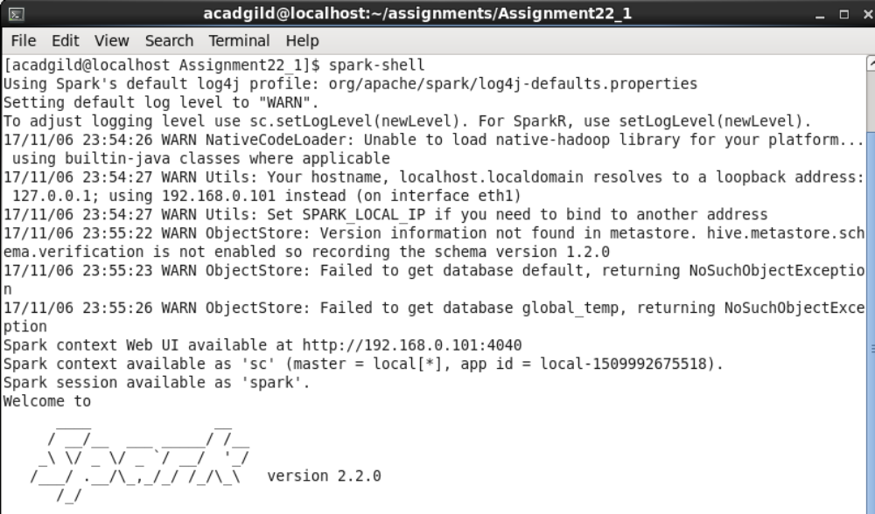
Loading data:-

scala> val census_data = sc.textFile("census.csv").map(x => x.split(",")).map(x => (x(0),x(2),x(3),x(4),x(5),x(6),x(7),x(8),x(9),x(10),x(11),x(12),x(13),x(14),x(15),x(16),x(17),x(18),x(19),x(20),x(21),x(22))).toDF("State" ,"Persons","Males" ,"Females" ,"Growth_1991_2001" ,"Rural" ,"Urban" ,"Scheduled_Caste_population" ,"Percentage_SC_to_total" ,"Number_of_households" ,"Household_size_per_household" ,"Sex_ratio_females_per_1000_males " ,"Sex_ratio_0_6_years" ,"Scheduled_Tribe_population" ,"Percentage_to_total_population_ST" ,"Persons_literate" ,"Males_Literate" ,"Females_Literate" ,"Persons_literacy_rate" ,"Males_Literatacy_Rate" ,"Females_Literacy_Rate" ,"Total_Educated").registerTempTable("census");

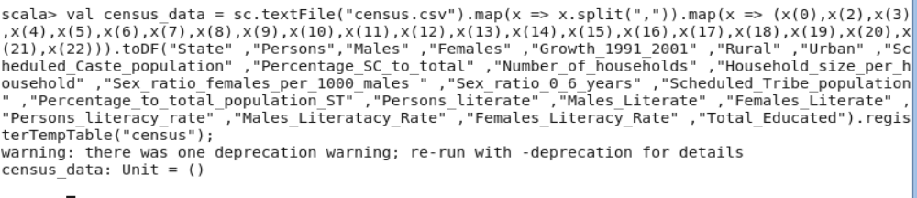
- Find out the state wise population and order by state

scala> val population = spark.sql("select state,sum(persons) as total_population from census group by state order by total_population desc").show(50);

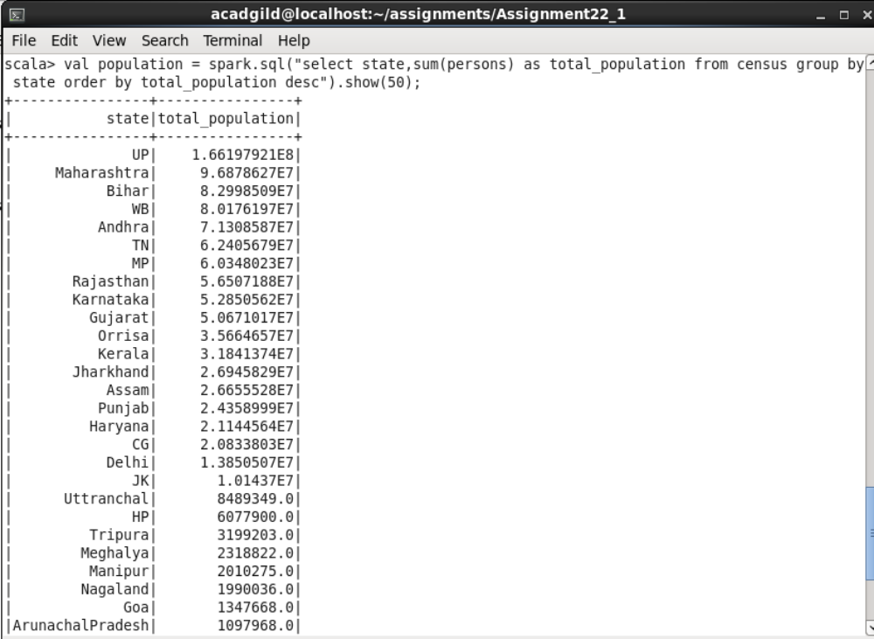
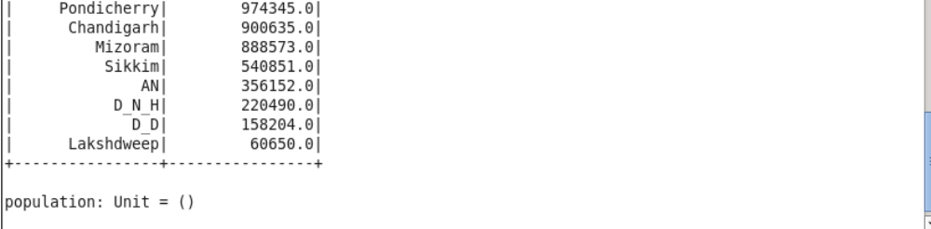
- Find out the Growth Rate of Each State Between 1991-2001

scala> val growth_rate = spark.sql("select state,avg(Growth_1991_2001) as total_growth from census group by state").show(50);

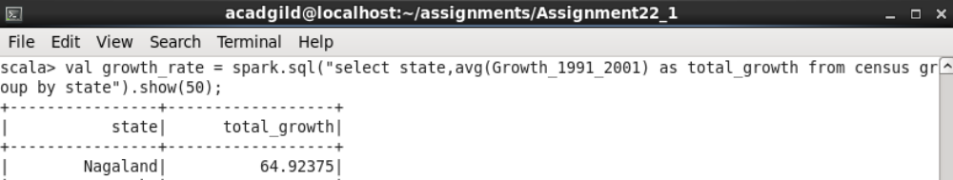
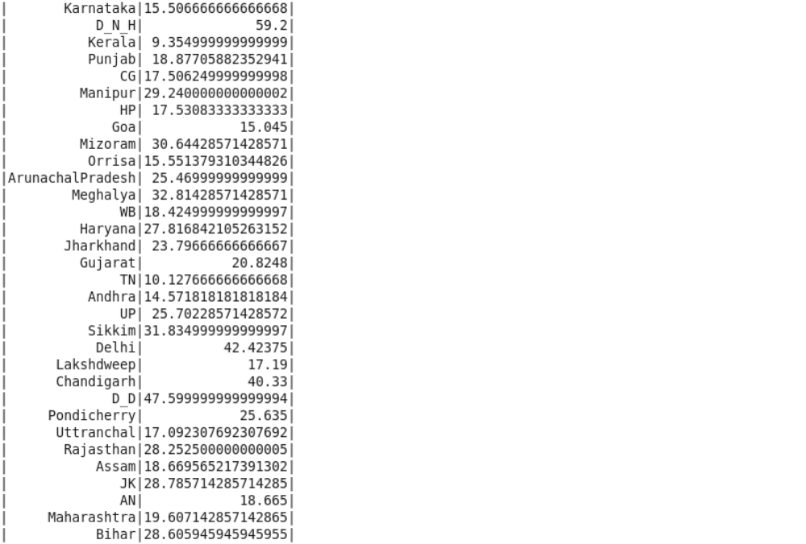
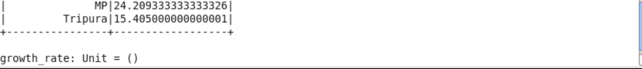

- Find the literacy rate of each state

scala> val literacy = spark.sql("select state,avg(Persons_literacy_rate) from census group by state").show(50);

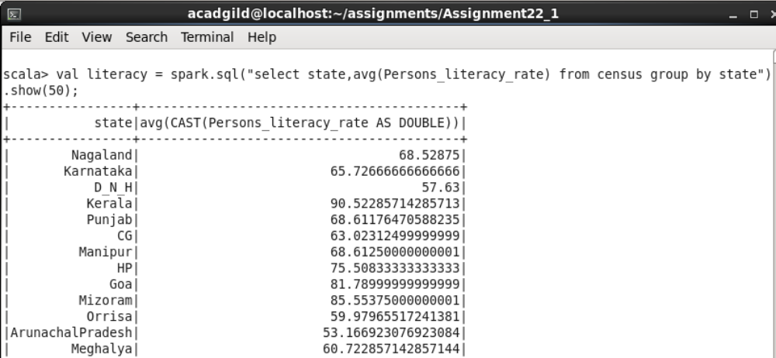

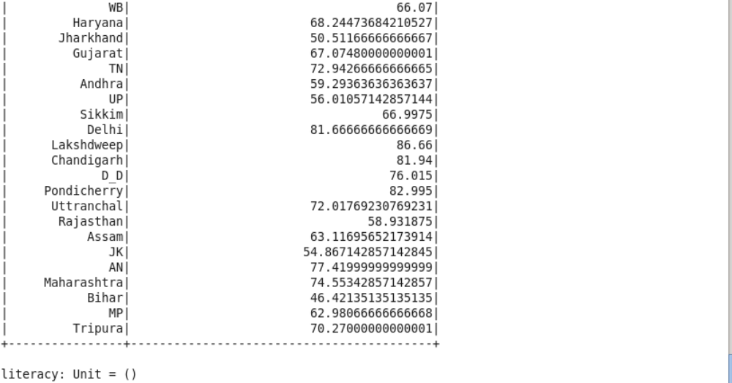

- Find out the States with More Female Population

scala> val female_pop = spark.sql("select state, sum(Males)-sum(Females) from census group by state").show(50);
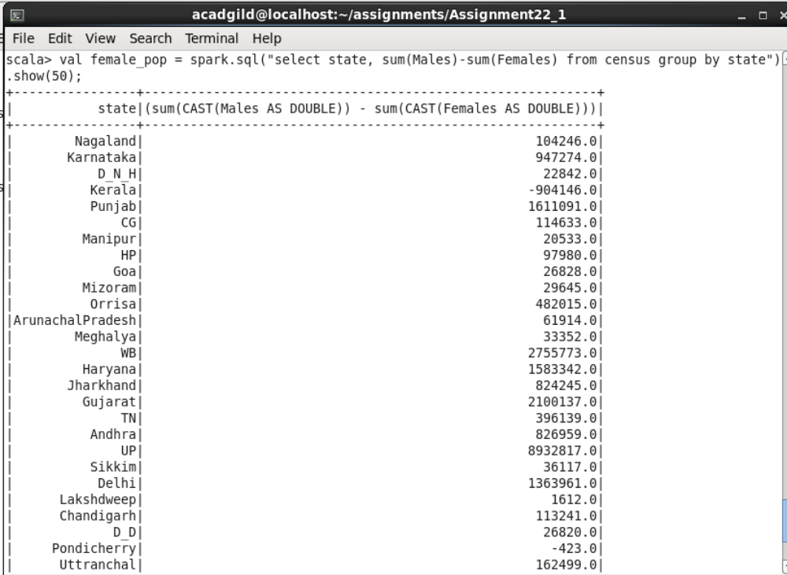

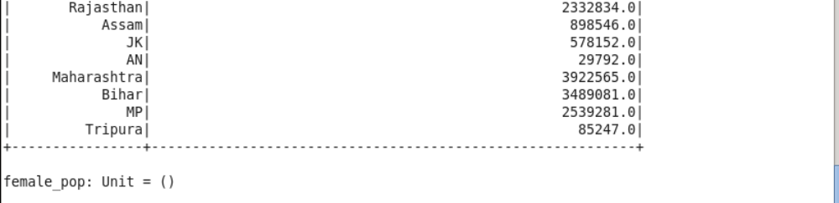

- Find out the Percentage of Population in Every State

scala> val percenet_pop = spark.sql("select state, (sum(persons) * 100.0) / SUM(sum(persons)) over() as percent_pop_by_state from census group by state").show(50);

