Session 5: Exploring Pig
Assignment 5.3
Implement the use case present in below blog link and share the complete steps along with
screenshot(s) from your end.
Link - https://acadgild.com/blog/pig-use-case-pokemon-data-analysis/

In this blog for Apache Pig beginners, we will use the simple Pig built-in functions to form two lists of 5 randomly selected Pokémons with some parameters set by the management. So Pig queries are listed below for the perusal of a data analyst.
The Pokémon Fight League (PFL) management for the 2017 match has first of all decided a minimum criterion for the entry selection process that filters through the defense power for any Pokémon, which should ideally be greater than 55.
Hence, the eligible list will be randomly formed after filtering out the Pokémons with a defenseless than 55.
Furthermore,Our job is to give 2 list of names of those Pokémons who will be eligible for taking part in PFL this year from the list of all the participating 800 Pokémons.
Use the link to download dataset for all the Pokémons seems like taking part in PFL 2017.
Especially relevant in addition readers may go through the link to practice the HIVE Use Case basics commands on the Pokémon dataset.

Ques 1: Find the list of players that have been selected in the qualifying round (DEFENCE>55).

Ques 2: State the number of players taking part in the competition after getting selected in the qualifying round.

Ques 3: Using random() generate random numbers for each Pokémon on the selected list.

Ques 4: Arrange the new list in a descending order according to a column randomly.

Ques 5: Now on a new relation again associate random numbers for each Pokémon and arrange in descending order according to column random.

Ques 6: From the two different descending lists of random Pokémons, select the top 5 Pokémons for 2 different players.

Ques 7: Store the data on a local drive to announce for the final match. By the name player1 and player2 (only show the NAME and HP).

Solutions:-

Firstly, loading all the data in pokemon dataset into PIG.

Loading the Dataset:-

grunt> Pokemon_Data = LOAD 'Pokemon.csv' USING PigStorage(',') AS(S_no:int,Name:chararray,Type1:chararray,Type2:chararray,Total:int,HP:int,Attack:int,Defense:int,SpAtk:int,SpDef:int,Speed:int);

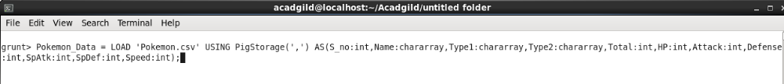

Ques 1: Find the list of players that have been selected in the qualifying round (DEFENCE>55).
Command:

grunt> selected_pokemon_list = FILTER Pokemon_Data BY Defense>55;

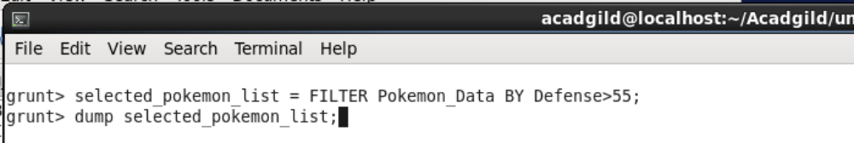

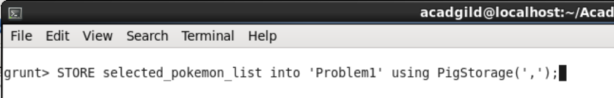

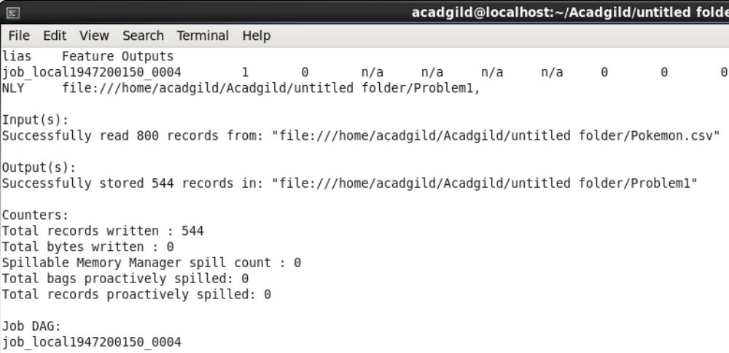
Output –

Attached the output file below

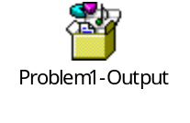

Ques 2: State the number of players taking part in the competition after getting selected in the qualifying round.

Command:-

group_selected_list = Group selected_pokemon_list All;
count_selected_list = foreach group_selected_list GENERATE COUNT(selected_pokemon_list);
STORE count_selected_list into 'Problem2' using PigStorage(',');

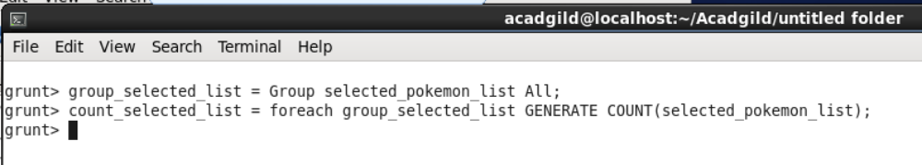
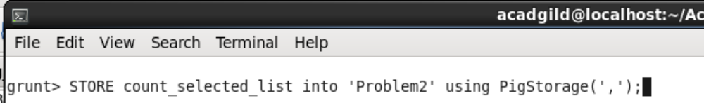
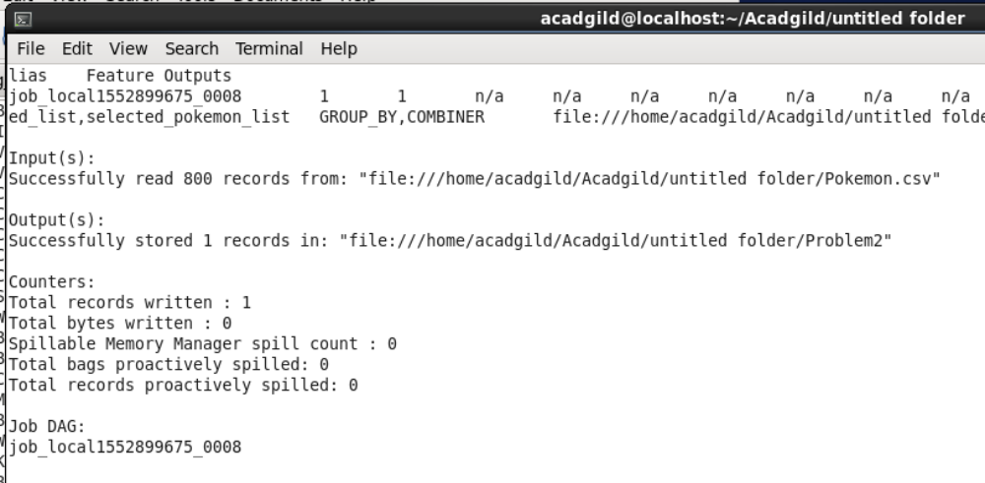

Output:-

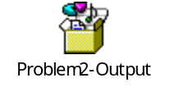

Ques 3: Using random() generate random numbers for each Pokémon on the selected list.

Command:-
random_include1 = foreach selected_pokemon_list GENERATE RANDOM(),Name,Type1,Type2,Total,HP,Attack,Defense,SpAtk,SpDef,Speed;

STORE random_include1 into 'Problem3' using PigStorage(',');

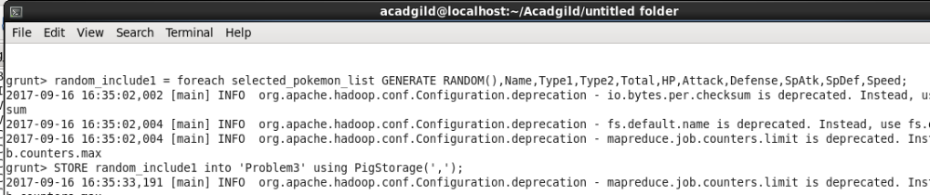

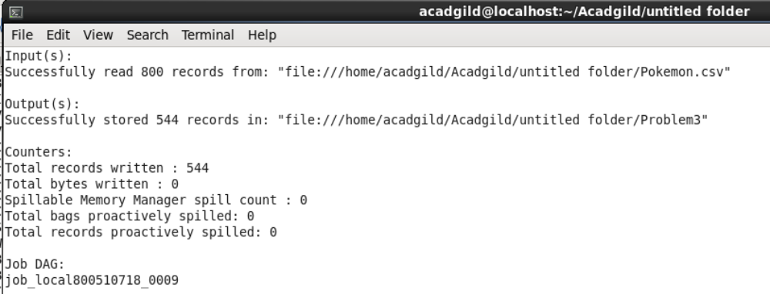

Output:-
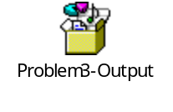

Ques 4: Arrange the new list in a descending order according to a column randomly.
Command:-
random1_desending = ORDER random_include1 BY $0 DESC;
STORE random1_desending into 'Problem4' using PigStorage(',');

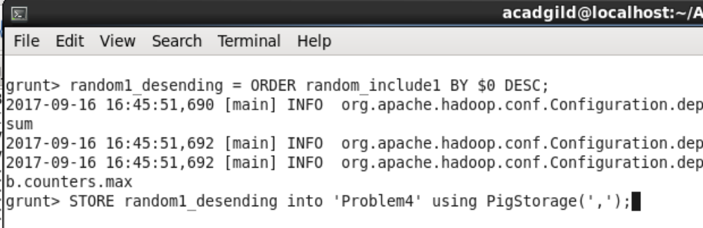
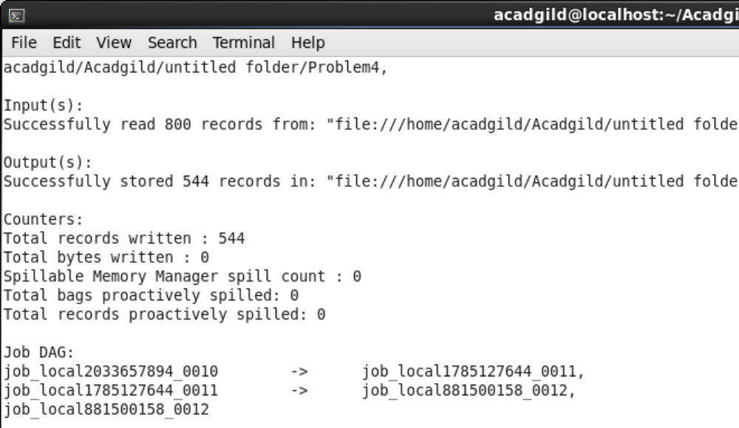

Output:-
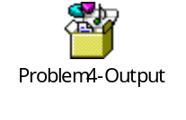

Ques 5: Now on a new relation again associate random numbers for each Pokémon and arrange in descending order according to column random.

Command:-
random_include2 = foreach selected_pokemon_list GENERATE RANDOM(),Name,Type1,Type2,Total,HP,Attack,Defense,SpAtk,SpDef,Speed;

random2_descending = ORDER random_include2 BY $0 DESC;

STORE random2_descending into 'Problem5' using PigStorage(',');

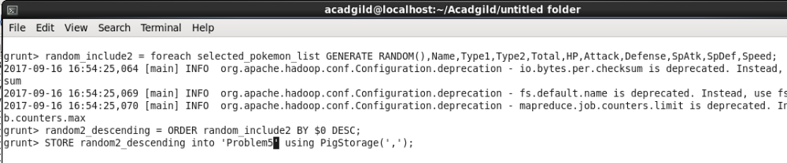

Output:-

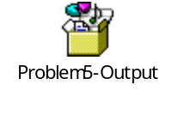

Ques 6: From the two different descending lists of random Pokémons, select the top 5 Pokémons for 2 different players.

Command :-
limit_data_random1_descending = LIMIT random1_desending 5 ;
limit_data_random2_descending = LIMIT random2_descending 5 ;
dump limit_data_random1_descending;
dump limit_data_random2_descending;

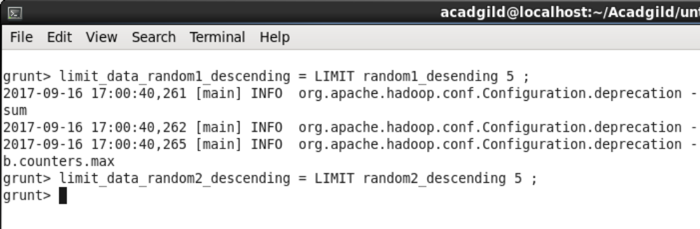
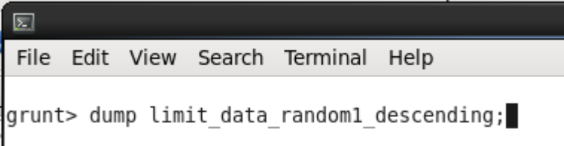
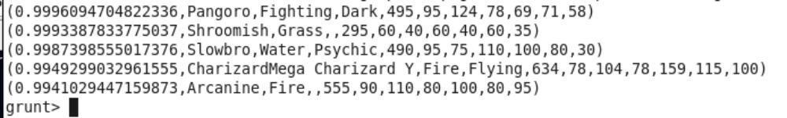
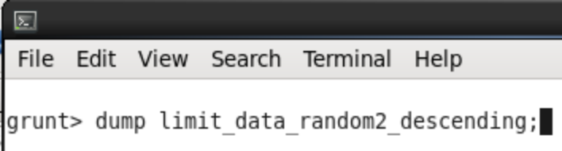
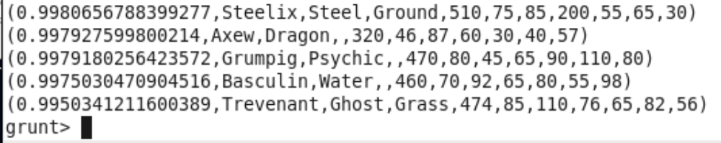

Ques 7: Store the data on a local drive to announce for the final match. By the name player1 and player2 (only show the NAME and HP).

Command:-

filter_only_name1 = foreach limit_data_random1_descending Generate ($1,HP);
filter_only_name2 = foreach limit_data_random2_descending Generate ($1,HP);
dump filter_only_name1;
dump filter_only_name2;
