**Business Requirements Document**

**Project Details**

|  |  |
| --- | --- |
| Project Name | Confsec |
| Project Type | Startup Initiated |
| Version | V1.0 |

**Overview:**

This document defines the high-level requirements of the CONFSEC Project. It will be for the following activities:

* Creating the solution design (ML Modules)
* Initial creation of process flow or road map
* Determining the project phases
* API Integrations
* Creation of UI/UX screen
* Single-SignOn integration

|  |
| --- |
| 1. **Proposed Business State** |
| This Confsec project detects risks in audio, visual, document, spoken, shown, and shared content in audio and video content when it integrates within the Team meetings like Zoom, Cisco WebEx, Microsoft Team meetings.  Artificial Intelligence and Machine learning modules will be created and helpful in flagging the meetings after detecting the non-preferable content. |

|  |  |
| --- | --- |
| 1. **Business Requirements** | |
| **ID** | **Requirement** |
| **2.1** | Business Meetings – include Zoom, WebEx and Microsoft Team meetings should be flagged if any non-proprietary or prohibited details or abusive language or video etc. (as per the ML Modules) |
| **2.1.1** | A notification should be sent to the higher-level management, if the meeting is flagged. |
| **2.2** | This application or project should be feasible and should work on all the types of browsers e.g.: Safari, Chrome, IE, Edge etc. |
| **2.3** | Project or application features should be available on the meeting screens, and able to use the functionalities with the help of single sign on (SSO)  <Are there any credentials requirements for the SSO from the meeting screens?> |
| **2.4** | An UI/UX screen design required for the application to fit in the modules (ML) |
|  |  |

|  |  |
| --- | --- |
| 1. **Functional and System Requirements** | |
| **ID** | **Requirement** |
| **3.1** | Machine Learning Module should be created as below mentioned: |
| **3.1.1** | **Expression Detection**  Record the expression of the people involved in the meeting.  E.g., Sad, Happy, Angry, Happy, Empowered, surprised, wondered, depressed, Motivational etc.  **NOTE:** Meeting should be flagged as per the Companies policy (in expression detection. |
| **3.1.2** | **Racial profiling**  Racial comments or words verbally or by text in the meeting should be recorded and flagged.  E.g., Words like Black people, Asians, Mexicans and derogatory statement etc. |
| **3.1.3** | **Sexting**  Sexting within the group or to an individual in the meeting should be recorded and flagged.  <Words lists need to be documented>  Keep the words/ url in appendix |
| **3.1.4** | **Flirting**  Meeting should be flagged if someone tries or flirt in the meeting.  <Emojis or Words verbally or by texts?> |
| **3.1.5** | **Gender biased opinion or Discrimination**  Meeting should be flagged, if any gender discrimination occurs in the meeting.  <Are there any key words/sentences?> |
| **3.1.6** | **Hate Speech**  Meeting should be flagged if there is any hate speech regarding the meeting content/individual/external scenarios like politics etc.  < sentimental analysis, get info from ML > defined by the regular expression or by text |
| **3.1.7** | **Threat**  Meeting should be flagged, if there is any threat to the group/individual.  <Threat can be either verbally/text/by expression> < |
| **3.1.8** | **Financial projection detection**  Meeting should be flagged if there is any financial information regarding the project/company/individual displays and detect (as per the company guidelines) on the screen/in the meeting.  <It includes Company’s secret contracts, individual account/PII info etc.> |
| **3.1.9** | **Adult / Porn content detection**  Meeting should be flagged, if there is any adult / porn content displays on the meeting screen or texts in the meeting.  E.g. If an individual has a wallpaper (nude content) in his room, it should be detected and flagged.  <The adult/porn texts are covered in sexting?> |
| **3.1.10** | **Credit card detection**  Meeting should be flagged, if an individual displays the Credit card image or enter the credit card details in the meetings. |
| **3.1.11** | **PII detection**  Meeting should be flagged, if an individual / group shares (or display) the PII info (Name, SSN, etc.) in the meeting. |
| **3.1.12** | **PCI-DSS detection**  Meeting should be flagged, if any information regarding the payment or credit card or transaction details displayed (or entered) in the meeting.  <Is it the same requirement like Credit Card detection requirement?> |
| **3.1.13** | **HIPPA Detection**  Meeting should be flagged, if any HIPAA related info displayed or entered in the meetings. |
| **3.1.14** | **Source code detection**  Meeting should be flagged, if any individual / group in the meeting display the Source code of the project.  <Is it really need to be detected? many meetings will share their screen with their teammates to work on the source code in the meetings.>  <Use the ML modules available> |
| **3.1.15** | **Object detection**  Artificial Intelligence - Objects needs to be detected in the meetings.  <What will be the outcome of this requirement?> |
| **3.1.16** | **Background detection**  Artificial Intelligence - Background needs to be detected in the meetings.  <What will be the outcome of this requirement?> |
| **3.1.17** | **Noise detection**  Noise should be detected in the meeting. (If there is any disturbance from an individual side, it needs to be flagged) |
| **3.1.18** | **Regular expression on audio**  Voice Expressions of the people should be detected and recorded in the meeting. |
| **3.1.19** | **Regular expression in video (Image / motion detection)**  Expressions of the people in the meetings should be detected and recorded.  <All the kind of expressions should be recorded. Meeting should be flagged only when the expressions fall under the above requirements category> |
| **3.2** | All the modules should be integrated into the application (API Integration) |
| **3.3** | UI/UX screen should be designed for application.  <Needs to elicit the separate requirements in designing the mock-up screens> |

# 1.End-2-End Architecture Flow

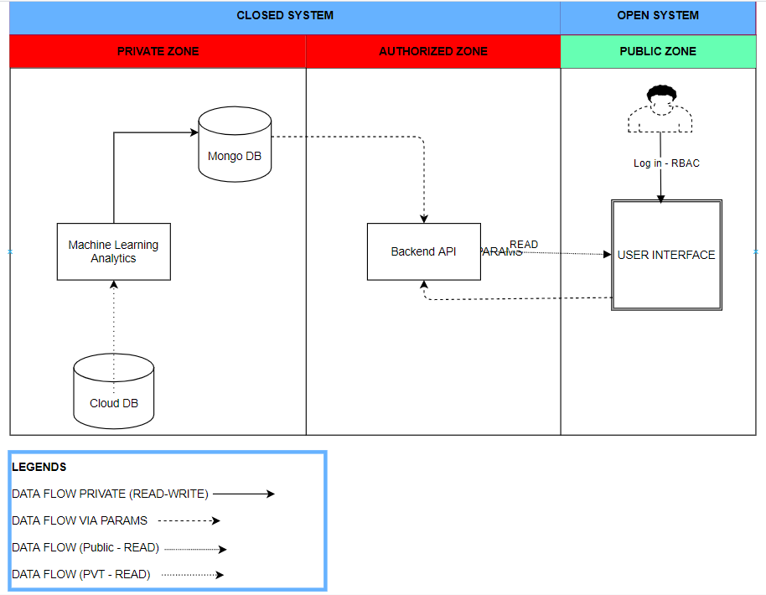

# 2. ML Flow

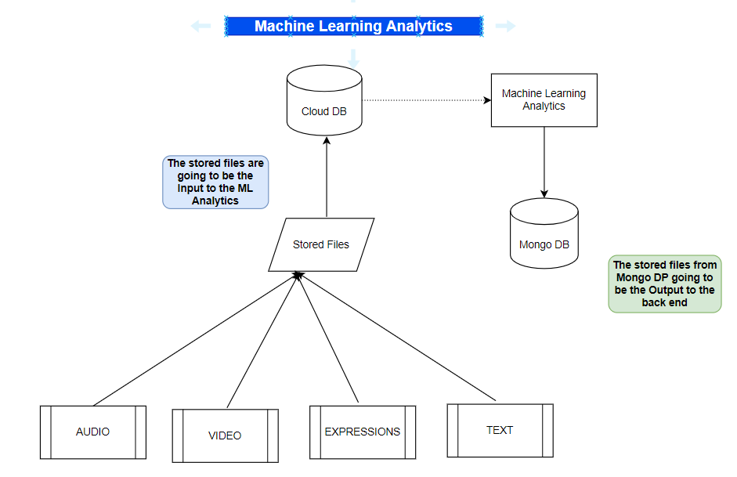

# 3. Back End process flow – Yet to be discussed

Estimated time to finish it by Sai by Jun 15, 2022

e-2-e flow including DMZ servers and public servers representation

# 4.UI/UX Flow – Yet to be discuss for designing

Create 3-4 mock up screens.

Get alicia to work on it.

**PHASES – STATUS**

|  |  |  |
| --- | --- | --- |
| **PHASE** | **Work / Details / Info** | **Status** |
| PH-1 | Requirements Gathering  Module design (ML Team)  API integrations (Backend) | In-Progress |
| PH-2 | Review on the requirements  UI/UX screen design (Front end development)  API Integrations |  |
| PH-3 | Work on SSO  API Integrations (Front and Back-end development) |  |
| PH-4 | Review on the project deliverable  Testing Phase |  |