EDP TRADE PROCESS
API Reference Document

Trade Segments
Segment | Description
EQ | Cash / Equity
DR | Derivative
CUR | Currency
SLB | Securities Lending & Borrowing
NCDEX | Commodity (NCDEX)
MCX | Commodity (MCX)
NSECOM | Commodity (NSECOM)
MF | Mutual Fund

Version 1.0 | Confidential | Internal Use Only

Document Overview
This document provides complete API reference details for the EDP (Exchange Data Processing) Trade Process system. It covers all 26 API steps, from the initial Holiday Master check through to Corporate Action Position Change, including Postman request/response screenshots for key steps.

📌 NOTE: The EQ (Cash) segment is used as the reference example throughout this document. The same sequence applies to all other segments: DR, CUR, SLB, NCDEX, MCX, NSECOM, and MF, unless explicitly stated otherwise.

Base Server URLs
EDP Status API : http://10.167.202.234:8087
Main Process API: http://10.167.202.164:8003
Brokerage API : http://10.167.202.164:8003/v1/api/brokerage

High-Level Process Flow
Step | Purpose | API Server | Endpoint / ProcessName
1 | Holiday Check | EDP Status API | BeginFileUpload
2 | Create Process ID | Main Process API | /getNewTradeProcess (PROCESSID:0)
3 | Get Upload Settings | Main Process API | /GetNewTradeProcessPromodalUploadSettings
4 | Chunk File Upload | Main Process API | /SaveTradePromodalUploadChunkFile
5 | Get Existing Process ID | Brokerage API | /getdropdown
6 | File Entry in CBOS | Main Process API | /SaveNewTradeProcessPromodalUploadFile
7 | File Upload Status Check | EDP Status API | FILEUPLOAD
8 | Execute Trade Process | Main Process API | /getNewTradeProcess (with ProcessID)
9 | Bill Posting Status | EDP Status API | BILLPOSTING
10 | Segment Recon | EDP Status API | RECON
11 | Contract Note Generation | EDP Status API | CONTRACTNOTEGENERATION
12 | Collateral Valuation GTG | EDP Status API | CollateralValuation
13 | Collateral Valuation Trigger | Main Process API | /GetCollateralValuation
14 | Collateral Allocation GTG | EDP Status API | CollateralAllocation
15 | Collateral Allocation Trigger | Main Process API | /MTFTradeProcessCollateralAllocation
16 | Fund Transfer GTG | EDP Status API | FundTransfer
17 | Fund Transfer Trigger | Main Process API | /MTFTradeProcessFundTransfer
18 | Cash Bill Posting GTG (MTF) | EDP Status API | BILLPOSTING (EQ)
19 | MTF Buy Trade Process | Main Process API | /MTFTradeProcess (BUY PROCESS)
20 | MTF Buy Trade Posting | Main Process API | /MTFTradeProcess (BUY POSTING)
21 | MTF Sell GTG | EDP Status API | EARLYPAYIN
22 | MTF Sell Process & Posting | Main Process API | /MTFTradeProcess (SELL PROCESS AND POSTING)
23 | Weekly Auto Closure GTG | EDP Status API | WEEKLYAUTOCLOSURE
24 | Weekly Auto Closure | Main Process API | /MTFTradeProcess (WEEKLY AUTOCLOSURE)
25 | Corp Action FO Bill GTG | EDP Status API | BILLPOSTING (DR)
26 | Corporate Action Pos Change | Main Process API | /getNewTradeProcess (FOPositionChange)

STEP 1 Check Holiday Master
Before starting any trade process, verify whether today is a holiday for the given segment. If the response returns SKIP, the process must not proceed.

Field | Value
Method | POST
URL | http://10.167.202.234:8087/api/edp/file_process_status
ProcessName | BeginFileUpload

Request Payload
{
"Segment" : "EQ",
"ProcessName" : "BeginFileUpload",
"UserID" : "CV0001"
}

Response
{ "Status": "Success", "Data": [{ "MSG": "SKIP" }] } // Holiday — do NOT proceed
{ "Status": "Success", "Data": [{ "MSG": "TRUE" }] } // Trading day — proceed

📌 NOTE: If MSG = "SKIP" it is a holiday. Stop here. If MSG = "TRUE" proceed to Step 2.

Postman Screenshot
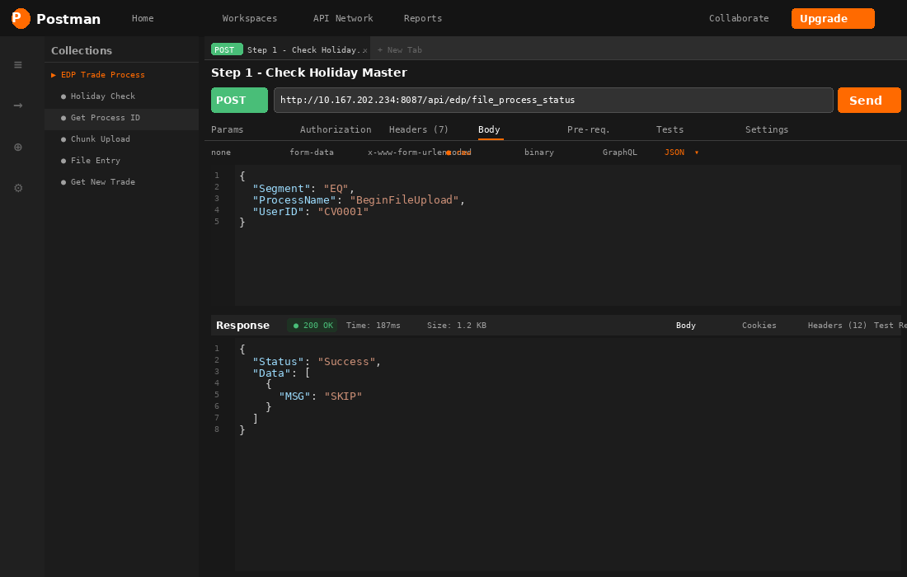
Step 1 — Holiday Check | Postman

STEP 2 Get New Trade Process (Create Process ID)
Creates a new trade process for the segment and trade date. Returns a Process ID (Table1) and a full list of upload steps with their statuses (Table2). Pass PROCESSID = 0 to create a new process.

Field | Value
Method | POST
URL | http://10.167.202.164:8003/v1/api/process/getNewTradeProcess
Key | Pass PROCESSID: 0 to create new

Request Payload
{
"GROUPNAME" : "EQ", // Segment Name
"LOGINID" : "CV0001", // User ID
"TRADEDATE" : "2026-06-29", // Trade Date (YYYY-MM-DD)
"PROCESSID" : "0" // 0 = Create New Process
}

Response
{
"Status": "Success",
"Result": {
"Table1": [{ "PROCESSID": 17658, "ISRUNNABLE": true, "ISAUTOUPLOAD": true }],
"Table2": [
{ "STEPNO": 1, "NAME": "Settlement Master NSE Upload", "STATUS": "PENDING", "UPLOADID": 551 },
{ "STEPNO": 2, "NAME": "Settlement Master BSE Upload", "STATUS": "PENDING", "UPLOADID": 678 },
{ "STEPNO": 3, "NAME": "BSE Scrip Upload", "STATUS": "PENDING", "UPLOADID": 81 },
{ "STEPNO": 4, "NAME": "NSE Scrip Upload", "STATUS": "PENDING", "UPLOADID": 82 },
// ... Steps 5-28 all STATUS: PENDING
]
}
}

📌 NOTE: Save the PROCESSID (e.g. 17658) from Table1 — it is required in Steps 6, 8, and all subsequent calls.

Postman Screenshot
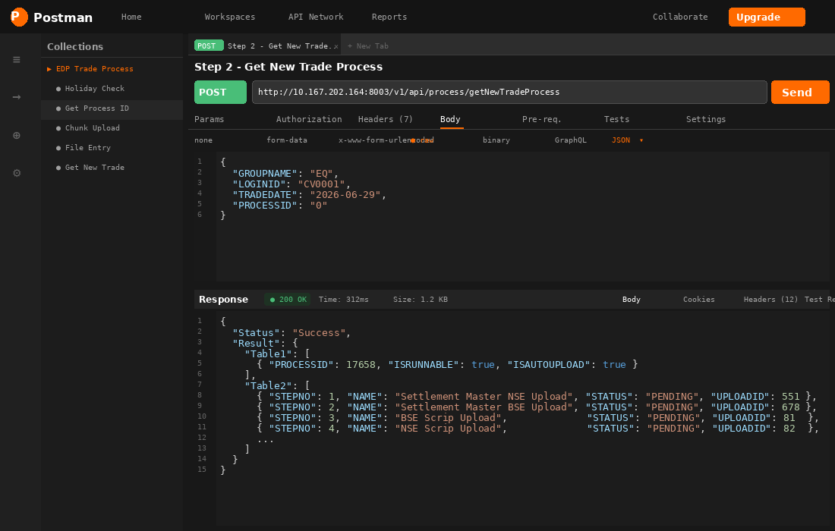
Step 2 — Get New Trade Process | Postman

Upload Steps Reference (Table2)
Step | Name | Upload ID | Optional
1 | Settlement Master NSE Upload | 551 | No
2 | Settlement Master BSE Upload | 678 | No
3 | BSE Scrip Upload | 81 | No
4 | NSE Scrip Upload | 82 | No
5 | NSE BSE InterOperable Scrip Mapping | 83 | No
6 | STT Indicator Upload | 84 | No
7 | STT not to Charge Upload | 94 | No
8 | BSE UDIFF Trade File Upload | 546 | No
9 | BSE Trade File Upload | 85 | Yes (visible)
10 | NSE Trade File Upload | 545 | No
11 | NSE Notice Trade File Upload | 86 | Yes (visible)
12 | BSE AUCTION Trade File Upload | 451 | Yes (visible)
13–28 | Trade Merger / Charges / Bill Posting / STK (auto-run) | 0 (auto) | No

STEP 3 Get File Upload Settings
Retrieve the expected file configuration for a given Upload ID — file name pattern, extension, column count, and a sample file link.

Field | Value
Method | POST
URL | http://10.167.202.164:8003/v1/api/process/GetNewTradeProcessPromodalUploadSettings

Request Payload
{
"UPLOADID": "81" // Upload ID from Step 2 Table2
}

Response
{
"Status": "Success",
"Result": [{
"ID" : 81,
"NAME" : "BSE SCRIP",
"FILE NAME (CONTAINS)" : "SCRIP",
"FILEEXTENSION" : "TXT",
"NO. OF COLUMNS" : 30
}]
}

📌 NOTE: Use FILE NAME (CONTAINS) and FILEEXTENSION to validate the correct file is selected before uploading.

Postman Screenshot
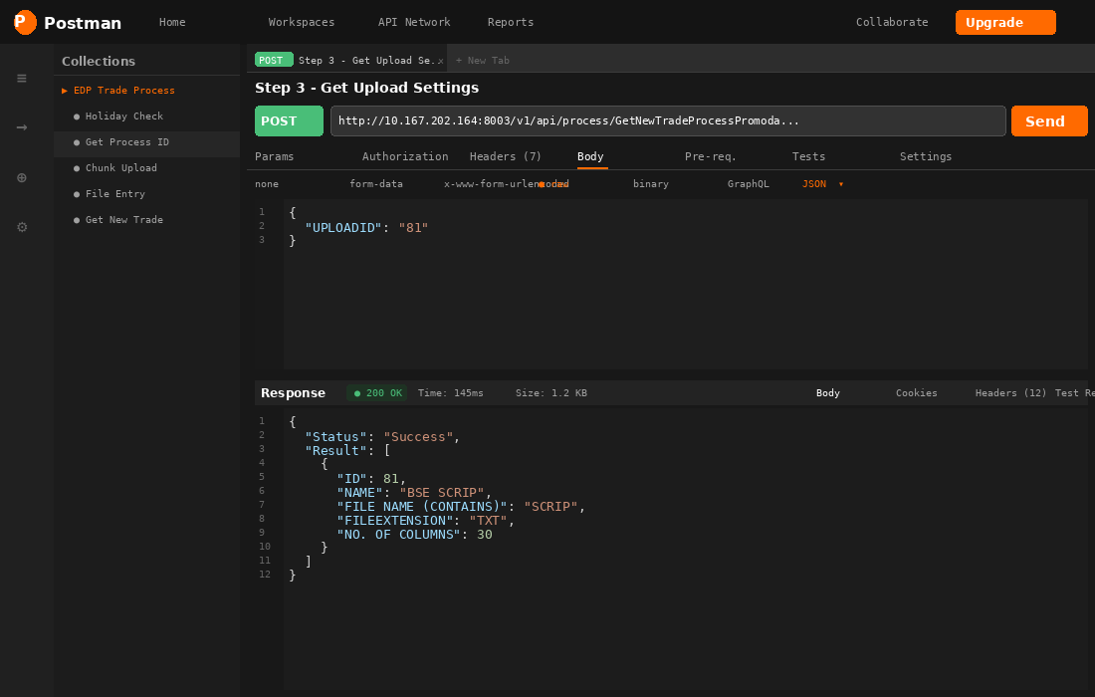
Step 3 — Get Upload Settings | Postman

STEP 4 File Upload — Chunk API
Upload the file in chunks. For small files a single chunk (CurrentChunk: 0, TotalChunks: 1) is sufficient. Generate a unique GUID client-side to identify this upload session.

Field | Value
Method | POST (multipart/form-data)
URL | http://10.167.202.164:8003/v1/api/process/SaveTradePromodalUploadChunkFile
Content-Type | multipart/form-data

Request Payload
-- Form Data Fields --
file : <binary file content>
CurrentChunk : 0
TotalChunks : 1
Guid : "a1b2c3d4-e5f6-4789-abcd-ef0123456789"
FileName : "SCRIP_190626.TXT"

Response
{
"Status" : "ChunkUploaded",
"Guid" : "3fa85f64-5717-4562-b3fc-2c963f66afa6",
"FileName" : "SCRIP_190626.TXT",
"currentChunk" : "0",
"totalChunks" : "1",
"fCount" : "2"
}

📌 NOTE: Save the Guid from the response — it becomes the uploadfoldername field in Step 6.

Postman Screenshot
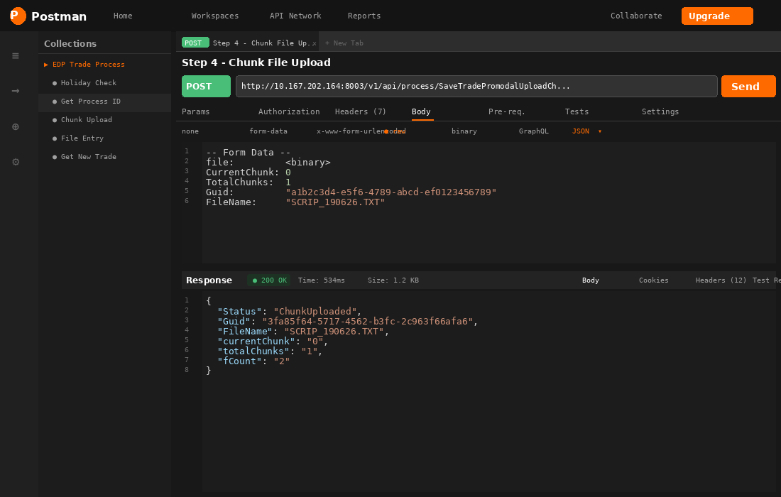
Step 4 — Chunk File Upload | Postman

STEP 5 Get Existing Process ID
Retrieves an existing Process ID for a given segment and trade date. Use when resuming an interrupted process.

Field | Value
Method | POST
URL | http://10.167.202.164:8003/v1/api/brokerage/getdropdown

Request Payload
{
"TAG" : "EXISTINGPROCESSID",
"LOGINID" : "CV0001",
"FILTER1" : "EQ", // Segment
"FILTER2" : "2026-06-29", // Trade Date (YYYY-MM-DD)
"extraoption2": "",
"extraoption3": ""
}

Response
{
"Status": "Success",
"Result": [{ "_KEY": 17658, "_DESC": "17658 - CV0001 - Jun 29 2026 2:19PM" }]
}

Postman Screenshot
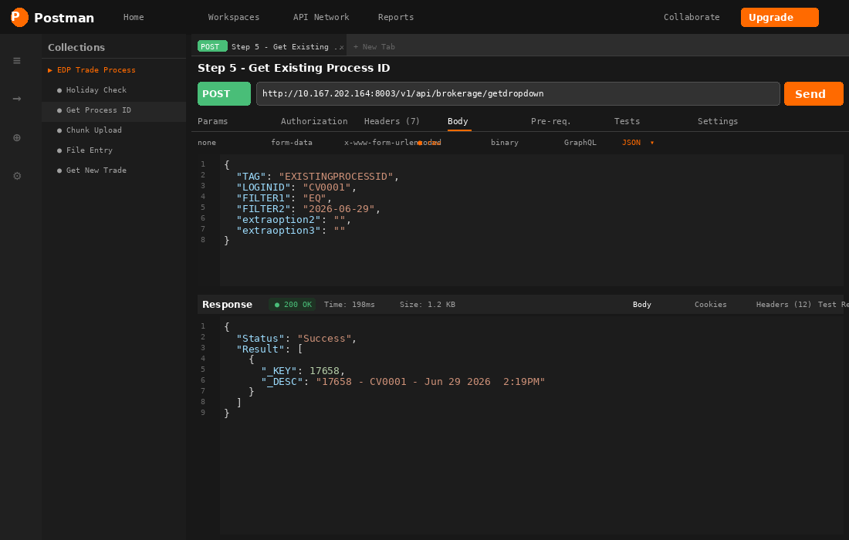
Step 5 — Get Existing Process ID | Postman

STEP 6 File Details Entry in CBOS Source
After chunk upload completes, register the file in the backend. This triggers the EXE to pick up the file from the GUID folder and process it.

Field | Value
Method | POST
URL | http://10.167.202.164:8003/v1/api/process/SaveNewTradeProcessPromodalUploadFile

Request Payload
{
"uploadid" : 81,
"loginid" : "CV0001",
"uploadfoldername": "3fa85f64-5717-4562-b3fc-2c963f66afa6", // GUID from Step 4
"uploadfilename" : "SCRIP_190626.TXT",
"ipaddress" : "10.167.202.164",
"file" : "",
"paraM1" : "2026-06-22", // Trade Date
"paraM2" : "", "paraM3": "", "paraM4": "", "paraM5": "",
"paraM6" : "", "paraM7": "", "paraM8": "",
"paraM9" : "17649", // Process ID from Step 2
"chunkFileUpload" : "YES"
}

Response
{ "Status": "Success", "Result": "File entry created successfully." }

📌 NOTE: Repeat Steps 3 → 4 → 6 for EVERY Upload ID listed in Table2 of Step 2 before calling Step 7.

Postman Screenshot
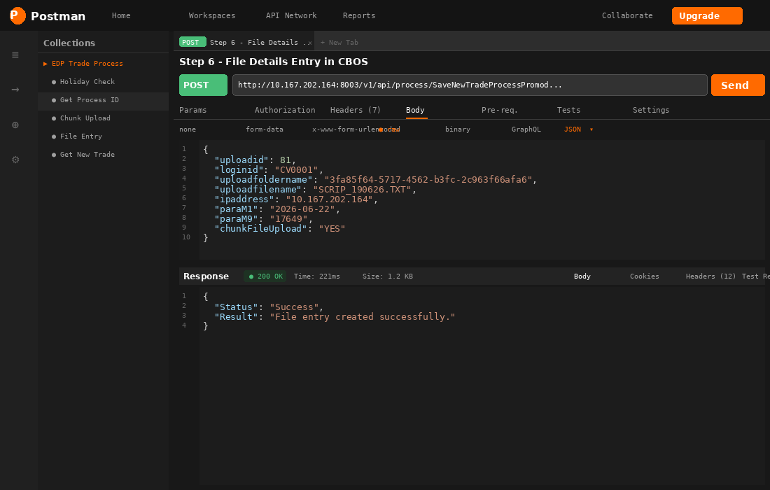
Step 6 — File Entry in CBOS | Postman

STEP 7 File Upload Status Check (Good to Go)
After all required files have been uploaded, poll this API to confirm all uploads are complete before executing the process.

Field | Value
Method | POST
URL | http://10.167.202.234:8087/api/edp/file_process_status
ProcessName | FILEUPLOAD

Request Payload
{
"Segment" : "EQ",
"ProcessName" : "FILEUPLOAD",
"UserID" : "CV0001"
}

Response
{ "Status": "Success", "Data": [{ "MSG": "FALSE" }] } // Not ready — keep polling
{ "Status": "Success", "Data": [{ "MSG": "TRUE" }] } // All uploads done — proceed

📌 NOTE: Poll this API repeatedly until MSG = "TRUE" before calling Step 8.

Postman Screenshot
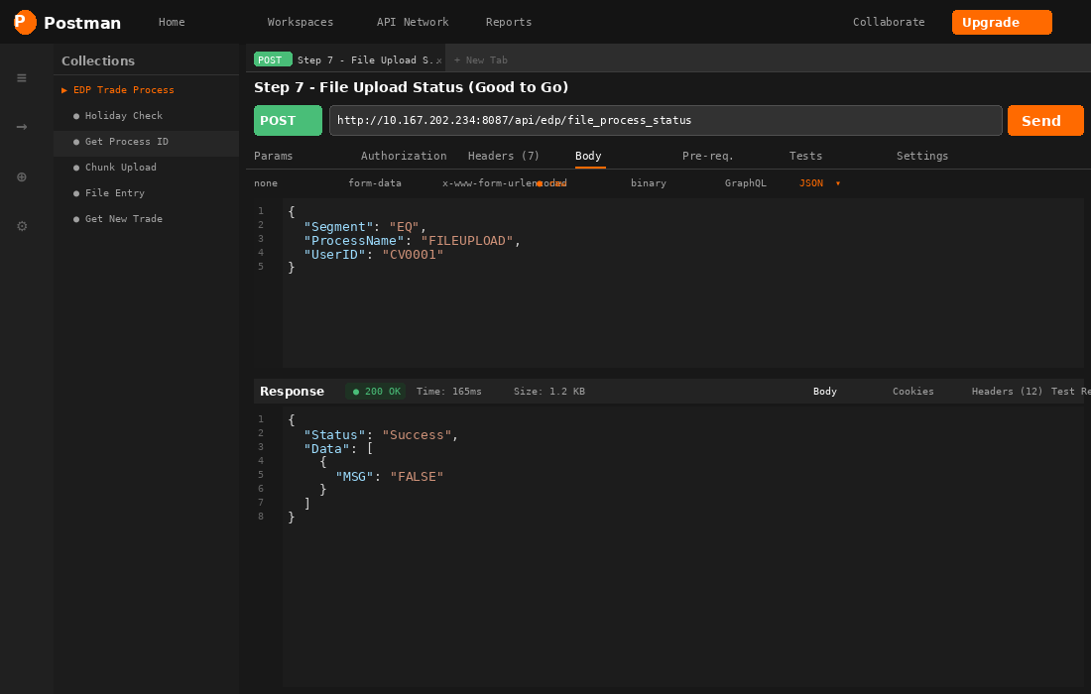
Step 7 — File Upload Status | Postman

STEP 8 Get New Trade Process (Execute — With Process ID)
Re-calls getNewTradeProcess with the saved Process ID to trigger execution of all uploaded steps. The system will auto-run Steps 13–28 after file-based steps complete.

Field | Value
Method | POST
URL | http://10.167.202.164:8003/v1/api/process/getNewTradeProcess
Key Difference | PROCESSID is the saved value — NOT 0

Request Payload
{
"GROUPNAME" : "EQ",
"LOGINID" : "CV0001",
"TRADEDATE" : "2026-06-29",
"PROCESSID" : "17658" // Saved Process ID from Step 2
}

Response
{
"Status": "Success",
"Result": {
"Table1": [{ "PROCESSID": 17658, "ISRUNNABLE": true }],
"Table2": [
{ "STEPNO": 1, "NAME": "Settlement Master NSE Upload", "STATUS": "SUCCESS" },
{ "STEPNO": 2, "NAME": "Settlement Master BSE Upload", "STATUS": "SUCCESS" },
{ "STEPNO": 3, "NAME": "BSE Scrip Upload", "STATUS": "PENDING",
"STATUSDESC": "UPLOAD FILE PENDING" },
// Remaining steps auto-process once file uploads complete
]
}
}

Postman Screenshot
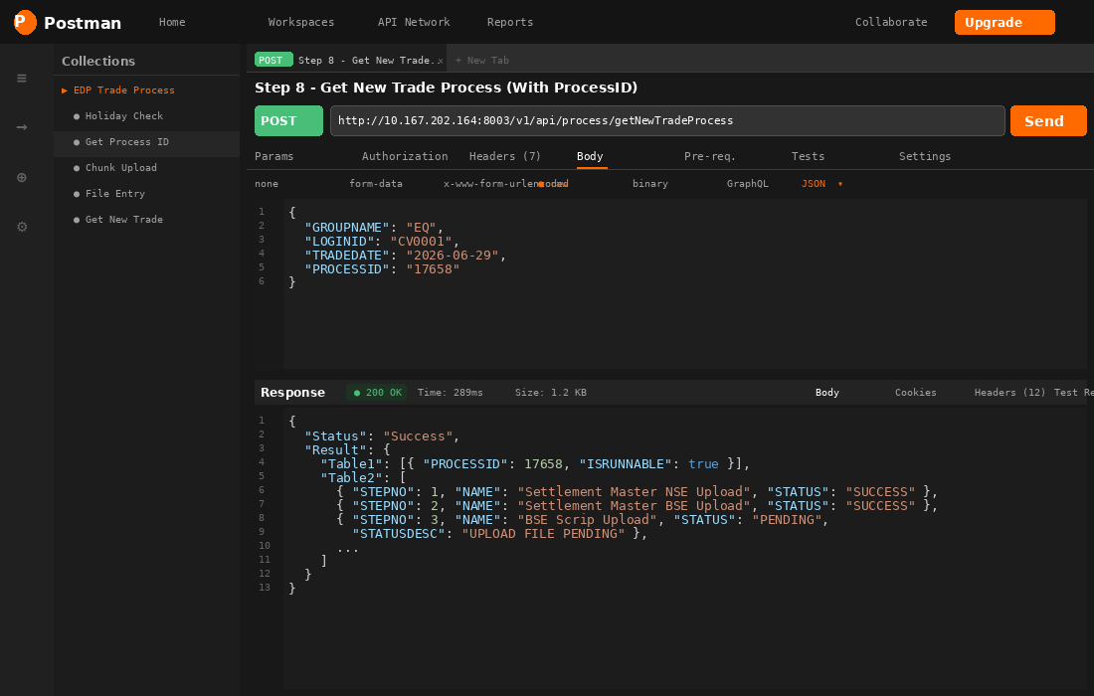
Step 8 — Execute Trade Process | Postman

STEP 9 EDP Bill Posting Status Check
Check whether Bill Posting has completed for the EQ segment before proceeding to Recon.

Field | Value
Method | POST
URL | http://10.167.202.234:8087/api/edp/file_process_status
Segment | EQ
ProcessName | BILLPOSTING

Request Payload
{
"Segment": "EQ", "ProcessName": "BILLPOSTING", "UserID": "CV0001"
}

Response
{ "Status": "Success", "Data": [{ "MSG": "False" }] } // Not yet complete
{ "Status": "Success", "Data": [{ "MSG": "True" }] } // Complete — proceed to Step 10

📌 NOTE: Wait for MSG = "True" before calling Step 10 (Segment Recon).

Postman Screenshot
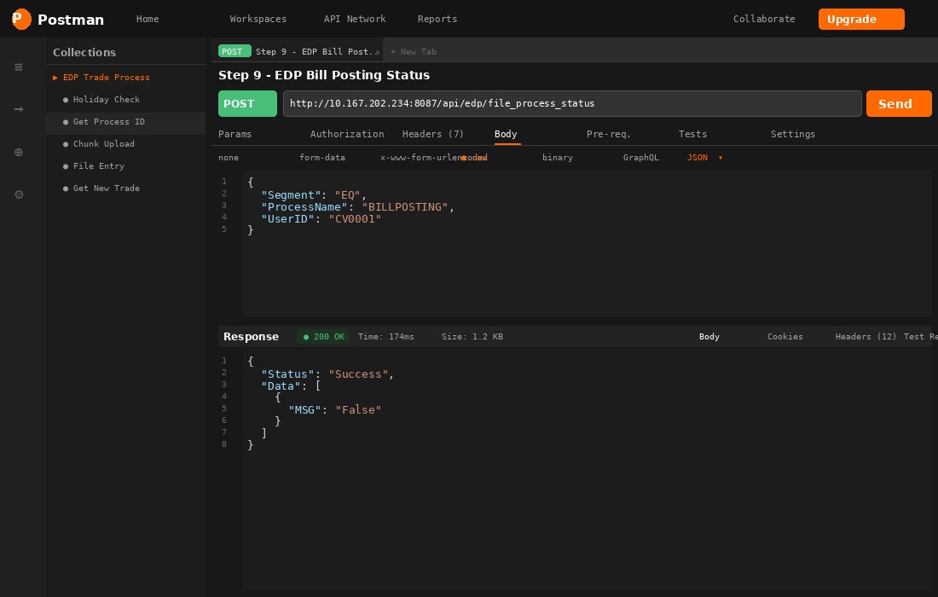
Step 9 — Bill Posting Status | Postman

STEP 10 Segment Recon Status Check
Verify that segment reconciliation is complete before triggering Contract Note Generation.

Field | Value
Method | POST
URL | http://10.167.202.234:8087/api/edp/file_process_status
Segment | DR
ProcessName | RECON

Request Payload
{
"Segment": "DR", "ProcessName": "RECON", "UserID": "CV0001"
}

Response
{ "Status": "Success", "Data": [{ "MSG": "FALSE" }] }
{ "Status": "Success", "Data": [{ "MSG": "TRUE" }] } // Proceed to Step 11

Postman Screenshot
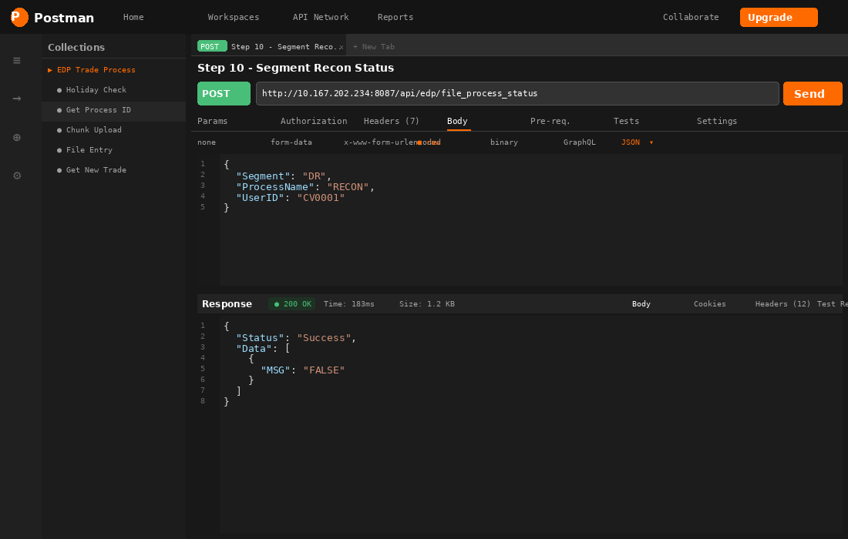
Step 10 — Segment Recon | Postman

STEP 11 Contract Note Generation Status Check
Verify Contract Note Generation is complete for the DR segment.

Field | Value
Method | POST
URL | http://10.167.202.234:8087/api/edp/file_process_status
Segment | DR
ProcessName | CONTRACTNOTEGENERATION

Request Payload
{
"Segment": "DR", "ProcessName": "CONTRACTNOTEGENERATION", "UserID": "CV0001"
}

Response
{ "Status": "Success", "Data": [{ "MSG": "FALSE" }] }
{ "Status": "Success", "Data": [{ "MSG": "TRUE" }] } // Proceed to Step 12

STEP 12 Collateral Valuation — Good to Go
Check whether Collateral Valuation can be triggered.

Field | Value
Method | POST
URL | http://10.167.202.234:8087/api/edp/file_process_status
Segment | DR
ProcessName | CollateralValuation

Request Payload
{
"Segment": "DR", "ProcessName": "CollateralValuation", "UserID": "CV0001"
}

Response
{ "Status": "Success", "Data": [{ "MSG": "FALSE" }] } // Not ready
{ "Status": "Success", "Data": [{ "MSG": "TRUE" }] } // Proceed to Step 13

STEP 13 Collateral Valuation Trigger
Trigger the Collateral Valuation process for a given margin date.

Field | Value
Method | POST
URL | http://10.167.202.164:8003/v1/api/process/GetCollateralValuation

Request Payload
{
"BUTTONNAME" : "COLLATERAL_VALUATION_DATEWISE",
"LOGINID" : "G_LID",
"MARGINDATE" : "19-Jun-2026"
}

Response
{
"Status": "Success",
"Result": { "Table1": [{ "MSG": "Process started successfully !
Click Refresh Button for Current Status." }] }
}

Postman Screenshot
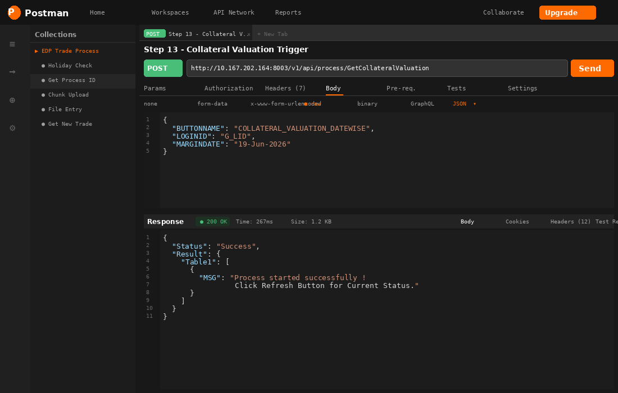
Step 13 — Collateral Valuation Trigger | Postman

STEP 14 Collateral Allocation — Good to Go
Check if Collateral Allocation can be triggered.

Field | Value
Method | POST
URL | http://10.167.202.234:8087/api/edp/file_process_status
Segment | DR
ProcessName | CollateralAllocation

Request Payload
{
"Segment": "DR", "ProcessName": "CollateralAllocation", "UserID": "CV0001"
}

Response
{ "Status": "Success", "Data": [{ "MSG": "FALSE" }] }
{ "Status": "Success", "Data": [{ "MSG": "TRUE" }] } // Proceed to Step 15

STEP 15 Collateral Allocation Trigger
Trigger the Collateral Allocation process.

Field | Value
Method | POST
URL | http://10.167.202.164:8003/v1/api/process/MTFTradeProcessCollateralAllocation

Request Payload
{
"LOGINID" : "G_LID",
"TRADEDATE" : "19-Jun-2026"
}

Response
{ "Status": "Success", "Result": { "Table1": [{ "MSG": "Process started successfully ! Click Refresh Button." }] } }

STEP 16 Fund Transfer — Good to Go
Check whether Fund Transfer can be triggered.

Field | Value
Method | POST
URL | http://10.167.202.234:8087/api/edp/file_process_status
Segment | DR
ProcessName | FundTransfer

Request Payload
{
"Segment": "DR", "ProcessName": "FundTransfer", "UserID": "CV0001"
}

Response
{ "Status": "Success", "Data": [{ "MSG": "FALSE" }] }
{ "Status": "Success", "Data": [{ "MSG": "TRUE" }] } // Proceed to Step 17

STEP 17 Fund Transfer Trigger
Trigger the Fund Transfer process.

Field | Value
Method | POST
URL | http://10.167.202.164:8003/v1/api/process/MTFTradeProcessFundTransfer

Request Payload
{
"LOGINID" : "G_LID",
"TRADEDATE" : "19-Jun-2026"
}

Response
{
"Status": "Success",
"Result": [{ "Result": "The specified @job_name ('MTF_RISK_UPDATE') does not exist." }]
}

📌 NOTE: If MTF_RISK_UPDATE SQL job does not exist, coordinate with the DBA team to create it on the DB server before running this trigger.

STEP 18 Cash Bill Posting Good to Go (For MTF Buy Trade)
Confirm EQ segment Bill Posting is complete before running the MTF Buy Trade Process.

Field | Value
Method | POST
URL | http://10.167.202.234:8087/api/edp/file_process_status
Segment | EQ
ProcessName | BILLPOSTING

Request Payload
{
"Segment": "EQ", "ProcessName": "BILLPOSTING", "UserID": "CV0001"
}

Response
{ "Status": "Success", "Data": [{ "MSG": "False" }] } // Not complete
{ "Status": "Success", "Data": [{ "MSG": "True" }] } // Proceed to Step 19

STEP 19 MTF Buy Trade Process
Execute the MTF Buy Trade Process for the given trade date.

Field | Value
Method | POST
URL | http://10.167.202.164:8003/v1/api/process/MTFTradeProcess
Date Format | DD-MMM-YYYY

Request Payload
{
"LOGINID" : "CV0001",
"TRADEDATE" : "30-JUN-2026", // Format: DD-MMM-YYYY
"TYPE" : "BUY PROCESS"
}

Response
{
"Status": "Success",
"Result": [{ "MSG": "Process completed successfully" }]
}

Postman Screenshot
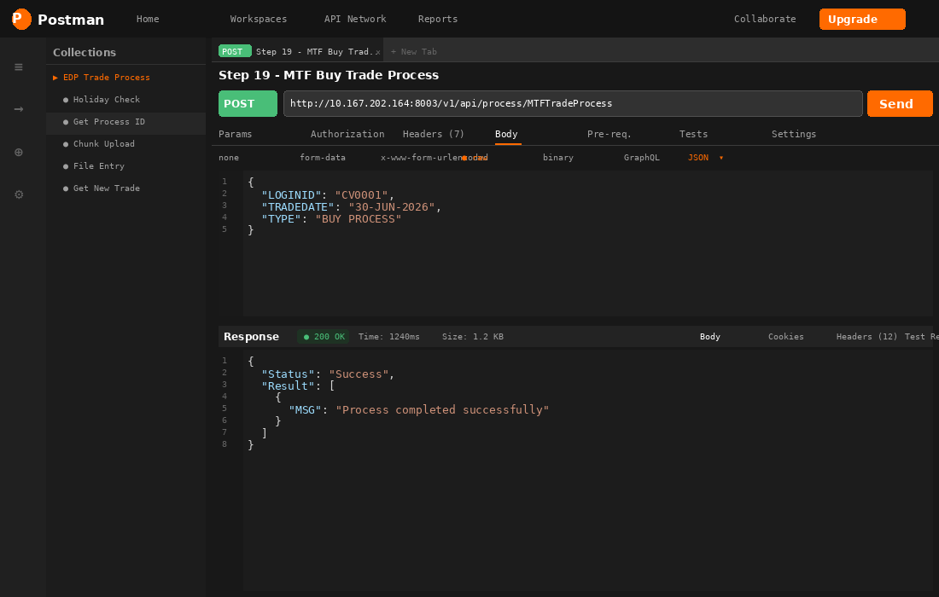
Step 19 — MTF Buy Trade Process | Postman

STEP 20 MTF Buy Trade Posting
Call immediately after Step 19 completes successfully.

Field | Value
Method | POST
URL | http://10.167.202.164:8003/v1/api/process/MTFTradeProcess

Request Payload
{
"LOGINID": "CV0001", "TRADEDATE": "30-JUN-2026", "TYPE": "BUY POSTING"
}

Response
{ "Status": "Success", "Result": [{ "MSG": "Process completed successfully" }] }

STEP 21 MTF Sell Process & Posting — Good to Go
Check whether Early Pay-In is complete before running MTF Sell.

Field | Value
Method | POST
URL | http://10.167.202.234:8087/api/edp/file_process_status
Segment | EQ
ProcessName | EARLYPAYIN

Request Payload
{
"Segment": "EQ", "ProcessName": "EARLYPAYIN", "UserID": "CV0001"
}

Response
{ "Status": "Success", "Data": [{ "MSG": "True" }] } // Proceed to Step 22

STEP 22 MTF Sell Process and Posting
Execute the MTF Sell Process and Posting.

Field | Value
Method | POST
URL | http://10.167.202.164:8003/v1/api/process/MTFTradeProcess

Request Payload
{
"LOGINID": "CV0001", "TRADEDATE": "30-JUN-2026", "TYPE": "SELL PROCESS AND POSTING"
}

Response
{ "Status": "Success", "Result": [{ "MSG": "Process completed successfully" }] }

STEP 23 Weekly Auto Closure — Good to Go
Check whether the Weekly Auto Closure process can be triggered. This step runs independently at 4:00 PM on trading days.

Field | Value
Method | POST
URL | http://10.167.202.234:8087/api/edp/file_process_status
Segment | EQ
ProcessName | WEEKLYAUTOCLOSURE

Request Payload
{
"Segment": "EQ", "ProcessName": "WEEKLYAUTOCLOSURE", "UserID": "CV0001"
}

Response
{ "Status": "Success", "Data": [{ "MSG": "True" }] } // Proceed to Step 24

STEP 24 Weekly Auto Closure
Runs independently at 4:00 PM on trading days. Do not trigger manually outside this window unless instructed.

Field | Value
Method | POST
URL | http://10.167.202.164:8003/v1/api/process/MTFTradeProcess
Schedule | 4:00 PM on trading days

Request Payload
{
"LOGINID": "CV0001", "TRADEDATE": "30-JUN-2026", "TYPE": "WEEKLY AUTOCLOSURE"
}

Response
{ "Status": "Success", "Result": [{ "MSG": "Process completed successfully" }] }

📌 NOTE: This process runs independently at 4:00 PM. Do not trigger outside the scheduled window.

STEP 25 Corporate Action Position Change — FO Bill Posting Check
Confirm FO (Derivative) Bill Posting is done before running Corporate Action Position Change.

Field | Value
Method | POST
URL | http://10.167.202.234:8087/api/edp/file_process_status
Segment | DR
ProcessName | BILLPOSTING

Request Payload
{
"Segment": "DR", "ProcessName": "BILLPOSTING", "UserID": "CV0001"
}

Response
{ "Status": "Success", "Data": [{ "MSG": "True" }] } // Proceed to Step 26

STEP 26 Corporate Action Position Change
This step requires two specific files provided by the Ops Team between 10:00 PM and 11:59 PM. Confirm both are available in the specified location before creating the process.

Required Files (check before proceeding):
1. _10412_ADJUSTED_POSITIONS.csv
2. _10412_EXISTING_POSITIONS.csv

📌 NOTE: Both files must be available in the designated location (shared by Ops Team) between 10:00 PM and 11:59 PM before creating the process template.

Step 26a — Create Process (PROCESSID: 0)
Field | Value
Method | POST
URL | http://10.167.202.164:8003/v1/api/process/getNewTradeProcess
GROUPNAME | FOPositionChange

{
"GROUPNAME" : "FOPositionChange", // Special Segment
"LOGINID" : "CV0001",
"TRADEDATE" : "2026-06-29",
"PROCESSID" : "0" // 0 = Create New
}

Step 26b — File Upload (Repeat Steps 3 → 4 → 6)
Upload both position files using the Chunk Upload flow (Steps 3, 4, 6) with the Upload IDs returned from the FOPositionChange process template.

Step 26c — Execute Process (With Process ID)
{
"GROUPNAME" : "FOPositionChange",
"LOGINID" : "CV0001",
"TRADEDATE" : "2026-06-29",
"PROCESSID" : "18756" // Process ID from Step 26a
}

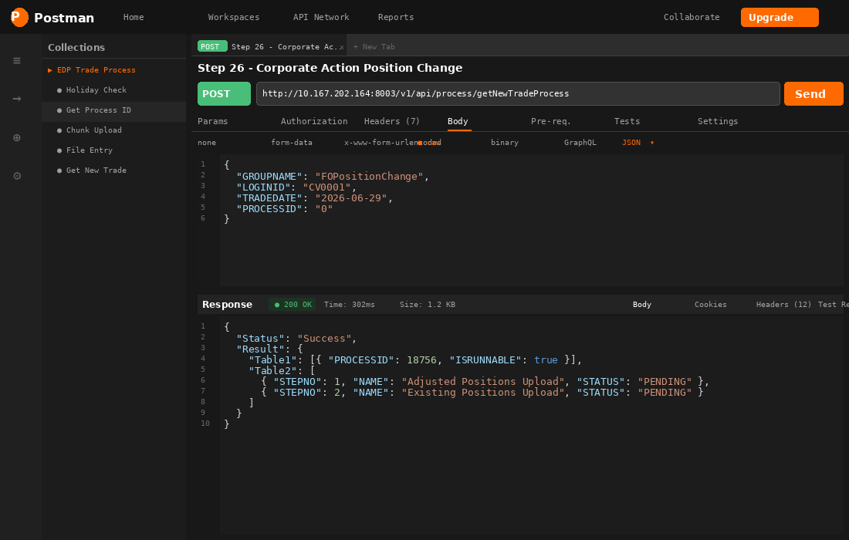
Step 26 — Corporate Action Position Change | Postman

Quick Reference — All API Endpoints
Step | Purpose | Full Endpoint
1 | Holiday Check | POST http://10.167.202.234:8087/api/edp/file_process_status — ProcessName: BeginFileUpload
2 | Create Process ID | POST http://10.167.202.164:8003/v1/api/process/getNewTradeProcess — PROCESSID: 0
3 | Get Upload Settings | POST http://10.167.202.164:8003/v1/api/process/GetNewTradeProcessPromodalUploadSettings
4 | Chunk File Upload | POST http://10.167.202.164:8003/v1/api/process/SaveTradePromodalUploadChunkFile
5 | Get Existing Process ID | POST http://10.167.202.164:8003/v1/api/brokerage/getdropdown — TAG: EXISTINGPROCESSID
6 | File Entry in CBOS | POST http://10.167.202.164:8003/v1/api/process/SaveNewTradeProcessPromodalUploadFile
7 | File Upload Status | POST http://10.167.202.234:8087/api/edp/file_process_status — ProcessName: FILEUPLOAD
8 | Execute Process | POST http://10.167.202.164:8003/v1/api/process/getNewTradeProcess — with ProcessID
9 | Bill Posting Status (EQ) | POST http://10.167.202.234:8087/api/edp/file_process_status — Segment: EQ, ProcessName: BILLPOSTING
10 | Segment Recon | POST http://10.167.202.234:8087/api/edp/file_process_status — Segment: DR, ProcessName: RECON
11 | Contract Note Status | POST http://10.167.202.234:8087/api/edp/file_process_status — ProcessName: CONTRACTNOTEGENERATION
12 | Collateral Valuation GTG | POST http://10.167.202.234:8087/api/edp/file_process_status — ProcessName: CollateralValuation
13 | Collateral Valuation Trigger | POST http://10.167.202.164:8003/v1/api/process/GetCollateralValuation
14 | Collateral Allocation GTG | POST http://10.167.202.234:8087/api/edp/file_process_status — ProcessName: CollateralAllocation
15 | Collateral Allocation Trigger | POST http://10.167.202.164:8003/v1/api/process/MTFTradeProcessCollateralAllocation
16 | Fund Transfer GTG | POST http://10.167.202.234:8087/api/edp/file_process_status — ProcessName: FundTransfer
17 | Fund Transfer Trigger | POST http://10.167.202.164:8003/v1/api/process/MTFTradeProcessFundTransfer
18 | Cash Bill Posting GTG (MTF) | POST http://10.167.202.234:8087/api/edp/file_process_status — Segment: EQ, ProcessName: BILLPOSTING
19 | MTF Buy Trade Process | POST http://10.167.202.164:8003/v1/api/process/MTFTradeProcess — TYPE: BUY PROCESS
20 | MTF Buy Trade Posting | POST http://10.167.202.164:8003/v1/api/process/MTFTradeProcess — TYPE: BUY POSTING
21 | MTF Sell GTG | POST http://10.167.202.234:8087/api/edp/file_process_status — Segment: EQ, ProcessName: EARLYPAYIN
22 | MTF Sell Process & Posting | POST http://10.167.202.164:8003/v1/api/process/MTFTradeProcess — TYPE: SELL PROCESS AND POSTING
23 | Weekly Auto Closure GTG | POST http://10.167.202.234:8087/api/edp/file_process_status — ProcessName: WEEKLYAUTOCLOSURE
24 | Weekly Auto Closure | POST http://10.167.202.164:8003/v1/api/process/MTFTradeProcess — TYPE: WEEKLY AUTOCLOSURE
25 | Corp Action FO Bill GTG | POST http://10.167.202.234:8087/api/edp/file_process_status — Segment: DR, ProcessName: BILLPOSTING
26 | Corporate Action Pos Change | POST http://10.167.202.164:8003/v1/api/process/getNewTradeProcess — GROUPNAME: FOPositionChange

© Motilal Oswal Financial Services Ltd | EDP Trade Process API Reference | Confidential | v1.0

