Experiment 2

To understand how data is transformed in Altryx i.e. modifying the column, cleansing data, adding a column and filtering of data.

# Modifying Columns

1. The data contains unclear column names and columns that are out of order.
2. Drag a Select tool onto the canvas from the toolbar and connect it to the Input Data tool.

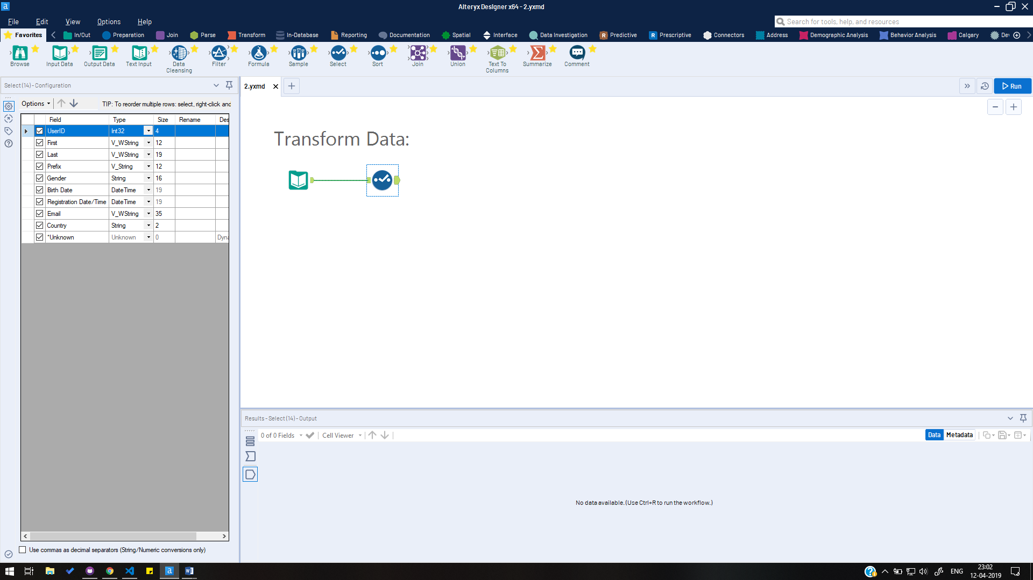

1. In the Configuration window on the left, click the Rename text box for the "First" field. Type "First Name" to rename the field.
2. Rename these two additional fields:

Last - "Last Name"

Email - "Registration Email"

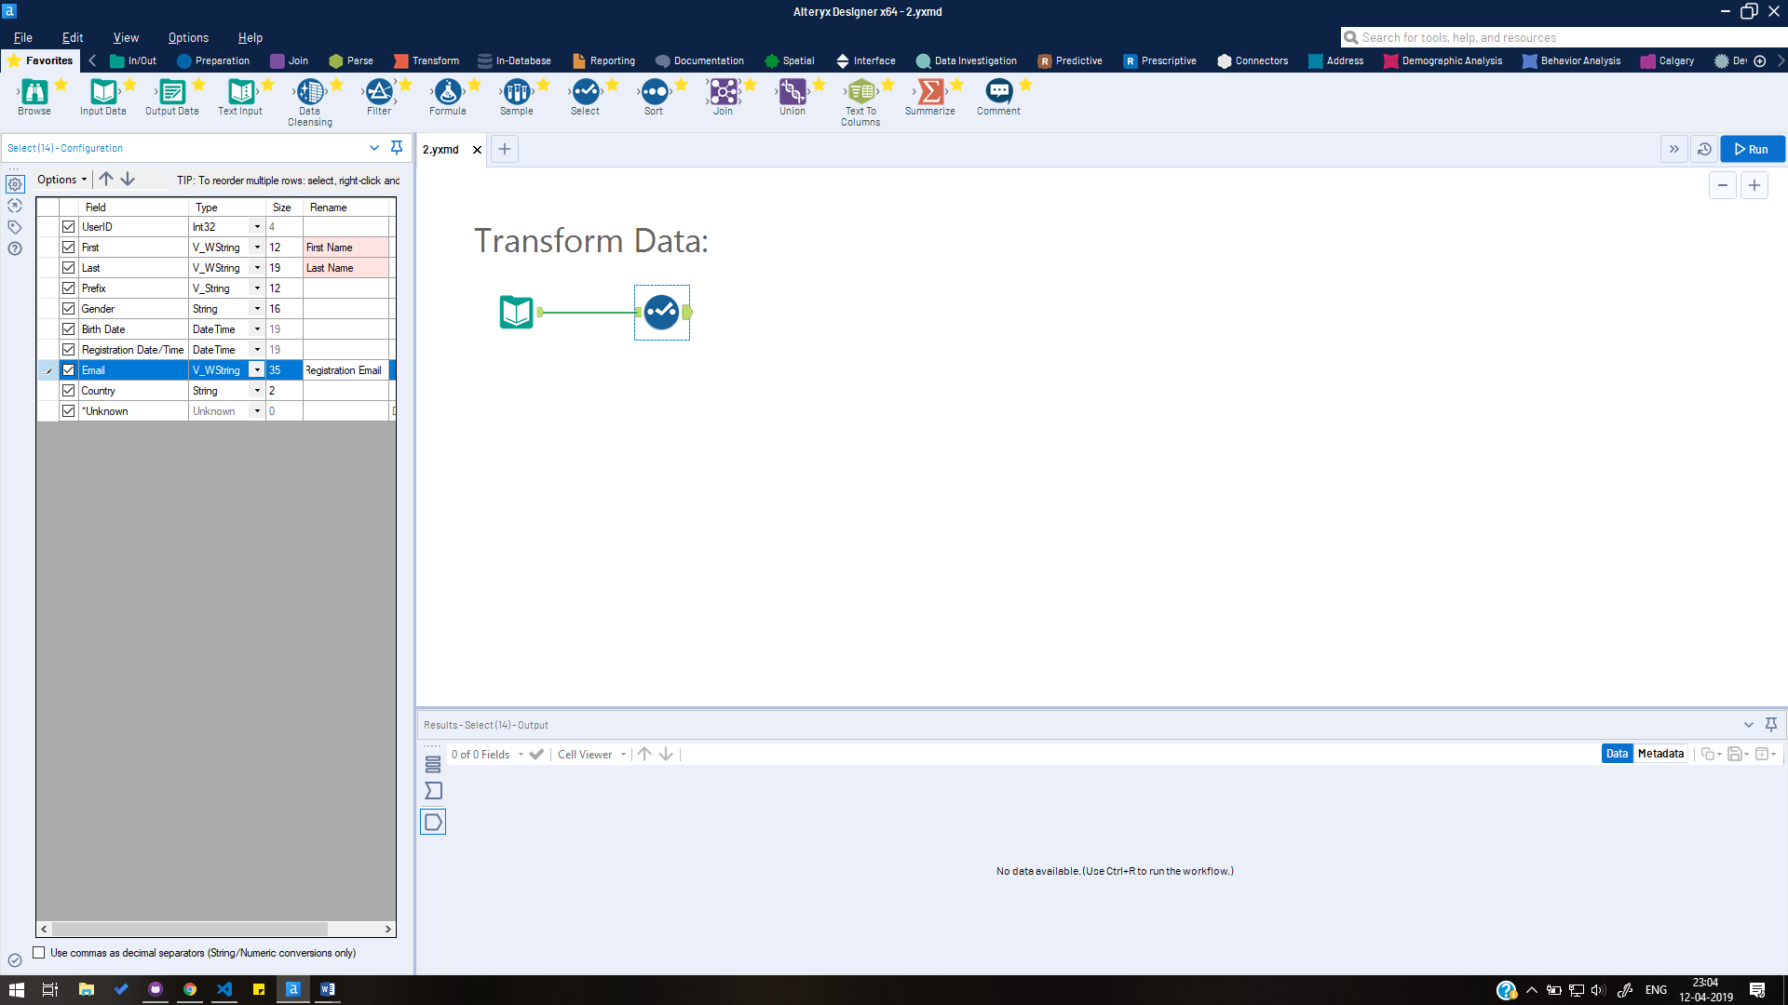

1. Locate Email. Right click and hold to drag Email above Registration Date/Time, or use the up arrow at the top of the configuration window.
2. Run the workflow. See the updated field names and order in the Results window.

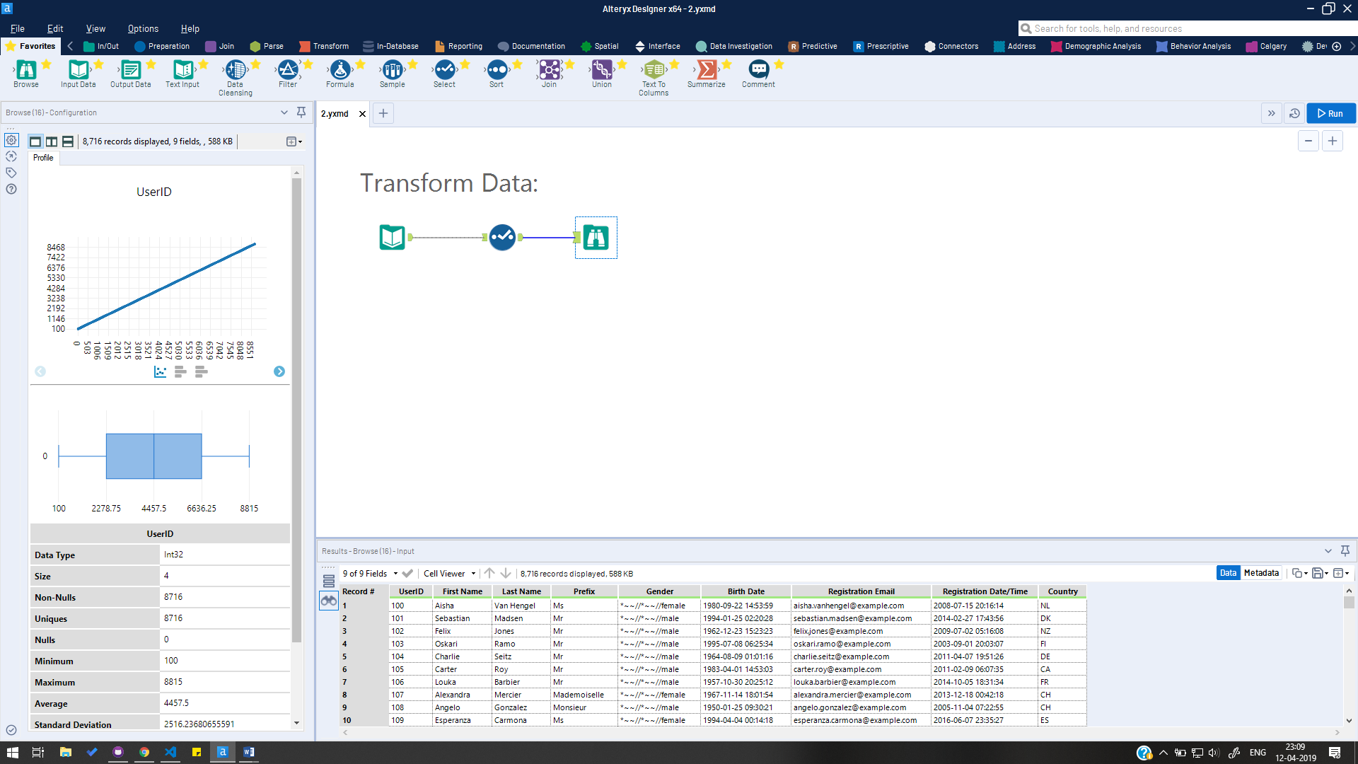

# Cleansing Data

1. The Gender column has unwanted characters ("*~~//") and is formatted as lowercase text.
2. Drag a Data Cleanse tool onto the canvas from the toolbar and connect it to the Select tool.
3. In the Configuration window on the left, under "Select Fields to Cleanse", uncheck all columns except Gender.

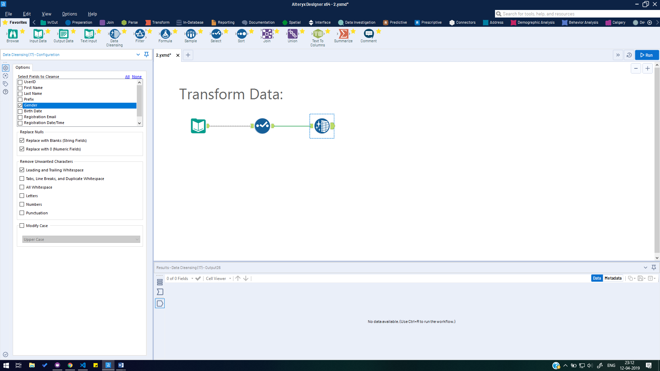

1. Under Remove Unwanted Characters, select Punctuation. Select Modify Case and use the drop down to select Title Case.
2. Run the workflow. See the corrections to the Gender column in the Results window.

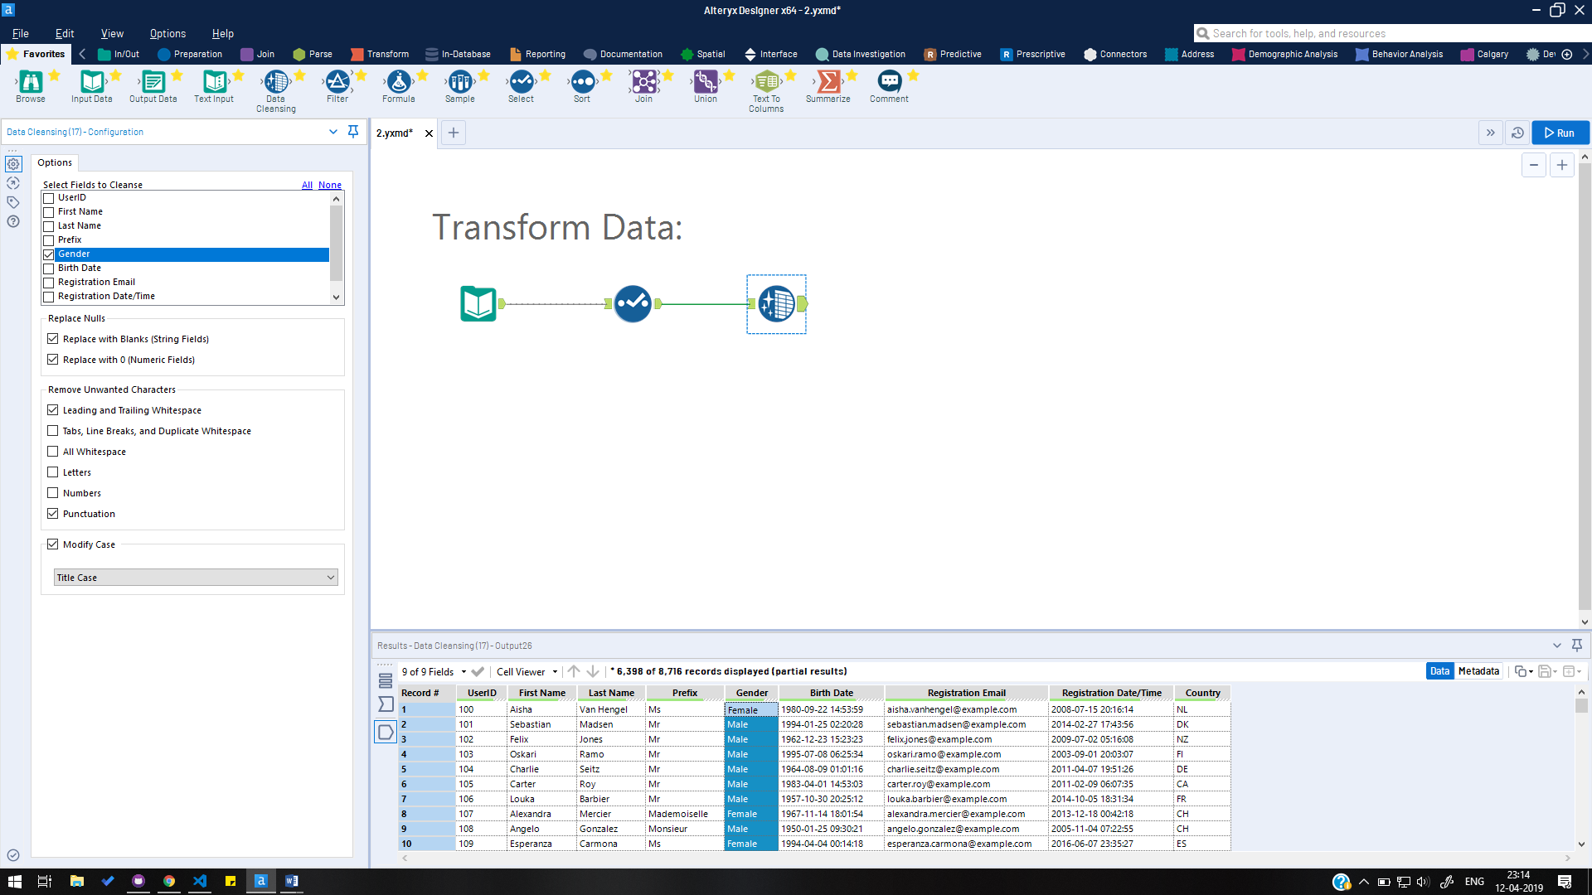

# Adding a Column

1. A new column using existing data is needed.
2. Drag a Formula tool onto the canvas from the toolbar and connect it to the Data Cleanse tool.
3. In the Configuration window on the left, use the Select Column drop down to select "+ Add Column". Type "Full Name" as the name of the new column.

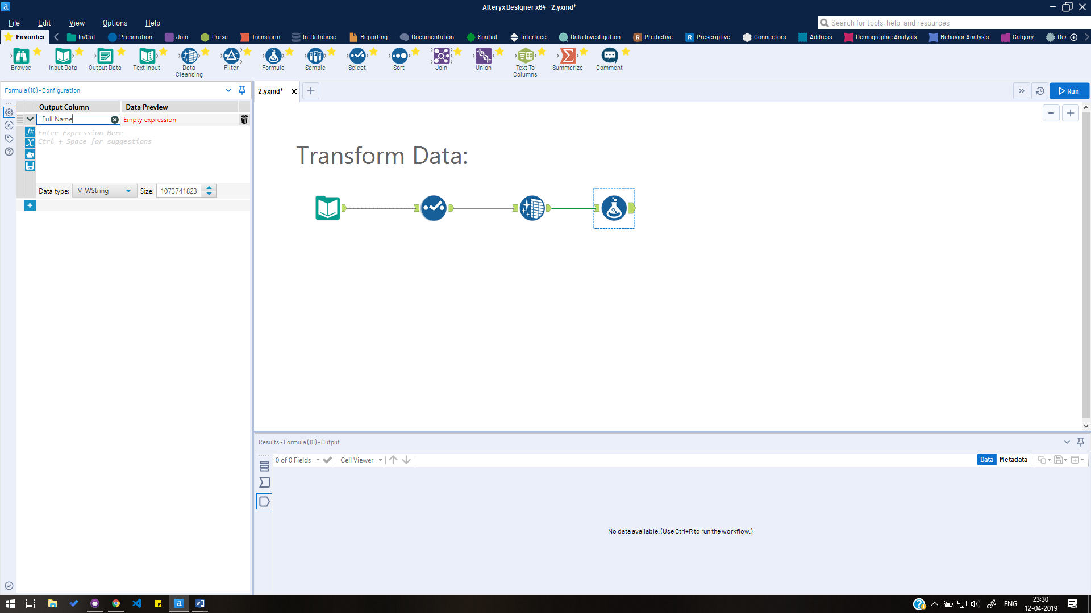

1. Data type and size can be adjusted under the Expression Editor. Keep the default Data type V_Wstring, and change Size to 35.
2. In the Expression Editor text box, which says Enter Expression Here, type the following expression: [First Name]+" "+[Last Name]
3. Run the workflow. See the new Full Name column in the Results window.

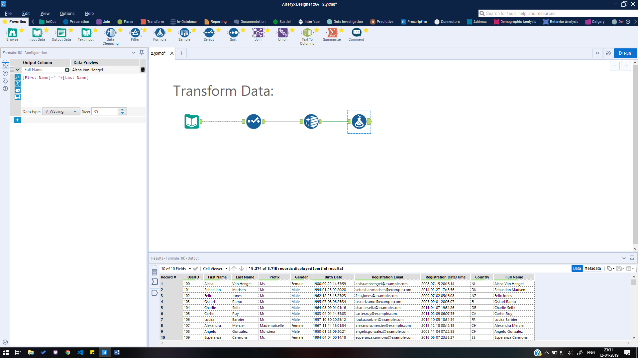

# Filtering Data

1. Only data that meets a specific condition is needed.
2. Drag a Filter tool onto the canvas from the toolbar and connect it to the Formula tool.

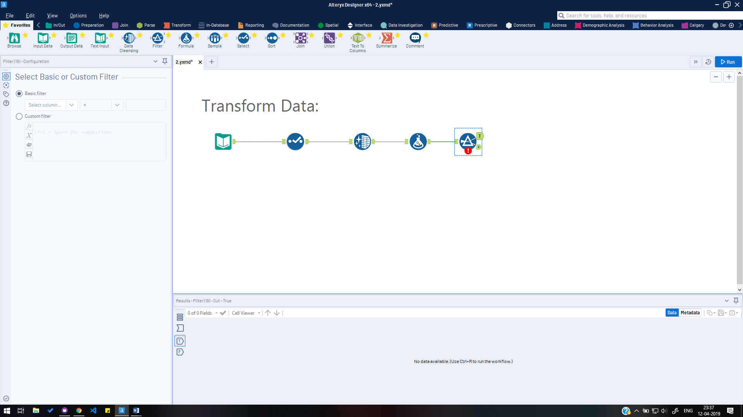

1. In the Configuration window on the left, confirm that Basic Filter is selected. Use the Select column dropdown to select Country. In the next drop down, select the operator Equals. In the text box, type "US".
2. Run the workflow to see the results in the Results window. Click between the T (True) and F (False) results pages or corresponding tool anchors to see which records did and did not meet the conditions of the filter expression.

