Toy Haven
Assignment 3, COMP40053: front-end website submission document
Live website | https://nihmathullahmazhar.github.io/toy-haven/
GitHub repository | https://github.com/nihmathullahmazhar/toy-haven
Technologies | HTML5, CSS3 (Flexbox and Grid, custom properties), vanilla JavaScript (ES5-compatible syntax, no libraries or frameworks)
Storage | localStorage — basket, wishlist, order history, feedback messages, newsletter subscribers, theme preference
Pages | Home, Product listing, Shopping cart, Checkout, Wishlist / collection, Feedback & support (plus an offline fallback page)

1. Overview
Toy Haven is a six-page front-end store selling collectible figurines, toys, board games and diecast model cars. I built it mobile first and without a framework, so the whole site is three stylesheets, one shared JavaScript file and a small script for each page. All 24 products sit in a single JSON array in js/data.js, and every listing, card, modal, basket row and order line is drawn from that one array.
There is no server behind the site, so anything a real shop would send to one is saved in localStorage instead. The basket survives a refresh and a browser restart, the wishlist remembers a status for each product, checkout writes the order into a local order history, and the feedback form keeps every message so the visitor can see what was actually recorded. The site is also a progressive web app, which means it can be installed to a home screen and pages that have already been visited still open with no connection.

2. Planning and design

2.1 Approach
I drew every page at 375px first and widened it from there, which is why the CSS only uses min-width media queries. The mobile layout is the default and wider screens add columns rather than take them away. There are four breakpoints: 40em (640px) for small tablets, 48em (768px) for the modal and the footer, 55em (880px) where the navigation turns into the animated hamburger, and 60em (960px) for the full desktop layout.

2.2 Colour palette and typography
Design tokens, declared once in css/base.css and reused everywhere
Token | Value | Used for
--brand | #5b2bd9 violet | Primary buttons, links, active states, price
--accent | #ff9f1c amber | Product tags and star ratings
--mint | #0f8f86 teal | Supporting highlights and value icons
--rose | #c2255c pink | Wishlist hearts and basket counter
--ink / --ink-soft | #17161c / #56545f | Body text and secondary text
--bg / --surface | #faf8f5 / #ffffff | Page background and cards
--font-display | Fredoka (Google Fonts) | Headings, buttons, prices
--font-body | Plus Jakarta Sans (Google Fonts) | Body copy, forms, tables

The same tokens are declared a second time under [data-theme="dark"], and that is all the theme switch in the header needs in order to recolour the site. No rule is written twice. I checked both themes for contrast and both pass at AA.

2.3 Wireframes
Each wireframe puts the mobile layout I designed first next to the desktop layout it grows into. They keep to the low-fidelity conventions taught in the module: black and white lines, no graphics, no dummy text and no colour, so the discussion stays on structure, hierarchy and function rather than on visual design.
The notation I used is:
- A rounded outline bar is one line of text; a few stacked inside a box are a block of copy.
- A solid black bar is a heading or an emphasised label such as a price.
- A box crossed corner to corner is an image or icon placeholder.
- A circle marked LOGO is the brand mark, the only word that appears in the drawings.
- An empty box is an input field; a box with a solid bar inside it is a button.
- A small square is a checkbox and a small circle is a radio button; plus and minus signs are the quantity stepper.
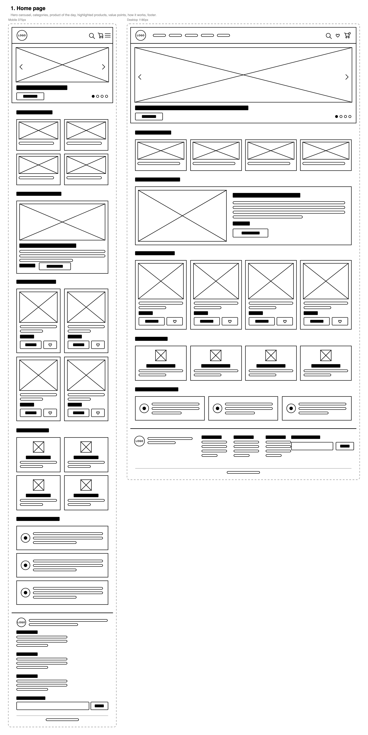
Wireframe of the home page in mobile and desktop layouts
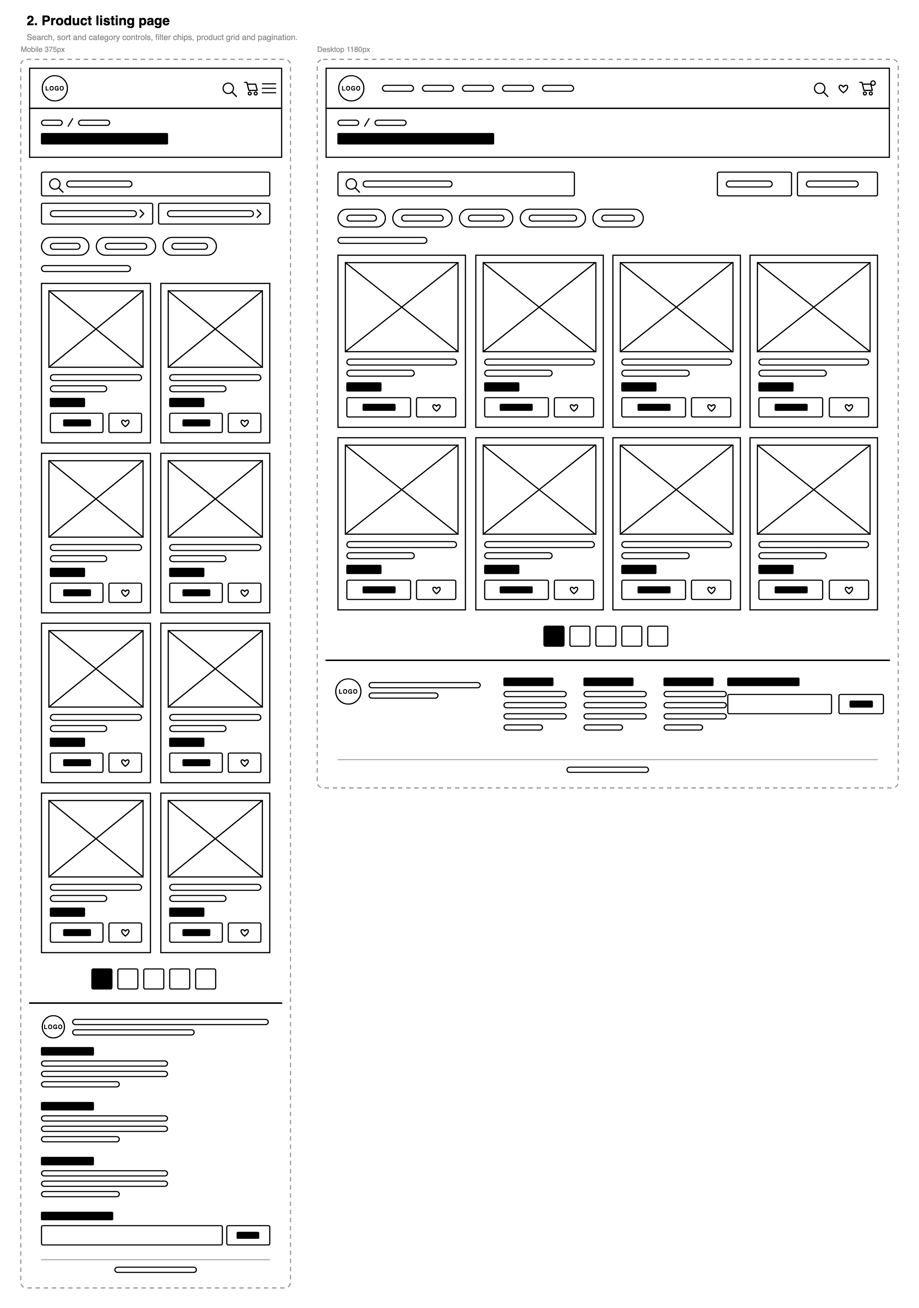
Wireframe of the product listing page in mobile and desktop layouts
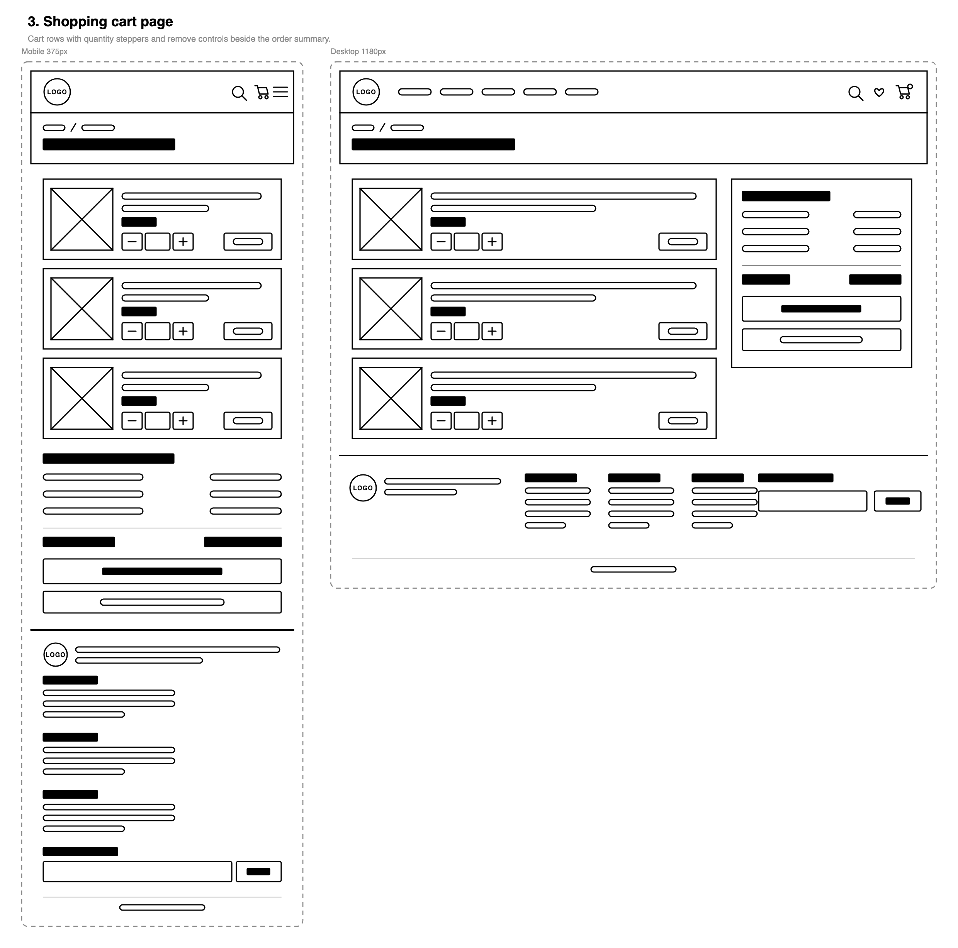
Wireframe of the shopping cart page in mobile and desktop layouts
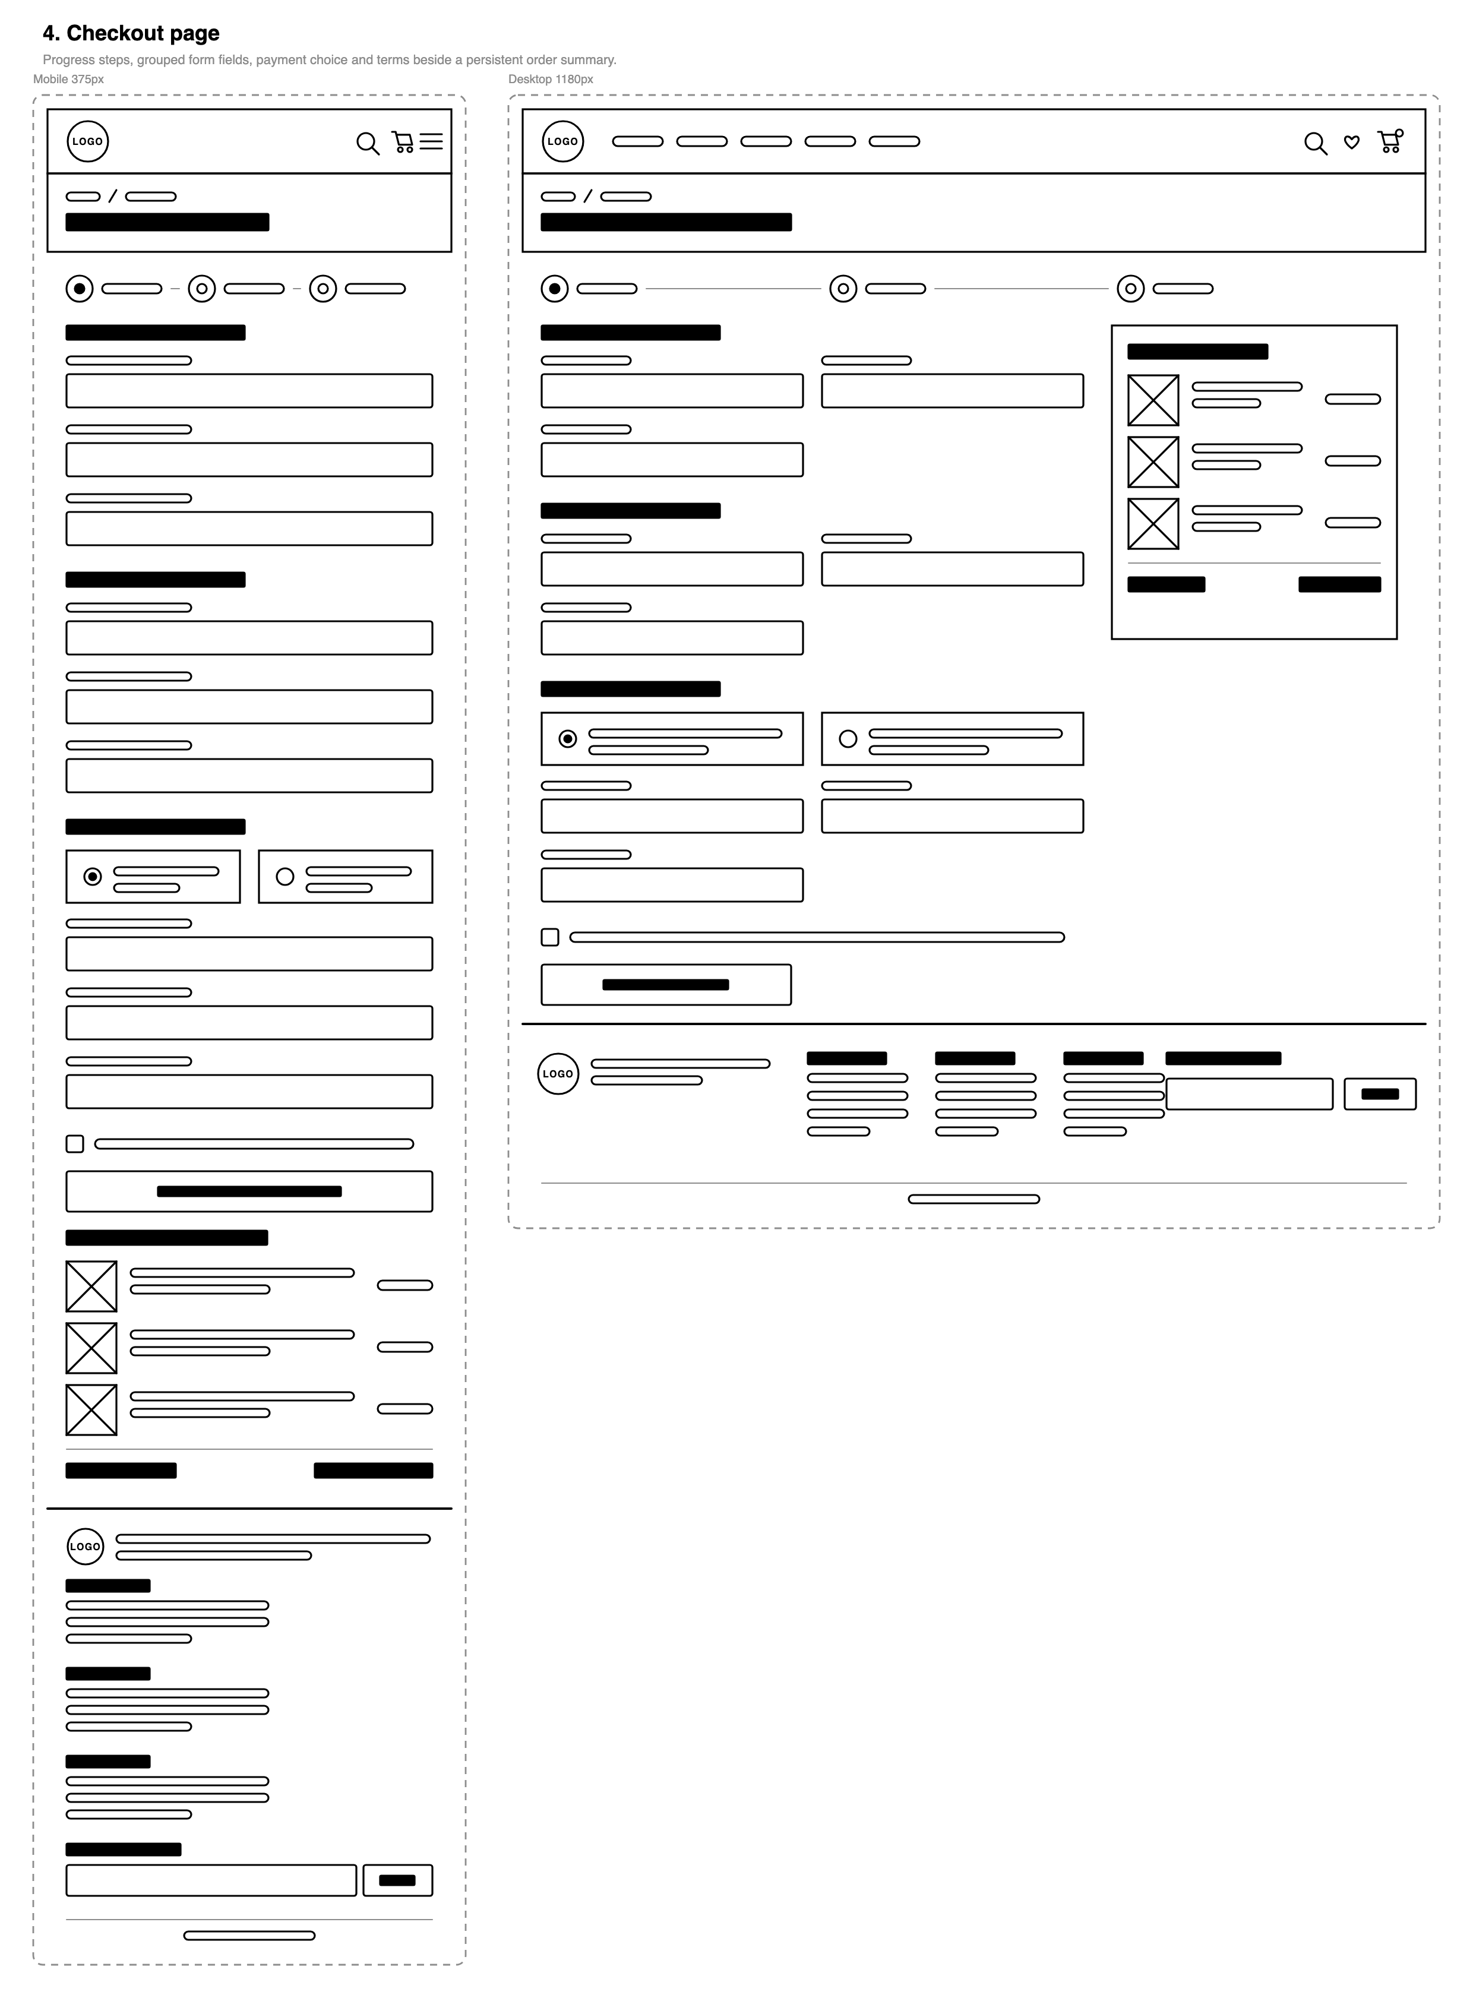
Wireframe of the checkout page in mobile and desktop layouts
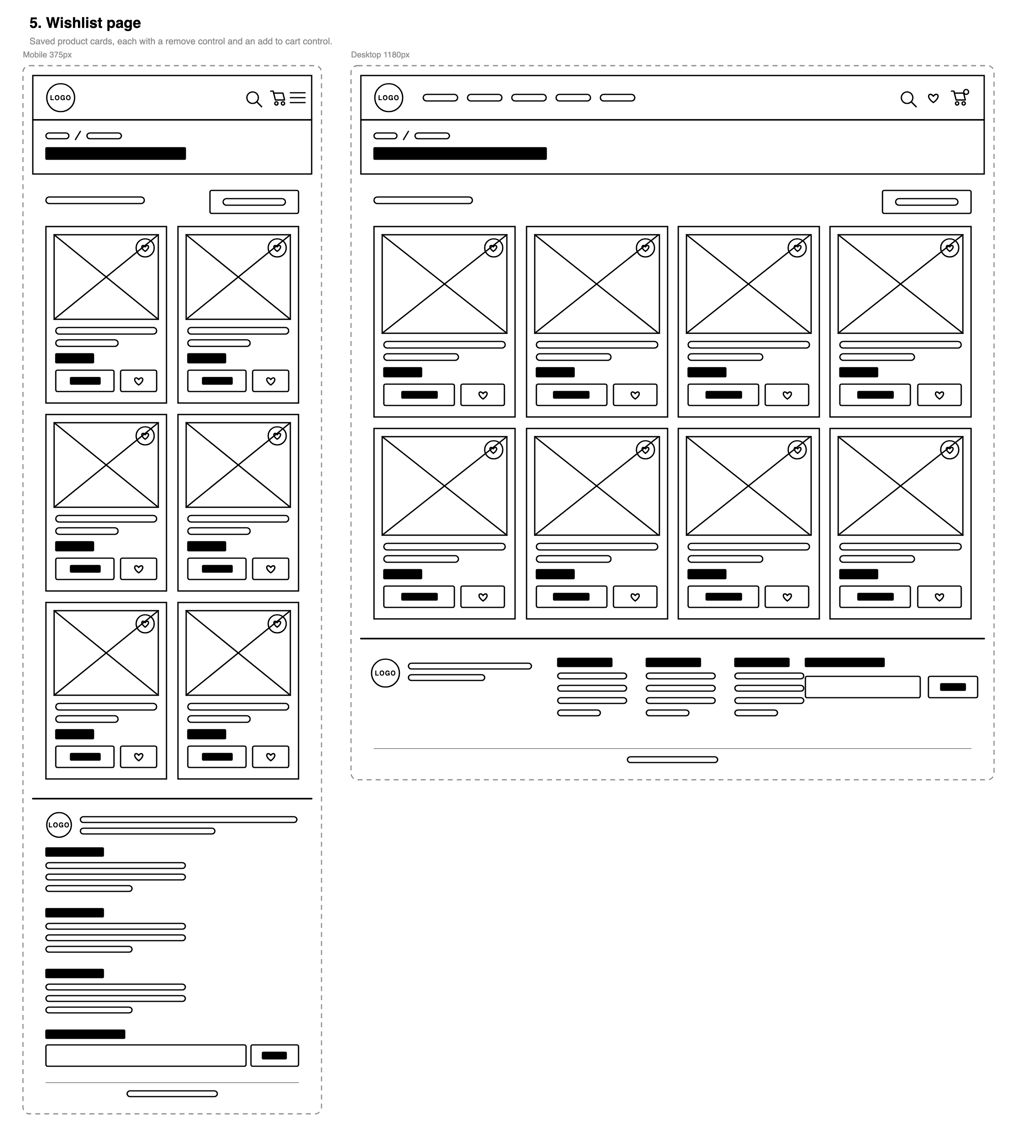
Wireframe of the wishlist page in mobile and desktop layouts
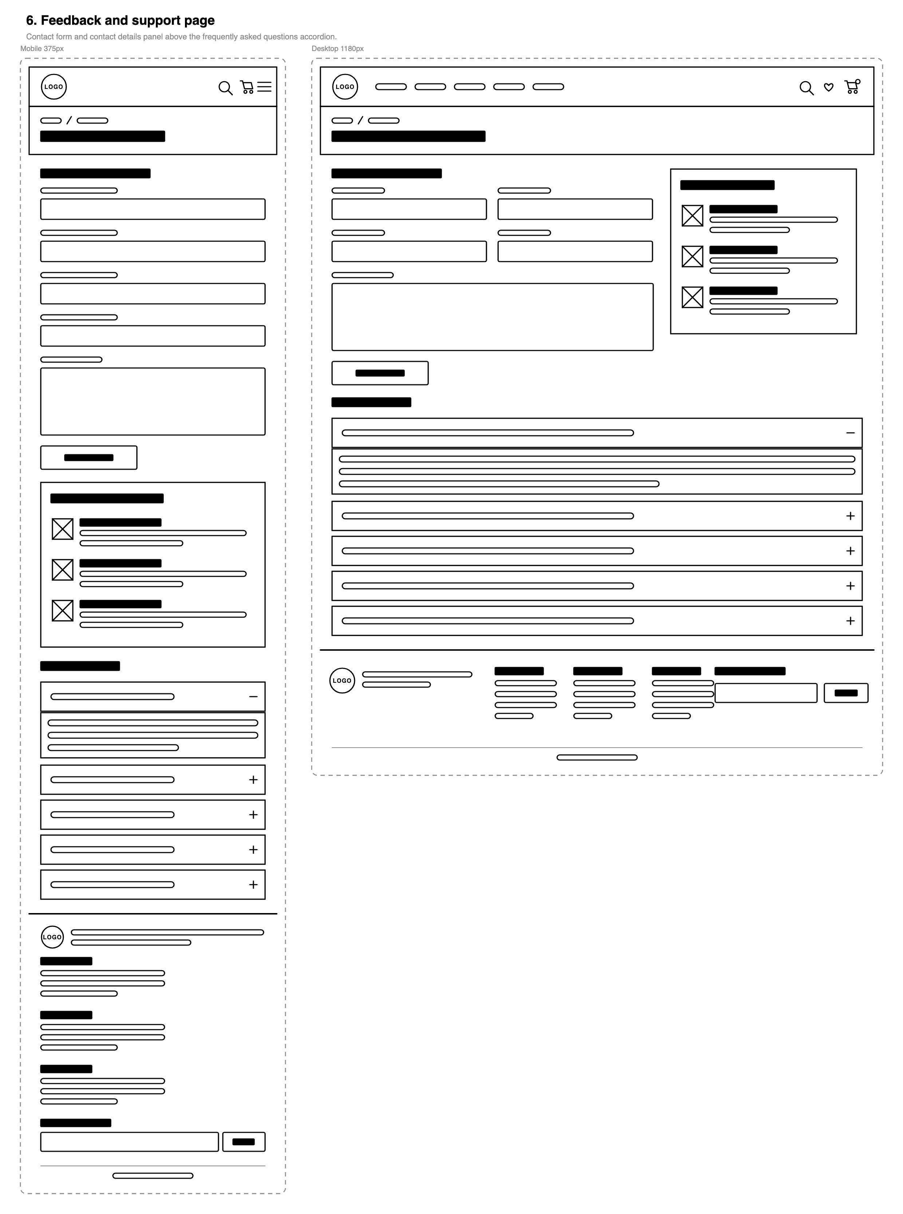
Wireframe of the feedback and support page in mobile and desktop layouts

3. Features by page
What each page contains and which requirement it satisfies
Page | Features
Home | Auto-rotating hero carousel (four promotional banners, 6-second interval, pauses on hover, focus and tab change, arrow-key support, dots and prev/next controls); responsive navigation with an animated hamburger; four category cards; Featured Product of the Day chosen from the calendar date; four top-rated product highlights; value grid; an ordered "how it works" list; live statistics calculated from the catalogue; footer newsletter form saved to localStorage.
Products | All 24 products rendered from the JSON catalogue as interactive cards (image, name, category, brand, rating, price); category filter chips with live counts; search by name, brand or category; five sort orders; a shareable query string (?category=toys&q=rocket); a detail modal with a full specification table; Add to Cart and Add to Wishlist on every card; friendly empty state when nothing matches.
Basket | Table of line items with product image, name, unit price, quantity stepper, line subtotal and remove; order summary with subtotal, delivery (free over £60, otherwise £4.95), 5% VAT and total; a note showing how much more is needed for free delivery; clear cart; progress indicator; empty state; the basket persists in localStorage.
Checkout | Validated form (name, email, phone, address, town, postcode); payment method switch between simulated card and cash on delivery, with card fields shown, formatted and validated only when card is selected; confirmation checkbox; live order summary; on success an animated tick, confetti, an order reference, a "what you ordered" table, the basket cleared and the order written to a local order history table.
Wishlist | Everything saved with the heart button, each item markable as Interested, Owned or Not interested; four live counters; status filter chips; move to basket; clear wishlist; empty states for both "nothing saved" and "nothing in this status".
Support | Fully validated feedback form (name, email, topic, message with a 10–600 character rule); animated confirmation with a reference; a table of messages stored on the device; contact details; an opening-hours table; a six-question FAQ accordion built with JavaScript, one answer open at a time, with arrow-key navigation.
Every page | Skip link, semantic landmarks, sticky header with live basket and wishlist counters, dark/light theme switch, scroll-reveal animations that respect prefers-reduced-motion, toast notifications instead of alert(), favicon set, PWA manifest and service worker.

4. JavaScript architecture and reusable functions
js/app.js returns a single object called TH that every page uses, and js/components.js returns THUI, which owns the markup shared between pages. If something appears on more than one page it is written once and reused.
Shared functions and where they are reused
Function | Purpose | Used on
TH.formatCurrency() | Formats every price the site shows | All six pages
TH.read() / TH.write() | Safe JSON read and write to localStorage with error handling | All six pages
TH.addToCart(), TH.setQty(), TH.cartTotals() | The single cart API — totals, delivery and VAT are calculated in one place | Home, Products, Basket, Checkout, Wishlist
TH.toggleWishlist(), TH.setWishStatus() | Wishlist storage and status handling | Home, Products, Wishlist
TH.validateField(), TH.validateForm(), TH.wireLiveValidation() | Rule-driven validation that paints inline errors and re-checks on blur | Newsletter (all pages), Checkout, Support
TH.toast() | Custom accessible notifications used instead of alert() | All six pages
TH.getProductOfTheDay() | Picks the daily featured product from the calendar day | Home
THUI.productCard() | Renders one product card — the same markup everywhere a product appears | Home, Products, Wishlist
THUI.openProduct() | Opens the detail modal, traps focus and restores it on close | Home, Products, Wishlist
THUI.emptyState() | Builds the illustrated empty state | Products, Basket, Wishlist

5. Testing

5.1 How the site was tested
- Functional testing: the 48 test cases below were executed in Google Chrome 152 on macOS, against the deployed site and a local server.
- HTML validity: every page submitted to the W3C Nu Markup Validation Service.
- CSS validity: all three stylesheets submitted to the W3C CSS Validation Service (CSS level 3 + SVG profile).
- Accessibility: WAVE and axe-core run on every page, in both light and dark themes, including the open modal and the invalid-form state.
- Lighthouse: every page audited in both the mobile and desktop presets.
- Responsiveness: checked at 320, 375, 414, 768, 1024, 1280 and 1600px.

5.2 Test cases
48 functional test cases, all executed and passed
ID | Area | Test | Steps | Expected result | Status
TC-01 | Global | Navigation links | Click each link in the header on every page | The matching page loads and its link is marked as the current page | Pass
TC-02 | Global | Animated hamburger menu | Narrow the window below 880px, click the hamburger | The bars animate into a cross, the menu slides open, Escape and choosing a link close it again | Pass
TC-03 | Global | Skip link | Press Tab on page load, then Enter | The skip link becomes visible and focus jumps to the main content | Pass
TC-04 | Global | Theme switch | Click the moon/sun button, reload the page | The site switches theme immediately and the choice is remembered on the next visit | Pass
TC-05 | Global | Basket counter | Add any product to the basket | The header counter increases, animates once and matches the basket contents on every page | Pass
TC-06 | Global | Wishlist counter | Save a product with the heart button | The wishlist counter in the navigation increases on every page | Pass
TC-07 | Global | Footer newsletter — invalid | Enter "not-an-email" and submit | Submission is blocked and "Enter an email address such as you@example.com." appears under the field | Pass
TC-08 | Global | Footer newsletter — valid | Enter collector@example.com and submit | A confirmation appears, a toast is shown and the address is stored under toyhaven.newsletter | Pass
TC-09 | Global | Footer newsletter — duplicate | Submit the same address twice | The second attempt reports that the address is already subscribed and is not stored twice | Pass
TC-10 | Global | Scroll reveal | Scroll down any page | Sections fade and rise into place once, and do not animate when the operating system requests reduced motion | Pass
TC-11 | Home | Carousel auto-rotation | Load the home page and wait | The hero changes slide every six seconds and loops back to the first slide | Pass
TC-12 | Home | Carousel controls | Click the next, previous and dot controls | The matching slide is shown, the active dot widens and the timer restarts | Pass
TC-13 | Home | Carousel pause | Hover over the hero, then move away | Rotation pauses while hovered or focused and resumes afterwards | Pass
TC-14 | Home | Carousel keyboard | Focus the hero and press the left and right arrow keys | The previous and next slides are shown | Pass
TC-15 | Home | Hidden slides are not focusable | Tab through the hero | Only the links of the visible slide receive focus | Pass
TC-16 | Home | Featured Product of the Day | Load the home page | One product is shown with its rating, three specifications, price and buttons; the same product is shown all day | Pass
TC-17 | Home | Featured highlights | Load the home page | The four highest-rated products are rendered as cards from the catalogue | Pass
TC-18 | Home | Live statistics | Load the home page | Products, categories, average rating and total reviews are calculated from the data, not hard coded | Pass
TC-19 | Home | Category cards | Click a category card | The product page opens filtered to that category | Pass
TC-20 | Products | Full catalogue renders | Open the product page | 24 cards are shown, each with image, name, category, rating, brand, age guidance and price | Pass
TC-21 | Products | Category filter | Click "Board Games" | Only the six board games remain and the results line reports "Showing 6 of 24 products in Board Games" | Pass
TC-22 | Products | Search | Type "rocket" in the search box | Only Cosmo Launch Rocket remains, updating as you type | Pass
TC-23 | Products | Search with no results | Type "zzzz" | The grid empties and an empty state offers to reset the shelf | Pass
TC-24 | Products | Sorting | Choose "Price: low to high", then "Customer rating" | Cards reorder correctly for each option | Pass
TC-25 | Products | Deep link | Open products.html?category=toys&q=rocket | The page opens already filtered and searched, with the chip and search box pre-set | Pass
TC-26 | Products | Reset filters | Apply filters, then click Reset filters | All 24 products return, the search box empties and the query string is cleared | Pass
TC-27 | Products | Product modal | Click Details on any card | A modal opens with a large image, description, price and a specification table | Pass
TC-28 | Products | Modal close and focus | Press Escape, click the backdrop, click the close button | The modal closes each way and focus returns to the button that opened it | Pass
TC-29 | Products | Add to cart from a card | Click Add to Cart | A success toast appears and the header counter increases | Pass
TC-30 | Products | Add to wishlist from a card | Click the heart | The heart fills, its label changes to "Remove …" and the wishlist counter increases | Pass
TC-31 | Basket | Line items | Add three different products and open the basket | Each product appears once with image, unit price, quantity and line subtotal | Pass
TC-32 | Basket | Increase quantity | Click + on a line | Quantity, line subtotal and all totals increase immediately | Pass
TC-33 | Basket | Decrease to zero | Click − until the quantity reaches zero | The line is removed from the basket and the totals update | Pass
TC-34 | Basket | Remove | Click Remove on a line | The line disappears, a toast confirms it and the counter updates | Pass
TC-35 | Basket | Delivery threshold | Basket under £60, then over £60 | Delivery is £4.95 with a note about the shortfall, then Free with a confirmation note | Pass
TC-36 | Basket | VAT and total | Compare the summary against a manual calculation | VAT is 5% of the subtotal and the total is subtotal + delivery + VAT | Pass
TC-37 | Basket | Persistence | Add products, close the browser, reopen the site | The basket is exactly as it was left | Pass
TC-38 | Basket | Clear cart | Click Clear cart | Every line is removed and the empty state with a Shop Now button is shown | Pass
TC-39 | Checkout | Empty basket | Open the checkout with an empty basket | The form is replaced by a message explaining there is nothing to check out | Pass
TC-40 | Checkout | Required fields | Submit the empty form | Ten inline errors appear, focus moves to the first invalid field and nothing is submitted | Pass
TC-41 | Checkout | Format rules | Enter "abc" as the email, "12" as the card number, "99/99" as the expiry | Each field reports its own specific message and blocks submission | Pass
TC-42 | Checkout | Cash on delivery | Choose Cash on delivery | Card fields are hidden and are no longer required; the order can be placed without them | Pass
TC-43 | Checkout | Order confirmation | Complete the form and submit | An animated tick, confetti, an order reference and a table of what was ordered are shown | Pass
TC-44 | Checkout | Basket cleared and history saved | Check the header and the history table after ordering | The basket counter returns to zero and the order appears in the local order history | Pass
TC-45 | Wishlist | Status marking | Mark a saved product Interested, then Owned | The chosen button is highlighted, the counters update and the choice survives a reload | Pass
TC-46 | Wishlist | Status filters and empty state | Filter by Owned with nothing owned | An empty state explains that nothing is marked owned yet | Pass
TC-47 | Support | Feedback validation and storage | Submit an empty form, then a valid one | Errors are shown first; the valid message produces a reference, a confirmation panel and a row in the saved-messages table | Pass
TC-48 | Support | FAQ accordion | Click several questions, then use the arrow keys | Only one answer is open at a time, the plus icon rotates and the arrow keys move between questions | Pass

5.3 HTML validation: W3C Nu Markup Validation Service
Every page returns no errors and no warnings
Page | Errors | Warnings | Result
index.html | 0 | 0 | Pass
products.html | 0 | 0 | Pass
cart.html | 0 | 0 | Pass
checkout.html | 0 | 0 | Pass
wishlist.html | 0 | 0 | Pass
support.html | 0 | 0 | Pass
offline.html | 0 | 0 | Pass

Validation turned up two problems and both were fixed. An <aside> was nested inside a section, so it became a titled <section>, and the screen-reader utility still used the old space-separated clip: rect(0 0 0 0) shorthand, which I rewrote with commas and paired with clip-path.

5.4 CSS validation: W3C CSS Validation Service
CSS level 3 + SVG profile
Stylesheet | Errors | Warnings | Result
css/base.css | 0 | 5 — custom properties cannot be checked statically, plus one vendor prefix | Pass
css/components.css | 0 | 151 — all "CSS variables are not statically checked" | Pass
css/pages.css | 0 | 114 — all "CSS variables are not statically checked" | Pass

The warnings are informational. The validator cannot work out the value of a CSS custom property while it is checking, so it raises one warning for every use. The only other warning is the -webkit-text-size-adjust prefix, which I kept on purpose to stop iOS Safari inflating text in landscape.
The result pages for all three stylesheets are below, taken from the deployed site rather than from local copies.
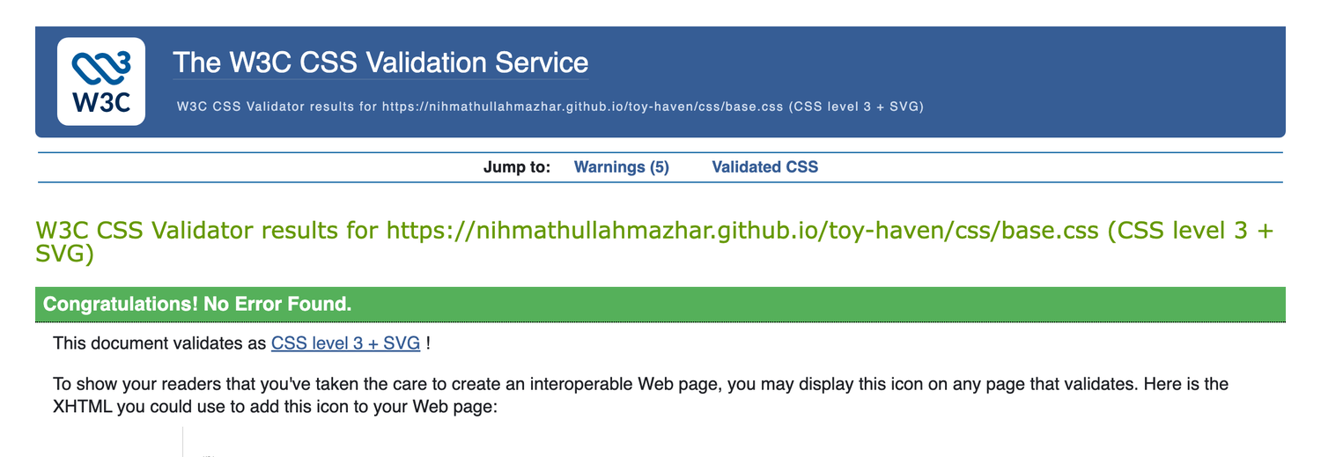
W3C CSS Validation Service result for base.css: no errors found
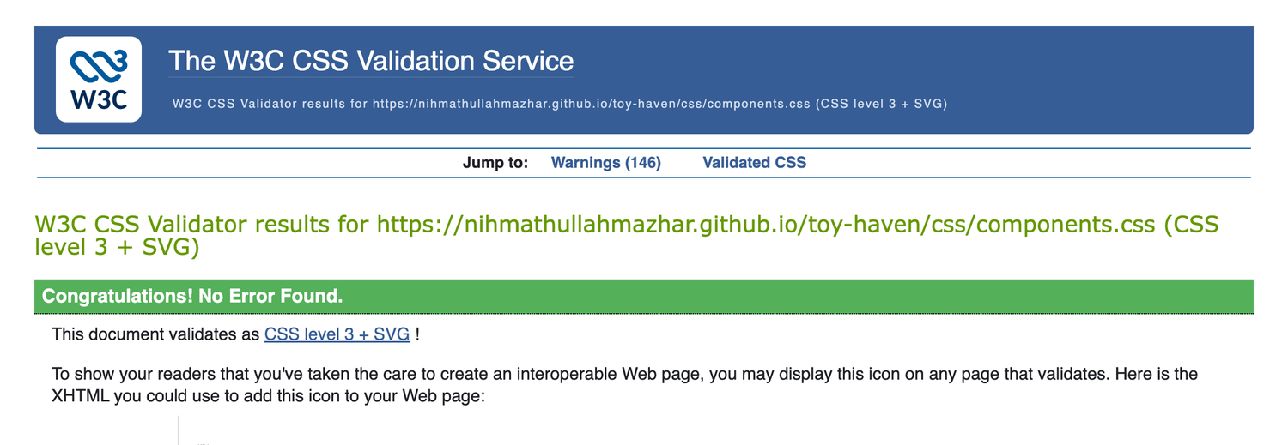
W3C CSS Validation Service result for components.css: no errors found
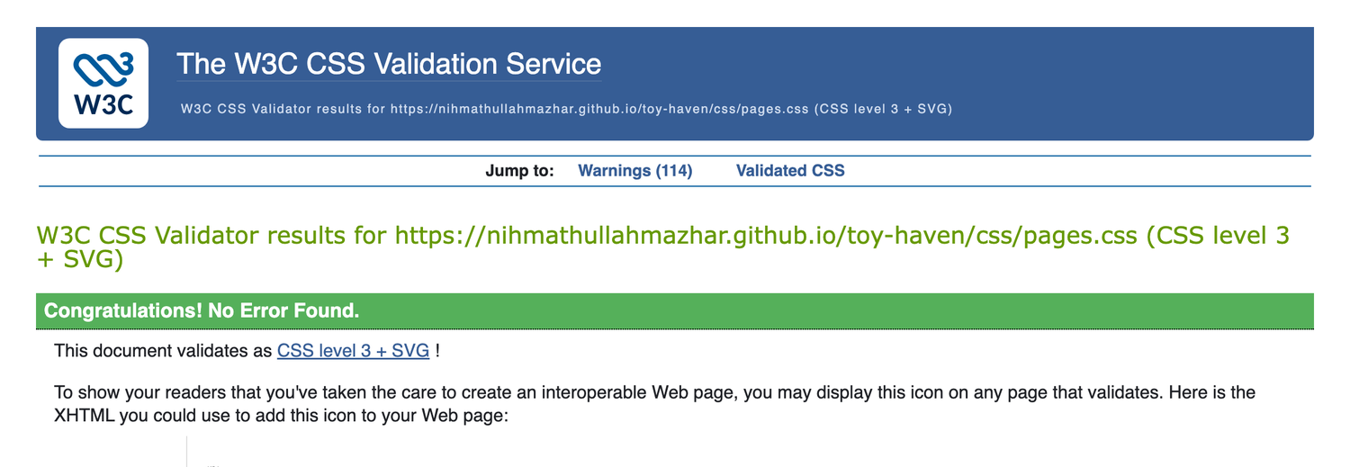
W3C CSS Validation Service result for pages.css: no errors found

5.5 Accessibility: WAVE and axe-core
Errors and contrast errors per page, in both themes
Page | Errors | Contrast errors | Result
Home | 0 | 0 | Pass
Products (including the open modal) | 0 | 0 | Pass
Basket | 0 | 0 | Pass
Checkout (including the invalid form state) | 0 | 0 | Pass
Wishlist | 0 | 0 | Pass
Support (including an open FAQ answer) | 0 | 0 | Pass

The accessibility work behind those results:
- Landmarks on every page: header, nav, main, footer, plus a skip link.
- A visible label for every form control, errors announced with role="alert" and linked by aria-invalid.
- Descriptive alternative text on product images, and empty alt on the purely decorative hero backgrounds.
- State exposed to assistive technology: aria-pressed on filter, heart and status buttons, aria-expanded on the hamburger and FAQ triggers, aria-current on the active page and slide.
- The carousel marks hidden slides with aria-hidden and removes their links from the tab order.
- The modal sets aria-modal, moves focus to its close button and returns focus to the trigger.
- Toasts are announced politely through a live region instead of interrupting with alert().
- All animation is disabled under prefers-reduced-motion, and both themes meet AA contrast.

5.6 Lighthouse
Google Lighthouse 12, headless Chrome, default mobile preset and desktop preset
Page | Mobile | Desktop
Perf. | Access. | Best pr. | SEO | Perf. | Access. | Best pr. | SEO
Home | 99 | 100 | 100 | 100 | 100 | 100 | 100 | 100
Products | 100 | 100 | 100 | 100 | 91 | 100 | 100 | 100
Basket | 100 | 100 | 100 | 100 | 100 | 100 | 100 | 100
Checkout | 100 | 100 | 100 | 100 | 100 | 100 | 100 | 100
Wishlist | 99 | 100 | 100 | 100 | 100 | 100 | 100 | 100
Support | 99 | 100 | 100 | 100 | 100 | 100 | 100 | 100

Every audit was run with Lighthouse 12.8 in headless Chrome. My first run scored 84 on mobile. Three changes took it to 99–100:
- Google Fonts are now preloaded and applied without blocking the first paint, with a <noscript> fallback — this removed 1.75 seconds of render blocking.
- Every product and banner image ships in two sizes (320px and 640px products, 800px and 1280px banners) served through srcset and sizes.
- The first hero image is preloaded and marked fetchpriority="high", which fixed a slow largest-contentful-paint.
The deployed site on GitHub Pages, audited over the public internet
Preset | Performance | Accessibility | Best practices | SEO
Mobile | 93 | 100 | 100 | 100
Desktop | 99 | 100 | 100 | 100

The live scores sit a few points below the local ones because of network latency and nothing else. Lighthouse measured a 900 ms server response on the first request, and GitHub Pages sets a ten-minute cache lifetime; neither can be changed from the site’s own code. Total blocking time is 0 ms and cumulative layout shift is 0.029 on both presets.

5.7 Responsiveness
Layout checked across device widths
Width | Representative device | Behaviour | Result
320px | iPhone SE (1st gen) | Single column, hamburger menu, one card per row, no horizontal scrolling | Pass
375px | iPhone SE / 13 mini | The reference mobile layout; hero copy panel fits without clipping | Pass
414px | iPhone Pro Max | As 375px with more comfortable spacing | Pass
768px | iPad portrait | Two-column cards, footer becomes four columns, modal becomes two columns | Pass
1024px | iPad landscape / small laptop | Full navigation returns, basket and checkout become two columns, four cards per row | Pass
1280–1600px | Desktop | Content is capped at 1180px and centred, so lines stay readable | Pass

5.8 Progressive web app
Installability and offline behaviour
Check | Expected | Result
Manifest | Name, short name, description, scope, start URL, standalone display, theme colours, 192px, 512px and maskable icons, three shortcuts | Pass
Favicons | favicon.ico, 32px PNG and a 180px Apple touch icon on every page | Pass
Service worker | Registers, activates and pre-caches 32 files of the application shell | Pass
Offline | Visited pages open with the network disabled; an unvisited page falls back to offline.html | Pass
Install | Chrome offers "Install Toy Haven" and the app opens in its own window | Pass

5.9 Screenshots of the finished site
The screenshots below were taken from the finished site in Chrome at two window widths, 390px and 1280px, with nothing changed between the two apart from the width of the window. They are the evidence behind the responsiveness table above: the same markup produces a single column with a hamburger menu on a phone and a multi-column layout on a desktop.
Every page at 390px (left) and at 1280px (right)
Home | 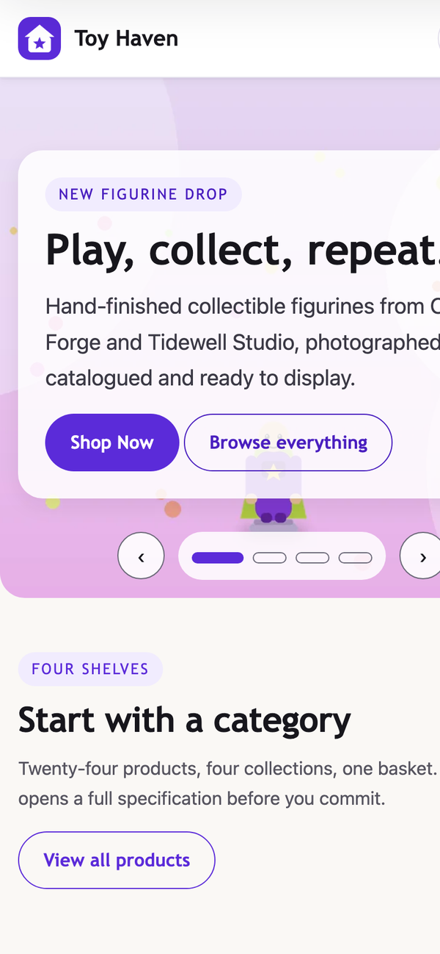 | 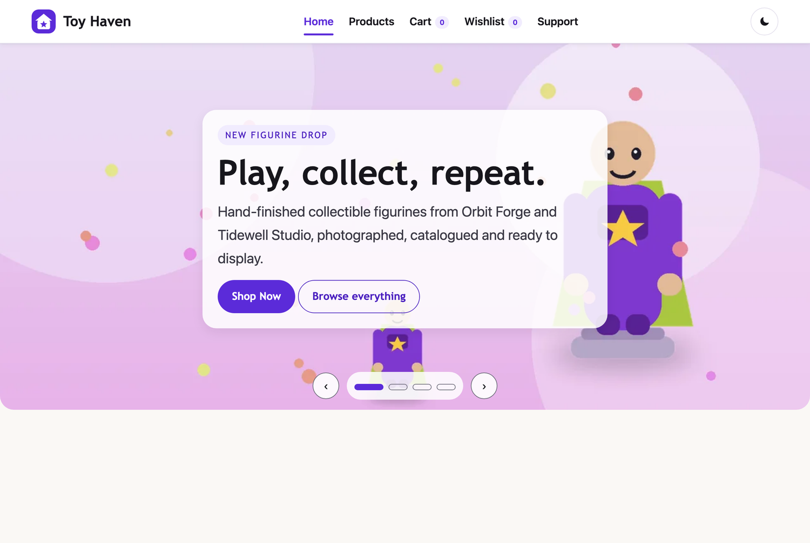
Products | 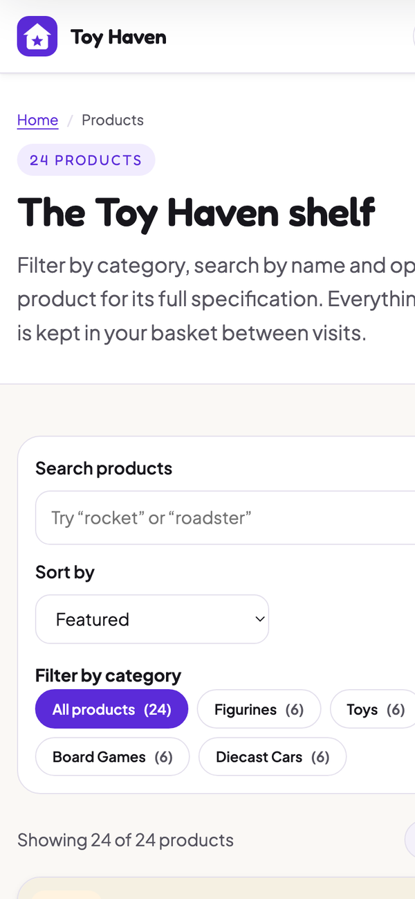 | 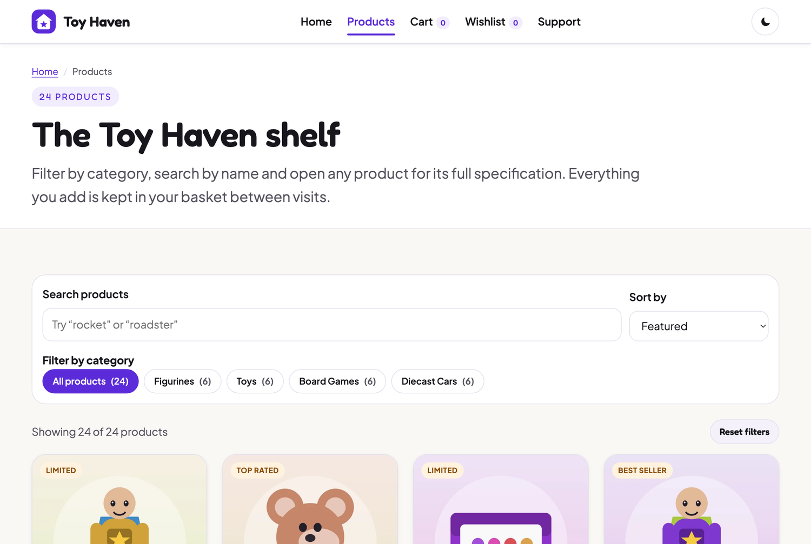
Basket | 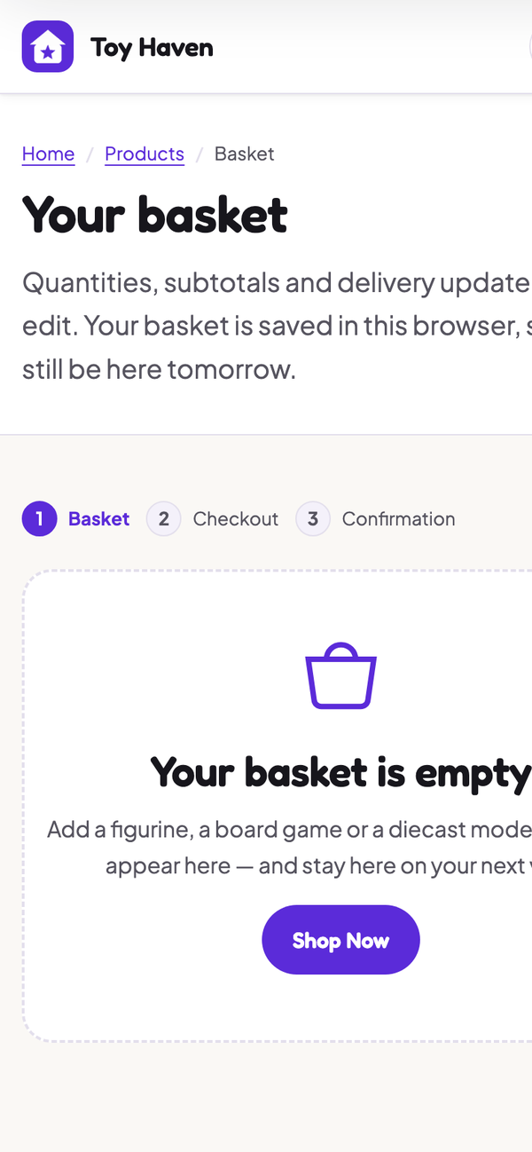 | 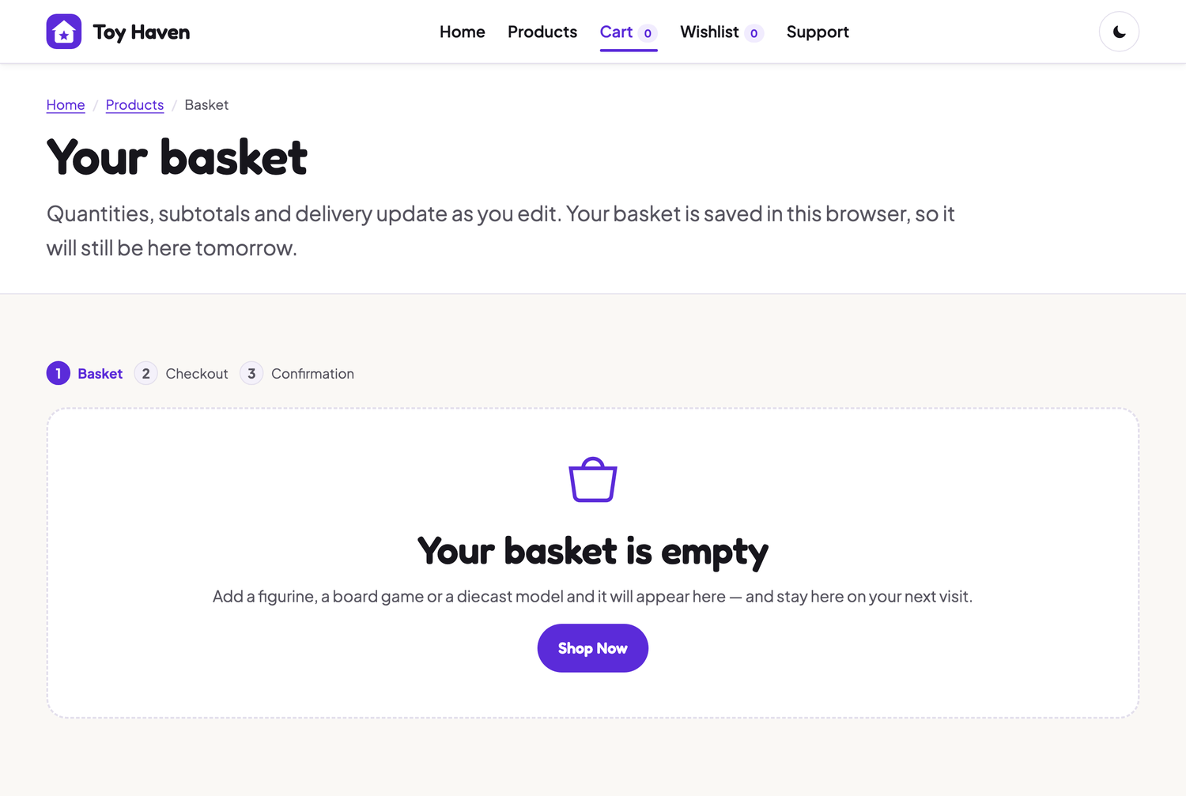
Checkout | 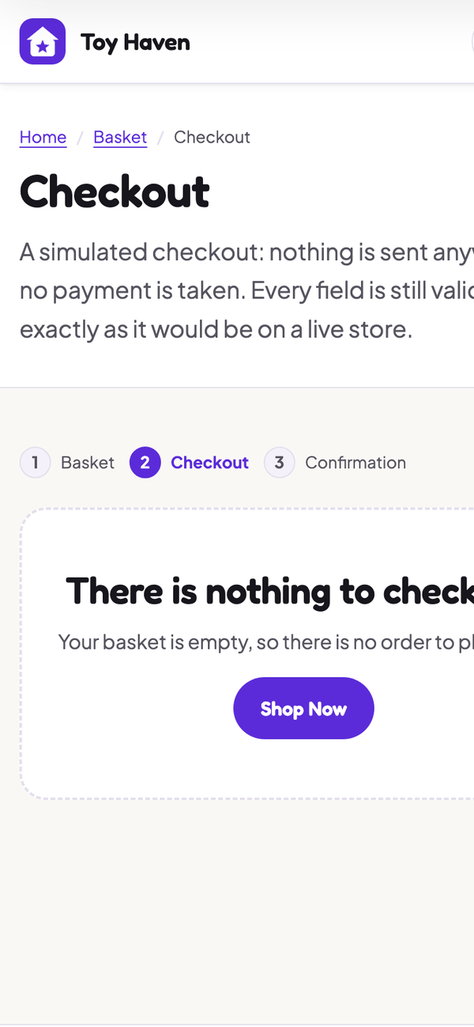 | 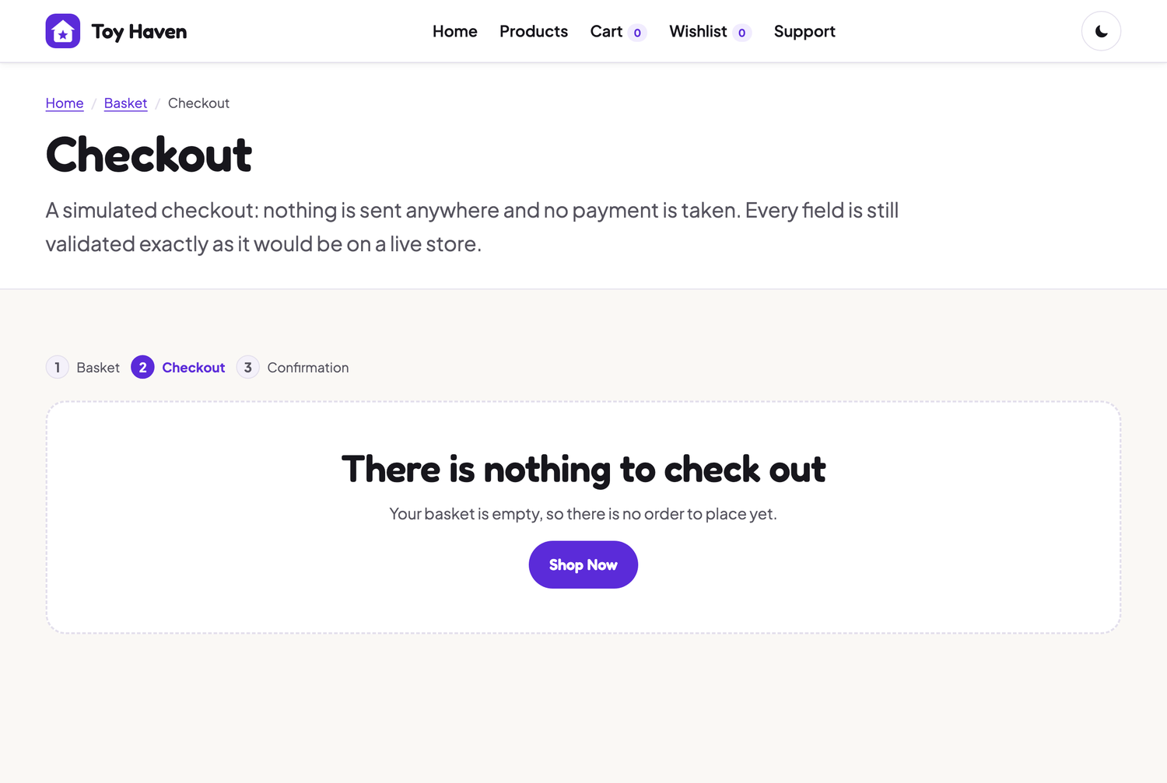
Wishlist | 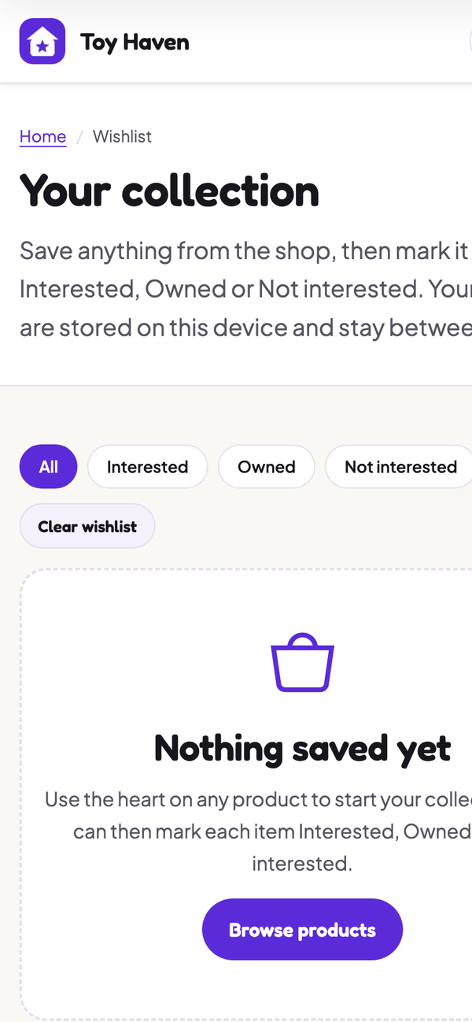 | 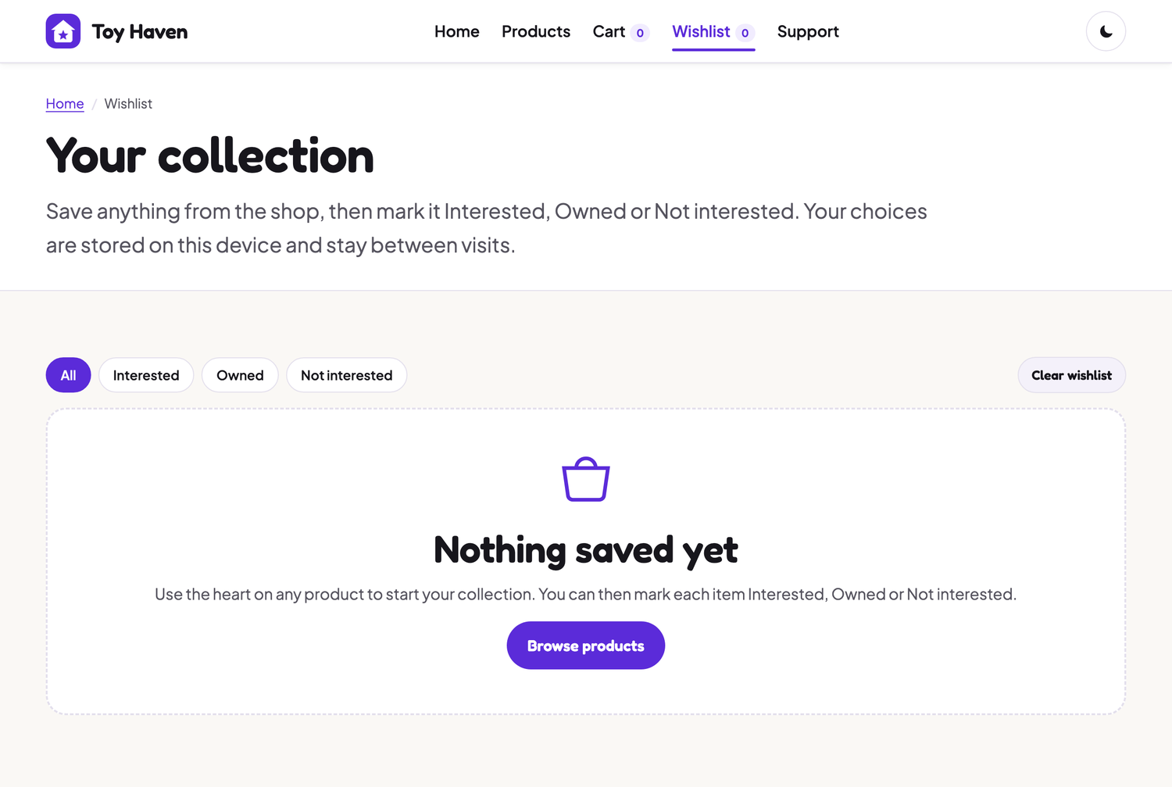
Support | 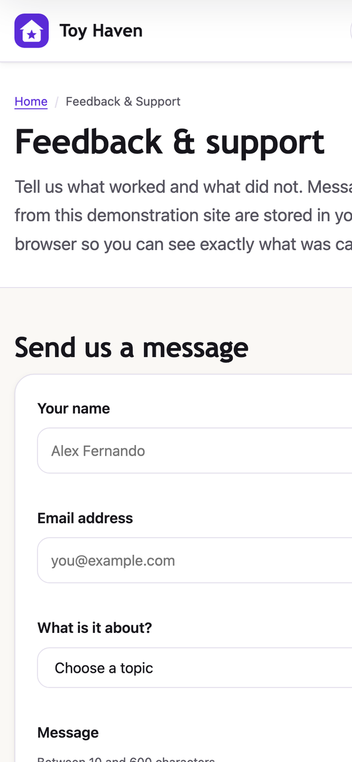 | 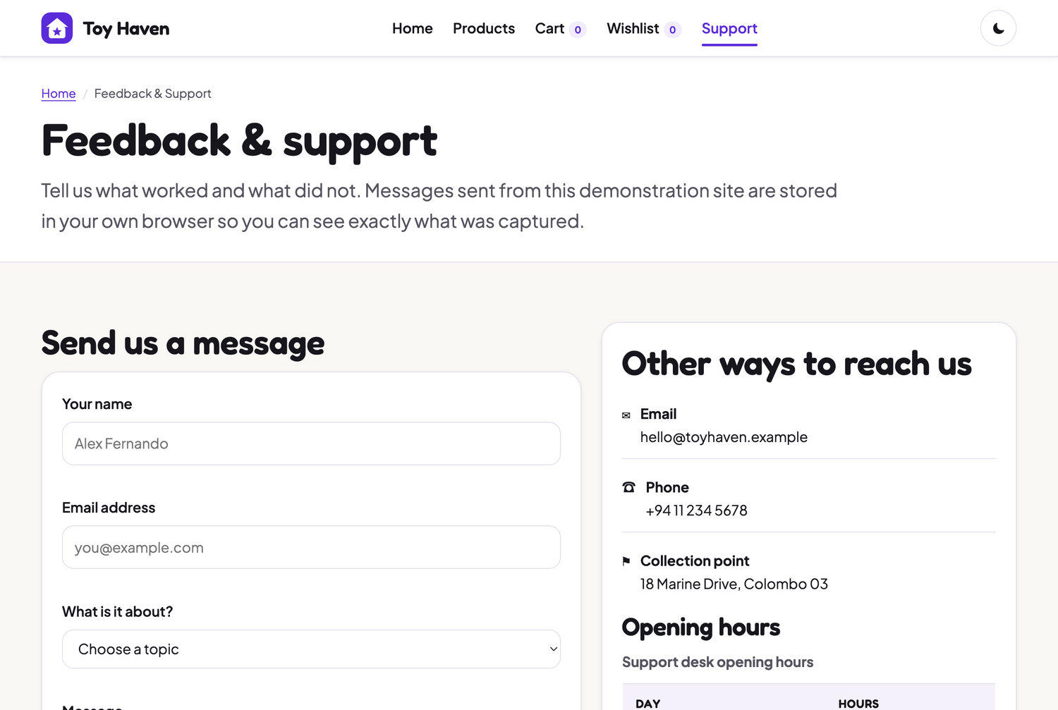

6. Hosting and deployment
- The project was committed to a dedicated repository named toy-haven.
- GitHub Pages was enabled in Settings → Pages, deploying from the main branch, / (root) folder.
- The site is publicly available at https://nihmathullahmazhar.github.io/toy-haven/ and was re-tested after deployment.
Every path in the site is relative, so it works at the repository sub-path on GitHub Pages and equally from the root of any other server.

7. Known limitations and future work
- There is no back end, so orders, messages and subscriptions stay on the device that created them; clearing browser data clears them.
- Payment is simulated. No card details are transmitted, stored or validated against a payment provider beyond format checks.
- The catalogue is fixed at 24 products in js/data.js. It is deliberately shaped like an API response so it could be replaced with a fetch() call without touching the rendering code.
- Product photography is replaced by original vector-style illustrations generated for this project, so no third-party images are used.
- Possible next steps: pagination or infinite scroll for a larger catalogue, product reviews, and a background-sync queue so orders placed offline are sent when the connection returns.

