|  |  |
| --- | --- |
|  |  |
| Client: | UCSD |
| Project: | Open Speech Platform |
| Document Number: | UCD-001-D002 |
| Document Title: | Procedure, Build Up and Testing, OSP |
| Submitted By: | Alexander Lynch |
| Date: | 6/8/2020 |

Table of Contents

1.0 Purpose and scope 3

2.0 Required Materials and Hardware 3

2.1 PCD 3

2.2 DJB 4

3.0 Acronyms and Terms Defined 4

4.0 Recommended Tools and Equipment 5

5.0 PCD Wearable Build-up procedure 5

5.1 Setup 5

5.2 Build-up 5

5.3 Acceptability Testing 6

6.0 DJB Earpiece Build-Up Procedure 6

6.1 Setup 6

6.2 Build Up DJB Earpiece 6

6.2.2 Build up custom USB Type-C Male plug and cable 6

6.2.8 Pre-test DJB PCB sub-assembly with PCD wearable before case assembly 8

Appendix 1: Serialization scheme 10

# Purpose and scope

This document gives instructions for building up and testing for acceptability Open Speech Platform (OSP) kits which included one (1) portable computing device (PCD) wearable and two (2) behind-the-ear-receiver-in-canal (BTE-RIC) or as also called “digital jelly bean” (DJB) earpieces. The PCD wearable comprises a battery-powered PCB assembly of the carrier board (a custom PCB with various i/o ports) and an off-the-shelf Wi-Fi enabled SOM mounded inside an MJF housing. The DJB earpiece also comprises a corded PCB board assembly of a custom rigid board and a custom flexible board with microphones suspended and encased in an SLA chassis and housing, respectively.

# Required Materials and Hardware

Materials and hardware are listed in order of assembly. Each kit contains 1 PCD unit and 2 DJB units

## PCD

|  |  |
| --- | --- |
| Item | Quantity per unit |
| OSP Carrier Board | 1 EA |
| Variscite DART-SD410 or equivalent SOM | 1 EA |
| WiFi Antenna | 1 EA |
| Shell, Bottom Half, PCD Case | 1 EA |
| PCD Heat set inserts, M1.6 | 3 EA |
| PCD Heat set inserts, M1.4 | 2 EA |
| Switch, Power, PCD Case | 1 EA |
| Button, Side, PCD Case | 2 EA |
| Samsung EA-BP2000 or equivalent battery (Li-ion; 3.7V; 2000 mAh) | 1 EA |
| Shell, Top Half, PCD Case | 1 EA |
| PCD adhesive foam tape | 4 CM |
| PCD Socket Head Cap Screws, M1.4x8 | 2 EA |
| PCD Socket Head Cap Screws, M1.6x8 | 3 EA |
| PCD Lanyard Dowel Pins | 2 EA |
| PCD Double hook lanyards | 1 EA |

## DJB

|  |  |
| --- | --- |
| Item | Quantity per unit |
| Mogami 4c. 33 awg Micro Mini Cable-GRY/SP or equivalent cable | 60 cm |
| Male plug USB 3.1 Type C DIY kit | 1 EA |
| Heat shrink cable sleeve | 15 mm |
| Metal ferrule, flanged | 1 EA |
| Wire Solder | 10+ drops |
| Electronics potting glue | 20+ drops |
| Grommet, Strain Relief, Housing, Alt, DJB | 1 EA |
| DJB P51-4994 mic-screen | 2 EA |
| DJB mic boot (pack of 200?) | 2 EA |
| Chassis, Left Half, DJB Case | 1 EA |
| Chassis, Right Half, DJB Case | 1 EA |
| Shell, Bottom Half, DJB Case | 1 EA |
| Shell, Top Half, DJB Case | 1 EA |
| DJB chassis pins, .270 | 2 EA |
| DJB chassis pins, .240 | 1 EA |
| DJB chassis pins, .230 | 1 EA |
| Black cyanacrolate, Loctite 4211 | 10+ drops |
| RIC Link, left | 1 EA |
| RIC Link, right | 1 EA |

# Acronyms and Terms Defined

|  |  |
| --- | --- |
| Term | Definition |
| OSP | Open Speech Platform |
| PCD | Portable Computing Device wearable |
| BTE-RIC | Behind-The-Ear-Receiver-In-Canal |
| DJB | Digital Jelly Bean earpiece |
| MJF | Multi-Jet Fusion, a 3D printing process with a nylon-like material |
| SLA | Stereo Lithography, a 3D printing process with an ABS or polypropylene-like material |
| SOM | System On Module |
| Carrier Board | The custom PCB of the PCD wearable with various i/o ports |
| Rigid Board | A custom PCB of the DJB wearable with various i/o ports |
| Flexible Board | A custom ribbon PCB of the DJB wearable with two microphones that plugs into the Rigid Board |

# Recommended Tools and Equipment

* Soldering iron including needle point tip (for installing thread inserts)
* Tweezers
* Heat gun (for heat shrink wrap)
* Wire clippers/strippers
* Metal ferrule crimping implement
* Metric Allen key wrenches (1.5 and 2.0 hex head)
* ESD safety equipment (anti-static wristband, etc.)
* Pin vise
* 0.55mm drill bit

# PCD Wearable Build-up procedure

## Setup

Utilize proper ESD safety equipment when handling electronic parts.

## Build-up

Install thread inserts in Bottom Half case piece with soldering iron at 500°F in position as shown below.

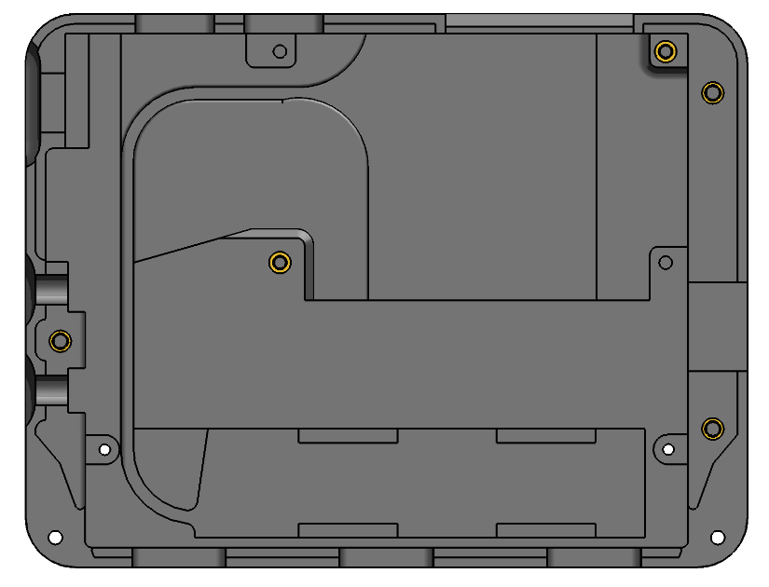

M1.4 Inserts

M1.6 Inserts

Figure . Thread insert positions in PCD Bottom Half Case

Remove tape from Wi-Fi Antenna and install in pocket as shown.

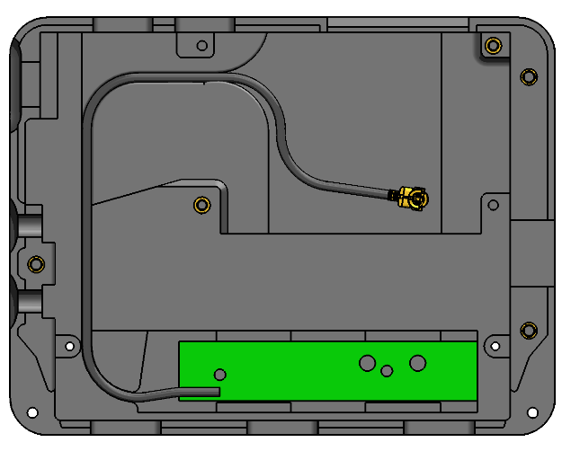

Figure . Wi-Fi antenna placement.

If not already assembled, install SOM to carrier board onto the PCD Carrier Board.

Plug in Wi-Fi Antenna connector to Wi-Fi socket on SOM.

Put Wi-Fi cable slack into pocket and place carrier board sub-assembly into position in the PCD bottom case and screw down with M1.4 screws.

Place buttons and power switch into position as shown.

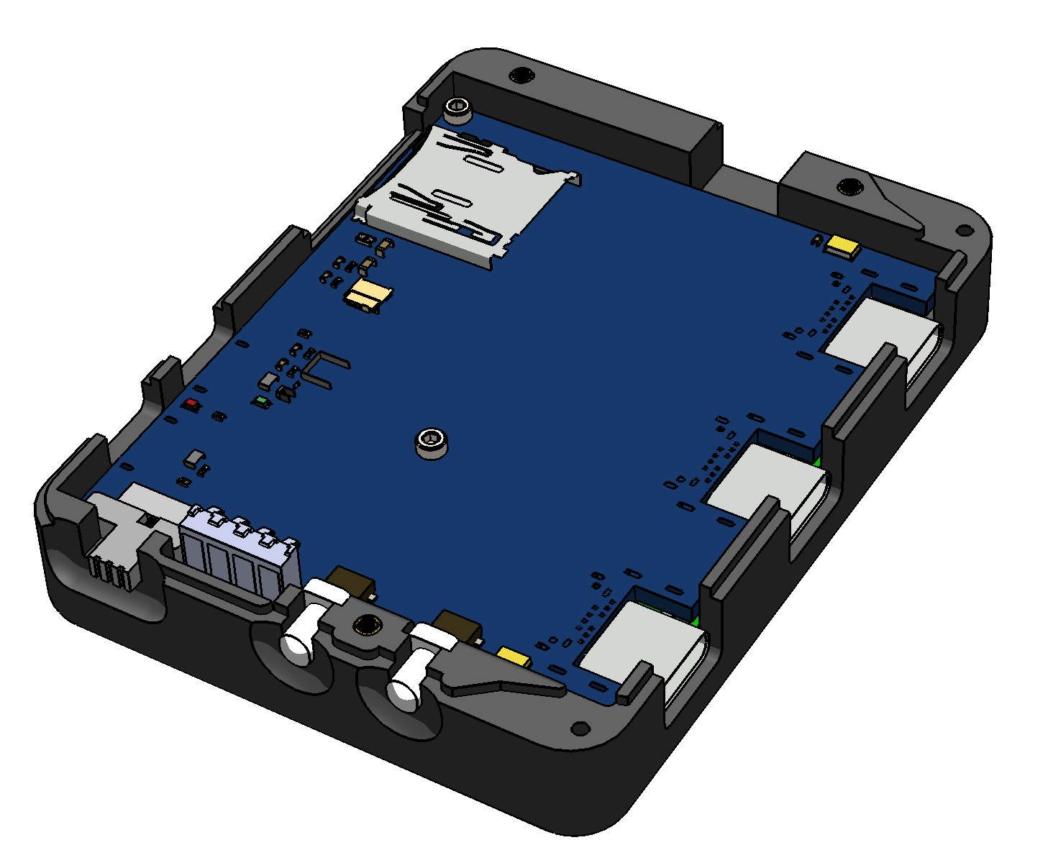

Power Switch

Power/Mute Buttons

Figure . Power Switch and Power/Mute Button placement

Place battery into position on top of carrier board and install PCD top case and screw in M1.6 screws.

Press in dowel pins.

Snap on leash.

Engrave serial number on case per predetermined schedule.

## PCD Acceptability Testing

Plug-in powered USB micro cable into ADB port. Red light should be seen near port indicating battery circuit is energized and battery is charging.

Unplug power USB micro cable. Toggle power switch to the on “I” position.

Watch for flashing indicator lights in open slit on opposite side of unit.

Unit has successfully booted when final repeating light flashing sequence is single blue pulses.

Ensure that only the PCD under testing is switched on, scan for a wireless network named “ospboard” with a wi-fi enabled computer or mobile device.

# DJB Earpiece Build-Up Procedure

## Setup

Utilize proper ESD safety equipment when handling electronic parts.

## Building Up DJB Earpiece

If the DJB rigid board looks like the following, trim the overhanging nose with trimmers back from the CS44 connector.

### Build up custom USB Type-C Male plug and cable.

* + - 1. Measure and cut length of 60 cm (or 24 inches) of 4-conductor cable.

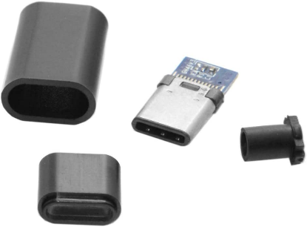

Outer housing

Inner housing

Rubber ferrule

Plug board

Figure . USB 3.1 Type C Male Plug DIY Kit components

* + - 1. Slip short cable shrink wrap length, USB kit outer housing, rubber ferrule, and metal ferrule with flange facing rubber ferrule, over cable.
      2. Cut away cable housing to expose wires.

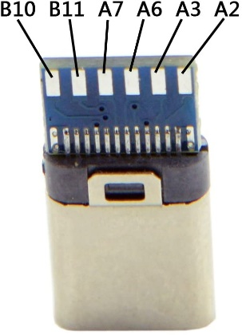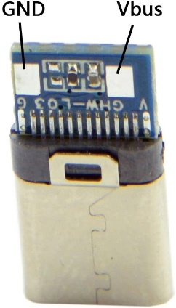

Figure . USB male plug board connection terminal diagram

* + - 1. Solder exposed wires by color to USB kit plug board per the table and figures below.

Table . USB plug board terminal wiring diagram

|  |  |
| --- | --- |
| Terminal | Wire Color |
| Vbus | **Red** |
| GND | **Black** |
| B10 | **Yellow** |
| B11 | **White** |

* + - 1. Crimp metal ferrule onto cable with flange ??mm from edge of plug board.
      2. Apply heat to shrink plastic sleeve butted up against metal ferrule flange.
      3. Nest housing over end of plug into final position fill housing with glue.
      4. Nest outer housing over inner housing into final position and apply glue to seam.
      5. Also apply glue to the gap between the rubber ferrule and the outer housing.

Slip strain relief grommet over opposite cut end of cable.

Cut away cable housing to expose wires and solder wires by color to the DJB rigid board as shown.

Table . Rigid board terminal wire assignment

|  |  |
| --- | --- |
| Terminal | Wire Color |
| G | **Black** |
| D+ | **White** |
| D­- | **Yellow** |
| V | **Red** |

Place small dab of glue at edge of cut cable housing.

Install rubber boots on the microphones of the DJB flexible board

Flip the ribbon socket lock handle on the DJB rigid board to the unlocked position and carefully insert the DJB flexible board connector end. Once installed, flip the ribbon socket lock handle back to the locked position.

### Pre-test DJB PCB sub-assembly with PCD wearable unit before case assembly.

* + - 1. Plug in a CS44 receiver into the DJB PCB sub-assembly.
      2. Plug the DJB’s USB cord into first the “LEFT” USB port of a powered-down fully assembled PCD unit.
      3. Hold receiver near ear and switch on PCD unit.
      4. After PCD unit is fully booted, listen to verify microphones are picking up. Lightly tap both.
      5. Repeat previous steps for “RIGHT” port on PCD.
      6. Remove CS44 receiver from DJB PCB sub-assembly and continue build-up in below steps.

Place the DJB board sub-assembly into the chassis halves with the microphone boots held snugly in their respective grooves.

Holding chassis sub-assembly together, insert particle filters into the microphone boots rim side down towards the microphone.

Place chassis sub-assembly into DJB bottom half shell

Ream pin holes in chassis and shell pieces with a 0.55mm drill bit mounted in a pin vise.

Carefully insert .240” chassis pin into bottom proximal hole.

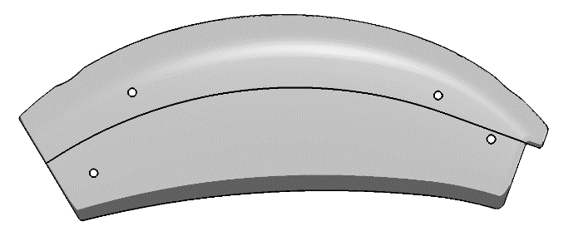

.230” pin

.240” pin

.270” pin

Figure . Pin placement on DJB assembly

Position strain relief grommet in groove of DJB bottom half shell and place dab of glue inside at interface of cable and grommet.

Install top half shell onto sub-assembly and carefully insert both .270” chassis pins.

Glue around entire interface of strain relief grommet and DJB shell sub-assembly. (Note: this may be done as a batch operation.)

Carefully insert .230” retention pin.

Attached serialized flag label to USB cord near connector end per pre-determined schedule.

## DJB Preliminary Acceptability Testing

Repeat steps 6.2.8.1 through 6.2.8.4 above to verify assembled DJB unit functions as expected.

1. Serialization scheme

Serialization Format:

[Device Type Code] – [Build Number] – [Unit 2-Digit Number of Build]

Device type codes:

PCD: *P*

DJB: *D*

Build number:

Phase I: *1*

Phase II: *2*

Further future builds: *3*, etc.

*Examples*:

1. *P–1–15* is the 15th PCD unit from the first build.
2. *D–2–08* is the 8th DJB unit from the second build.

Note: Kits can be mixed and matched of PCD units and DJB units.