1. Recommended website structure
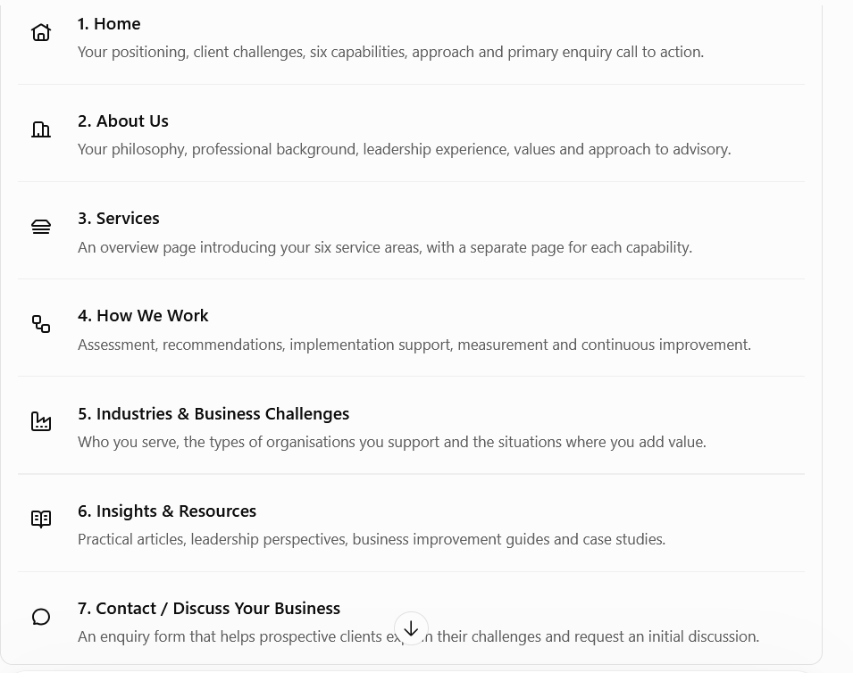

2. Homepage: proposed content and copy

Section 1 — Hero banner
BUSINESS ADVISORY · TRANSFORMATION · GROWTH (hero headline)
Build a Stronger Business. Prepare for What's Next.
We work with business leaders to sharpen strategy, strengthen performance and develop the people, processes and systems needed for sustainable growth.

Section 2 — The business challenges you address
Heading: Growth brings opportunity. It also brings complexity.
As businesses expand, the systems and practices that worked in the early stages may no longer be enough. Decisions become more complex, responsibilities overlap, costs rise and management visibility can weaken.
We help leadership teams identify the underlying issues, prioritise the right changes and develop practical ways to improve performance.

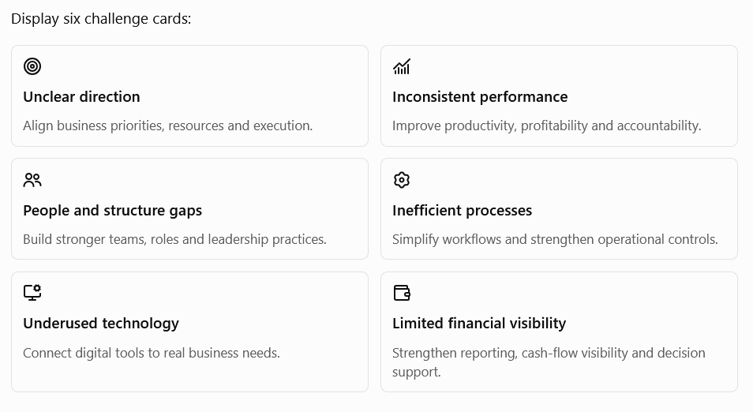

Section 3 — Our services
Heading: Connected capabilities. One business objective.
Suggested introduction:
Business challenges rarely exist in isolation. A growth strategy may require a new operating model, stronger leadership, better financial controls and the right technology.
Our advisory capabilities bring these elements together to help businesses move from identifying problems to implementing meaningful improvements.

Strategy Advisory
Define the direction, identify growth opportunities and translate business ambitions into clear priorities and executable plans.
Business strategy · Growth planning · Market expansion · Operating models

Performance Improvement
Improve the way the business operates by addressing inefficiencies, strengthening processes and making performance more measurable.
Process redesign · Cost optimisation · Productivity · Performance management

People & Change
Align organisational structure, leadership, talent and workplace practices with the needs of the business.
Organisation design · HR strategy · Leadership · Change management

Digital & Innovation
Identify where technology, automation and new ways of working can solve business problems and unlock new opportunities.
Digital strategy · ERP/CRM advisory · Automation · Innovation

Finance & Accounting
Strengthen financial discipline, reporting and management information to support informed decisions and business control.
Financial planning · Management reporting · Cost control · Accounting processes

Managed Services
Help businesses organise and operate selected support functions through defined processes, appropriate expertise and clear service standards.
Finance operations · HR administration · MIS support · Process coordination
These descriptions should link to individual service pages, each with its own detailed scope, typical engagements and enquiry button.

Section 4 — Who we work with
Heading: Advisory for businesses at different stages of growth
- Growing SMEs: Businesses that need stronger management systems, clearer accountability and scalable processes.
- Family-owned businesses: Organisations seeking professionalisation, improved governance and a more structured approach to growth.
- Established companies: Businesses pursuing operational improvement, organisational change or digital transformation.
- New ventures and expansion projects: Promoters who need help building a business model, setting up functions and preparing for market entry.

Section 5 — How we create value
Heading: From understanding the problem to making progress

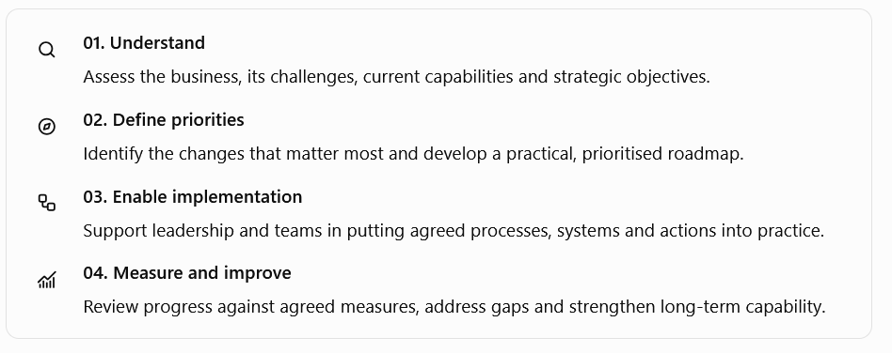

Section 6 — Why work with us?
.
- Business-first thinking: Recommendations are connected to commercial objectives and practical constraints.
- Integrated perspective: Strategy, people, operations, finance and technology are considered together.
- Practical implementation: Advice is designed to be applied, not simply presented in a report.
- Proportionate solutions: Systems and structures are designed around the organisation's size, maturity and resources.
- Clear accountability: Priorities, responsibilities and performance measures are established wherever appropriate.
- Long-term capability: The objective is to leave the organisation better equipped to manage its own growth.

Section 7 — Closing call to action
Heading: Let's discuss what your business needs next.
Whether you are planning your next stage of growth, improving performance or addressing challenges within a business function, the first step is to understand where you are and what needs to change.
Button: Discuss Your Business
Secondary link: Explore Our Services

3. Six service pages should contain;

Page 1 — Strategy Advisory
Suggested headline: Set a Clear Direction for Sustainable Growth.
- Corporate and business strategy
- Business model development
- Market entry and geographic expansion
- Growth and commercial strategy
- Product and channel strategy
- Strategic planning and prioritisation
- Organisation and operating model alignment
- Business establishment and re-engineering
- Family business professionalisation and governance support
Typical client questions to address:
- Where should we focus our growth?
- Which products, markets or customers deserve priority?
- Are our resources aligned with our objectives?
- How do we turn a strategic plan into accountable action?
Desired outcome: A clear direction, prioritised initiatives, defined responsibilities and a practical roadmap.
Page 2 — Performance Improvement
Suggested headline: Make Your Business Work Better.
Offerings:
- Business process review and redesign
- Operational efficiency
- Cost and productivity improvement
- Sales process improvement
- Supply chain and procurement review
- KPI and performance management
- SOP development
- Management reporting and MIS
- Business re-engineering
- Continuous improvement programmes
Desired outcome: Better visibility, less process friction, stronger controls and improved use of resources.

Page 3 — People & Change
Suggested headline: Build the Organisation Your Strategy Needs.
Offerings:
- Organisation structure and role clarity
- HR strategy and policy development
- Manpower planning
- Performance management
- Leadership development
- Talent acquisition process design
- Compensation and incentive frameworks
- Employee engagement and retention
- Learning and development
- Change management and culture
- HR process improvement
Desired outcome: Clear accountability, capable teams, stronger leadership practices and better alignment between people and business goals.

Page 4 — Digital & Innovation
Suggested headline: Make Technology Work for Your Business.
Offerings:
- Digital maturity assessment
- Digital transformation roadmap
- ERP/CRM requirements and selection advisory
- Business process automation
- MIS and dashboard design
- Workflow digitisation
- AI opportunity assessment
- Technology implementation coordination
- Digital adoption and change support
- Innovation and new business model development
Desired outcome: Better-connected processes, improved information flow, reduced manual effort and more effective use of technology.

Page 5 — Finance & Accounting
Suggested headline: Turn Financial Information into Better Decisions.
Offerings:
- Budgeting and forecasting
- Management accounts and MIS
- Cost and profitability analysis
- Cash-flow planning
- Working capital management
- Financial controls
- Finance process redesign
- Accounts receivable and payable processes
- Management reporting
- Finance system and ERP requirements
- Virtual finance management support, where offered
Desired outcome: Better financial visibility, disciplined cash management, clearer profitability and more reliable decision support.
Important: Distinguish advisory, management accounting and operational finance support from statutory audit, reserved professional work and regulated tax/legal services. Any such services should be delivered through appropriately qualified professionals.

Page 6 — Managed Services
Suggested headline: Reliable Business Support, Built Around Your Needs.
This page needs special attention because managed services can mean very different things to different clients.
I would define your offering as the ongoing management or coordination of agreed business-support processes, using defined deliverables, reporting and service standards.
Potential offerings, depending on the delivery capability you establish:
- Management reporting and MIS preparation
- Finance operations coordination
- Accounting process support
- HR administration and payroll coordination
- SOP and compliance-calendar administration
- CRM and sales-reporting support
- Vendor and procurement coordination
- Management review and action tracking
- Business process monitoring
- Outsourced functional coordination
For every offering, explain:
- What the service covers.
- What the client must provide.
- What you or your delivery team will perform.
- How frequently it will be delivered.
- What reports or outputs the client receives.
- What remains the responsibility of the client or its statutory professionals.
Desired outcome: Dependable support functions without requiring the client to build every capability internally.
Only list services you can genuinely deliver, either directly or through a reliable professional network.

About Us
Helping Businesses Build Strong Foundations for Growth
Every business reaches a point where its next stage of growth requires more than hard work and ambition. It requires clearer direction, stronger management practices, capable people and systems that can keep pace with change.
Our advisory practice works with business owners and leadership teams to address these challenges through practical, business-focused solutions.
We bring together perspectives from strategy, people management, operations, commercial development, finance and technology to help organisations understand their priorities and make better-informed decisions.
Our approach is collaborative and grounded in the realities of each business. We aim to develop solutions that are appropriate to the organisation's needs, resources and ambitions, while helping its people build the confidence and capability to sustain progress.
Our belief: Better businesses are built when sound strategy is supported by capable people, disciplined execution and systems that work.

• Our purpose
• Our business philosophy
• Founder / principal consultant profile
• Professional experience and areas of expertise
• How we approach client engagements
• Values and working principles
• Contact invitation

5. Industries & business challenges page
I would not claim deep expertise in every industry. Instead, show the types of businesses and challenges you understand.
Potential sectors to feature, where supported by your experience and network:
- Manufacturing and processing
- FMCG, food and distribution
- Retail and consumer businesses
- Software and technology services
- Family-owned and promoter-led enterprises
- Start-ups and growing SMEs
- Hospitality and service businesses
You can also organise this page by business situation:
- Establishing a new venture
- Preparing for rapid growth
- Improving profitability and operational control
- Professionalising a family business
- Reorganising management and responsibilities
- Implementing ERP, CRM or other business systems
- Strengthening finance and reporting
- Expanding into new markets
This allows prospective clients to recognise their own situation even if they do not identify with a particular industry.

6. How We Work page
Use this page to explain the different ways a client can engage you.
Engagement model | Purpose
Business diagnostic | Understand the present position, gaps and priorities.
Defined advisory project | Address a specific problem or deliver a defined outcome.
Transformation assignment | Support a broader business or functional improvement programme.
Retained advisory | Provide ongoing strategic guidance and management reviews.
Managed services | Deliver agreed recurring activities and reporting.
Business establishment | Support a new venture from planning through launch and initial stabilisation.
Make clear that scope, duration, deliverables and fees are agreed for each assignment.
I would also explain the general engagement cycle: initial discussion, assessment, proposal, agreed scope, implementation support and periodic review.

7. Insights & Resources page
This will help demonstrate your thinking and give prospective clients a reason to revisit your website.
Start with articles that reflect the actual work you want to attract:
- Why Growing Businesses Need Better Management Systems
- When Should a Family Business Professionalise Its Operations?
- How to Build an Effective KPI and MIS Framework
- Why ERP Implementation Often Fails to Solve Business Problems
- How to Improve Profitability Without Simply Cutting Costs
- Building a Sales Process That Does Not Depend on One Person
- What Should Be Included in a 90-Day Business Establishment Plan?
- How to Decide Between In-House Teams and Outsourced Services
- How Better Financial Reporting Supports Business Growth
- Moving from Founder-Dependent Operations to Structured Management
Use anonymised case studies only where confidentiality is protected and you have permission to publish the relevant details. You can also write illustrative business scenarios, clearly labelled as examples rather than actual client results.

8. Contact page
Keep it simple and professional.
Headline: Tell Us Where Your Business Needs to Go.
Suggested form fields:
- Name
- Company
- Designation
- Email
- Phone
- Industry
- Service of interest
- Brief description of the challenge
- Preferred contact method
Include your business email, telephone/WhatsApp contact and location or service geography. You do not need to publish your personal address.
Use a call to action such as "Request an Initial Discussion", rather than promising a free detailed consultation.

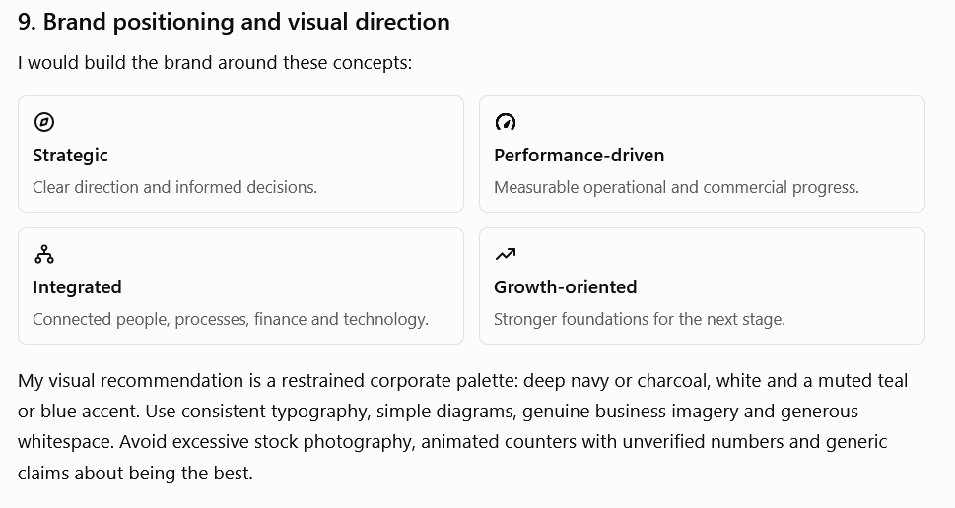

10. Final recommendation: your core message
The website should have one consistent message across every page:
You help businesses make the transition from ambition to structured, sustainable performance.
Your six service areas explain what you do. Your methodology explains how you work. Your background, examples and insights explain why clients should trust you.
That combination is stronger than simply listing six departments.
Before developing the final copy, I would settle on the consultancy's brand name, whether the website represents you personally or a registered firm, and whether managed services will be delivered by you, employees or partner professionals. Those decisions will determine the right tone, credibility claims and scope of the website.

