AZURE DEPLOYMENT AND APPLICATION VERIFICATION REPORT
Project Name: TextForge
Team Name: QUARK
Problem Statement ID: UC-06 — Text Processing Tool SaaS
Cloud Platform: Microsoft Azure
Report Version: 1.0

1. Deployment Overview
The Text Processing Tool SaaS application has been prepared for deployment on Microsoft Azure. This report documents the application's deployment details, live user interface, deployed application version, Azure resources, verification status, and instructions for accessing and running the application.
The application provides text validation and processing capabilities through a web interface and backend API. It is designed to support tenant-based access, subscription plans, usage quotas, and processing history.
Deployment Status: Successfully Deployed
2. Live Application URL
Live UI URL: TEXTFORGE URL [https://textforge-dev.nicebay-333335a7.centralindia.azurecontainerapps.io/]
Deployment Verification: Verified
The live URL provides access to the deployed application's user interface.
Screenshot 1 — Live Application
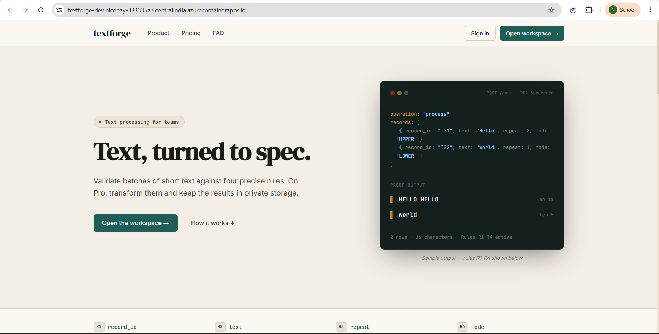
Figure 1: Application running
3. Deployed Application Version
Field | Details
Deployment method | Azure Container Apps
Container image registry | Azure Container Registry
Registry name | acrtextforge8291
Container App Environment | cae-textforge-dev
Manage Identity | id-textforge-dev
Storage account | sttextforge8291
Container App name | textforge-dev
Container App status | Running
The deployed image version or Git commit identifies the application code associated with this deployment.
Screenshot 2 — Azure Container App
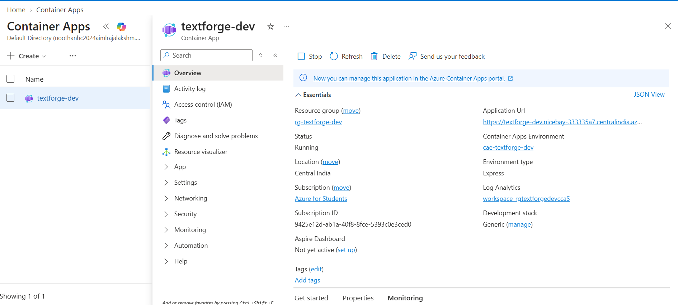
Figure 2: Container App deployment and application status in the Azure portal.
4. Azure Resources and Status
The following Azure services are used or planned as part of the application infrastructure. The status column must reflect the actual state of each resource at the time of submission.
Azure Resource | Purpose | Status
Resource Group | Groups the project's Azure resources | Running
Azure Container Registry | Stores the container image | Running
Azure Container Apps Environment | Provides the container hosting environment | Running
Azure Container App | Runs the application and exposes its URL | Running
Azure Storage Account | Provides Blob Storage | Running
Private Blob Container | Stores objects privately | Running
Log Analytics Workspace | Collects and supports analysis of logs | Running
Resource Verification: Partially Verified
Screenshot 3 — Azure Resource Group
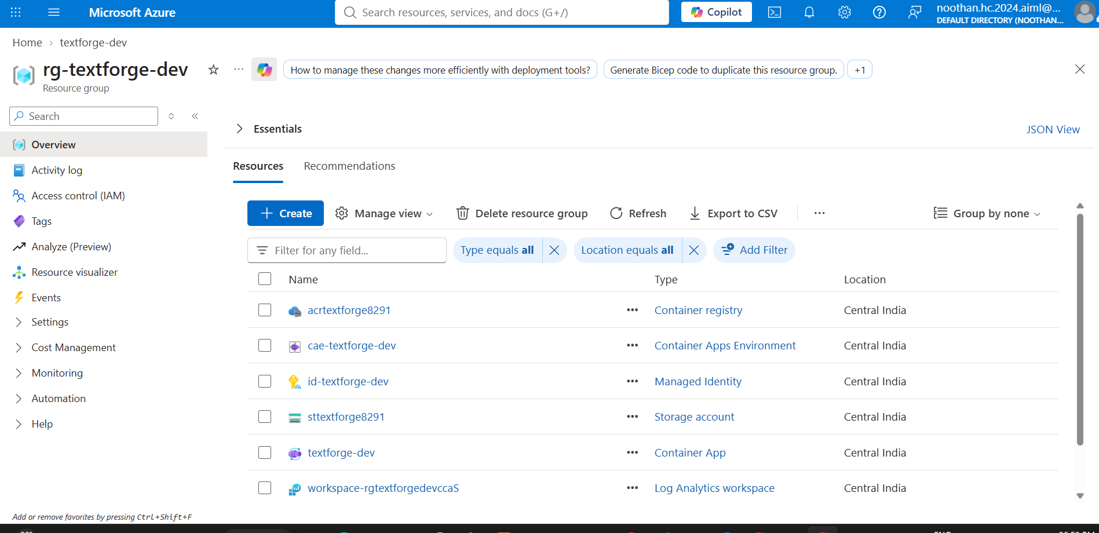
Figure 3: Azure resources associated with the application deployment.
5. Application Features and Verification
The following checks are intended to verify the deployed application against its required functionality.
Test ID | Verification Item | Expected Result | Actual Status
T01 | Open the live UI URL | Application interface loads | Pass
T02 | Access the health endpoint | Application reports healthy status | Pass
T03 | View available tools | Available operations are displayed | Pass
T04 | Submit valid input for validation | Validation results are returned | Pass
T05 | Process valid text input | Processed output is returned | Pass
T06 | View processing history | Previous runs are displayed | Pass
T07 | Verify SQL persistence | Run and result data persist as required | Pass
T08 | Verify Blob Storage integration | Required storage operations succeed | Pass
T09 | Verify application logs | Relevant logs can be inspected | Pass
Only mark a test as Pass after completing it against the deployed application. If a feature is not yet integrated, mark it Pending or Not Applicable as appropriate.
Screenshot 4 — Application Functionality
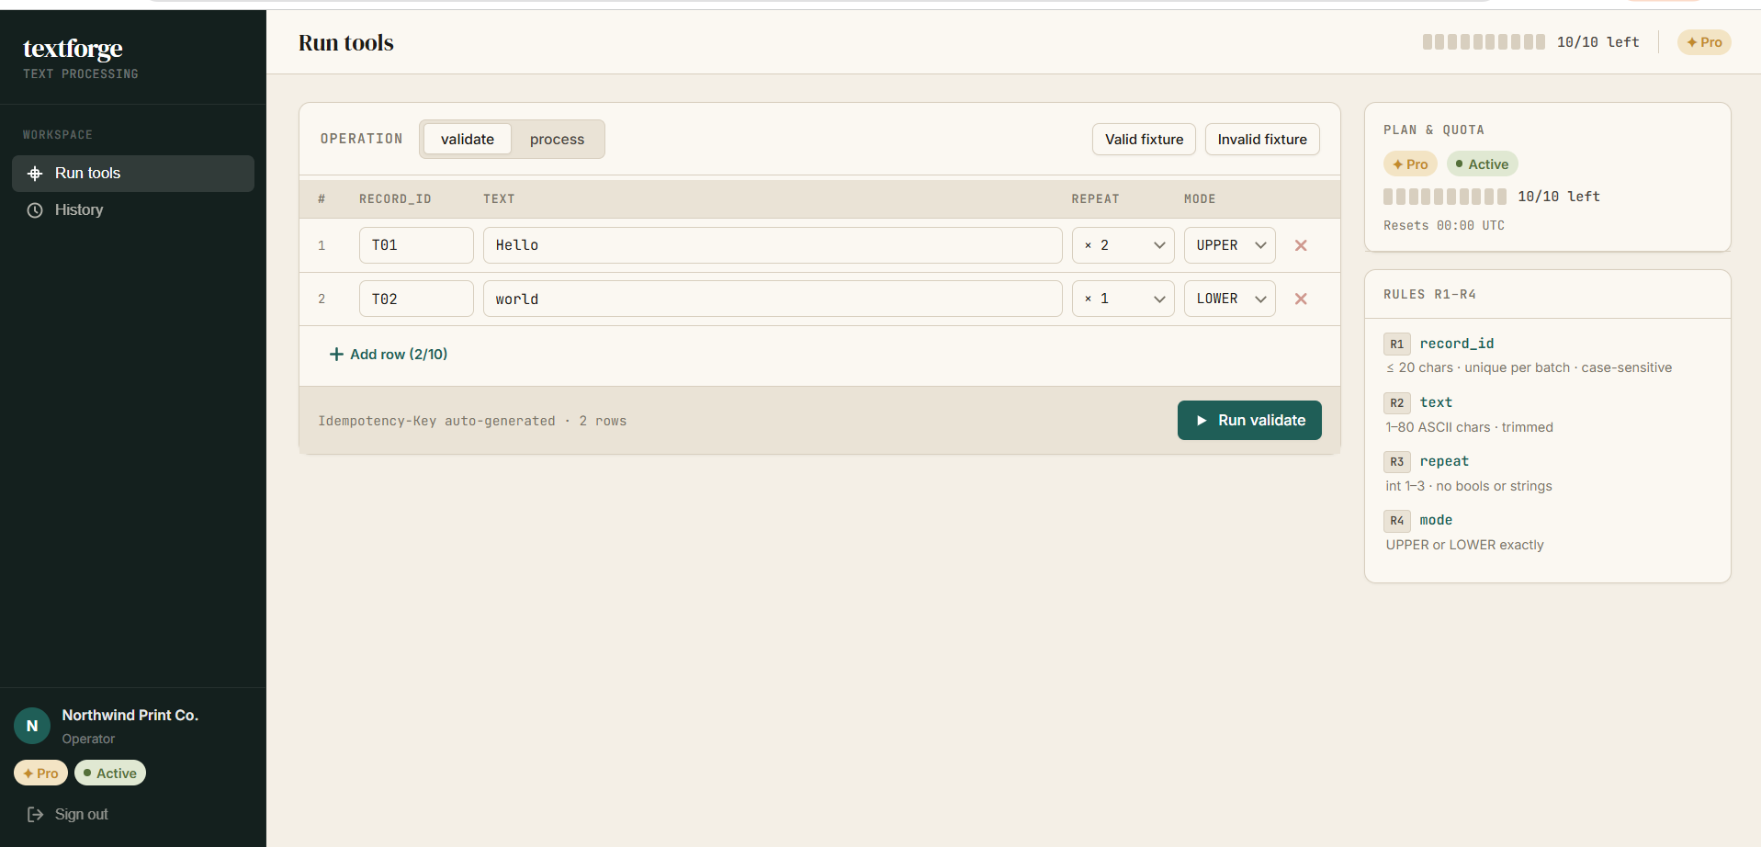
Figure 4: Successful application operation using the deployed interface.
6. Test Login Details
The following test account can be used to verify the application's functionality.
Pro Plan with As Operator
Pro Plan as Viewer
Basic plan as Operator
Basic Plan as Viewer
Preseeded Sandbox Demo Accounts
Security Note: Test credentials should be provided only through an approved secure channel. Do not include production credentials, Azure account passwords, database passwords, access keys, or connection strings in this report.
If the application does not yet have working authentication, state that test login is pending instead of inventing credentials.
7. Application Deployment and Running Steps
The following steps describe the intended deployment and verification workflow.
- Prepare the application: Obtain the application source code, Dockerfile, configuration templates, and database migration scripts.
- Build the container image: Package the application into a Docker-compatible container image.
- Push the image to Azure Container Registry: Authenticate to the registry and upload the tagged application image.
- Deploy to Azure Container Apps: Configure the Container App to run the intended image and expose the required application port.
- Configure application settings: Set the required environment variables, database connection configuration, and Blob Storage authentication.
- Initialize the database: Apply the required SQL migrations and verify the necessary tables.
- Verify the deployment: Open the live URL, check the health endpoint, and exercise the required application features.
- Inspect logs: Use Azure's logging facilities to investigate startup failures, configuration problems, and application errors.
These are deployment steps, not a claim that every step has already succeeded. The final report should reflect the actual deployment process used by the team.
8. Logging and Monitoring
Logging Service: Azure Log Analytics
Log Analytics Workspace: workspace-rgtextforgedevccaS
Verification Status: Verified
Application and platform logs are used to help diagnose deployment failures, application startup issues, and runtime errors.
Screenshot 5 — Application Logs
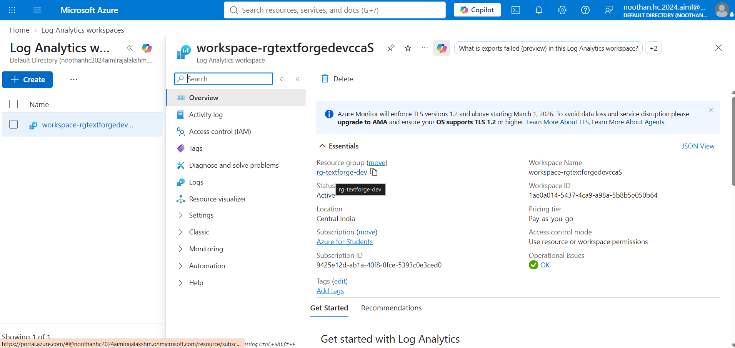
Figure 5: Application or platform logs used to verify deployment health.
9. Deployment Summary
The deployment report records the live application endpoint, deployed version, associated Azure resources, application verification results, and access instructions.
Final Deployment Status: [Successfully Deployed / Partially Deployed / Deployment Pending]
Live UI URL: https://textforge-dev.nicebay-333335a7.centralindia.azurecontainerapps.io/
Outstanding Issues: None
Prepared By: QUARK
Submission Date: [21/10/2026]

