A
Project Report on
"सूर्यसंकल्प"
(Design Solar Powered Off-Grid Storage System for Home Automation)

For the
Partial Fulfilment of
Master Degree of Science (Electronic Science)
Affiliated to
Savitribai Phule Pune University

By
Nikhil Krishnakant Kavate
2334251
(2203004)

Under the Guidance of
Prof. G. Tarate
Department of Electronic Science
Progressive Education Society's
Modern College of Arts, Science & Commerce (Autonomous)
Shivajinagar, Pune-411005
Date (20/04/2024)

ACKNOWLEDGEMENT

It gives me a great pleasure in presenting the Project report on सूर्यसंकल्प: -Design Solar Powered Off-Grid Storage System for Home Automation.
I’d like to take this opportunity to thank our internal guide Prof. T.B. Sonawane and Prof. G.M. Tarate for giving me all the help and guidance I needed. I really grateful to them for their kind support. Their valuable suggestions were very helpful.
I am also grateful to Prof. D.B. Gaikwad, Head Department of Electronics Science, MCASC Shivajinagar, Pune-5 for his indispensable support, suggestions.
With deep sense of gratitude, we thank to Principal and Management of, MCASC Shivajinagar, Pune-5 for providing all necessary facilities and their constant encouragement and support.

THANK YOU...

Nikhil Krishnakant Kavate

INDEX
Sr.no. | Title of contents | Page no.
1. | ABSTRACT | 4
2. | INTODUCTION | 6
3. | Discussion of Design Method | 7
4. | Description of Design | 8
5. | System Design | 11
6. | Block Diagram | 12
7. | Component Information | 13
8. | Circuit Diagram and Working | 26
9. | Internet of Things | 30
10. | Code | 32
11. | Appendix - A | 38
12. | Appendix - B | 39
13. | Component List | 40

Abstract:
Solar energy can provide a huge amount source of renewable energy (electrical and thermal). To provide Light when sun is not shining. That's the goal of my Solar Energy Storage project!
In an age where environmental consciousness intertwines with technological prowess, the convergence of Solar Power and IoT emerges as a transformative force. At its core lies the harnessing of solar energy, a potent and infinitely renewable resource, coupled with the ingenuity of IoT, which bestows intelligence and connectivity upon traditionally static systems. This combination holds the promise of reshaping the landscape of energy generation, distribution, and consumption in profound ways.
Unveiling the Potential of Solar Power:
Solar energy, abundant and inexhaustible, has long been hailed as a cornerstone of sustainable development. With advancements in photovoltaic technology, the efficiency and affordability of solar panels have soared, rendering solar power an increasingly viable alternative to conventional energy sources. However, the intermittent nature of sunlight poses challenges to its widespread adoption. Enter IoT, with its array of sensors, data analytics, and automation capabilities, offering solutions to optimize solar energy utilization and mitigate its inherent limitations.
Empowering Connectivity with IoT:
The Internet of Things, a network of interconnected devices embedded with sensors and software, empowers solar infrastructure with unprecedented levels of intelligence and control. Through real-time monitoring of solar panels' performance, weather conditions, and energy consumption patterns, IoT enables proactive maintenance, fault detection, and optimal energy management. Moreover, IoT facilitates seamless integration with existing power grids, enabling dynamic adjustments to supply and demand fluctuations, thus enhancing grid stability and resilience.

Pioneering Innovations in Solar IoT Applications:
From smart solar farms to residential rooftop installations, the applications of Solar IoT span a diverse spectrum. In agriculture, IoT-enabled solar irrigation systems optimize water usage based on soil moisture levels and weather forecasts, fostering sustainable farming practices. In urban environments, IoT-integrated solar streetlights autonomously adjust brightness levels and detect motion, enhancing safety and energy efficiency. Furthermore, in remote areas, IoT-equipped solar microgrids provide reliable electricity access, empowering underserved communities and spurring socio-economic development.

Introduction:
To provide Light when sun is not shining. That's the goal of my Solar Energy Storage project! Main focus of this system is to create eco-friendly energy, store energy in efficient way.
Solar Energy Management System is a system that converts solar rays or energy into electrical energy. In addition to that BMS and IOT is used.
BMS is used to detect and protect the battery from over-charged, over- discharge, over-current short-circuits and automatically voltage balance function.

Project Design Specifications Table:
Component | Specification
Solar Panel | Voc= 22.06V, Isc= 2.23A, Vmp= 19V, Imp=2.11A, 40Watt.
Battery | 12V, 7Ah SMF Battery (Sealed Maintenance Free Battery)
Battery Charger | Compatible with 12V battery and less.
ESP32 Microcontroller | Tensilica Xtensa LX6 microprocessor at 160 or 240 MHz with single 2.4 GHz Wi-Fi-and-Bluetooth combo chip.
Power Supply module | Provides stable 3V/5V power for ESP32
Inverter | Input: DC12V, Output: AC220-240V, 200Watt
Short Circuit Protection | --------------
Relay Channel | 4 channel relay OV= 4, Max O/P= AC250V, with Optocoupler
Safety Feature | Overvoltage protection, Over battery charge protection, Battery reverse voltage protection

Design Description:
In recent years, there has been a significant surge in the adoption of renewable energy technologies, driven by the increasing awareness of environmental sustainability and the need to mitigate climate change. One such technology that has gained immense popularity is solar power. Solar energy offers a clean, abundant, and renewable source of electricity, making it an attractive option for both residential and commercial applications.
The aim of this project is to develop a Solar Powered Off-Grid Storage System for Home Automation. This system integrates solar photovoltaic (PV) panels, energy storage in the form of a 12V 7Ah battery, and an ESP32 microcontroller for intelligent control and monitoring. Additionally, it incorporates an inverter for converting DC power from the battery into AC power, enabling the usage of standard household appliances, and a battery charger to efficiently manage the charging process.
The integration of home automation capabilities enhances the system's functionality by allowing users to remotely monitor and control various devices and appliances within their home. By leveraging the connectivity and processing power of the ESP32 microcontroller, users can optimize energy usage, schedule tasks, and receive real-time notifications, thereby maximizing energy efficiency and convenience.

Simulation and Design Methods:
System Overview:
The system consists of several key components, including solar PV panels, a 12V 7Ah battery, an ESP32 microcontroller, an inverter, a battery charger, and a short circuit protection circuit. The primary objective is to integrate these components to create a self-sustaining off-grid system capable of powering household appliances and enabling home automation functionalities.
Design Approach:
The design approach involves several iterative steps to ensure the functionality, efficiency, and reliability of the system:
Component Selection:
Careful consideration is given to selecting components based on their specifications, compatibility, and performance characteristics. For example, the solar panels must provide sufficient power output to charge the battery effectively, while the battery charger and inverter must be capable of handling the expected load requirements.
System Sizing:
Proper sizing of the components is critical to meet the energy demands of the intended applications. This includes determining the capacity of the battery based on expected energy consumption, sizing the solar panels to match the charging requirements, and selecting an inverter with adequate power output.

Control and Monitoring:
Integration of the ESP32 microcontroller enables intelligent control and monitoring of the system. The microcontroller is programmed to manage charging and discharging cycles, monitor battery voltage and temperature, and communicate with external devices for home automation functions.
Simulation Approaches:
Simulation and design software such as Proteus or EasyEDA is utilized to model and analyse the system's behaviour under various operating conditions. The following simulation approaches are employed:
Control Algorithm: Arduino IDE is a software platform used for programming Arduino microcontroller boards. It provides a user-friendly interface for writing, compiling, and uploading code to Arduino boards. The IDE includes features such as a code editor, compiler, uploader, library manager, serial monitor, and board manager. It's widely used by hobbyists, students, and professionals for creating a variety of electronics projects.
Areas Requiring Attention:
Several areas require careful attention during the design process:
Safety: Ensuring the safety of the system and its users is paramount. This includes implementing, overcurrent protection and short circuit protection prevent electric shocks or fire hazards.
Efficiency: Maximizing energy efficiency is essential to optimize the system's performance and minimize energy wastage. This involves selecting high-efficiency components, optimizing control algorithms, and minimizing losses during energy conversion.

Reliability: The system must be reliable and resilient to withstand varying environmental conditions and operational loads. Robust design practices, redundant components, and fail-safe mechanisms are incorporated to enhance reliability and uptime.
In conclusion, the simulation and design methods employed in the development of the Solar Powered Off-Grid Storage System for Home Automation project are essential for ensuring the functionality, efficiency, and reliability of the system. By carefully selecting components, sizing the system appropriately, and simulating its behavior under different conditions, a robust and optimized design can be achieved, laying the groundwork for successful implementation and operation.

Description Of Design:

Block diagram:

Voltmeter
ter

Block diagram:
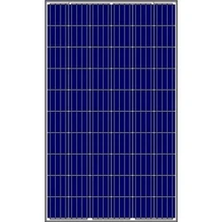
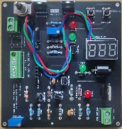
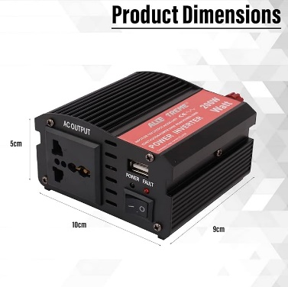
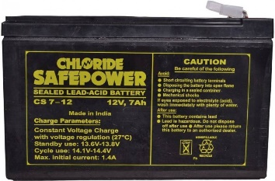
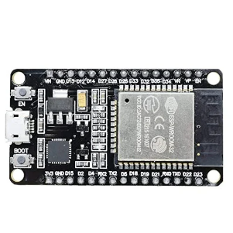
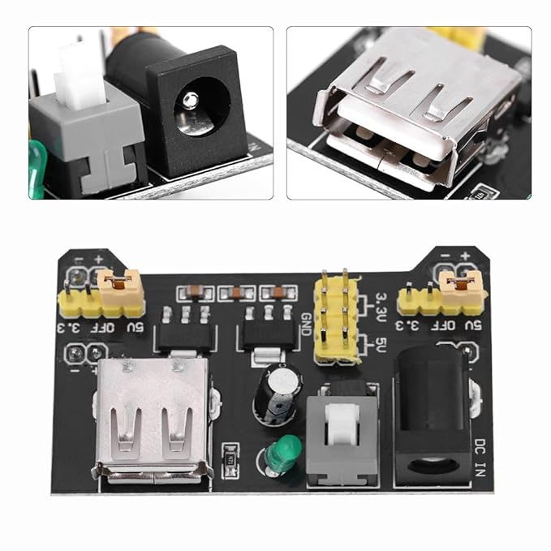
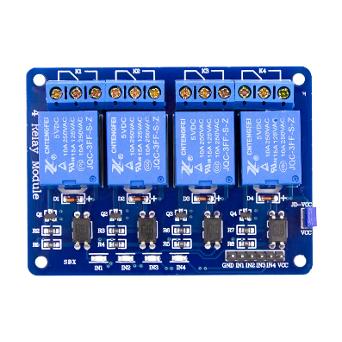
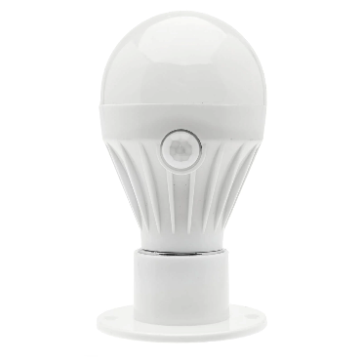
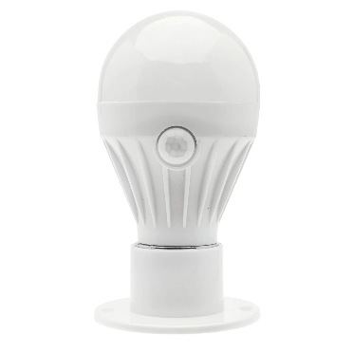

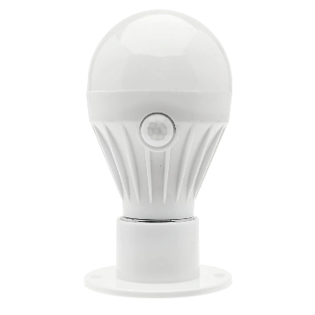
Led Bulb-4
Led Bulb-3
Led Bulb-2
Led Bulb-1
Relay Module
ESP32
3V/5V Power Supply
Led Bulb-1
Inverter
Salar Panel
Charger Circuit

Solar Pannel:

Solar panels are those devices which are used to absorb the sun's rays and convert them into electricity.
The MxP1240 40Watt, 22.06V Poly-crystalline Solar Panel (Model No. MxP1240) is ideal for a variety of home applications like charging small batteries that power garden lighting and surveillance cameras.

Specification:
- Anodized aluminium alloy frame
- Fully weatherproof
- 40Watt solar panel
- High transmittance tempered glass Durable and lightweight
- Open Circuit Voltage (Voc) = 22.06 V
- Short Circuit Current (Isc) = 2.23 A
- Voltage at Maximum Power (Vmp) = 19.0 V
- Current at Maximum Power (Imp) = 2.44 A
- Maximum System Voltage = 600 V
- Temperature Coefficient = -0.52%W/ °C

Charger:
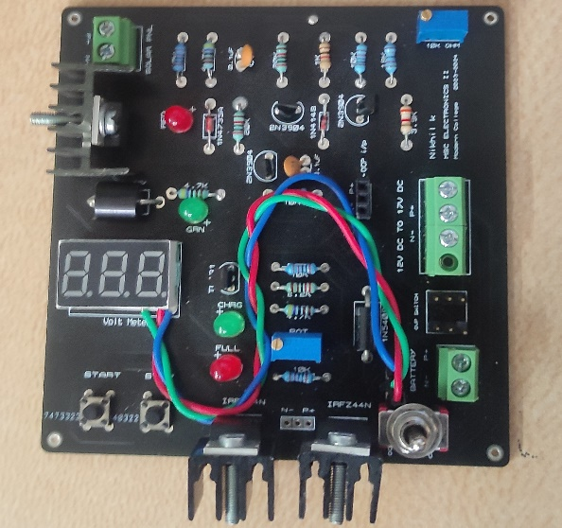
Charger Board:
Specification:
- Adjustable regulated output supply (1V to19V).
- Over-Charge Protection.
- Built-in Voltmeter.
- Compatible with less than 12V and 12V battery.
- Led indicators for Charging, Full Charge,

Circuit Diagram:
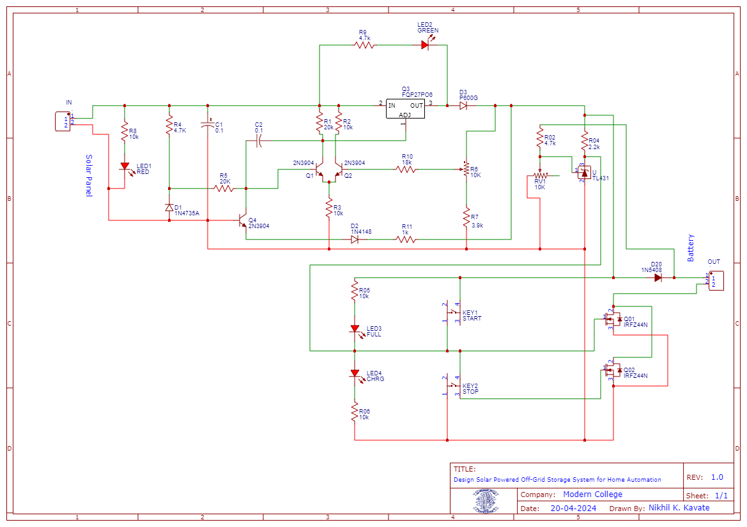

Proteus Design Suite:



Proteus is an electronic design automation software used for designing, simulating, and testing electronic circuits and PCB layouts. It offers a user-friendly interface, comprehensive component library, and simulation capabilities.

EasyEDA:


EasyEDA is a web-based EDA (Electronic Design Automation) tool that allows users to design PCBs (Printed Circuit Boards) and schematics in a collaborative environment. It offers a simple and intuitive interface, making it suitable for beginners and experienced users alike. EasyEDA features a wide range of components in its library, supports SPICE simulation, and provides features for PCB layout design and routing. It's popular for its ease of use and accessibility, as it runs entirely in a web browser without the need for installation.

3D Model:
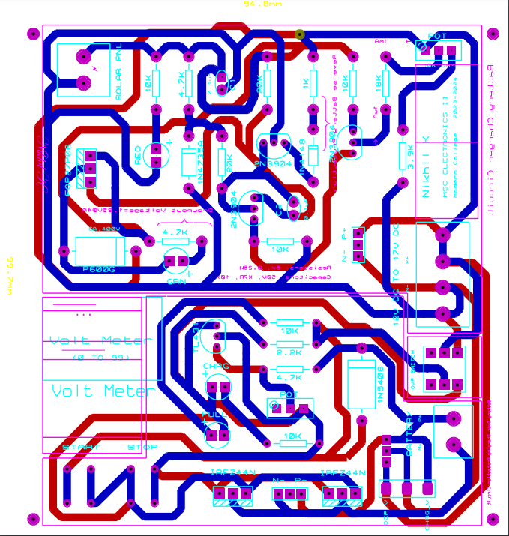

PCB Routing:
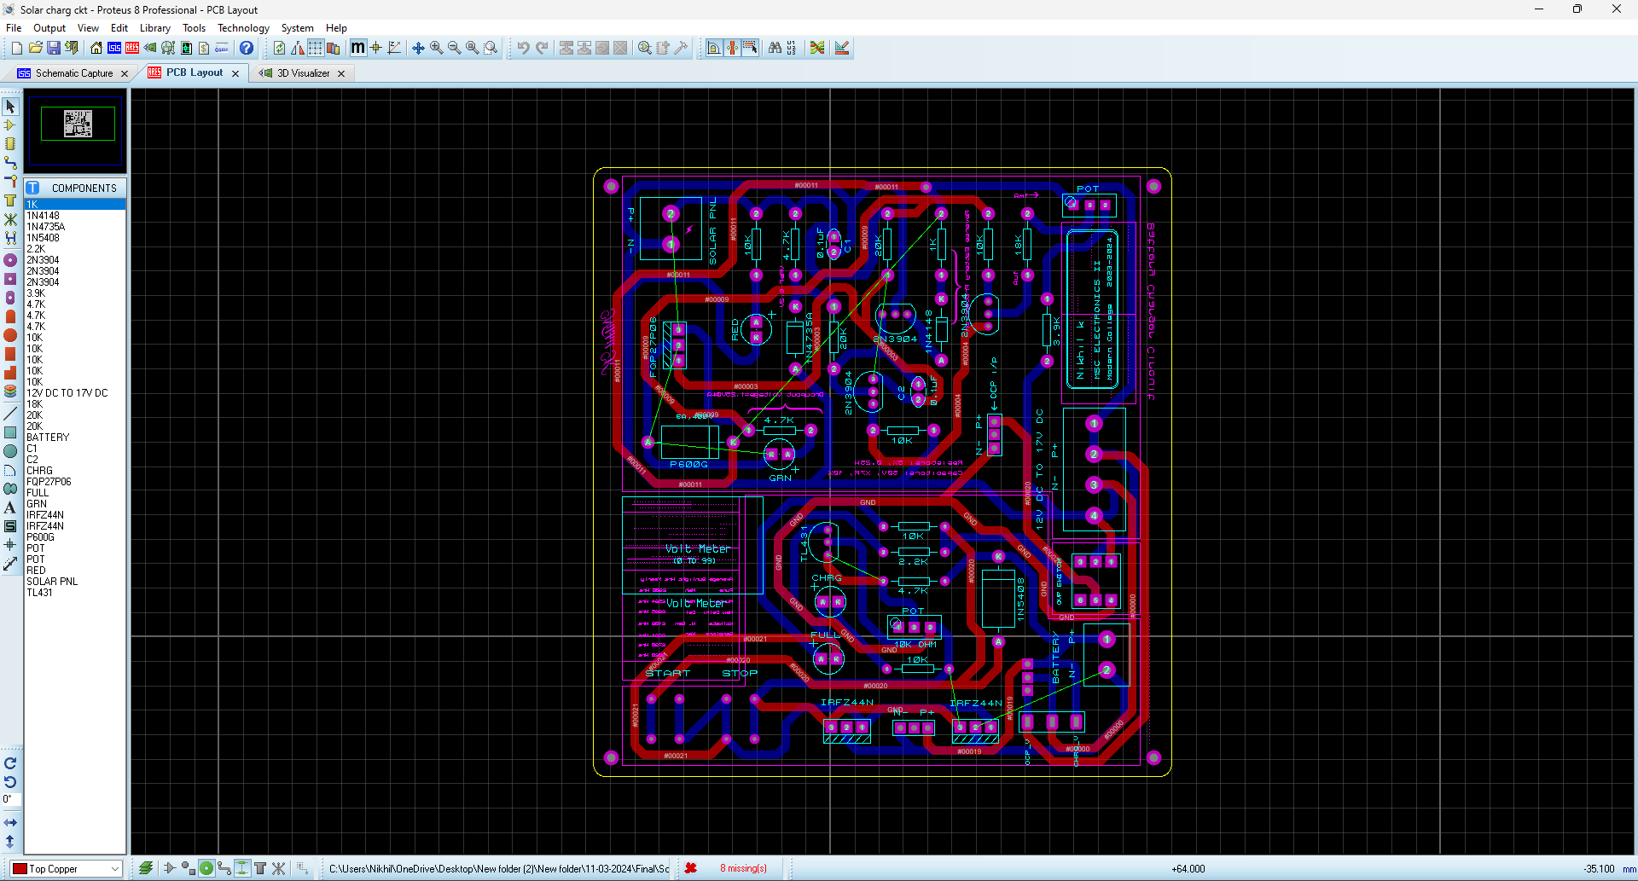

Printed Circuit Board (PCB):
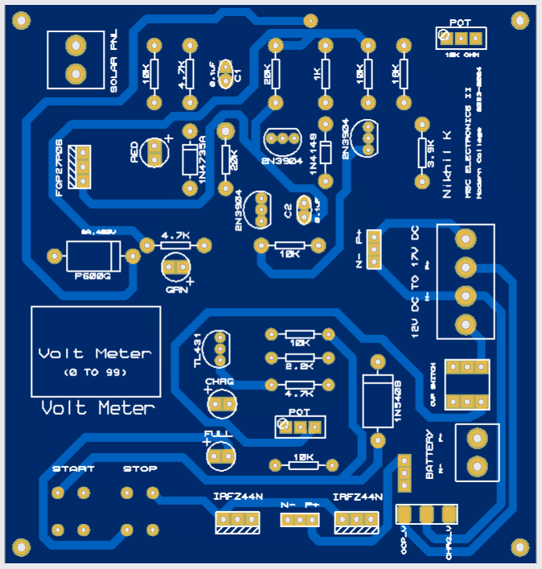

PCB Top View:

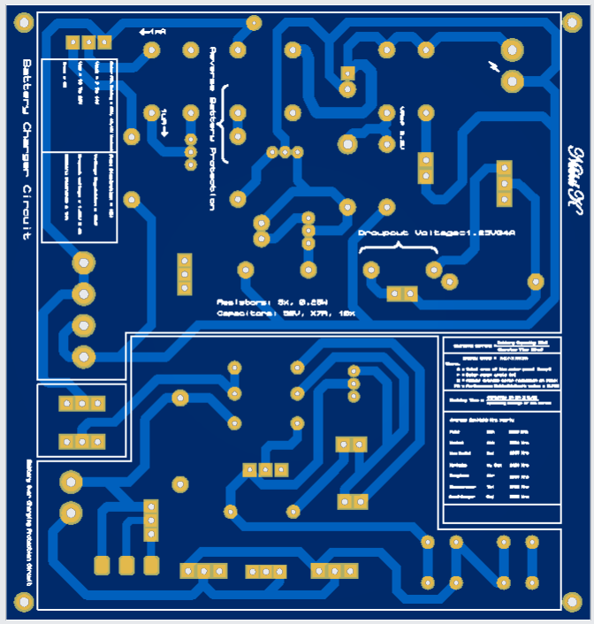

PCB Bottom View:

PCB Silk Top View:

PCB Silk Bottom View:

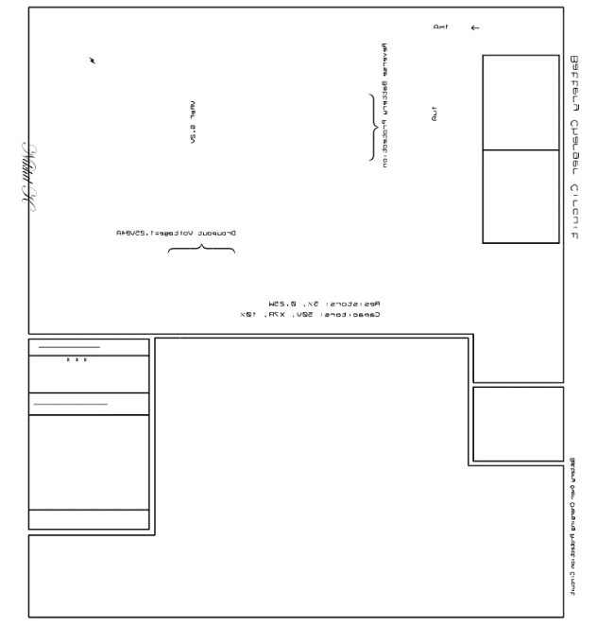
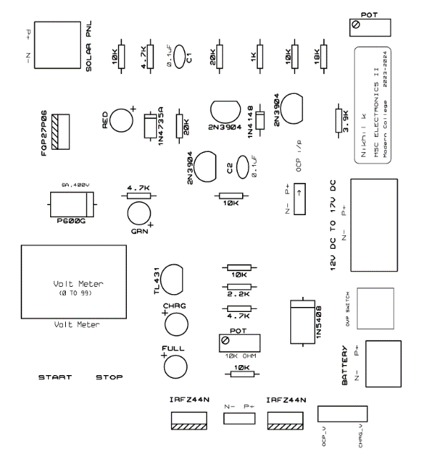

PCB Copper Bottom View:

PCB Copper Top View:

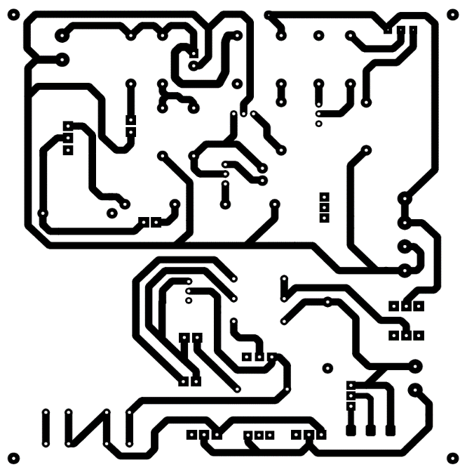
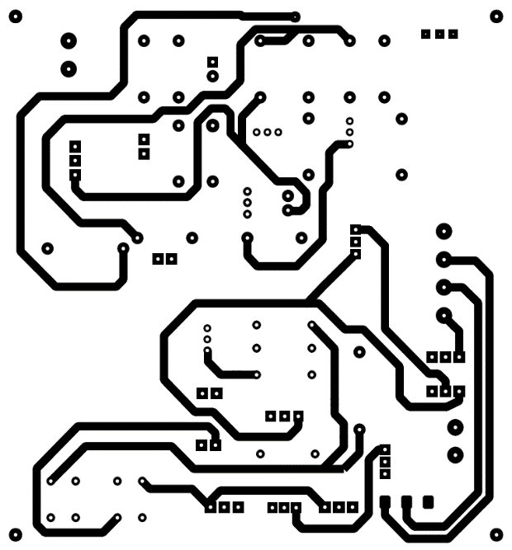

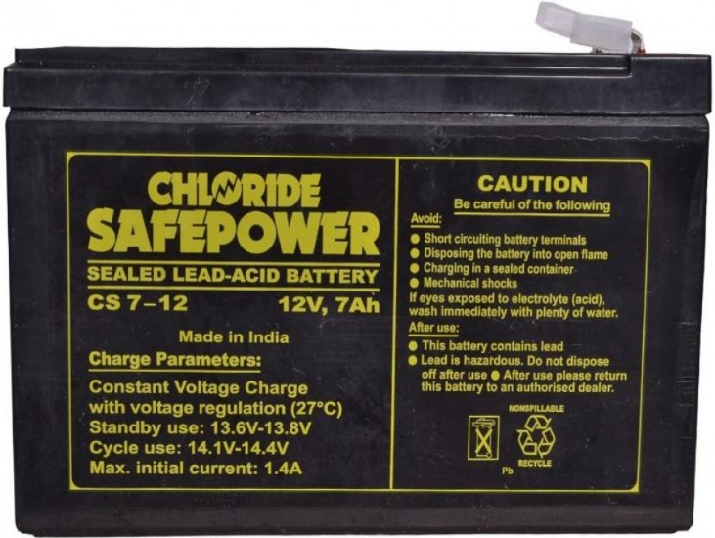
Battery:

The Exide Safepower 12V 7Ah battery is a reliable sealed lead-acid (SLA) battery designed for various applications requiring backup power. With a voltage of 12 volts and a capacity of 7Ah, it offers a stable and consistent power supply. Its sealed design ensures safety and allows for maintenance-free operation.

Charging Parameter:
- Battery to be recharged in CC-CV mode only
- Constant voltage charge with current limits (at 27°C)
- Max. Charging Current = 2.1A
- Min Charging Current = 0.7A
- Float voltage = 13.6V – 13.8V
- Cyclic voltage = 14.6V – 14.8V
- Boost voltage = 14.0V – 14.2V
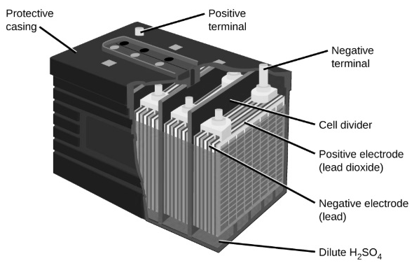
Specification:
- Sealed Maintenance Free Battery
- Voltage = 12V
- Capacity = 7aH
- Nominal voltage = 12V
- Model = CS12-7aH
- Rated Capacity at 20hr = 7V/Cell at 27°C

ESP-WROOM-32:


Specifications of ESP-WROOM-32:
- Single or Dual-Core 32-bit LX6 Microprocessor with clock frequency up to 240 MHz
- 520 KB of SRAM, 448 KB of ROM and 16 KB of RTC SRAM.
- Supports 802.11 b/g/n Wi-Fi connectivity with speeds up to 150 Mbps.
- Support for both Classic Bluetooth v4.2 and BLE specifications.
- 34 Programmable GPIOs.
- Up to 18 channels of 12-bit SAR ADC and 2 channels of 8-bit DAC
- Serial Connectivity include 4 x SPI, 2 x I²C, 2 x I²S, 3 x UART.
- Ethernet MAC for physical LAN Communication (requires external ethernet module).
- 1 Host controller for SD/SDIO/MMC and 1 Slave controller for SDIO/SPI.
- Motor PWM and up to 16-channels of LED PWM.
ESP32 MICROCONTROLLER:
ESP32 is a series of low-cost, low-power system on a chip microcontroller with integrated Wi-Fi and dual-mode Bluetooth. The ESP32 series employs either a Tensilica Xtensa LX6 microprocessor in both dual-core and single-core variations, Xtensa LX7 dual-core microprocessor or a single-core RISC-V microprocessor and includes built-in antenna switches, RF balun, power amplifier, low-noise receive amplifier, filters, and power-management modules. ESP32 is created and developed by Espressif Systems, a Chinese company based in Shanghai, and is manufactured by TSMC using their 40 nm process. It is a successor to the ESP8266 microcontroller


Relay Module:
Relay module:
One type electro-mechanical component that serves as a switch is the relay. In order to open or close contact switches, DC is used to activate the relay coil. A coil and two contacts, such as ordinarily open (NO) and usually closed (NC), are often found in a single channel 5V relay module (NC). This gives a general overview of the 5V relay module and hoe it operate, but first we need to understand what a relay is and how its pins are configured.
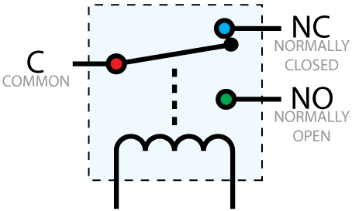
An automated switch called a 5V relay is frequently used in automatic control circuits to regulate high currents with low current signals. The relay signal’s input voltage spans the 0 to 5v range. In order to control high voltage, current loads such solenoid valves, motors, AC loads, and lighting, a relay module with a single channel board is employed. This module’s main purpose is to connect with many microcontrollers, including PIC, ESP32, and others.

Working:
The relay opens or closes switch contacts using the current supply. Typically, a coil is used to magnetise the switch contacts and draw them together when the switch is engaged. As soon as the coil is not reinforced, a spring push them independently. There are primarily two advantages to employing this approach. The first is that less current is needed to activate the relay than is needed to switch the relay contacts. The other advantage is that there is no electrical connection between the contacts and the coil because they are both galvanically separated.
4- Channel Relay:
Relays: The module typically contains four individual relays, each capable of independently controlling a separate electrical circuit. These relays are electromechanical switches that can make or break the connection between the common (COM) terminal and either the normally open (NO) or normally closed (NC) terminal.
Control Signal Input: Each relay channel has an input terminal for the control signal. When a digital signal (usually logic HIGH or LOW) is applied to this terminal from the control device, it activates or deactivates the corresponding relay.
Output Terminals: The module also includes output terminals for each relay channel. These terminals are where you connect the electrical loads that you want to control, such as lights, motors, heaters, or other devices.
Power Supply: The relay module requires a separate power supply to operate the relays and the control circuitry. This power supply is typically a low-voltage DC source, such as 5V or 12V, and is connected to the module's power input terminals.
Optical Isolation (Optional): Some relay modules include optical isolation between the control signal and the relay circuit. This helps protect the control device (e.g., microcontroller) from voltage spikes or other disturbances in the relay circuit.
LED Indicators (Optional): Many relay modules feature LED indicators for each channel to visually indicate whether the relay is activated (LED illuminated) or deactivated (LED off).
Compatibility: Relay modules are compatible with a wide range of microcontrollers and control devices that can provide digital output signals. They are commonly used in DIY electronics projects, home automation systems, robotics, industrial automation, and more.
Inverter:

- Battery-Powered Inverter:
This portable inverter converts 12V DC to 240V AC power and offers 200 watts of continuous power and 400 watts of peak power. Simply use alligator clips to connect the inverter to the battery, and then use it for a variety of applications.
- Heat dissipation with a cooling fan:
The fan that is built into the back panel of this portable power inverter makes it a dependable option and makes it simple to use for extended periods of time because it maintains the inverter's ideal temperature.
- 1 Quick-Charging USB Port & 1 AC Socket:
It has 1 USB plug socket and 1 Indian AC outlet, making it extremely useful for a wide range of applications. It also has a compact size, making it ideal for carrying around.
- Wide Applications:
This portable power inverter has a wide range of applications and is ideal for charging and powering laptops, smartphones, televisions, kindles, lights, car gadgets, camping equipment, and a wide range of other electronics.
Indicator Light and Multi-Protection:
This incredible portable inverter has a ton of features, such as overload protection, short circuit protection, over-temperature protection, and under/over voltage protection, which will extend the device's lifespan. It also has two indicator lights, which are useful for indicating battery charge and discharge.

Power Supply Module:


MB 102 Breadboard Power Supply Module 3.3Volt / 5Volt:
This is a 3.3V/5V MB102 Breadboard Power Supply Module which provides a dual 5 V and 3.3 V power rails and has a multi-purpose female USB socket.
The 3.3V/5V MB102 Breadboard Power Supply Module securely fits in a standard MB102 400 or 800 tie points breadboard it also features reverse polarity protection, the module can take 6.5V to 12V input and can produce 3.3V and +5V.
The module can also output 5V on USB connector or input through the USB connector. It’s a must-have product for experimenters those have to test/prototype electronic circuits on the breadboard.
Features:
Breadboard power supply module, compatible with 5V, 3.3V.
Apply to MB102 breadboard
Fluctuation two road independent control can switch over to 0 V, 3.3 V, 5 V
On-board two groups of 3.3V, 5V DC output plug pin, convenient external lead use.

LED Bulb:


LED bulbs are lighting devices that use light-emitting diodes (LEDs) as their light source. They have become increasingly popular due to their energy efficiency, long lifespan, durability, and versatility.
LED bulbs contain no hazardous materials such as mercury, unlike fluorescent bulbs, making them safer for the environment. Additionally, their energy efficiency helps reduce greenhouse gas emissions associated with electricity generation.

Electrical Switch:
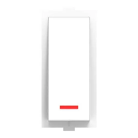

A switch is used to complete or break an electric circuit in order to use an electric appliance. When a switch is in the ON position, it completes the circuit and allows current to flow through. Similarly, a switch is in the OFF position when it breaks the circuit and prevents current from passing through.

System Design:
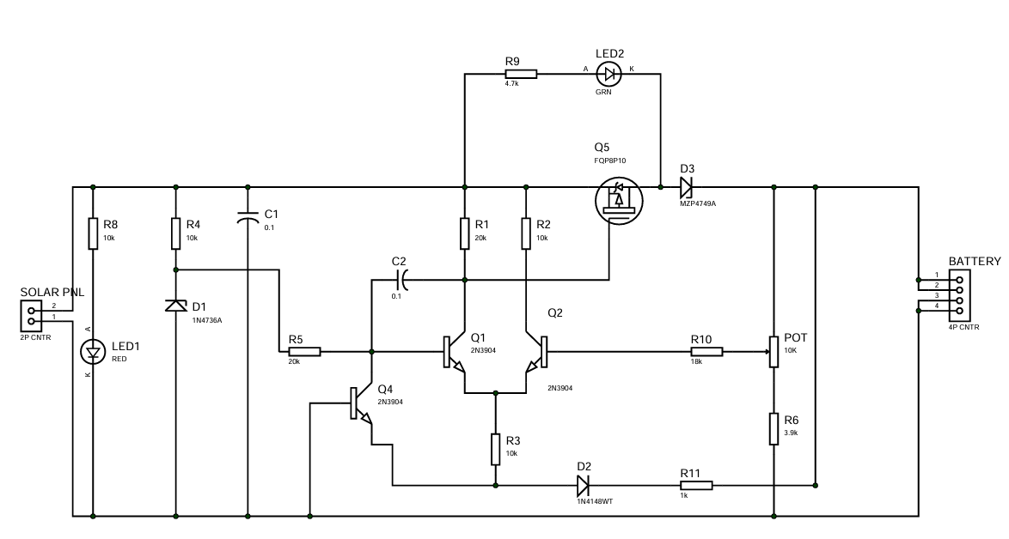
Charger Circuit Diagram:

Charger circuit Working:
- LDO Solar Charge Control Circuit Operation
- R4 and D1 form a 6V shunt Zener voltage reference.
- Q1 & Q2 make up the classic differential amplifier that amplifies the difference between the reference voltage and the feedback voltage from the arm of potentiometer R6.
- The output is taken from the collector of Q1 and drives the gate of P Channel MOSFET Q3. Differential voltage gain is probably in the order of 100 to 200.
- For best performance, I selected Q1 & Q2 for matched hFE.
- As the feedback voltage increases at the arm of R6, Q2 turns on harder and steals some of the emitter current away from Q1. The collector current of Q1 follows the emitter current and drops less voltage across R1 thus reducing Vgs of Q3 and turning it off.
- C2 provides frequency compensation to prevent the amplifier from oscillating.
- Q3 is dormant unless the battery is connected reverse –should this happen, Q3 turns on and reduces the reference voltage input to zero thus turning Q1 & Q3 and preventing damaging battery current.
- D3 prevents the battery voltage from appearing across an inactive solar panel.

Battery Over Charge Protection Circuit Diagram:

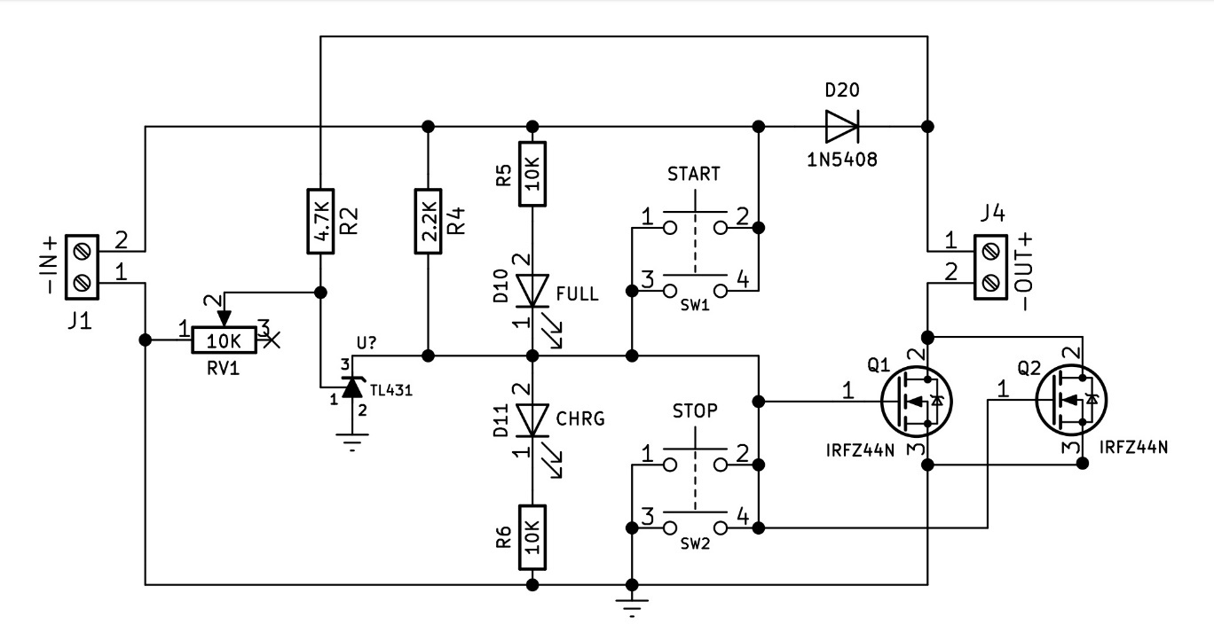

Working:
- Auto cut Off 12v Battery Charger Circuit using Mosfets.
- Input is connected to J1 and output is connected to J2.
- 2.2k Ω (R4) gives positive signal to the gate that turn on the Mosfet to pass negative at output.
- For auto cut off here TL431 shunt regulator is used.
- And reference pin1 of TL431 is connected to voltage divider.
- 10k Ω (RV1) variable resistor is used to set cutoff threshold.
- And 4.7k Ω (R2) resistor directly connected to positive of battery so that when battery voltage reaches to set threshold reference pin (pin2) of shunt regulator receives positive signal and passes negative from pin2 to pin3 of TL431.
- So positive signal coming2.2k Ω (R4) resistor goes ground and turn off Mosfets and FULL Led turn off.
- Manual START and STOP button is added
- N5408 barrier diode for battery up to 30Ah and MIC10A for battery up to 100Ah.

Short Circuit Protection Circuit:
Diagram:
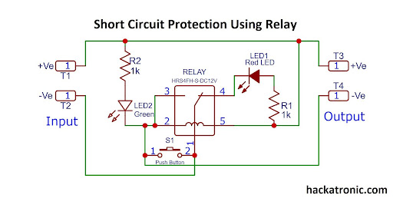

PCB Bottom View:

PCB Bottom View:

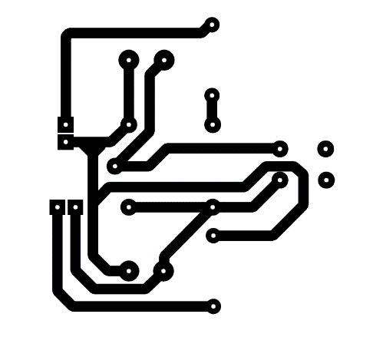
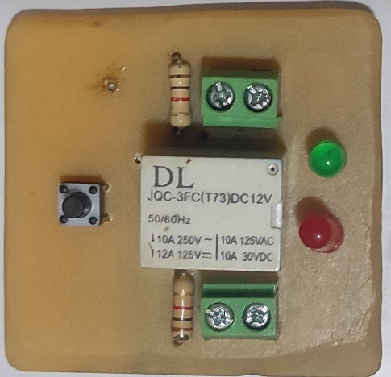

Working:

Direct Connection: The load is connected in series with the relay contacts. This means that the current passing through the load also passes through the relay contacts.
Normal Operation: During normal operation, when the current flowing through the circuit is within safe limits, the relay remains in its default state. The contacts of the relay are closed, allowing current to flow through the load uninterrupted.
Short Circuit Detection: When a short circuit occurs, the current in the circuit increases significantly beyond the normal operating range. This increased current flows through the relay contacts.
Overcurrent Response: The increased current causes the relay's coil to generate a magnetic field, which activates the relay. As a result, the relay contacts switch to an open state, breaking the circuit and disconnecting the load from the power source.
Protection Activation: By opening the circuit, the relay prevents excessive current from flowing through the load, thereby protecting the components from damage due to the short circuit.
Manual Reset: After the short circuit is cleared, the protection circuit have reset button. This may involve physically resetting the relay or closing its contacts again to restore power to the load.

IoT
The term IoT, or Internet of Things, refers to the collective network of connected devices and the technology that facilitates communication between devices and the cloud, as well as between the devices themselves.
- To make smart and intelligent usage of energy and its conservation in home appliances
- To control and monitor any System
- To show the effective way of power utilization and conservations
- To save energy and proper management of appliances
IFTTT
IFTTT stands for "If This, Then That." It's a web-based service that allows you to create conditional statements called applets. These applets automate tasks between various internet-connected services and devices. For example, you could create an applet that says, "If I post a photo on Instagram, then save it to my Dropbox." It's all about connecting different apps and devices to make your digital life simpler and more efficient.
Algorithm for IFTTT:
- Start Assistant
- Give voice command to turn appliance ON/OFF
- Assistant send data to turn appliance ON/OFF to IFTTT
- IFTTT checks what the command is and execute predefined if statement and forwards corresponding data to Adafruit
- Adafruit turns switches with respect to data received from IFTTT
- NodeMCU (ESP32) collects switch data from Adafruit over internet
- NodeMCU turns ON/OFF relay connected to corresponding switch
- Appliance Starts/Stops.

Adafruit:
Adafruit was founded in 2005 by MIT
Adafruit is a cloud based free IoT web server used to create virtual switches, is linking to IFTTT website abbreviated as “If This Then That” which is used to create if conditional statements.
Adafruit IoT (Internet of Things) refers to Adafruit's line of products, tutorials, and resources focused on creating connected devices and projects. They offer various IoT development boards, sensors, modules, and software tools designed to help makers and developers build Internet-connected devices for home automation, environmental monitoring, wearable technology, and more. Adafruit's IoT offerings often integrate with popular platforms and protocols like MQTT, Adafruit IO, and various cloud services to enable easy data collection, control, and interaction with IoT projects.

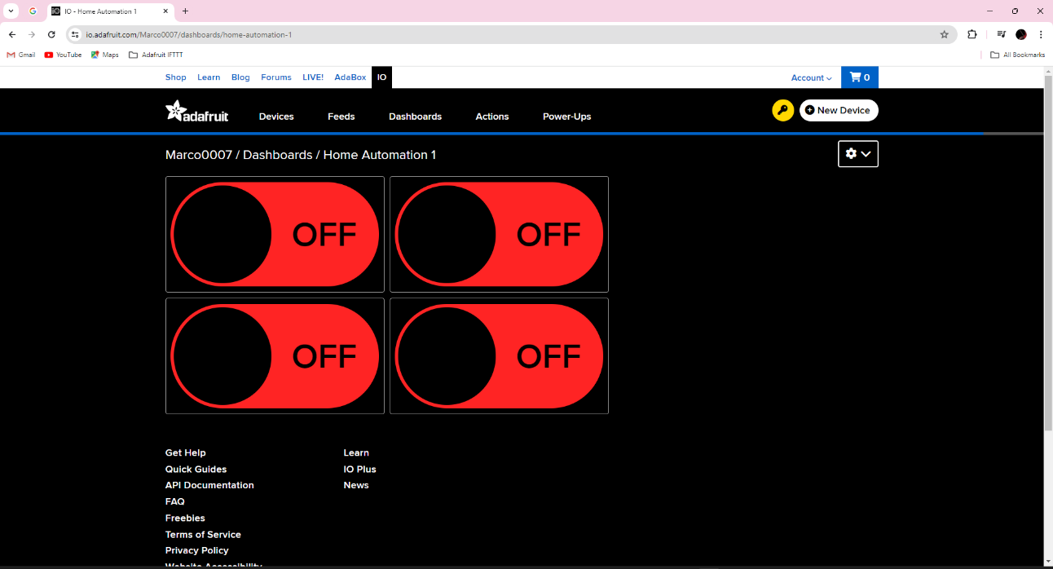

Home automation
Program Code to control switches:
//#include <ESP8266WiFi.h>
#include <WiFi.h>
#include "Adafruit_MQTT.h"
#include "Adafruit_MQTT_Client.h"
#define Switch1 12
#define Switch2 14
#define Switch3 27
#define Switch4 26
#define WLAN_SSID "POCO X2"
#define WLAN_PASS "nikhil@6388"
#define AIO_SERVER "io.adafruit.com"
#define AIO_SERVERPORT 1883
#define AIO_USERNAME "Marco0007"
#define AIO_KEY "aio_afDW49YTneD4PzPjzq7gCtfTHskd"
WiFiClient client;
//WiFiClientSecure client;
Adafruit_MQTT_Client mqtt(&client, AIO_SERVER, AIO_SERVERPORT, AIO_USERNAME, AIO_KEY);
Adafruit_MQTT_Subscribe Light1 = Adafruit_MQTT_Subscribe(&mqtt, AIO_USERNAME"/feeds/Switch1");
Adafruit_MQTT_Subscribe Light2 = Adafruit_MQTT_Subscribe(&mqtt, AIO_USERNAME "/feeds/Switch2");
Adafruit_MQTT_Subscribe Light3 = Adafruit_MQTT_Subscribe(&mqtt, AIO_USERNAME"/feeds/Switch3");
Adafruit_MQTT_Subscribe Light4 = Adafruit_MQTT_Subscribe(&mqtt, AIO_USERNAME "/feeds/Switch4");
void MQTT_connect();
void setup()
{
Serial.begin(115200);
pinMode(Switch1, OUTPUT);
pinMode(Switch2, OUTPUT);
pinMode(Switch3, OUTPUT);
pinMode(Switch4, OUTPUT);
Serial.println(); Serial.println();
Serial.print("Connecting to ");
Serial.println(WLAN_SSID);
WiFi.begin(WLAN_SSID, WLAN_PASS);
while (WiFi.status() != WL_CONNECTED)
{
delay(500);
Serial.print(".");
}
Serial.println();
Serial.println("WiFi connected");
Serial.println("IP address: ");
Serial.println(WiFi.localIP());
mqtt.subscribe(&Light1);
mqtt.subscribe(&Light2);
mqtt.subscribe(&Light3);
mqtt.subscribe(&Light4);
}
void loop()
{
MQTT_connect();
Adafruit_MQTT_Subscribe *subscription;
while ((subscription = mqtt.readSubscription(20000)))
{
if (subscription == &Light1)
{
Serial.print(F("Got: "));
Serial.println((char *)Light1.lastread);
int Light1_State = atoi((char *)Light1.lastread);
digitalWrite(Switch1, Light1_State);
}
if (subscription == &Light2)
{
Serial.print(F("Got: "));
Serial.println((char *)Light2.lastread);
int Light2_State = atoi((char *)Light2.lastread);
digitalWrite(Switch2, Light2_State);
}
if (subscription == &Light3)
{
Serial.print(F("Got: "));
Serial.println((char *)Light3.lastread);
int Light3_State = atoi((char *)Light3.lastread);
digitalWrite(Switch3, Light3_State);
}
if (subscription == &Light4)
{
Serial.print(F("Got: "));
Serial.println((char *)Light4.lastread);
int Light4_State = atoi((char *)Light4.lastread);
digitalWrite(Switch4, Light4_State);
}
}
}
void MQTT_connect()
{
int8_t ret;
if (mqtt.connected())
{
return;
}
Serial.print("Connecting to MQTT... ");
uint8_t retries = 3;
while ((ret = mqtt.connect()) != 0)
{ // connect will return 0 for connected
Serial.println(mqtt.connectErrorString(ret));
Serial.println("Retrying MQTT connection in 5 seconds...");
mqtt.disconnect();
delay(5000);
if (retries == 0)
{
while (1);
}
}
Serial.println("MQTT Connected!");
}

Appendix – Datasheet:

TL431- (Page- 1,2,3) - https://html.alldatasheet.com/html-pdf/5774/MOTOROLA/TL431/256/1/TL431.html
IRFZ44N - (Page- 1,2,3) - https://html.alldatasheet.com/html-pdf/17807/PHILIPS/IRFZ44N/497/2/IRFZ44N.html
1N5408 - (Page- 1) - https://www.alldatasheet.com/datasheet-pdf/pdf/201493/TSC/1N5408.html
1N4735A - (Page- 1,2) - https://datasheet.octopart.com/1N4735A-ON-Semiconductor-datasheet-98394419.pdf?_gl=1*5wow4h*_ga*MTYzNDUxMjMwNy4xNzEzNTMyOTU1*_ga_SNYD338KXX*MTcxMzUzMjk1Ni4xLjEuMTcxMzUzMjk3MC4wLjAuMA..
2N3904 - (Page- 1,2) - https://html.alldatasheet.com/html-pdf/421681/KEC/2N3904/53/1/2N3904.html
FQP27P06 - (Page- 1,2) - https://html.alldatasheet.com/html-pdf/52358/FAIRCHILD/FQP27P06/407/1/FQP27P06.html
1N4148 - (Page- 2,3) - https://html.alldatasheet.com/html-pdf/15021/PHILIPS/1N4148/245/1/1N4148.html
Relay - (Page- 1,2) - https://components101.com/sites/default/files/component_datasheet/5V%20Relay%20Datasheet.pdf

Appendix B – Bibliography:
Important Software and Websites
- Proteus Software
- Arduino IDE
- EasyEDA
- www.jlcpcb.com

Reference
- www.youtube.com
- www.ifttt.com
- www.adafruit.com
- www.electroschematics.com/12v-ldo-solar-charge-control
- https://chat.openai.com/
- https://www.google.com

Name | QTY | Part Number | DESCRIPTION
Heat Sink | 3 | # | Heat Sink, 1.5"H, 3.9°C/W
MOSFET | 1 | FQP27P06 | MOSFET Transistor, TO-220, 60V, 27A
MOSFET | 2 | irfz44n / irf3205 | N-Channel Power Mosfet
Rectifier | 1 | P600G | Rectifier, 6A, 400V
Diode | 1 | 1N4148 | Diode, 100V, 0.1A
Zener Diode | 1 | 1N4735A | Zener, 6.2V, 0.5W
Transistor | 3 | 2N3904 | NPN Transistor, 40V, 200MA, TO-92
Capacitor | 2 | # | Capacitor, 0.1, 10%, 50V, X7R
LED | 2 | RED AND GREEN | 3.0-3.8V, 20mA
Shunt Regulator | 1 | TL431 | #
Diode | 1 | 1n5408 / MIC10A | #
Push Button | 2 | # | Tactical
NodeMCU | 1 | # | #
Battery | 1 | Exide Powersafe | SMF 12V, 7Ah
Potentiometer | 2 | # | Multi Turn 10KΩ
Resistor | # | # | 1KΩ, 3.9KΩ, 4.7KΩ, 10KΩ, 18KΩ, 20KΩ (0.25W, 5%, Carbon film)
Relay | 1 | # | 5V, 10A 250V
4-Channel relayModule | 1 | # | 5V, 10A 250V
Inverter | 1 | Power Inverter | I/P= DC 12V, O/P= AC 220-240V, 200Watt.
ESP32 | 1 | ESP-WROOM-32 | Wi-Fi 802.11 b/g/n (2.4 GHz), Bluetooth v4.2 BR/EDR and BLEDual-core Tensilica LX6 microprocessor, running at up to 240 MHz.
Power Module | 1 | DC to DC | I/P= DC 12V, O/P= 3.3V/5V.
Solar Panel | 1 | MxP1240 | 22.6V, 40Watt
Component List:

