

A

Project Report on

"**Drive Safe**"

(Smart Connected Vehicle using CAN and IoT Communication)

For the

Fulfilment of

Post Graduate Diploma (DESD)

Project

By

*Nikhil Krishnakant Kavate (86822)*

*Mrinal* *Eashwar Taiwade (87404)*

*Romesh B**hojraj Dudhbarwe (86861)*

*Prasad* *Rajendra Jadhav (87249)*

Under the Guidance of

Sir. N. Ghule



**Department of DESD**

**Sunbeam Institute of Information Technology**

**Hinjewadi, Pune-** **411057**

Date (12/02/2025)

**ACKNOWLEDGEMENT**

It gives us a great pleasure in presenting the project report on **DriveSafe - Smart Connected vehicle using CAN and IoT Communication**.

We would like to take this opportunity to thank our internal guides, **L-Mentor A. Tembhurnikar** and **L-Mentor N. Shirke**, for providing us with all the help and guidance we needed. We are really grateful to them for their kind support. Their valuable suggestions were very helpful.We are also grateful to **Prof. D. Dhande**, Course Coordinator of DESD, Sunbeam Hinjewadi, Pune-57 for his indispensable support & suggestions.

With deep sense of gratitude, we thank to CEO and Management of, Sunbeam Hinjewadi, Pune-57 for providing all necessary facilities and their constant encouragement and support**.**

THANKING YOU...

**Nikhil Krishnakant Kavate**

**Mrinal Eashwar Taiwade**

**Romesh Bhojraj Dudhbarwe**

**Prasad Rajendra Jadhav**

|  |  |  |
| --- | --- | --- |
| Sr.no. | Title of contents | Page no. |
| 1. | ABSTRACT | 5 |
| 2. | INTODUCTION | 7 |
| 3. | Discussion of Design Method | 9 |
| 4. | System Design | 14 |
| 5. | Block Diagram | 15 |
| 6. | Component Information | 16 |
| 7. | Circuit Diagram | 26 |
| 8. | Working | 29 |
| 9. | Appendix – A Datasheet | 30 |
| 10. | Appendix - B | 31 |
| 11. | Component List | 32 |

**INDEX**

**Abstract:**

Ensuring vehicle safety through intelligent systems has become a crucial aspect of modern automotive technology. This project focuses on integrating alcohol detection, door status monitoring and speed tracking to enhance vehicle security and prevent accidents.

The system utilizes two STM32 microcontrollers and an ESP8266 module. The STM32F407 Discovery board is interfaced with an MQ3 alcohol sensor, which detects alcohol levels and transmits data over the CAN communication protocol. A second STM32 board receives this data and prevents the vehicle from starting if the alcohol level exceeds a predefined threshold level or if the door is not securely closed. Additionally, the ESP8266 module is used to measure vehicle speed using a Grove coupler sensor and transmits the data to the ThingsBoard platform for real-time monitoring. The vehicle's door lock/unlock mechanism is controlled using the GPIO pins of the STM32 board.

By integrating these technologies, this project aims to improve vehicle safety by preventing drunk driving and ensuring proper security measures. The use of IoT enables remote monitoring, making the system more efficient and accessible for real-world applications.

**Enhancing Vehicle Safety with Smart Technology:**

Vehicle safety is a paramount concern in modern transportation, necessitating innovative solutions to prevent accidents and ensure safety. By integrating advanced sensors, real-time monitoring, and IoT-based connectivity, this project aims to enhance vehicle safety through intelligent automation. The combination of alcohol detection, door status verification and speed monitoring addresses critical risk factors associated with road safety. Leveraging CAN communication for reliable data transmission and cloud-based analytics for remote tracking, this system not only prevents unsafe vehicle operation but also empowers users with real-time insights, setting a new standard for smart automotive security.

**Reinforcing Vehicle Security with IoT:**

The Internet of Things (IoT) enhances vehicle safety by providing real-time monitoring and data analysis. In this project, IoT is used for speed monitoring, where an ESP8266 module measures vehicle speed and sends the data to ThingsBoard for remote tracking. Other safety features, such as alcohol detection and door status monitoring, operate through STM32 microcontrollers and CAN communication. This system ensures reliable data transmission, prevents unsafe vehicle operation, and provides real-time insights for better security and safety.

**Innovating Vehicle Safety with Intelligent Systems:**

From real-time monitoring to automated safety checks, the integration of smart technology in vehicles is transforming road safety. This project leverages IoT and embedded systems to prevent unsafe driving conditions by incorporating alcohol detection and door status verification. The system ensures that the vehicle does not start if the alcohol level exceeds a set threshold or if the doors are not securely closed, using CAN communication and GPIO-based detection. Additionally, real-time speed tracking via an ESP8266 module enables remote monitoring on ThingsBoard. By integrating these safety measures, this project enhances vehicle security and promotes responsible driving practices.

**Introduction:**

Preventing accidents and enhancing vehicle security are the primary objectives of this project. The system is designed to ensure that the vehicle does not start under unsafe conditions, such as when alcohol is detected or the doors are not properly closed.

The project integrates an MQ3 alcohol sensor with an STM32F407 Discovery board, which sends data over the CAN communication protocol to a second STM32 board. If the alcohol level exceeds a predefined threshold or if the door is open, the system prevents the motor from starting. Additionally, an ESP8266 module is used to measure vehicle speed using a Grove coupler sensor, with real-time data monitoring on ThingsBoard.

By leveraging IoT and embedded system technologies, this project ensures smarter, safer, and more responsible vehicle operations, reducing risks and improving road safety.

**Design Description:**

In recent years, advancements in automotive safety technologies have played a crucial role in reducing road accidents and enhancing vehicle security. One of the major concerns in transportation safety is drunk driving and improper vehicle access, which can lead to severe consequences. To address this issue, this project integrates embedded systems and IoT to develop an intelligent vehicle safety mechanism.

The proposed system consists of two STM32 microcontrollers and an ESP8266 module working together to ensure safe vehicle operation. The STM32F407 Discovery board is interfaced with an MQ3 alcohol sensor, which detects alcohol levels and transmits data over the CAN communication protocol to a second STM32 board. This second microcontroller verifies the received data and prevents the motor from starting if the alcohol concentration exceeds a set threshold or if the vehicle doors are not securely closed, as detected using buttons and GPIO pins.

Additionally, the ESP8266 module is integrated with a Grove coupler sensor to measure vehicle speed and transmit real-time data to the ThingsBoard platform for monitoring and analysis. By leveraging CAN communication, IoT-based monitoring, and real-time safety checks, this system enhances vehicle security, prevents accidents, and promotes responsible driving habits.

**Project Design Specifications Table:**

|  |  |
| --- | --- |
| Component | Specification |
| STM32F407  Disc Board | ARM Cortex-M4, 168 MHz, 1MB Flash, 192KB RAM, Pins: Up to 82. |
| ESP8266MOD | GPIO Pins: Up to 17, Flash Memory: Up to 16MB, Operating Vol= 3.3V DC. |
| MQ3  Gas Sensor | Operating Voltage: 5V DC, Preheat time =24hr, Response time<11. |
| MCP2551  CAN Transceiver | Operating Vol= 4.5V to 5.5V, Max Data Rate= 1Mbps, Max Node =112. |
| 5v dc Motor | Operating Vol= 5V DC, No-Load Speed= 2000-6000. |
| MB 102 Breadboard Power Supply | I/P= DC 12V, O/P= 3.3V/5V. |
| Resistors | 120Ω ±5%. |
| Relay Channel | 4 channel relay OV= 4, Max O/P= AC250V, with Optocoupler. |
| Lm393IR | Operating Vol= 3.3V-5V DC, Interface: 4-Pin (VCC, GND, AO, DO). |
| Switch | Toggle, PCB / Panel. |
| Adjustable Speed Controller Regulation | I/P Vol= 1.8V-15V DC, Max O/P Pow= 30w, Max O/P Current= 2A. |

**Simulation and Design Methods:**

**System Overview:**

The proposed vehicle safety system consists of several key components, including two STM32 microcontrollers, an MQ3 alcohol sensor, an ESP8266 module, a Grove coupler sensor, and GPIO-based door status detection. The primary objective is to integrate these components to enhance vehicle security by preventing the vehicle from starting under unsafe conditions.

The STM32F407 Discovery board is responsible for detecting alcohol levels using the MQ3 sensor and transmitting data over the CAN communication protocol to a second STM32 board. This board processes the received data and ensures that the vehicle starts only if the alcohol level is below the threshold and all doors are securely closed, detected using buttons and GPIO pins.

Additionally, the ESP8266 module is employed to measure vehicle speed via the Grove coupler sensor and transmit real-time data to ThingsBoard for remote monitoring. By integrating these components, the system ensures a smarter, safer, and more reliable approach to vehicle operation and accident prevention.

**Design Approach:**

The design approach for this vehicle safety system follows an iterative process to ensure its functionality, efficiency, and reliability. The system is structured into three key modules: alcohol detection, door status verification, and speed monitoring, all working together to prevent unsafe vehicle operation.

1. **Alcohol Detection and Processing:** The MQ3 alcohol sensor is interfaced with the STM32F407 Discovery board, which continuously monitors alcohol levels. The system sends data via CAN communication to the second STM32 board.
2. **Door Status Verification:** A set of buttons and GPIO pins are used to check whether the vehicle doors are properly closed. If any door remains open, the second STM32 board ensures that the motor will not start, adding an additional layer of safety.
3. **Speed Monitoring and IoT Integration:** An ESP8266 module is connected to a Grove coupler sensor to measure vehicle speed. The collected data is transmitted to ThingsBoard, allowing remote monitoring and data analysis for better safety insights.

The combination of **CAN communication, embedded systems, and IoT monitoring** enhances the overall reliability of this vehicle safety solution.

**Component Selection:**

Careful consideration is given to selecting components based on their specifications, compatibility, and performance characteristics to ensure the reliability of the vehicle safety system. Each component is chosen to meet the functional requirements efficiently while maintaining seamless integration.

* **STM32F407 Discovery Board:** Selected for its powerful processing capabilities and compatibility with **CAN communication**, ensuring reliable data transmission between microcontrollers.
* **MQ3 Alcohol Sensor:** Chosen for its sensitivity in detecting alcohol levels, allowing accurate assessment of driver sobriety.
* **Second STM32 Board:** Responsible for processing received data and controlling the motor operation based on alcohol levels and door status.
* **ESP8266 Module:** Used for its **Wi-Fi connectivity**, enabling real-time speed monitoring and data transmission to **ThingsBoard**.
* **Grove Coupler Sensor:** Selected for its ability to measure vehicle speed accurately, ensuring real-time performance tracking.
* **Buttons and GPIO Pins:** Implemented for **door status detection**, preventing vehicle startup if doors are not properly closed.

Each component plays a crucial role in enhancing the system’s **efficiency, accuracy, and reliability**, ensuring that the vehicle operates safely under appropriate conditions.

**System Sizing:**

Proper sizing of the components is crucial to ensure the system functions efficiently under all conditions. This includes determining the **threshold levels, communication bandwidth, and power requirements** for optimal performance.

* **Alcohol Detection Threshold:** The MQ3 sensor's output is calibrated to detect alcohol concentration, ensuring that the vehicle does not start if the driver is intoxicated.
* **CAN Communication Bandwidth:** The CAN protocol is configured to handle real-time data transmission between the two STM32 boards without delays or data loss.
* **Power Requirements:** The STM32 boards, ESP8266 module, and sensors are powered efficiently to ensure stable operation, considering current consumption and voltage regulation.
* **Speed Measurement Accuracy:** The Grove coupler sensor is calibrated to provide precise speed readings, ensuring real-time monitoring without errors.

By carefully optimizing these parameters, the system ensures **reliable performance, fast response times, and enhanced vehicle safety**, making it an effective real-world solution.

**Control and Monitoring:**

The integration of STM32 microcontrollers and an ESP8266 module enables intelligent control and monitoring of the vehicle safety system. Each controller is programmed to ensure real-time decision-making and seamless data communication for enhanced security.

* **Alcohol Detection and Motor Control:** The STM32F407 Discovery board processes data from the MQ3 sensor and transmits it via CAN communication to the second STM32 board. If the alcohol level exceeds the threshold, the motor remains off.
* **Door Status Verification:** The second STM32 board continuously monitors door status through buttons and GPIO pins. If any door is open, the vehicle will not start.
* **Speed Monitoring and IoT Integration:** The ESP8266 module collects speed data from the Grove coupler sensor and sends it to ThingsBoard for real-time monitoring and analysis.
* **System Communication and Response:** The CAN protocol ensures fast and reliable data exchange between the microcontrollers, enabling quick decision-making and preventing unsafe vehicle operation.

by combining **embedded control & real-time monitoring** the system enhances vehicle safety, ensuring that it operates only under safe conditions.

**Areas Requiring Attention:**

Several aspects of the **vehicle safety system** require careful consideration during the design and implementation process to ensure optimal performance and reliability:

* **Safety**: Ensuring the safety of both the vehicle and its occupants is paramount. This includes implementing threshold-based motor control to prevent a drunk driver from starting the vehicle, door status verification to ensure proper closure, and short circuit protection to avoid electrical hazards.
* **Efficiency:** The system must operate efficiently to ensure seamless communication between microcontrollers and real-time data processing. This involves optimizing the CAN communication protocol, refining control algorithms for faster decision-making, and ensuring minimal power consumption by the ESP8266 module.
* **Reliability:** The system should be robust enough to function under varying environmental and operational conditions. To enhance reliability, fail-safe mechanisms are incorporated, such as ensuring the STM32 microcontrollers handle unexpected sensor failures gracefully.

**Conclusion:**

The simulation and design methodologies employed in developing the Vehicle Safety System with Alcohol Detection and Speed Monitoring are critical to ensuring its functionality, efficiency, and reliability. By carefully selecting components, optimizing system sizing, and simulating various operational conditions, a highly dependable and secure vehicle control system is achieved. This approach lays the foundation for real-world implementation, enhancing road safety and responsible vehicle usage.

**Description of Design:**

**Connection diagram:**

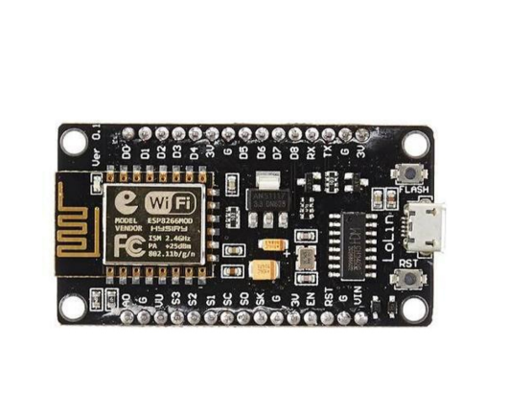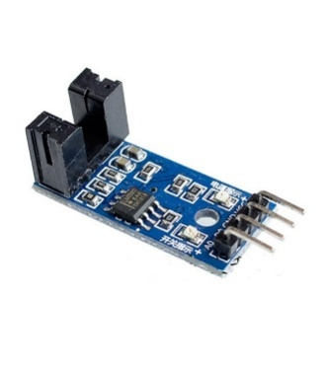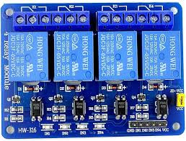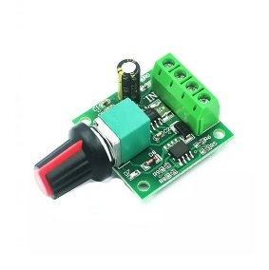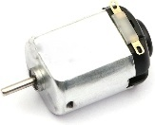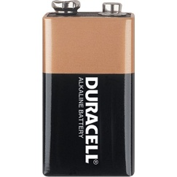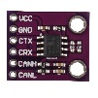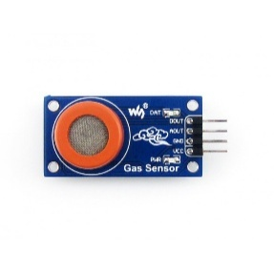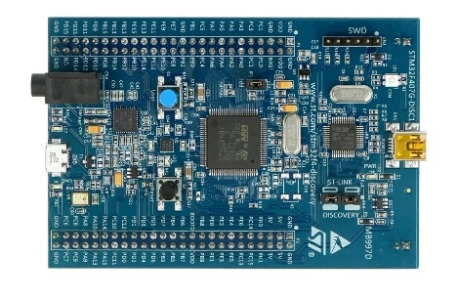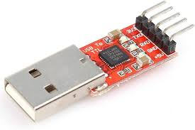

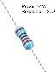

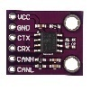



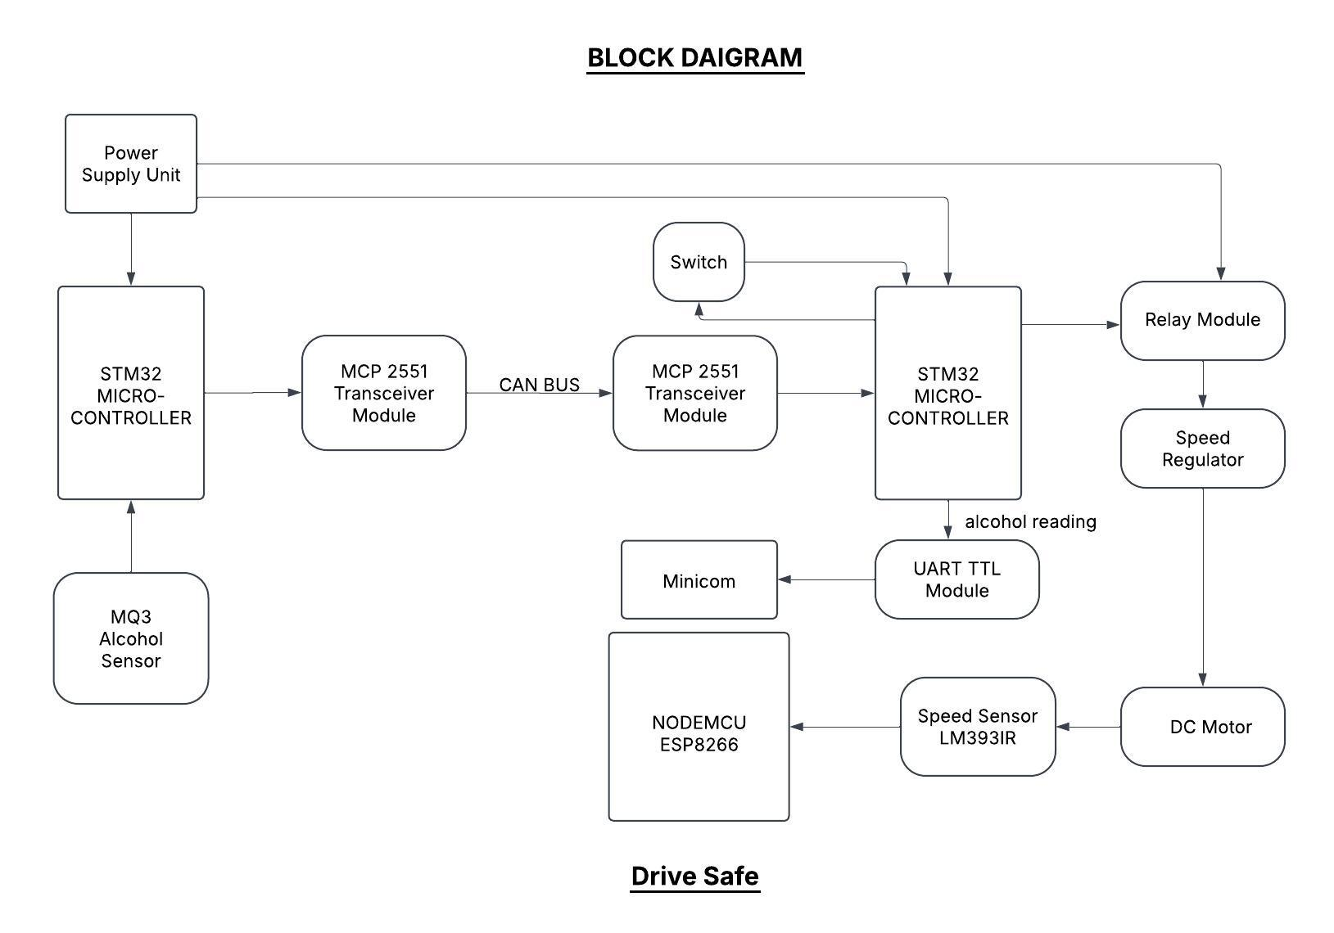

**STM32F407 Discovery Board:**

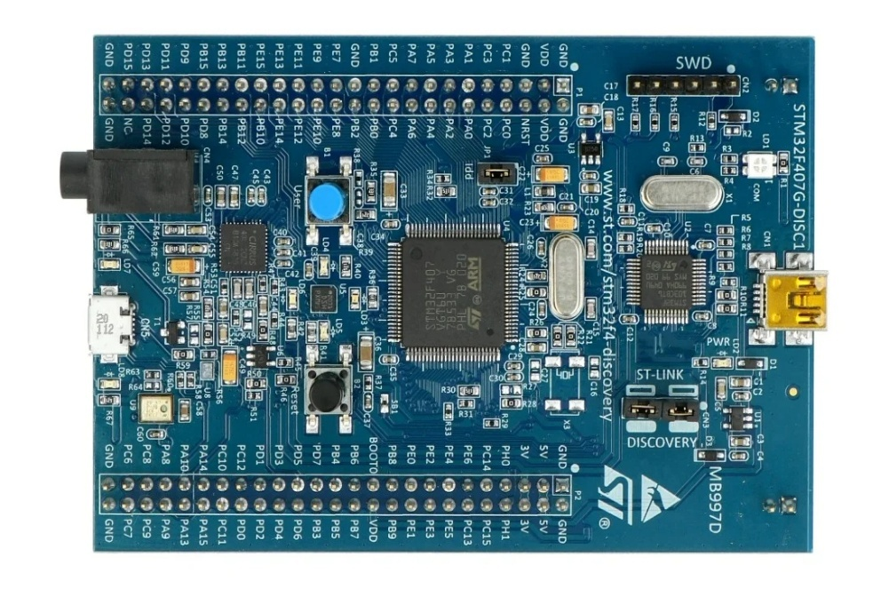The STM32F407 Discovery board is a powerful development platform featuring the STM32F407VG microcontroller with a high-performance ARM Cortex-M4 core. It includes rich peripherals, making it ideal for embedded system development, real-time processing, and IoT applications. The onboard ST-LINK/V2 debugger allows for easy programming and debugging, making it a popular choice among developers and engineers.

**Specification:**

1. **Microcontroller:** STM32F407VG with ARM Cortex-M4 core running at 168 MHz.
2. **Memory:** 1 MB Flash, 192 KB SRAM.
3. **GPIOs:** Up to 82 I/O pins (multiplexed with peripherals).
4. **ADC/DAC:** 3x 12-bit ADC (24 channels), 2x 12-bit DAC.
5. **Communication Interfaces:**

* 4x USART, 2x UART, 3x SPI, 2x I2C, 2x CAN, 1x SDIO.

1. **Timers:** 17 timers including general-purpose, PWM, and watchdog.
2. **External Memory Support:** FSMC for SRAM, NOR, NAND Flash, and SDRAM.
3. **Connectivity:** USB OTG full-speed and high-speed support.
4. Onboard Peripherals:

* 3-axis accelerometer.
* MEMS audio sensor (MP45DT02).
* DAC output with onboard audio codec.

1. Debugging and Programming: Integrated ST-LINK/V2 debugger

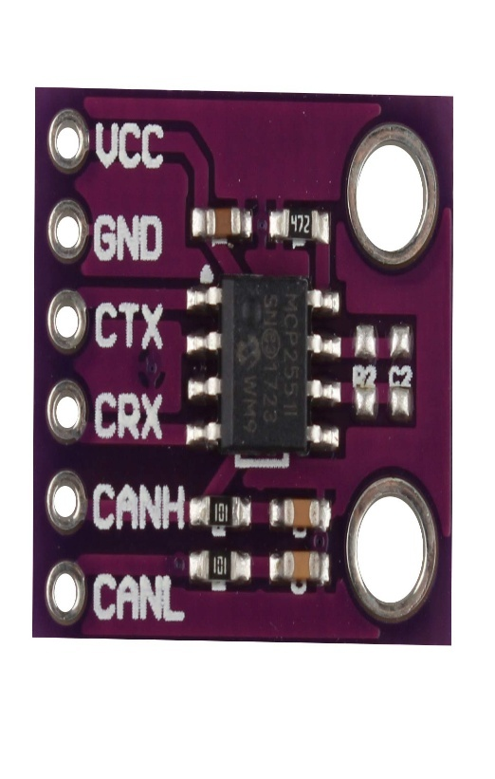**MCP2551 CAN Transceiver:**

**Transceiver Module**:

The MCP2551 is a high-speed CAN transceiver designed for reliable communication in Controller Area Network (CAN) applications. It provides differential signal transmission and reception, ensuring robust data exchange even in electrically noisy environments. With built-in protection features like short-circuit handling, thermal shutdown, and dominant timeout, the MCP2551 enhances system stability and safety, making it ideal for automotive, industrial and embedded applications.

**Specification:**

1. **Operating Voltage**: 5V.
2. **Data Rate**: Supports up to 1 Mbps.
3. **CAN Protocol**: Compliant with ISO-11898 standard.
4. **Bus Pins**: CANH (High) and CANL (Low) for differential signal transmission.
5. **I/O Levels**: Compatible with 3.3V and 5V logic levels.
6. **High Noise Immunity**: Common-mode range of -2V to +7V.
7. **Thermal Protection**: Over-temperature protection with automatic shutdown.
8. **Fail-Safe Features**:

* Slope control for reduced EMI.
* Short-circuit protection on CANH and CANL pins.
* Dominant timeout function prevents bus lockup.

1. **Low Power Mode**: Standby mode for reduced power consumption.
2. **Package Type**: Available in PDIP, SOIC, and TSSOP packages.

**Specifications:**

* 1. **Operating Voltage**: 5V DC.
  2. **Current Consumption**: Less than 150mA.
  3. 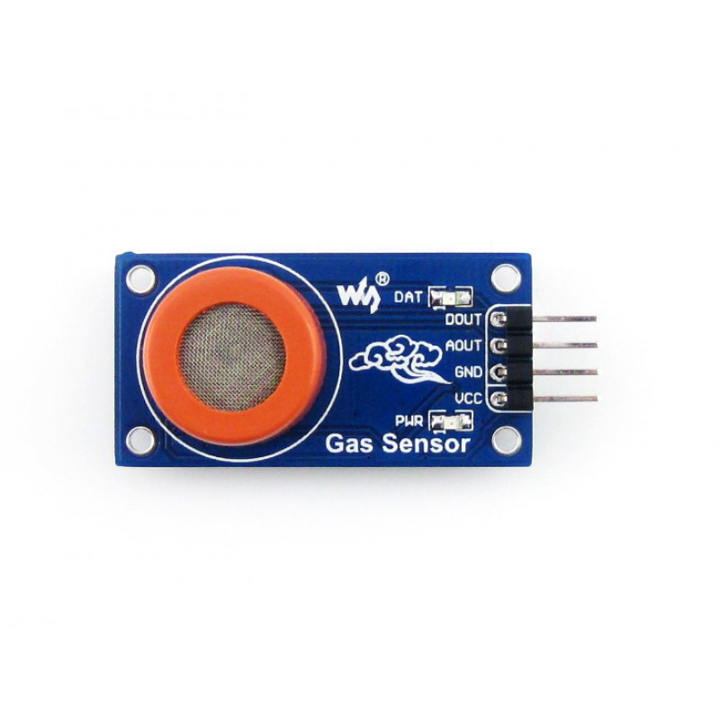**Detection Range**: 25-500 ppm (parts per million) of alcohol vapor.
  4. **Sensitivity**: Detects ethanol, benzene, and other alcohol vapours.
  5. **Response Time**: ≤ 10 seconds.
  6. **Recovery Time**: ≤ 30 seconds.
  7. **Heater Resistance**: 31Ω ± 3Ω at 5V.
  8. **Preheat Time**: Over 24 hours for best accuracy.
  9. **Output**: Analog voltage output proportional to alcohol concentration.
  10. **Operating Temperature**: -10°C to 50°C.

**MQ3 Alcohol Detection Sensor:**

The MQ3 is a widely used gas sensor designed for detecting alcohol vapours in the air. It works by measuring changes in electrical resistance due to alcohol presence. The sensor outputs an analog signal that can be processed by microcontrollers like STM32 or Arduino. Due to its high sensitivity, fast response time, and ease of integration, the MQ3 is commonly used in breathalysers, automotive safety systems, and industrial alcohol detection applications.

**ESP8266MOD:**

**Specifications of ESP8266:**

1. **CPU**: 32-bit Tensilica L106 running at up to 160 MHz.
2. 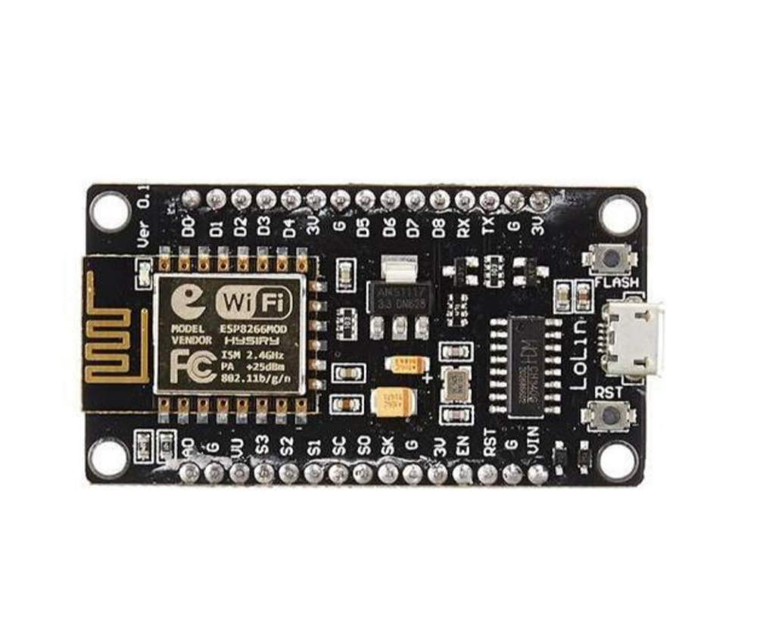 **Memory**: 80 KB user RAM, 32 KB instruction RAM, and external flash support.
3. **Wi-Fi**: Supports 802.11 b/g/n with speeds up to 72.2 Mbps.
4. **GPIOs**: Up to 17 GPIO pins for interfacing with peripherals.
5. **ADC**: Single-channel 10-bit ADC for analog input.
6. **Serial Interfaces**: Supports SPI, I2C, UART (up to 115200 bps).
7. **Power Consumption**: Ultra-low power consumption with deep sleep mode (~20 µA).
8. **Operating Voltage**: 3.0V to 3.6V, with an average working current of ~80 mA.
9. **Flash Storage**: Supports external SPI flash up to 16 MB.
10. **Security**: Supports WEP, WPA, WPA2 encryption for secure Wi-Fi communication

**ESP8266 MICROCONTROLLER:**

ESP8266 is a low-cost Wi-Fi-enabled microcontroller developed by Espressif Systems. It features a highly integrated design with a 32-bit Tensilica L106 processor, built-in TCP/IP stack, and various GPIOs for interfacing. Despite its low power consumption, the ESP8266 offers robust wireless connectivity, making it widely used in IoT applications for smart devices, home automation, and sensor networks.

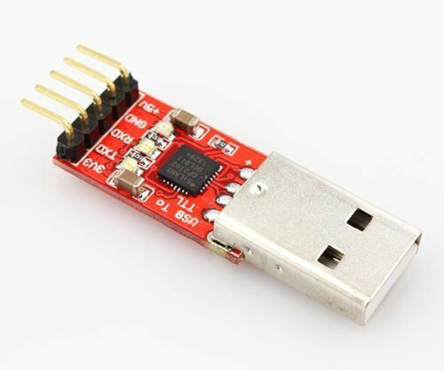**USB to TTL Serial Converter Adapter Module:**

The FT232RL FTDI USB to TTL Serial Converter is a reliable module used for serial communication between USB-enabled devices and microcontrollers. It converts USB signals into TTL logic levels, making it ideal for interfacing with embedded systems such as Arduino, ESP8266, and STM32. It provides a stable data transfer rate, supports multiple baud rates, and is widely used in embedded applications.

**Specifications:**

1. **Chipset**: FT232RL by FTDI (Future Technology Devices International).
2. **USB Interface**: Full-speed USB 2.0 compliant.
3. **Baud Rate**: Supports standard baud rates from 300bps to 3Mbps.
4. **Operating Voltage**: 3.3V / 5V switchable output.
5. **EEPROM**: Built-in, allowing custom configurations.
6. **Flow Control**: Supports RTS/CTS, DTR/DSR, and XON/XOFF.
7. **Driver Support**: Compatible with Windows, macOS, and Linux.
8. **LED Indicators**: TX and RX LEDs for data transmission status.
9. **Connectors**: Standard 6-pin header for easy interfacing (DTR, RXD, TXD, VCC, CTS, GND).
10. **Protection**: Built-in over-current protection and reverse polarity protection.

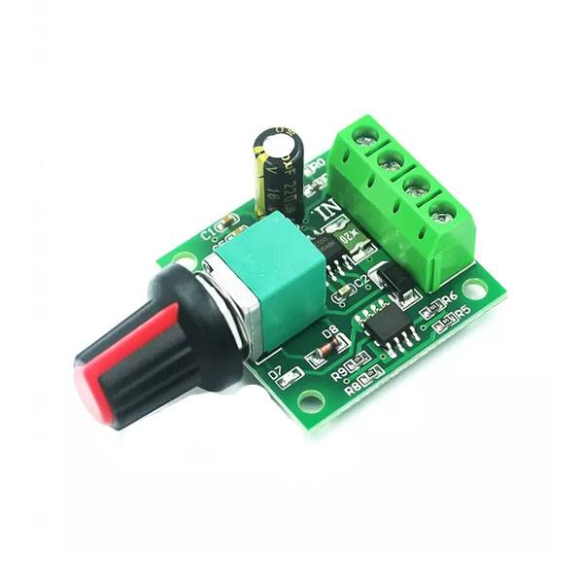 **1.8V – 12V/2A DC Motor PWM Speed Regulator:**

This module is a compact and efficient DC motor speed controller that operates using PWM technology. It allows precise speed adjustments for DC motors operating within the 1.8V to 12V range while handling currents up to 2A. The speed is easily adjusted via a potentiometer, robotics, and small motorized applications. The regulator ensures smooth motor performance while preventing overheating and excessive power loss.

**Specifications:**

1. **Operating Voltage**: 1.8V to 12V DC.
2. **Maximum Current**: 2A continuous output.
3. **Control Method**: PWM (Pulse Width Modulation) for precise speed control.
4. **PWM Frequency**: Typically, 20kHz (varies by model).
5. **Adjustment Range**: 0% to 100% duty cycle.
6. **Potentiometer Control**: Knob-based speed adjustment.
7. **Efficiency**: High efficiency with minimal heat dissipation.
8. **Protection Features**: Overcurrent protection and short circuit protection.
9. **Compact Design**: Small form factor for easy integration into projects.
10. **Applications**: Suitable for DC motor speed control, LED dimming, and other low-voltage applications

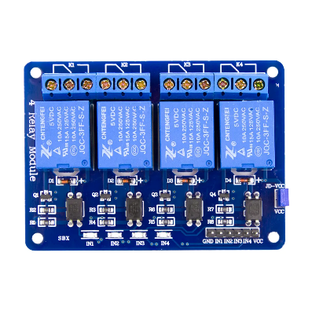**Relay Module:**

**Relay module:**

One type electro-mechanical component that serves as a switch is the relay. In order to open or close contact switches, DC is used to activate the relay coil. A coil and two contacts, such as ordinarily open (NO) and usually closed (NC), are often found in a single channel 5V relay module (NC). This gives a general overview of the 5V relay module and hoe it operate, but first we need to understand what a relay is and how its pins are configured.

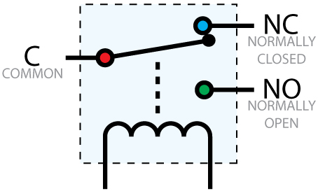An automated switch called a 5V relay is frequently used in automatic control circuits to regulate high currents with low current signals. The relay signal’s input voltage spans the 0 to 5v range. In order to control high voltage, current loads such solenoid valves, motors, AC loads, and lighting, a relay module with a single channel board is employed. This module’s main purpose is to connect with many microcontrollers, including PIC, ESP32, and others.

**Working:**

The relay opens or closes switch contacts using the current supply. Typically, a coil is used to magnetise the switch contacts and draw them together when the switch is engaged. As soon as the coil is not reinforced, a spring push them independently. There are primarily two advantages to employing this approach. The first is that less current is needed to activate the relay than is needed to switch the relay contacts. The other advantage is that there is no electrical connection between the contacts and the coil because they are both galvanically separated.

**4- Channel Relay:**

Relays: The module typically contains four individual relays, each capable of independently controlling a separate electrical circuit. These relays are electromechanical switches that can make or break the connection between the common (COM) terminal and either the normally open (NO) or normally closed (NC) terminal.

Control Signal Input: Each relay channel has an input terminal for the control signal. When a digital signal (usually logic HIGH or LOW) is applied to this terminal from the control device, it activates or deactivates the corresponding relay.

Output Terminals: The module also includes output terminals for each relay channel. These terminals are where you connect the electrical loads that you want to control, such as lights, motors, heaters, or other devices.

Power Supply: The relay module requires a separate power supply to operate the relays and the control circuitry. This power supply is typically a low-voltage DC source, such as 5V or 12V, and is connected to the module's power input terminals.

Optical Isolation (Optional): Some relay modules include optical isolation between the control signal and the relay circuit. This helps protect the control device (e.g., microcontroller) from voltage spikes or other disturbances in the relay circuit.

LED Indicators (Optional): Many relay modules feature LED indicators for each channel to visually indicate whether the relay is activated (LED illuminated) or deactivated (LED off).

Compatibility: Relay modules are compatible with a wide range of microcontrollers and control devices that can provide digital output signals. They are commonly used in DIY electronics projects, home automation systems, robotics, industrial automation, and more.

**Grove Coupler Sensor:**

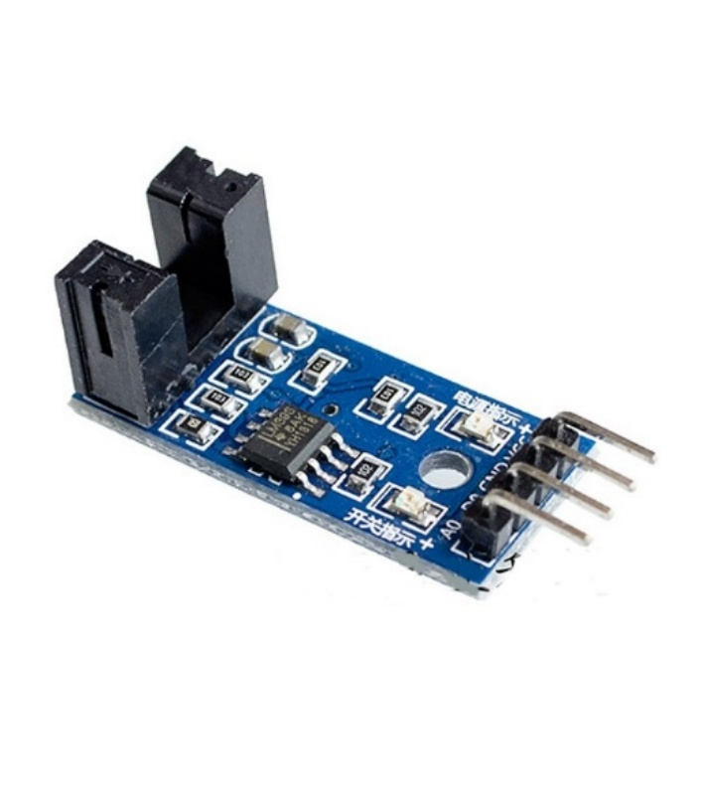

The Grove Coupler Sensor is an infrared optocoupler used for speed measurement, and motor rotation monitoring. It consists of an infrared emitter and a photodetector placed in a U-shaped housing. When an object (such as a rotating encoder disk) interrupts the IR beam, the sensor detects the change and outputs a digital signal. This sensor is widely used in robotics, motor control, and automation systems, offering precise and reliable performance.

**Specifications:**

1. **Operating Voltage**: 3.3V / 5V DC.
2. **Current Consumption**: ≤ 10mA.
3. **Sensor Type**: Infrared (IR) based optocoupler.
4. **Output Type**: Digital (High/Low) signal and Analog signal.
5. **Detection Distance**: Typically, 3-5mm.
6. **Response Time**: Fast response to speed changes.
7. **Operating Temperature**: -20°C to 85°C.
8. **Mounting**: Grove-compatible interface for easy plug-and-play integration.
9. **Dimensions**: Compact, making it suitable for embedded applications.

**Power Supply Module:**

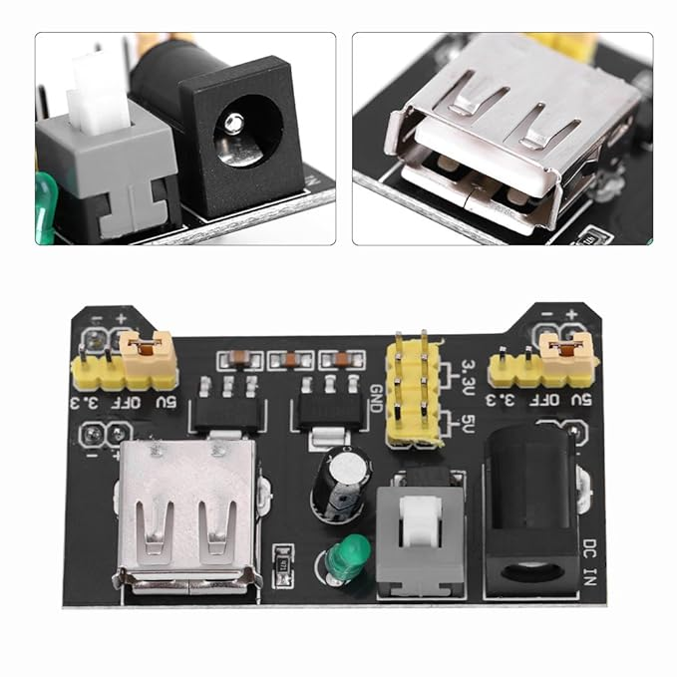

**MB 102 Breadboard Power Supply Module 3.3Volt / 5Volt:**

This is a 3.3V/5V MB102 Breadboard Power Supply Module which provides a dual 5 V and 3.3 V power rails and has a multi-purpose female USB socket.

The 3.3V/5V MB102 Breadboard Power Supply Module securely fits in a standard MB102 400 or 800 tie points breadboard it also features reverse polarity protection, the module can take 6.5V to 12V input and can produce 3.3V and +5V.

The module can also output 5V on USB connector or input through the USB connector. It’s a must-have product for experimenters those have to test/prototype electronic circuits on the breadboard.

**Features:**

Breadboard power supply module, compatible with 5V, 3.3V.

Apply to MB102 breadboard

Fluctuation two road independent control can switch over to 0 V, 3.3 V, 5 V

On-board two groups of 3.3V, 5V DC output plug pin, convenient external lead use.

**Circuit Diagram:**

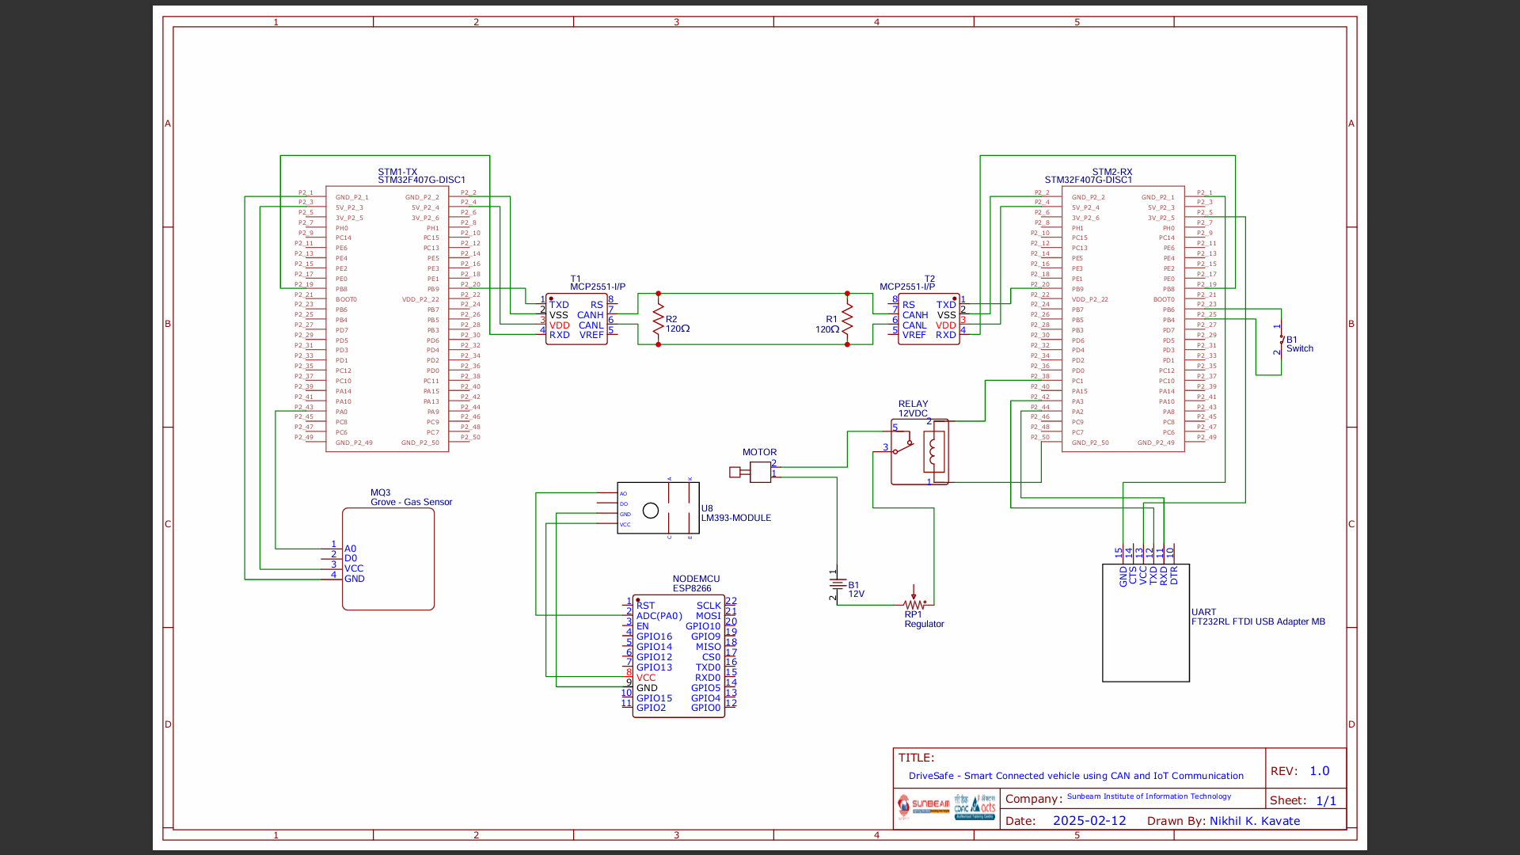

**STM32CubeIDE:**



STM32CubeIDE is an integrated development environment (IDE) by STMicroelectronics for developing applications on STM32 microcontrollers. It combines code editing, compilation, and debugging tools with STM32CubeMX for peripheral configuration and code generation. The IDE supports C/C++ development and provides built-in debugging features for seamless embedded system programming.

**EasyEDA:**



EasyEDA is a web-based EDA (Electronic Design Automation) tool that allows users to design PCBs (Printed Circuit Boards) and schematics in a collaborative environment. It offers a simple and intuitive interface, making it suitable for beginners and experienced users alike. EasyEDA features a wide range of components in its library, supports SPICE simulation, and provides features for PCB layout design and routing. It's popular for its ease of use and accessibility, as it runs entirely in a web browser without the need for installation.

**Arduino IDE:**

****The Arduino IDE is an open-source software used for writing, compiling, and uploading code to Arduino microcontroller boards. It features a user-friendly code editor with syntax highlighting, a compiler to convert code into machine-readable instructions and an uploader for loading program the board. The built-in Library Manager allows users to install additional libraries, while the Serial Monitor and Plotter help with debugging and real-time data visualization. Supporting multiple Arduino boards, it simplifies embedded development and is widely used in IoT, robotics, and automation projects due to its ease of use and extensive community support.

**Working:**

We have used two STM32F407G-DISC1 boards, one act as a Transmitter(stm32-Tx) & other act as a Receiver(stm32-Rx), stm32-Tx board takes reading from Alcohol sensor(MQ3) through ADC pin (PA0), analog reading generated from sensor(volts) is converted to digital reading by 12 bit ADC of stm32-Tx board in range between 0 to 4095, this digital reading is calibrated to alcohol reading (ppm or mg/L), this alcohol reading is transmitted over CAN bus using transceiver(MCP2551), through CAN communication alcohol concentration reading is transmitted over CAN bus in standard frame format. stm32-Rx receives reading from transceiver(separately used for stm32-Rx). When reading is received, for each reading Rx0 interrupt is generated which executes ISR defined in code, received reading is stored into a particular variable & transmitted to UART TTL Module(connected to PC) using RS232 protocol, on PC Linux terminal readings are shown on minicom.

As aim of the project is to start or stop motor according to set threshold value of alcohol reading, sense motor speed in rpm & display it on IOT platform,

one GPIO pin PC1 is set in output mode, when alcohol reading is lesser than particular set threshold value the GPIO output pin PC1 becomes high & send high signal to relay which activates relay coil & DC motor starts. To vary the speed of motor one speed control regulator is connected between relay & motor, due to which we can vary speed manually.

When alcohol reading is greater than or equal to set threshold value the output pin PC1 set to low(0V), which send low signal to relay due to which relay deactivates & motor stops.

When motor runs, we are measuring speed of motor through speed measuring sensor Groove Coupler Module(LM393IR) which is connected to NodeMCU board(ESP8266) through ADC A0 pin, this sensor generates analog reading which is converted to digital(range from 0 to 1023) using ADC(10 bit) & calibrated to speed in RPM, this reading is sent to IOT platform using HTTP.

ADC - Analog to digital convertor

UART - Universal Asynchronous receiver transmitter

TTL - Transistor-Transistor logic

ISR - Interrupt Service Routine

IOT - Internet of Things

HTTP - Hypertext transfer protocol

MQ-3 - Metal Oxide Semiconductor(MOS) Sensor

**Appendix A – Datasheet:**

**STM32F407VG MCU Discovery Board -**https://www.st.com/resource/en/user_manual/um1472-discovery-kit-with-stm32f407vg-mcu-stmicroelectronics.pdf

**MQ3 (Alcohol Detection Sensor Module) –** <https://cdn.sparkfun.com/assets/6/a/1/7/b/MQ-3.pdf>

**ESP8266MOD –** <https://www.espressif.com/sites/default/files/documentation/esp8266-technical_reference_en.pdf>

**MCP2551 (Transceiver) -** <https://ww1.microchip.com/downloads/en/devicedoc/20001667g.pdf>

**LM393IR (Motor Speed Measuring Sensor Module) -** <https://5.imimg.com/data5/VQ/DC/MY-1833510/lm393-motor-speed-measuring-sensor-module-for-arduino.pdf>

**4 Channel 5VRelayModule -** <https://mm.digikey.com/Volume0/opasdata/d220001/medias/docus/5773/TS0011%20DATASHEET.pdf>

**5V dc Motor -** <https://cdn.sparkfun.com/datasheets/Robotics/RP6%20motor%20TFK280SC-21138-45.pdf>

**MB 102 Breadboard Power Supply Module**

<https://handsontec.com/dataspecs/mb102-ps.pdf>

**Appendix B– Bibliography:**

**Important Software and Websites**

* 1. STM32CubeIDE
  2. Arduino IDE
  3. EasyEDA

**Reference**

1. [www.youtube.com](http://www.youtube.com)
2. <https://www.google.com>
3. <https://thingsboard.io/>
4. <https://ai.thestempedia.com/docs/evive-iot-kit/interfacing-mq-3-gas-sensor-with-evive/>

|  |  |  |  |
| --- | --- | --- | --- |
| Name | QTY. | Part Number | DESCRIPTION |
| STM Discovery Board | 2 | STM32F407 | ARM Cortex-M4, 168 MHz, 1MB Flash, 192KB RAM, Pins: Up to 82. |
| Gas Sensor | 1 | MQ3 | Operating Voltage: 5V DC, Preheat time =24hr, Response time<11 |
| CAN Transceiver | 2 | MCP2551 | Operating Vol= 4.5V to 5.5V, Max Data Rate= 1Mbps, Max Node =112. |
| Motor | 1 | --------------- | Operating Vol= 5V DC, No-Load Speed= 2000-6000. |
| Breadboard Power Supply | 1 | MB 102 | I/P= DC 12V, O/P= 3.3V/5V. |
| Resistors | 2 | --------------- | 120Ω ±5%. |
| Speed Sensor | 1 | LM393IR | Operating Vol= 3.3V-5V DC, Interface: 4-Pin (VCC, GND, AO, DO) |
| Switch | 1 | --------------- | Toggle, PCB / Panel. |
| Adjustable Speed Controller Regulation | 1 | TL494 | I/P Vol= 1.8V-15V DC, Max O/P Pow= 30w, Max O/P Current= 2A. |
| ESP | 1 | ESP8266MOD | GPIO Pins: Up to 17, Flash Memory: Up to 16MB,  Operating Vol= 3.3V DC |

**Component List:**