Abstract

Introduction
Selecting the correct passing option in football is a structured decision problem shaped by player positioning, direction of play, and tactical risk. At each decision moment, a ball carrier must choose one pass from several feasible alternatives, each offering a different level of progression and safety. Existing machine-learning approaches typically address this problem by learning statistical preferences from historical data. Such methods do not solve the underlying optimization problem and often struggle to generalize when the spatial configuration of players changes. In this work, I frame football pass selection as an explicit optimization task and study whether near-term quantum methods can recover optimal decisions directly from the geometry of play. I compare the Quantum Approximate Optimization Algorithm (QAOA) with a continuous-variable photonic quantum computer, Dirac-3.

Methods
Each on-ball decision is treated as a single optimization instance. Given the ball carrier’s position and all teammate locations at that instant, we identify viable passing options using realistic constraints. The receiver must be a teammate, cannot be the ball carrier, must lie within a practical passing distance, and must form a valid angle relative to the attacking direction.
For each candidate pass, we compute a continuous value score reflecting two core football principles. First, forward progression, where passes aligned with the attacking direction are preferred. Second, effective distance, where extremely short passes provide limited benefit and excessively long passes incur higher risk, with medium-range progression rewarded most. These scores are normalized and encoded into a QUBO formulation, where selecting exactly one pass corresponds to minimizing the objective.
This formulation evaluates the quality of every feasible action in the current game state. QAOA/Dirac-3 is applied to this formulation to predict which pass should have been taken for each decision moment. Performance is evaluated by comparing the predicted pass against the brute-force optimal solution obtained by exhaustively evaluating all candidates.
In addition, decision behavior is analyzed at the player level. For each carrier summary statistics is computed over their decision moments, including the decision efficiency score (DES), match rate to the optimal solution, and value gap statistics. These features capture how closely a player’s on-pitch decisions align with the optimisation-defined optimum. Players are then grouped using unsupervised clustering based on these statistics, producing interpretable decision-style categories without using player identity or role information.

Results
Table 1 shows a clear performance hierarchy. Dirac-3 achieves the highest optimal-pass recovery accuracy and the lowest value gap, followed by QAOA, while the machine-learning baseline performs poorly by comparison.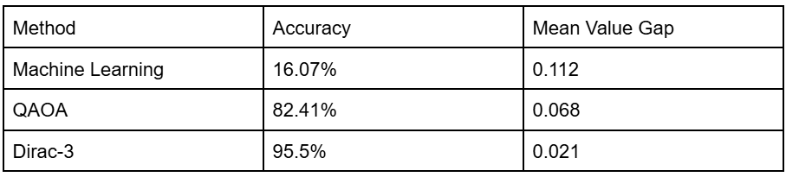
Table 2 presents player-level decision classifications: Optimal / Efficient, Conservative / Safe; and Inefficient / Risky.
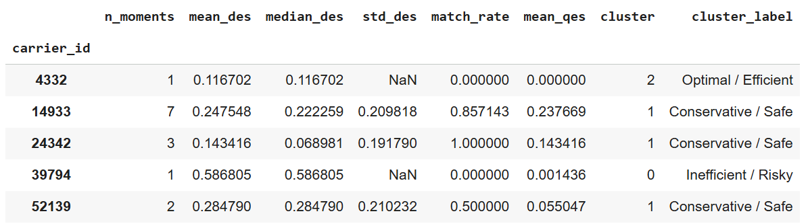
Conclusion
This study shows that football passing decisions benefit from being treated as explicit optimization problems rather than purely learned predictions. Beyond passing, the same formulation can be extended to other football decisions, such as shooting selection, ball progression, and defensive positioning, highlighting quantum optimization as a promising direction for broader decision analytics in sport.
Note. QAOA experiments are fully reproducible using open-source implementations. Dirac-3 results are included as an optional extension to assess performance on a real photonic quantum computer and require API access (Free for Basic use).

