Hi I am nisar

**Hi I am rajni**

**Hi I am rajni**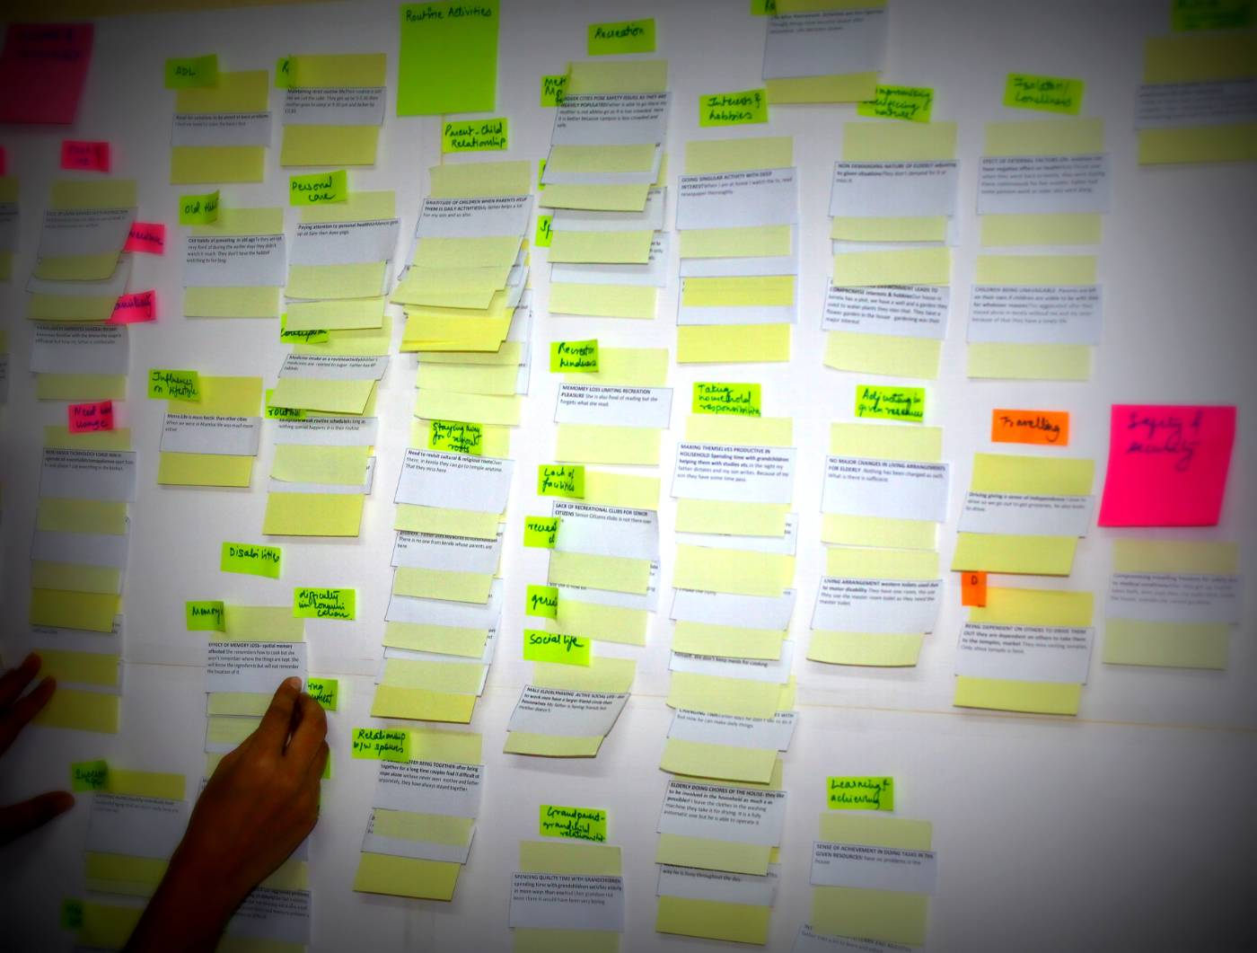

**Hi I am nisar**

**Hi I am nisar**

