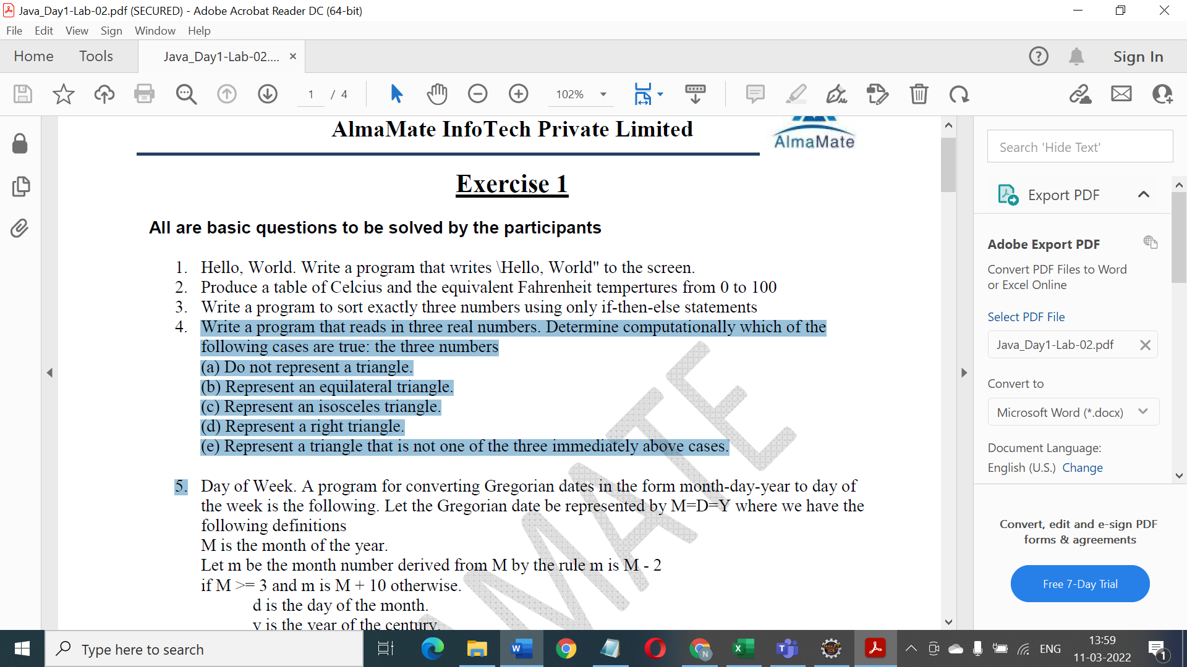

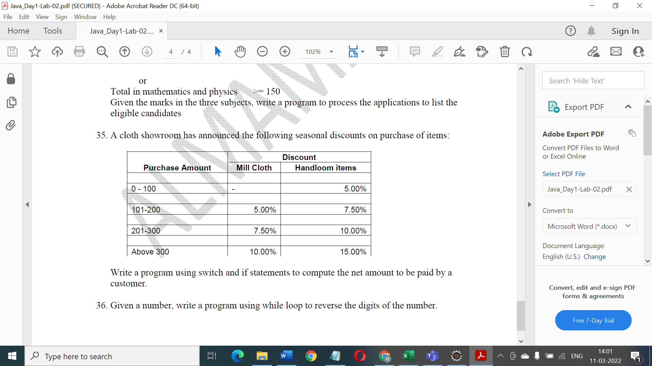

Arrays

1. Find smallest and largest number in an array of 10 elements

2. Find a given no in an array

3. Arrange all elements of an array as follows:

Array-> 12,-9,3,-18,15,6

Ans-> -9, -18, 12,3,15,6

4. Arrange all elements of an array in descending order.

5. Sum of Two Matrix.

6. Diagonals Sum of Two Matrix

7. Exchange First row with last row

1 2 3 4 4 2 3 1

5 6 7 8 8 6 7 5

9 10 11 12 12 10 11 9

1. [Check if string contains valid number](http://www.java-examples.com/check-string-contains-valid-number-example) (Example “10.0”, 19.5r”--- second value is not valid)
2. [Convert String to Character Array](http://www.java-examples.com/convert-string-character-array-example)
3. [Java Char Array To String](http://www.java-examples.com/java-char-array-string-example)
4. Convert [Java Date to String](http://www.java-examples.com/java-date-string-example)
5. Find a string in another string and store the reverse of the second string in place of substring in first string. For example🡪 in word “computer” searches “put” and make a new word as “comtuper”.
6. Take a string from the user and checks whether that string is empty or not. If it is not empty then check it for palindrome
7. [Java String valueOf Example](http://www.java-examples.com/java-string-valueof-example)
8. [Substring Example](http://www.java-examples.com/sub-string-example)
   * 1. Write a program to add 10 numbers

2. Write a program to add some integers. The last number will be 0

3. Write a program to read integers from the user. The program should keep on multiplying the numbers and print the result. The last number will be 0.

4. Write a program to print all even numbers between x and y

5. Write a program to print all multiples of n between x and y

6. Write a program to print all even numbers between x and y assuming that x can be greater or lesser than y

7. Write a program to print all multiples of n between x and y assuming that x can be greater or lesser then y

8. Write a program to find the sum of n numbers, ignoring all numbers > x

9. Write a program to find the largest and second largest number from a list of n numbers

10. Write a program to print a table with time starting from 0:0 to 11:59

0:0

0:1

...

0:59

1:0

1:1

...

11:59