**Transport Company Project**

**Project Objective**

**I**t maintains all the information about any vehicle that is administered in a transport company with the sufficient details including the details of: the vehicle’s owner, contact number and the Insurance details along with all the available transport services that is provided by the company.

Users of the system include admin, manager of each branch as well as the normal visitors.  Admin after being logged in can search, update, create or delete manager’s details of each branch. The admin can search trucks and monitor their status and see visitor queries. The manager can view and manipulate truck status, the branch trucks and the information. Users can view trucks, check services and ask queries.

SSL can be used so that secured access can be granted for all the confidential user’s data. Availability for 24 hours, 7 days a week is another requirement. Browser testing and support is being sought different web browsers. Reports should be available to be exported in .XLS and .PDF formats.  Creation of a UML diagram in detailed length that is with component class and sequence is required for the whole system and all of it’s sub-components.

**Proposed System**

The existing system is totally dependent upon the manual work. In this system, the services are been done by the manual labor itself and the data base is also managed manually. This lead to the generation of less secure and less accurate manual work and more time will be taken in order to complete the whole work.

**Existing System**

Existing is totally automated and every single detail is being available on the internet. Morever, all the work is done automatically via machines and computerized system which in the end leads to the easy working of the system with more accurate amount of data being generated and easy to maintain. All the task will be done so easily using this software.

**Transport Company Snapshots**

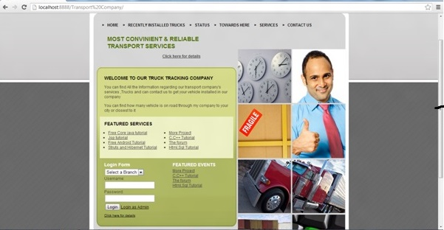

**Modules**  
**Administrative module**

The administrative module plays a crucial part in the whole system. This module allows the admin to get properly logged into the system with valid id and password. After the admin is properly logged in, he/she can perform an array of pivotal tasks in the system including searching manager module and modifying it, according to the need and even deleting it. The admin also has the facility to search through the vehicle’s status and track vehicles. This module can also respond to the visitor’s queries.

**Managing module**

This module allows each manager to view the status of the vehicles and accordingly manipulate then with respect to particular need. Each branch’s vehicle details with the vehicle’s status can be tracked.

**Visitors module**

 Prospective customers in this module can visit the services being offered by the transport company and also can garner information about the vehicles present in their possession. In this module the visitors can also make necessary and apt queries.

# ****Connect Globe Project****

## ****Connect Globe Objective****

**C**onnect Globe provides a common platform where common people can share their experiences, information and hurdles all over the globe and people can consult and discuss on any topic that is created by only the registered user. Moreover the user can give their precious advice on any topic or report. Admin and common people can used this application.

The admin after being logged in can create and also post any topic or report that is to be discussed. Admin can also control the posts and the proceeding of the reports. Admin also can view old comment history and post his own comment on topics. Common people can view reports after being logged in and can share the reports and also post and view comments. Any kind of can be used by you for the creation of the project. You can choose among any kinds of IDE including Eclipse, Myeclipse and Net beans or any other such software tools available. Oracle 10g is used as the database for the development of the project and as server, Apache tomcat, Glass fish, WebSphere etc. any can be used. The back end tools necessary for this project are JDBC, JSP, AJAX and JAVA script while the back end key is the Oracle software.

After importing the files on the IDE, all the tables associated with the program will be created automatically.

## ****Existing System****

In the recent time, there is no useful platform or any single platform where people can share their feelings, their views, their platforms and can discuss each and everything with the other people. Existing Connect Globe system needs a lot of efforts and needs a platform for the people where they can while sitting at their own home, can discuss things across with anyone using the internet and pc connection only.

## ****Proposed System****

Proposed Connect Globe system is totally worked towards providing a platform for the people who wish to connect and discuss things with other people as well. Proposed Connect Globe system is highly automated and worked towards the well being of the people. People just need to post each and everything and they can connect via this application with any one across the globe.

## ****Project Snapshot****

[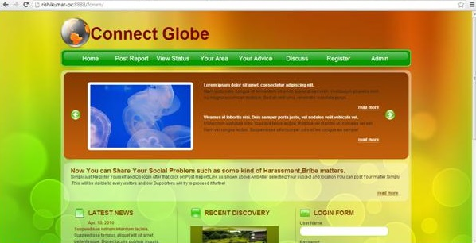](https://images.projectsgeek.com/2016/09/Connect-Globe-project.jpg)

## ****Connect Globe Modules****

**Administrative module:** The administrative module gives exclusive rights to the admin to post particular topics or reports that is to be discussed after getting logged in properly. The security measures are also given an utmost priority in this module and the user’s important and confidential data are protected in right manner. The admin can also control the posts as well as the proceedings of the reports. The admin module also has the rights to view and modify old comment history, delete inappropriate comments and post own comments on the topics.

**Users Module:** The module allows the users to get logged into the system and view posts or reports that they wish to. The users can share the posts or reports, post any contents and also view other people’s comments.

# ****Online Pharmacy Project****

## ****Project Objective****

**T**his Online Pharmacy Project is aimed to develop a systematic way to keep track of the medicine supplies by the distributors as well as make orders and modify them as a customer. Users of the system include Admin, distributor and customer. The admin after successfully logging in would be able to visit the customer’s profile and see the details, delete customers, create new customer profile, browse through the ordered medicine details and also delete or update placed orders. As a distributor, when logged in, you can browse through all the orders and select the particular orders to be distributed. After logging in as a customer, you can place order and keep track of it by contacting the distributor.

The front end of the Online Pharmacy Project contains software such as Java script, JSP, AJAX. The back requires Oracle software to run. IDE eclipse, net beans or my eclipse must be installed. Oracle 10g database is being used, with the username system and the oracle as the password. Any IDE can be used for the development of the project, Oracle 10g can be used for database and Apache Tomcat, Web logic, Jboss, glass fish, as server.

## ****Existing System****

The existing Online Pharmacy Project system in the pharmacy project consists of a lot of critical drawbacks. The overall system primarily being dependent upon manual interventions and scrutiny, often produced a considerable amount of errors in the project. In the existing system, the admin did not have the provision of adding new medicines to the database after searching the database. The Online Pharmacy Project system was not being able to be operate effectively in a multi user environment and also the interface was not user friendly. Generation of reports in customized format was difficult and maintaining daily logs was also a tedious and time consuming affair.

## ****Proposed System****

This newly proposed Online Pharmacy Project looks forward to eliminate the flaws present in the prevailing system. The proposed Online Pharmacy Project system, minimizes manual intervention and as a result produces error free, effective and efficient workflow software. The graphical interface makes the project extremely user friendly and is less time consuming. The proposed system will be able to perform many different kinds of important activities automatically including easy report printing and searching of the database.

## ****Online Pharmacy Project Snapshot****

[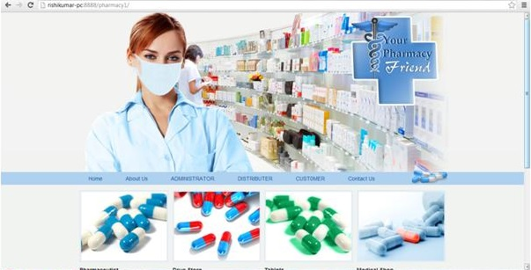](https://images.projectsgeek.com/2016/09/Online-Pharmacy-Project.jpg)

## ****Online Pharmacy Project Modules****

**Script Assist:** This module is intended to help newly appointed assistants to work in accordance with the defined rules and regulations upon particular modules through the help of different kinds of instructions and resources.

**Compound Assist:** This module particularly helps the customer my automatically arranging the preferences for him/her.

**Prescription Assist:** This module aims to make the system more efficient as well as effectively fast and incorporates the feature of automatic database updating.

**File Badger:** This module without any human interference performs each task effectively and hence saves a lot of money as well as time.

# Mail Casting Project

## ****Project Objective****

**A** mailer application for a company that can be used by the employees of the company only. It can be run on internet. Each user can send mails, receive mails and delete mails after getting logged in!

Any kinds of IDE can be used to develop the project such as eclipse, Net beans. Oracle 10g can be used for the database and Web logic, WebSphere or any other platforms can be used for server. The user can very easily send mails to particular persons over the domains, view received mails and even delete mails. Java server pages,AJAX and Java script are used as front end tool and Oracle is used as the back end tool.

Certain software requirements are there to run the project. In order to run the Mail Casting Project you first need to install any particular IDE among the most popular ones such as: eclipse, net beans. In order to meet the database requirement of the project, Oracle 10g database is used with a particular and specific username and password. Running the Mail Casting Project is very simple. All you need to do is import the file of the project on the IDE of your choice and then run it. The table creations will happen automatically for all the tables.

## ****Existing System****

In the existing Mail Casting Project system, if one has to send the mails to any one of the other, than he or she will have to keep all the addresses in their mind and along with them, if they want to mail, than they have to keep their id and password along with them. Existing Mail Casting Project system is quite an hectic task.

## ****Proposed System****

In the proposed Mail Casting Project system, the employees of the company can send the mails to all the clients via a single applications only. They just not need to login into all the stuffs for their gmail id and all the other relevant id’s in order to mail certain important documents or anything’s on their clients. Proposed Mail Casting Project system is very much useful for all the employees and all the workers as well as clients of the company.

## ****Mail Casting Snapshots****

[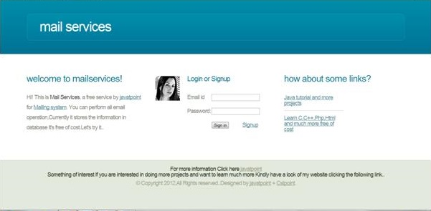](https://images.projectsgeek.com/2016/09/Mail-Casting-Project.jpg)

## ****Mail Casting Project Modules****

The employee or users module:

The user module or the employee module has the provision, where the employees or the users of the system can send emails intra organization to any person they wish to. The users of the Mail Casting Project system will also be able to view the names, employee designation and also display picture of the receiver if available. The receiver on the other end will also be able to view all these details of the sender. The employees can also make scheduled messages, meaning that they can choose a particular time and also on which particular date a message will be sent to a receiver or a cluster of receivers. The users can also send emails in any particular pre-defined format that are mostly required in any professional organization. A bunch of such professional email templates are also available.

# ****Payment Billing Product Project using JSP****

## ****Project Objective****

**A**n Institute which has many different branches at different places would want to manipulate and maintain the salary of the accountant as well as the students payment and personal details.

Users of the system are the institute’s admin as well as the accountants of the particular branches. The admin after being logged in can search, update, create or delete the accountant’s details of each branch. The admin can search and modify the student’s profiles from different branches. Branch accountant after login can search student’s payment and personal details, update old records or save new student info.

As the project output has a great amount of data deposited, so a secure and safe access is necessary for the confidential use’s data. SSL technology can also be used for this purpose. The Payment Billing Product system will be required to be active and available 24 X 7. Browser testing features should be there with support for Mozilla, Internet explorer etc. A detailed UML diagram is expected to be present for the system with full details and all it’s sub parts. Reports available should be exportable in .PDF and .XLS format. The user interface is tried to be maintained as professional as possible. AJAX has been used for all the registration forms and search options available.

## ****Existing system****

The existing Payment Billing Product systems of the payment billing product cannot efficiently manage the huge amount of deposited data in the database and modification of the data is also not very much possible. As in the existing system, data retrieval and handling is slow, with non- graphical text based interface it is not at all user friendly. As the existing Payment Billing Product system hosts a lot of offline works, done manually, the process automatically becomes sluggish and generating report in this kinds of system is extremely difficult. Data sharing, modification and capture is least feasible in the current system.

**Proposed System**

The proposed Payment Billing Product system makes attempts to make certain enhancements to the existing systems. In the proposed system, handling of huge amounts of data is made easier with much efficient data management with the provision of modification of data. The graphical user interface and fast retrieval and data handling makes the proposed system extremely user friendly. The data transactions being done primarily on net, very few paper works would be needed and generating reports will also be much faster.

## ****Payment Billing Product Snapshot****

[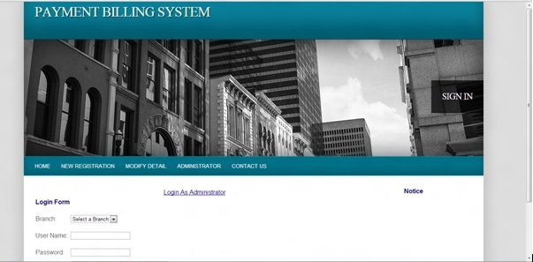](https://images.projectsgeek.com/2016/09/Payment-Billing-Product.jpg)

**Payment Billing Product Modules**

**Administrative module:** The administrative module has the privilege of getting access to the accountant’s details of each branch. The admin of the system will have to get logged in with proper user id and password and then can search through the system for accountant’s details, create, update or even delete accountants from the system. The admin can also search the users from each different branch and can browse through their profiles.

**Branch Accountants module:** This module has the option to view and moderate the user’s profile details including the payment and personal details after proper login has been done. The accountants can also integrate new data an the system database or modify or delete old records from the system

# ****Broadcasting Chat Server Project****

## ****Project Objective****

**C**hatting or Teleconferencing is a process of utilizing technology to bring people and their ideas together despite of the geographical obstacles. Chat server has two types of broadcasting. One is Public i.e. the message is broadcast to all connected users and another one is Private that means the broadcasting will be limited between two clients. Through the help of this project, the users can easily communicate and also interact with each other. The users have the ability to share all kinds of information to other users also such as transferring of various files, records, voice mails, photos etc.

The Broadcasting Chat Server Project that is required to run this project is JRE or the Java Run time Environment software and the users interact with the server by GUI i.e. Graphical User Interface. It operates in two forms. One is List form where it contains the details of those who are connected to the server and second is Chat form where the actual communication takes place.

In order to run the Broadcasting Chat Server Project, first you have to write: Java My server. After that open different dialog box by clicking the executable jar file My client multiple times. You can now log yourself in by entering your name and start communicating with others and sharing information’s.

## ****Existing System****

The Broadcasting Chat Server system which used to be there earlier had numerous drawbacks. The system used to get hung when the user wanted to ,log in to the server. The Broadcasting Chat Server Project system delayed in providing information about the users who are currently logged in or logging in after some time. The communications made through the server side lacked serious security concerns. The client side server often miserably failed to display error messages and display of appropriate messages was also delayed. Private chat facility lacked numerous features and even the facility of incorporating more people and creating a group chat was absent

**Proposed System**

The proposed system swears to nullify all the errors in the existing system. The end users in this system are given the utmost priority and security. The client after being logged in now can easily send messages to other clients with the additional feature of covert private messages and group chat facility. The users can now see other logged in user;s details very efficiently including their logged in time, duration and also their personal details like name and messages. The server server sides with utmost advanced security feature will be maintaining the log in information of the users and the user’s list with details.

## ****Broadcasting Chat Server Snapshot****

[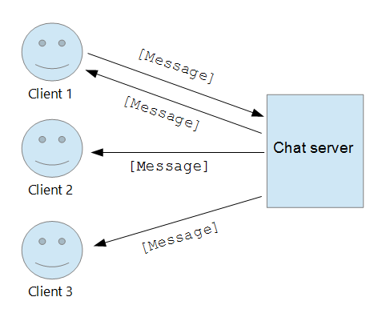](https://images.projectsgeek.com/2016/09/Broadcasting-Chat-Server.png)

## ****Broadcasting Chat Server Modules****

**Server Application:** The server application module handles the part of messages being sent and received by the broadcasting server. This module is associated with the SSL techniques, TCP/IP etc. parts of the system. This module contains certain innate logic’s which allow it to carry data about sent messages, proper routes of sending as well as receiving messages.

**Client Application:** The users module, allows the user or the client to get logged in with valid username and password. The client or the user of the system can go through the actual process of message sending in this module with other users of the system.

# ****City Classified and Search****

[](https://images.projectsgeek.com/2016/09/City-Classified-and-Search-Project.jpg)

## ****Project Objective****

In this platform, the users can submit and also view the classified after they are properly logged in and they also can search details of the particular city’s institutions such as different shopping malls, colleges, hospitals, schools etc.

After being properly logged in, the admin can post or update information on different institutions of the city such as hospitals, schools, shopping plazas etc. The admin can post city classifieds with contact details and can also delete previous posts. Posters and viewers can view classifieds and after being logged in can post classifieds. They can also get details of the city. This is a process to create a dynamic and fast page. By exchanging small quantity of data with the server this also makes web pages to be updated asynchronously. This means updating the parts of a web page is possible, without refreshing the full page. This can create a summarized UML diagram for the system and its sub-ordinates. And the results that are made may be exportable in .pdf or in .xls.

## ****Existing Systems****

The previously existing City Classified and Search system model of the city classifieds and search was complex and needed plenty amount of manual interventions. The City Classified and Search Project system was thus error prone and also sluggish. In most modules of the system, facility was not available. The structural layout and the interface was not at all user friendly. Uploading content with enhanced features were absent and also integration between all the modules was not there. The City Classified and Search Project system also did not support the facilities of email subscription for being updated and RSS feeds.

**Proposed System**

The proposed City Classified and Search Project system looks forward to eliminate the disadvantages that are associated with the existing system and in return would incorporate few advanced features. The inclusion of an inline link to the particular pages will enable the user or the seeker or poster to stay under a single domain and the classifieds websites could be associated with the homepage of the server. Email subscriptions as well as RSS feeds will be there and email notification system for ad posting feature would be available. The interface is being given a professional outlook to make it more users friendly. Updating and editing of the posted ads will be made possible according to the convenience of the user.

## ****City Classified and Search Module****

## ****User Module****

By using this registration module, the user of the project or City Classified and Search system through any particular website will be able to at his/her own liberty access specific contents available on that website and also gain access to other such particular websites. The City Classified and Search Project system in the module will have a 2 tier verification process which will include mechanisms of redirection and identification. Searching specificity to the users would be given at the time of registration.

**Administrative Module**

This powerful module will have all the pivotal tools by which one can perform several important tasks including adding and deletion of modules, editing modules, interaction with users, categorizing and manipulating search options among many others.

## ****Multimedia Support****

In this module, the admins have the power to incorporate new additional animations or videos to the websites. With several built in features, the seekers or posters would be able to view the animations easily when visiting any such particular websites.

# ****Online Banking Project using JSP****

## ****Project Objective****

Online Banking Project is the project which is aimed to develop an Online Banking service for customer. The system comprises of an online application which can be accessed inside the organization and as well the outside when properly logged in. The admin after being logged in can perform multiple works digitally like having access to users accounts, their details, personal details, transactions details etc. The users have the provision to access the account details, update the account and see the transaction details as well as make proper changes accordingly.

Online Banking Project is also known as Electronic Funds Transfer. Using the system, the customer can directly transfer the funds from one bank to another, rather than going to the bank, stand in the queue and asked for the cheque and even without carrying the cash with you.

**Existing System**

In the conventional banking, the users of the system had to wait in long queues to perform their needed banking jobs. The traditional system mostly followed tedious manual jobs and accessing the accounts of the users from the comfort of their homes was not possible. The Online Banking Project system being primarily dependent upon the manual works done by the bank employees, catering to a large number of users was slower and error prone. In fact the branches often lacked the necessary connection or network among the central organization and among themselves, making cross banking a difficult job for the users. The customers also lacked the basic liberty to check the details and status of their accounts on their own and according to their convenience. Daily basis information updates and account transactions were not possible to be tracked. Even to have such additional features, the user had to pay extra lump of sum.

## ****Proposed System****

The proposed Online Banking Project system aims to eliminate the deficiencies that prevailed in the existing system. In the proposed online banking system, the users had the liberty to operate their respective accounts from their own convenient locations. The general banking jobs like checking balance and updating their account could now be done very easily and the user could do it anytime. Availing the Online Banking Project system, the users can make necessary payments for their other family members too and could make payments of any kinds of bills very easily and fast. As the manual interventions in the systems are almost null, chances of any error occurring is almost zero. The user would be having the facilities to check monthly transactions , debit and credit history and also make fund transfers to another valid particular account at lightning speed.

## ****Snapshots****

[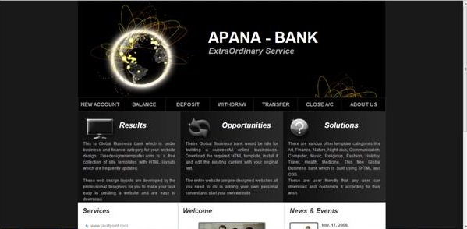](https://images.projectsgeek.com/2016/10/Online-Banking-Project.jpg)

## ****Online Banking Project Module****

The module allows the users of the Online Banking Project system to be logged into the system through the server and get connected with the activities and facilities being provided to the customers. In order to log in valid and particular login ID and password has to be given.

**Admin Module:** The admin after being logged in can perform multiple works digitally like having access to user’s accounts, their details including personal detail and transactions details among many other important tasks. The admin also oversees the transaction processes and nullifies any error or security concerns.

**Client/ User Module:** In this module, the users have the provision to access the account details, update the account and see the transaction details as well as make proper changes accordingly. They can also make fund transfers to a valid recipient and receive funds. They can also at their own convenience do these and many other associated tasks.

# ****Online Library Project using JSP****

## ****Objective****

An online platform where the users can find their needed study material would be extremely helpful for the users. The project aims to create one kind of an online library, which would have numerous books and users could access them after they have logged in. User of the system includes admin and library members, visitors.

## ****Existing System****

The existing Online Library Project system lacks many features and hence searching of books and members is a tedious job to do. The existing system lacked any such feature which would allow the provision to particularly identify any books and add pictures to it. The manual process involved in the Online Library Project system made the system lagging prone and had several provisions or spaces, where error could happen. The data entry of new users or updating books and and data required manual works which could be error prone and was not terse. Sharing of files was not possible and adding extra links provision was also not there, making it difficult for the users to do reference external reading. The existing system also was not fast, user friendly and contained less data storage capacity

**Proposed System**

The proposed Online Library Project system makes the convenient system fast and adding tagged search option would make searching much easier and less time consuming for the users. The admin of the Online Library Project system would be able to incorporate in the system new members and update their information in almost no time. Searching books and members, getting information about the borrowed and returned books will could be done very fast by the admin and also in a convenient manner. The proposed Online Library Project system also aims to make the interface extremely user friendly with a great look and feel kind of environment where chances of error are less and the storage capacity is more. The admin and logged in members will be able to access reports and files in supported and customization formats and tracking system is advanced and fast.

## ****Snapshots****

[](https://images.projectsgeek.com/2016/10/Online-Library-Project.jpg)

## ****Online Library Project Modules****

**Admin Module:** The most crucial module part, allowed the administrator to log in with exact details and perform many important jobs. The administrator could create a new staff directory, browse through the details of the staff members and modify their details. The admin module also has the provision to update and also modify the information regarding any particular book or several books.

**Library Members Module:** The library member module also has the provision to get logged in with the given log in details. This module allowed the members to browse through the e-library and also issue any preferred book with the appropriate book id.

**Visitors’ module:** This module allowed the users to make a visit of the online library system without even being logged in. The users could search and browse through available book but could not issue those.

# ****Online Quiz Project using JSP****

[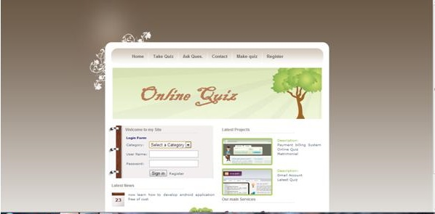](https://images.projectsgeek.com/2016/09/Online-Quiz-Project.jpg)

## ****Project Objective****

The Online Quiz Project provides a common platform where the connection between student and teacher can take place online. The registered teachers can create Quizzes and students can then take part in quizzes and can assess their own performance.

Users of the Online Quiz Project system include teacher and the students. After being properly logged in, the teachers can enter questions, based upon different subjects. The teacher can also give options and the answers to the questions at the time of creating the quiz. The students according to their subject of interest can search quiz, with proper id attempt quiz see the overall result and individual question’s answers. The non functional requirements include secure and safe access of data or confidential user’s details. 24 hours through out the week availability is also important. The support for browser testing for Mozilla, Internet Explorer, Firefox and NN is required.

The user interface priorities are also important as it is the feeling the user gets when he or she is supposedly using the application. The priorities are most prominently given on the interface’s look to make its look and feel much professional. AJAX is used with most of the registration forms and also with all of the search options and also at the id each searched results.

**Proposed System**

For taking quizzes, in the proposed Online Quiz Project system, all the work is done automatically. There will be a timer, which counts the timing remains automatically and there will be the automatic checking of the marks even. Positive marks will counted as one whereas negative marks will be deducted for every wrong answer. For negative deduction, ¼ marks will be deducted. Proposed Online Quiz Project system is highly automated and accuracy is guaranteed.

**Existing System**

In the existing Online Quiz Project system, for taking quizzes, the work done needs labor and manually it takes a lot of time to complete the task. Also, creating documents for asking for the questions in the quizzes takes a lot of time, and apart from this database maintenance is quite a tough task as compared to the management, if done is automatic. The existing Online Quiz Project system is highly automated and need less time to compute the wrong and the right answer even.

**Online Quiz Project Module**

**Quiz Control Module**

The controller has power to change the criteria is given to the controller of examination and give an interface from where controller will make new Expert and Admin for Exam Dept.

## ****Manage Admin****

In this module the controller will Create, Delete and Edit administrator for the exam dept. with the greater part of their subtle elements. A Login name and password has been given through which the administrator can later login to play out the majority of their errands.

## ****Manage Expert****

In this module the controller will Create, Delete and Edit specialists for they can later send question sets for target and additionally subjective inquiries which will be requested that comprehend to understudies under exam process.  
Normal as Manage Admin module, A Login name and password has been given here too through which the master can later login to send questions.

**Album Manager Project in Java**

## ****Project Objective****

Organizing your personal images and photos with inbuilt template will be an added advantage for using your creativity. Through this album creator you will able to view your images in different styles and patterns. You will able to list all images either in grid view or in matrix style. Before creating an album you will have to select the type of templates and look which you want to give for your album and all the templates has been provided under this one single package. The concept of tiles has been used to improve the design section for this java projects.

To load the pictures into your particular created album, you can select images either one by one or all the images at one time only. Once uploading process completed, it will provide the number of images, their particular size with their default name. Even from all these features, you can select any particular album, to convert all the images to an html file so that you can use it for your personal website just by including the name of html page. Its viewing section has been divided into two section, upper section and lower section. Upper section will display the listing of images and upon selecting any image, its detailed view will be available under bottom section.

## ****Existing System****

There was no facility of selecting multiple images at the same time and users were bound to upload single images at a time. Even the size and pixel setting were not provided by the existing system. Users can see the images in the default size and no provision was provided to resize the images while viewing. Rating options and putting watermark for any images, thus users were not able to give any unique identification to a particular image. Scrolling facility was not available for while listing of images and have to check out every images one by one by selecting particular image.

**Proposed System**

To make a unique album creator some of the exciting features has been added to make it interesting while using this system. Users can see all images by selecting a single image of particular album and scroll down through your mouse to see the next image. Even you can review any image by zooming in and out and rotating the image into 360 direction. The best part of it is creating an html file with the list of images. While selecting this option, a default folder at particular destination will be created with all necessary files which are required to make a file such as its css file, image folder and a single web page.

# Visa Processing System Project using Java

We want to develop a web based application which will provide an automated way to maintain the information for visa processing. This Visa Processing System will speed up the time required to get the visa while the software is mainly used for applying for the visa also, it will store the information for the future transaction. Hence this software will be helpful to get the visa and the information related to visa in reduced time.

## ****Existing system****

In the Visa Processing System which is present, works on a manual basis and it does not provide an effective visa processing system. As the process is manual the there are a lot of registers present, which decrease the accuracy in the information to be stored and increases the cost to store the details while the time required to access the information also increased. For maintaining these many registers and accessing the information requires a high amount of manpower which again increases costs in the overall process.

## ****Proposed system****

The visa processing system will increase the efficiency of the system by automating the visa processing task. This will increase the speed of accessing the details regarding the visa with reduced amount of error in the information. The system will most beneficial to an organization which has a number of clients in another country as they need to store the details of each employee for applying the visa. The visa processing system will manage the information on the behalf of the organization and will notify once the visa is approved. Hence the system will provide an effective means to manage the information and to apply for a visa, an organization can also make online payment through the system for visa and can check the status of the visa. If due to any reason the visa is not approved it will provide a solution for visa approval.

## ****Visa Processing System Module****

**Admin module**

The admin will be a manager or HR executive of the organization, it will have the control over the number of users who can access the system. The admin can apply for visa renewal and can access the details regarding visa approval.

**Visa processing system**  
This module will maintain the details of applied visa, passport, the number of times any particular man has visited on the site, the number of tours has done by any person.

**On-site data module**  
This contains the details regarding the date of issues of visa, the date of flight, for how many days visa has issued.

**Report handler module**

This will provide the information related to the person who went to abroad, the progress in the work, the status of visa.

The main aim of this Help Desk System is to develop a software which can provide the solution for all problem send by the workers of an organization. This Help Desk System will also track the issues raised by the employee so they can check whether their problem is solved or not. It will provide the user a standard system in which they can raise any problem in an organization and find the solution which has already has happened. The intention is to make a software which will give an option to colleagues to raise any problem in the system. The problem will be sent by message or email to the HR person.

The problems which can be raised are budget, allowance, assets, plea, contract, co-workers related issue, guidance, improvements, jobs etc. This type of Help Desk System will reduce the work in the HR department and will help in accessing the details regarding the problem in any organization and it will also help in the future problem.

## ****Existing System****

In the present time, the tracking of any issue is not an easy process as some need to write down each and every problem on paper. The HR person will first divide the problem into the different category based on the department or type of problem. To create new details in the system through manual process is a very tedious process as one need to write it and then maintain the information, to update the details, and hence the sending or receiving a single information a person need to do taught work which also a time-consuming process. In manual help desk system, there is a lot of probability of errors.

While in the proposed Help Desk System all the data is given to the automatic HR help desk system. At the time of sending itself, it will arrange all the problem according to the department and type of issues raised. It will track the issue so a person who raised the problem can know about that in real time. The creation and updating of details of any new user are very easy and can be done with some clicks of a button.

## ****Help Desk System Modules****

This Help Desk System contains several modules to construct user module, HR module, HR head module. In the user module, a person can log into the system to raise the issue and can keep track of the solution. While in the HR module the HR person can view all the query raised by the worker and will try to resolve the issue. The HR head module will act as a super module as it has control to create or delete any user and can look at any problem.

## ****Forensic Management System Objective****

            Modern science and technology has revolutionised the field of crime solving and has made the process much faster and more reliable. The word Forensic refers to all the science and technology used in the solving of crime. The aim of this Forensic Management System is to manage the large volumes of data that are produced in the process of solving crimes by the application of scientific methods and modern technology.

When creating a new case file the system will be able to store specific information in categories. Such as crime scene photographs, details about any fire arms used, all the fingerprint and DNA evidence, etc. Fingerprint data and DNA data can be sent to the concerned laboratory from this system and the results can be viewed on the same. All detective notes will also have to be entered on this system. In the event that a detective has to cooperate with other departments, this system can be used to easily collaborate on case files, temporary user profiles can be created if the other department does not implement this system. Superiors in the police department generally have to keep tabs on their subordinates and this system will enable this without the need of personally meeting the officer being reviewed. All the details relating to a case will be stored on the system on a regular basis and this can be accessed by users with valid credentials.

An important feature of this system will be its search feature. Repeat criminals generally repeat their modus operandi and there may be other similarities in cases that can be exploited for quickly solving cases. Since the system forces all case files to be stored in a uniform format it will be easy detectives to search old case files for similarities in cases.

            Security of work and accountability is important to curb corruption in the police force. This system will automatically log all user activity, regardless of officer rank, in a secure read only file. Case files once created by an officer can only be edited by the officers or detectives in charge of the case. In the event of compromised security the system will automatically shut access to its servers and can only be accessed from a central computer at the Police department.

## ****Existing System****

            In Police Departments today, paper case files are created for each case. These files are usually kept at the Police station and only one copy is maintained. Access to the file depends on how vigilant the station officers are. Generally inspectors and detectives rely on their memory of peculiar case details to form connections between cases. Different reports are requested from laboratories or other departments and each of these facilities have to courier these sensitive documents, which takes time.

## ****Proposed System****

            The proposed Forensic Management System will be able to reduce the paper trail required in the process. Digital files will make the sharing and appending of case files extremely easy. Since access to the system is required to view a case file it becomes very simple to track and regulate access to the case files. Documents from different laboratories regarding analyses can be securely and instantly sent via the internet. This Forensic Management System will augment the crime solving and record keeping abilities of a modern police force.

## ****Modules****

**Admin:**The admin can create user profiles and will be able to track user activity. Any attempts to breach the security of the system will automatically lock out the system and notify the admin.

**Supervisor:** The supervisor module is reserved for the higher officials in the police department. They will be able to view current and past case files and statistics about solving crimes.

**Officer:**The officer module will be able to create case files and can add information in the same. They will be able to search old case files and order reports from different facilities.

**Facility:** This module is for facilities such as laboratories and other departments such as the Department of Motor Vehicles to log reports requested by investigating officers.

**Guest:** The guest profile can be created for officers from other departments who are collaborating on the investigation. They will be able to add data about the case they are investigating but will not be able to access historical case files. Any request for access to old case files will be routed to the profile of Officers they are working with and will have to be approved by them.

# Stores Management System

## ****Project Objective****

            The Stores Management system will enable a chain of stores to coordinate with their supplier to facilitate on time supply and to maintain updated information about available stocks at each store.

            This Stores Management System can be hosted over either an intranet or over the internet. For stores owned by the manufacturer the system can be operated over a company wide network to enable transfer of information. In the case of various dealers selling shoes made by the manufacturer it may be easier to host the system over the internet.

 The system has two main functions, to inform the manufacturer of dealer requirement of stocks and to maintain records of all dealer transactions. It is desirable for the dealer to maintain only the required amount of stocks so as to reduce warehousing charges. The dealer can place orders to the manufacturer in two ways:

1. By explicitly ordering a specific quantity of stocks to be delivered on a particular day.
2. By setting a requirement that the manufacturer maintains a minimum amount of stock at the dealer warehouse. When the stock dips beyond a specific value an automatic buy order will be generated for the manufacturer to fulfil.

All records of these transactions will be maintained and cash payments can be made at a later date.

            The Stores Management System will keep track of the unique Stock Keeping Unit (SKU) of the products sent to each store. The Cost Price of the product will be set by the manufacturer and this is the amount the dealer will be required to pay the manufacturer. The Selling Price of the product can be set by the dealer based on their requirement. Whenever new stocks arrive at the dealer’s warehouse it will be updated in the system along with the SKU. When this product is sold at a store it will be deducted from the dealer’s inventory and the customer details along with the SKU of the product sold will be recorded.

            The system will be able to generate reports about daily, monthly sales and based on historical information predict the demand of coming months. This will help dealers and the manufacturer to prepare for upcoming festive seasons when shopping increases.

**Stores Management System Snapshots**

**Existing System**

The existing Stores Management System consists of maintenance of individual ledgers or excel sheets by both the manufacturer and the dealer. The manufacturer will have to resolve differences between both the records before cash settlements can be done. This task becomes daunting when the manufacturer has to deal with dealers spread out over the country. The dealer will have to manually go through ledgers on a daily basis to decide when it is time to place a new buy order. It is also difficult to spot trends in shopping patterns.

**Proposed System**

            The proposed Stores Management System will ensure that both the manufacturer and the dealer is working with just one version of records so as to avoid discrepancies. The manufacturer need not worry about working with different dealers in different parts of the country. The tracking of SKU will help identify changes in stock and in the unfortunate event of a product recall it will make it easier to identify the customers who bought a defective product. It is easy to spot spikes in shopping and plan accordingly for the same.

**Modules**

**Manufacturer:** The manufacturer will be able to create new login IDs for new dealers and set the Cost Price for different products. They will be able to track contract details and payment due on different contracts.

**Dealer:** The dealer will be able to initiate single or recurring buy orders. This module will alert the manufacturer about changes in stocks and expected shipments. The dealer will be able to observe historical sale data and use this to determine future demand and order accordingly. The dealer will also be able to set the Selling Price for each product.

**Admin:**  The admin will be able to control manufacturer login IDs and access.

**DataMart Management System**

**Project Objective**

            Today supermarkets and department stores are the epitome of globalization. They bring together goods sourced from different parts of the world and offer immense choice to each consumer. This DataMart Management System is designed to handle warehouse and inventory management tasks of such stores. The number of suppliers to modern day stores increases the complexity of the existing system as each supplier will have to be individually contacted and receipts generated and shared for each transaction. This DataMart Management System will facilitate the process of maintaining stock records, ordering new stocks and payment. It will also help suppliers and the store to track trends and statistics of sales.

The process starts with the addition of a new supplier to the system. The supplier will be able to enter the lead time, i.e. the time needed from placing the order to order delivery, for each product. Terms such as transit insurance, late delivery penalty and price per unit can be decided at this time. It will be the supplier’s responsibility to update the system with any changes in delivery times due to festive sales, holidays, etc. When the store places an order for a batch of product units, the supplier will arrange delivery within the stipulated time and will update the system with the Stock Keeping Unit (SKU) for each unit being sent. The store will confirm receipt of the units and their SKU upon delivery. The scanning of the SKU can be completed easily using a bar code scanner. The store can also set automatic ordering options, which will automatically place an order for a product once the supplies go below a specified level.

            The selling prices of the products are then decided and the product goes onto the shelves of different stores. The sales of the product can be tracked across the chain using the SKU. Whenever a product is sold or discounted or returned the SKU for the product will be required for updating the records. The store can use this data to predict stocks required in the future and the supplier can see the sales data for their products to make manufacturing decisions. Payment for the products can be completed using the system at any time. Receipts for sales will be maintained on the system and can be printed out at will.

**Existing System**

            The existing DataMart Management System depends on the use of paper and multiple files. Each order can be placed using phone calls or emails and will be followed by official quotations. Orders are sent and receipts generated after which payment is made. This whole process lacks the flexibility and agility required to succeed in today’s fast paced market. Disputes can arise due to mismatch of records and tracking the sales of each unit is a herculean task.

**Proposed System**

            The proposed DataMart Management System will speed up the process and will make it more responsive to customer demands. Delays in payments and ordering can be eliminated by the presence of this electronic system that will maintain a shared and tamper proof record. The supplier and store can predict changes in demand and plan accordingly. Defects in any batch of the product can be easily tracked due to the use of SKUs.

**Modules**

**Admin:** The admin module will make access IDs for each supplier and will be able to access sales data over the whole chain of stores. Payments to the suppliers and setting of prices will also be done here.

**Store:** Each store in the chain will have a user ID to access this module. Through this module they will be able to set how many stocks they require from the warehouse, they can also see sales data for their store and notify the central office about defects or returns of products.

**Supplier:** The supplier will be able to confirm terms of sale with the admin and confirm orders on the system. They will receive payment via this system and can view the receipts on the system. The supplier can also see sales data for each product to gauge its demand.

**Online News portal project in Java**

PROJECT OBJECTIVE

The main objective behind developing this Online News portal project in Java is to provide a system for the news agencies where they can share the everyday news to their customers. Not only this but even the people who love to read/view the news every day can also use this system as here they can read the news as and when they want to read it. All they need to do is to log in to the system and then, they can update themselves with the latest updates going on in the world.

You can download java projects with source code such as hospital management system, hotel management system, online examination management system, cab booking system, bus management system etc on oout website in java projects section. Please feel free to comment on project if you are facing any issue while running the projects. Most of the projects can be run on eclipse or netbeans IDE.

EXISTING SYSTEM

In the existing Online News portal project in Java, if a person wants to get some news about the world or what is going on around him/her, then he /she needs to go through the newspaper. It is a very long process. First to buy the newspaper and then to go through every page of the paper. If someone is looking for some specific sector news, then it got tough for them to get the news directly.

PROPOSED SYSTEM

In the proposed Online News portal project in Java, while going through the application, the reader can directly login into the system and he/she can choose the domain of news, which they are looking for and can read it. Though, it is also not needed to buy the newspaper. They can read it online. Also, every update/news will come to them directly. The updates will appear to their feeds automatically.

1. USER PANEL

The user panel is that panel which is accessed by the readers of this Online News portal. Via this panel, a user can log in into the system and check the news as per his/her choice. This panel is only for the readers. They have to login into the system and choose the language in which they will be likely to read the news. They will also ask for the options which will say what are the most read topics or subjects in which the user is interested in.

2. ADMIN PANEL

Admin module is for the admins of the Online News portal. They are the people who update the news for their readers. They login from the backend and update the daily news. They also automate the time as and when the news should go live. They can restrict the viewers for particular news too. They can choose who can view the news and who cannot. Sometimes, they can also restrict the users too.

3. NEWS FEED MODULE

All the news by the admin is updated into this module. This news has many sections and each section is specific to a particular domain. Admin can update the news into this panel and thus viewers and readers can read the news from their feed.