**Transport Company Project**

**Project Objective**

**I**t maintains all the information about any vehicle that is administered in a transport company with the sufficient details including the details of: the vehicle’s owner, contact number and the Insurance details along with all the available transport services that is provided by the company.

Users of the system include admin, manager of each branch as well as the normal visitors.  Admin after being logged in can search, update, create or delete manager’s details of each branch. The admin can search trucks and monitor their status and see visitor queries. The manager can view and manipulate truck status, the branch trucks and the information. Users can view trucks, check services and ask queries.

SSL can be used so that secured access can be granted for all the confidential user’s data. Availability for 24 hours, 7 days a week is another requirement. Browser testing and support is being sought different web browsers. Reports should be available to be exported in .XLS and .PDF formats.  Creation of a UML diagram in detailed length that is with component class and sequence is required for the whole system and all of it’s sub-components.

**Proposed System**

The existing system is totally dependent upon the manual work. In this system, the services are been done by the manual labor itself and the data base is also managed manually. This lead to the generation of less secure and less accurate manual work and more time will be taken in order to complete the whole work.

**Existing System**

Existing is totally automated and every single detail is being available on the internet. Morever, all the work is done automatically via machines and computerized system which in the end leads to the easy working of the system with more accurate amount of data being generated and easy to maintain. All the task will be done so easily using this software.

**Transport Company Snapshots**

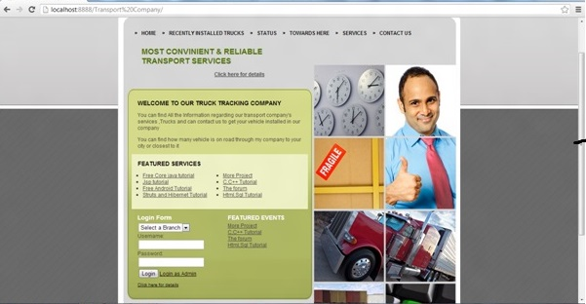

**Modules**  
**Administrative module**

The administrative module plays a crucial part in the whole system. This module allows the admin to get properly logged into the system with valid id and password. After the admin is properly logged in, he/she can perform an array of pivotal tasks in the system including searching manager module and modifying it, according to the need and even deleting it. The admin also has the facility to search through the vehicle’s status and track vehicles. This module can also respond to the visitor’s queries.

**Managing module**

This module allows each manager to view the status of the vehicles and accordingly manipulate then with respect to particular need. Each branch’s vehicle details with the vehicle’s status can be tracked.

**Visitors module**

 Prospective customers in this module can visit the services being offered by the transport company and also can garner information about the vehicles present in their possession. In this module the visitors can also make necessary and apt queries.

# ****Connect Globe Project****

## ****Connect Globe Objective****

**C**onnect Globe provides a common platform where common people can share their experiences, information and hurdles all over the globe and people can consult and discuss on any topic that is created by only the registered user. Moreover the user can give their precious advice on any topic or report. Admin and common people can used this application.

The admin after being logged in can create and also post any topic or report that is to be discussed. Admin can also control the posts and the proceeding of the reports. Admin also can view old comment history and post his own comment on topics. Common people can view reports after being logged in and can share the reports and also post and view comments. Any kind of can be used by you for the creation of the project. You can choose among any kinds of IDE including Eclipse, Myeclipse and Net beans or any other such software tools available. Oracle 10g is used as the database for the development of the project and as server, Apache tomcat, Glass fish, WebSphere etc. any can be used. The back end tools necessary for this project are JDBC, JSP, AJAX and JAVA script while the back end key is the Oracle software.

After importing the files on the IDE, all the tables associated with the program will be created automatically.

## ****Existing System****

In the recent time, there is no useful platform or any single platform where people can share their feelings, their views, their platforms and can discuss each and everything with the other people. Existing Connect Globe system needs a lot of efforts and needs a platform for the people where they can while sitting at their own home, can discuss things across with anyone using the internet and pc connection only.

## ****Proposed System****

Proposed Connect Globe system is totally worked towards providing a platform for the people who wish to connect and discuss things with other people as well. Proposed Connect Globe system is highly automated and worked towards the well being of the people. People just need to post each and everything and they can connect via this application with any one across the globe.

## ****Project Snapshot****

[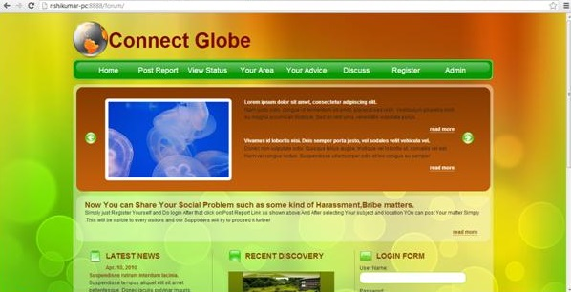](https://images.projectsgeek.com/2016/09/Connect-Globe-project.jpg)

## ****Connect Globe Modules****

**Administrative module:** The administrative module gives exclusive rights to the admin to post particular topics or reports that is to be discussed after getting logged in properly. The security measures are also given an utmost priority in this module and the user’s important and confidential data are protected in right manner. The admin can also control the posts as well as the proceedings of the reports. The admin module also has the rights to view and modify old comment history, delete inappropriate comments and post own comments on the topics.

**Users Module:** The module allows the users to get logged into the system and view posts or reports that they wish to. The users can share the posts or reports, post any contents and also view other people’s comments.

# ****Online Pharmacy Project****

## ****Project Objective****

**T**his Online Pharmacy Project is aimed to develop a systematic way to keep track of the medicine supplies by the distributors as well as make orders and modify them as a customer. Users of the system include Admin, distributor and customer. The admin after successfully logging in would be able to visit the customer’s profile and see the details, delete customers, create new customer profile, browse through the ordered medicine details and also delete or update placed orders. As a distributor, when logged in, you can browse through all the orders and select the particular orders to be distributed. After logging in as a customer, you can place order and keep track of it by contacting the distributor.

The front end of the Online Pharmacy Project contains software such as Java script, JSP, AJAX. The back requires Oracle software to run. IDE eclipse, net beans or my eclipse must be installed. Oracle 10g database is being used, with the username system and the oracle as the password. Any IDE can be used for the development of the project, Oracle 10g can be used for database and Apache Tomcat, Web logic, Jboss, glass fish, as server.

## ****Existing System****

The existing Online Pharmacy Project system in the pharmacy project consists of a lot of critical drawbacks. The overall system primarily being dependent upon manual interventions and scrutiny, often produced a considerable amount of errors in the project. In the existing system, the admin did not have the provision of adding new medicines to the database after searching the database. The Online Pharmacy Project system was not being able to be operate effectively in a multi user environment and also the interface was not user friendly. Generation of reports in customized format was difficult and maintaining daily logs was also a tedious and time consuming affair.

## ****Proposed System****

This newly proposed Online Pharmacy Project looks forward to eliminate the flaws present in the prevailing system. The proposed Online Pharmacy Project system, minimizes manual intervention and as a result produces error free, effective and efficient workflow software. The graphical interface makes the project extremely user friendly and is less time consuming. The proposed system will be able to perform many different kinds of important activities automatically including easy report printing and searching of the database.

## ****Online Pharmacy Project Snapshot****

[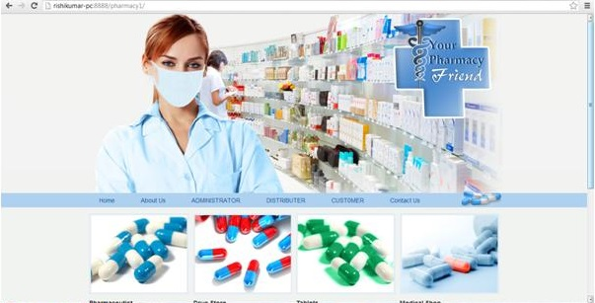](https://images.projectsgeek.com/2016/09/Online-Pharmacy-Project.jpg)

## ****Online Pharmacy Project Modules****

**Script Assist:** This module is intended to help newly appointed assistants to work in accordance with the defined rules and regulations upon particular modules through the help of different kinds of instructions and resources.

**Compound Assist:** This module particularly helps the customer my automatically arranging the preferences for him/her.

**Prescription Assist:** This module aims to make the system more efficient as well as effectively fast and incorporates the feature of automatic database updating.

**File Badger:** This module without any human interference performs each task effectively and hence saves a lot of money as well as time.

# Mail Casting Project

## ****Project Objective****

**A** mailer application for a company that can be used by the employees of the company only. It can be run on internet. Each user can send mails, receive mails and delete mails after getting logged in!

Any kinds of IDE can be used to develop the project such as eclipse, Net beans. Oracle 10g can be used for the database and Web logic, WebSphere or any other platforms can be used for server. The user can very easily send mails to particular persons over the domains, view received mails and even delete mails. Java server pages,AJAX and Java script are used as front end tool and Oracle is used as the back end tool.

Certain software requirements are there to run the project. In order to run the Mail Casting Project you first need to install any particular IDE among the most popular ones such as: eclipse, net beans. In order to meet the database requirement of the project, Oracle 10g database is used with a particular and specific username and password. Running the Mail Casting Project is very simple. All you need to do is import the file of the project on the IDE of your choice and then run it. The table creations will happen automatically for all the tables.

## ****Existing System****

In the existing Mail Casting Project system, if one has to send the mails to any one of the other, than he or she will have to keep all the addresses in their mind and along with them, if they want to mail, than they have to keep their id and password along with them. Existing Mail Casting Project system is quite an hectic task.

## ****Proposed System****

In the proposed Mail Casting Project system, the employees of the company can send the mails to all the clients via a single applications only. They just not need to login into all the stuffs for their gmail id and all the other relevant id’s in order to mail certain important documents or anything’s on their clients. Proposed Mail Casting Project system is very much useful for all the employees and all the workers as well as clients of the company.

## ****Mail Casting Snapshots****

[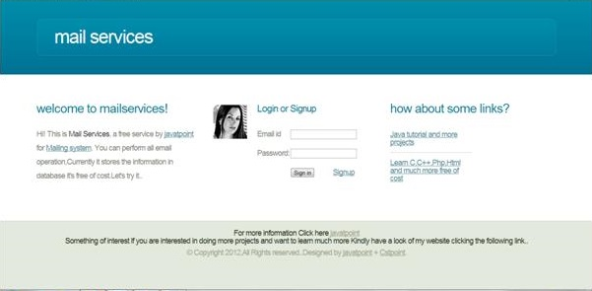](https://images.projectsgeek.com/2016/09/Mail-Casting-Project.jpg)

## ****Mail Casting Project Modules****

The employee or users module:

The user module or the employee module has the provision, where the employees or the users of the system can send emails intra organization to any person they wish to. The users of the Mail Casting Project system will also be able to view the names, employee designation and also display picture of the receiver if available. The receiver on the other end will also be able to view all these details of the sender. The employees can also make scheduled messages, meaning that they can choose a particular time and also on which particular date a message will be sent to a receiver or a cluster of receivers. The users can also send emails in any particular pre-defined format that are mostly required in any professional organization. A bunch of such professional email templates are also available.

# ****Payment Billing Product Project using JSP****

## ****Project Objective****

**A**n Institute which has many different branches at different places would want to manipulate and maintain the salary of the accountant as well as the students payment and personal details.

Users of the system are the institute’s admin as well as the accountants of the particular branches. The admin after being logged in can search, update, create or delete the accountant’s details of each branch. The admin can search and modify the student’s profiles from different branches. Branch accountant after login can search student’s payment and personal details, update old records or save new student info.

As the project output has a great amount of data deposited, so a secure and safe access is necessary for the confidential use’s data. SSL technology can also be used for this purpose. The Payment Billing Product system will be required to be active and available 24 X 7. Browser testing features should be there with support for Mozilla, Internet explorer etc. A detailed UML diagram is expected to be present for the system with full details and all it’s sub parts. Reports available should be exportable in .PDF and .XLS format. The user interface is tried to be maintained as professional as possible. AJAX has been used for all the registration forms and search options available.

## ****Existing system****

The existing Payment Billing Product systems of the payment billing product cannot efficiently manage the huge amount of deposited data in the database and modification of the data is also not very much possible. As in the existing system, data retrieval and handling is slow, with non- graphical text based interface it is not at all user friendly. As the existing Payment Billing Product system hosts a lot of offline works, done manually, the process automatically becomes sluggish and generating report in this kinds of system is extremely difficult. Data sharing, modification and capture is least feasible in the current system.

**Proposed System**

The proposed Payment Billing Product system makes attempts to make certain enhancements to the existing systems. In the proposed system, handling of huge amounts of data is made easier with much efficient data management with the provision of modification of data. The graphical user interface and fast retrieval and data handling makes the proposed system extremely user friendly. The data transactions being done primarily on net, very few paper works would be needed and generating reports will also be much faster.

## ****Payment Billing Product Snapshot****

[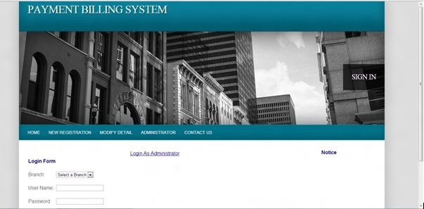](https://images.projectsgeek.com/2016/09/Payment-Billing-Product.jpg)

**Payment Billing Product Modules**

**Administrative module:** The administrative module has the privilege of getting access to the accountant’s details of each branch. The admin of the system will have to get logged in with proper user id and password and then can search through the system for accountant’s details, create, update or even delete accountants from the system. The admin can also search the users from each different branch and can browse through their profiles.

**Branch Accountants module:** This module has the option to view and moderate the user’s profile details including the payment and personal details after proper login has been done. The accountants can also integrate new data an the system database or modify or delete old records from the system

# ****Broadcasting Chat Server Project****

## ****Project Objective****

**C**hatting or Teleconferencing is a process of utilizing technology to bring people and their ideas together despite of the geographical obstacles. Chat server has two types of broadcasting. One is Public i.e. the message is broadcast to all connected users and another one is Private that means the broadcasting will be limited between two clients. Through the help of this project, the users can easily communicate and also interact with each other. The users have the ability to share all kinds of information to other users also such as transferring of various files, records, voice mails, photos etc.

The Broadcasting Chat Server Project that is required to run this project is JRE or the Java Run time Environment software and the users interact with the server by GUI i.e. Graphical User Interface. It operates in two forms. One is List form where it contains the details of those who are connected to the server and second is Chat form where the actual communication takes place.

In order to run the Broadcasting Chat Server Project, first you have to write: Java My server. After that open different dialog box by clicking the executable jar file My client multiple times. You can now log yourself in by entering your name and start communicating with others and sharing information’s.

## ****Existing System****

The Broadcasting Chat Server system which used to be there earlier had numerous drawbacks. The system used to get hung when the user wanted to ,log in to the server. The Broadcasting Chat Server Project system delayed in providing information about the users who are currently logged in or logging in after some time. The communications made through the server side lacked serious security concerns. The client side server often miserably failed to display error messages and display of appropriate messages was also delayed. Private chat facility lacked numerous features and even the facility of incorporating more people and creating a group chat was absent

**Proposed System**

The proposed system swears to nullify all the errors in the existing system. The end users in this system are given the utmost priority and security. The client after being logged in now can easily send messages to other clients with the additional feature of covert private messages and group chat facility. The users can now see other logged in user;s details very efficiently including their logged in time, duration and also their personal details like name and messages. The server server sides with utmost advanced security feature will be maintaining the log in information of the users and the user’s list with details.

## ****Broadcasting Chat Server Snapshot****

[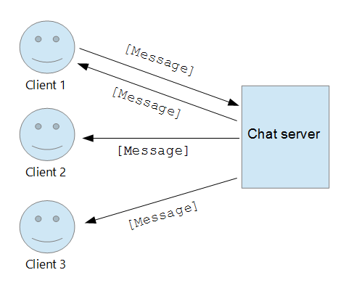](https://images.projectsgeek.com/2016/09/Broadcasting-Chat-Server.png)

## ****Broadcasting Chat Server Modules****

**Server Application:** The server application module handles the part of messages being sent and received by the broadcasting server. This module is associated with the SSL techniques, TCP/IP etc. parts of the system. This module contains certain innate logic’s which allow it to carry data about sent messages, proper routes of sending as well as receiving messages.

**Client Application:** The users module, allows the user or the client to get logged in with valid username and password. The client or the user of the system can go through the actual process of message sending in this module with other users of the system.

# ****City Classified and Search****

[](https://images.projectsgeek.com/2016/09/City-Classified-and-Search-Project.jpg)

## ****Project Objective****

In this platform, the users can submit and also view the classified after they are properly logged in and they also can search details of the particular city’s institutions such as different shopping malls, colleges, hospitals, schools etc.

After being properly logged in, the admin can post or update information on different institutions of the city such as hospitals, schools, shopping plazas etc. The admin can post city classifieds with contact details and can also delete previous posts. Posters and viewers can view classifieds and after being logged in can post classifieds. They can also get details of the city. This is a process to create a dynamic and fast page. By exchanging small quantity of data with the server this also makes web pages to be updated asynchronously. This means updating the parts of a web page is possible, without refreshing the full page. This can create a summarized UML diagram for the system and its sub-ordinates. And the results that are made may be exportable in .pdf or in .xls.

## ****Existing Systems****

The previously existing City Classified and Search system model of the city classifieds and search was complex and needed plenty amount of manual interventions. The City Classified and Search Project system was thus error prone and also sluggish. In most modules of the system, facility was not available. The structural layout and the interface was not at all user friendly. Uploading content with enhanced features were absent and also integration between all the modules was not there. The City Classified and Search Project system also did not support the facilities of email subscription for being updated and RSS feeds.

**Proposed System**

The proposed City Classified and Search Project system looks forward to eliminate the disadvantages that are associated with the existing system and in return would incorporate few advanced features. The inclusion of an inline link to the particular pages will enable the user or the seeker or poster to stay under a single domain and the classifieds websites could be associated with the homepage of the server. Email subscriptions as well as RSS feeds will be there and email notification system for ad posting feature would be available. The interface is being given a professional outlook to make it more users friendly. Updating and editing of the posted ads will be made possible according to the convenience of the user.

## ****City Classified and Search Module****

## ****User Module****

By using this registration module, the user of the project or City Classified and Search system through any particular website will be able to at his/her own liberty access specific contents available on that website and also gain access to other such particular websites. The City Classified and Search Project system in the module will have a 2 tier verification process which will include mechanisms of redirection and identification. Searching specificity to the users would be given at the time of registration.

**Administrative Module**

This powerful module will have all the pivotal tools by which one can perform several important tasks including adding and deletion of modules, editing modules, interaction with users, categorizing and manipulating search options among many others.

## ****Multimedia Support****

In this module, the admins have the power to incorporate new additional animations or videos to the websites. With several built in features, the seekers or posters would be able to view the animations easily when visiting any such particular websites.

# ****Online Banking Project using JSP****

## ****Project Objective****

Online Banking Project is the project which is aimed to develop an Online Banking service for customer. The system comprises of an online application which can be accessed inside the organization and as well the outside when properly logged in. The admin after being logged in can perform multiple works digitally like having access to users accounts, their details, personal details, transactions details etc. The users have the provision to access the account details, update the account and see the transaction details as well as make proper changes accordingly.

Online Banking Project is also known as Electronic Funds Transfer. Using the system, the customer can directly transfer the funds from one bank to another, rather than going to the bank, stand in the queue and asked for the cheque and even without carrying the cash with you.

**Existing System**

In the conventional banking, the users of the system had to wait in long queues to perform their needed banking jobs. The traditional system mostly followed tedious manual jobs and accessing the accounts of the users from the comfort of their homes was not possible. The Online Banking Project system being primarily dependent upon the manual works done by the bank employees, catering to a large number of users was slower and error prone. In fact the branches often lacked the necessary connection or network among the central organization and among themselves, making cross banking a difficult job for the users. The customers also lacked the basic liberty to check the details and status of their accounts on their own and according to their convenience. Daily basis information updates and account transactions were not possible to be tracked. Even to have such additional features, the user had to pay extra lump of sum.

## ****Proposed System****

The proposed Online Banking Project system aims to eliminate the deficiencies that prevailed in the existing system. In the proposed online banking system, the users had the liberty to operate their respective accounts from their own convenient locations. The general banking jobs like checking balance and updating their account could now be done very easily and the user could do it anytime. Availing the Online Banking Project system, the users can make necessary payments for their other family members too and could make payments of any kinds of bills very easily and fast. As the manual interventions in the systems are almost null, chances of any error occurring is almost zero. The user would be having the facilities to check monthly transactions , debit and credit history and also make fund transfers to another valid particular account at lightning speed.

## ****Snapshots****

[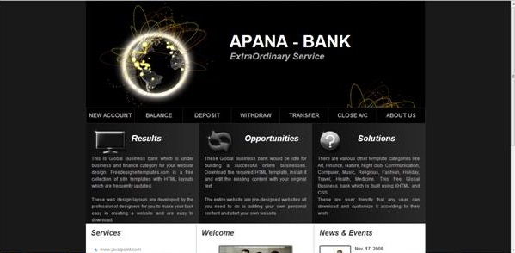](https://images.projectsgeek.com/2016/10/Online-Banking-Project.jpg)

## ****Online Banking Project Module****

The module allows the users of the Online Banking Project system to be logged into the system through the server and get connected with the activities and facilities being provided to the customers. In order to log in valid and particular login ID and password has to be given.

**Admin Module:** The admin after being logged in can perform multiple works digitally like having access to user’s accounts, their details including personal detail and transactions details among many other important tasks. The admin also oversees the transaction processes and nullifies any error or security concerns.

**Client/ User Module:** In this module, the users have the provision to access the account details, update the account and see the transaction details as well as make proper changes accordingly. They can also make fund transfers to a valid recipient and receive funds. They can also at their own convenience do these and many other associated tasks.

# ****Online Library Project using JSP****

## ****Objective****

An online platform where the users can find their needed study material would be extremely helpful for the users. The project aims to create one kind of an online library, which would have numerous books and users could access them after they have logged in. User of the system includes admin and library members, visitors.

## ****Existing System****

The existing Online Library Project system lacks many features and hence searching of books and members is a tedious job to do. The existing system lacked any such feature which would allow the provision to particularly identify any books and add pictures to it. The manual process involved in the Online Library Project system made the system lagging prone and had several provisions or spaces, where error could happen. The data entry of new users or updating books and and data required manual works which could be error prone and was not terse. Sharing of files was not possible and adding extra links provision was also not there, making it difficult for the users to do reference external reading. The existing system also was not fast, user friendly and contained less data storage capacity

**Proposed System**

The proposed Online Library Project system makes the convenient system fast and adding tagged search option would make searching much easier and less time consuming for the users. The admin of the Online Library Project system would be able to incorporate in the system new members and update their information in almost no time. Searching books and members, getting information about the borrowed and returned books will could be done very fast by the admin and also in a convenient manner. The proposed Online Library Project system also aims to make the interface extremely user friendly with a great look and feel kind of environment where chances of error are less and the storage capacity is more. The admin and logged in members will be able to access reports and files in supported and customization formats and tracking system is advanced and fast.

## ****Snapshots****

[](https://images.projectsgeek.com/2016/10/Online-Library-Project.jpg)

## ****Online Library Project Modules****

**Admin Module:** The most crucial module part, allowed the administrator to log in with exact details and perform many important jobs. The administrator could create a new staff directory, browse through the details of the staff members and modify their details. The admin module also has the provision to update and also modify the information regarding any particular book or several books.

**Library Members Module:** The library member module also has the provision to get logged in with the given log in details. This module allowed the members to browse through the e-library and also issue any preferred book with the appropriate book id.

**Visitors’ module:** This module allowed the users to make a visit of the online library system without even being logged in. The users could search and browse through available book but could not issue those.

# ****Online Quiz Project using JSP****

[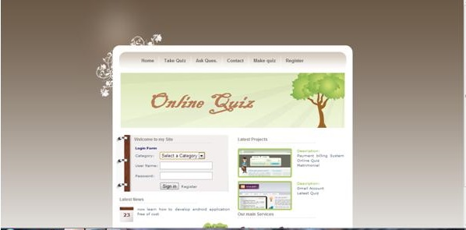](https://images.projectsgeek.com/2016/09/Online-Quiz-Project.jpg)

## ****Project Objective****

The Online Quiz Project provides a common platform where the connection between student and teacher can take place online. The registered teachers can create Quizzes and students can then take part in quizzes and can assess their own performance.

Users of the Online Quiz Project system include teacher and the students. After being properly logged in, the teachers can enter questions, based upon different subjects. The teacher can also give options and the answers to the questions at the time of creating the quiz. The students according to their subject of interest can search quiz, with proper id attempt quiz see the overall result and individual question’s answers. The non functional requirements include secure and safe access of data or confidential user’s details. 24 hours through out the week availability is also important. The support for browser testing for Mozilla, Internet Explorer, Firefox and NN is required.

The user interface priorities are also important as it is the feeling the user gets when he or she is supposedly using the application. The priorities are most prominently given on the interface’s look to make its look and feel much professional. AJAX is used with most of the registration forms and also with all of the search options and also at the id each searched results.

**Proposed System**

For taking quizzes, in the proposed Online Quiz Project system, all the work is done automatically. There will be a timer, which counts the timing remains automatically and there will be the automatic checking of the marks even. Positive marks will counted as one whereas negative marks will be deducted for every wrong answer. For negative deduction, ¼ marks will be deducted. Proposed Online Quiz Project system is highly automated and accuracy is guaranteed.

**Existing System**

In the existing Online Quiz Project system, for taking quizzes, the work done needs labor and manually it takes a lot of time to complete the task. Also, creating documents for asking for the questions in the quizzes takes a lot of time, and apart from this database maintenance is quite a tough task as compared to the management, if done is automatic. The existing Online Quiz Project system is highly automated and need less time to compute the wrong and the right answer even.

**Online Quiz Project Module**

**Quiz Control Module**

The controller has power to change the criteria is given to the controller of examination and give an interface from where controller will make new Expert and Admin for Exam Dept.

## ****Manage Admin****

In this module the controller will Create, Delete and Edit administrator for the exam dept. with the greater part of their subtle elements. A Login name and password has been given through which the administrator can later login to play out the majority of their errands.

## ****Manage Expert****

In this module the controller will Create, Delete and Edit specialists for they can later send question sets for target and additionally subjective inquiries which will be requested that comprehend to understudies under exam process.  
Normal as Manage Admin module, A Login name and password has been given here too through which the master can later login to send questions.